RESponse paper

Z516

Abu Saleh Md Noman

amdnoman

The selected reading for this response paper was chosen from Chapter 13: ‘Metaphors, Idioms and Affordances’ of ‘Cooper, A., Reimann, R., & Cronin, D. (2007). About Face 3: The Essentials of Interaction Design (3rd ed.). Indianapolis, IN: Wiley.’ The concept or idea that this paper is going to address is use of metaphors and idioms in different interface design, their pros and cons and devising a better way to overcome the limitations. This paper will also discuss how these ideas can be extended to future research and everyday life.

Metaphors has become a buzzword in terms of interface design of technology (e.g., mobile apps) and day-to-day life (e.g., traffic signs). According to Lakoff and Johnson, “Metaphor is principally a way of conceiving of one thing in terms of another”. In fact, in our everyday life the use of metaphor is very common (e.g., ‘life is a gamble’). It usually refers to a mapping of one domain to the meaning of a different domain. The usage of such metaphors in User Interface (UI) design is particularly useful for novice users who are interacting with it for the first time since it is intuitive to infer from them based on past experience. The authors argued that while implementation-centric interfaces require users to have the domain knowledge to successfully interact, the metaphoric interfaces enable users to recognize the visual/verbal metaphors (e.g., a trash box essentially indicates it is a place to dump unnecessary files) from pure intuition.

However, one has to acknowledge the pitfalls of metaphors such as they don’t blend well with all kind of programs (scalability issue). Also, metaphors are sometimes confined to cultural boundaries, i.e., the background of users and designers might not match which results into incompatible design. Besides, once the users become professionals from newbies it becomes untidy, hectic and tedious at times. The authors also pointed that finding good metaphors is cumbersome and sometimes programs rely heavily on metaphors (called global metaphors) which adds significant overhead to simple navigation. This leads us to design interfaces idiomatically rather than metaphorically. Because learning and remembering these idioms are easier for humans (for example learning to use mouse). That is why most GUI elements in modern technology prefer learning idiomatically without invoking any intuition.

In real world, there are myriads of examples of interfaces which uses the power of idioms and metaphors in design. Figure 1 shows a standard layout of websites. The frames are placed as if it is supporting the middle frame which contains the body of website. Figure 2 represents title bar of Facebook homepage which includes metaphors like ‘dialog box’ meaning messages, ‘magnifier’ representing search, ‘lock’ representing security settings etc. Figure 3 illustrates use of metaphors in traffic signs such as red signal meaning something harmful or impeding ahead, deer sign meaning deer warning in that area etc. Figure 4 shows overuse of metaphors making the interface misleading. Figure 5 illustrates the navigation of Nexus 5 device, the highlighted buttons functionality is confusing which shows the misuse of metaphors.

The future research prospect of using metaphors and idioms in UI design is challenging yet intriguing. It is becoming time consuming to interact with computer using keyboard and mouse. Therefore, the state of the art UIs should enable users to interact using face recognition, finger and voice gesture etc. In my future research I wish to improve (incorporate new metaphors and exclude misused ones) the existing technology for helping autistic children. This new UIs will eventually require new metaphors, so evolution of metaphors is endless. However, we need to keep in mind that metaphors should be used carefully so that it fits to the content, congruous to every cultural aspects and scale properly. In this regard I believe that, using idioms in UI design can offer great help because there are more idioms to be invented, they are more adaptable and free of cultural bias and are consistent, learnable and efficient. The crux is understanding which is suitable when: while metaphors are more reliable and static, idioms can be fluid and evolving.

References

1. Cooper, A., Reimann, R., & Cronin, D. (2007). About Face 3: *The Essentials of Interaction Design (3rd ed.).* Indianapolis, IN: Wiley.
2. Lakoff, G., & Johnson, M. (2008). *Metaphors We Live By*: University of Chicago Press.
3. <https://medium.com/@weareignition/why-ux-designers-should-use-idioms-rather-than-metaphors-f0e4718f4960>
4. Lanquetin, N. (2007). *Evaluation & Use of Metaphor in Advanced Interface Design* from<http://psbase.com/studies/uad/wdd/ca1034a_report/ca1034a_report.pdf>
5. <http://www.ouxinstitute.com/>

Appendix

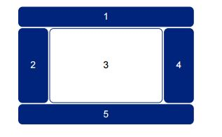

Figure 1



Figure 2

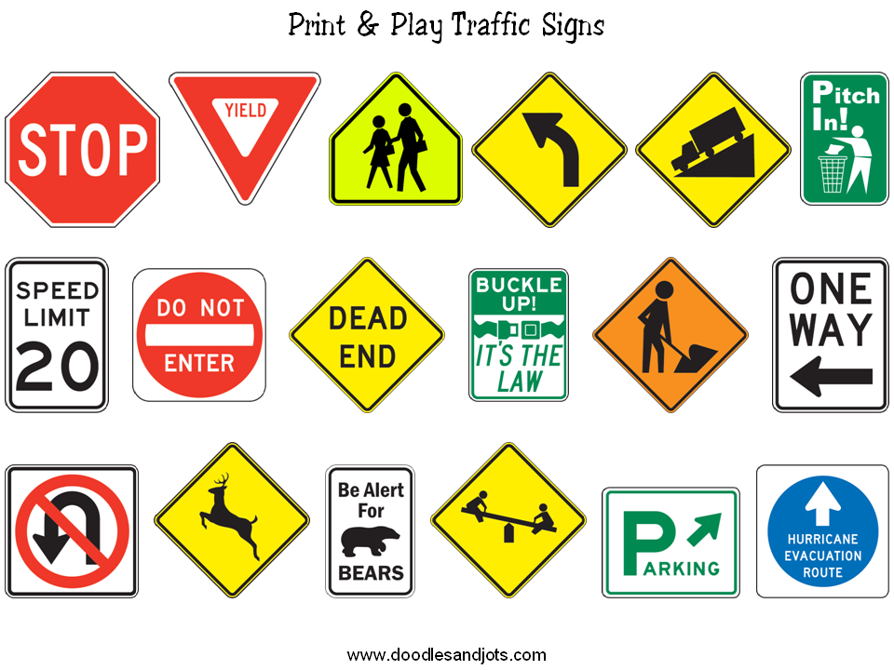

Figure 3

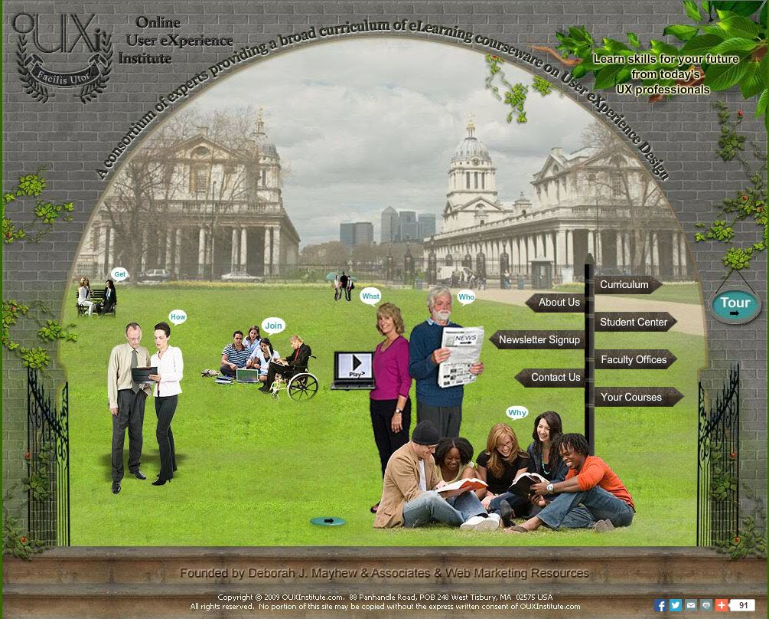

Figure 4



Figure 5