HCI - HappyTravel

| Sonali Atram  MIS Student  IU Bloomington  satram@iu.edu |  | Abu Saleh Md Noman  PhD Student  IU Bloomington  amdnoman@iu.edu |
| --- | --- | --- |

# ABSTRACT

In the last ten years, the perspective of tourism industry and the way people travel has been revolutionized. The advent of the Internet and access of the majority of the population to new information technologies has generated a significant change in international tourist patterns and engendered new behavior. "Travel, Tourism and Technology": these three terms has become interrelated and indispensable in modern era. Clearly technology is becoming a major source to serve the needs of travelers, companies etc.. Thus, it is high time to analyze what travelers want, how their decisions are influenced based on these technologies, what kind of experience they want to get and design or adapt new technologies meeting their requirements. In this project, understanding how travelers behave is of critical importance to us because it has evolved radically over the years. We wanted to comprehensively analyze the influence of technology (websites, mobile apps etc.) in the decision making of travelers. We also wanted to understand what kind of experience the travelers want to get and if it has any impact in deciding the place they want to visit. We interviewed travelers to learn and understand the thought process behind choosing a particular location to visit and its influencing factors. Based on the interview intentions for visits and the satisfaction rate, we created and sent couple of surveys out which resulted in 100 followed by 24 people responding. After that, we tried to provide a solution, *HappyTravel*, which fulfills their requirement and get a feedback from users.

## Keywords

Travel tourism; Data analysis; HappyTravel; Influences

# INTRODUCTION

The way we travel has changed immensely in last 10­-15 years. Latest travel search engines like Travelocity, Expedia and Tripadvisor make it easy to plan trips beforehand. Reviews by users for every travel destinations, hotels and places also give us confidence and makes us feel safe to visit the location we have never visited before. The application of technology prior to traveling and during travel has forced researchers to facilitate more user friendly technology for travelers around the globe. According to Think With Google's '5 Stages of Travel,' the average traveler visits about 22 travel-related sites prior to booking a vacation and 70 percent of business travelers will check into their flights and hotels via their mobile devices. It is therefore of no wonder that technology and tourism are becoming closely intertwined.

Travelers nowadays frequently consult various travel planning websites and travel agencies. Although some of these services are fully-fledged, often they fail to provide a feasible solution meeting the demands of people. Also, it still has a less impact on where we travel. Other than planning and booking for flights and tickets, we are not sure how much personal impact it has on our decisions to travel to certain places. The existing technology in tourism business comes to little help in decision making of millions of travelers travelling every year. Thus, although travel tourism online industry makes it very easy to plan trips ahead of times and saves great deal of money doing so we wanted to see how much influence it really has on deciding where to go and what type of experiences to get.

This motivated our choice of interview and survey questions to get some answers about how travelers arrange their activities and support their requirements accordingly with technology available today. We have analyzed traveler’s responses about existing systems and whether there is a need for more information. As we said earlier the main focus and motivation of *HappyTravel* project are:

* Understanding the influence of existing technology on travelers planning.
* Understanding the demand of travelers and find the correlation of this with their plans.
* Providing a prototype fulfilling their demands.
* Trying to overcome the drawbacks of existing technology (e.g. lack of family friendly travel planning media).

Incorporating the feedbacks from interviews and surveys that we conducted, we provided a wireframe of a webportal that is not fully developed. The rest of the paper describes the existing technology, research methods and instruments, data analysis and future directives.

**EXISTING TECHNOLOGY**

With the rapid growth of technology including websites, mobile apps, online travel agencies etc., modern travelers use tech­nology more than ever before. Recent study shows that the Internet has revolutionized the tourism industry more than any other factor in the last few decades. With access to the vast pool of information available online and information sharing among online travelers, an increasing number of travelers are seeking information via Internet prior to making any travel decisions.

Technology is helping people plan and travel in various ways. For example, “*the Mondrian Hotel in New York City's Soho neighborhood provides each of it’s guest an iPad in a room to use to order food, plan their travel and coordinate transportation. The Roadside America app helps travelers uncover hidden gems and roadside attractions during their road trips. Social networking campaigns like the one launched by Mayor Buckhorn in Tampa Bay, Florida, uses social media to engage tourists. What's more, photography innovations such as the Tamaggo 360 ­Imager allow consumers to capture their vacation experiences like never before*” [7]. Recent research shows these are the medias people find and share information: Internet websites, Search engines, Blogs, E-Mail, eNewsletters, List-serves, Wiki, iPods, Pod-casting, PDA, Wireless phones, GPS mapping, Laptops, Web-cams, Webinars, RSS feeds, Web-TV, GPS mapping, Online games, Social networking and personal sites.

Some websites and apps currently used are as follows:

|  |  |
| --- | --- |
| Website and/or App | Purpose |
| SeatGuru | Pick a good seat in flight |
| Points.com | Track your status |
| Worldmate Gold | Keep track of itinerary |
| Hipmunk | Stay at desired holiday location |
| Priceline | Cheap booking and deals |
| TripAdvisor | Get other travelers review |
| Flight+ | Track your flight |
| Google maps | Navigate the roads |
| Roadtrippers | Plan roadtrips |
| Expedia | Plan trip and booking in advance |

Table 1. Existing technology in use.

*Tripadvisor*

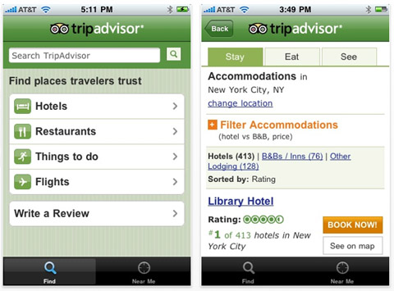

Figure 1: Tripadvisor mobile app

Tripadvisor is the largest travel online community available. It allows users to book flights, hotel, vacation rental etc.. It also allows travelers to review and compare prices, make 3-4 days travel plan, upload pictures and write forums.

*Expedia*

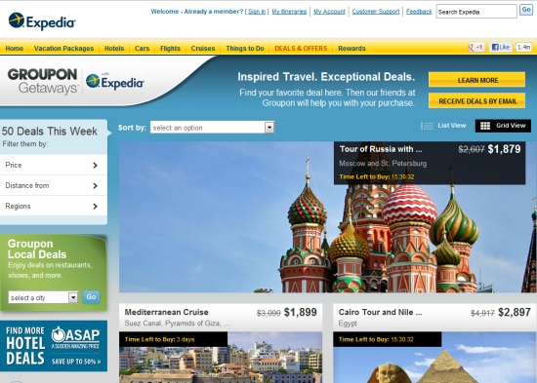

Figure 2: Expedia website

Expedia offers similar provisions as Tripadvisor. It has some additional features like Bundle deals, cruise booking etc.. Like Tripadvisor it also has mobile version.

*Google travel dashboard*

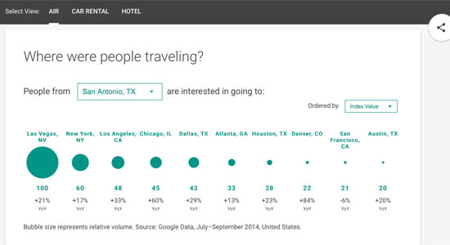

Figure 3: Travel Dashboard

Google travel dashboard has been the latest addition. It allows travelers to view the trend in car rental, air and hotel categories so that they can plan beforehand. It shows statistical data of where people are traveling, most popular itinerary, top searches, travel videos and much more.

*Roadtrippers*

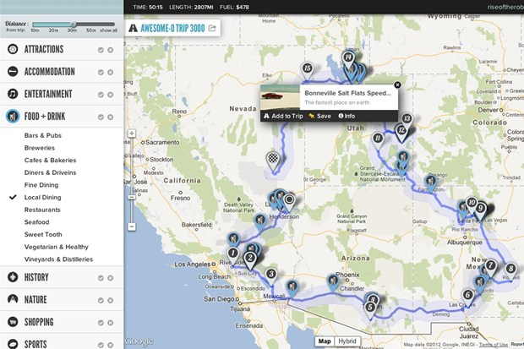

Figure 4: Roadtrippers map

Roadtrippers is another very popular service used by people interested in road trips across USA. It allows them set a source and destination with different checkbox options. As shown in Figure 4, it creates the map for the user and places some legends on the map depending on the selection (attraction, food & drink, points of interest, camping & RV, nightlife, shopping, sports etc.).

*Significant others*

-‘CICtourGUNE’ features an intelligent platform that monitors, measures, analyzes and models the flows of visitors to the different destinations [8].

-‘GESFOR THOFU’ has implemented a plan that aims to establish a model for the hotel of the future [8].

- 'Venice Connected' is another comprehensive management tool to monitor tourist flows in Venice [8].

- Google Maps, Gasbuddy, Triposo, Kayak are also popular among travelers.

# related works

We did not find a lot of previous work on this topic. Most of the previous works addressed how tourism can be flourished and its business aspect. The effect of social media in tourism destination were discussed in [1]. The use and impact of online travel reviews were analyzed by the authors in [2]. Social travel planning in enterprise was researched in [3].

A context aware electronic tourist guide is another novel approach in this regard [4]. The earliest work on developing a location-aware tourist guide was Cyberguide [5]. Another related work on tourist guides was conducted as part of the HIPS (Hyper-Interaction within Physical Space) project [6].

The experiences and practices of travelers were previously ignored in different tourism literature. Therefore there is a significant difficulty in understanding and designing tourism technologies which meets the demand of travelers. This motivated our choice of quantitative and qualitative methods to look in depth at how tourists arrange their activities and support their requirements accordingly with assistive technology.

# REFERENCES

1. Miguéns J, Baggio R, Costa C. Social media and tourism destinations: TripAdvisor case study. *Advances in Tourism Research*. (2008)
2. Gretzel, U. and Yoo, K.H. Use and Impact of Online Travel Reviews. *Information and Communication Technologies in Tourism 2008*, 35–46.
3. Aizenbud-Reshef, N., Barger, A., Guy, I., Dubinsky, Y., and Kremer-Davidson, S. Bon voyage. *Proceedings of the ACM 2012 conference on Computer Supported Cooperative Work - CSCW '12*
4. Cheverst, K., Davies, N., Mitchell, K., Friday, A., and Efstratiou, C. Developing a context-aware electronic tourist guide. *Proceedings of the SIGCHI conference on Human factors in computing systems - CHI '00*, .
5. Long, S., Kooper, R., Abowd, G.D., and Atkeson C.G. Rapid Prototyping of Mobile Context-Aware Applications: The Cyberguide Case Study, in *Proceedings of 2nd ACM International Conference on Mobile Computing* (Rye NY, 1996), ACM Press.
6. Broadbent, J., and Marti, P. Location Aware Mobile Interactive Guides: usability issues, in *Proceedings of the Fourth International Conference on Hypermedia and Interactivity in Museums (ICHIM97)* (Paris, 1997).
7. Vong, K. How Technology in Tourism is Taking Travel to the Next Level. *- TREND HUNTER PRO*. http://www.trendreports.com/article/technology-in-tourism.
8. Technology in tourism. http://dtxtq4w60xqpw.cloudfront.net/sites/all/files/pdf/unwtodigitalresources_volume1_techtourism_eng.pdf.

1.<http://www.sciencedirect.com/science/article/pii/S2212567114002731>

2. <http://floripaconvention.com.br/MyFiles/unwtodigitalresources_volume1_techtourism_eng.pdf>

3. <http://www.trendreports.com/article/technology-in-tourism>

4. <https://blog.travefy.com/2013/10/how-technology-has-helped-the-tourism-industry/>

## 5. http://www.surveymonkey .com <https://www.surveymonkey.com/summary/PddQUFn8pUflYgcLzEUF5Z68HPPsm1P119xCBacxfzY_3D>