Who Is Doing What in Open Source Collaborative Platform: A Case Study Wikipedia

|  |  |  |
| --- | --- | --- |
|  | Abu Saleh Md Noman  School of Informatics and Computing  Indiana University Bloomington  amdnoman@indiana.edu |  |

|  |  |
| --- | --- |
|  |  |

Abstract

**Modern online communities are experiencing privacy concerns in open source. A lot of online discussion communities nowadays offer users to hide their identity and interact. Such flexibility is understandable, however, they engender threats to the reputation and reliability in collective goods. In this study I am interested in studying one such open source online community: Wikipedia. Wikipedia is the largest open and free online encyclopaedia that is accessible to all. I am especially interested in finding the type of activity that the anonymous users are doing on Wikipedia articles and how the fellow Wikipedians are reacting to that. Since not a lot of previous work addressed these issues it is important to study the aforementioned issues to build an innate understanding of recent ongoing vandalism of Wikipedia pages and ways to preventing those. The size of Wikipedia is vast (approximately 28,085,962 users, 5,135,196 English articles and 39,169,255 wiki pages) and that makes the study of Wikipedia more interesting. The study reveals ~90% of the vandalism or foul edits are done by unregistered users in Wikipedia thanks to the free and open nature of it. The community reaction seemed to be immediate: most vandalisms were reverted within five minutes on an average. Further analysis shed light on the tolerance of Wikipedia community, reliability of anonymous users revisions and feasibility of early prediction of vandalism.**

1. Introduction

Wikipedia is the largest multilingual, web-based, free-content encyclopedia that is available in the internet. This project is supported by Wikimedia foundation and it is completely open source that means it is editable by anyone. Since its birth in 2001, it has experienced a massive growth in size and now it is invoking 374 million unique visitors monthly as of September 2015 [24]. About 70,000 active contributors are there working on more than 38 million articles in almost 292 languages. As of today there are 5,135,190 articles in English (compared to 3.9 million articles to nearest competitor Baike.com, Chinese wiki). Everyday there are tens of thousands of edits and visits to different Wikipedia pages help it grow and the gigantic size and diversity in Wikipedia data makes it particularly intriguing for researchers interested in mining patterns [1] and trends in the data. People from all backgrounds, cultures and ages can view and edit existing pages that makes the collaboration regardless of their qualification, it is the content not the quantity that matters. The reliability of the edits are reviewed by bots and experienced wikipedians ensuring the quality of content that pertains.

However, the credence of such contribution are often questionable because of this open nature. While articles or pages evolve over the period of time and the collaboration making them more comprehensive, they are vulnerable to misinformation, errors, vandalism, foul edits, hacks etc.. Every Wikipedia article has an ‘Edit’ and ‘View History’ button (Figure 1(a)) that allows user to make necessary changes, summarize them and publish. They can make minor edits (spelling correction, grammatical changes) that require no further attention or they can make major edits which require further scrutiny by the community. Some pages are semi-protected indicated by the lock sign but still can be edited by placing an edit request. Depending on the access method the users can be classified into two categories:

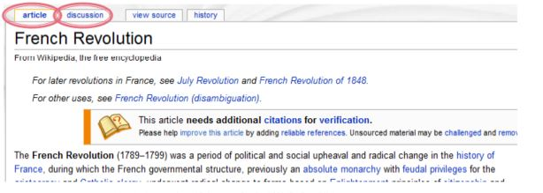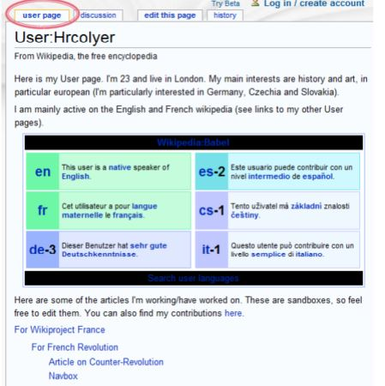

Figure 1. (a) A typical Wiki page (b) A typical user page (image taken from Wikipedia)

Registered user (those who have individual user page (Figure 1(b)) and account), unregistered user (do not have an account and identified by IP address). Both type of users can edit, talk and discuss before making edits. Anonymous users prefer to hide their identity and that engenders privacy issue under this study.

This require exhaustive study of massive Wikipedia dataset to unearth the association of different kind of user with type of edits and quality of edits [2]. Precisely, I want to analyze the edit history [5] of different Wikipedia articles and find out interesting facts that can be extracted from it i.e., types of editors/contributors, recognizing editor characteristics from edits they make [3,4], how do articles evolve, community reactions to edits etc.. Wikipedia is built on online collaboration and information sharing among users. Since it is free and open to all, there are myriads of talking, editing and corresponding changes which are going on every day. The main motivation behind this project idea is in recent years it is observed that there are plenty of foul editing, vandalism that is taking place. To prevent this we need to identify what kind of editors are doing these and which types of articles are susceptible to these malicious activities. So in this research I have two research questions:

* What anonymous and registered people are doing (type of edits)?
* How people are reacting to those (edit over edits)?

Previous works addressed different aspects of Wikipedia study on editor behavior, influences, personality traits etc. [6, 7, 8] but above mentioned questions were not well answered according to my knowledge.

***Research challenges.*** This work addressed various challenges for making the study possible. First, the dataset of Wikipedia dump is of titanic scale. The English wiki dump produces terabytes of edit history which was cumbersome to handle. Second, the results of analysis are often misleading and it is difficult to determine a comprehensive metric for the study. Third, due to the nature and size of data the presence of bias in study is difficult to catch.

***Contribution.*** The main contributions of this study are:

* **Detecting** type of edits by type of users.
* **Identifying vandals** and the reliability of their contribution.
* **Community reaction** in terms of reversion made over edits.
* **Feasibility study** of early prediction of vandalism on articles.

The remainder of this paper describe these contributions in detail. Section II deals with overview of my approach, section III describes the design of the study (data and methods), section IV reports the evaluation results, section V is devoted for discussion, section VI shows some related works on this issue followed by the conclusive remarks.

1. Related Work
   1. Privacy in Open Source

Fang and LeFevre [10] proposed a template for the design of a social networking privacy wizard. As an instance of this general framework, they have built a wizard based on an active learning paradigm called uncertainty sampling. Lucas and Borisov [9] studied the architecture that makes a trade-off between security and usability in the interests of minimally affecting users' workflow and maintaining universal accessibility.

Maden [11] addressed several questions about the privacy settings people choose for their social networking profiles, and provides new data about the specific steps users take to control the flow of information to different people within their networks.

Privacy is typically protected by anonymization, i.e., removing names, addresses, etc. Avind and Vitaly [12] presented a framework for analyzing privacy and anonymity in social networks and developed a new re-identification algorithm targeting anonymized social-network graphs. Smith et. al [13] looked at the issue based on an analysis of social media in Flickr, Locr, Facebook and Google+, they discussed privacy implications and potential of the emerging trend of geo-tagged social media. They also presented a concept with which users can stay informed about which parts of the social Big Data deluge is relevant to them.

* 1. Wikipedia Study

Through a survey of randomly chosen participants from the English-language Wikipedia community, Michail [14] explored the effects of anonymity on the likelihood of conforming to group opinion. His findings indicated that although people perceive anonymity differently depending on their anonymity state, different states of anonymity do not have a strong effect on the likelihood of conforming to group opinion. Leskovec et. al [15] investigated a particular deliberative process that is extensive, public, and recorded: the promotion of Wikipedia admins, which is determined by elections that engage committed members of the Wikipedia community. Rad and Berbosa [16] compared five different methods for modelling and identifying controversy, and discussed some of the unique difficulties and opportunities inherent to the way Wikipedia is produced. Aniket et. al [17] proposed that Wikipedia has been a resounding success story as a collaborative system with a low cost of online participation. In this study they examined how the influence of “elite” vs. “common” users changed over time in Wikipedia.

* 1. Wikipedia Vandalism Study

Adler et. al [18] presented the results of an effort to integrate three of the leading approaches to Wikipedia vandalism detection: a spatio-temporal analysis of metadata (STiki), a reputation-based system (WikiTrust), and natural language processing features. They examined in detail the contribution of the three approaches, both for the task of discovering fresh vandalism, and for the task of locating vandalism in the complete set of Wikipedia revisions. Potthas [19] presented results of a new approach to detect destructive article revisions, so-called vandalism, in Wikipedia. They discussed the characteristics of vandalism as humans recognize it and develop features to render vandalism detection as a machine learning task.

Adler et. al [20] presented using the full set of features computed by WikiTrust, they have been able to construct classifiers that identify vandalism with a recall of 83.5%, a precision of 48.5%, and a false positive rate of 8%, for an area under the ROC curve of 93.4. Using these classifiers, they have implemented a simple Web API that provides the vandalism estimate for every revision of the English Wikipedia. A statistical language model, constructing distributions of words from the revision history of Wikipedia articles was presented in [21]. As vandalism often involves the use of unexpected words to draw attention, the fitness of a new edit when compared with language models built from previous versions may well indicate that an edit is a vandalism instance.

1. Overview of Approach

The purpose of this study is to identify anonymous user behavioral pattern in Wikipedia edits and corresponding feedback received. We can do so by formulating our problem space and goals again in a nutshell: Wikipedia is the best online encyclopedia available which is free and open to edit for all. It is very easy to make an edit on an existing article. Registered users as well as anonymous users (using their IP address, Figure 2(a)) can modify any article anytime (except few exceptions). Wikipedia stores all the edit history and the entire snapshot of the article is saved. Each article has a talk page and discussion page. People can talk and discuss before and after making an edit. Every registered editor has his own page where he can update his personal information and interest. Every user page also associate with a talk page which reflects the topics he is interested in. Using distance metric between two consecutive versions of articles, we can analyze how much changes are made, the type of edits and type of editors. Further digging into things might reveal the characteristics of the editor, clustering them into groups and/or take preventive measures against foul edits/vandalism (Figure 2(b)). It is important to understand that, *‘Vandalism is the act of editing the project in a malicious manner that is intentionally disruptive’.* However, my interest in mining this data is not only limited to these fields only, rather I am open to unearth any other interesting trend that might fall in the way.



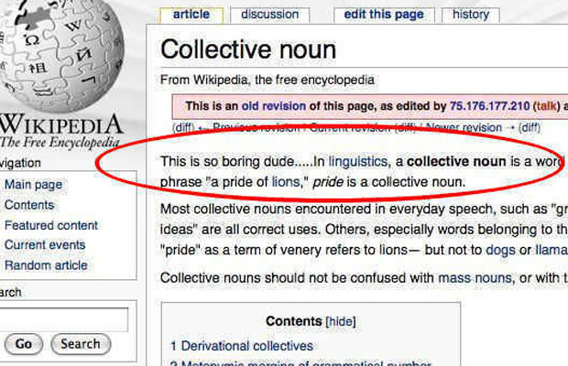

Figure 2: (a) Anonymous user in shadow (b) Vandalism example (image source: https://en.wikipedia.org/wiki/Wikipedia:IPs_are_human_too)

The approach adopted in this paper to answer my questions can be divided into following subcategories:

* 1. Understanding Anonymous User Behavior

In order to better understand the behaviors of anonymous users, it is important to analyze the percentage of articles where they are contributing. Later we focused on several questions and tried to answer them such as:

• How do anonymous users edit? For example, if they prefer to stay on topic or they stray. So we need to compare the similarity between the current and previous edits made by anonymous users. We also have to measure the type of edits that they are making such as if they contain negative emotions/words etc..

• How do they gather popularity? For example, if they are contributing to a controversial topic and making further controversial edits, how community is reacting to that in talks or discussion pages. What is the number of threads in the relevant discussions initiated by the anonymous users etc.

• How anonymous users react to community reaction? If they remain silent or attempt to make further edits and what is the consequence.

• If there any group that exists in terms of number of times their edits get reverted?

* 1. Measuring Community Reaction

Community feedback is of extreme importance in this study. We have to analyze if the community is particularly harsh, flexible or lenient towards anonymous users. To measure this, we can count the number or percentage of times their edits are getting reverted. It might turn out that these edits are more reliable and are less likely to be reverted. So it is not hard to judge from this metric what is the ratio of reverts for each user type. A deeper analysis might reveal if there is any community bias towards the registered users and if the tolerance of community towards anonymous users edits are evolving over time.

* 1. Predicting Edits By Anonymous Users

By training a Machine Learning classifier(bag-of-words strategy) with existing articles those are already edited by anonymous users, we can predict if a future unseen article is going to be edited by an anonymous user. This way, if we can prove anonymous edits are more likely a vandalism, we can take preventing measures. This approach is still ongoing so it might not be reflected in the results or evaluation section for the time being.

1. Data and Methods

The data is collected from the huge data dumps those are already available in wikimedia sites (https://dumps.wikimedia.org/enwiki/). The dumps for different language versions of Wikipedia are kept separate. It is important to note that the data are available in XML format (some previous version have SQL and HTML dumps too but are out of date) and needed to be transformed into more readable format. So I had to execute a Java tool that is already available called *mwdumper* that converts the XML to SQL. Some other tools such as mwdump.py, ImportDump.php, xml2sql (<https://meta.wikimedia.org/wiki/Data_dumps/Tools_for_importing>) are also available. But considering the huge size of English wiki dump, *mwdumper* is the best solution that generates the script without getting crashed. For data preprocessing, Wikipedia provides a set of tool such as DiffDB, MediaWiki API, Wiki Edit History Analyzer, Wikiprep (<http://wikipapers.referata.com/wiki/List_of_data_processing_tools>) etc.. For this study *Wiki Edit History Analyzer* was used which processes MediaWiki revision history and produces summaries of edit actions performed. Basic edit actions include insert, delete, replace, and move; high-level edit actions include spelling correction, wikify, etc. WikiXray Python Parser is another tool written in Python programming language that helped me expedite some analysis. Data visualization is another important aspect of this study to get an insight of the edit history. Several interesting tools those were used in different part of the study include: HistoryFLow, Listen to Wikipedia, StatMediaWiki, Wiki Explorer (<http://wikipapers.referata.com/wiki/List_of_visualization_tools>) etc.. After initial analysis, data was loaded into a MySQL database and relevant results were extracted.

There are three main reasons behind why Wikipedia dataset was chosen for this particular study: First, wiki dataset is publicly available in chunks and it is ideal for comprehensive longitudinal study. Second, Wikipedia data offers the diversity unlike anything else. All data are representative of sample drawn from diverse population. Third, the dataset is apparently harmless since it contains no personal information about user. For the sake of the study and brevity of analysis, the dataset used was ‘enwikisource-20160305-pages-meta-history.xml’ (https://dumps.wikimedia.org/enwiki/) combined with another dump of Bengali Wikipedia ‘bnwikibooks-20160407-pages-meta-history.xml’ from another timeframe. This was done to introduce more diversity in the data. The whole dataset was divided into 50 different tables under a predefined schema. The three main tables are given by:

* *user* – gives the names and total number of edits for each used in the dataset;
* *page* – provides information about the Wikipedia pages in the dataset;
* *revision* – saves the revision of each page with user id, comments and timestamp.

The remaining tables describe the page/user categories and their relations. Table pagecategory gives information about page categories. Similarly, table category provides information about user categories.

Table 1 summarizes the dataset:

|  |  |  |  |
| --- | --- | --- | --- |
| Dataset | # of revisions | #of Registerd Users | #of Anonymous Users |
| 20160305 | 158148 | 2795 | 5779 |
| 20160407 | 148317 | 2590 | 5987 |

Table 1: Dataset Summary

Some study were performed based on random articles using the ‘Random article’ option provided in the Wikipedia webpage navigation pane. For that study 150 random articles were chosen from wide range of topics. Later, the study extracted features from edits those were reverted eventually. A Machine Learning classifier is trained (bag-of-words strategy) and later tested to predict if an article is likely to get edited by anonymous users. It might be the case such edits can be reliable. But if not, then it can act as a precursor to preventing foul edits and vandalism. Since this study is incomplete it is not explained in detail. It is kept for future analysis.

The metric used for vandalism study is the percentage of posts marked as vandalism, therefore,

$$\frac{revisions marked as vandalism}{total number of revisions}*100\%$$

Community reaction is marked by the percentage of posts by anonymous users getting reverted (marked as ‘rv’ in revision comment section). So,

$\frac{number of reverted revisions by anonymous users}{number of revisions by anonymous users}$

Reliability of user edit is measured by retention rate of articles given by,

$$\frac{number of character retained}{total number of characters}*100\%$$

1. Results

This section is devoted to the findings of the analysis performed on the dataset mentioned above. The results are depicted using graphs and tables. The analysis can be grouped according to different dataset and corresponding research questions. So following subsections will try to elucidate the results:

1. Type of Edit

At first I analyzed the type of article both type of users are targeting. The result is depicted in Figure 3.

Figure 3. Type of articles

Figure 4. Type of edits

It turns out that majority of the articles targeted by registered users are related to Biography (38.9%), followed by Geographic location (21.1%), TV shows, History, Sports, Politics etc.. Intuitively the targeted articles for unregistered users turn out to be the same too with somewhat different percentage.

The category of edits by both types of users are reported in Table 2:

|  |  |  |
| --- | --- | --- |
| 20160407 dataset | # of Major edits | # of minor edits |
| Registered | 83000 | 62475 |
| Anonymous | 12672 | 1 |

Table 2: Edit Category

It clearly shows number of edits done by registered users are dominating than that of the IP users and mostly the type of edits are major edits. The number of edits per year by each user type was not surprising as well (Figure 5): registered users dominated unregistered users here too.

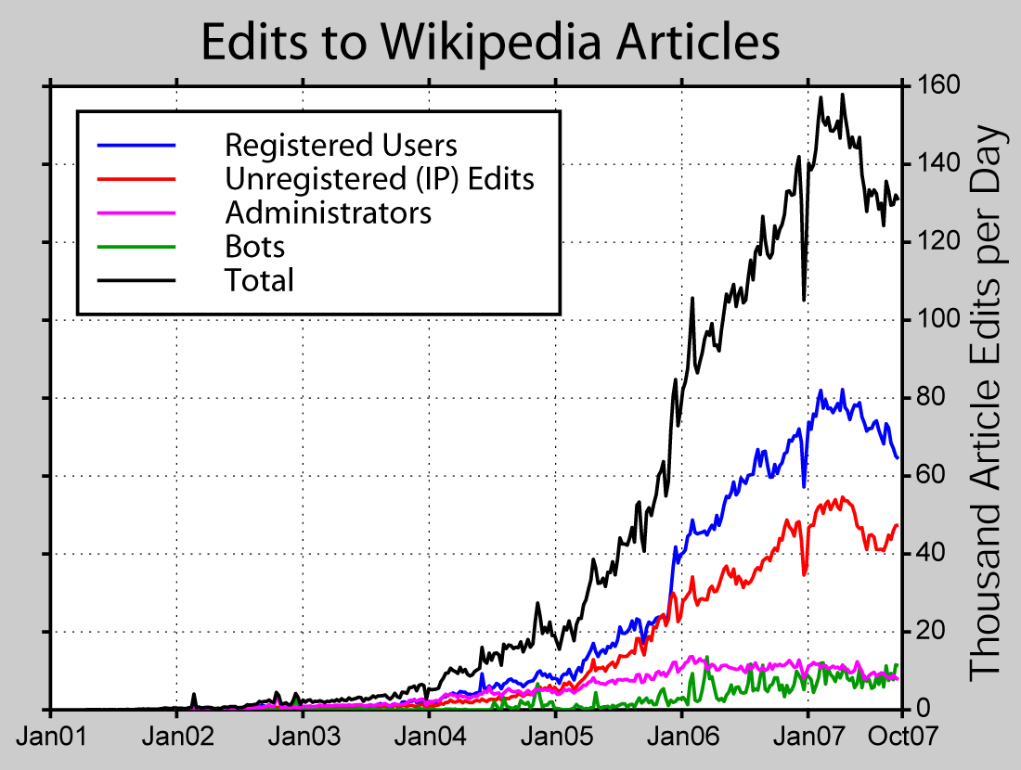

Figure 5. Number of edits by users

Figure 6. Reliability by user

Figure 6 shows the reliability of edits by user type in terms of retention rate defined previously. It shows that when number of edits are getting higher, the reliability of anonymous users drop while the reliability of registered user increase. This result is congruous to the study presented in [3].

1. Vandalism Study

The direction of the research shifted towards vandalism study at this point because it was one of the most important research questions. Vandalisms are often caused by lack of knowledge, attention seeking attitude, personal grudge etc.. It is important to understand not every malicious act is considered as vandalism. Things like abuse of tags, illegitimate page creation, spam external linking, trolling etc. are considered few of different types of vandalisms. The vandalism study was performed on different dataset: for randomly selected articles and 20160407 dataset.

For randomly selected articles the manual analysis yielded following results:

|  |  |  |  |  |
| --- | --- | --- | --- | --- |
| Year | #of Articles | # of Edits | # of Vandalism | #Caused By Anonymous Users |
| 2010 | 100 | 670 | 34 | 25 |
| 2011 | 80 | 584 | 29 | 18 |
| 2012 | 120 | 1015 | 59 | 45 |

Table 3: Vandalism Study

On an average, ~90% of times the vandalism are caused by anonymous users as predicted. However, study on user pages yielded interesting result. Out of 10 randomly generated user page, the ratio (% of vandalism done by registered to anonymous) returned was 53:47. This might be indicative of the fact that, anonymous user tend to target main article pages while registered users are main culprit for vandalisms in user pages. The analysis on *20160407* dataset yielded similar results: out of 156 commented vandalisms, 124 were done by IP users consistent with the previous finding.

1. Community Reaction

Community reaction is marked by the percentage of posts by anonymous users getting reverted. If *i<j<k* in chronological order of revisions and *i=k*; then article j is a **revert.** To study the community reaction, 150 randomly chosen articles were sampled and the findings are depicted in Figure 7(a):

Figure 7(a). Number of edits getting reverted by user. 7(b). Number of edits getting reverted by user.

Figure 7(b) illustrates the result of *20160407*dataset. It is evident that both type of users are mainly doing normal edits during their lifetime. Registered users are making more reverts (maybe caused by vandalism) than anonymous users and anonymous users edits are more likely to get reverted.

Another important measure of community reaction is the average time elapsed before the vandalized article gets reverted. Out of these 150 sampled articles, 32 were found to be vandalized. About 25% of them were corrected in less than 90 seconds. The mean response time was about 5 minutes. The results are depicted in Figure 8.

Figure 8. Elapsed time before reverted

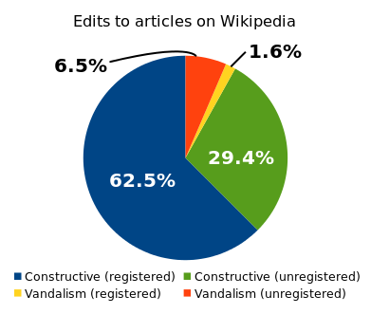

Figure 9. Analysis of 248 edits

A study conducted in 2007 (Figure 9) of 248 edits showed about 80% of vandalism are done by unregistered users [25]. However, 81.9% of edits by unregistered users were not vandalism. So it is a common misconception that all IP users are disruptive and hence their additions are routinely reverted introducing a community bias. This is another future direction of this study.

1. Discussion

The results of this study are fairly conclusive. Registered users, as expected, account for most edits while anonymous users cause most vandalism. It turns out not all anonymous users are vandals though. Another important finding was reliability of edits made by these users. It varied gradually over a period of time and proved that anonymous users with less number of edits are in fact more reliable than registered users. This could attributed to the fact that such unregistered users are experts on specific fields and do not bother about reputation in such community. The results showed the community is does not tolerate these misdeeds; they get reverted eventually and in very quick succession too.

Wikipedia has a counter vandalism unit (CVU) responsible for detecting and correcting vandalism. However, the vast size of the dataset of Wikipedia require efficient algorithm for faster detection of such anomalies. One possible solution could be predicting vandals early and keep every page semi-protected so that not every edit is reflected before scrutinized by a bot reviewer. The feasibility of such implementation require more rigorous data mining which is kept for future work. The study of Wikipedia data was challenging yet fruitful but it suffered from some pitfalls such as: First, due to huge nature of dataset exhaustive study could not be performed. So the restriction on dataset might introduce bias in the study. Second, the selection of random articles were made under the assumption that the randomness of drawing the sample is purely random without any guarantee. Third, there was no statistical test performed to test the hypotheses and approximate a confidence level.

1. Conclusion

Wikipedia’s free and open nature has given it the utmost popularity. In this study I did not want prove this concept wrong. but to make Wikipedia a better place for Wikipedians it is necessary to understand what different types of users are doing and the fellow community is reacting to that. In this study it was evident that unregistered users mostly cause the vandalisms and the community is particularly harsh in maintaining the content quality. This study can be a first step to solving existing issues with vandalism and ways to addressing them. This study engendered a lot of new horizon yet to be explored; few of these include:

* Demographics of vandals and proportion of vandals using dynamic IP making them hard to catch.
* Why some articles are more prone to vandalism? What is the motivation behind such malice?
* Evolution of vandals over time. How is their activity throughout the day?
* Is it fruitful to block IP users from making further edits?
* Classifying the vandals to detect the vandalism ahead of time.
* Other privacy issues in Wikipedia i.e. leak user private information from user page and factors influencing privacy loss.

[subsection 2.1 stub]

1. Conclusion

[conclusion stub]

Reference

[reference stub]

[reference stub]