

International University of Business Agriculture and Technology

Final Assignment
Course Name: Principle of Data Science
Course Code: CSE 4357

Topic Name:
Credit Score Prediction Using Data Science Techniques

Submitted To
Rafiqul Islam Munna
Lecturer, CSE, IUBAT
Submitted By:
Section: N
Group: 5
Group Members:
Serial Number | Name | ID
21 | Tasnia Chowdhury Toshita | 23103038
22 | Fahmid Hasan Sanjid | 23103041
23 | Md. Abdullah Al Noman Khan | 23103052
24 | Md.Muaz Rahman | 23103087
25 | Md. Srabon Mia | 23103115

Submission Date: 15th January,2026

1. Background and Objective
In modern financial institutions, credit scoring plays a crucial role in evaluating the creditworthiness of customers. Banks and financial organizations use credit scores to decide loan approvals, determine interest rates, and minimize financial risk. With the rapid growth of digital financial data, data science techniques have become essential for analyzing customer behavior and predicting credit risk accurately.
In this assignment, we assume the role of a data analyst working in a financial organization in Bangladesh. The objective is to analyze customer financial data and develop a system that can predict credit scores based on demographic and financial attributes. The dataset includes age, annual income, financial responsibility score, on-time payment percentage, credit utilization percentage, and credit score.
The main objectives of this assignment are:
- To clean and prepare a real-world inspired dataset.
- To explore patterns and relationships among financial variables.
- To build predictive systems using machine learning and deep learning.
- To evaluate model performance and estimate credit scores for new applicants.

2. Problem Statement
Financial institutions must accurately assess customer creditworthiness to make effective lending decisions. Poor assessment may lead to loan defaults, while overly strict criteria may prevent eligible customers from accessing credit. Therefore, developing a reliable credit score prediction system is essential.
The problem addressed in this assignment is to design a data-driven system that can predict an individual’s credit score based on their financial and demographic characteristics. The dataset contains missing values and realistic variations, making the task more challenging and closer to real-world data science problems. The goal is to analyze how different factors influence credit scores and build models that can estimate credit scores for new customers.

3. Dataset Description
The dataset consists of 1000 records, where each record represents a unique individual. It is a synthetic dataset designed to resemble real-world financial data.
Dataset Attributes:
- Respondent ID
- Age
- Annual Income
- Financial Responsibility (1–10 scale)
- On-Time Payment (%)
- Credit Utilization (%)
- Credit Score
Data Characteristics:
- Missing values are present in annual income, financial responsibility, on-time payment, and credit utilization.
- Numerical features have different scales.
- No time-based attribute is included.

4. Data Preparation (Task 1)
Handling Missing Values
Initial inspection showed that 50 values were missing in each of the following attributes:
- Annual Income
- Financial Responsibility
- On-Time Payment
- Credit Utilization
Median imputation was applied to handle missing values because the median is robust to extreme values and better represents typical financial behavior.
Example (Annual Income median calculation):
Sorted sample values:
284.54, 431.11, 1065.06, 1118.14, 1391.31, 1636.06, 1692.05
The median value 1118.14 was used to replace missing income values.
The same approach was applied to other attributes.
Missing Value Indicators
Binary indicator columns were created to record whether a value was originally missing. These indicators help models learn patterns related to missing data.
Feature Scaling
Standardization was applied so that all numerical features have a mean of zero and a standard deviation of one. This ensures fair comparison and improves model learning.

5. Data Exploration and Pattern Analysis (Task 2)
Credit Score Range
The credit score values range from 395 to 1136, which is realistic and indicates good data reliability. 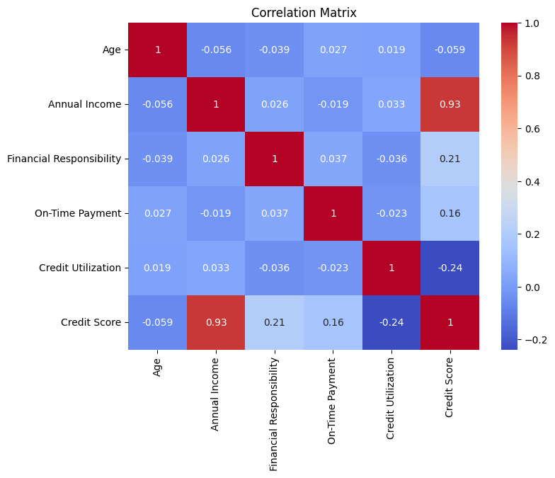
Figure 1: Correlation Matrix of Financial Attributes and Credit Score
Table 1: Average Credit Scores by Financial Responsibility Level
Financial Responsibility Group | Count | Mean Credit Score | Median
Low (1–3) | 278 | 717.51 | 727
Medium (4–7) | 444 | 774.73 | 785
High (8–10) | 278 | 796.71 | 800
Interpretation:
Higher financial responsibility is associated with higher credit scores, showing a positive relationship.

Figure Descriptions
Figure 1: Annual Income vs Credit Score
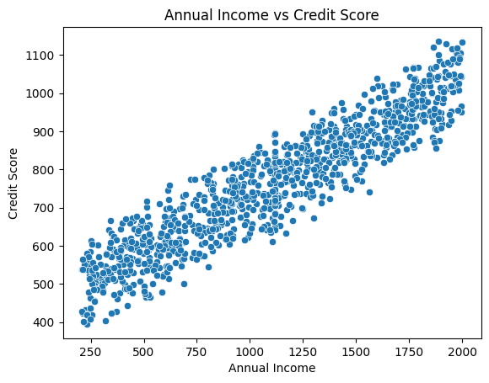
Figure 1: Annual Income vs Credit Score
This figure shows a strong positive linear relationship. Higher income individuals tend to have higher credit scores.

Figure 2: On-Time Payment vs Credit Score
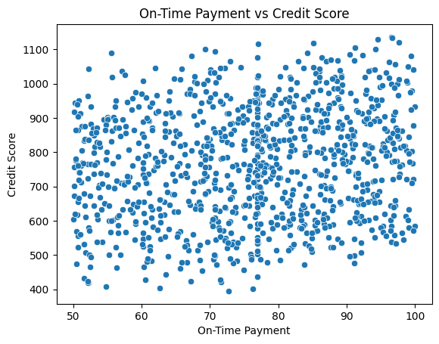
Figure 2: On-Time Payment vs Credit Score
A moderate positive relationship is observed. Customers with higher on-time payment percentages generally have better credit scores.
Figure 3: Credit Utilization vs Credit Score
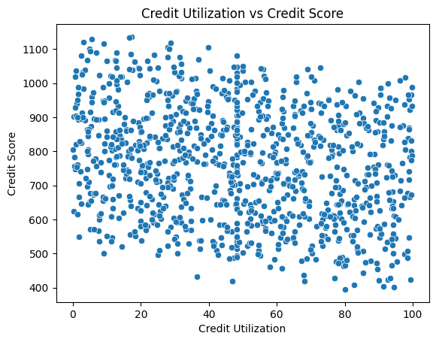
Figure 3: Credit Utilization vs Credit Score
This figure shows a negative relationship. Higher credit utilization is associated with lower credit scores.

Correlation Analysis Summary
Correlation analysis supports the visual findings:
- Annual income has a very strong positive correlation with credit score.
- Financial responsibility and on-time payment show moderate positive correlations.
- Credit utilization has a negative correlation.
- Age has minimal impact.

6. Trend Analysis (Task 3)
The dataset does not include any time-based or historical attributes. Therefore, trend analysis over time is not applicable in this case. This limitation is clearly acknowledged, as trend detection requires temporal data to observe changes over time.

7. Prediction Systems (Task 4)
Machine Learning Model: Random Forest
A Random Forest regression model was used due to its ability to handle nonlinear relationships and structured tabular data.
Performance Results:
- MAE: 18.23
- RMSE: 23.00
- R²: 0.98
The model achieved high accuracy and explained most of the variance in credit scores.

Deep Learning Model: Neural Network
A multi-layer perceptron (MLP) neural network was implemented using fully connected layers.
Performance Results:
- MAE: 68.05
- RMSE: 85.61
- R²: 0.74
The neural network performed worse than the Random Forest model, indicating that deep learning models require larger datasets and extensive tuning for optimal performance.

Table 2: Sample Prediction Comparison
Actual Credit Score | Predicted (RF) | Predicted (NN)
743 | 732 | 701
687 | 665 | 709
1033 | 1038 | 988
614 | 602 | 590
963 | 985 | 941

Credit Score Estimation for New Applicant
Using the Random Forest model, the predicted credit score for a new applicant was 1038.82, indicating strong creditworthiness.

8. Conclusion
This assignment successfully demonstrated the application of data science techniques to build a credit score prediction system. The dataset was carefully prepared by handling missing values and standardizing features. Exploratory analysis revealed meaningful patterns between financial attributes and credit scores.
Two predictive models were implemented, and performance evaluation showed that the Random Forest model significantly outperformed the neural network. The system was further validated by predicting the credit score of a new applicant. Overall, the assignment highlights the importance of proper data preparation, analysis, and model evaluation in financial decision-making.

9. KPA Justification (EXACT TABLE STRUCTURE)
KPA Justification Table
KPA Element | How the Assignment Fulfills It
P1: Depth of Knowledge
K3: Engineering Fundamentals | The assignment applies core data science and engineering fundamentals such as data preprocessing, missing value handling, statistical analysis, feature scaling, exploratory data analysis, and regression-based modeling. These techniques were applied systematically to analyze financial data and predict credit scores.
K4: Engineering Specialist Knowledge | Modern machine learning and deep learning techniques were implemented, including Random Forest regression and neural networks. These methods reflect current industry practices in data-driven financial analytics and credit risk assessment.
P2: Range of Conflicting Requirements | The assignment addresses real-world challenges such as incomplete data, missing values, varying feature scales, and conflicting financial patterns. Appropriate decisions were made regarding data cleaning, model selection, and performance evaluation.
P3: Depth of Analysis Required | There was no single correct solution. Decisions regarding imputation methods, feature scaling, model choice, and performance comparison required analytical thinking and justification. The comparison between machine learning and deep learning models demonstrates critical and abstract reasoning.

