Redshift Cost Analysis – UA Account
Objective
Analyze Amazon Redshift cost in the UA account and identify the resource generating the cost.

1. Cost Summary
Parameter | Value
Date Range | 01 Jan 2026 – 30 Jun 2026
Total Redshift Cost | $1,457.88
Average Monthly Cost | $242.98
Service | Amazon Redshift

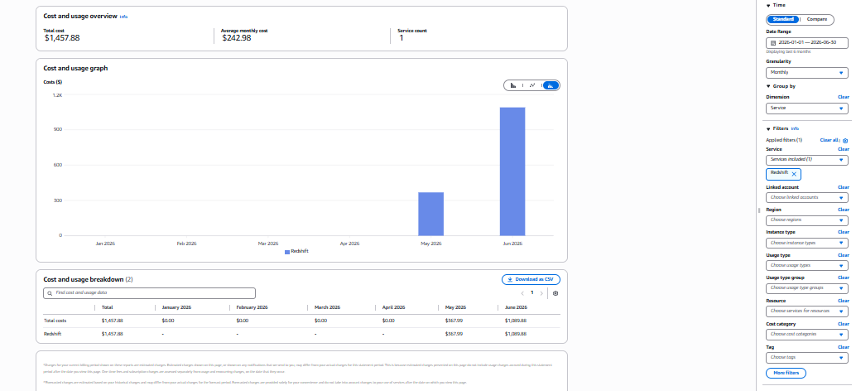

2. Usage Type Breakdown
Usage Type | Cost (USD)
USE1-Redshift:ServerlessUsage | $1,456.97
USE1-RMS:Serverless | $0.91

Observation: Almost all Redshift cost is generated by Redshift Serverless compute usage.

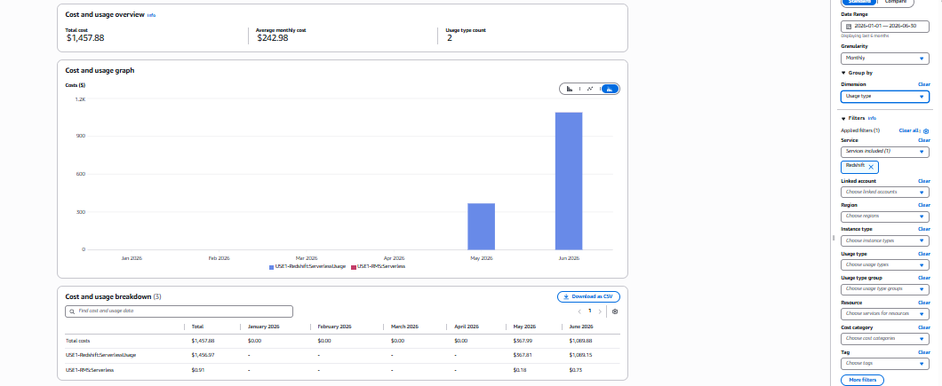

3. Resource Details
Resource | Value
Service Type | Amazon Redshift Serverless
Namespace | ezfdw-ua-ns
Workgroup | ezfdw-ua-wg
Status | Available
Region | US East (N. Virginia)

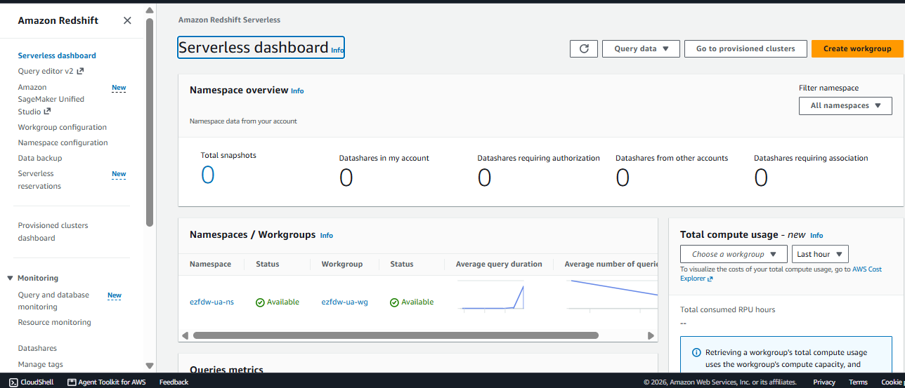

5. Findings
- Total Redshift cost for the selected period is $1,457.88.
- 99.94% of the cost is generated by USE1-Redshift:ServerlessUsage.
- The active Serverless workgroup is ezfdw-ua-wg.
- Cost increased from $367.99 in May to $1,089.88 in June.

6. Recommendations
- Review Query History for ezfdw-ua-wg.
- Identify long-running or expensive queries.
- Configure Serverless usage limits.
- Monitor Redshift costs regularly using Cost Explorer.

