Average people: Focus on food quality & quantity

Remember:

* if you’re exercising for general health and fitness;
* if your goals are more modest; and/or
* you don’t have unique physiological needs…

…then**you *probably don’t need any particular workout nutrition strategies*.**

Focus on:

* eliminating nutrient deficiencies;
* ensuring your portions are the right size; and
* starting to eating right for your body type.

For more on these, check out … [How to fix a broken diet: 3 ways to get your eating on track](https://www.precisionnutrition.com/fix-a-broken-diet).

Not everyone needs nutrient timing

These days, even women’s magazines like *Cosmopolitan* recommend exercise drinks to help with hydration and recovery. Nutrient timing, they say, is important for every exerciser.

Well, we hesitate to disagree with the eminent sports nutrition pros staffing lifestyle magazines, but most people don’t need to worry about nutrient timing. Ever.

At Precision Nutrition, we’ve worked with over 30,000 people through our [coaching programs](https://www.precisionnutrition.com/coaching). This experience, combined with the latest scientific evidence, suggests that **for most people trying to look and feel their best, nutrient timing is not a main priority**.

For a review, check out … [Is nutrient timing dead? And does “when” you eat really matter?](https://www.precisionnutrition.com/nutrient-timing)

Indeed, for a lot of people, stressing out about:

* when to eat their carbs;
* when to eat their fats; and
* what to eat in and around their workouts…

…can be distracting, even self-sabotaging.

(For other people, nutrient timing actually gives them a framework for making good food decisions and controlling total intake. Of course, if that’s you, rock on with the nutrient timing!)

Context matters

Remember, *we’re not saying nutrient timing is good or bad here*.

It certainly can, and often does, work.

But **nutrient timing is *just one tool*. Like every tool, it has to be used skillfully, in the right way and in the right situation.**

What’s true for the pre-diabetic office worker who’s never exercised is certainly not true for the serious endurance runner or the long-time bodybuilder. In fact, the people who stand to benefit most from specific nutritional strategies around their workouts are athletes.

So, in the end, if you’re reading this as an athlete, or a serious exerciser – or a trainer/coach who works with these populations – know that these strategies could help make a difference.

Nutrient timing isn’t magic

Nutrient timing won’t suddenly transform your physique or performance. This is especially true if you aren’t yet doing basic good habits *consistently*.

If you’re a recreational exerciser who just wants to look and feel better, [this is the article](https://www.precisionnutrition.com/fix-a-broken-diet) to read.

Workout nutrition in detail

For those of you interested in learning more, let’s dig in.

First we’ll cover what’s happening during the pre-exercise, during-exercise, and post-exercise time periods.

Then we’ll share what to eat to get the most out of them.

Pre-exercise nutrition needs

What and when you eat **before exercise** can make a big difference to your performance and recovery.

In the three hours before your workout, you’ll want to eat something that helps you:

* sustain energy;
* boost performance;
* hydrate;
* preserve muscle mass; and
* speed recovery.

Here are a few ways to ensure you’re meeting your requirements.

**Protein before exercise**

Eating some protein in the few hours before exercise:

* **Can help you maintain or even increase your muscle size**. That’s important for anyone who wants to improve health, body composition, or performance.
* **Can reduce markers of muscle damage** (myoglobin, creatine kinase, and myofibrillar protein degradation). Or at least prevent them from getting worse. (Carbohydrates or a placebo eaten before exercise don’t seem to do the same thing.) The less damage to your muscles, the faster you recover, and the better you adapt to your exercise over the long term.
* **Floods your bloodstream with amino acids just when your body needs them most**. This boosts your muscle-building capabilities. So not only are you preventing damage, you’re increasing muscle size.

Before you rush off to mix a protein shake: While protein before a workout is a great idea, speed of digestion doesn’t seem to matter much. So any protein source, eaten within a few hours of the workout session, will do the trick.

**Carbs before exercise**

Eating carbs before exercise:

* **Fuels your training and helps with recovery.**It’s a popular misconception that you only need carbs if you’re engaging in a long (more than two hour) bout of endurance exercise. In reality, carbs can also enhance shorter term (one hour) high-intensity training. So unless you’re just going for a quiet stroll, ensuring that you have some carbs in your system will improve high intensity performance.
* **Preserves muscle and liver glycogen**. This tells your brain that you are well fed, and helps increase muscle retention and growth.
* **Stimulates the release of insulin**. When combined with protein, this improves protein synthesis and prevents protein breakdown. Another reason why a mixed meal is a great idea. No sugary carb drinks required.

**Fats before exercise**

Fats before exercise:

* **Don’t appear to improve nor diminish sport performance**. And they don’t seem to fuel performance — that’s what carbs are for.
* **Do help to slow digestion**, which maintains blood glucose and insulin levels and keeps you on an even keel.
* **Provide some vitamins and minerals**, and they’re important in everyone’s diet.

Pre-exercise nutrition in practice

With these things in mind, here are some practical recommendations for the pre-exercise period.

Depending on what suits your individual needs, you can simply have normal meal in the few hours before exercise. Or you can have a smaller meal just before your exercise session. (If you’re trying to put on mass, you may even want to do both.)

**Option 1: 2-3 hours before exercise**

This far in advance of your workout, have a mixed meal and a low-calorie beverage like water.

If you’re a man, here’s what your meal might look like:

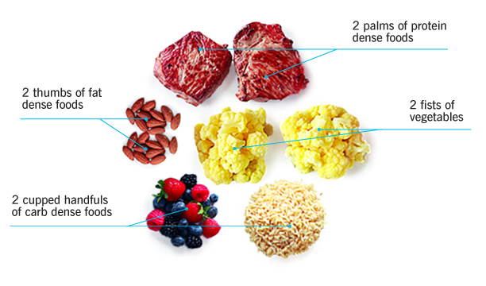

If you’re a woman, here’s what your meal might look like.

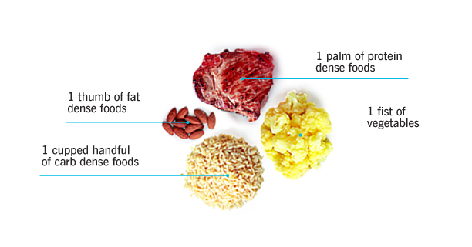

Note: Your actual needs will vary depending on your size, goals, genetics, and the duration and intensity of your activity.

For example, an endurance athlete preparing for a 20 mile run will need more carbs than someone getting ready for a 45 minute gym session.

[This article](https://www.precisionnutrition.com/fix-a-broken-diet) talks more about how you can individualize these meals for your own needs.

**Option 2: 0-60 minutes before training**

Rather than eating a larger meal 2-3 hours before exercise, some people like to eat a smaller meal closer to the session.

The only issue with that: the closer you get to your workout, the less time there is to digest. That’s why we generally recommend something liquid at this time, like a shake or a smoothie.

Yours might look like this:

* 1 scoop protein powder
* 1 fist of veggies (spinach works great in smoothies)
* 1-2 cupped handfuls of carbs (berries or a banana work great)
* 1 thumb of fats (like mixed nuts or flax seeds)
* low-calorie beverage like water or unsweetened almond milk

Here’s a delicious example:

* 1 scoop chocolate protein powder
* 1 fist spinach
* 1 banana
* 1 thumb peanut butter
* 8 oz. chocolate, unsweetened almond milk

It probably goes without saying, but with pre-training nutrition, choose foods that don’t bother your stomach. Because… er… you know what happens if you don’t.

During-exercise nutrition needs

What you eat or drink during exercise is only important under specific circumstances. But if you are going to eat during exercise, your goals will be similar to those for pre-workout nutrition. Above all, you’ll want to maintain hydration.

Goals of nutrition during exercise:

* stay hydrated;
* provide immediate fuel;
* boost performance;
* preserve muscle; and
* improve recovery.

**Protein during exercise**

Eating protein during exercise:

* **Helps prevent muscle breakdown**. This can lead to improved recovery and greater adaptation to training over the longer term. And this is especially true if it has been more than three hours since your last meal. You only need a small amount of protein to control protein breakdown — around 15 grams per hour. If you’re the type of person who prefers to exercise on an empty stomach, then 5-15 grams of [EAAs](https://www.precisionnutrition.com/supplements) during training can be helpful. (15 grams per hour during training, 5 grams per hour during competition.)
* **Is really only necessary for some people**: athletes doing long, intense training bouts, multiple daily training sessions, and/or more advanced individuals trying to make significant changes to their body composition.

**Carbs during exercise**

Eating carbs during exercise:

* **Provides an immediate fuel source**. This helps boost performance and facilitate faster recovery. It keeps our stress hormone cortisol down, and beneficial hormones up.
* **Is only beneficial in certain circumstances**: endurance athletes on long runs, for people who want to gain a lot of muscle, and for highly active people who need every calorie they can get to increase size, strength, and/or performance.

How many carbs should you eat?

That depends. The maximum amount of carbohydrates that can be digested/absorbed during exercise is 60-80 grams per hour.

However, if you include protein in the mix, you can achieve the same endurance benefits with only 30-45 grams of carbohydrate per hour. Note: the protein also protects against muscle breakdown so it’s typically a good idea to add some in.

**Fats during exercise**

Eating a bit of fat before and after exercise can be a great idea. (And tasty, too!)

But you should try to avoid eating fats during exercise. That’s because fats can be more difficult to digest. And during training, you don’t want to give your stomach more work than it can handle.

During-exercise nutrition in practice

Do you need to eat during your workout?

That depends on how long it’s been since your last meal and the length/type of exercise you’re planning on.

**Exercise lasting less than two hours**

For training that’s less than two hours long, the main focus should be hydration. This is especially true if you’re using good pre- and post-training nutrition. So make sure you bring plenty of water.

But what about sports drinks? They don’t offer much benefit for events less than two hours long. Especially if you ate a good pre-exercise meal.

There are some exceptions, though.

1. If you’re exercising **in the heat and sweating a lot**, sports drinks may be useful since they have electrolytes that help speed hydration and recovery.
2. Also, if you’re going to be **competing or training again in less than eight hours**, sports drinks may jumpstart recovery before the next session.
3. If you’re **trying to gain maximum muscle**, then including a protein and carbohydrate drink or some EAAs during training could provide a small advantage.
4. Finally, **at the highest end of sport or competition**, while it may not help, it certainly won’t hurt to sip on a sports drink during competition to ensure maximal hydration and energy supply.

**Exercise lasting more than two hours**

For training that is longer than two hours, sports drinks can be a huge help. Every hour you’ll want to consume:

* 15 grams protein
* 30-45 grams carbs

This can come in the form of liquids, gels, or even some solid food.

Many endurance athletes prefer to drink water and eat fruit and other foods to supply their energy even on really long runs. Either approach is fine, as long as you ensure you’re getting enough protein, carbohydrates and electrolytes, especially sodium.