**SMART INTERNZ EXTERNSHIP PROGRAM**

**Project Component**

**“ANALYSIS OF SALES TREND ON WALMART”**



*By*

*Yogeesh S (20BCE0004)*

*Pradeep Kumar R(20BDS0183)*

*Noman Khan (20BCE2600)*

*Rushwanth (20BCN7163)*

**A Comprehensive Analysis of Seasonal Sales Trend on Walmart**

1. **INTRODUCTION**

**1.1 Overview**

“A Comprehensive Analysis of Seasonal Sales Trend on Walmart Dataset" utilizes Tableau visualization to delve into the provided dataset from Walmart. The dataset encompasses various crucial metrics like sales, profit, quantity, region, and Order ID. The objective of this analysis is to gain insights into seasonal patterns in sales and their impact on profitability across different regions. Through Tableau, an array of visualizations has been created to present distinct facets of the dataset. Firstly, an overview of sales is depicted using line charts or bar graphs, giving a comprehensive view of the sales trend over time and enabling the identification of any significant seasonal patterns. Profitability is then analyzed, potentially employing bar graphs or pie charts to illustrate profit distribution across categories, regions, or specific products. By conducting this comprehensive analysis of the seasonal sales trend on the Walmart dataset using Tableau visualization, valuable patterns are identified, data-driven decisions can be made, and strategies can be formulated to maximize sales and profitability.

**1.2 Purpose**

This study aims to provide a comprehensive analysis of seasonal sales trends at Walmart, one of the largest retail chains globally. By examining the dataset encompassing sales, profit, product categories, sub-categories, and years, this analysis sheds light on the patterns and fluctuations in consumer behavior throughout the year. The study explores the impact of seasons on Walmart's sales performance and offers insights into the strategies that can be employed to maximize sales during different seasons. The findings of this analysis contribute to understanding the dynamics of retail sales and inform decision-making for optimizing seasonal performance.

1. **LITERATURE SURVEY**

**2.1 Existing Problem**

Addressing these challenges requires careful data preprocessing, validation, and consideration of external factors. It is important to be aware of these potential problems while analyzing the Walmart dataset to ensure the accuracy, reliability, and relevance of the insights obtained from the analysis.

**A) Limited Contextual Information**: The provided dataset may lack contextual information that could provide additional insights into sales trends. For example, the dataset might not include demographic data, customer segmentation, or specific marketing campaigns. The absence of such information may limit the depth of analysis and the ability to uncover underlying drivers of sales trends.

**B) Data Consistency and Granularity**: The consistency and granularity of the dataset can impact the level of analysis and the ability to derive meaningful insights. The dataset might have varying levels of detail, with some data aggregated at a high level (e.g., regional sales) and others at a more granular level (e.g., individual product sales). Ensuring consistency and aligning the granularity of the data across different dimensions is essential for accurate analysis.

**2.2 Proposed Solution**

* **Enhancing Contextual Information:** If the dataset lacks certain contextual information, it may be beneficial to incorporate additional data sources or external data. This could involve integrating demographic data, customer segmentation information, or market research data. Such supplemental information can provide deeper insights into sales trends and help identify specific customer preferences or target segments.
* **Ensuring Data Consistency and Granularity:** To address inconsistencies and granularity issues, it is important to harmonize the data across different dimensions. This can involve aggregating or disaggregating data to a consistent level of granularity. For instance, if regional sales are at a higher level of aggregation, it may be necessary to drill down to individual store or product-level data for more detailed analysis. Ensuring consistency in the way data is recorded and reported across different dimensions helps maintain accuracy and enables meaningful comparisons.

1. **THEORETICAL ANALYSIS**

**3.1 Block Diagram**

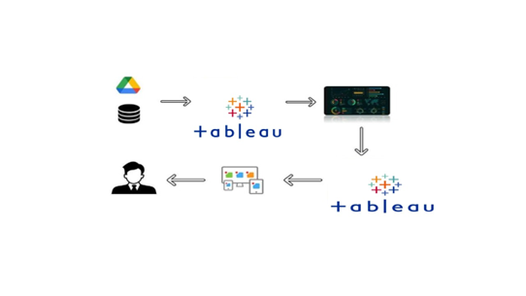

**3.2 Hardware / Software designing**

**A) Software Requirements**

* Tableau Desktop
* MySQL
* Tableau Public
* Python

**B) Hardware Requirements**

* PC/Laptop

1. **EXPERIMENTAL INVESTIGATIONS**

* The research on "Profit Margin Analysis by Sub-category" focuses on analyzing profit margins within each sub-category of products. It helps businesses identify the most profitable sub-categories, evaluate pricing strategies, and make informed decisions regarding product development and promotion.
* Research on "Regional Sales Analysis" has examined the variations in sales performance across different regions and their impact on overall profitability. It investigates factors such as customer preferences, market conditions, and local competition that influence regional sales patterns.

### Studies on "Profitability Analysis by Category and Sub-category" have focused on understanding the profitability of different product categories and sub-categories. These analyses help businesses identify the most profitable areas and make informed decisions regarding resource allocation and product assortment.

**Check out the below link to understand the dataset in detail:**  [**https://www.kaggle.com/code/damathajorisaxel/walmart-sales-analysis/input**](https://www.kaggle.com/code/damathajorisaxel/walmart-sales-analysis/input)

[**https://drive.google.com/file/d/1oe6vaHxM2xN8i4tMaXbBewOyex06ddP3/view?usp=sharing**](https://drive.google.com/file/d/1oe6vaHxM2xN8i4tMaXbBewOyex06ddP3/view?usp=sharing)

This Dataset contains information of Category of product, Sub-Category, Order ID, Product Name, Location, Sales, Profit, and Year

**Connect MySQL and Tableau with the dataset** [**https://drive.google.com/file/d/1LAAyMYbOEOoA4jpx218B_5LzkRo063t0/view?usp=sharing**](https://drive.google.com/file/d/1LAAyMYbOEOoA4jpx218B_5LzkRo063t0/view?usp=sharing)

1. **FLOWCHART**

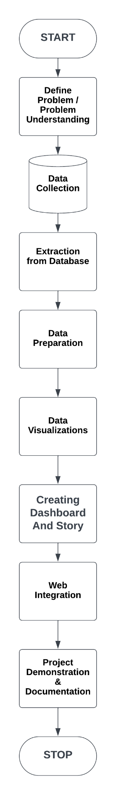

1. **RESULT**

**Activity 6.1: Sales and Profit Trends by Categories**

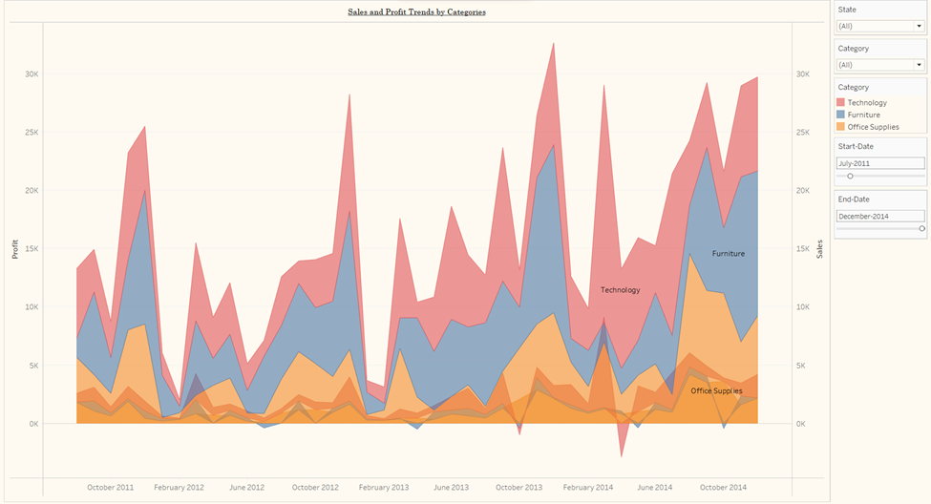

**Activity 6.2: Sales and Profit by Region**

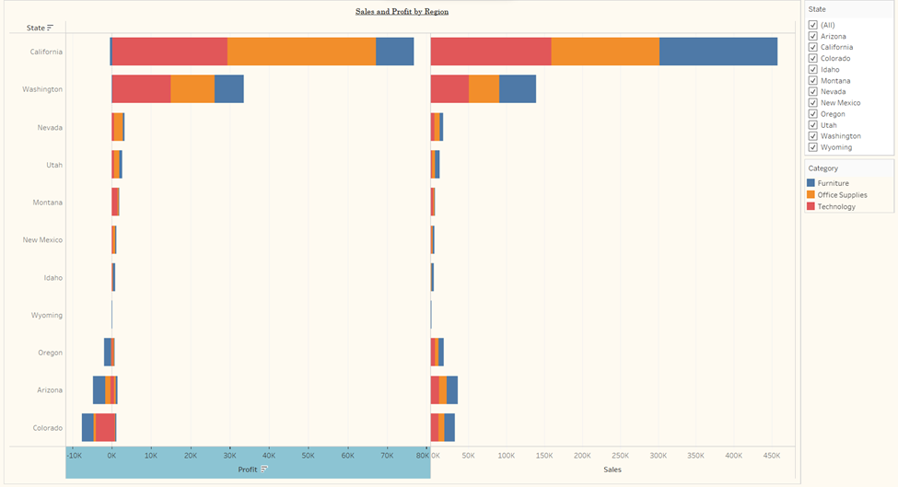

**Activity 6.3: Sales and Profit by Product Category and Sub-Category**

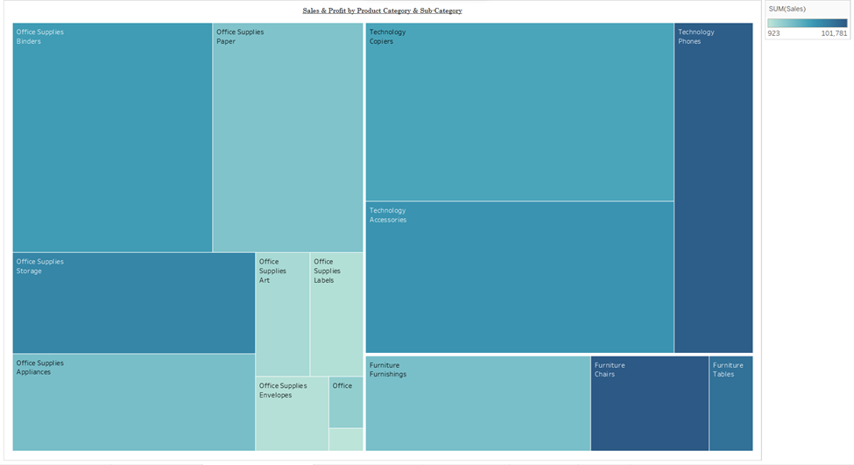

**Activity 6.4: Correlation between Sales Profit and discounts**

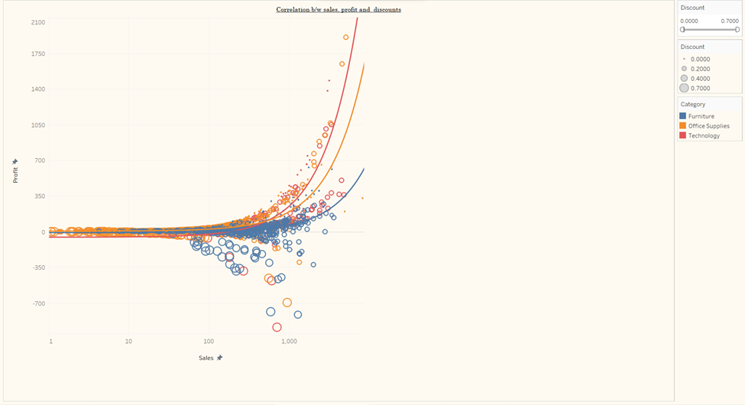

**Activity 6.5: KPI Chart for Total Sales**

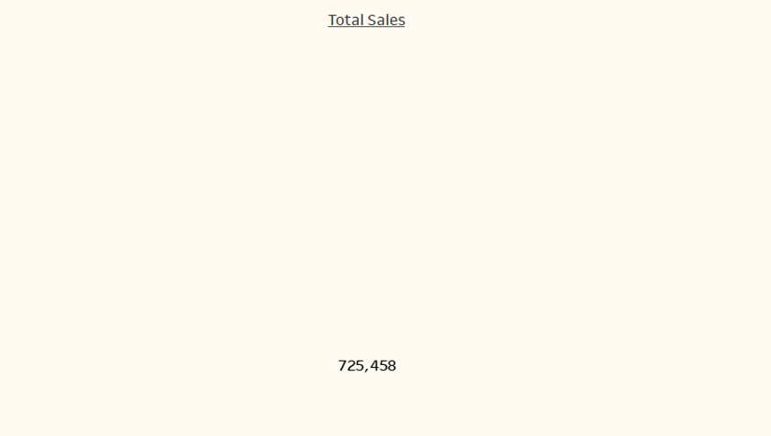

**Activity 6.6: KPI Chart for Total Profit**

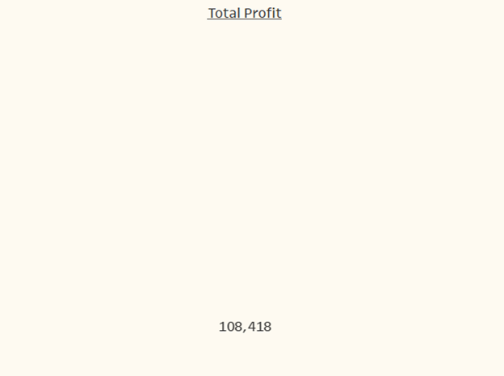

**Activity 6.7: Bubble chart in order to Profit**

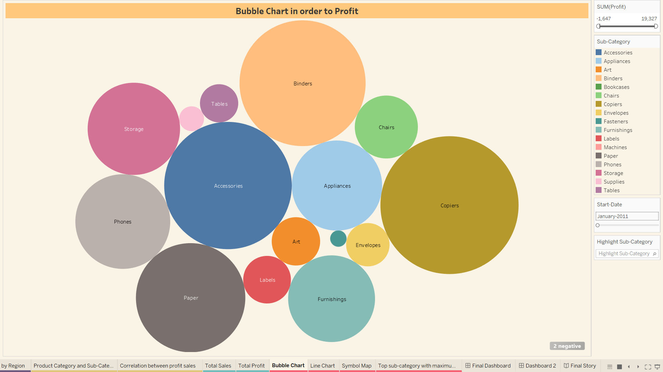

**Activity 6.8: Average Sale in order to Order Dates**

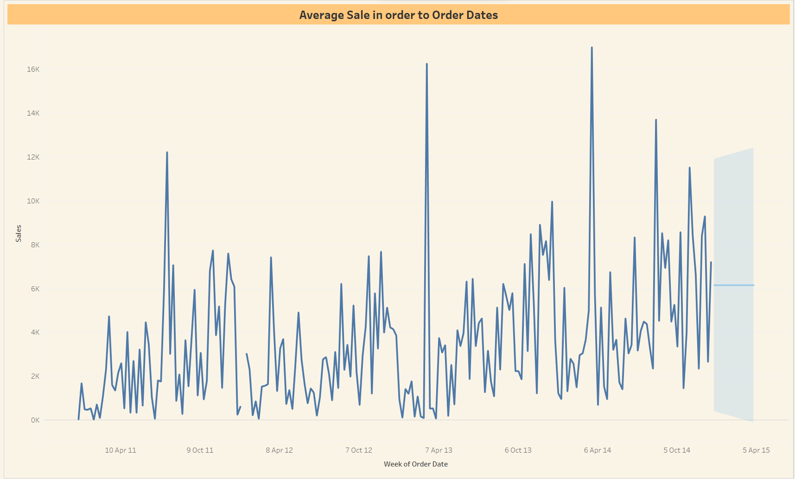

**Activity 6.9: Symbol Map in order to Sales**

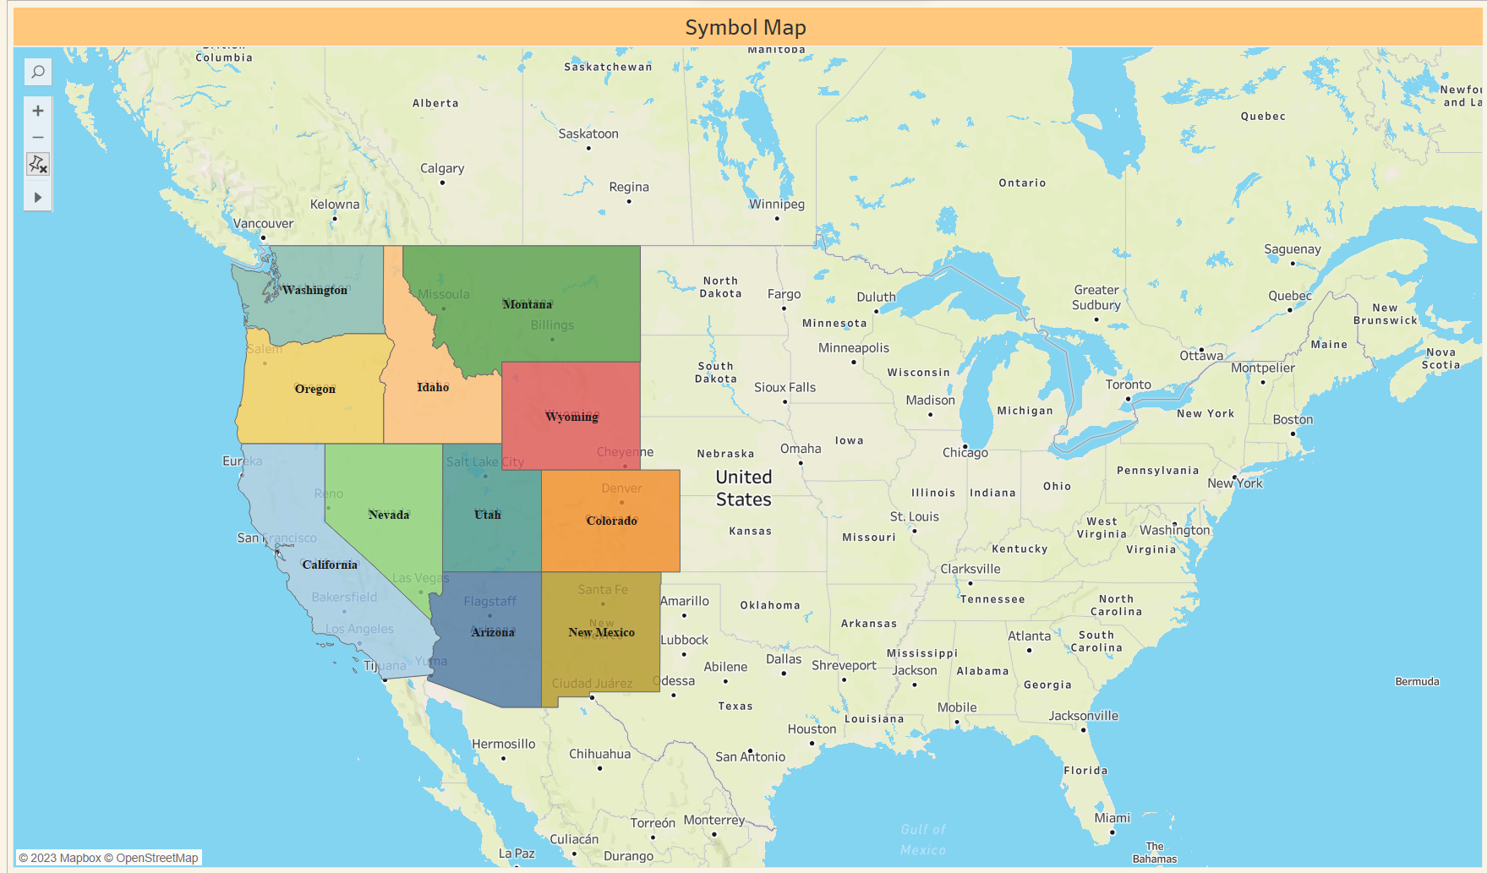

**Activity 6.10: Symbol Map in order to Sales**

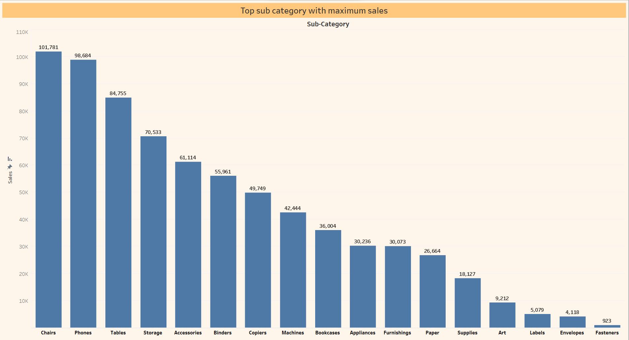

### **Dashboard No.1**

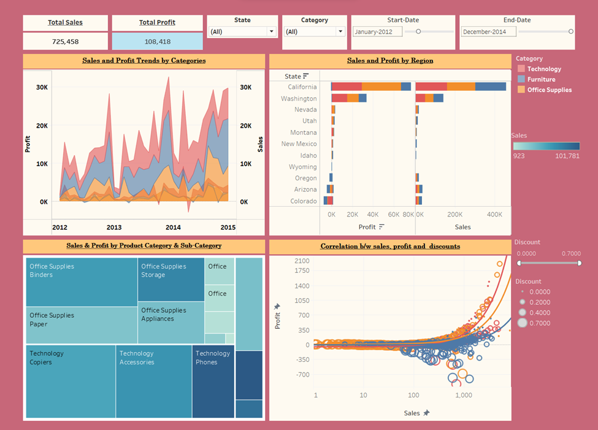

**Dashboard No.2**

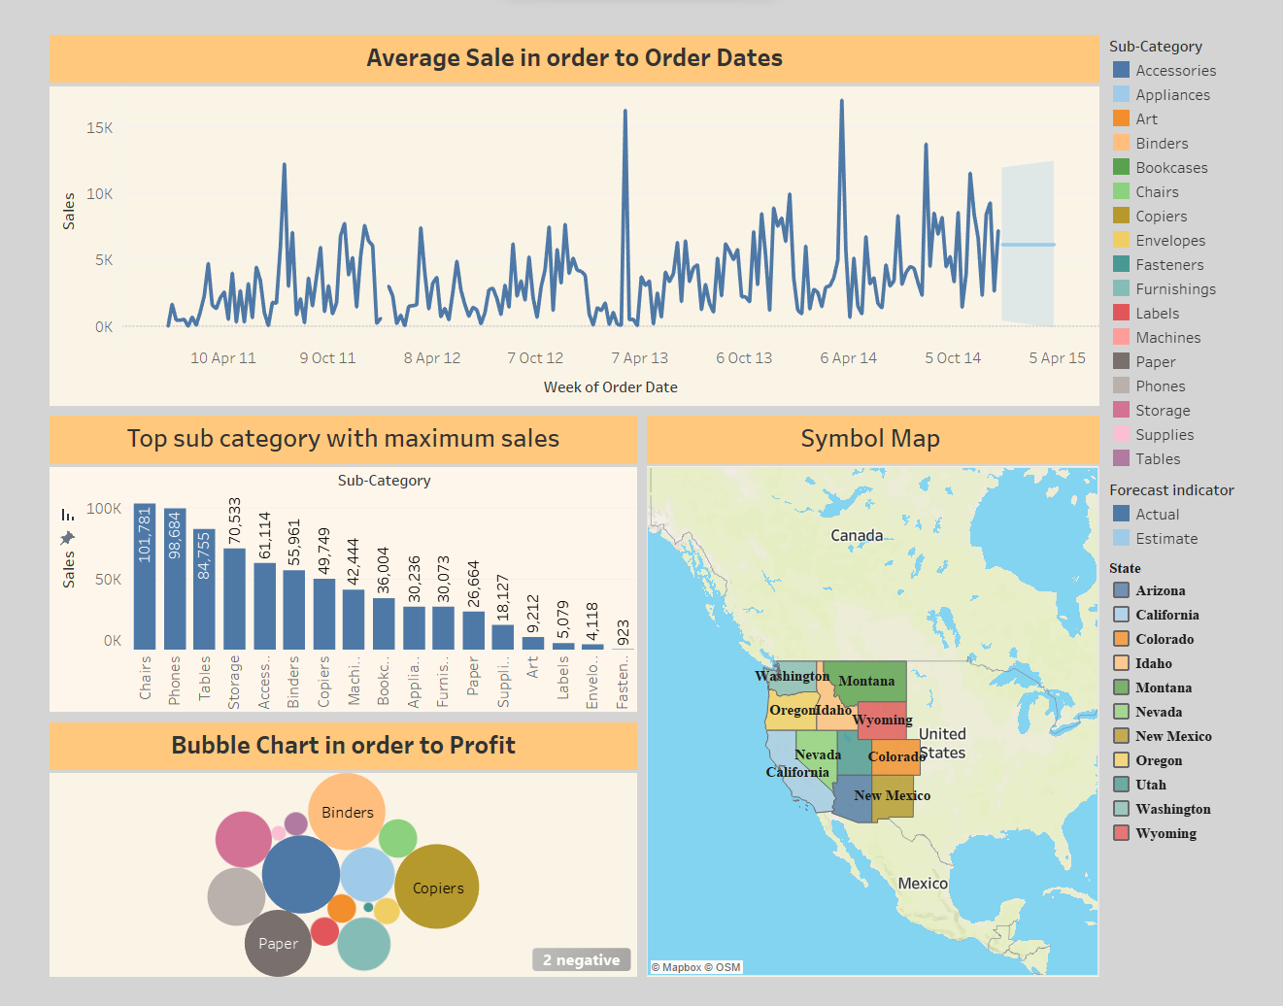

**Explanatory video:**

[**https://www.loom.com/share/716cc56aebc247b7ba32e930ae86e2ee**](https://www.loom.com/share/716cc56aebc247b7ba32e930ae86e2ee)

[**https://drive.google.com/file/d/1xBsbmoGWwVR-UOI6Te3XVOJpSb2p5iXL/view?usp=sharing**](https://drive.google.com/file/d/1xBsbmoGWwVR-UOI6Te3XVOJpSb2p5iXL/view?usp=sharing)

### **Story**

* The Area Chart shows the comprehensive trend on sales and profit, differentiated by category

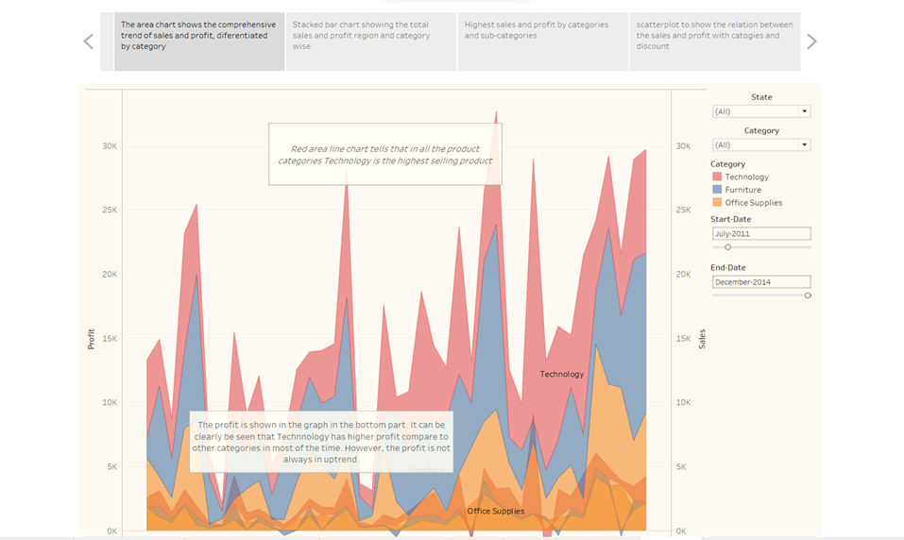

* Stacked Bar Chart showing total sales and profit region and category wise

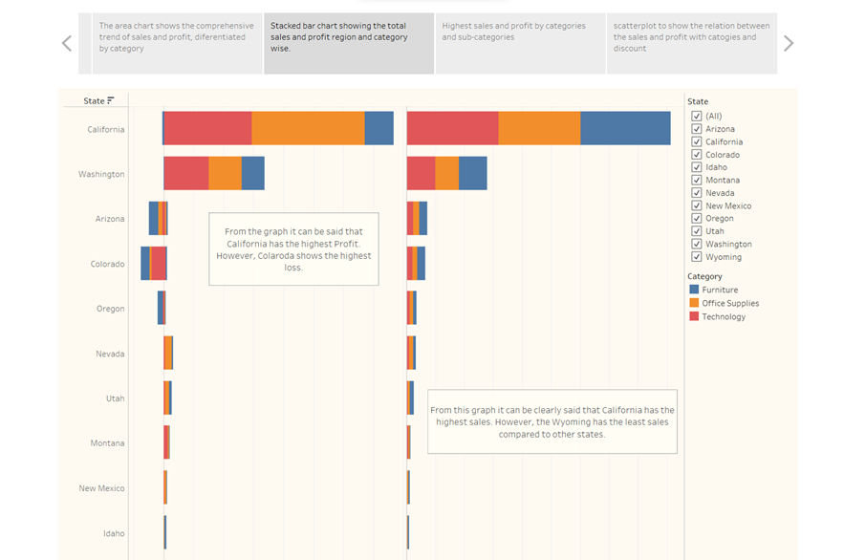

* Tree Map showing highest sales and profit by categories and sub-categories

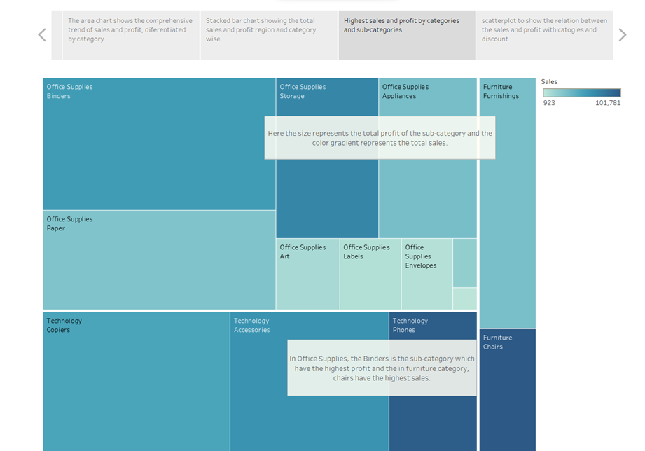

* Scatter Plot showing the relation between the sales and profit with categories and discount

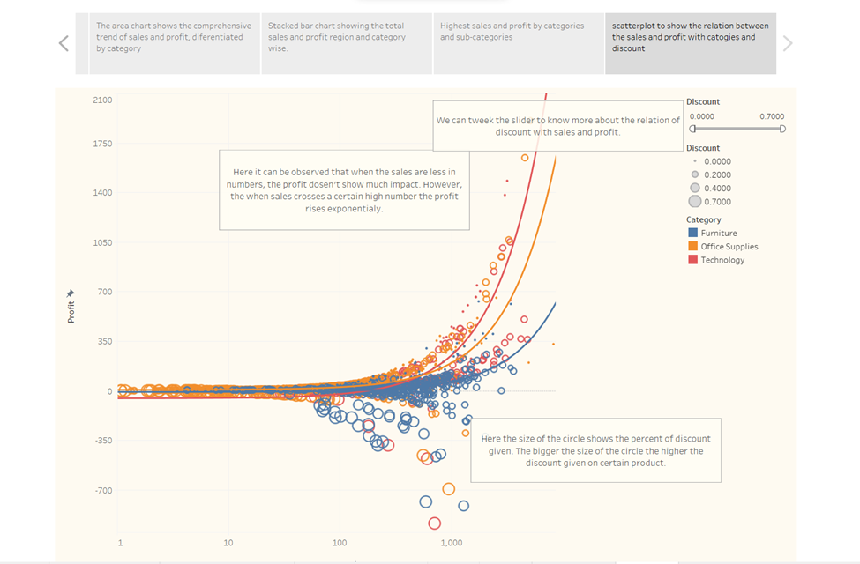

**Explanatory Video:**

<https://www.loom.com/share/331efe82380a4d93b8591fb3a9e6e013?sid=5604ab5b-6294-4c5a-a220-4e1d601f4be9>

**Web Integration**

Publishing helps us track and monitor key performance metrics, to communicate results and progress. Help a publisher stay informed, make better decisions, and communicate their performance to others.  
  
 Integrating dashboard/reports/stories to the web**.**

**Step 1: Go to Dashboard/story, click on share button on the top ribbon**

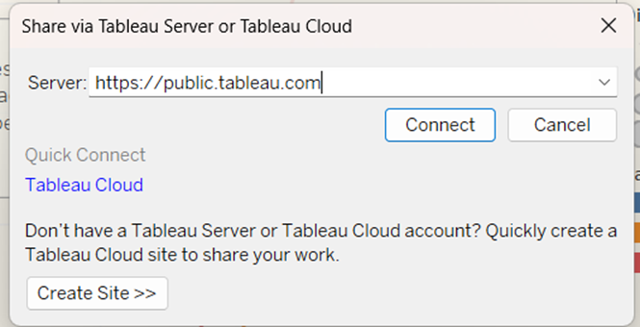

**Step 2: Click the connect Button and click Save.**

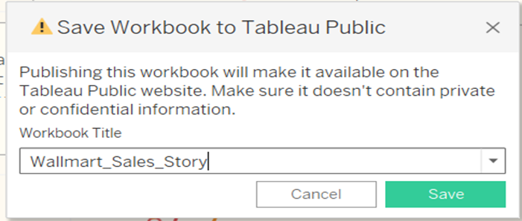

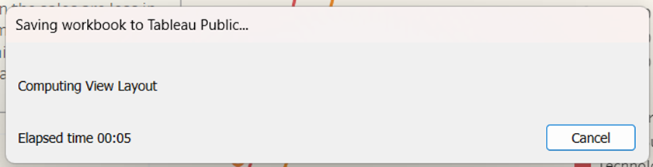

At the end, it will redirect to Tableau public.

**Tableau Public Story Link:**

**https://public.tableau.com/views/Wallmart_Sales_storyFinal/FinalStory?:language=en-US&publish=yes&:display_count=n&:origin=viz_share_link**

**Tableau Public Dashboard Link:**

[**https://public.tableau.com/views/Wallmart_Sales_Dashboardno1/FinalDashboard?:language=en-US&publish=yes&:display_count=n&:origin=viz_share_link**](https://public.tableau.com/views/Wallmart_Sales_Dashboardno1/FinalDashboard?:language=en-US&publish=yes&:display_count=n&:origin=viz_share_link)

**https://public.tableau.com/views/Wallmart_Sales_Dashboardno2/Dashboard2?:language=en-US&publish=yes&:display_count=n&:origin=viz_share_link**

**Integrating with Tableau Public**

**Explanatory video:** [**https://drive.google.com/file/d/1-emKyGy_waaeXgHsRPv1HJFJq5zfz5HB/view?usp=sharing**](https://drive.google.com/file/d/1-emKyGy_waaeXgHsRPv1HJFJq5zfz5HB/view?usp=sharing)

**Integrating with bootstrap website.**

**Explanatory video:** <https://drive.google.com/file/d/1FBgTsAcQKT7QXf8zrDnapkqQb4xvVkkm/view?usp=sharing>

**Implementing Flask**

**Explanatory video:** <https://drive.google.com/file/d/1FBgTsAcQKT7QXf8zrDnapkqQb4xvVkkm/view?usp=sharing>

1. **ADVANTAGES & DISADVANTAGES**

**Advantages of the Proposed Solution:**

**1. Improved Data Accuracy:** The proposed solutions, such as handling missing data, ensuring data quality, and addressing granularity issues, contribute to improving the accuracy of the analysis. By addressing these challenges, the insights derived from the dataset are more reliable and trustworthy.

**2. Enhanced Decision-Making:** The proposed solutions enable more informed decision-making by providing a more comprehensive and accurate understanding of seasonal sales trends. By considering external factors, accounting for seasonality, and incorporating contextual information, the analysis becomes more insightful and actionable.

**3. Holistic Analysis:** The proposed solutions cover various aspects of the dataset, including sales trends, profitability, regional performance, quantity analysis, and order patterns. This comprehensive approach allows for a holistic understanding of the dataset and facilitates the identification of valuable insights.

**4. Relevance and Context:** By enhancing the dataset with additional contextual information and addressing missing information, the analysis becomes more relevant and provides a deeper understanding of the factors influencing sales trends. This enables more targeted strategies and decision-making.

**Disadvantages and Limitations of the Proposed Solution:**

**1. Complexity and Time-Consuming:** Implementing the proposed solutions, such as data cleaning, handling missing data, and incorporating external factors, can be complex and time-consuming. It may require additional resources, expertise, and computational power to process and analyze the data effectively.

**2. Data Availability and Accessibility:** The proposed solutions assume the availability of relevant data and external sources. However, accessing and integrating additional data sources may not always be feasible due to data availability constraints, privacy concerns, or data sharing limitations.

**3. Subjectivity and Interpretation:** The analysis and interpretation of the dataset rely on human judgment and subjectivity. Different analysts may approach the analysis differently, leading to varying interpretations and conclusions. It is important to consider multiple perspectives and validate the findings to mitigate any potential biases.

**4. Assumptions and Simplifications:** The proposed solutions make certain assumptions and simplifications to address the challenges encountered during the analysis. These assumptions may not always hold true in real-world scenarios, which could impact the accuracy or generalizability of the analysis results.

**5. Limitations of Tableau:** While Tableau is a powerful data visualization tool, it may have limitations in handling large datasets or complex data transformations. It is important to be mindful of these limitations and consider alternative tools or techniques if necessary.

1. **APPLICATION**

**1. Seasonal Demand Planning:** By understanding the seasonal patterns in sales, Walmart can better plan and manage its inventory and supply chain. This analysis helps identify peak seasons and anticipate fluctuations in demand, enabling more accurate forecasting and efficient allocation of resources.

**2. Promotional Campaign Optimization:** The analysis allows Walmart to identify the most effective timing for promotional campaigns based on seasonal trends. By aligning promotions with peak sales periods or targeting specific regions during their respective high-demand seasons, Walmart can optimize the impact of its marketing efforts and maximize sales.

**3. Regional Performance Analysis:** Examining the sales and profitability across different regions helps Walmart identify high-performing regions as well as regions with untapped potential. This insight can inform decisions related to expansion, resource allocation, and marketing strategies tailored to specific regional characteristics.

**4. Product Assortment and Category Management:** By analyzing seasonal sales trends, Walmart can identify the most popular products and categories during specific seasons. This information guides decisions regarding product assortment, inventory management, and category promotions, ensuring that the right products are stocked in the right quantities to meet customer demand.

**5. Pricing and Discount Strategies:** Understanding seasonal sales patterns can assist Walmart in developing pricing and discount strategies. For example, identifying off-peak seasons with lower sales can help determine appropriate discounting strategies to stimulate demand during those periods. Conversely, during peak seasons, Walmart can optimize pricing to maximize profit margins.

1. **CONCLUSION**

In conclusion, the comprehensive analysis of seasonal sales trends on the Walmart dataset using Tableau visualization provides valuable insights into Walmart's business performance and enables data-driven decision-making. Through this analysis, we have explored various aspects of the dataset, including overall sales trends, seasonal patterns, regional performance, quantity analysis, and order patterns. By leveraging visualizations and statistical techniques, we have identified seasonal sales patterns, peak seasons, and fluctuations in sales over time. This understanding of seasonality helps Walmart improve inventory management, plan promotional campaigns more effectively, and optimize pricing strategies based on demand fluctuations.The analysis has also shed light on regional performance, allowing Walmart to identify high-performing regions and regions with growth potential. This information can guide resource allocation, expansion strategies, and targeted marketing efforts to capitalize on regional variations in demand. Furthermore, examining the relationship between quantity and sales has provided insights into customer buying behavior. This information contributes to improved inventory management and assists in identifying opportunities for cross-selling or upselling.The analysis of order patterns and frequency has provided valuable insights into customer preferences and order trends. This knowledge can help Walmart enhance customer segmentation, personalize marketing efforts, and improve customer satisfaction.

1. **FUTURE SCOPE**

Integration with Online Sales Data: Integrating the analysis of seasonal sales trends with online sales data can provide a holistic view of Walmart's sales performance. This integration can include analyzing website traffic patterns, online purchase behavior, and the impact of online marketing campaigns. Understanding the relationship between offline and online sales can guide omnichannel strategies and enhance overall sales performance.

Competitive Analysis: Conducting a comparative analysis of Walmart's seasonal sales trends with its competitors can provide valuable market insights. Examining competitors' pricing strategies, promotional campaigns, and regional performance can help identify competitive advantages, benchmark performance, and uncover growth opportunities.

Real-Time Analytics and Dashboard Reporting: Developing real-time analytics capabilities and interactive dashboard reporting can enable continuous monitoring of seasonal sales trends. This can help Walmart promptly identify any deviations or anomalies, allowing for proactive decision-making and timely interventions.

1. **BIBLIOGRAPHY**

Reference Link: <https://www.kaggle.com/code/damathajorisaxel/walmart-sales-analysis>

1. **APPENDIX**

GitHub Repository Link: