Economics course outline:

Here is the resource link.You will find every Book resource given by mam:
https://l.facebook.com/l.php?u=https%3A%2F%2Fdrive.google.com%2Fdrive%2Ffolders%2F1XM09gRyXJY2a3jC-S3sWxOnH9ltUbToN%3Fusp%3Dsharing&h=ATNNAUglXyHkFkYPJT44BhTcIuqGBkP0nhyNEkktP6pOqLGFGGXLymT9KB8Tyuj6UrWD7aL7ZzQVPY4Zimxe-n5NIcC003J78axtTUwQp28BsGA_G-AOvQbuEtjjMDBl8_eavg

Economics class note:
https://l.facebook.com/l.php?u=https%3A%2F%2Fdrive.google.com%2Ffile%2Fd%2F1SshjZVm_eTuLNaOnWQ0MpqMm7NWYhOIu%2Fview%3Fusp%3Dembed_facebook&h=ATNHHruYWkj6hkHlTqerTO3UoqNBUuNdeCqenompgXc5ezvHX2XzXDe3K3DNdG2vJi_BY7gG4DLWxB-rNcf2IsLEWctff-mDi9gW1Kw7Rpq4POgJ0wKmvuyM30FX3VVCn-vt&s=1&enc=AZPX7oFMN1GhaNFeeJjwsJAlTuY2A7Es7aFBKzRzFtoRrC-pZyQM0k4spWD_N8fcMmrvbv-Rj1nYUE8qHwBXW0HKCc-Cu7qLUaE3eSPTW_iswA

Economics suggestion:
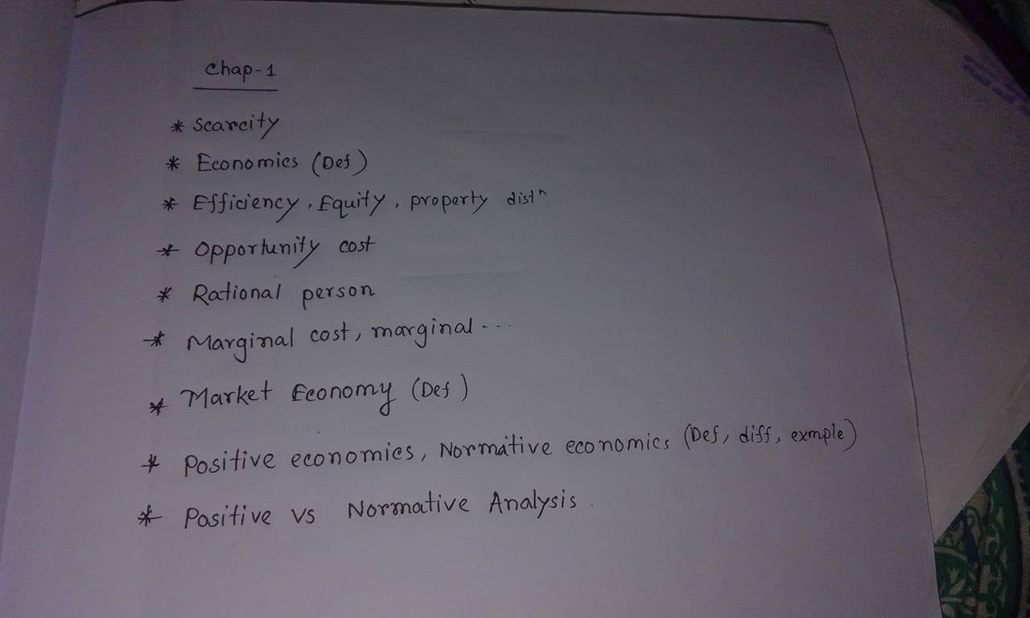
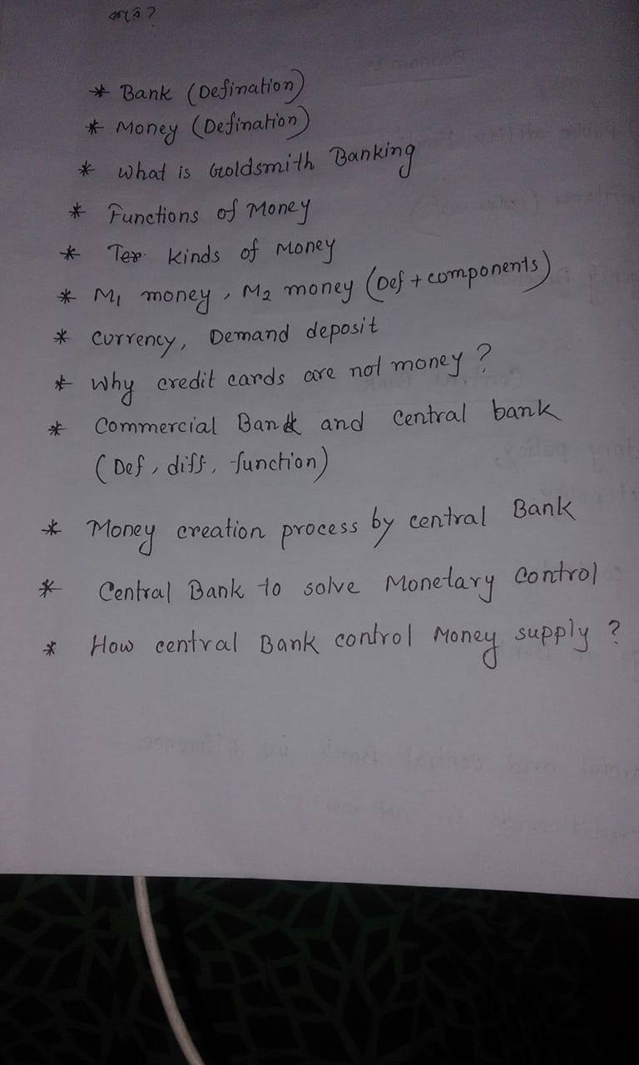

First tt question :
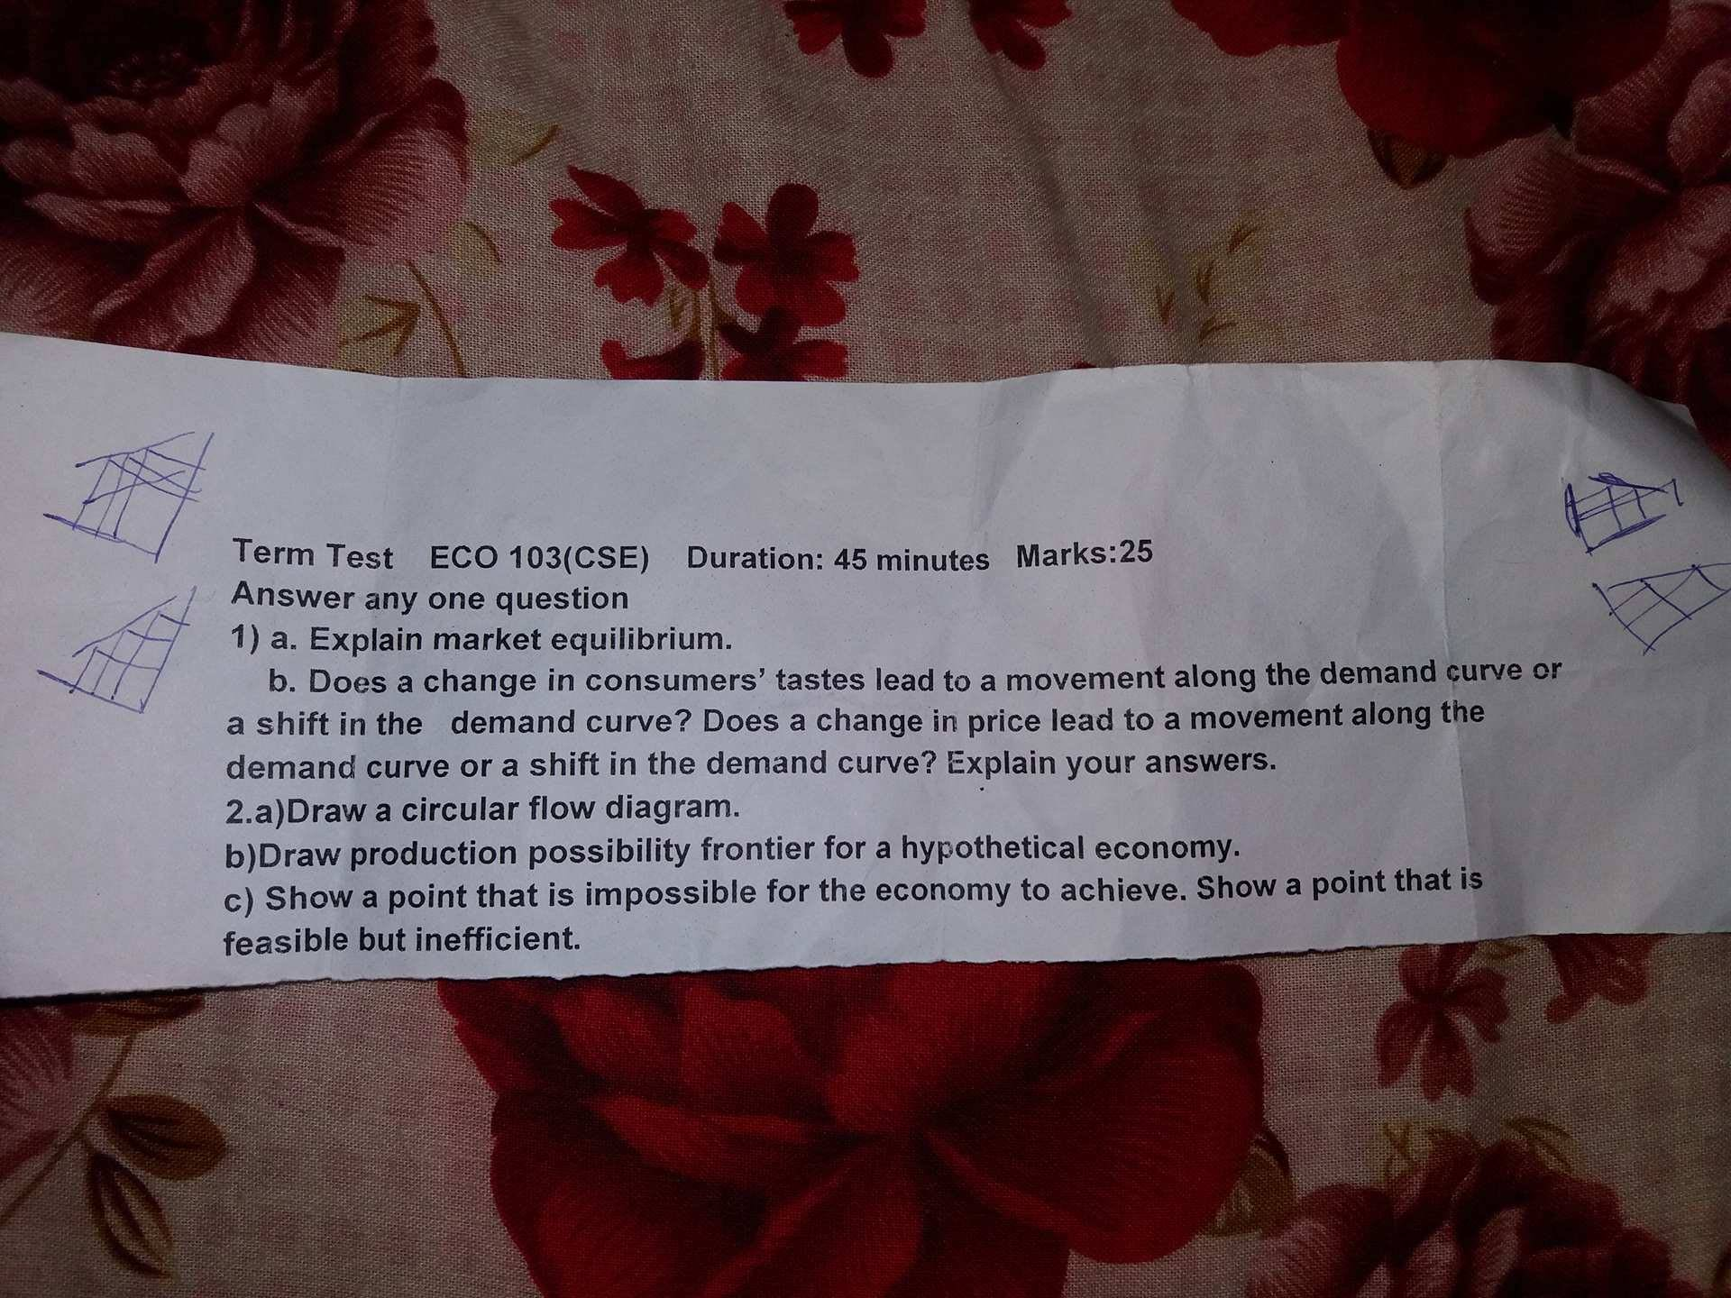
Second tt question:
