Course outline of MAT-204D (Laplace)

Complex variable:
Book: Schaum's Complex Variables
Chapter 1:
Complex number system,Euler formula,Roots of a complex number, DeMoivre’s theorem and it’s application
Solved problems: 2,4,5,7,13,16,17,21,27,28,29,48,50
Chapter 2:
Complex function,Derivative of a complex function,Differentiable in a region
Solved problems: 25 & 30
Chapter 3:
Analytic functions, Cauchy-Riemann equations,Harmonic functions,Singularity and poles
Solved problems: 2,3,6,7
Supplementary problems: 47-53
Chapter 4:
Complex integration, Cauchy’s theorem,Green’s Theorem
Solved problems:21,22
Supplementary problems:29,43,44
Chapter 5:
Cauchy’s Integral formula
Supplementary problems: 30-39
Chapter 7:
Residues,Calculation of residues,Residue theorem
Supplementary problems: 40,41,46,47,48

Laplace Transform:
Book: Schaum's outline of theory and problems of Laplace transforms Schaum's outline series
Chapter 1:
Topics:
Definition of laplace transform, Laplace transform of different functions, Linearity property, Translation & change of scale property, Periodic function,The sine integral, Initial value theorem
Solved problem: 1-26 & 36,37, 48,49
Chapter 2:
Inverse Laplace transform, Convolution Theorem,Partial fraction,Application of Laplace transform, Cramer’s Rule,
Solved problem: 4-28
Chapter 3:
Application to Differential equations
Solved problem: 1-14 , 14**

Fourier Series:
Chapter 3:
Fourier Series,Properties,Odd function,Even Function,Half range sine & Cosine Fourier series,Finite Fourier transformation,
Solved problems: 1-7,9,10
Supplementary Problems:35,36,37,47,48

Class note link: https://www.facebook.com/groups/droppers.group.cse.sust/search/?query=laplace

First tt Question;
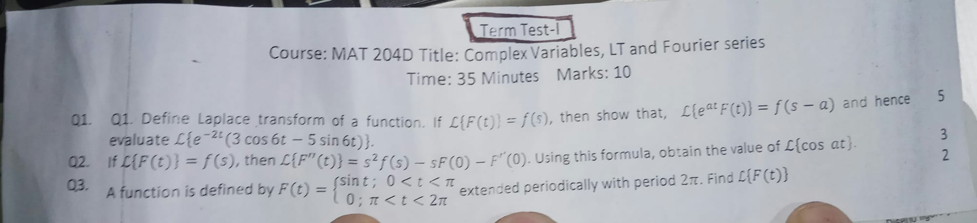
Second tt question:

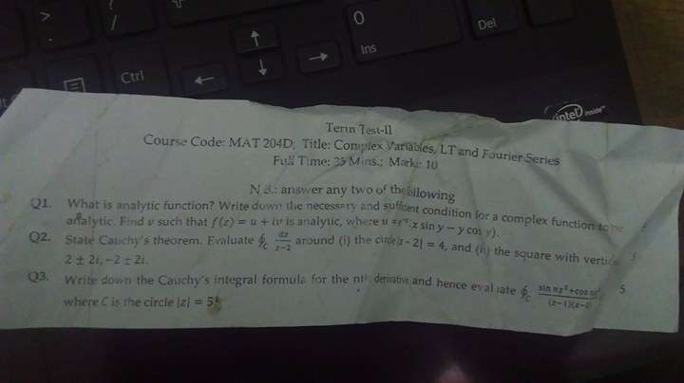
Laplace assignment question:
