# User Acceptance Testing (UAT)

# Barchester City Council Carpark System

# Performed by: Noman Ahmed Khan

UAT Testing:

In the User Acceptance Testing for this system, we will be testing the following functionalities:

* Launching the Application
* Car Entry Sensor Outside
* Car Entry Sensor Inside
* Collecting AdHoc Ticket
* Payment for Adhoc Ticket
* Verifying Season Ticket
* Car Exit Sensor Inside
* Car Exit Season Outside
* Exit Pillar Functionality
* Testing Logic of Carpark (Capacity)

UAT Test Case # 1

Launch the BCCCP Carpark System Application:

Under this test case, we will check whether the application is launched or not.

|  |  |  |  |  |
| --- | --- | --- | --- | --- |
| Test # | Test Description | Values | Expected Result | Actual Result |
| 1 | Start the BCCCP application from Eclipse | Run the main class. | The application should start and show the user interface. | Shown below |

Screenshot test 1:

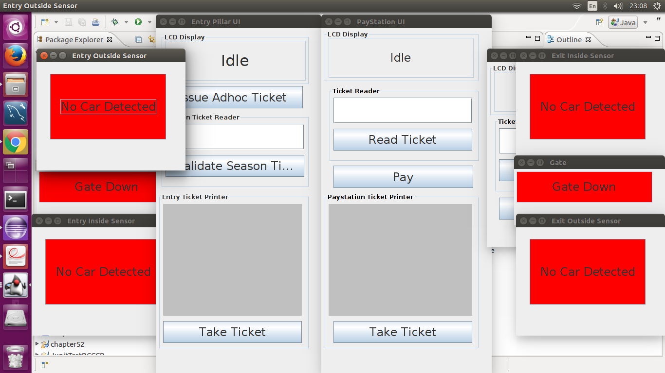

UAT Test Case # 2:

Carpark Entry Sensors Outside/Inside:

Under this test case, we will check whether the carpark entry sensors both inside and outside are working accordingly. And whether their states are changed accordingly.

|  |  |  |  |  |
| --- | --- | --- | --- | --- |
| Test # | Test Description | Values | Expected Result | Actual Result |
| 2a | When a new car is approaching to enter the carpark, the sensor is checked if it is activated or not. | Click on the carpark entry sensor outside to activate the sensor. | The car should be detected and the push button should be activated to collect ad-hoc ticket. | Shown below. |
| 2b | The car collects the ticket, check whether the inside sensor is activated or not. | Click on the issue ad-hoc ticket and then collect ticket. And then click the inside sensor to activate it. | The gate should go up and the second sensor should now be activated. The state should change to Entering carpark. | Shown below. |
| 2c | The car enters, check whether the outside sensor is deactivated or not. | Click on the outside sensor to deactivate it. | The sensor should be deactivated and the state should be changed to car has entered. | Shown below. |
| 2d | The car enters, check whether the inside sensor is deactivated or not. | Click on the inside sensor to deactivate it. | The sensor should be deactivated and the state should be changed to idle now. | Shown below. |

Screenshot test 2a:

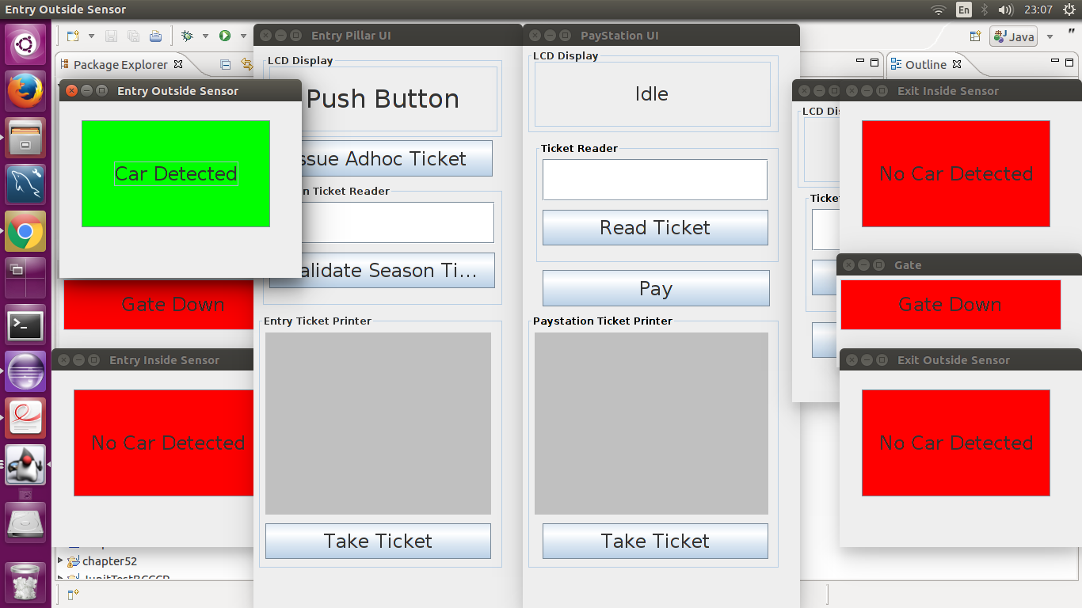

Screenshot 2b:

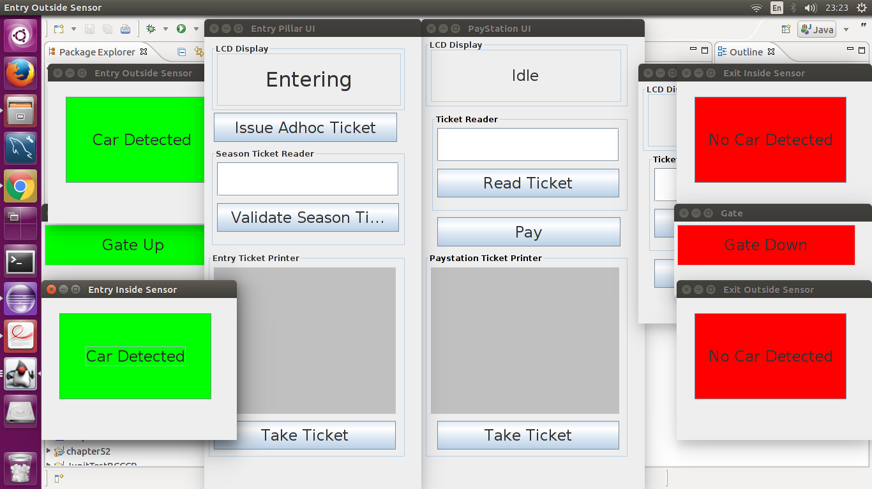

Screenshot 2c:

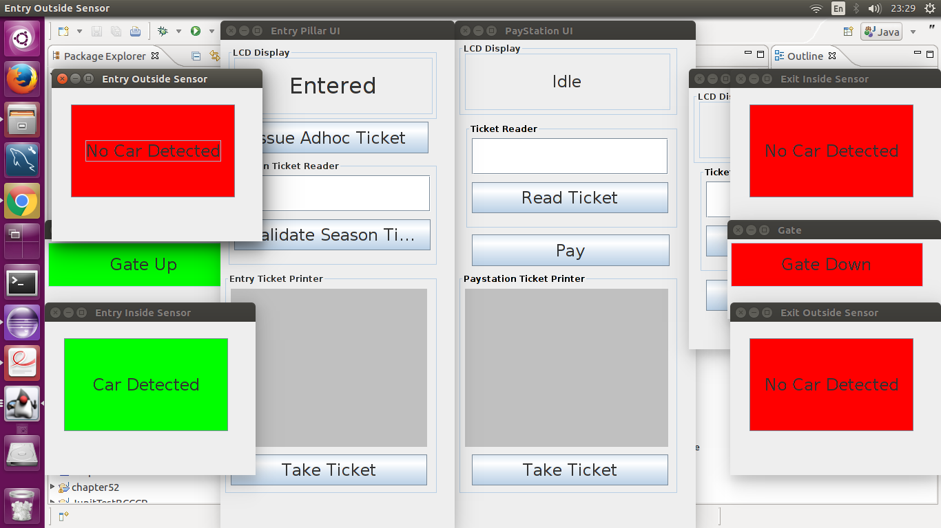

Screenshot 2d:



UAT Test Case # 3:

Issue and Collection of Ad-Hoc Ticket:

Under this testing, we will check whether the Adhoc ticket is issued and whether or not it can be collected. We also check that this process occurs without any errors and that no same ticket is issued twice.

|  |  |  |  |  |
| --- | --- | --- | --- | --- |
| Test # | Test Description | Values | Expected Result | Actual Result |
| 3a | Once the car enters, push the "Issue Ticket" button to issue an ad-hoc ticket. | Click the "Issue Ad-hoc Ticket" Button. | The ticket should be issued with details shown in the display. | Shown below. |
| 3b | Once the ticket is issued, collect the ticket by pressing the "Take Ticket" button. | Click the "Take Ticket" Button. | The ticket should be taken, without any errors. The display should be changed to ticket taken. | Shown below. |
| 3c | Issue another ticket for a different car. Check whether the ticket is different than the one taken from the previous car. | Click the "Issue Ad-hoc Ticket" button. | The ticket number should be different from the ticket that was issued earlier. | Shown below. |

Screenshot Test 3a:

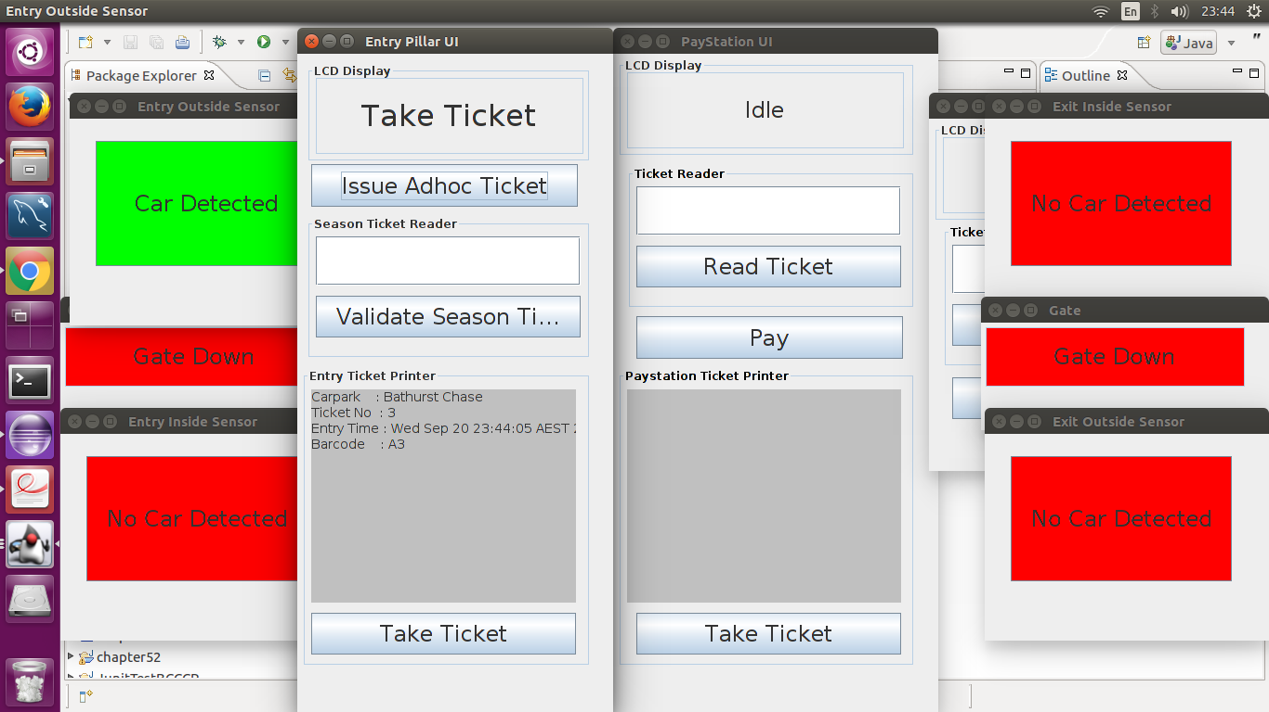

Screenshot Test 3b:

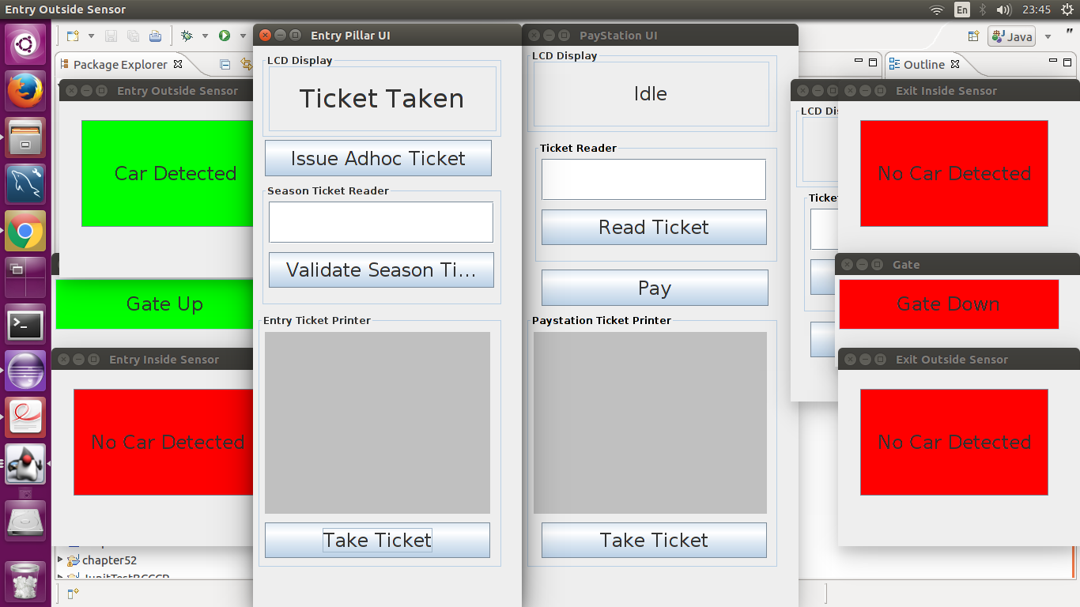

Screenshot Test 3c:

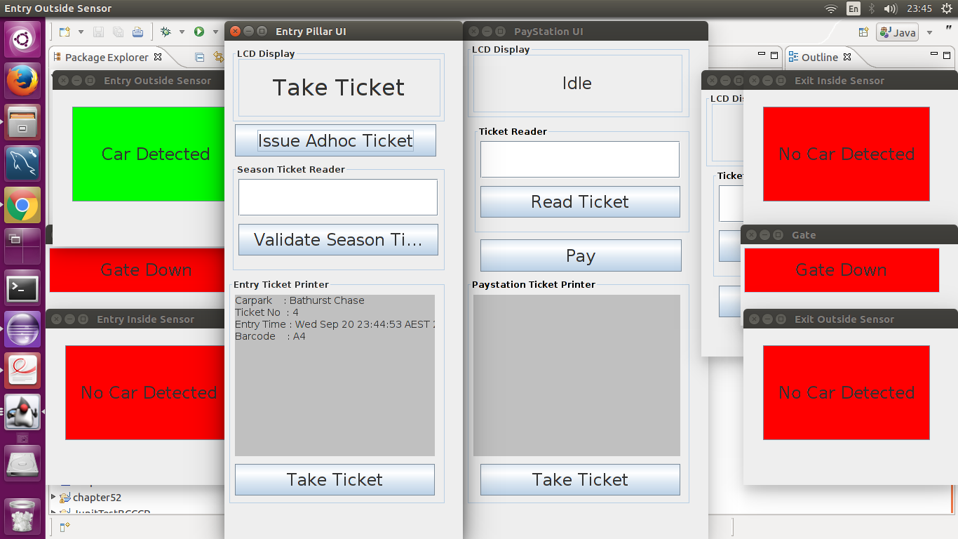

UAT Test Case #4:

Verify Season Ticket:

Under this test, we will check whether the customer holder of season ticket can verify their ticket to enter the carpark or not.

|  |  |  |  |  |
| --- | --- | --- | --- | --- |
| Test # | Test Description | Values | Expected Result | Actual Result |
| 4a | Enter a valid season ticket and check whether the ticket is validated or not. | Enter the ticket number S2222 which is a valid ticket number. | The season ticket should be validated. | Shown below. |
| 4b | Enter an invalid season ticket and check whether the ticket is validated or not. | Enter the ticket number S3333 which is an invalid ticket number. | The season ticket should not be validated. | Shown below. |

Screenshot Test 4a:

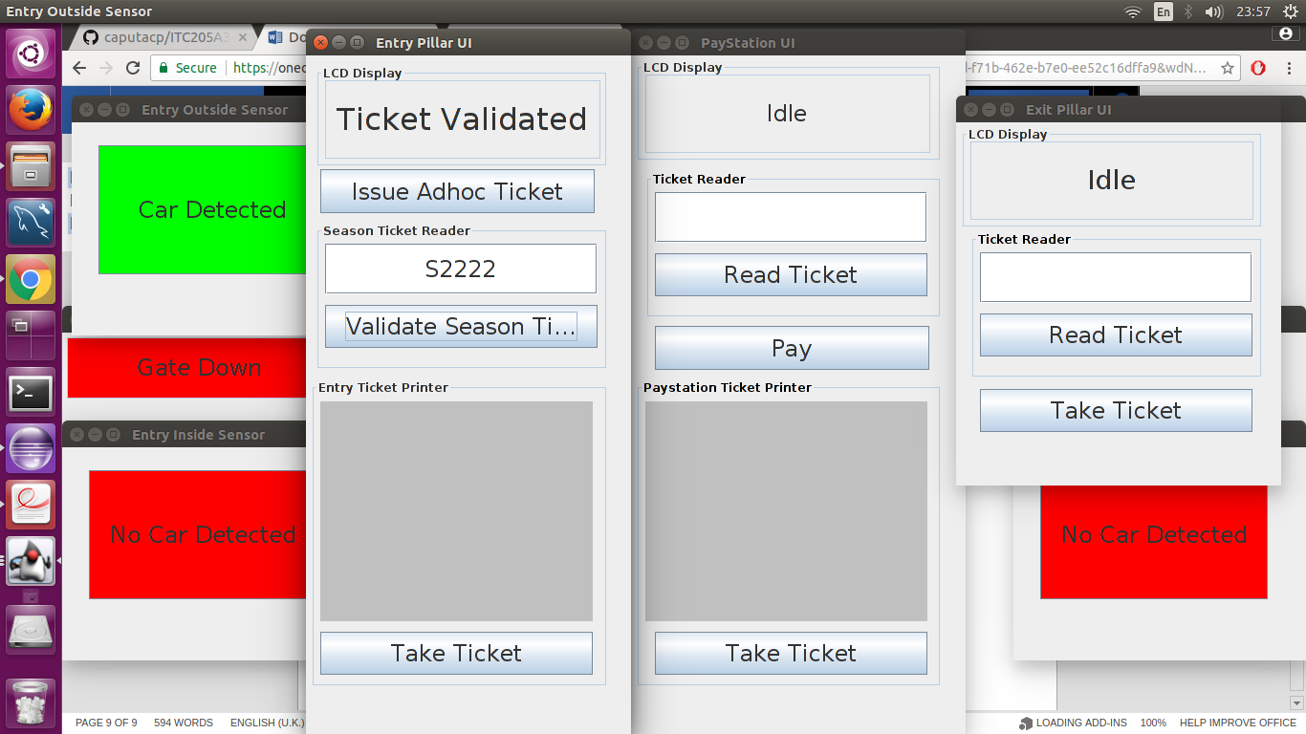

Screenshot Test 4b:

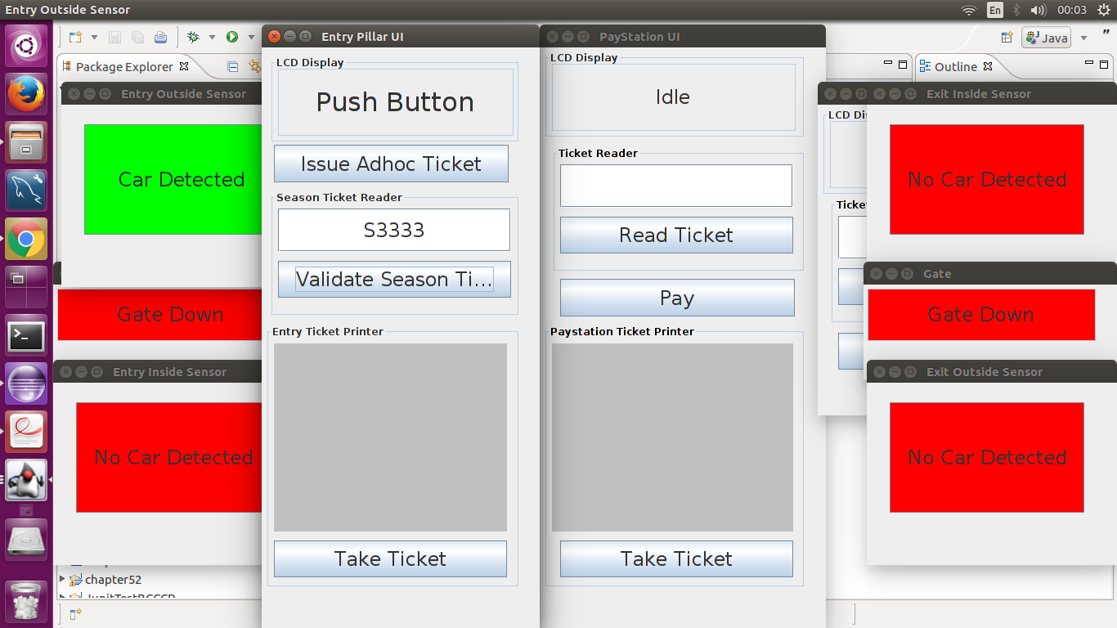

UAT Test Case #5:

Payment for Ad-hoc Ticket:

Under this test case, we will check whether the payment for ad-hoc ticket can be done without any errors. It is to be noted that under this test, we are not checking the fare for the ticket is being calculated correctly or not.

|  |  |  |  |  |
| --- | --- | --- | --- | --- |
| Test # | Test Description | Values | Expected Result | Actual Result |
| 5a | Go to paystation and read ticket. Check whether it is read and asks for payment to be made. | Insert ticket "A4". | The paystation should ask the user to pay some amount of money for the ticket. | Shown below. |
| 5b | Pay for the ticket and see whether the receipt is printed for that ticket payment. | Pay for ticket "A4" | The state should be changed to paid and receipt should be printed. | Shown below. |
| 5c | Take the ticket and check whether user can take the ticket without any error generated. | Take Ticket button is pushed. | The ticket should be taken and state should be changed to idle. | Shown below. |

Screenshot Test 5a:

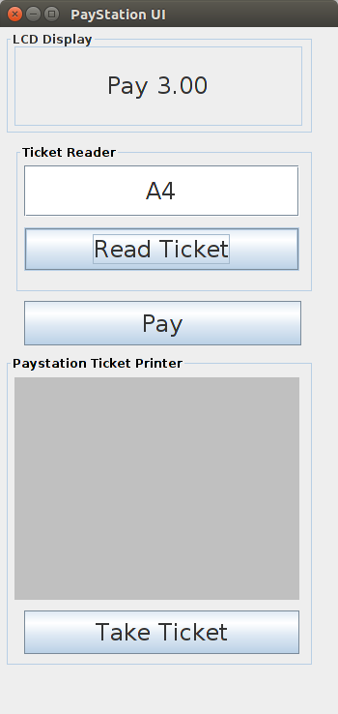

Screenshot Test 5b:

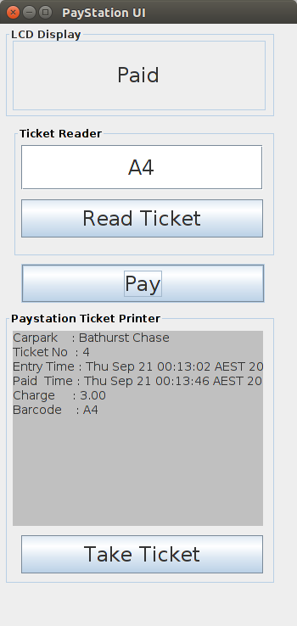

Screenshot 5c:

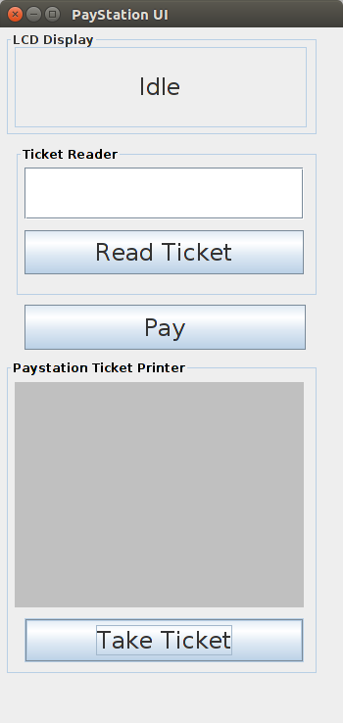

UAT Test Case# 6:

Carpark Exit Pillar and Exit Sensors:

Under this test case, we will check whether the exit user pillar is working correctly or not by reading valid/invalid tickets and checking whether they are being processed. Check the whether the exit sensors are functioning properly or not.

|  |  |  |  |  |
| --- | --- | --- | --- | --- |
| Test # | Test Description | Values | Expected Result | Actual Result |
| 6a | Activate exit sensor and read the paid ad-hoc ticket at the exit and check whether it is processed or not. | Click on Exit Sensor Inside and Read ticket "A4" at the exit. | The ticket is valid and it should be processed. | Shown below. |
| 6b | Activate exit sensor and read the season ticket at the exit and check whether it is processed or not. | Click on Exit Sensor Inside and Read ticket "S2222" at the exit. | The ticket is valid and it should be processed. | Shown below. |
| 6c | Activate exit sensor and read an invalid ticket at the exit and check whether it is processed or not. | Click on Exit Sensor Inside and Read ticket "A6" at the exit. | The ticket is invalid and should not be processed. | Shown below. |
| 6d | Activate exit sensor and read a ticket that has not yet been paid for and check whether it is processed or not. | Click on Exit Sensor Inside and Read ticket "A3" at the exit. | The ticket has not yet been paid for and should not be processed. | Shown below. |
| 6e | Collect the processed ticket and check whether the gate is opened or not. | Click on "Take Ticket". | The ticket should be taken and the gate should be up. | Shown below. |
| 6f | Activate the Exit sensor outside so the car can leave. | Click on Exit sensor outside. | The sensor should be activated and state should be changed to car exiting. | Shown below. |
| 6g | Deactivate the Exit sensors. | Click on Exit Sensor inside. | The sensor should be activated and state should be changed to car exited. | Shown below. |

Screenshot 6a:

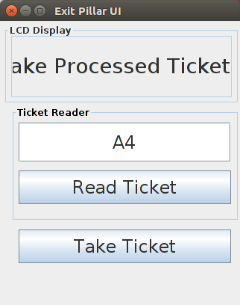

Screenshot 6b:

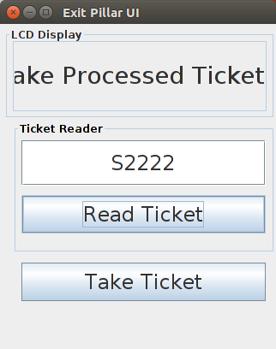

Screenshot 6c:

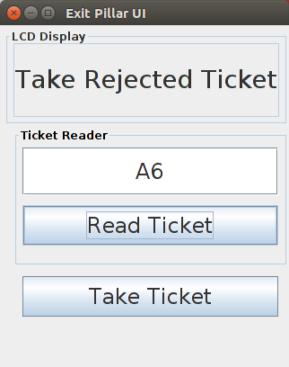

Screenshot 6d:

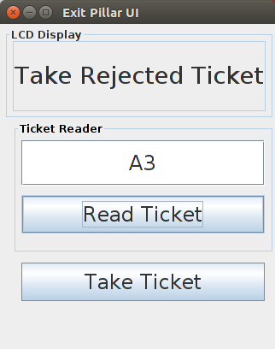

Screenshot 6e:

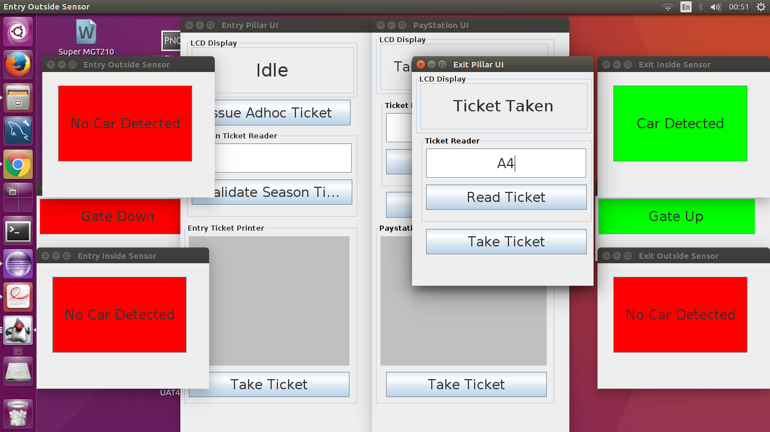

Screenshot 6f:

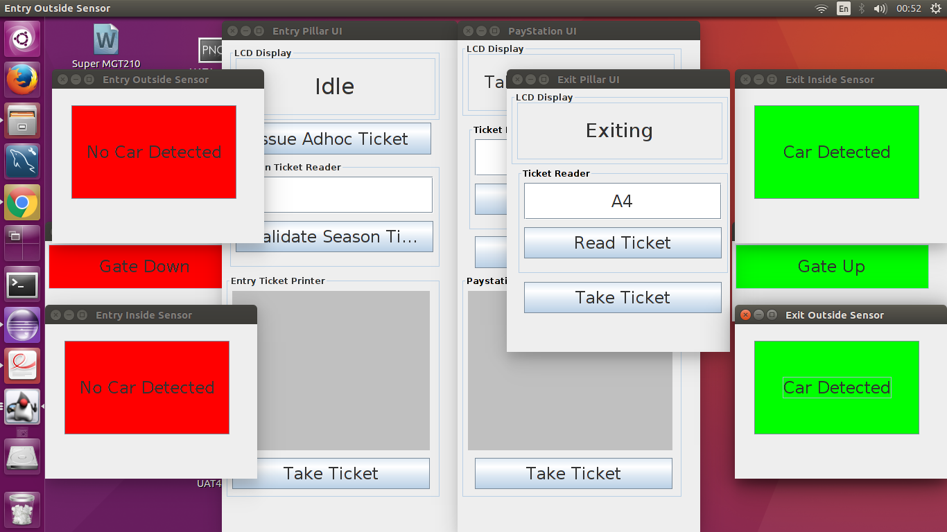

Screenshot 6g:

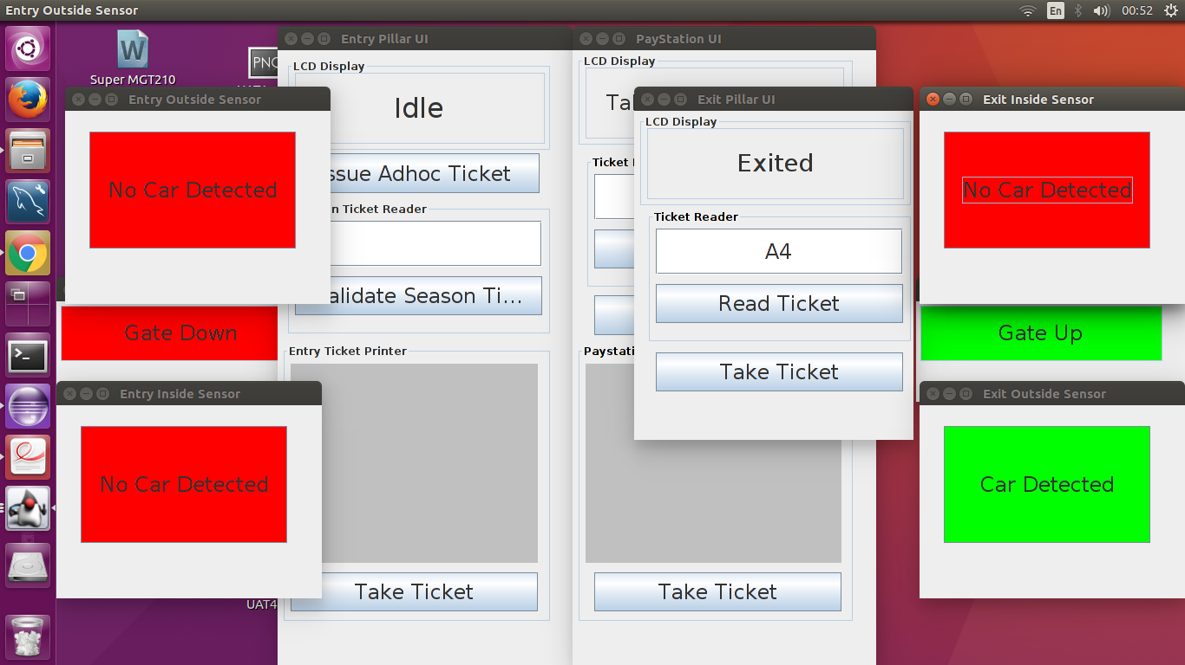

UAT Test Case# 7:

Carpark Entry & Capacity Testing (Non-functional Requirement):

Under this test, we will check whether the carpark allows cars to be entered when it's capacity is full. We will check the algorithm that only 10% of the carpark spaces are reserved for the season ticket holders on a weekday while the remaining spaces are to be occupied by the ad-hoc ticket holders.

|  |  |  |  |  |
| --- | --- | --- | --- | --- |
| Test# | Test Description | Test Values | Expected Result | Actual Result |
| 7a | Allocate only 10 spaces to Barchester Carpark, Issue ad-hoc ticket to cars until the carpark is full. | Issue 9 ad-hoc ticket. | 9 ad-hoc tickets should be issued without any error generated. | The result is shown below with the issuence of the 9th ad-hoc ticket. |
| 7b | Issue a 10th ad-hoc ticket. | Issue 10th ad-hoc ticket. | The carpark should generate a message that the carpark is full. 10th ad-hoc ticket should not be generated unless a car leaves the carpark. | The result is shown below. |
| 7c | Allow entry to season ticket holder. | Allow S1111 to be verified and entered into carpark. | The season ticket holder S1111 is validated and allowed entry to carpark. | The result is shown below. |
| 7d | Make one car leave the carpark and issue another ad-hoc ticket. | Issue the 10th ad-hoc ticket. | The ticket Is issued as one car left and now 1 space became available as 9/10 spaces are for ad-hoc ticket holders. | The result is shown below with the issuance of 10th ad-hoc ticket. |

Screenshot 7a:

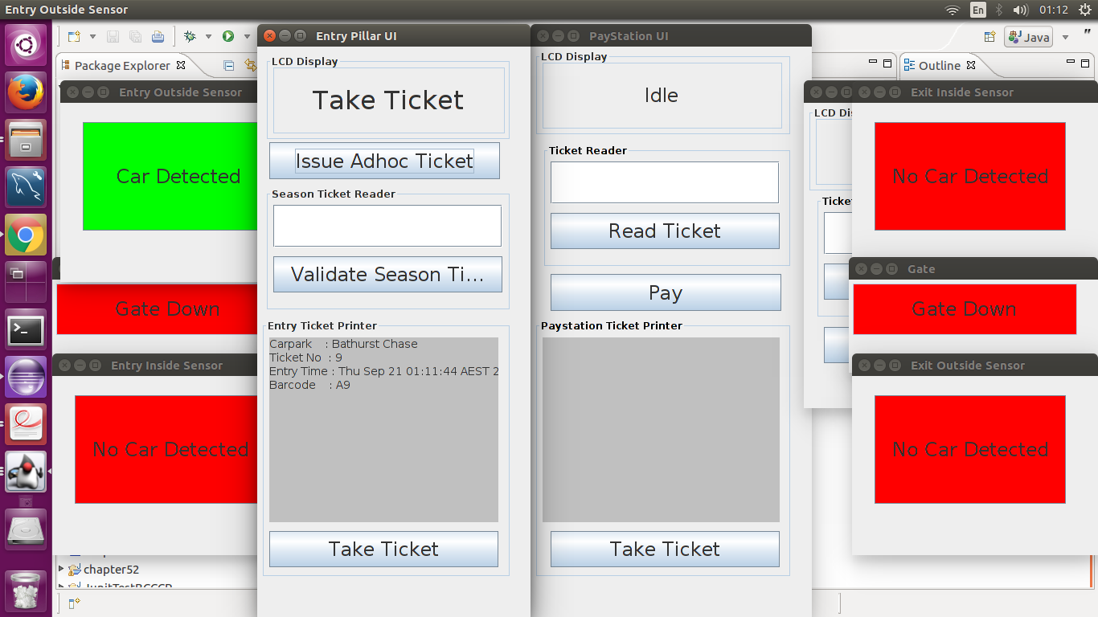

Screenshot 7b:

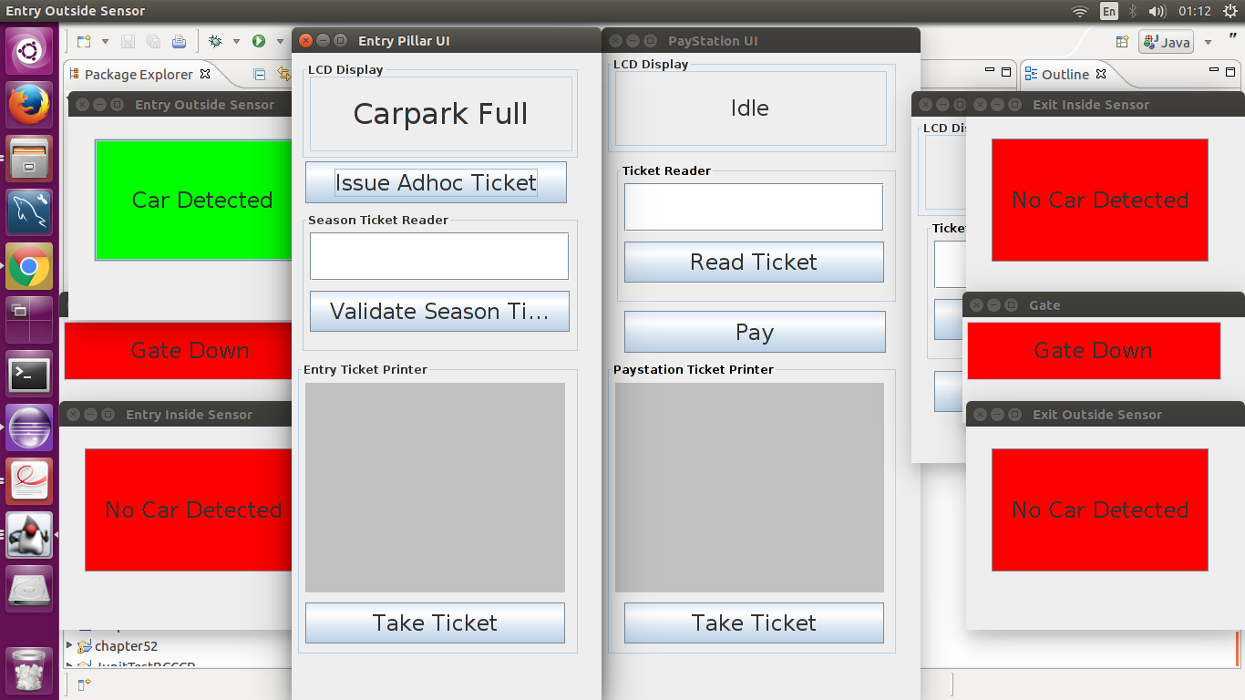

Screenshot 7c:

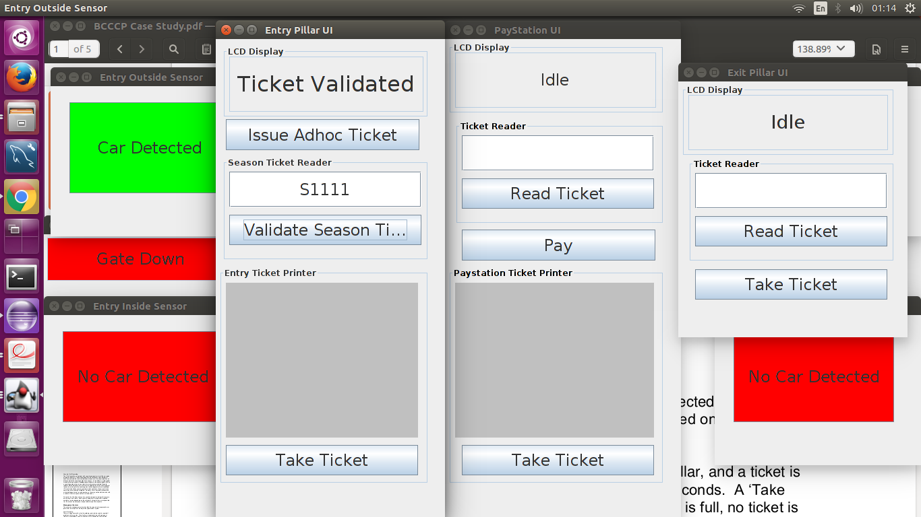

Screenshot 7d:

