Noman Ahmed Khan

11567969

ITC313

Programming in Java 2

Assignment 2

**Task 1:**

In this task we are to create a program in java that will:

* Read a File from Command Line
* Calculate how many times an upper case letter occurs in that file
* Calculate the percentage of the letters
* Display Asterisks that depict a histogram for the letters.

The User will enter the filename at command line like:

>>java TestAlphabets mytext.txt

The program consists of three files(Java/Class):

1. Alphabets: This has all the methods needed to create a histogram
2. TestAlphabets: This will use the methods of Alphabets to create histogram
3. TestingAlphabets: Consists of code to carry out Junit Testing.

**Results:**

The program was tested with three different files. The results are as below:

1. Mytext.txt

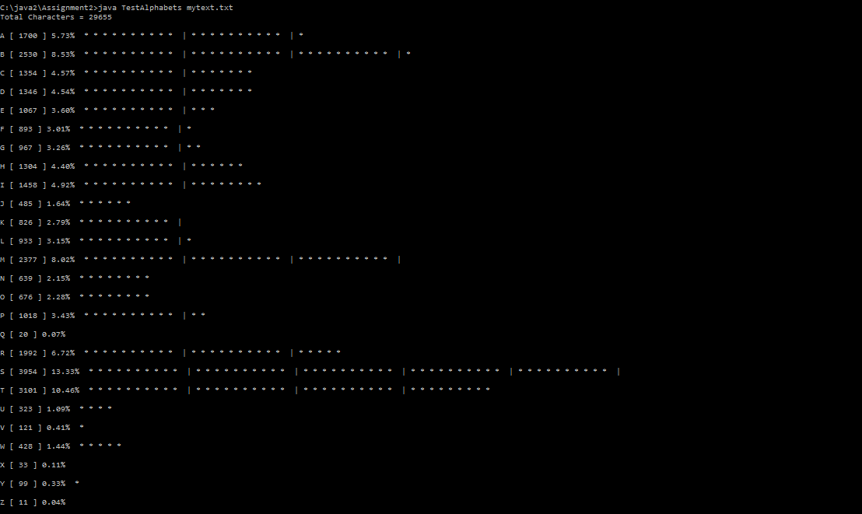

1. Jtext.txt

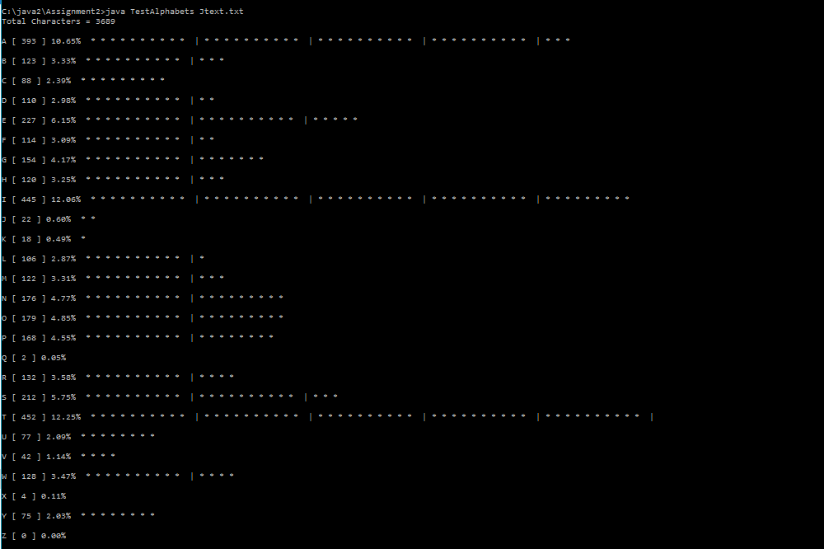

1. The source code file itself TestAlphabets.java

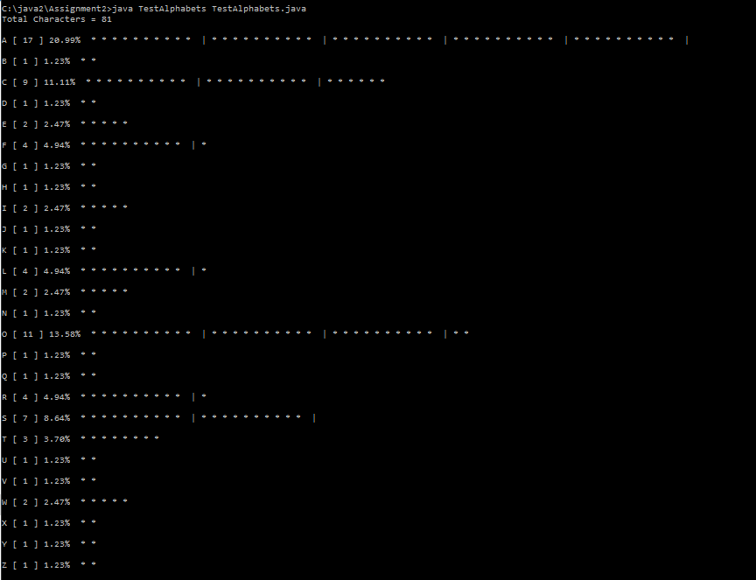

**UML Diagram Task1:**



**Task 2:**

In this task we are to create a GUI program using JavaFX that will:

* Prompt User to enter the file name in the text box and press “View”
* Upon clicking “View” the program will display an animated Histogram of all the upper case letters occurring in the file that was input.

The program is run from cmd as:

>> java JavaFXHistogram

The program consists of file:

JavaFXHistogram.java

JavaFXHistogram.class

**Results:**

The program was tested with three files:

1. Mytext.txt

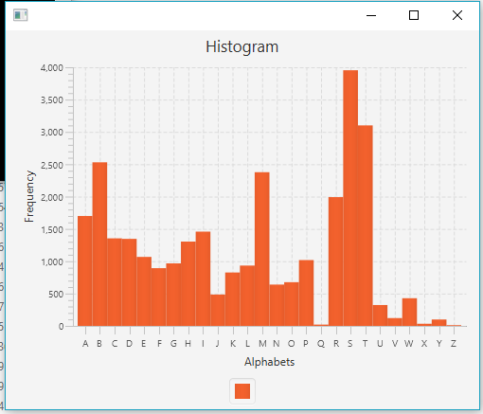

1. Jtext.txt

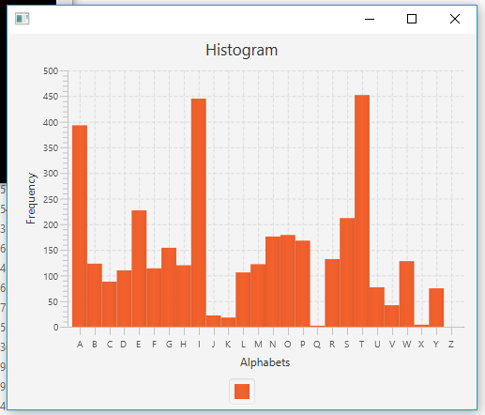

1. The code itself JavaFXHistogram.java

