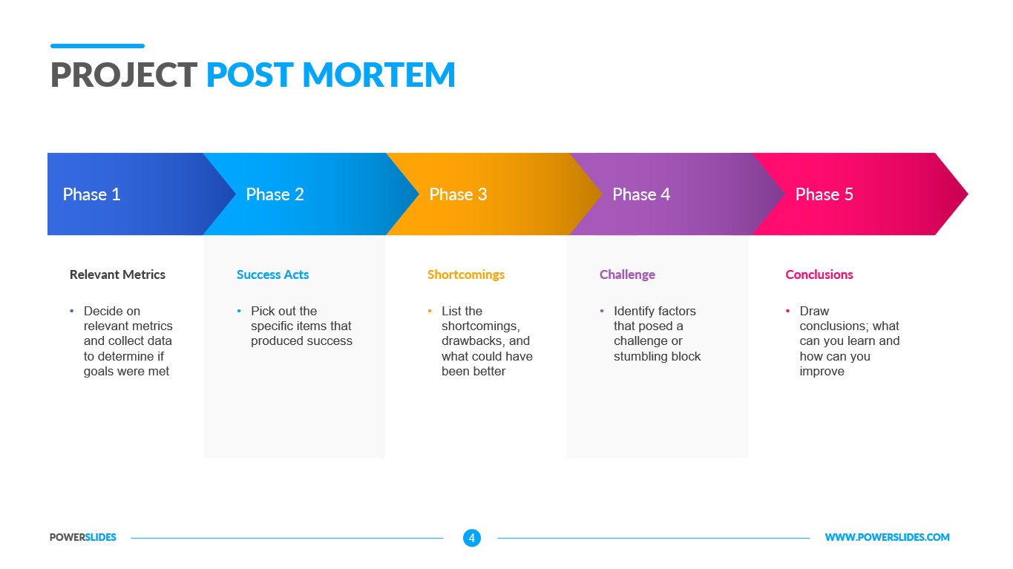

Relevant Metrics:

Success:

Team Acts

Backup Support

Shortcomings:

1. Light Sensor to Hub Communication Lag, wheels can only move at 20 and add to total time. We are using light sensor in multiple functions like drive to color, follow line, align to line.
2. Number or programs/routs that need to be form in limited amount of time.

Challenges:

1. Light sensor to hub to wheel communication lag
2. Wheel traction
3. Add remove attachment
4. Align to line wasn’t working properly

Conclusions/Improvement:

1. Speed up drive to color with minimum distance with drive to distance before reaching the minimum distance.
2. Add acceleration and deceleration to turn, relative_distance and relative_distance_to_color.
3. Merge routes (3 routes), add masterpiece and minifigure delivery of with routes.
4. Plans for total point and attention to challenges.
5. Count Down to 0 block when robot is waiting on user
6. Add counter for virtual reality in case the other group couldn’t get pink