We need to change positions of unfinished sub-menus Hiring, Licenses, Statistics, Additional funds

Licences and hiring can be added to the footer in the meantime and we could use in the menu ‘ about us ‘ a dropdown menu with ‘ our story ‘ ( displaying existing page ) and ‘ licences ‘ ( creating a new page here with licence information

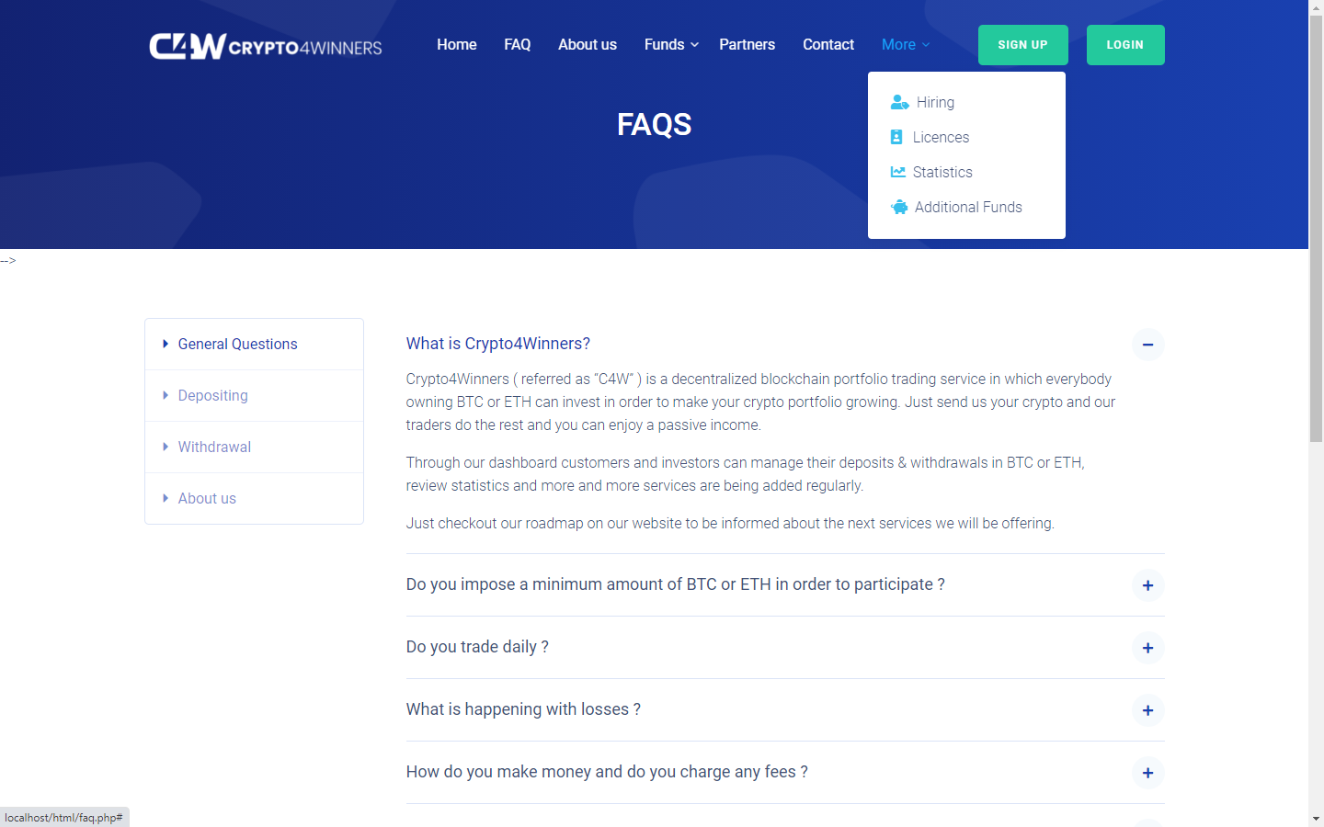

There was a menu called ‘security’ this one can be exchanged against ‘ Statistics’ or even better ‘ Performances ‘

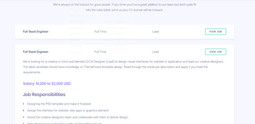

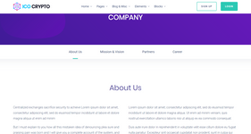

we can add like this the page called " about us " , we keep a dropdown menu for "about us" , if you click on the about us page, you will get displayed the current existing one but we need to add those effects to it like in the screenshots ( it is based on the template you have, you can check the "cyanus about us" page, code is already there and you see the animations etc

aboutus1.png is the page for the Careers/Job offerings

here same, code is existing in "cyanus career" template, we just need to adapt it with our color schemes

for the page "licences" , we can split it into 2 pages, 1x Crypto4Winners and 1x Crypto4wealth - we can use the format of "cyanus multi - token info " and displaying the content of c4wealth.png to a form of like c4wealth1.png and the contents of crypto4winners in a form like c4winners.png by having the "ETH Fund" , "BTC Fund" and "Global Crypto Fund" and on the bottom of each , c4wealth and c4winners, a signup button which refers to the signup page of c4winners respectively to the new webpage [crypto4wealth.fund](http://crypto4wealth.fund/" \t "https://app.clickup.com/t/_blank) for that specific fund

[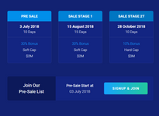](https://t6618902.p.clickup-attachments.com/t6618902/dffe9dec-93f9-48d1-849e-a2481f723598/c4winners.PNG" \t "https://app.clickup.com/t/_blank)

