# Muhammad Noman Shafqat 111572 SE5A

***Question 1* : What is the effect of using the wrong sign when filtering with the contra harmonic mean filter?**

When R<0 Salt noise will be removed.

When R>0 Pepper noise will be removed.

***Question 2:* Why do you think the median filter works on salt and pepper noise but not Gaussian noise?**

Salt noise is basically pixel values nearing 255 and Pepper noise are near to 0. When median filter is applied the pixel value at the middle has more chances of being the median but on the other hand gaussian noise is random value can be any number between 0 to 255 so it’s hard to predict the effectiveness of median filter on gaussian noise.

## Arithmetic Mean Filter

Works good on Gaussian and speckle noise and almost has no effect on the others.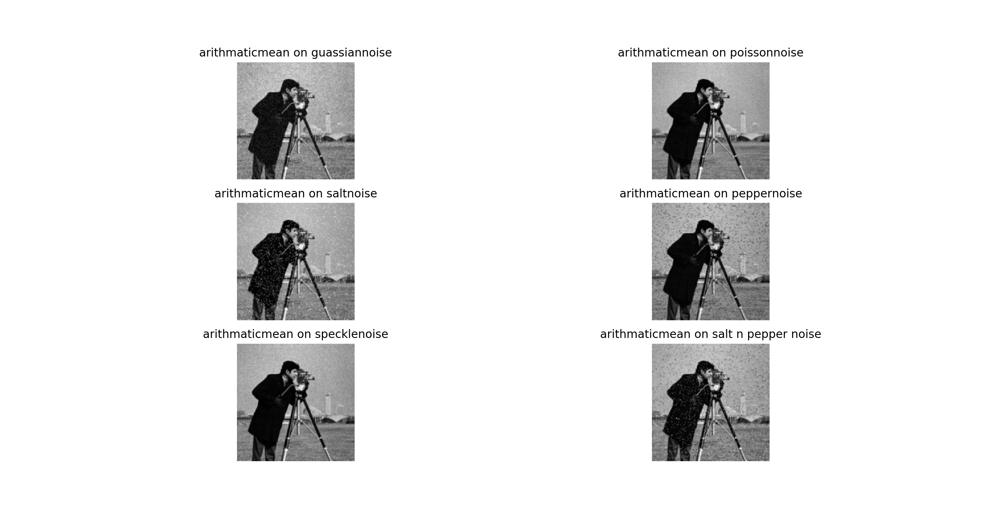

## Max Filter

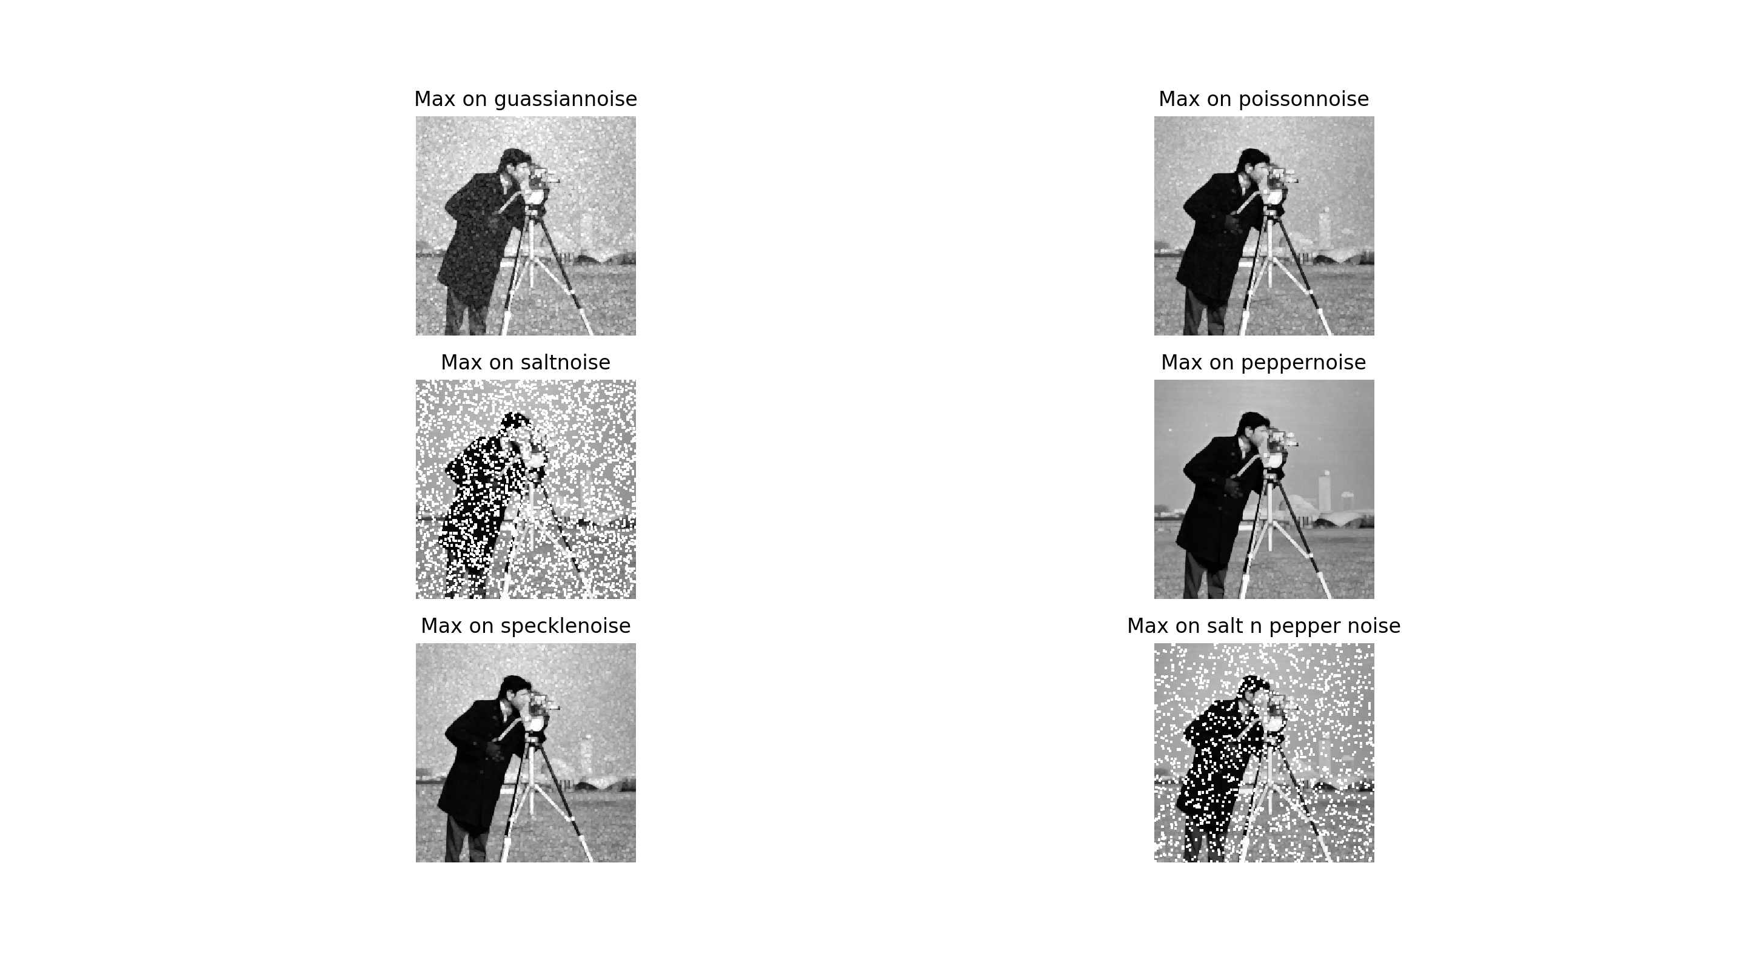

Works better at pepper noise but doesn’t give good results on other type of noise.Performs worst at pepper noise.

## Min Filter

## 

Works better at salt noise but doesn’t give good results on other type of noise. Performs worst at pepper noise.

## Median Filter

Works better at both salt noise and pepper noise but doesn’t give good results on other type of noise and has worst results at Gaussian noise.

## Geometric Mean Filter

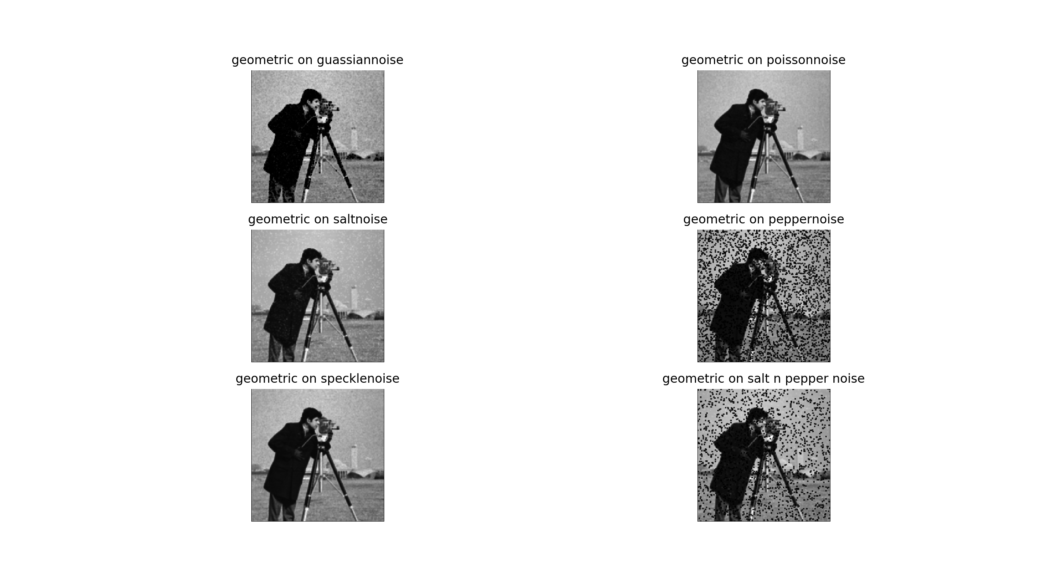

Performs Worst at pepper noise and cleans the salt noise but the traces of it still remain. Not any notable effect on the other Noises.

## Contra Harmonic Mean Filter (R<0) -0.5 used

Performs Worst at pepper noise and good at removing the salt noise but the traces of it still remain. Not any notable effect on the other Noises.

## Contra Harmonic Mean Filter (R>0) 0.5 used

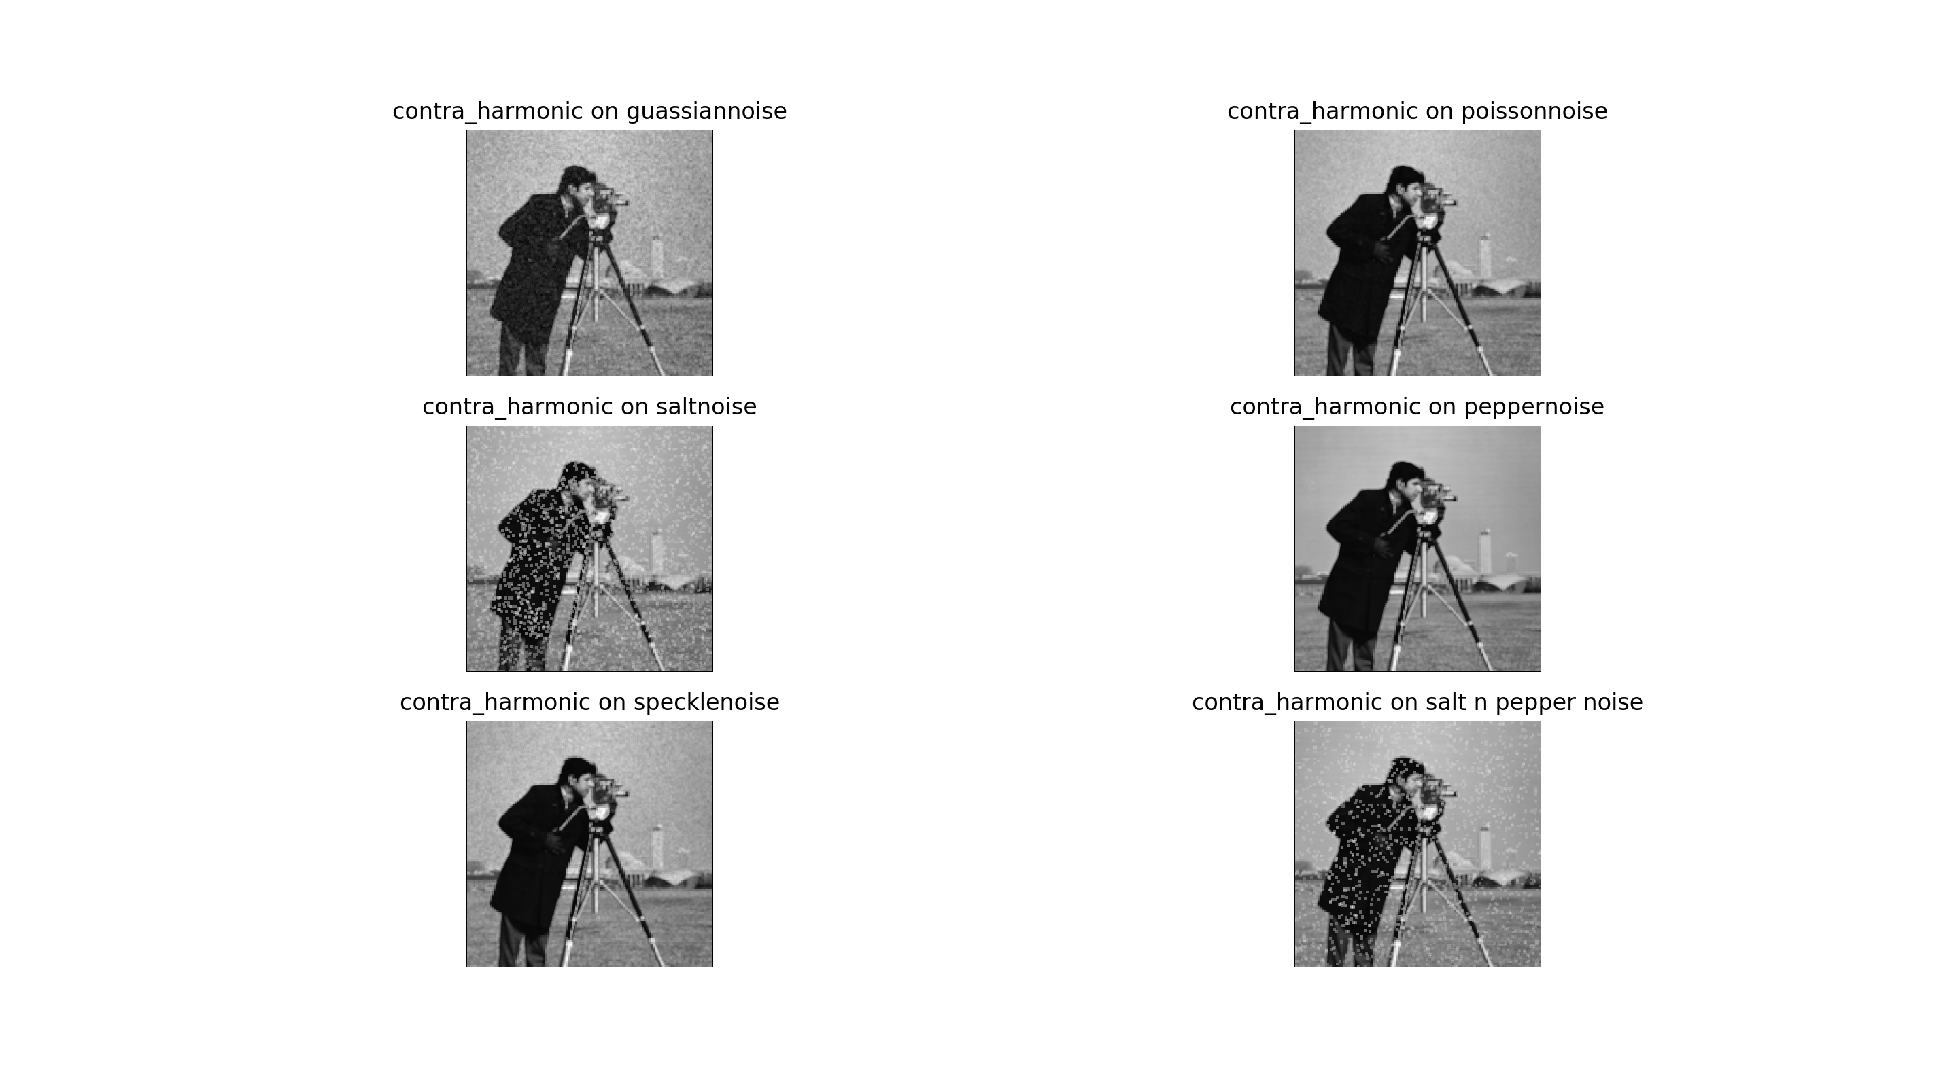

Performs Worst at Salt noise and best at removing the pepper noise. Not any notable effect on the other Noises.

## Harmonic Mean Filter

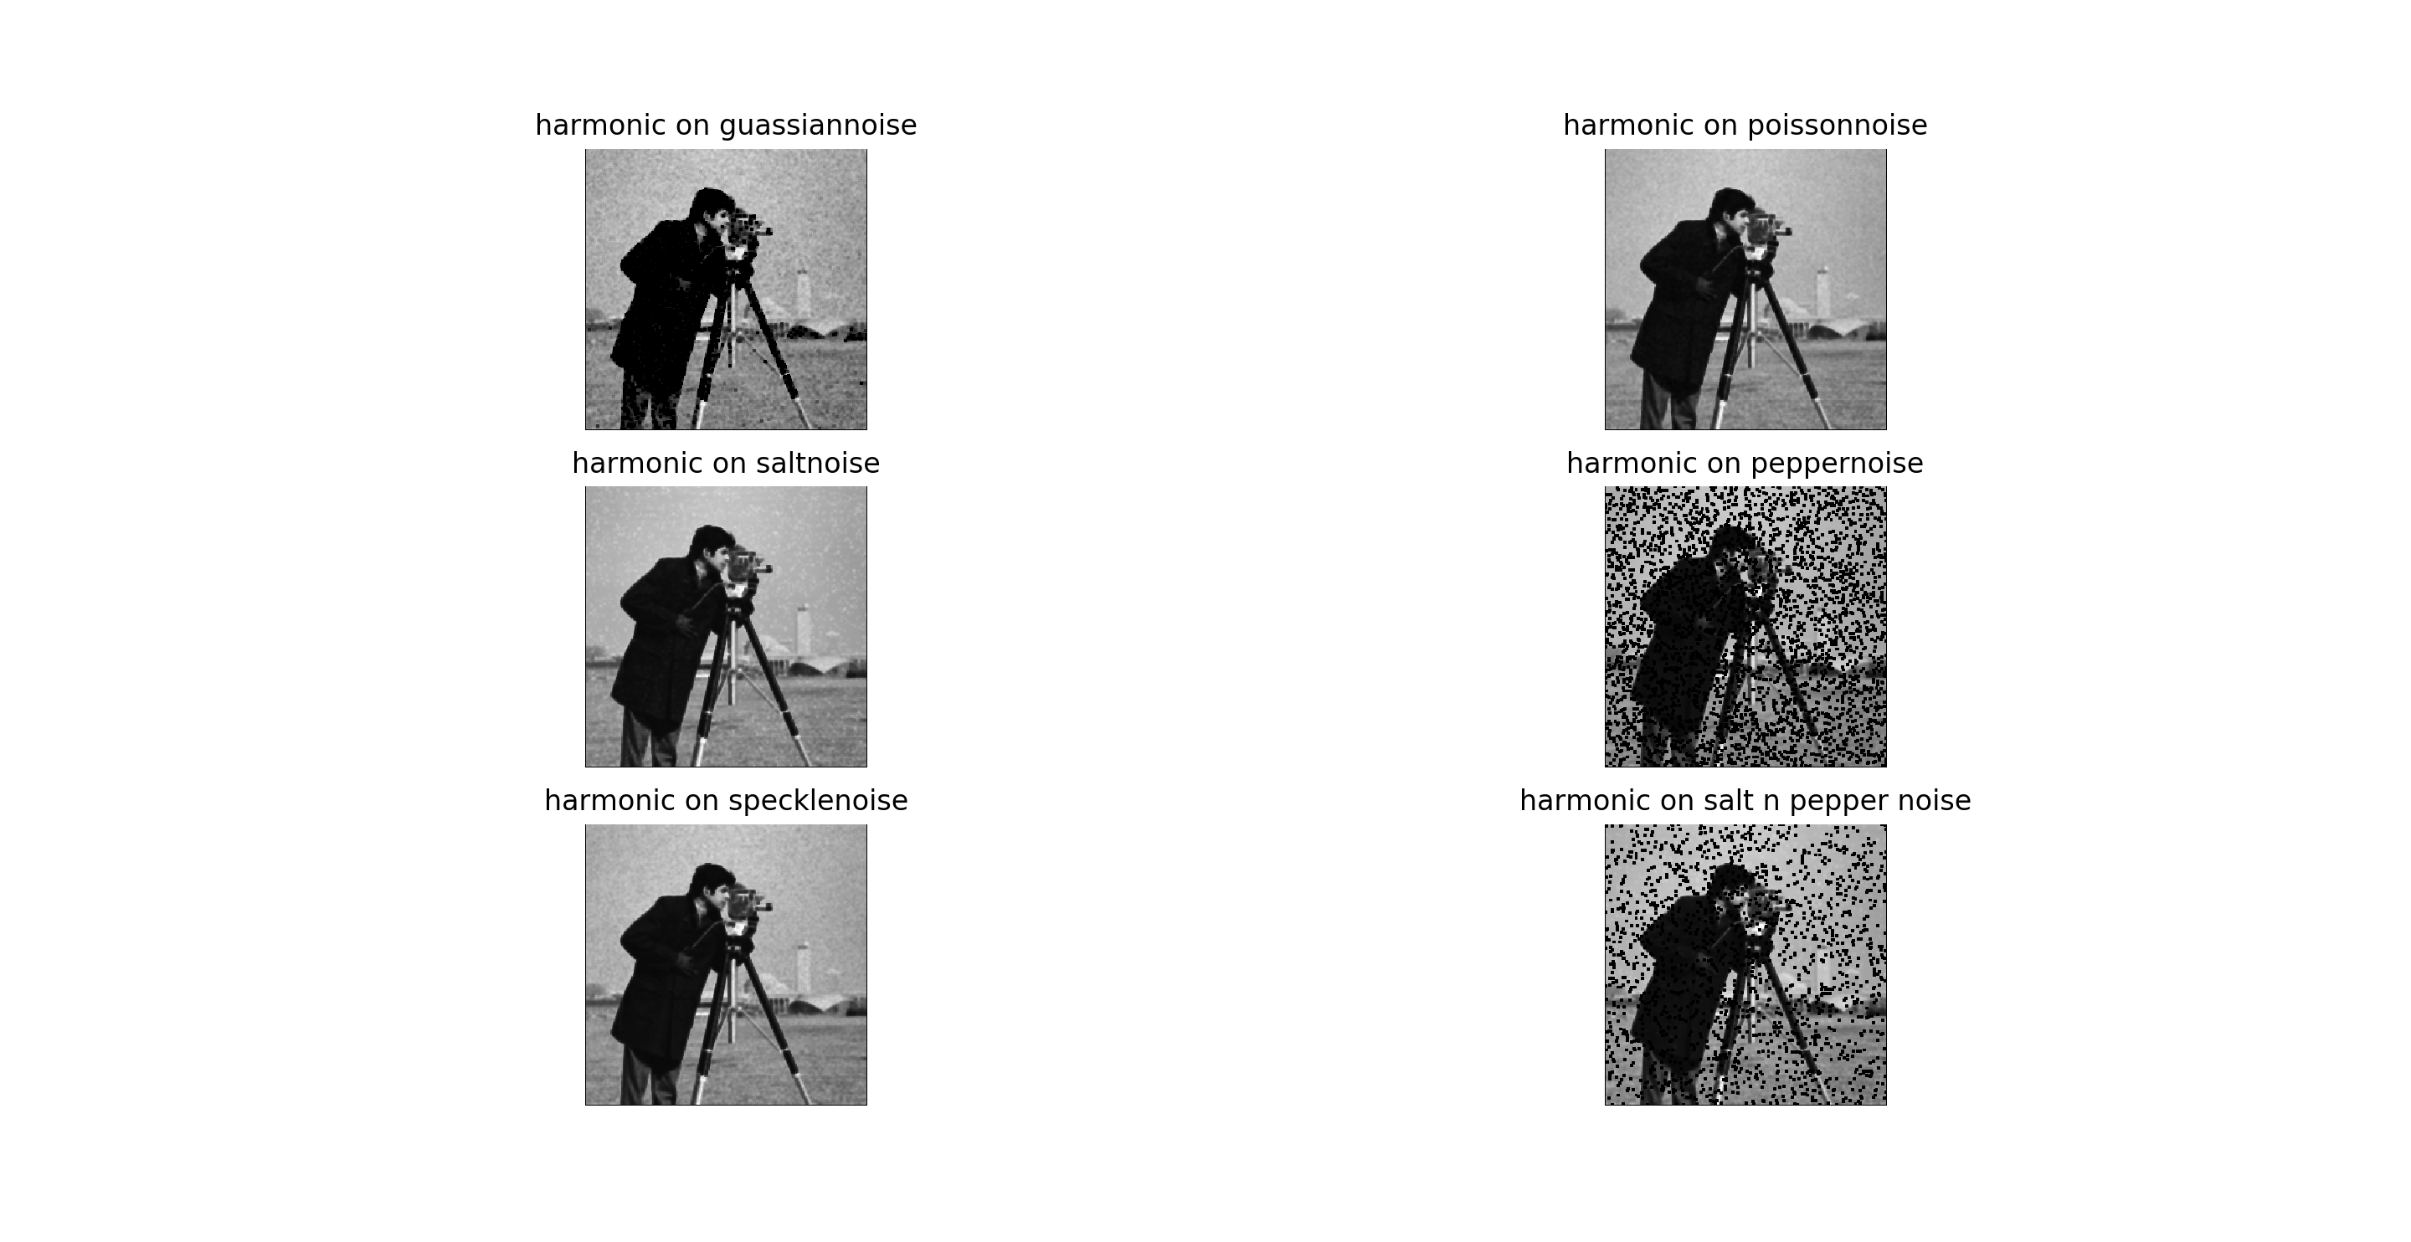

Performs Worst at pepper noise and good at removing the salt noise but the traces of it still remain.Not any notable effect on the other Noises.