5 Ways to Speed Up Your Site With Better Images
Draft for review. Target keyword: image optimization for SEO.
Images are usually the heaviest part of a page. A slow hero image pushes back your Largest Contentful Paint, and Google measures it. The fix is rarely a redesign: it is smaller files, honest names and a sentence of alt text.
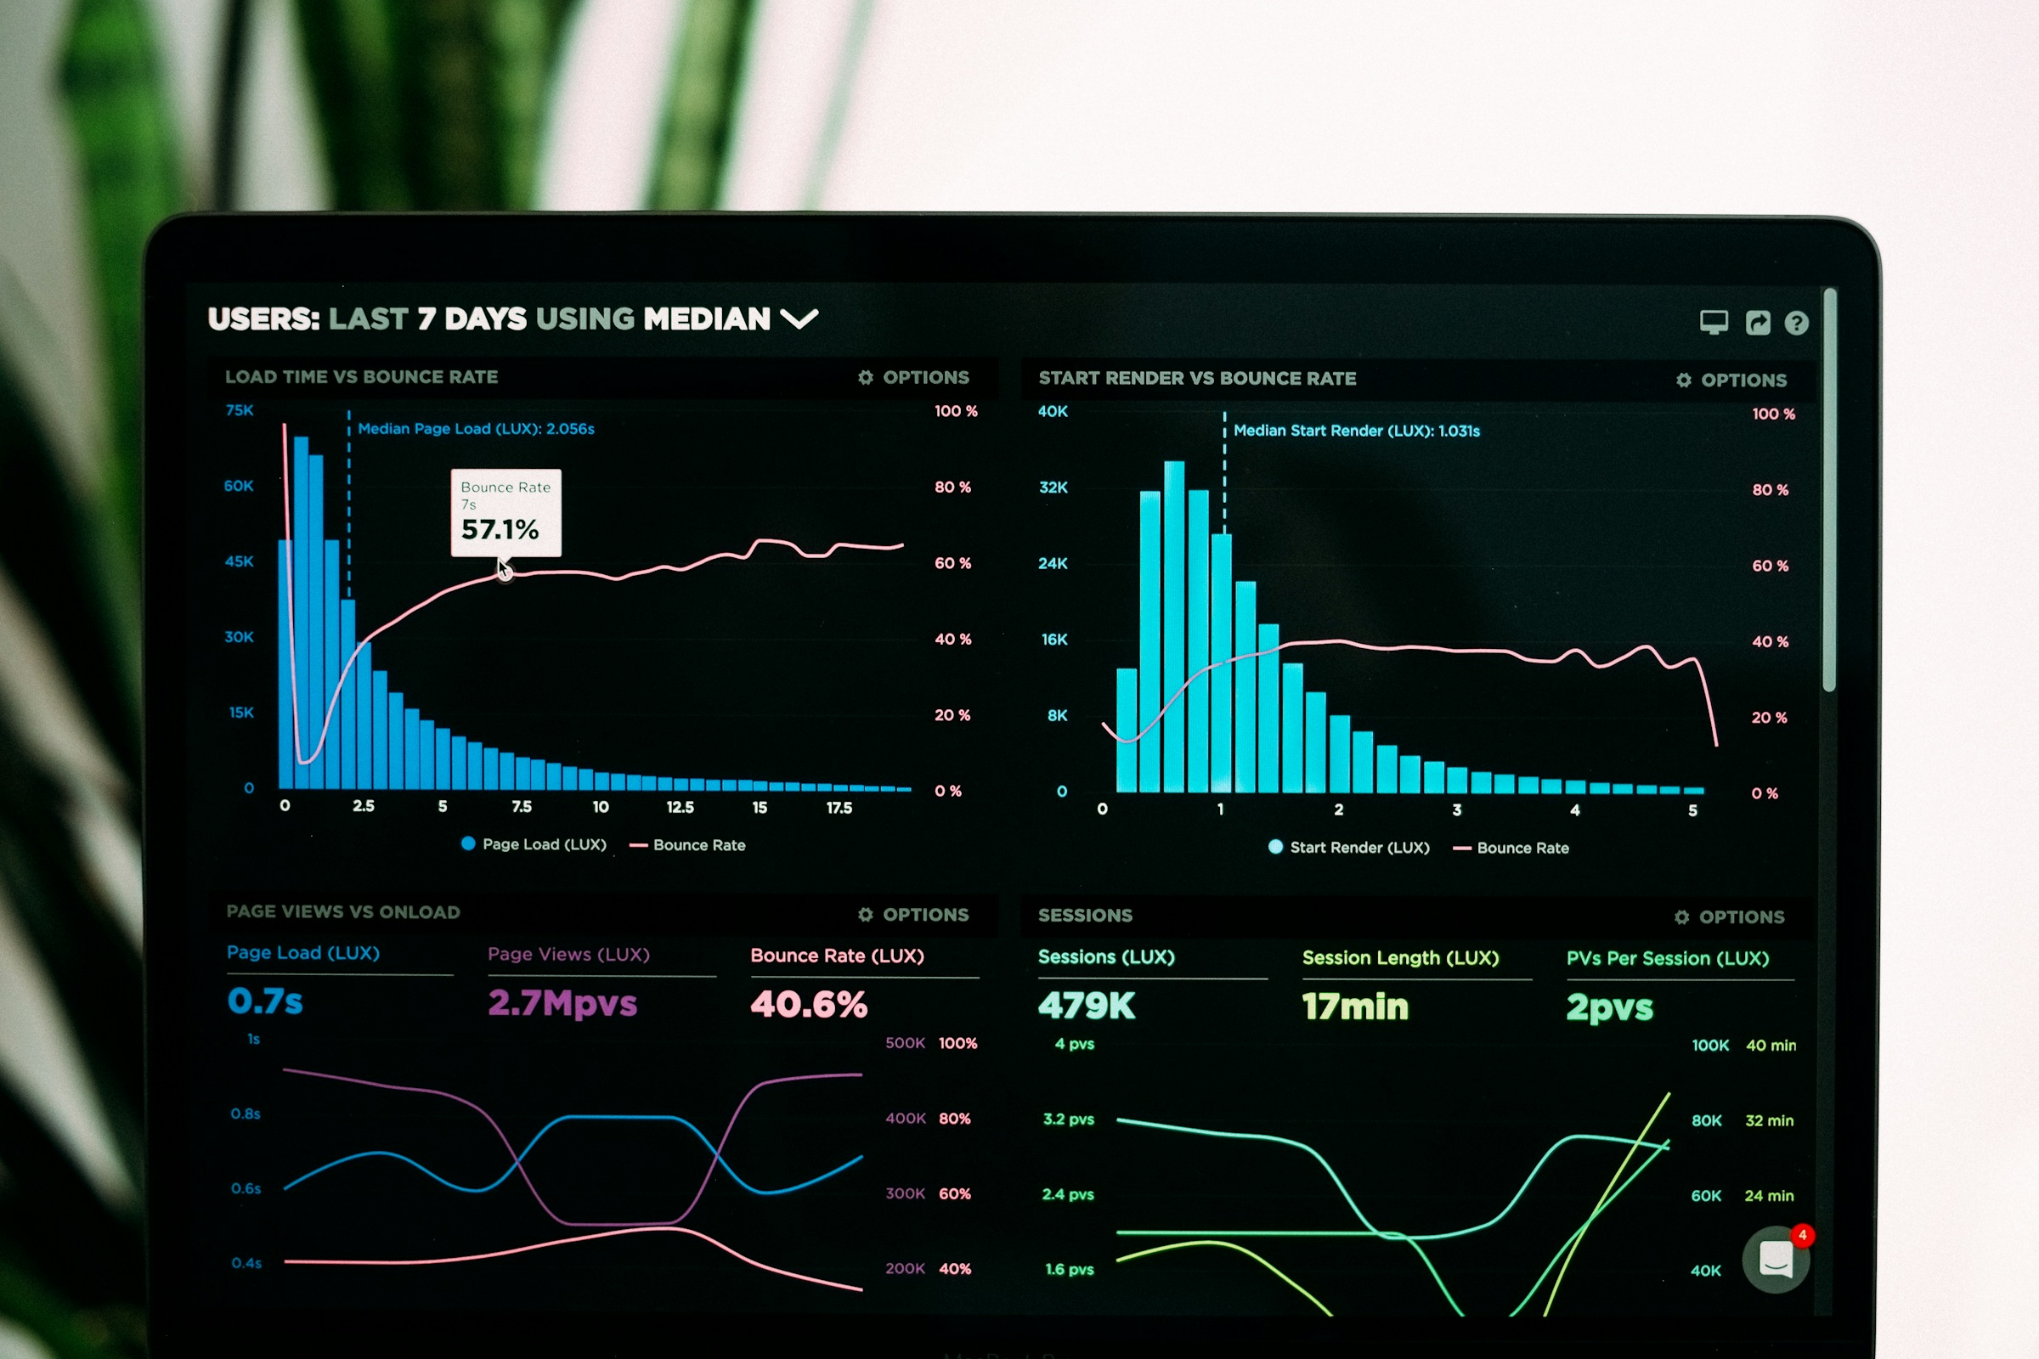
Check load time and bounce rate together before you change anything.

1. Convert before you upload
A PNG straight from a design tool can weigh several megabytes. The same picture as WebP or AVIF looks identical at a fraction of the size.
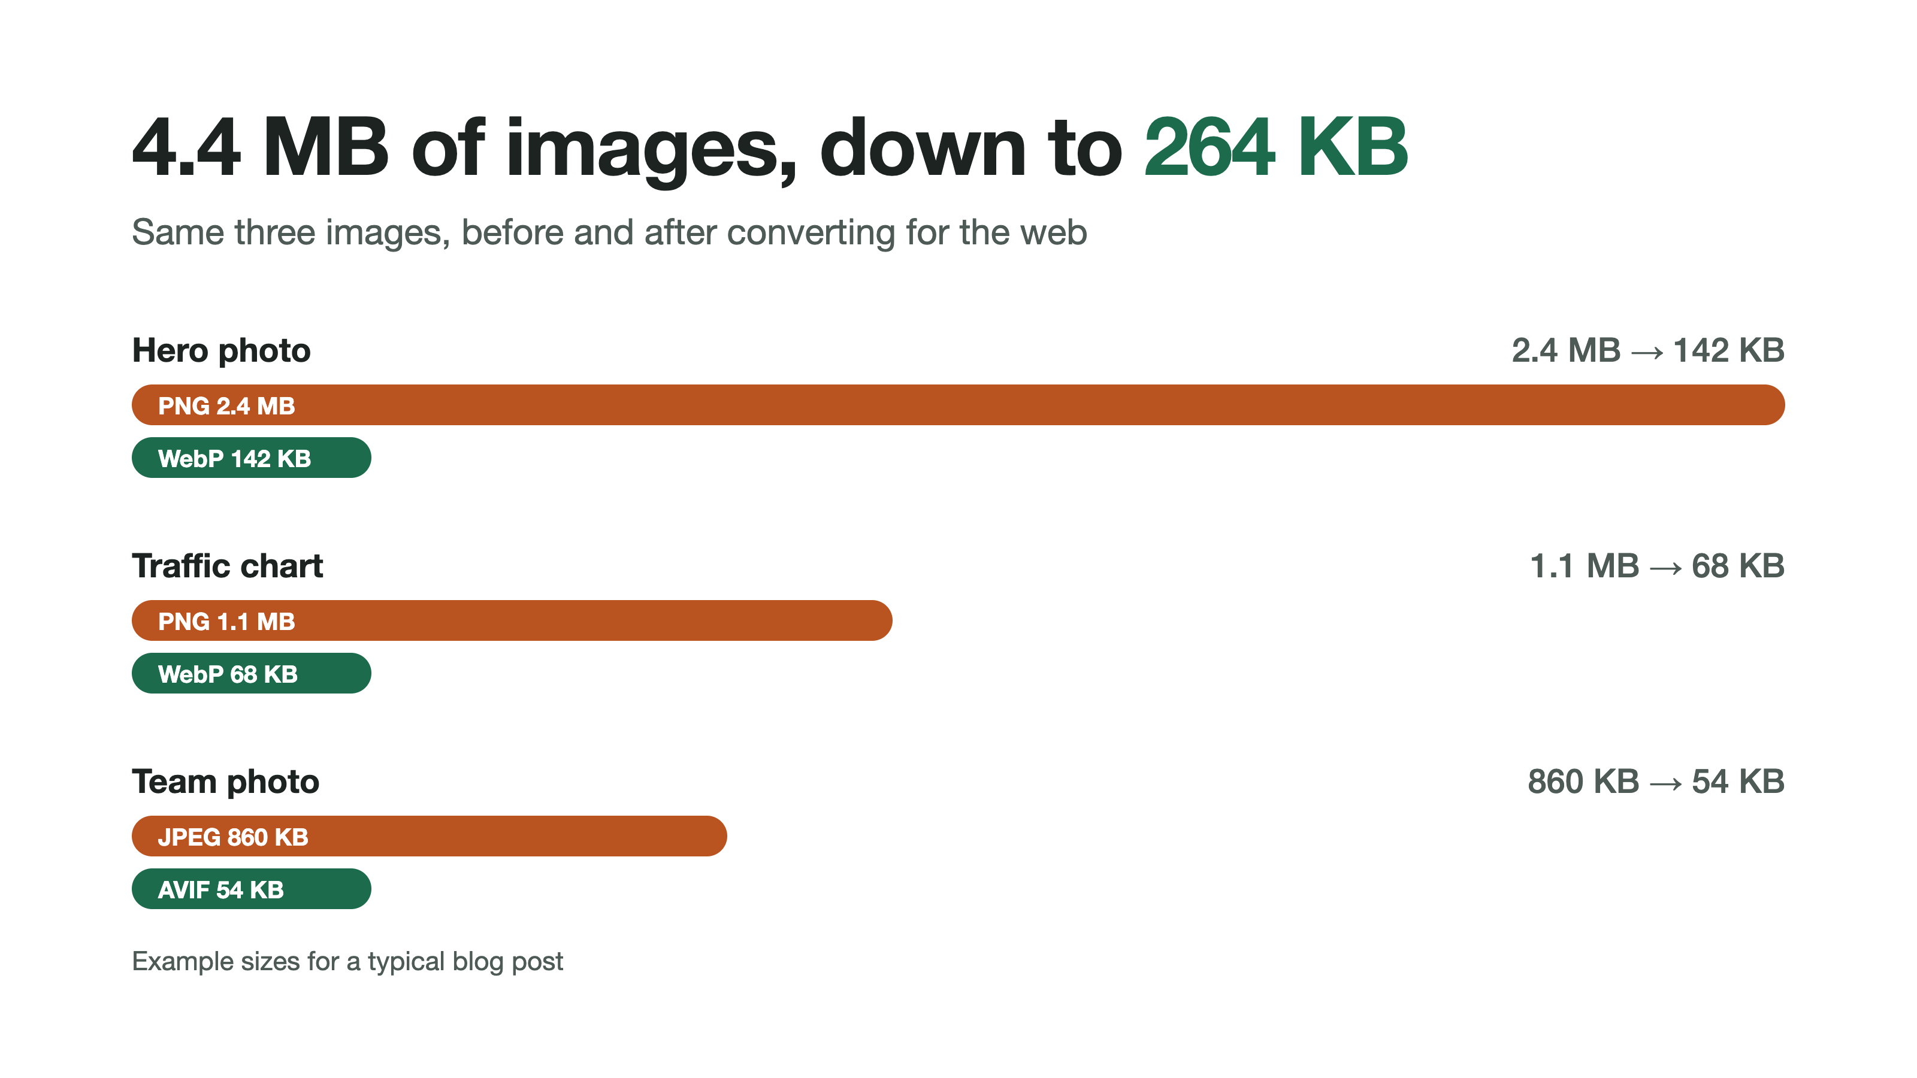

2. Name and describe every image
Quick wins for the content team  - Rename files to the topic, not the camera: team-reporting-call.webp.  - Write alt text for people who cannot see the image.  - Keep one keyword per image, and never repeat it. | 

3. Run the checklist on every post
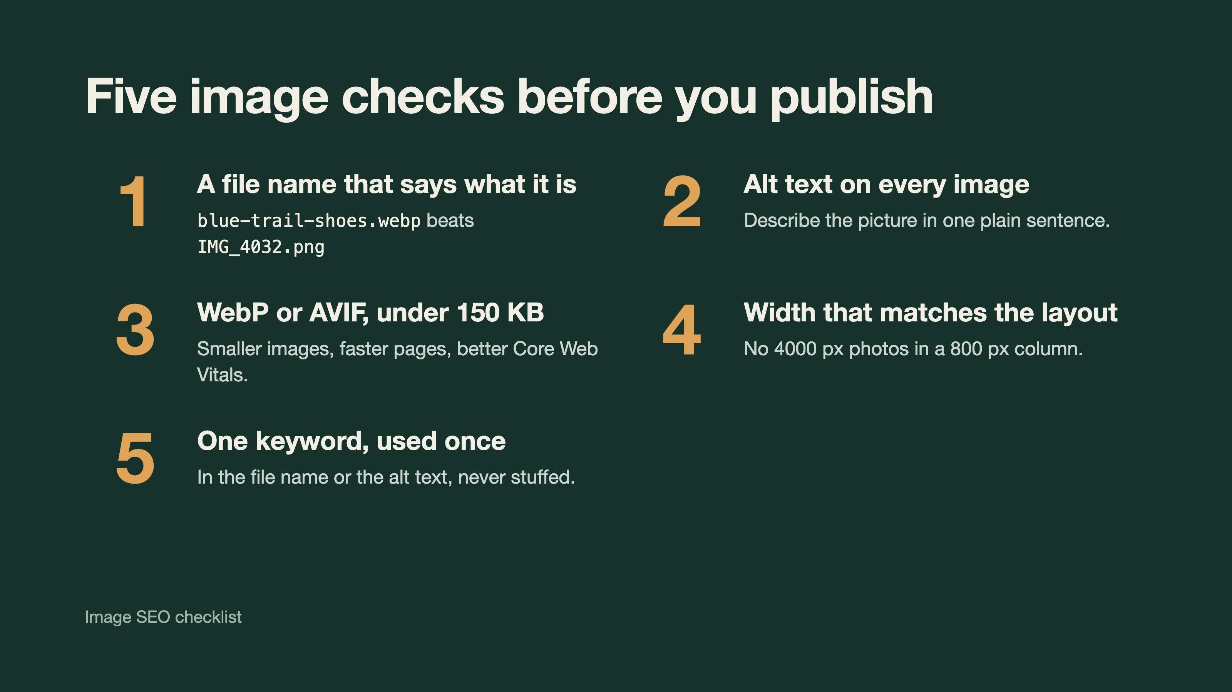
Next steps: send the converted set to the developer and publish on Thursday.

