RAICHU

Remote Access Infrastructure - Controlled Hardware Unit
Senior Project Report

Authored By:
Ben Tankersley And Thomas Tsang

CMPE 195B – SJSU

Project Advisor: Prof. Frank Lin

Advisor Signature: Date:
December 2012
ABSTRACT

The goal of technology has always been to enable people, and recent developments in this sector have further enabled people to improve their lives. A driving source of innovation is the demand to improve the quality of life. Cars enabled people to increase their travel distance, telephones enabled people to communicate over longer distances, and the Internet has removed a physical barrier between people. The overall standard of living increases as the innovation and technology continue to grow exponentially.
If the goal of technology is to enable people to do more with less effort, then one of the major proponents driving innovation is to enable technology to be more accessible to everyone. Many personal computers have the ability to be controlled from a remote so people do not have to be physically present at the terminal to be productive; the RAICHU system aims to achieve a similar goal. RAICHU, or Remote Access Infrastructure for Controlled Hardware Units, is designed to enable users to remotely control devices over the World Wide Web. This not only enables people to control devices remotely in real-time, but also allows devices to act on set schedules, or completely autonomous. The RAICHU system is not necessarily about any device or application; RAICHU is about the system. RAICHU enables a multitude of devices to be controlled remotely and simultaneously. By accessing the RAICHU system through a web browser, or a Smartphone, people can control any device on the globe that can access the RAICHU system. RAICHU will allow developers and engineers to integrate remote controlled features into their products with easy.

Table of Contents
Chapter 1 Introduction
  - Project goals and objectives
  - Problem and motivation
  - Project application and impact
  - Project results and deliverables
  - Market research

Chapter 2 Background and Related Work
2.1 Background and used technologies
  - State-of-the-art
  - Literature survey

Chapter 3 Project Requirements
3.1 Domain and business requirements
3.2 System (or component) function requirements
3.3 Non-function requirements
3.4 Hardware requirements
3.5 Software requirements

Chapter 4 System Design
4.1a Architecture design – RC Car
4.2a Interface and components – RC Car
4.3a Structure and logic design – RC Car
4.4a Hardware/Software design problems and solutions – RC Car

4.1b Architecture design – Quadcopter
4.2b Interface and components – Quadcopter
4.3b Structure and logic design – Quadcopter
4.4b Hardware/Software design problems and solutions – Quadcopter

4.1c Architecture design – RAICHU System
4.2c Interface and components – RAICHU System
4.3c Structure and logic design – RAICHU System
4.4c Hardware/Software design problems and solutions – RAICHU System

Chapter 5 Project Plan and Schedule – and this
5.1 Project team
5.2 Project tasks and schedule

Chapter 6 Tools and Standards
6.1. Tools Used

Chapter 7 Testing and Experiment
7.1 Testing and Experiment Scope
7.2 Testing and Experiment Plan

Chapter 8 Project Progress and Status
References

List of Figures
Figure 1. RC Car Control Schematic Page No. 11
Figure 2. RC Car to RAICHU Integration Page No. 12
Figure 3. Quadcopter Control Schematic Page No. 14
Figure 4. Quadcopter Car to RAICHU Integration Page No. 15
Figure 5. RAICHU Control Schematic Page No. 17
Figure 6.Testing Progression Page No. 21

List of Tables
Table 1Project Progression Timeline Page No. 20

Chapter 1: Introduction
  - Project goals and objectives
The goal of this project is create a infrastructure to allow the remote control of devices through the use of the internet. The whole of the infrastructure is made up be several parts all working together to achieve remote capabilities. The server will manage the clients and devices in the system. The devices will utilize the RAICHU API to integrate the remote capabilities into their normal functionalities. Clients will make use of mobile and desktop applications to take control of the remote devices. These three parts of the system will combine to form the entire RAICHU system and each will be discussed in depth throughout this report. The RAICHU system will increase functionality of many devices and also allow for more freedom and peace of mind. Whether it is turning off a light at home that was left on, or monitoring the security cameras at your business while on travel, RAICHU has the potential to make an impact in almost anyone;s life.

  - Problem and motivation
The internet is almost everywhere we go, whether it be via Smartphone, PC or other internet connected devices, we rarely find ourselves more than an arms length away from our next status update, bill payment or shoe purchase. Many companies have realized this change in American culture and have capitalized by allowing internet users to control many things that were traditionally not possible over the web. Major companies such as Safeway, Netflix and Bank of America, are using the internet to allow customers to complete business from the web, without the face-to-face contact that was the norm.
This project seeks to further consumers ability to have an automated and remotely connected life. Similar to Bank of American features, where a customer can transfer money, automatic pay bills each week, and check on balances from anywhere the world, RIACHU seeks to enable users this type of remote power in other aspects of life. Whether it is turning a light off from across the United States, or ensuring you locked the door when you were the last to leave the office, RAICHU's goal is to empower its users to do more with speed and ease. With everything taking to the cloud, RAICHU will help bring devices to that cloud and help developers get web enabled products to market.

  - Project application and impact
The RAICHU system has the potential to impact many aspects of academia, the industry, and society. RAICHU utilizes many components to formulate its' core functionality. The project is developed on several open source technologies, and the code will also be open sourced for community development and improvement.
Academia has the ability to benefit from studying and implementing the RAICHU system by the interfacing with devices and taking a deeper look into the semantics of the server architecture. The RAICHU system covers many topics that are addressed in academia focusing on modern computer and cloud systems . Utilizing key concepts of networking, database technologies, embedded systems, real-time operating systems, mobile and web applications and many other technologies that converge into one system students can benefit from the RAICHU system.
Industry impact will be determined by the open source community, where developers are free to enhance and maintain the project and improve/increase functionality of the system. The hopes of the creators of RAICHU are such that RAICHU will continue to grow after the scope of this project to become a very well know system for getting devices connected to the could. This is only possible with vast community support and adoption of RAICHU. It is not easy to penetrate into an industry that is dominated by well know players such as Google and NetApp, but with a strong foundation and highly usable code base, it is possible to form new standards and affect the market on a much high level than just selling one product. RAICHU will be an every growing and evolving system and, in time, has the potential to make a very large impact on the industry.
The greatest impact of RAICHU would be on society and people's everyday way of life. Since users will be able to take remote control of devices and automate their devices' functionality, many everyday activities will become trivial tasks that can be done from the comfort of their couch or 35,000 feet in the air. RAICHU has the ability to alter day-to-day life for many people and allow developers to get cloud technologies into the hands of consumers faster and easier. Within a small amount of time, RAICHU can change lives forever.

  - Project results and deliverables
There are three main deliverables for this project that make up the core of RAICHU: the server, the web applications and the API. For the purpose of demonstration, devices such as a small RC car, a media player, and power bank of wall outlets will be designed with the RAICHU API to utilize the capabilities of the RAICHU system. The final results of this project will be a working prototype of the first RAICHU system. This prototype will then become the base system that the open source community can use, contribute too and evolve into a much larger entity. The system that is designed is a proof of concept in sorts and will not necessarily address every known issue with creating such a large scale system. Yet, these short comings will be identified, and if possible, long term solutions may be laid out to solve these problems. It is also a hope that this project will spark the imagination of developers and consumers alike, and spark a movement to use RAICHU and formulate a standard in creating an “Internet of Things.”

1.5 Market research
There are several companies on the market that offer similar products to that of RAICHU; namely Smart home, ioBridge and more recently Comcast. The first two companies mentioned specialize in creating products to help automate features in your home such as power outlets and smart light switches. However, what these two companies lack is an all encompassing system for controlling and maintaining these devices. The products they offer are very neat, but do not effectively solve the problem of creating an internet of things.
The products that Comcast has to offer are the closest thing to the RAICHU system. For monthly fees, Comcast offers a service dubbed Xfinity Home. This is a home security system that also allows the user to integrate devices into their security system such as light switches, thermostats and security cameras. The Xfinity Home system is very robust, However, we believe it to have a very large shortcoming. The system only allows users to add on devices that are sold by Comcast and only covers the realm of home security. RAICHU seeks to mimic Comcast in many aspects but also improve in area's where they fall short by allowing developers to integrate any device into the system and users to access a much larger array of devices.
Companies that specialize in this field generally do not have the sales and revenue of other tech companies. It is our goal to help this market emerge as a viable leader in the consumer electronics industry and open the door for similar companies to help extend the reach of web-enabled devices to all knew heights.

Chapter 2: Background and Related Work

2.1 Background and used technologies

The RAICHU server architecture utilizes three main components: a
HTTP server, database server, and device control server. The HTTP server is an Apache based web server that is developed with open source software from the Apache Software Foundation. Initially released in 1995, Apache has been developed and maintained by an open source community and is available under a plethora of operating systems. Since April 1996, Apache has been most popular HTTP server in use; Apache is estimated to server 57.46% of all active websites and 65.24% of the top servers across all domains. (Needs Reference) By utilizing a well known system for the HTTP server, we are not only reducing the amount of background leg work in producing a new server, but also sticking to norms of the industry. This will allow for future upgrades to the system with more ease than if we went with our own server or a not as well known and maintained system.
For our database server, we chose to use MySQL, currently the world’s most used relational database management system. We chose MySQL due to its abundance of features (such as multiple database storage engines) and for its broad community support. Many high profile web applications use MySQL as their database backend, such as Wikipedia, Facebook, and Twitter. The widespread use made MySQL and easy choice for the database portion of RAICHU.(Needs Reference)
The last of the components is a custom device control server written in Python. The device controller bridges the gap between RAICHU devices and the server components, as the device controller server interacts with the database and the web server to control devices. This is the portion of the RAICHU server architecture that will contain the most intellectual design and will absorb a large majority of development time.

2.2 State-of-the-art
Most of the devices that are currently on the market are controlled by infra-red and radio frequency telemetry systems. However, there is one company that has made large strides in the area of connecting devices using the internet: ioBridge. ioBridge manufacturers Internet-enabled devices and products for vendors to avoid the complexity of piecing components together from multiple sources. IoBridge is doing a lot of ground work in producing web-enabled devices and building a consumer market in that are. However, RAICHU seeks to be a part of the state-of-the-art and contribute to this newly booming market sphere.

2.3 Literature survey

Aside from ioBridge's documentation and products, we came across a protocol written by Chris Armbruster to standardize the communication format sent over the web from embedded devices. Armbruster’s protocol focuses on “controlling and monitoring devices connected to the Internet”. This protocol is similar to the framework we are looking to create as it is pushing for a standard that can be used when control devices that reside in a remote location. There is much room in this field for an official standard to be created and implemented by IEEE as many more companies and consumers are looking for a standardized method of controlling remote devices over the web.

Chapter 3 Project Requirements

  - Domain and Business requirements

Name | DBR-01: Control in Real Time
Summary | The RAICHU system should allow for remote access in real time from any location in the world that has access to an Internet signal.
Rationale | After a user selects a device and a relay is created by the server between the device and the client, control and feedback from the device should occur in real time. This will allow users to interact with time crucial devices and know their commands will execute within an acceptable time frame.
Requirements | > The client should have a active connection to the server and active relay should be maintained to the device for the duration of use.  > Client commands are valid and the connection is dropped during relay.  > Device is in a state than can accept and react to user/RAICHU commands.  > Device reacts in real time to user commands.

Name | DBR-02: Simultaneous Control of Multiple Devices
Summary | The RAICHU system should allow users to interact with multiple RAICHU enable devices simultaneously.
Rationale | Users of the RAICHU system should have control of all of their devices extended to them at the same time. For instance, a user that has three light switches and a door lock for one location, should be be able to control all devices at the same time.
Requirements | > Robust sever that allows client to access multiple devices and control them at the same time.  > Device is in a state than can accept and react to user/RAICHU commands.

Name | DBR-03: Functional for Commercial and Consumer Use
Summary | The RAICHU system should allow be functional and usable for commercial and consumer use.
Rationale | The RAICHU system should present value to both commercial and consumer users. A company should be able to use the system for managing lighting, locking the doors and surveillance, while consumer users should be able to schedule their heater, and close their garage door. The RAICHU system should have the capacity to benefit everyone and make on impact to everyones lives.
Requirements | >Web and mobile applications should allow for in depth customization to fit individual use cases.

3.2 Functional System Requirements

Name | FR-01: Remote Connection from Anywhere
Summary | The RAICHU system should allow users to connect to their devices from anywhere in the world.
Rationale | Whether a user is in their living room or in another country, if they have internet access, they should be able to access and control their devices from either a mobile application on their smartphone or a web application on their personal computer.
Requirements | >Web and mobile applications that are user friendly and easily accessible from anywhere.

Name | FR-02: Plug-N-Play Functionality
Summary | The RAICHU system should allow for users to add devices to system semi-autonomously.
Rationale | The setup and connection to a remote RAICHU device should be nearly as simple as plugging it in. This will allow users of the system to spend less time configuring and more time using.
Requirements | >Advanced server and device API that allow for quick connection capabilities and little user interaction.

Name | FR-03: Mobile and Web Applications
Summary | The RAICHU system should allow for devices to be accessed through both mobile and web applications.
Rationale | Users should never have to be more than an arms length away from monitoring and controlling their devices. This could mean sitting at their computer at work or on the bus with their smartphone. RAICHU keeps users connected.
Requirements | >Design of both web and mobile applications to support RAICHU client connections to devices.

Name | FR-04: Device Ownership
Summary | The RAICHU system should allow for multiple users to have “ownership” of same device and conversely allow multiple devices to be controlled by the same user.
Rationale | There are many instances where a device should be able to receive commands from multiple users, such as a husband and wife controlling their garage door. This option should be settable via the mobile and web applications and kept persistent in the data base. Devices should also be able to be marked as a “lockable” device. Meaning that when one users has the device, no other authorized users can interact with the device until the lock is released.
Requirements | >Ability to save device settings and retrieve those settings to correctly provision ownership.  >Continuously updated knowledge of device status.

Name | FR-05: Device Feedback
Summary | The RAICHU system should allow for devices that are feedback enabled to deliver important information to users through email and push notifications, even if the device is not currently being used at that time.
Rationale | There are many instances where a device should be able to receive commands from multiple users, such as a husband and wife controlling their garage door. This option should be settable via the mobile and web applications and kept persistent in the data base. Devices should also be able to be marked as a “lockable” device. Meaning that when one users has the device, no other authorized users can interact with the device until the lock is released.
Requirements | >Server to allow for email and push notifications if device requires it.  >Continuously updated knowledge of device status.

Name | FR-06: Wireless Connectivity
Summary | The RAICHU system should allow for devices that are Wi-Fi enabled.
Rationale | The initial prototypes for the RAICHU system all run on Wi-Fi. Although a wired system would still work. It is outside of the scope of this project. With a Wi-Fi enable device, converting it into a wired device should prove to be trivial with the correct hardware.
Requirements | >Wi-Fi connectivity of RAICHU enable devices.

3.3 Non-Function System Requirements

Name | NFR-01: User Friendly Applications
Summary | The RAICHU system should have web and mobile apps that are fast, powerful and user friendly.
Rationale | It is far to common for a person to get new device and only use it the first time they open and then place it on a shelf to gather dust. Also, over 95% of mobile applications are only opened one time after being installed on a device. RAICHU needs to present users with and easy to use interface that is fast and fun to keep users coming back, and utilizing their RAICHU devices to the full os their potential.
Requirements | >Web and mobile apps that are fast, powerful and user friendly.

Name | NFR-02: Safe and Secure Control
Summary | The RAICHU system must be secure to keep unwanted users and threats from attacking the system.
Rationale | When a powerful system such as RAICHU can be controlling things such as security cameras, locks and even safes, it is all too important to have a strong security system that can prevent unwanted users from gaining control of devices.
Requirements | >Strong security interface

  - Hardware Requirements

- RAICHU Server
  - need stuff from thomas
- Remote Controlled Car
  - 1 - Lpc2148 Arm micro controller and breakout board.
  - 2 - dc motors
  - 2 - electronic speed control circuits
  - 3 - axis gyro
  - 3 - super sonic distance sensors
  - 1 - WiFly Wi-Fi module
- Power Bank
  - 2 - 240 VAC relays
  - 2 - commercial power outlets
  - 1 - WiFly Wi-Fi module
  - 1 – mBed micro controller

Note: The hardware requirements mentioned are based on devices that can utilize the RAICHU system. They are being created to demonstrate the systems ability to control devices that are based on different platforms and different end use cases.

  - Software requirements

- Server Development Tools
  - Python
  - Apache
  - MSSQL/MySWL database software
  - Sublime Text 2
- Device / API Development Tools
  - Eclipse
  - Visual Studio 2010
  - Hercules Terminal
  - HyperLoad boot loader
  - mBed tools
  - FreeRTOS
- Mobile and Web Applications
  - Eclipse
  - Clang
  - Sublime Text 2
  - Adobe FlashBuilder
  - Adobe ColdFusion

Chapter 4 System Design
4.1a RC Car Architecture design

The RC component is designed to show RAICHU users the real time capabilities this system has to offer by allowing control of the device from a remote location in real time. The architecture of the system is rather straight forward for a RC car system. The RC car incorporates a hardware system that consists of two DC motors that use PWM circuits for speed control along with a main micro controller that operates the car and its multiple functions. The car communicates to the RAICHU system through the use of a Wi-Fi module that allows it to connect to a wireless internet signal. The software that is utilized in the car is a real time operating system that allows for effective resource management of the car and allows for the car to have multiple states of operation consisting of: On/Off, Park, Drive and Roam. The RTOS also allows for an effective mesh of the hardware devices with a software interface to allow for simple control over the RAICHU system. The Wi-Fi module that will be used in all devices through this project is the Roving Networks Wi-Fly. This is a feature packed device that is capable of connecting to a wireless network and establishing a connection to a host. The RAICHU API allows for easy configuration of the Wi-Fly device.

4.2a Interface and Component Design

The car will consist of a micro controller at the core that controls two motors via PWM motor controllers. One motor will be for forward/reverse and the other will be for steering. Distance sensors are incorporated to keep the car from running into obstacles. The car will get its commands on which directions to go via an integrated Wi-Fi module that will connect the car to the rest of the RAICHU system. A detailed schematic can be found in the appendix.

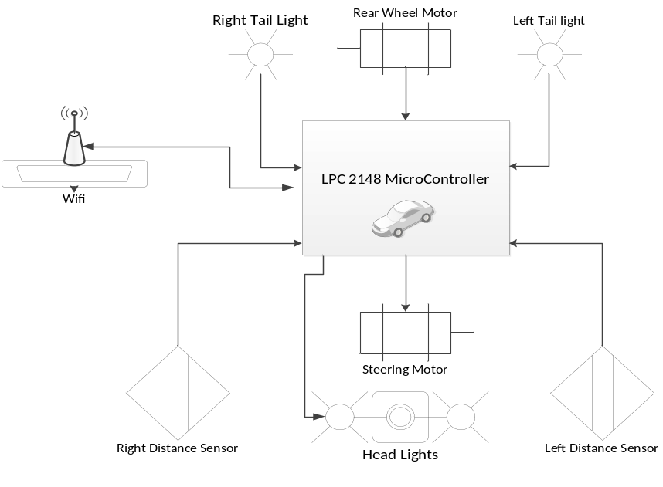
Figure 1 - RC Car Control Schematic

4.3a Structure and logic design

The logic that powers the cars micro controller is a C language based real time operating system name FreeRTOS. This is an open source OS for embedded devices that allows for process scheduling and interprocess communication that will allow the RC car to be easily integrated into the RAICHU system. The OS will run two main processes: one that is controlling the forward/reverse and left/right speeds and another that is constantly updating the motor values by receiving commands from the RAICHU server via a client. OS handles will be used for inter process communication. To implement the functionality needed by the Wi-Fi board the RAICHU API will used.

4.4a Hardware/software design problems and solutions

The main hardware and software problem that is found in the RC car portion of the RAICHU system is the fact the car is going to have to be controlled in real time from a remote location. With any internet application there is always the possibility of lag and loss of transmission packets due to a slow or weak connection. There is no full proof way to ensure that the system will never run into a conflict like this but there are multiple things that can be done in both hardware and software that can help prevent a collision in the event of slow or lost transmission.
The first thing is selecting hardware that will allow for fast transmission of the commands to the car and also hardware the boasts strong signal characteristics so the chances of losing a signal due to interference or range are reduced.
The other ways to prevent collisions and data loss is by adding software checks. One check will be on the car side to ensure that is receiving commands from the router when it thinks it should. If it detects a loss in commands it will put itself in park preventing it from becoming a ghost car. The other is on the RAICHU side to make sure it is constantly in communication with the device and that the device is powered and ready to run. Software checks can put the car in park when it senses a loss in signal strength/ throughput which will overall prevent the car from incurring unwanted collisions.

4.1c RAICHU Server Architecture Design

The overall encompassing design of the system includes: devices, server, and web/mobile client operators. Two example devices are covered in the above section. This section will detail the server component of the system. RAICHU server is broken down into three components: web server, database, and device controller. The components will be explained in order of execution. Upon boot up, the RAICHU server will listen for incoming connections through the device controller. Upon accepting a connection, the device controller then relays the connection information to the database server and logs the metadata of the device, IP address, connection time, and device type. We run a MySQL server as our database, where we log device information, connection logging, and devices we support. For example, if the RAICHU server supports MP3 functionality, we could need to create a table in the database to store song information, playlists, etc. With all this information in the database, the web server utilizes this information and relays this to the user through a web client (web browser) or a mobile client (smart phone/tablet). From there, the client can login to the server and select from a pool of devices. Upon selection, client can send commands to the device through PHP sockets. In summary, the RAICHU has a simple architecture where the functionality of components are isolated to reduce complexity so that errors would be easy to detect. Each component has a limited or no exposure to other components in the system. For example, devices can only send data to the device controller, and receive data from the web server. The device controller only accepts connections from devices, and relays processed information to the database.

4.2c Interface and component design
The RAICHU server consists of the web server, database, and device controller. The device controller consists of a listener, data processor, and database connection handler. Upon connection, the listener accepts the connection, and hands off the incoming data to the data processor. The data processor will verify for data validity and correctness before passing it to the database connection handler. The database connection handler then connects to the database and writes the parsed data, returning any errors if necessary. The device controller becomes more complicated and requires multithreading when supporting more devices, such as a robot vehicle, or a stationary device such as an MP3 player.

4.3c Structure and logic design

The structure of RAICHU relies on its core components, which are the web server, database, and the device controller. This current iteration has a simplified architecture to ease up on design and implementation.
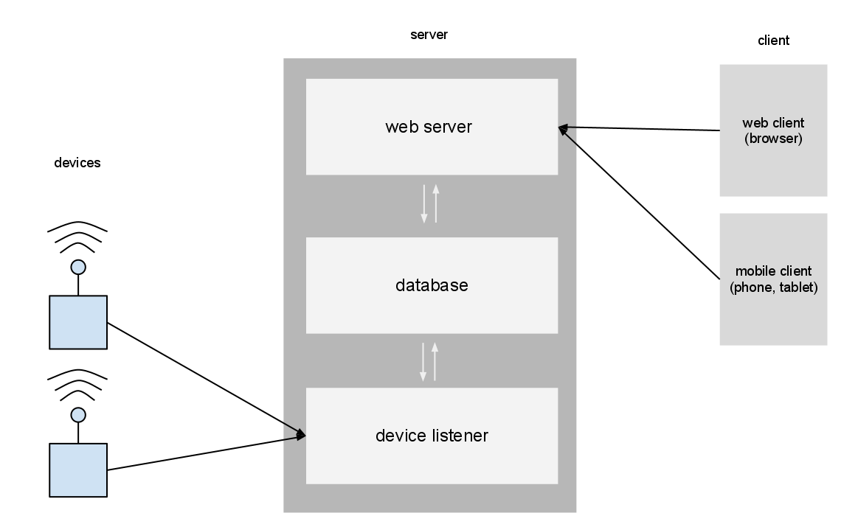
Figure 2 - RAICHU Control Schematic
4.4c Hardware/software design problems and solutions
One of the greatest issues to the RAICHU system is multithreading and scaling. To account for handling multiple requests, the device controller has to be multithreaded. Multithreading a server introduces a lot of issues especially in a system like this since there are multiple instances of reading and writing to the database. To solve this problem, we would have to carefully design the threads to take proper precautions before executing by utilizing semaphores and mutexes. Scaling is another problem that the system could potentially run into. Although scale is not an issue now, it’s important to design with scale in mind. A key question to ask is, how well does the server perform under a high stress load? To account for this, we need to simulate stress on the server, by simulating multiple connections, multiple actions, etc.

Chapter 5 Project Plan and Schedule

5.1 Project Team

The RAICHU team consists of Thomas Tsang and Ben Tankersley. As computer engineering students both team members are assuming multiple roles in both the hardware and software development of the RAICHU system.
Thomas is mainly focusing on the framework that will be the backbone of the RAICHU communication system. The software and networking aspects of managing multiple devices over the internet is being handled by Thomas. This allows Ben the ability to focus on other aspects of the RAICHU system such as device integration, mobile and web applications and more of the front in aspects that RAICHU users will encounter. Although each team member has clear roles, as a part of the RAICHU team each member contributes to the others work when needed. This not only allows for more complete and concise team understanding of the system but also adds an added level of functionality to the system as each team member has valuable ideas, methods and skill sets that will make the RAICHU system come to life.

5.2 Project Tasks and Schedule

The project task and schedule are based on a two semester timeline. These two periods can be broken down into two basic project periods: Research and Design, and Implementation and Testing. The Research and design phase will span from January 2012- roughly mid-July 2012. The Implementation phase will pick up where the Research phases ends in mid-July and span to the end of the fall semester in December 2012.
- Research and Design
  - Initial Project research
  - Prototyping Project Components
    - RC Car
    - Home/Business devices
    - RAICHU Server framework
    - Web and Mobile Apps
    - RAICHU API
  - Initial prototype Testing
- Testing and Implementation
  - Test Prototypes
  - Document initial design flaws
  - Rework prototypes
  - Begin Implementation of reworked designs
  - Launch for initial testing
  - Final testing
  - Launch Completed RAICHU System
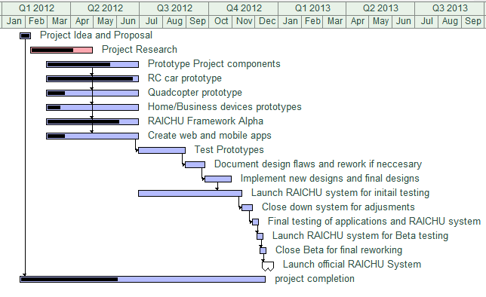
Table 1- Project Progress Timeline

Chapter 6 Tools and Standards
6.1. Tools Used
There are numerous different tools used in the creation of both the hardware devices that will be interfaced into the RAICHU system and also the software aspects.
- Hardware:
  - Various micro controllers and supporting peripheral hardware devices: These micro controllers will be the basis for each hardware device that is incorporated into the RAICHU system. The micro controllers will act as the “brain” in each device.

NOTE: The list of micro controllers used will be expanded upon once all the devices are built and each device can have an accurate representation
in the report
.
  - WiFly Wi-Fi module: This module will be incorporated into each device as it is going to serve as the medium between the RAICHU server and the devices themselves.
  - Mobile Devices: Various mobile devices and platforms will be used to host the applications that can connect to the RAICHU servers and allow for mobile control of devices.
  - Server: A server will be needed to host the RAICHU web application and also house the RAISHU database.

- Software:
    - Apache HTTP server
    - MySQL
    - Python

Chapter 7 Testing and Experiment

7.1 Testing and Experiment Scope
There are separate testing procedures for each aspect of the RAICHU system. The RAICHU framework: which consists of the server, middle-tier and frontend are all software, while the RC car, Quad-copter and home/business devices are hardware components that not only have to work individually but also have the ability to be integrated into the RAICHU system. Each device must be tested separately for functionality before the system is combined as a whole and tested as large unit.

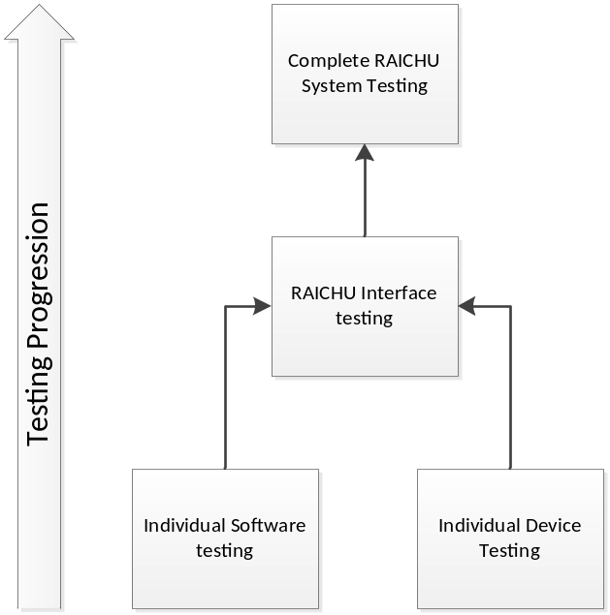
Figure 3 - Testing Progression

7.2 Testing and Experiment Plan

Each device will be individually tested for functionality outside the realm of RAICHU. For instance, the RC car will be tested for the abilities to drive, turn etc. These capabilities will all be tested over Wi-Fi as that is the way the devices will be controlled from the RAICHU server.
The Quadcopter will be difficult to test because of the inherent dangers of a flying object with spinning blades. There will be extensive testing on the auto-leveling systems and the flight controls before the device even takes flight for the first time. The Quadcopter will be first be tested for flight using a system such as Bluetooth or simple USB communication before the Wi-Fi system is tested. It is speculated that over Wi-Fi at any nominal distances there will be trouble controlling the flight of the device due to lag and interference in transmission.
Once the devices are completed and tested for functionality they will be integrated into the RAICHU system and have their controls tested over the internet. An important thing to monitor during this testing phase is the latency in each device and how responsive the controls are.
The RAICHU software will all be tested independently of the devices up until the point of integration. The software modules will all be instantiated to perform their basic functions. After the testing of basic functionality is completed a more complex user interface will be added to enhance the visual appeal of the software.

Chapter 8 Project Progress and Status

As of the beginning of May 2012, the project has been moving along smoothly. The RAICHU system is beginning to shape its self and small unit testing shows good signs. The system is capable of controlling simple mp3 player functions such as play, stop, next song, etc. over Wi-Fi. Although these functions are controlled over Wi-Fi the commands are not truly being sent over the internet rather in a local network. The integration of the server and the system becoming live on the internet will be implemented soon. The RC car is complete and ready to be retro fitted with Wi-Fi module. It has been tested to date using Bluetooth. The Quadcopter is still in the research stage but a nearly complete bill of materials is on hand. The team will begin acquiring the necessary parts as soon as possible. As for the other devices, the team is still debating what devices to incorporate. We feel that this is the least urgent part of our project as if the system is built to spec then it will be rather easy to retro fit any device with RAICHU capabilities.
References

Armbruster, Chris. Device Control Protocol Specification. http://dcp.chrisarmbruster.com/Introduction.html

NetCraft (2012). March 2012 Web Server Survey. http://news.netcraft.com/archives/2012/03/05/march-2012-web-server-survey.html

http://www.smarthome.com/aboutus.html

http://www.comcast.com/home-security

mbed

eclipse

apache

