RAICHU

Remote Access Infrastructure - Controlled Hardware Unit
Senior Project Report

Authored By:
Ben Tankersley And Thomas Tsang

CMPE 195B – SJSU

Project Advisor: Prof. Frank Lin

Advisor Signature: Date:

April 2012
ABSTRACT

The goal of technology has always been to enable people, and recent developments in this sector have further enabled people to improve their lives. A driving source of innovation is the demand to improve the quality of life. Cars enabled people to increase their travel distance, telephones enabled people to communicate over longer distances, and the Internet has somewhat removed a physical barrier between people. The overall standard of living increases as the innovation from technology continues to grow exponentially.
If the goal of technology is the enable people to do more, then one of the major proponents driving innovation is to enable technology to be more accessible to people. Many personal computers have the ability to be controlled from a remote so people do not have to be physically present at the terminal to be productive; the RAICHU system is aims to achieve this goal. RAICHU, or Remote Access Infrastructure-Controlled Hardware Unit, is designed to enable users to remote control devices remotely over the World Wide Web. This not only enables people control devices remotely in real-time, but also allows devices to act on set schedules, or automated. The RAICHU system is not necessarily about any device or application; RAICHU is about the system. RAICHU enables a multitude of devices to be controlled remotely and simultaneously. By accessing the RAICHU system through the web browser, or a Smartphone, people can control any device on the globe that can access the RAICHU system.

Table of Contents
Chapter 1 Introduction
  - Project goals and objectives
  - Problem and motivation
  - Project application and impact
  - Project results and deliverables
  - Market research

Chapter 2 Background and Related Work
2.1 Background and used technologies
  - State-of-the-art
  - Literature survey

Chapter 3 Project Requirements
3.1 Domain and business requirements
3.2 System (or component) function requirements
3.3 Non-function requirements
3.4 Context and interface requirements
3.5 Technology and resource requirements

Chapter 4 System Design
4.1a Architecture design – RC Car
4.2a Interface and components – RC Car
4.3a Structure and logic design – RC Car
4.4a Hardware/Software design problems and solutions – RC Car

4.1b Architecture design – Quadcopter
4.2b Interface and components – Quadcopter
4.3b Structure and logic design – Quadcopter
4.4b Hardware/Software design problems and solutions – Quadcopter

4.1c Architecture design – RAICHU System
4.2c Interface and components – RAICHU System
4.3c Structure and logic design – RAICHU System
4.4c Hardware/Software design problems and solutions – RAICHU System

Chapter 5 Project Plan and Schedule – and this
5.1 Project team
5.2 Project tasks and schedule

Chapter 6 Tools and Standards
6.1. Tools Used

Chapter 7 Testing and Experiment
7.1 Testing and Experiment Scope
7.2 Testing and Experiment Plan

Chapter 8 Project Progress and Status
References

List of Figures
Figure 1. RC Car Control Schematic Page No. 11
Figure 2. RC Car to RAICHU Integration Page No. 12
Figure 3. Quadcopter Control Schematic Page No. 14
Figure 4. Quadcopter Car to RAICHU Integration Page No. 15
Figure 5. RAICHU Control Schematic Page No. 17
Figure 6.Testing Progression Page No. 21

List of Tables
Table 1Project Progression Timeline Page No. 20

Chapter 1: Introduction
  - Project goals and objectives
The goal of this project is to build a project that demonstrate the ability to control devices remotely over the Internet. The system will allow users to login and select devices to control through their web browser and through their mobile devices (smart phones, tablets) to further widen usability.

  - Problem and motivation
Although technology is growing at an exponential rate, accessibility has always been an issue. For example, the control range of an RC car is the limit of the radio frequency. If upgraded to equip Bluetooth technologies, the control range expands to a range of 30 to 100 meters. Regardless of what technology used, the user is limited to the physical limits of the transmission frequency (with the exception of satellite transmissions, however satellites are not available to consumers). The RAICHU system enables devices to be controlled anywhere with Internet access, with the only limitation being the range of the wireless access point.
Although RAICHU is just the system, it can adapt to the requirements of the user. For example, RAICHU can be extended to home automation: RAICHU devices can be scheduled to water plants, start the playing music on the stereo, and turn off the lights. RAICHU can also be extended to control robots in real time, and theoretically any device that be interfaced with RAICHU.
If the goal of technology is to enable people, then the RAICHU system is enabling people to do more.

  - Project application and impact
The RAICHU system impacts many aspects of academia, the industry, and to society. RAICHU includes many components that comprise its core functionality. The project is developed on several open source technologies, and the code will also be open sourced for community development and improvement. Academia could benefit by implementing the system and interfacing devices to the system; the RAICHU system utilizes networking, database, embedded systems, real-time operating systems, and many other technologies to converge into the core components. Impact upon the industry is determined by the open source community, where developers are free to enhance and maintain the project and improve and increase functionality. The greatest impact would be on society since users can control devices and automate functionality. Users would be able to control a pool of devices through a web and mobile device interface and automate many actions.

  - Project results and deliverables
The main deliverable part of this project is the core component of RAICHU, which is to accept and talk to connecting devices. For the purpose of demonstration, we will have devices such as a Quadcopter, a small car, and an media player to be controlled. Additional deliverables include the web interface and the mobile application that would connect to the server and control devices. The deliverable server components are the device listener and the database schema. With ample time, we can build and support more devices to interface on the system.

1.5 Market research

There are several companies on the market that offer similar products to that of RAICHU; namely Smart home and ioBridge. These to companies specialize in home automation and the ability to control devices from Smartphones, the web, etc. It is our goal to produce devices and a system integrates seamlessly, offers simple customer control with full customization and support, and near plug-n-play capability. Our other goal is to surpass these other companies by offering the RAICHU system at a more reasonable price.
Companies that specialize in this field generally do not have the sales and revenue of other tech companies. It is our goal to help this market emerge as a viable leader in the tech industry and open the door to more similar companies to help extend the realm of home/business control to another level.

Chapter 2: Background and Related Work

2.1 Background and used technologies
The RAICHU system has three main components: Apache HTTP server, MySQL database server, and device control server. Apache HTTP server is a web server software written by the Apache Software Foundation. Initially released in 1995, Apache has been developed and maintained by an open source community and is available under a plethora of operating systems. Since April 1996, Apache has been most popular HTTP server in use; Apache is estimated to server 57.46% of all active websites and 65.24% of the top servers across all domains. For our database server, we chose to use MySQL, currently the world’s most used relational database management system. We chose MySQL due to its abundance of features (such as multiple database storage engines) and for its broad community support. Many high profile web applications use MySQL as their database backend, such as Wikipedia, Facebook, and Twitter. Last of the components is a custom device control server written in Python. The device controller bridges the gap between the RAICHU devices and the server components, as the device controller server interacts with the database and the web server to control devices.

2.2 State-of-the-art
Currently on the market are mostly devices controlled by infra-red and radio frequency. However, this is one company that has made some strives in this area in connecting devices over the internet: ioBridge. ioBridge manufacturers Internet-enabled devices and products for vendors to avoid the complexity of piecing components together from multiple sources.

2.3 Literature survey

Aside from ioBridge, we came across a protocol written by Chris Armbruster to standardize the communication format sent over. Armbruster’s protocol focuses on “controlling and monitoring devices connected to the Internet”. This protocol is similar to the framework we are looking to create as it is a standard that can be used when control devices that reside in a remote location. There is much room in this field for an official standard to be created and implemented by IEEE as many more companies and consumers are looking for a standardized method of controlling devices from remote locations.

Chapter 3 Project Requirements
3.1 Domain and business requirements
The domain and business requirements for the RAICHU system are as follows:

- The RAICHU system will allow for remote access of multiple devices in real time from any location in the world that has access to an Internet signal.
- The RAICHU system may be utilized by both consumer households and businesses alike to control a various array of devices such as lights, doors, surveillance, etc.
- The system will allow for users to take Wi-Fi enabled devices and control them from anywhere using both RAICHU mobile and web applications.
- There is no preliminary cost model for the RAICHU system as the system is in the early development phase.
- The system may incorporate the use of devices that be connect to “dumb” devices to allow for those devices to be integrated into the RAICHU system

3.2 System functional requirements
The functional requirements of the RAICHU system are as follows:

- System will allow for user to add devices to system semi-autonomously.
- Devices can be accessed through both mobile application and web application.
- multiple users can have “ownership” of same device.
- Users with access to a device can “take” device for use and control while removing the device from others users available device list
- Device controls can be configured per device and stored in the RAICHU server.
- Device control per device can be configured specifically per user regardless of multiple users.
- Devices that are feedback enabled can deliver important feedback to users through email, notifications at system log in and push notifications.
- Devices will utilize Wi-Fi as their main source of communication.

3.3 Non-function requirements
The non-functional requirements of the RAICHU system are as follows:

  - The system has to be fast and responsive to allow for control of devices in real time.
  - The web and mobile apps need to be fast, powerful and user friendly.
  - Minimal set up should be required to initially control a device through the RAICHU system.
  - System must be secure to keep unwanted users and threats from attacking the system.
  - Support of a wide array of devices and the capability to make a non-RAICHU device, RAICHU capable.
  - RAICHU system should be easily obtained and accessed.

3.4 Hardware Requirements
The hardware requirements for the RAICHU system are as follows:
- Remote Controlled Car
  - Lpc2148 Arm microcontroller and breakout board.
  - pulse width modulation motor controllers.(2)
  - 5v power regulating circuit.
  - RC car Chassis and motors - stock from Toys’R Us
  - WiFly Wi-Fi module
- Remote Controlled Quad-Copter
  - Lpc2148 Arm microcontroller and breakout board.
  - 4 dc motors
  - 4 electronic speed control circuits
  - 3- axis gyro
  - 3-axis accelerometer
  - WiFly Wi-Fi module
- Home/business Devices
  - There will be an array of household/business devices that will work with the RAICHU system.
  - door locks
  - lighting controls
  - Thermostat controls
  - Surveillance

Note: Hardware requirements will be expanded upon once devices are finalized and an accurate record of all hardware used can be obtained.

3.5 Software requirements
The software requirements for the RAICHU System are as follows:

- Eclipse/Visual Studio 2010/ Adobe Flex IDEs.
- FreeRTOS- embedded RTOS software.
- MSSQL/MySQL- database software.
- Apache

Chapter 4 System Design
4.1a RC Car Architecture design

The RC component is designed to show RAICHU users the real time capabilities system has to offer by allowing for control of the device from a remote location in real time. The architecture of the system is rather straight forward for a RC car system. The RC car incorporates a hardware system that consists of two DC motors that use PWM circuits to control along with a main microcontroller that operates the cars functions. The car communicates to the RAICHU system through the use of a Wi-Fi module that allows it to connect to a wireless internet signal. The software that is utilized in the car is a real time operating system that allows for effective resource management of the car and allows for the car to have multiple states of operation consisting of: On/Off, Park, Drive and Roam. The RTOS also allows for an effective mesh of the hardware devices with a software interface to allow for simple control over the RAICHU system.

4.2a Interface and Component Design
The car will consist of a micro controller at the core that controls two motors via PWM motor controllers. One motor will be for forward/reverse and the other will be for steering. The car will get its commands on which directions to go via an integrated Wi-Fi module that will connect the car to the rest of the RAICHU system.
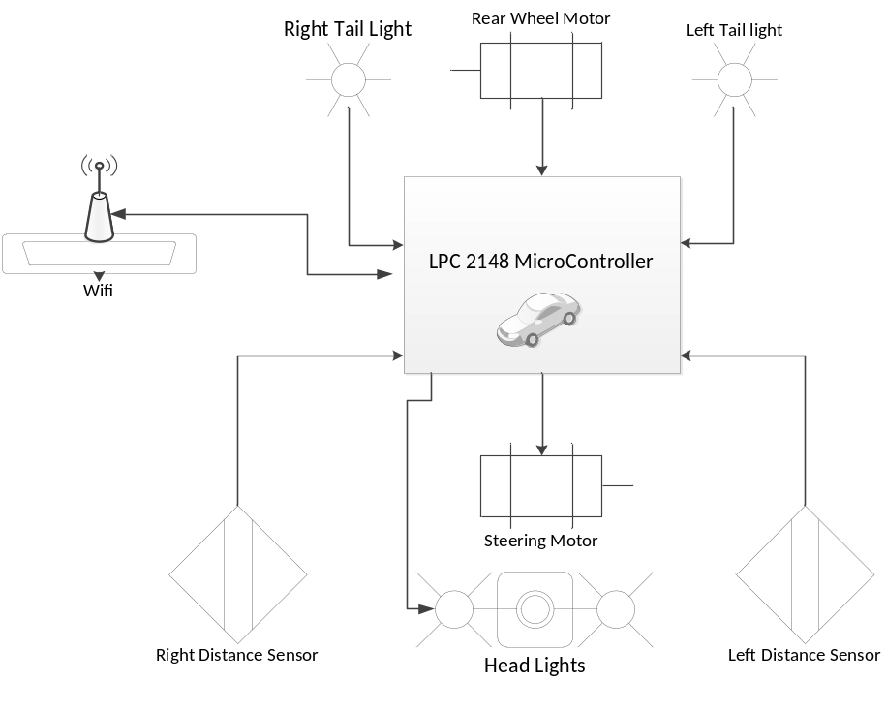
Figure 1 - RC Car Control Schematic

4.3a Structure and logic design
The hardware seen in the diagram above will be controlled via the RAICHU system. The system will send a command to the car allowing for it to engage in one of several activities. The commands sent from the RAICHU system as structured in a way that will allow for a rapid communication between the car and the system to give the most accurate controlling possible over the remote system. Since the commands are going to be issued over a Wi-Fi system their size must be small enough to allow for rapid streaming of commands so the car can be effectively controlled.

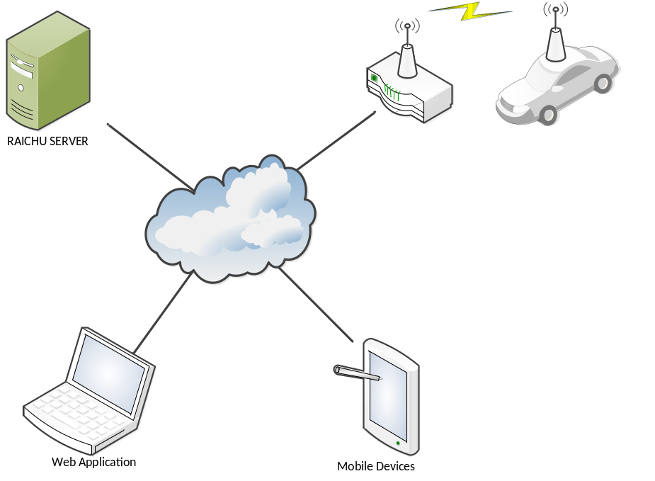
Figure 2 - RC Car to RAICHU Integration

4.4a Hardware/software design problems and solutions

The main hardware and software problem that is found in the RC car portion of the RAICHU system is the fact the car is going to have to be controlled in real time from a remote location. With any internet application there is always the possibility of lag and loss of transmission packets due to a slow or weak connection. There is no full proof way to ensure that the system will never run into a conflict like this but there are multiple things that can be done in both hardware and software that can help prevent a collision in the event of slow or lost transmission.
The first thing is selecting hardware that will allow for fast transmission of the commands to the car and also hardware the boasts strong signal characteristics so the chances of losing a signal due to interference or range are reduced.
The other ways to prevent collisions and data loss is by adding software checks. One check will be on the car side to ensure that is receiving commands from the router when it thinks it should. If it detects a loss in commands it will put itself in park preventing it from becoming a ghost car. The other is on the RAICHU side to make sure it is constantly in communication with the device and that the device is powered and ready to run. Software checks can put the car in park when it senses a loss in signal strength/ throughput which will overall prevent the car from incurring unwanted collisions.

4.1b Quadcopter Architecture design
The quad-copter will fit into the RAICHU system as another device that can be controlled in real time. This application will show the RAICHU systems diversity and also speed in controlling a device that has a very small margin of error. The device its self will consist of frame, motors, speed controllers, micro-controller and Wi-Fi module. The micro-controller will also be running an RTOS to allow for efficient processor management and ease of integration into the overall system.

4.2b Interface and component design
The quad-copter will consist of a X-shaped frame that houses a micro-controller at the intersection and motor at the end of each arm. Each motor will be connected to the micro-controller through an electronic speed controller that will allow for effective speed management of each motor. The micro-controller will also make use of a 3-axis gyro and a 3-axis accelerometer to get accurate readings on roll, pitch and yaw. Again, the system will incorporate a Wi-Fi module to communicate to the rest of the RAICHU system.
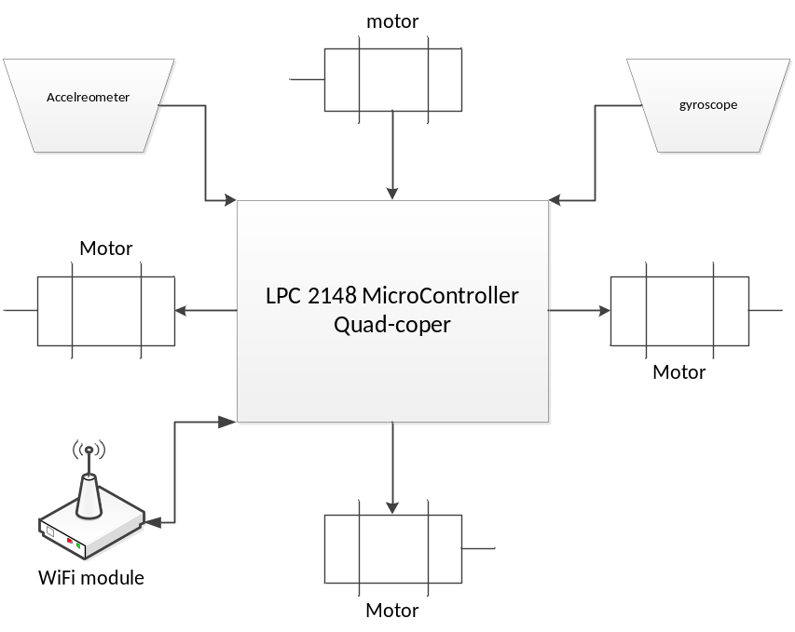
Figure 3 – Quadcopter Control Schematic
Note: a more in-depth software and hardware schematic and flow chart will be added when the system is completed since research and testing are still underway on the system

4.3b Structure and logic design
The hardware seen in the diagram above will be controlled via the RAICHU system. The system will send a command to the Quadcopter allowing it to fly via remote controlling over the RAICHU framework. The logic inside the micro-controller will be the same RTOS system that is found in the RC car. Although it is running a similar RTOS it is going to have many changes to accommodate for flight. A PID controller will implemented into the RTOS to allow the copter to essentially self level its self in flight and keep a more stable flight trajectory whether hovering or in movement. This aspect will become very important as the RAICHU system will have some sort of inherent delays and lag that will make flight a hard obstacle to concur.

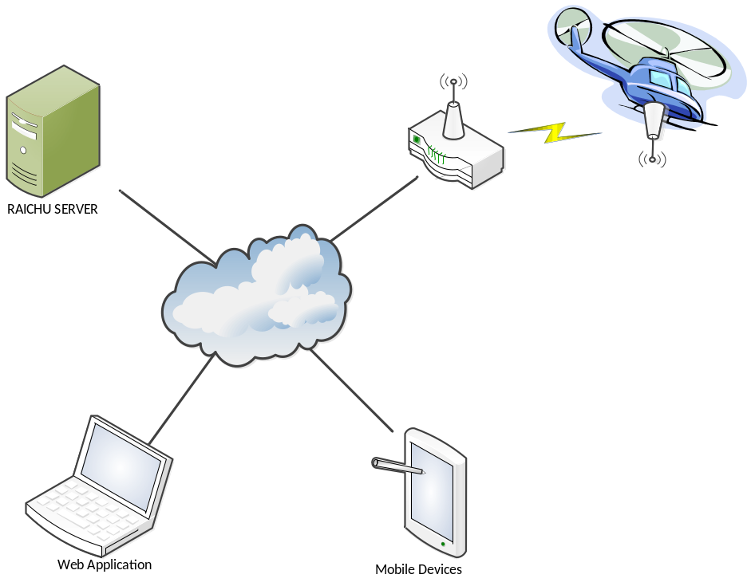
Figure 4 - Quadcopter to RAICHU Integration

4.4b Hardware/software design problems and solutions
The main hardware and software problem that is found in the copter portion of the RAICHU system is the fact the Quadcopter is going to have to be controlled in real time from a remote location. With any internet application there is always the possibility of lag and loss of transmission packets due to a slow or weak connection. There is no full proof way to ensure that the system will never run into a conflict like this but there are multiple things that can be done in both hardware and software that can help prevent a collision in the event of slow or lost transmission.
The first thing is selecting hardware that will allow for fast transmission of the commands to the car and also hardware the boasts strong signal characteristics so the chances of losing a signal due to interference or range are reduced.
The other ways to prevent collisions and data loss is by adding software checks. One check will be on the copter side to ensure that is receiving commands from the router when it thinks it should. If it detects a loss in commands it will put itself in park preventing it from becoming a ghost car. The copter will also be strongly tested and the PID controller will be finely tuned to allow the copter to hover with minimal to no communication from the server. The other is on the RAICHU side to make sure it is constantly in communication with the device and that the device is powered and ready to run. Software checks can put the copter into a static hover or even land the copter to ensure that collisions do not occur.

4.1c RAICHU System Architecture Design
The overall encompassing design of the system includes: devices, server, and web/mobile client operators. Two example devices are covered in the above section. This section will detail the server component of the system. RAICHU server is broken down into three components: web server, database, and device controller. The components will be explained in order of execution. Upon boot up, the RAICHU server will listen for incoming connections through the device controller. Upon accepting a connection, the device controller then relays the connection information to the database server and logs the metadata of the device, IP address, connection time, and device type. We run a MySQL server as our database, where we log device information, connection logging, and devices we support. For example, if the RAICHU server supports MP3 functionality, we could need to create a table in the database to store song information, playlists, etc. With all this information in the database, the web server utilizes this information and relays this to the user through a web client (web browser) or a mobile client (smart phone/tablet). From there, the client can login to the server and select from a pool of devices. Upon selection, client can send commands to the device through PHP sockets. In summary, the RAICHU has a simple architecture where the functionality of components are isolated to reduce complexity so that errors would be easy to detect. Each component has a limited or no exposure to other components in the system. For example, devices can only send data to the device controller, and receive data from the web server. The device controller only accepts connections from devices, and relays processed information to the database.

4.2c Interface and component design
The RAICHU server consists of the web server, database, and device controller. The device controller consists of a listener, data processor, and database connection handler. Upon connection, the listener accepts the connection, and hands off the incoming data to the data processor. The data processor will verify for data validity and correctness before passing it to the database connection handler. The database connection handler then connects to the database and writes the parsed data, returning any errors if necessary. The device controller becomes more complicated and requires multithreading when supporting more devices, such as a robot vehicle, or a stationary device such as an MP3 player.

4.3c Structure and logic design

The structure of RAICHU relies on its core components, which are the web server, database, and the device controller. This current iteration has a simplified architecture to ease up on design and implementation.
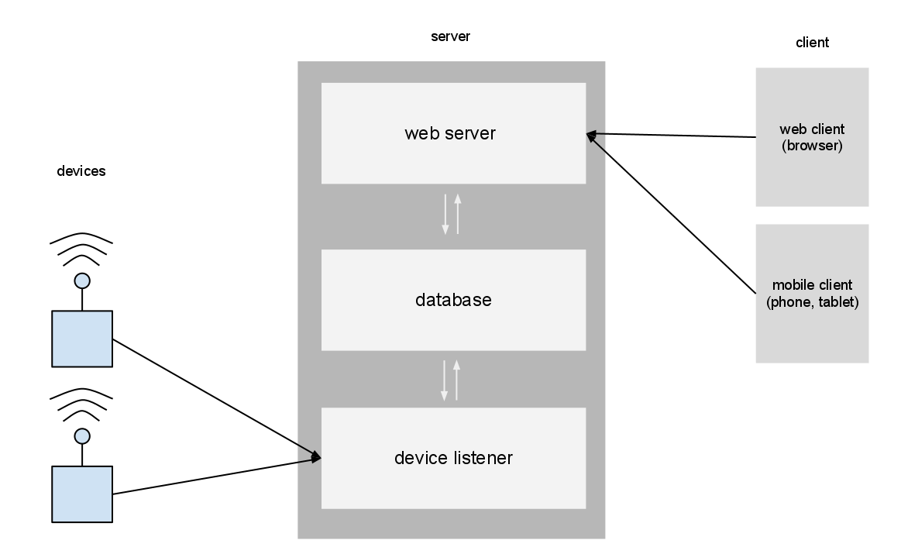
Figure 5 - RAICHU Control Schematic
4.4c Hardware/software design problems and solutions
One of the greatest issues to the RAICHU system is multithreading and scaling. To account for handling multiple requests, the device controller has to be multithreaded. Multithreading a server introduces a lot of issues especially in a system like this since there are multiple instances of reading and writing to the database. To solve this problem, we would have to carefully design the threads to take proper precautions before executing by utilizing semaphores and mutexes. Scaling is another problem that the system could potentially run into. Although scale is not an issue now, it’s important to design with scale in mind. A key question to ask is, how well does the server perform under a high stress load? To account for this, we need to simulate stress on the server, by simulating multiple connections, multiple actions, etc.

Chapter 5 Project Plan and Schedule
5.1 Project Team

The RAICHU team consists of Thomas Tsang and Ben Tankersley. As computer engineering students both team members are assuming multiple roles in both the hardware and software development of the RAICHU system.
Thomas is mainly focusing on the framework that will be the backbone of the RAICHU communication system. The software and networking aspects of managing multiple devices over the internet is being handled by Thomas. This allows Ben the ability to focus on other aspects of the RAICHU system such as device integration, mobile and web applications and more of the front in aspects that RAICHU users will encounter. Although each team member has clear roles, as a part of the RAICHU team each member contributes to the others work when needed. This not only allows for more complete and concise team understanding of the system but also adds an added level of functionality to the system as each team member has valuable ideas, methods and skill sets that will make the RAICHU system come to life.

5.2 Project Tasks and Schedule

The project task and schedule are based on a two semester timeline. These two periods can be broken down into two basic project periods: Research and Design, and Implementation and Testing. The Research and design phase will span from January 2012- roughly mid-July 2012. The Implementation phase will pick up where the Research phases ends in mid-July and span to the end of the fall semester in December 2012.
- Research and Design
  - Initial Project research
  - Prototyping Project Components
    - RC Car
    - Quadcopter
    - Home/Business devices
    - RAICHU Framework
    - Web and Mobile Apps
  - Initial prototype Testing
- Testing and Implementation
  - Test Prototypes
  - Document initial design flaws
  - Rework prototypes
  - Begin Implementation of reworked designs
  - Launch for initial testing
  - Final testing
  - Launch Completed RAICHU System
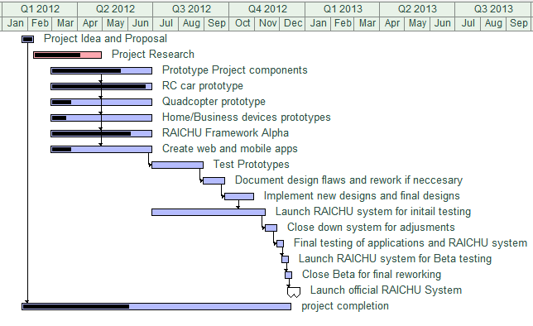
Table 1- Project Progress Timeline

Chapter 6 Tools and Standards
6.1. Tools Used
There are numerous different tools used in the creation of both the hardware devices that will be interfaced into the RAICHU system and also the software aspects.
- Hardware:
  - Various microcontrollers and supporting peripheral hardware devices: These microcontrollers will be the basis for each hardware device that is incorporated into the RAICHU system. The microcontrollers will act as the “brain” in each device.

NOTE: The list of microcontrollers used will be expanded upon once all the devices are built and each device can have an accurate representation
in the report
.
  - WiFly Wi-Fi module: This module will be incorporated into each device as it is going to serve as the medium between the RAICHU server and the devices themselves.
  - Mobile Devices: Various mobile devices and platforms will be used to host the applications that can connect to the RAICHU servers and allow for mobile control of devices.
  - Server: A server will be needed to host the RAICHU web application and also house the RAISHU database.

- Software:
    - Apache HTTP server
    - MySQL
    - Python

Chapter 7 Testing and Experiment

7.1 Testing and Experiment Scope
There are separate testing procedures for each aspect of the RAICHU system. The RAICHU framework: which consists of the server, middle-tier and frontend are all software, while the RC car, Quad-copter and home/business devices are hardware components that not only have to work individually but also have the ability to be integrated into the RAICHU system. Each device must be tested separately for functionality before the system is combined as a whole and tested as large unit.

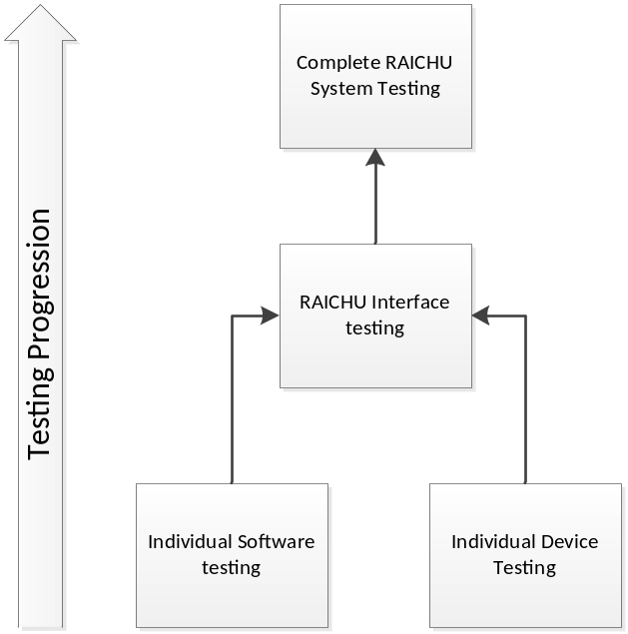
Figure 6 - Testing Progression

7.2 Testing and Experiment Plan

Each device will be individually tested for functionality outside the realm of RAICHU. For instance, the RC car will be tested for the abilities to drive, turn etc. These capabilities will all be tested over Wi-Fi as that is the way the devices will be controlled from the RAICHU server.
The Quadcopter will be difficult to test because of the inherent dangers of a flying object with spinning blades. There will be extensive testing on the auto-leveling systems and the flight controls before the device even takes flight for the first time. The Quadcopter will be first be tested for flight using a system such as Bluetooth or simple USB communication before the Wi-Fi system is tested. It is speculated that over Wi-Fi at any nominal distances there will be trouble controlling the flight of the device due to lag and interference in transmission.
Once the devices are completed and tested for functionality they will be integrated into the RAICHU system and have their controls tested over the internet. An important thing to monitor during this testing phase is the latency in each device and how responsive the controls are.
The RAICHU software will all be tested independently of the devices up until the point of integration. The software modules will all be instantiated to perform their basic functions. After the testing of basic functionality is completed a more complex user interface will be added to enhance the visual appeal of the software.

Chapter 8 Project Progress and Status

As of the beginning of May 2012, the project has been moving along smoothly. The RAICHU system is beginning to shape its self and small unit testing shows good signs. The system is capable of controlling simple mp3 player functions such as play, stop, next song, etc. over Wi-Fi. Although these functions are controlled over Wi-Fi the commands are not truly being sent over the internet rather in a local network. The integration of the server and the system becoming live on the internet will be implemented soon. The RC car is complete and ready to be retro fitted with Wi-Fi module. It has been tested to date using Bluetooth. The Quadcopter is still in the research stage but a nearly complete bill of materials is on hand. The team will begin acquiring the necessary parts as soon as possible. As for the other devices, the team is still debating what devices to incorporate. We feel that this is the least urgent part of our project as if the system is built to spec then it will be rather easy to retro fit any device with RAICHU capabilities.
References

Armbruster, Chris. Device Control Protocol Specification. http://dcp.chrisarmbruster.com/Introduction.html

NetCraft (2012). March 2012 Web Server Survey. http://news.netcraft.com/archives/2012/03/05/march-2012-web-server-survey.html

