1. WMS (Web Map Service) is a standard protocol created by the Open Geospatial Consortium in 1999 for serving georeferenced map images over the internet.

2.

a) <https://demo.geo-solutions.it:443/geoserver/wms?request=getCapabilities> . I see metadata about operations, services, and data (capabilities) that are offered by the WMS server.

b) <https://demo.geo-solutions.it:443/geoserver/wms?bbox=-130,24,-66,50&styles=population&Format=image/png&request=GetMap&layers=topp:states&width=550&height=250&srs=EPSG:4326>

c) png file

d) [https://demo.geo-solutions.it:443/geoserver/wms?bbox=-130,24,-66,50&styles=population&Format=image/jpeg&request=GetMap&layers=topp:states&width=550&height=250&srs=EPSG:4326](https://demo.geo-solutions.it:443/geoserver/wms?bbox=-130,24,-66,50&styles=population&Format=image/jpeg&request=GetMap&layers=topp:states&width=550&height=250&srs=EPSG:4326e)

e) <https://demo.geo-solutions.it/geoserver/wms?bbox=-130,24,-66,50&styles=population&Format=image/jpeg&request=GetMap&layers=topp:states&width=800&height=600&srs=EPSG:4326>

f) <https://demo.geo-solutions.it/geoserver/wms?bbox=-130,24,-66,50&styles=population&Format=image/jpeg&request=GetMap&layers=topp:states&width=550&height=250&srs=EPSG:4326&version=1.3.0>. The image is blank.

g) <https://demo.geo-solutions.it:443/geoserver/wms?bbox=-130,24,-66,50&styles=population&format=jpeg&info_format=text/plain&request=GetFeatureInfo&layers=topp:states&query_layers=topp:states&width=550&height=250&x=170&y=160>

We get spatial and attribute data for the feature (Arizona in this case) at a given location on a map.

h) [https://demo.geo-solutions.it/geoserver/wms?bbox=-130,24,-66,50&styles=population&format=jpeg&info_format=text/plain&request=GetFeatureInfo&layers=topp:states&query_layers=topp:states&width=550&height=250&x=170&y=160](https://demo.geo-solutions.it/geoserver/wms?bbox=-130,24,-66,50&styles=population&format=jpeg&info_format=text/plain&request=GetFeatureInfo&layers=topp:states&query_layers=topp:states&width=550&height=250&x=170&y=160.) . The response is the same because the default feature count I 1 and the previous feature was a single one.

i) It is the default format for the information requested for the feature.

j) <https://demo.geo-solutions.it:443/geoserver/wms?bbox=-130,24,-66,50&styles=population&format=jpeg&subtype=gml/3.1.1&request=GetFeatureInfo&layers=topp:states&query_layers=topp:states&width=550&height=250&x=170&y=160>. I see the coordinates of each point of the features on the map.

k) The features that are in the gml package file, which are the USA_population, Arizona polygon e.t.c.

l) The points are shown as a map in qgis of Arizona.

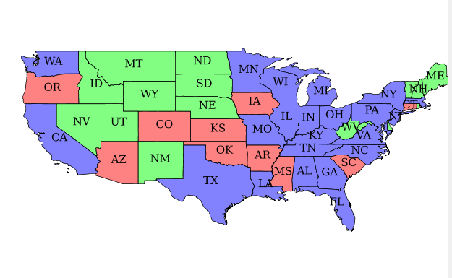

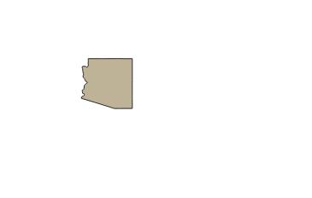

3. Queryable WMS

4. gml