**Analysis, Insights and Visualizations**

1. Insight 1 – Who is the dog with the highest favorite count of tweet?

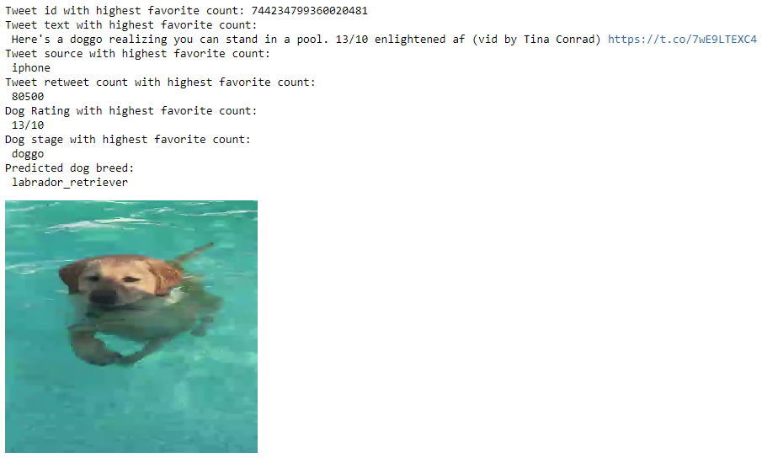

1. 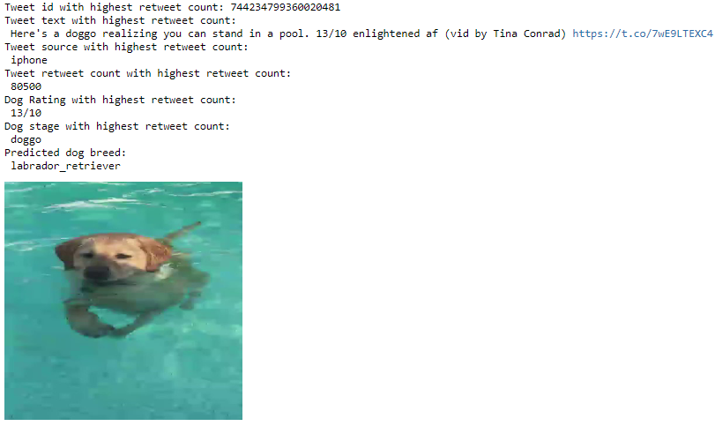Insight 2 – Who is the dog with the highest favorite count of tweet?

The swimming dog Doggo predicted to be a Labrador retriever was both the most favorite and most retweeted tweet.

1. What is the distribution of tweet platform sources? How many tweets came from an iphone or from other sources?

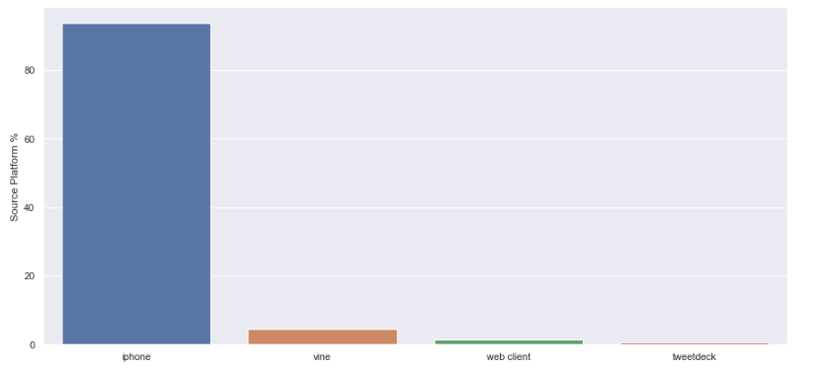

From the % distribution of the tweet sources, it was found that more than 90% of all the tweets from the @WeRateDogs account came from an iphone platform whereas a meagre amount came from other sources like Vine or the twitter web client.

1. Which one was the tweet that showed a dog with the highest rating (rating numerator)?

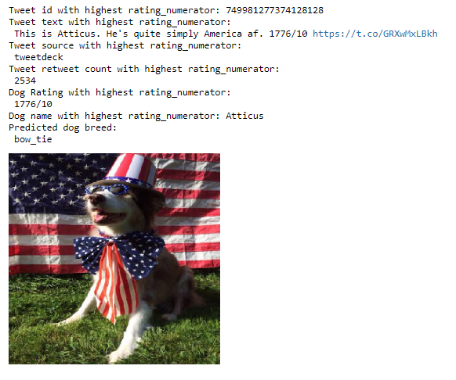

The dog Atticus was the highest rated dog with a superb 1776 rating numerator possibly due to his immense cuteness. It is interesting that the image prediction algorithm predicted the dog to be a bow tie with the highest confidence, possibly owing to the reason that the face of the dog was mostly occluded by his large bow tie.

1. Which one was the tweet that showed a dog with the lowest rating (rating numerator)?

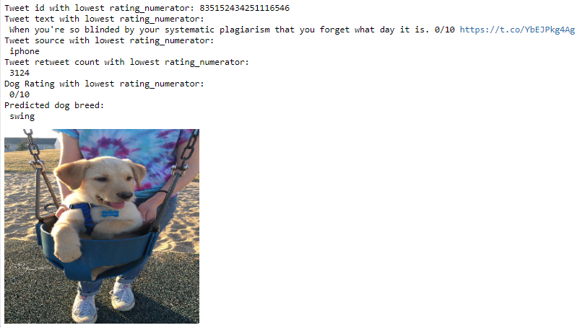

The tweet with the lowest dog rating was that of a puppy swinging on a swing. Again, the algorithm wrongly predicted the picture was that of a swing with highest confidence, possibly due to the large shape of the swing in comparison to the smaller body of the puppy.

1. Are the most retweeted tweets the most favorite tweets?

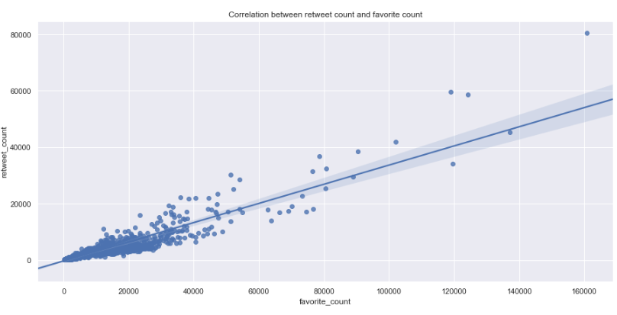For this a correlation/regression plot was done between retweet counts and favorite counts of all the available tweets.

From the regression plot above, it is evident that there is a strong positive correlation between the retweet and favorite counts of a tweet. Hence, it can be concluded that the most favorite tweets are infact those that are also retweeted the most.