Abstract
- Introduction
According to the World Bank, organic waste accounts for approximately 44-46% by mass of total municipal waste production (Kaza et al., 2018). Managing this fraction remains a key challenge for local decision-makers, especially with regulations evolving toward circular economy. A range of treatment technologies exists for organic waste, notably anaerobic digestion and composting. These processes have different configurations, depending on their scale (for example home versus industrial composting), as well as on the type of by-products generated (particularly in the case of anaerobic digestion, biogas can be converted into electricity, heat, or upgraded to biomethane). (reference)
LCA of organic waste management
From an environmental perspective, several Life Cycle Assessment (LCA) studies have been conducted to compare different organic management systems and to attempt to identify the most suitable one. These comparisons typically involve an existing scenario (baseline) and one or more alternatives (reference), or explore multiple hypothetical scenarios (reference). In most cases, a scenario is defined by a single treatment technology, while environmental performance of hybrid systems is rarely assessed. In practice, conventional comparative LCA approaches remain limited in their ability to allows to test a limited strategy, which restricts the identification of near-optimal system configurations across a wide range of possibilities.
Par ailleurs, la gestion des déchets municipaux souvent relève d’une responsabilité territoriale (UNEP, 2024). Cependant, en ACV, il n’existe pas de méthode consensuelle pour définir le périmètre d’un territoire. (référence) Dans plusieurs études ACV, le périmètre choisi est un pays entier (exemple …). (Al-Rumaihi et al., 2020; Bahramian et al., 2025; Liu et al., 2022)
D’un point de vue environnemental, plusieurs ACV comparatifs ont été menés pour trouver le meilleur système de gestion de biodéchets dans un contexte particulier. La comparaison porte sur un scénario actuel et d’autres alternatives (référence) ou bien plusieurs nouveaux scénarios fictifs (référence). Souvent, un scénario est défini par une seule technologie. Par exemple, (Lu et al., 2020) ont comparé l’enfouissement des biodéchets, avec 4 scénarios basés sur différentes technologies de compostage. Il est plus rare que la performance d’une combinaison de technologies soit évaluée. (Ardolino et al., 2018) ont par exemple comparé 4 scénarios de méthanisation couplée à 2 technologies de valorisation du biogas : par CHP pour produire de l’électricité et de la chaleur, et une purification pour obtenir du biométhane. Ces 4 scénarios se différencient par la part de biogaz envoyé dans chaque traitement de biogaz. LIMITE : cette incap
D’autre part, alors que la gestion des déchets relève d’une responsabilité territoriale, dans plusieurs études, les ACV sont menées pour un pays entier … LIMITE : justification de la substitution : marché, impact du transport, niveau de décentralisation : dans quelle mesure une technologie est adaptée à un territoire.
Existing optimizaton frameworks
- Réalisme du marché : flux de coproduits …
- Pourtant la littérature montre que trouver un marché de coproduits est soumis par plusieurs contraintes (Salmenperä et al., 2021)

- Method
  - Optimization framework
    - Terminology definition
Table … presents all the parameters used in the optimization model.
Symbol | Definition | Units
m | Municipality
MUN | Set of municipalities within the territory
o | Source of biowaste
O | Set of possible waste sources, including single-family households and multi-family housing.
sf | Single-family households
mf | Multi-family housing
M(m,o) | Mass of biowaste generated in municipality m from origin o | ton
t | A treatment technology
T | Set of treatment technologies
s | Treatment facility location
S | Set of potential facility locations
poss_tech(t,s) | Binary parameter equal to 1 if site s can host technology t, and 0 otherwise
cp | Co-product of biowaste treatment
CP | Set of co-products
mark | Market where a co-product can be valorized
MARK | Set of co-product markets
Poss_mark(cp, mark) | Binary parameter equal to 1 if mark can receive cp, and 0 otherwise
Dc(m) | Waste collection distance within municipality m | km
D(m,s) | Distance entre m et s | km
D(s,mark) | Distance between municipality m and site s | km
CAP(cop) | Maximum market capacity for conventional products within the territory | Unit of cp
    - Definition of variables
The optimization framework is designed to track materials flows along the entire value chain, from waste producers to treatment technologies and downstream coproduct markets. Accordingly, three decision variables are defined:
- $x(m, o, t, s)$: flow of biowaste generated in municipality m from source o, sent to technology t located at site s
- $y(t, s)$: binary variable equal to 1 if technology t is activated (installed) at site s, and 0 otherwise
- $z(t,cp,s,mark)$: flow of co-coproduct cp produced by technology t at site s and delivered to market mark.
    - Objective function
The optimization aims to minimize the environmental impact of biowaste management system, as defined by the following objective function:
Min. $F_{i}=\sum_{m,t,o,s}{x(m,o,t,s).(I_{{col}_{i}}(m)+I_{{tr}_{i}}(m,t,s)+I_{i}(t) - I_{{sub}_{i}}(t)+I_{{use of cp}_{i}}(t))}+\sum_{t,s,cp,mark}{z\left(t,s,cp,mark\right).I_{{tr-cp}_{i}}\left(cp\right).d_{\left(s,mark\right)}}$
Explain all terms
Normalization method for multi-objective optimization
In the case of multi-objective optimization, each impact indicator is normalized relative to the impact of current system. The objective function is therefore expressed as follows:
Min. $G = \sum_{i}{\frac{W_{i}}{N_{i}}.F_{i}}$
Where $W_{i}$ : Weight of the impact indicator i ; and $N_{i}$ : impact of current system for indicator i
    - Constraints
Table … details all the constraints in the optimization model
Constraints | Equations/Inequations
All source-separated biowaste must be treated | $∀m∈MUN :$  $$\sum_{s}{\sum_{t in tech}{x\left(m,sf,t,s\right)}}=M_{home,m}$$  $$\sum_{s}{\sum_{t in tech}{x(m,mf,t,s)}}=M_{build,m}$$
The amount of biowaste processed by each technology must respect its capacity limits | $$∀t∈T, ∀s∈S:$$  $$\sum_{o in origin}{\sum_{m in mun}{x\left(m,o,t,s\right)≤ub\left(t\right)*y(t,s)}}$$  $$\sum_{o in origin}{\sum_{m in mun}{x\left(m,o,t,s\right)≥lb\left(t\right)*y(t,s)}}$$
A technology can only be installed at a site where it is feasible | $$∀t∈T,∀s∈S,ifposs-tech\left(t,s\right)=0:$$  $$\sum_{m}{\sum_{o}{x\left(m,o,t,s\right)}}=0$$
All co-products generated must be allocated to markets | $∀t∈T,∀s∈S, ∀cp∈CP$:  $$\sum_{mark}{z(t,s,cp,mark)}=\sum_{m}{\sum_{o}{x\left(m,o,t,s\right)*}}y_{cp,t}$$
A co-product can only be sent to a compatible market | $∀cp∈CP,∀mark∈MARK, if poss(cp,mark)=0$:  $$\sum_{t}{\sum_{s}{z\left(t,s,cp,mark\right)=0}}$$
The environmental benefits from substitution are limited by the market size of the conventional product being substituted

  - LCA of biowaste treatment technologies
    - Goal and scope
This section aims to compare the different waste treatment technologies that are later integrated into the optimization framework. The functional unit is defined as the treatment of 1 tonne of biowaste. The technologies under study are presented in Figures […]. The system boundaries exclude the transport of biowaste, as distances are dependent on the specific territory considered.
Symbol | Description of the technology | Coproduct
HC | Home composting | Compost
IC | Industrial composting | Compost
AD-elec-heat-digestate | AD coupled with CHP. Digestate is directly used on land without composting
AD-elec-heat-compost | AD coupled with CHP. Digestate is composted
AD-biomet-digestate
AD-biomet-compost
AD-heat-digestate
AD-heat-compost

    - Life cycle inventory
Inventory data for home and industrial composting were obtained using the PaCTEA tool developed by (Ravoahangy et al., 2026). Data for anaerobic digestion technologies were compiled from multiple literature sources. A detailed description of all inventory data is provided in the Appendix.
Resources and emissions related to the background processes are obtained from ecoinvent database (version 3.9).
    - Life cycle impact assessment
For impact assessment, we used Impact World+ v2.1 method. Specifically, the footprint version was used to calculate climate change impacts, while the expert version was applied for the damage categories ecosystem quality and human health.
  - Case study
    - Territory description
The optimization framework was applied to a territory located in northern France, namely the Agglomération de la Région de Compiègne (ARC). This intermunicipal authority comprises 22 municipalities, including both rural and urban areas.
The total amount of household biowaste generated in 2023 was estimated at 5,347 tonnes. This quantity is used as the basis for the optimization. Currently, no dedicated treatment system for biowaste is implemented in the territory. As biowaste is still mixed with residual household waste, it is primarily treated through incineration.
The input data required for the optimization at the municipal level are detailed in the Supporting information.
Existing technologies
At the departemental scale, several industrial facilities dedicated to organic waste treatment have been identified (figure xxx). We assume that these facilities can process the biowaste generated by the territory. The information used to characterize these installations were obtained from publicly available sources and supplemented with assumptions where necessary.
In the scenario allowing new investments a new biowaste treatment facility is assumed to be located in Villers-Saint-Paul, where a municipal solid waste incineration plant is currently operating. Figure xxx illustrates the geographical location of these facilities.
The distances between each facility and each municipality of ARC, as well as capacity constraints of each installation, are detailed in Supporting information.
FIGURE
Co-product markets within the territory
Fertilizer market
According to UNIFA, France consumed 1,831 kt of nitrogen (N), 316 kt of phosphorus (P), and 354 kt of potassium (K) in 2024. These are the most recent data available, and no significant variation is assumed for future years.
To estimate the fertilizer market at the ARC scale, a uniform per capita consumption across France is assumed. Based on this approach, the annual fertilizer demand within the ARC is estimated at 2.25 kt for N, 0.39 kt for P, and 0.44 kt for K.
Peat market
Peat accounts for approximately 45% of the volume of growing media in France (source). The growing media market is divided into two segments: a professional market (1,670,000 m³/year) and a hobby market (1,684,000 m³/year) (source). This corresponds to peat consumption of 751,500 m³/year for the professional segment and 757,800 m³/year for the hobby segment.
Using the same scaling approach as for fertilizers, the substitution potential of compost at the ARC scale is estimated at 933 m³/year for the hobby market and 925 m³/year for the professional market.
In addition, it is assumed that compost produced by households can only substitute peat in the hobby market, whereas compost produced by industrial facilities (industrial composting and anaerobic digestion) can supply both market segments.
Energy market

    - Optimization of biowaste management system
In this case study, we aim to identify the optimal biowaste management system adapted to the territory under two scenarios. In the first scenario, no new investments are allowed, and only existing technologies can be used to treat the biowaste generated within the territory. In the second scenario, the optimizer is allowed to select additional technologies from those included in the model.
First, single-objective optimizations are performed to determine the optimal system when minimizing, separately, climate change, ecosystem quality, and human health impacts. Then, given that climate change is one of the most prominent environmental concerns at the societal level (ref), multi-objective optimizations are conducted to explore trade-offs between climate change and damage-level indicators. To this end, a set of optimizations is performed by varying the weight assigned to climate change (0, 0.25, 0.5, 0.75, and 1). To avoid double counting, the contribution of climate change is excluded from the damage indicators (ecosystem quality and human health) when performing these multi-objective analyses.
Hypotheses
Sensitivity analysis
- Results
  - LCA results
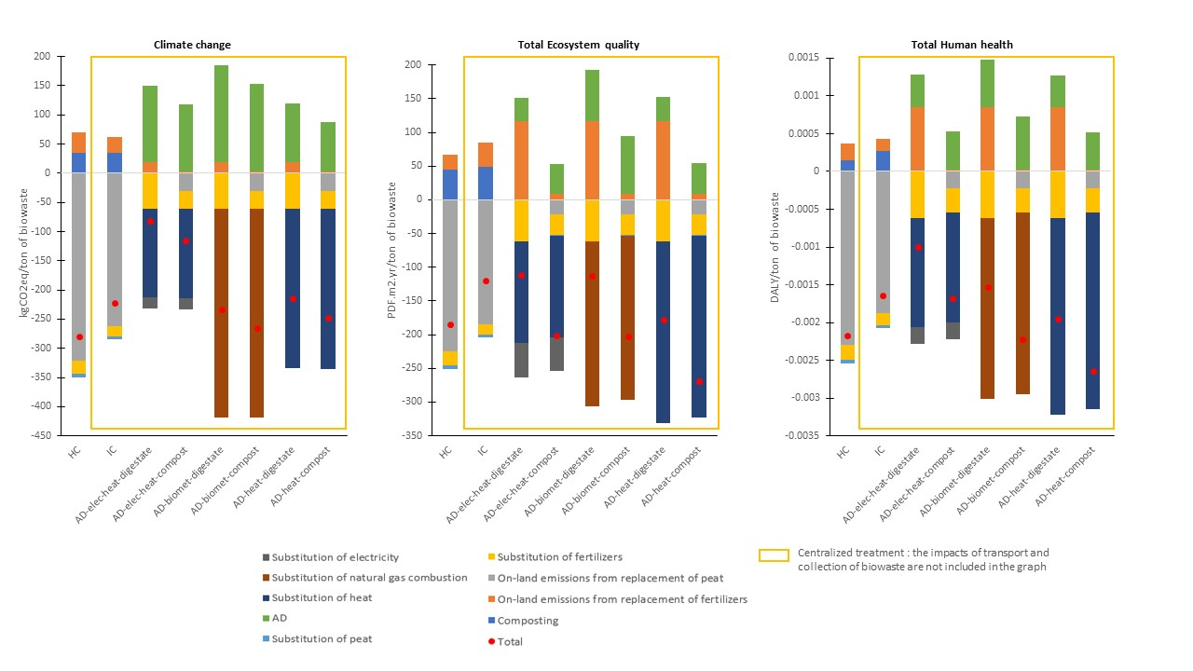
Across all indicators, the total environmental impact is negative, reflecting overall environmental benefits driven by the substitution of conventional products with co-products. Regarding the two areas of protection—total ecosystem quality and total human health—the AD-heat-compost pathway performs best, with scores of −268.34 PDF·m²·yr per ton of biowaste and −2.64 × 10⁻³ DALY per ton, respectively. In contrast, the AD-electricity-heat-digestate pathway shows the least favorable performance, with impacts of −111.81 PDF·m²·yr and −1.0 × 10⁻³ DALY per ton of biowaste. In both technologies, the substitution of conventional heat is the main contributor to environmental benefits; however, direct biogas combustion produces more heat than combined heat and power (CHP). Furthermore, the land application of digestate significantly contributes to environmental burdens in the AD-electricity-heat-digestate scenario.
Transport and collection impacts must also be considered to assess the total system performance, although these depend strongly on municipality size and facility location. Notably, home composting does not involve transport and collection impacts.
For climate change, home composting performs best among all technologies, mainly due to substantial benefits from avoided peat use, achieving −279.99 kg CO₂-eq per ton of biowaste. Among centralized options, AD-biomet-compost shows the best performance (−265.33 kg CO₂-eq per ton), while AD-electricity-heat-digestate has the highest impacts (−82.31 kg CO₂-eq per ton of biowaste).
  - Results of optimization
    - Single objective
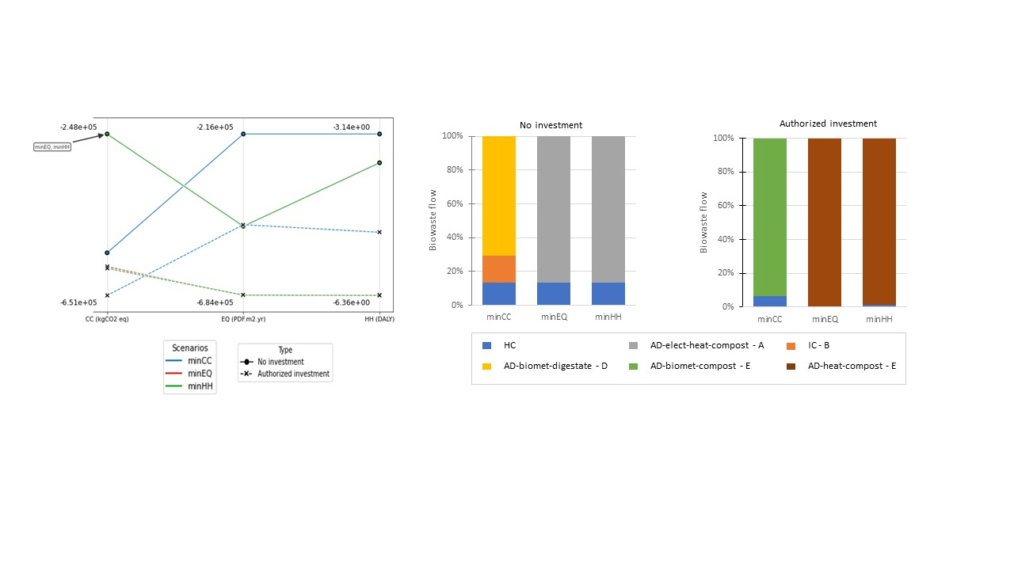
- Without investement :
• Without investment, when minimizing ecosystem quality (EQ) or human health (HH), the optimization results in the same technology mix and flow distribution: 13.3% allocated to home composting (HC) and 86.73% to AD-electricity-heat-compost. From a life cycle assessment (LCA) perspective focused on human health, HC clearly performs best among the technologies available in the territory (Fig. 2). However, not all eligible waste streams—those originating from households—are directed toward this option. This is because, beyond a certain threshold, no additional benefits can be obtained from peat substitution due to the limited hobby peat market within the territory. The remaining biowaste is therefore allocated to the most efficient centralized technology available, namely AD-electricity-heat-compost.
For ecosystem quality, LCA results indicate that AD-electricity-heat-compost performs better than HC. Nevertheless, not all waste is directed toward this technology. Indeed, for some municipalities, the impacts of collection and transport reduce its overall performance. As a result, the optimizer favors HC instead, until the peat substitution benefit limit is also reached.
Minimizing either HH or EQ leads to the same configuration, resulting in overall impacts of −3.72 DALY, −4.84 × 10⁵ PDF·m²·yr, and −2.48 × 10⁵ kg CO₂-eq.
When minimizing climate change (CC), a similar constraint applies: the flow allocated to HC is limited by the hobby peat market, even though LCA results identify it as the best-performing option in terms of climate change. Subsequently, 70.6% of the flow is directed to AD-biomethane-digestate (site D), while the remaining 16.11% is sent to IC (IC, site B). Although LCA results show that AD-biomethane-digestate performs better than IC, spatial factors explain this allocation. Indeed, the ARC map indicates that site B is closer to the territory than site D. Consequently, incineration is favored until the professional peat market constraint is reached. Minimizing climate change leads to overall impacts of −5.45 × 10⁵ kg CO₂-eq, −2.16 × 10⁵ PDF·m²·yr, and −3.14 DALY.
With investment
When investment is allowed, existing facilities are no longer utilized, and new installations are deployed depending on the optimization objective. In the case of climate change (CC) minimization, 93.5% of biowaste is directed to AD-biomethane-compost, while only 6.5% is allocated to home composting (HC). Among all available technologies, AD-biomethane-compost is the second-best performing option after HC. However, the share of biowaste sent to HC does not correspond either to the total waste generated by households or to the maximum amount that would yield environmental benefits through peat substitution. This is because the optimizer is constrained to allocate at least 93.5% of the flow to AD-biomethane-compost, which corresponds to the minimum capacity required to justify the construction of a new facility. Under this objective, the system achieves impacts of −6.51 × 10⁵ kg CO₂-eq for climate change, −4.79 × 10⁵ PDF·m²·yr for ecosystem quality, and −5.10 DALY for human health.
Regarding the scenario of total ecosystem quality minimization, all biowaste flows are directed to a single centralized technology, namely AD-heat-compost, which is also the best-performing option for this indicator among all technologies. This configuration results in impacts of −6.84 × 10⁵ PDF·m²·yr for ecosystem quality, −6.35 DALY for human health, and −5.79 × 10⁵ kg CO₂-eq for climate change.
When minimizing human health (HH) impacts, the same centralized technology is favored, receiving 98.71% of the total biowaste, as it also performs best for this indicator. The remaining 1.29% is allocated to HC and originates from a municipality with the highest collection distance among all municipalities. This optimized system yields an impact of −6.36 DALY for human health, along with −5.83 × 10⁵ kg CO₂-eq for climate change and −6.83 × 10⁵ PDF·m²·yr for ecosystem quality.
Impact de l’objectif choisi : différence entre les scénarios
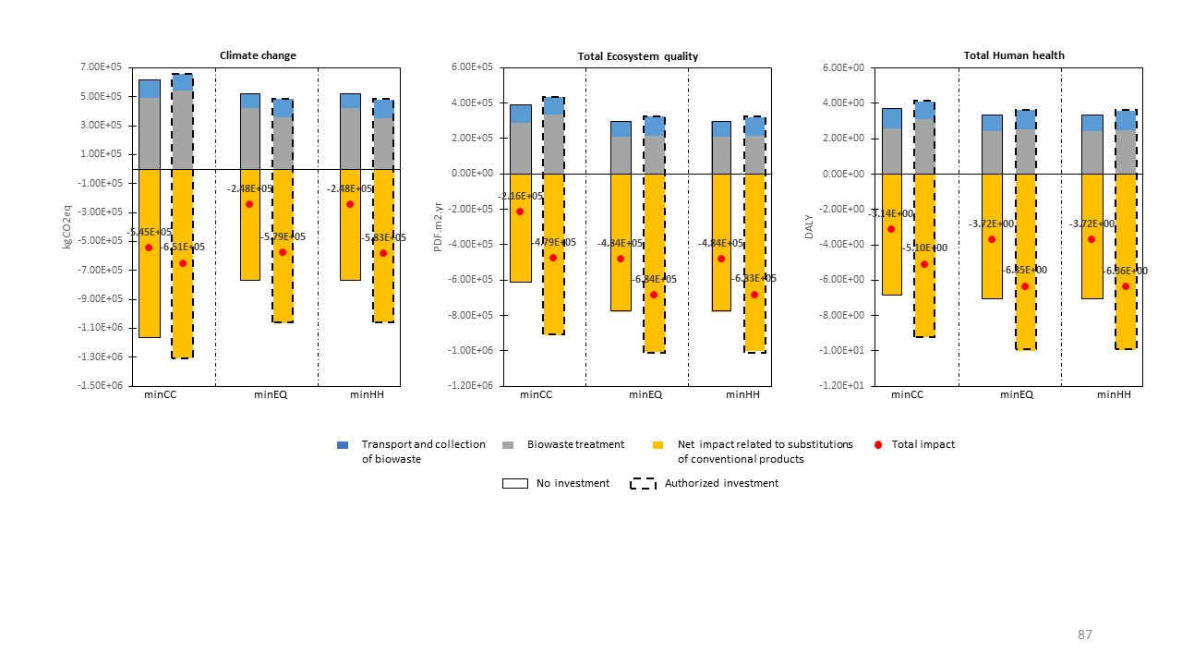
- Investissement vs sans investissement
    - Multi-objectives
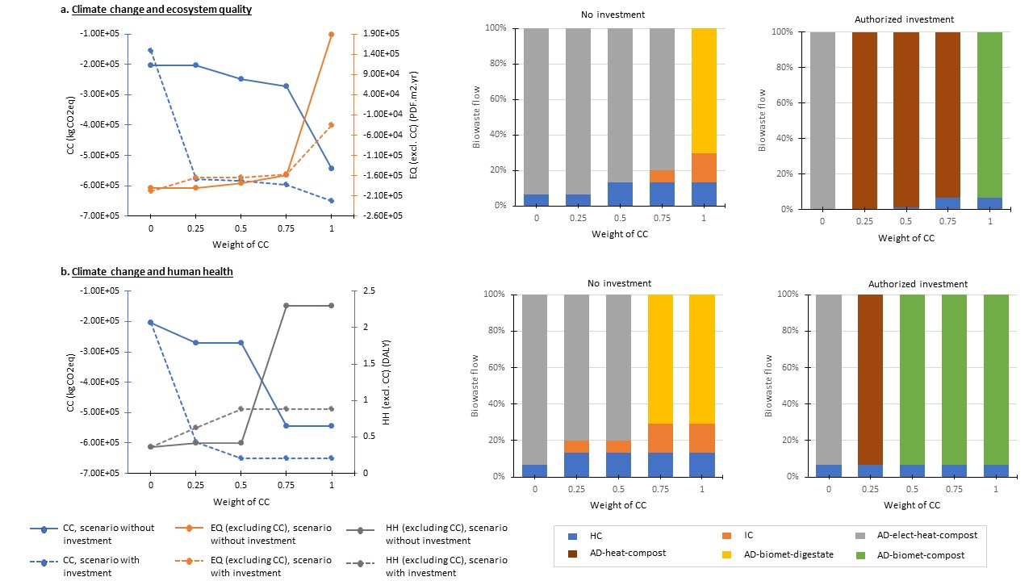
• Trade-off between climate change (CC) and ecosystem quality (EQ)
Without investment.
For CC weights ranging from 0 to 0.5, the selected technologies remain home composting (HC) and AD-electricity-heat-compost, with variations in the allocation of flows between them. When the CC weight increases to 0.75, a small fraction of biowaste (6.7%) is redirected to industrial composting (IC). Across the range from 0 to 0.75, no abrupt technological transition is observed. Over this interval, climate change impacts improve from −2.03 × 10⁵ to −2.72 × 10⁵ kg CO₂-eq, while ecosystem quality impacts excluding CC (EQ_exclCC) decrease from −1.90 × 10⁵ to −1.59 × 10⁵ PDF·m²·yr.
A major shift occurs when the CC weight reaches 1. The dominant technology switches from AD-electricity-heat-compost to AD-biomethane-digestate, accompanied by an increase in flows directed to industrial composting in order to reach the maximum peat substitution market. Between weights of 0.75 and 1, climate change performance improves substantially (from −2.72 × 10⁵ to −5.45 × 10⁵ kg CO₂-eq), while ecosystem quality deteriorates significantly (from −1.59 × 10⁵ to +1.89 × 10⁵ PDF·m²·yr).
With investment.
When CC is not considered (weight = 0), only AD-electricity-heat-compost is selected, with 93.5% of biowaste directed to a newly installed facility and the remainder treated by existing technologies. As soon as a weight of 0.25 is assigned to CC, the system configuration changes completely, with all biowaste redirected to AD-heat-compost. This leads to a marked improvement in climate change performance (from −1.54 × 10⁵ to −5.79 × 10⁵ kg CO₂-eq), while EQ_exclCC slightly deteriorates (from −1.98 × 10⁵ to −1.65 × 10⁵ PDF·m²·yr).
Between CC weights of 0.25 and 0.75, the dominant technology remains unchanged, although the share of biowaste allocated to HC gradually increases for municipalities with higher collection distances and associated impacts. When the CC weight reaches 1, AD-biomethane-compost becomes the dominant technology. Climate change performance further improves to −6.51 × 10⁵ kg CO₂-eq, whereas EQ_exclCC benefits are substantially reduced to −3.46 × 10⁴ PDF·m²·yr.
Trade-off between climate change (CC) and human health (HH)
Without investment.
When varying the weights of CC and HH (excluding CC), similar technologies are selected as in the CC–EQ trade-off, but system configurations stabilize earlier, i.e., at lower CC weights. From CC weights of 0 to 0.5, the dominant technology remains AD-electricity-heat-compost, with a gradual increase in the share of biowaste allocated to both home composting (HC) and industrial composting (IC). Over this range, climate change impacts improve from −2.03 × 10⁵ to −2.72 × 10⁵ kg CO₂-eq, while HH impacts excluding CC increase slightly from −0.365 to 0.415 DALY.
At CC weights of 0.75 and 1, the system configuration shifts markedly toward a combination of AD-biomethane-digestate (70.62%), industrial composting (16.11%), and HC (13.28%). As the CC weight increases from 0 to 0.75 and 1, climate change impacts improve from −2.03 × 10⁵ to −5.45 × 10⁵ kg CO₂-eq, while HH_exclCC impacts increase significantly from −0.365 to 2.3 DALY.
With investment.
When investment is allowed and CC is not weighted (weight = 0), the existing AD-electricity-heat-compost technology is favored, receiving 93.5% of the total flow, with the remainder allocated to HC. This configuration results in impacts of −2.03 × 10⁵ kg CO₂-eq for climate change and −0.365 DALY for HH_exclCC.
At a CC weight of 0.25, AD-electricity-heat-compost is replaced by AD-heat-compost, leading to a substantial improvement in climate change performance (−5.97 × 10⁵ kg CO₂-eq), while HH_exclCC increases to 0.62 DALY. The system configuration then changes and stabilizes from a CC weight of 0.5 onward, with AD-biomethane-compost becoming the dominant technology. Under this configuration, climate change impacts reach −6.51 × 10⁵ kg CO₂-eq, while HH_exclCC rises to 0.88 DALY.
- Sensitivity analysis
  - Sorting rate
In this sensitivity analysis, the nominal sorting rate was varied by −50% and +50% (Figure XXX).
Without investment, when the sorting rate decreases to 30%, the quantity of biowaste allocated to composting remains unchanged in order to maintain the same level of peat substitution. As a result, the reduction in sorted waste mainly affects the flows directed to anaerobic digestion. The impacts of the minimized indicators decrease by −65%, −67%, and −78% for climate change (CC), ecosystem quality (EQ), and human health (HH), respectively. When the sorting rate increases to 90%, the dominant technology (i.e., the one receiving the largest share of flows under the nominal sorting rate) receives additional inputs until reaching its maximum capacity. This corresponds to AD-biomethane-digestate in the CC minimization scenario and to AD-electricity-heat-compost in the EQ and HH scenarios. Additional technologies are then mobilized to treat the remaining waste. Under these conditions, the impacts of the minimized indicators increase by +35%, +40%, and +70% for CC, EQ, and HH, respectively.
When investment is allowed, a sorting rate of 30% does not generate sufficient waste to justify the installation of new facilities. Consequently, both the technology selection and flow distribution remain identical to the no-investment scenario at the same sorting rate. The impacts of the minimized indicators decrease further, reaching −71%, −77%, and −87% for CC, EQ, and HH, respectively.
At a sorting rate of 90%, newly installed facilities receive larger material flows. This leads to higher impacts, with the impacts of the minimized indicators increasing by +67%, +63%, and +70% for CC, EQ, and HH, respectively.
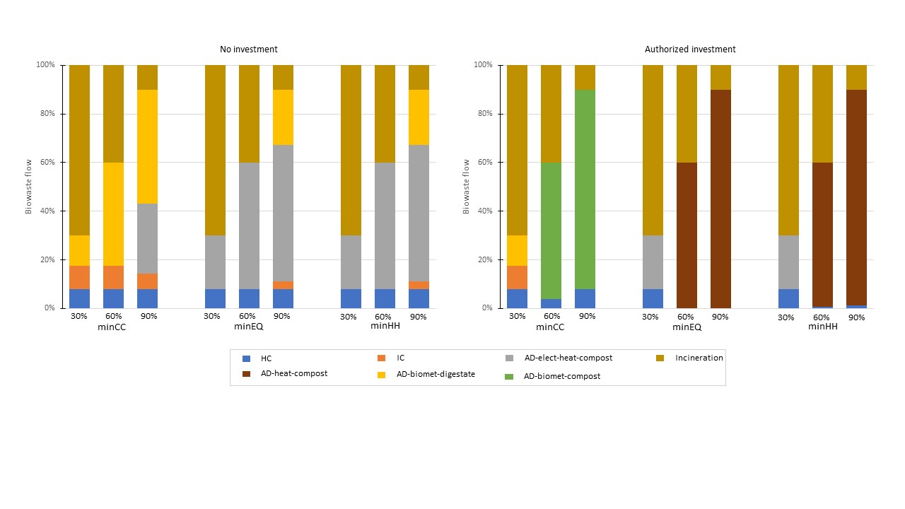
Market
Future electricity mix
- Discussion and limits
  - Discussion of results
  - Comparison with existing optimization frameworks
  - Limits
- Conclusion

