In this experiment, you will play a game that involves choosing between blue and green squares. **The aim of the game is to accumulate as many points as possible.**

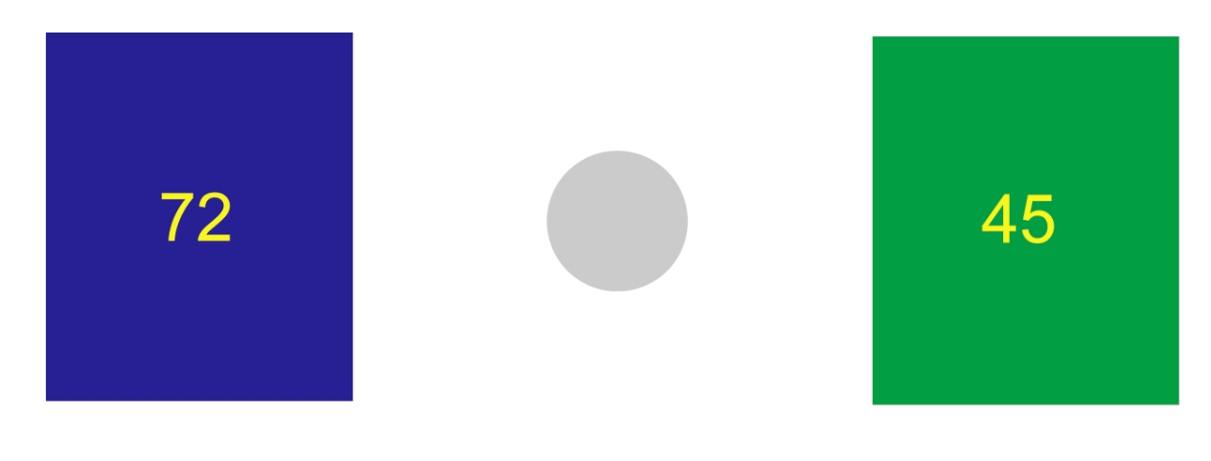

On each round of the game, you will see a screen like the one shown above. You must choose either the blue box or the green box. To choose the *left* option (in this example the blue box), press the left button on the button box. To choose the *right* option (in this example the green box), press the right button. The colours may swap sides from round to round.

If your chosen answer is the correct answer, you score the number of points inside the box (between 0 and 100). In the above round, for example, let us assume blue is the correct answer. If you were to choose blue, then 72 points would be added to your total. If you were to choose green, however, you would score nothing. The correct answer will be highlighted soon after you have made your choice.

You will also be asked to put on some headphones. Some sounds will occasionally be played over the headphones, which may or may not be pleasant to listen to.

***“Which box should I choose?”***

Importantly*,* ***the chances that each colour is correct are not equal****.* By considering which colour has been correct more often in the past, you will be able to build a feeling for which colour is more likely to be correct in the current round.

Remember, however, that it is ***not always best*** to choose the colour that is most likely to be correct. You should weigh up the chance that the colour is correct with the number of points that you’ll score if it turned out to be the right answer.

***Ratings***

Every so often, the experiment will pause, and you will be asked to rate how you are currently feeling, from 1 to 10. Please answer as honestly as possible. Use the mouse to click on the appropriate rating.