NB:

* The most important one is that you **need to compute your summary statistics for each participant before looking them for the group**. This is because we have **repeated measures**.
* You'll be able to do more if you keep separate variables for the Go/NoGo condition and the Win/Avoid condition.
* I've done this for the RT already. I'll push my code asap and then look at p(Go)

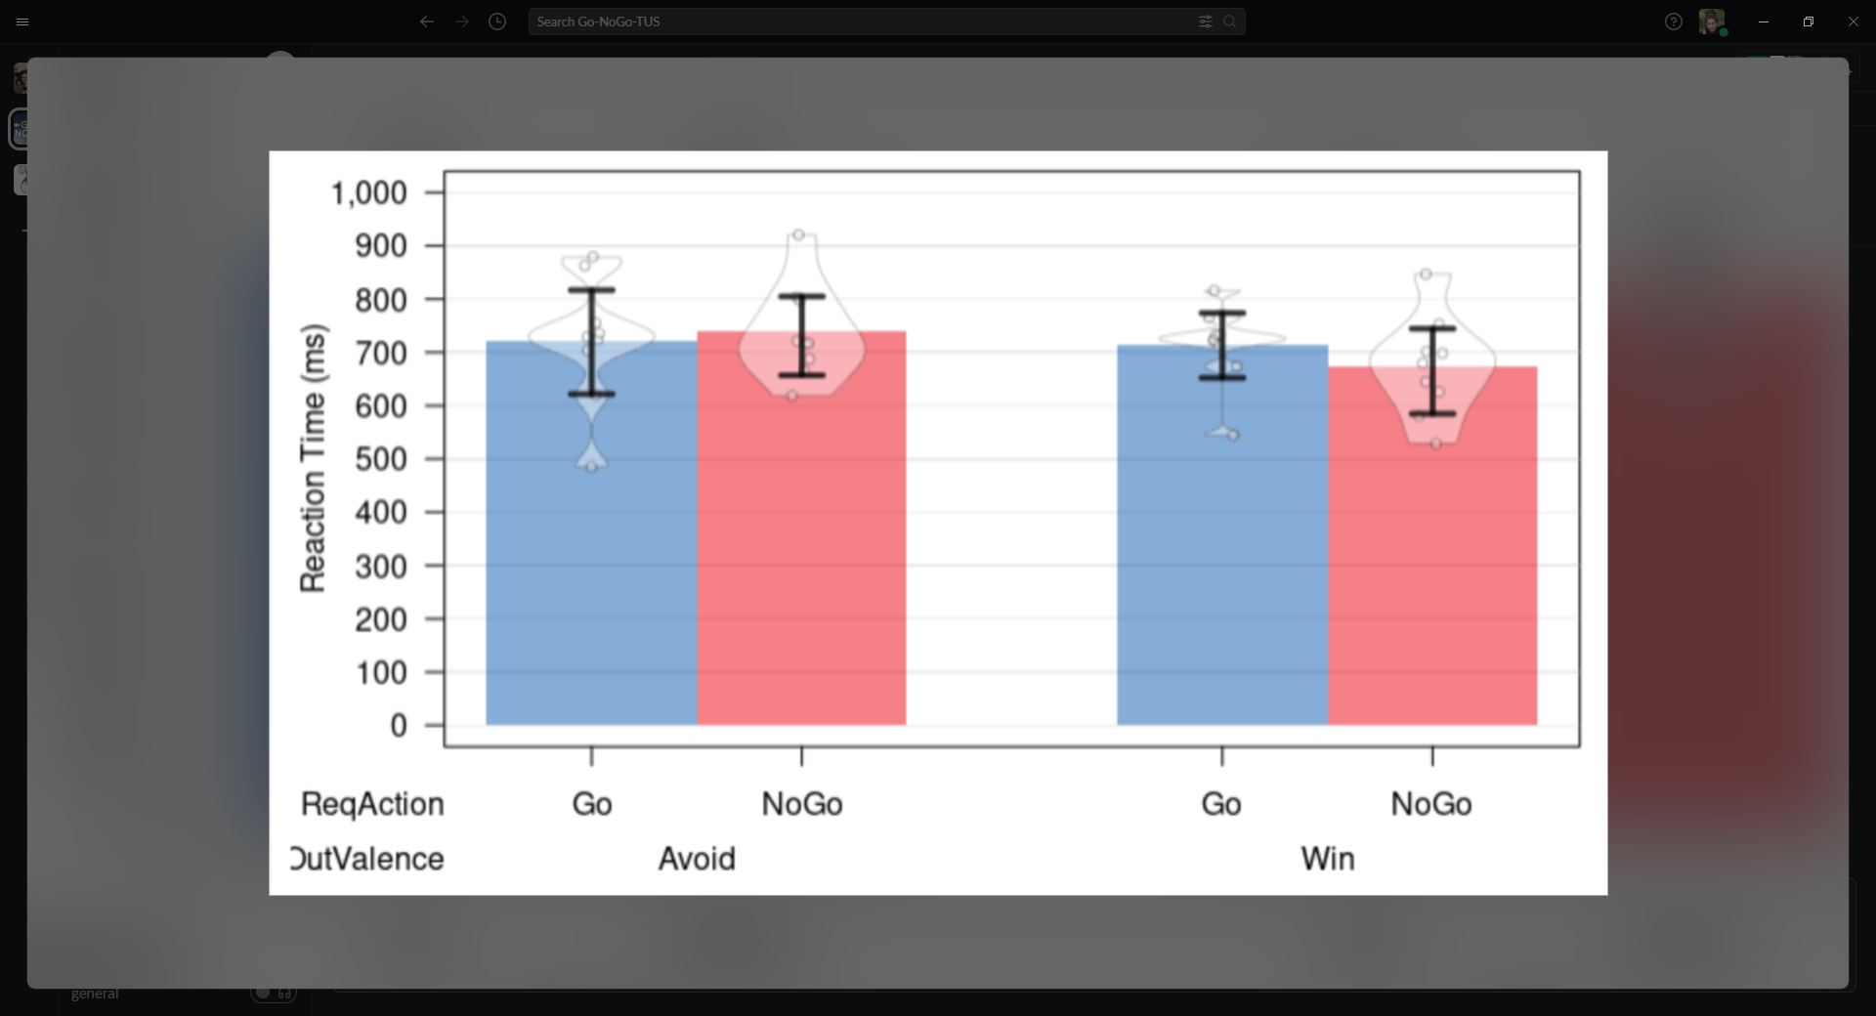

EF: Nomi and I also worked on the issue that the presses don't start at 50% which I cannot believe

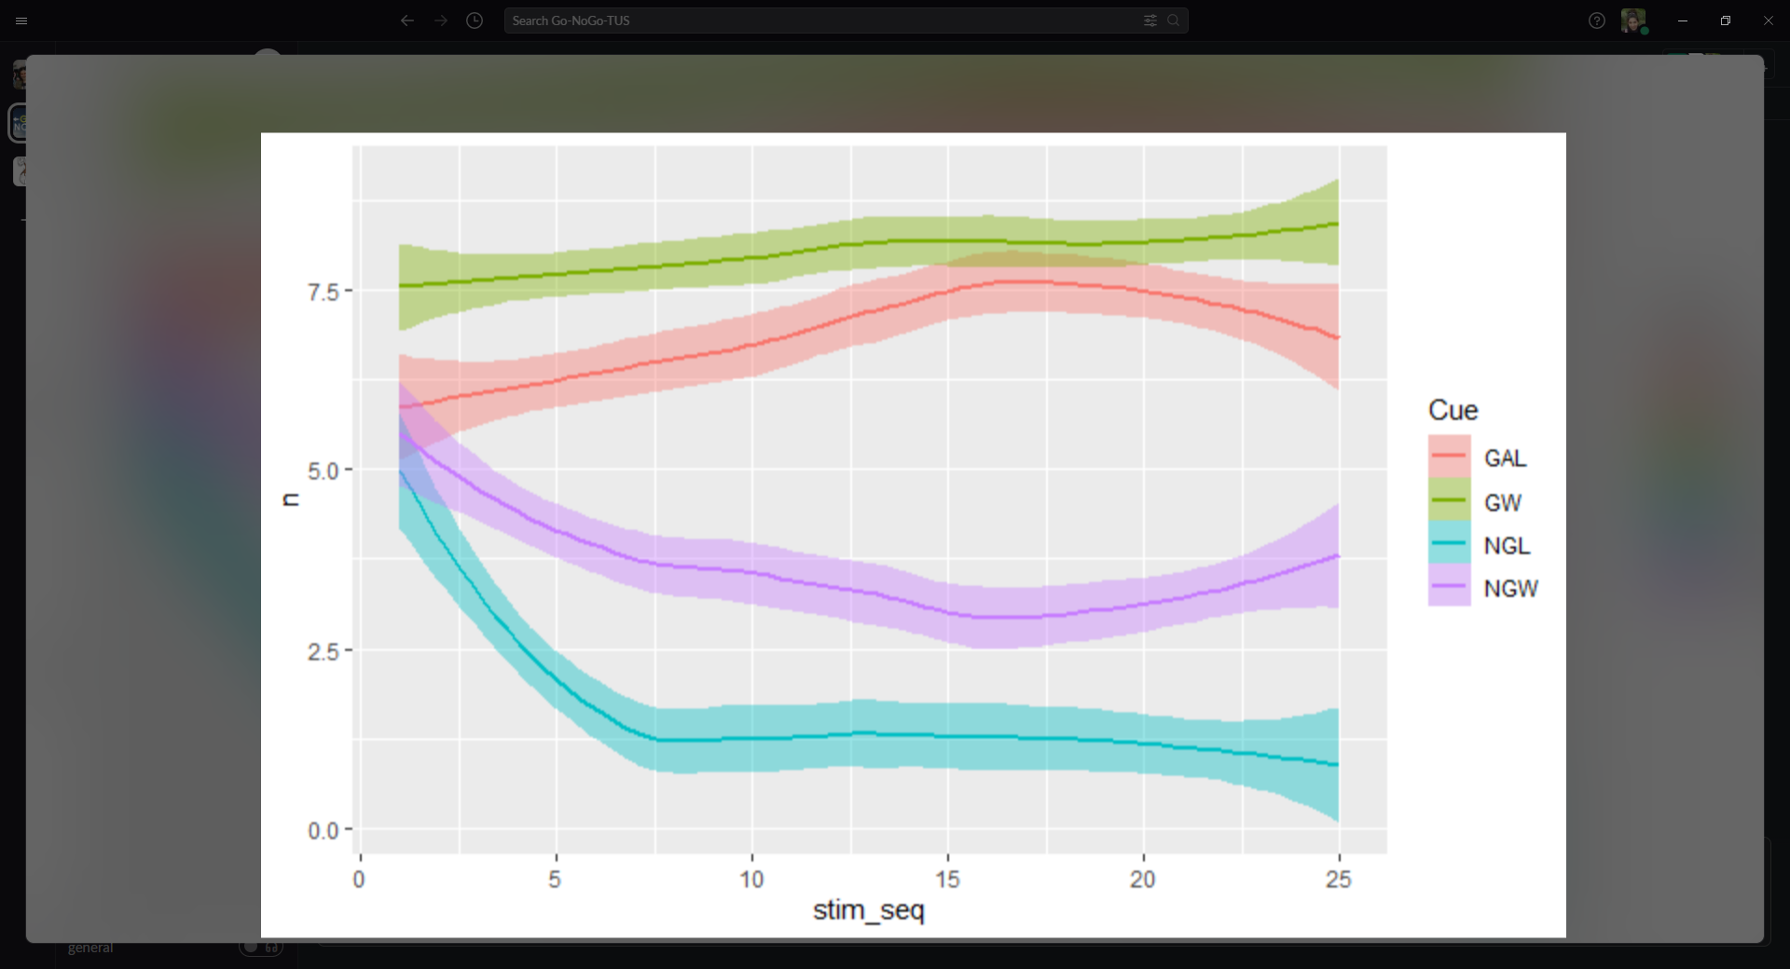

NB: I just looked at the data a bit more. It actually makes sense to me that they won't start at 50%. They have a bias towards pressing the button when they start. The same bias occurred in Hanneke's paper. Their pp started at ~70%

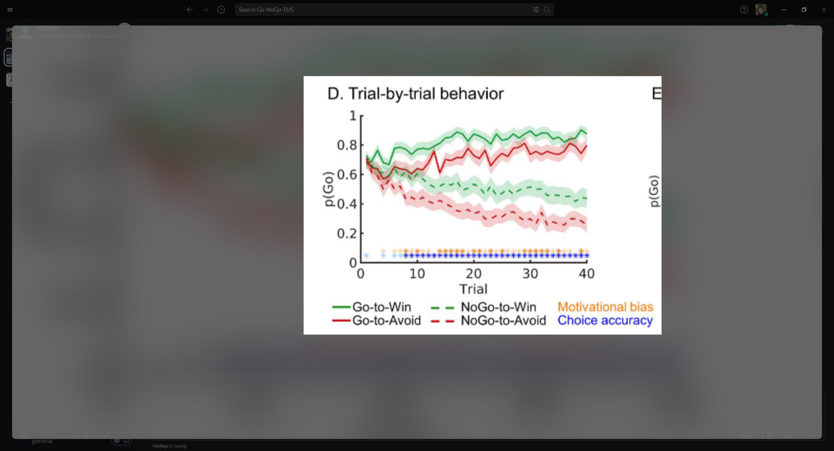

I got this for our data.The shape is similar to yours, but the starting point higher...

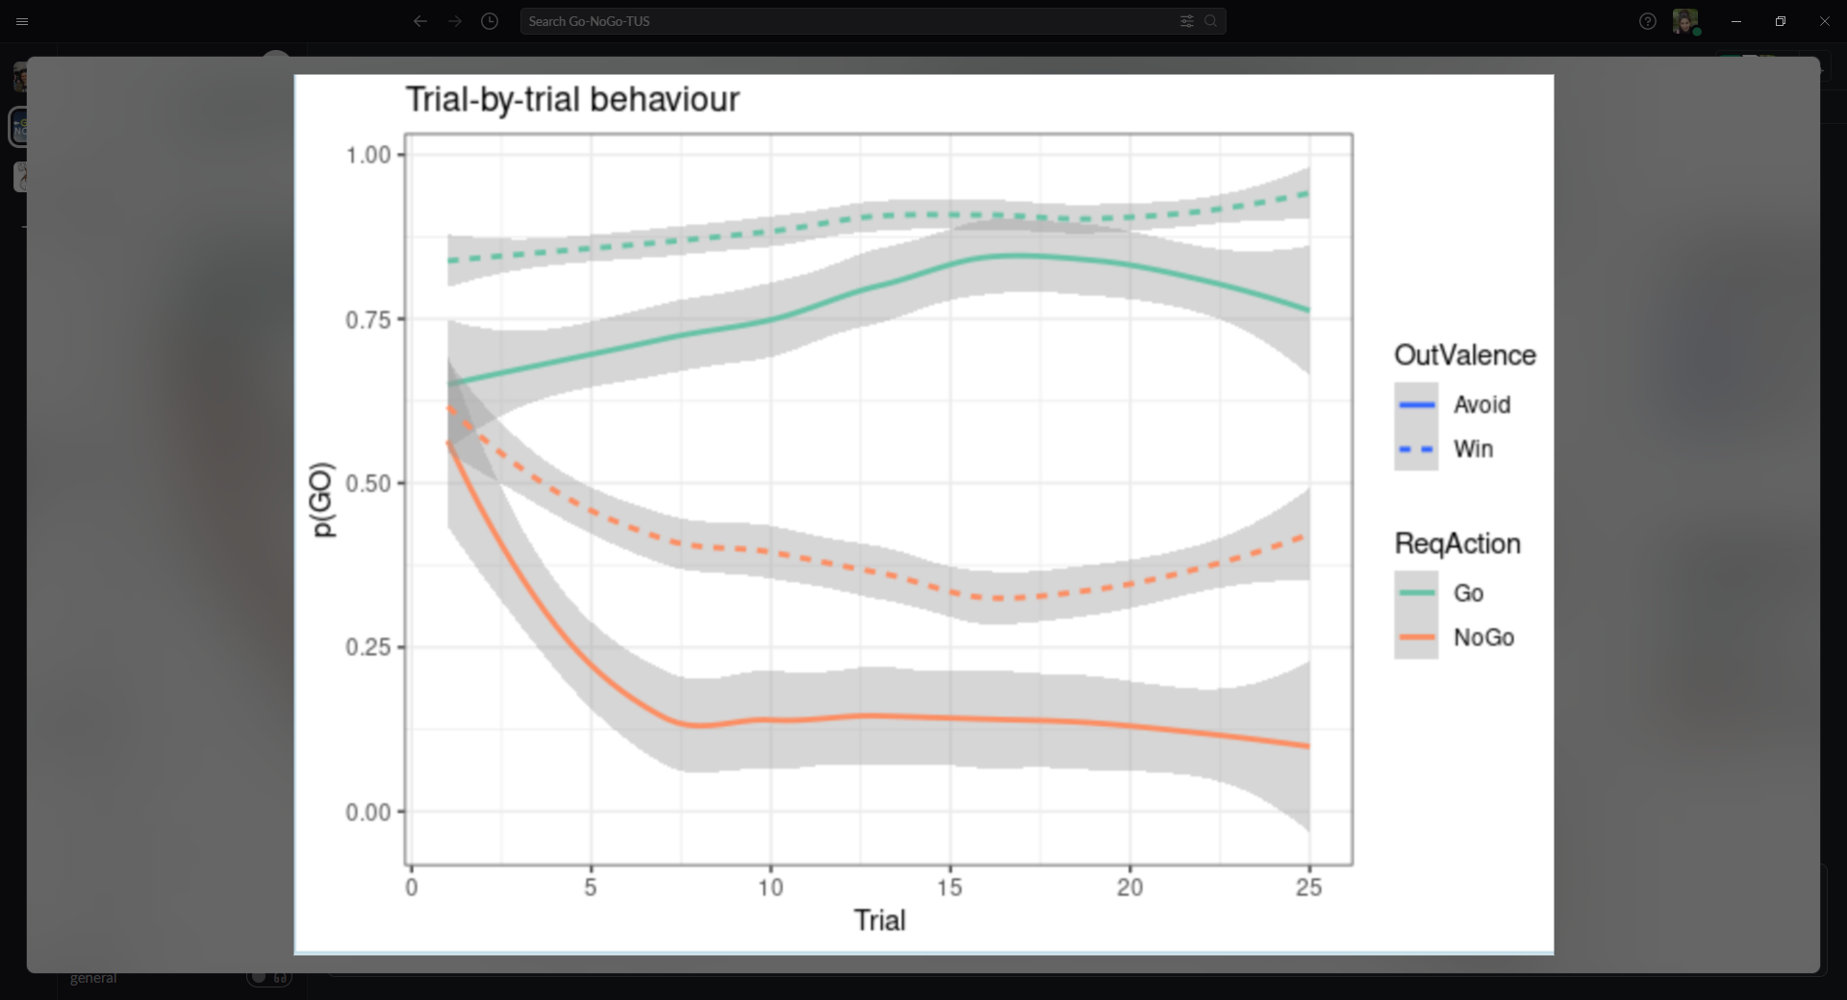

This is the % of choosing the correct cue:

