Web Programming

Project Report

Group:

Noman Ali (17k-3652)

Mubashir Hashmi (17k-2394)

Date of Submission:

21.December.2020

Live Hosting URL:

Table of Contents

1. Project Assignment Page.
2. Description.
3. Features.
4. Class Diagram.
5. Sequence Diagram.
6. Use case Diagram.
7. Architecture Diagram.
8. Deployment Diagram.
9. Data Flow Diagram.
10. Data Dictionary.
11. Work Breakdown Structure.
12. Project Gantt Chart.
13. ER Diagram.
14. Setup Instructions.

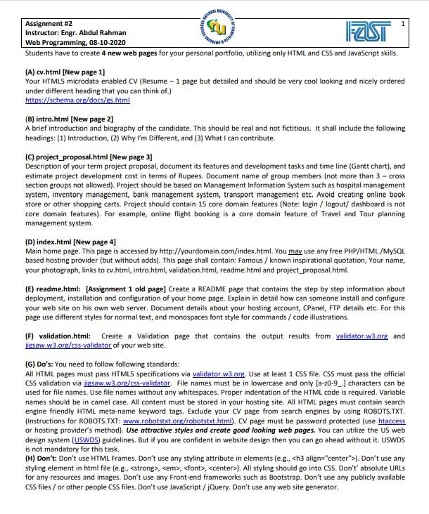

Description:

The project of Web Programming is developed to manage the Final Year Project. The project name is Diet And Exercise Recommendation System. It is a mobile application in our FYP. But in the Web Programming semester project, we develop the web application using React JS. In our project, we recommend users a diet and exercise plan by taking some information from the user. We take information from users in two ways. Either he can take photos of his physique or he can answer some questions.

The management of the system involves the users,diets, exercises, diet schedule and exercise schedule lists management. We are using mongoDB and microservices architecture on backend and REACT JS on frontend.

Features:

1. Add Exercise
2. Delete Exercise
3. Update Exercise
4. Retrieve Exercise
5. Add Diet
6. Delete Diet
7. Update Diet
8. Retrieve Diet
9. Add User
10. Delete User
11. Update User
12. Retrieve User
13. Add Custom Diet Schedule
14. Delete Custom Diet Schedule
15. Add Custom Exercise Schedule
16. Delete Custom Exercise Schedule

Class Diagram

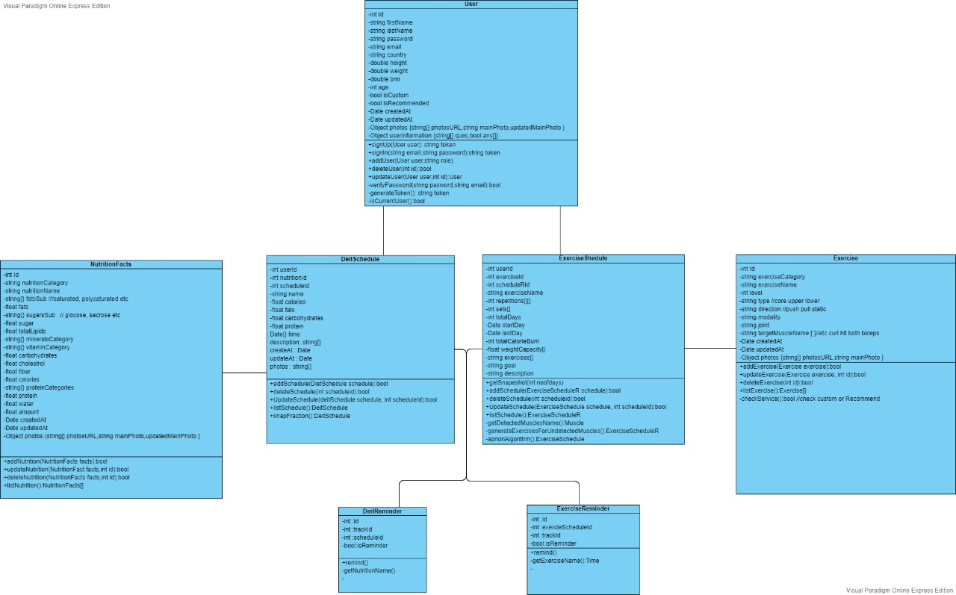

Sequence Diagram

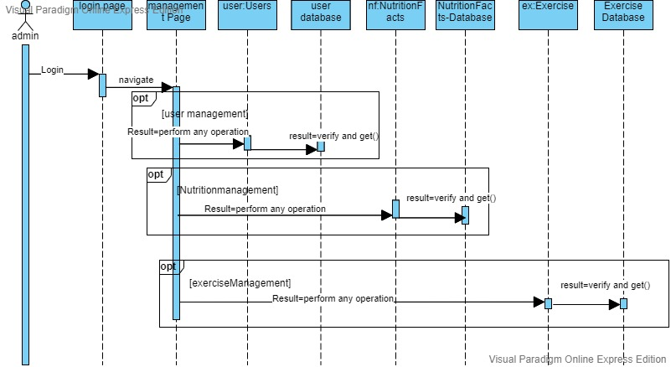

Use case Diagram

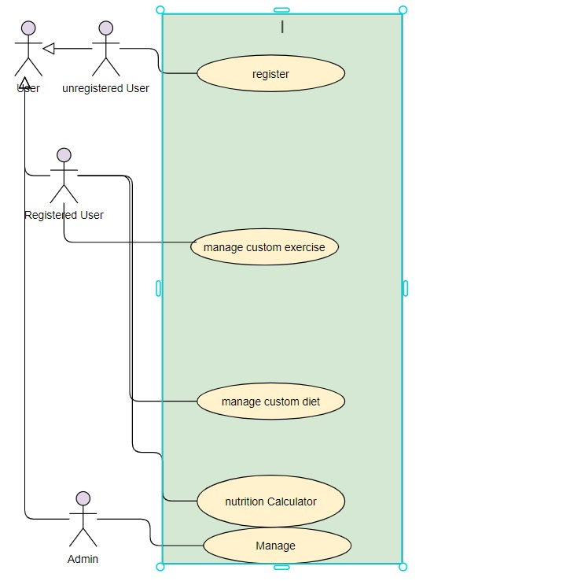

Architecture Diagram

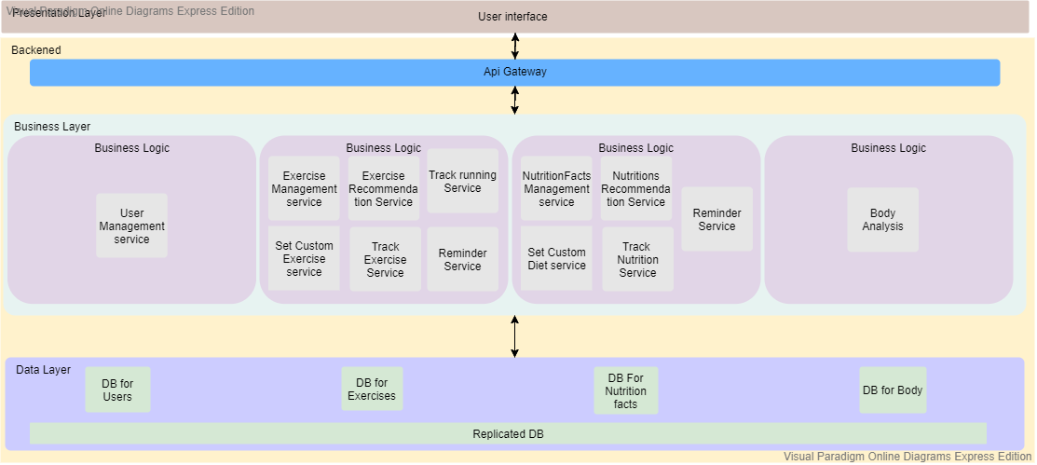

Deployment Diagram

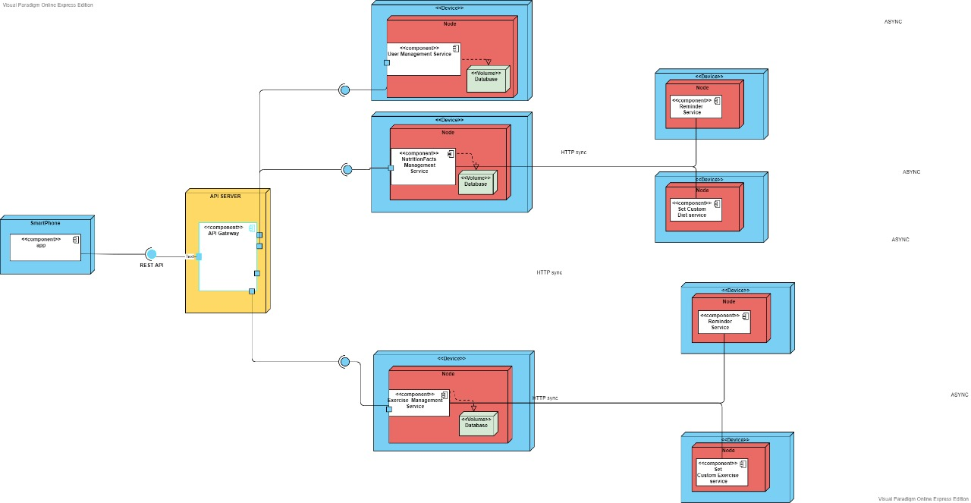

DFD

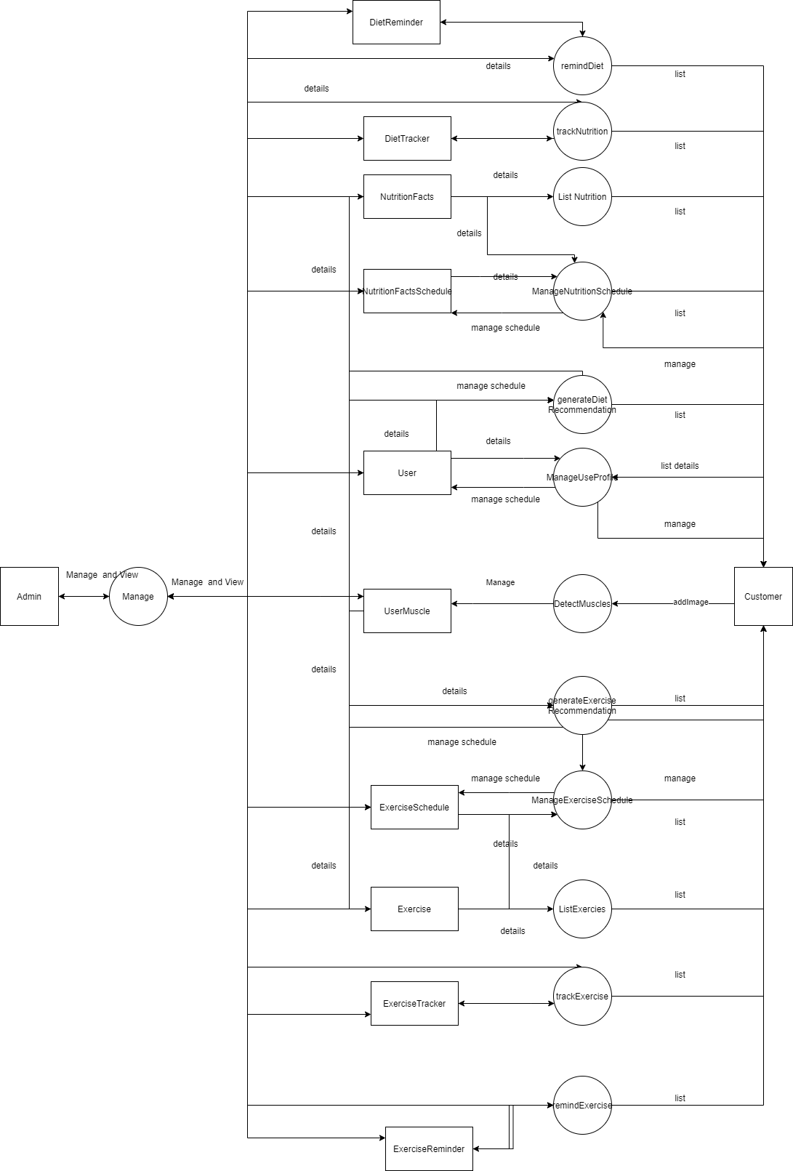

### **Data Dictionary**

#### **Data 1**

|  |  |  |  |  |  |  |  |
| --- | --- | --- | --- | --- | --- | --- | --- |
| **< Data 1>** | | | | | | | |
| **Name** | | User | | | | | |
| **Alias** | | Write other names used for the first entry. | | | | | |
| **Where-used/how-used** | | during authorization, and using services managing profile,recommending and custom | | | | | |
| **Content description** | | Notation for representing content. | | | | | |
|  | | | | | | | |
| **Column Name** | **Description** | | **Type** | **Length** | **Null able** | **Default Value** | **Key Type** |
| id | id of user | | string | [24] | False |  | PK |
| firstName | first name of user | | string | [24] | False |  |  |
| lastName | last name of user | | string | [24] | False |  |  |
| password | password of user for login | | string | [200] | False |  |  |
| email | email of user | | string | [30] | False |  |  |
| country | country of user | | string | [20] | True | *NULL* |  |
| height | height of user | | float | 1 | False |  |  |
| weight | weight of user | | float | *1* | False |  |  |
| bmi | bmi of user | | float | *1* | False |  |  |
| age | age of user | | int | *1* | False |  |  |
| isCustom | true if user customized schedule | | bool | *1* | True | NULL |  |
| isRecommend | true if user use recommendation schedule | | bool | *1* | True | NULL |  |
| createAt | date of account creation | | Date | *1* | False |  |  |
| updateAt | date of account update | | Date | *1* | False |  |  |
| photos | photos of user | | Array | [*] | True | NULL |  |
| userInformation | information of user | | Array | [*] | True | NULL |  |

#### **Data 2**

|  |  |  |  |  |  |  |  |
| --- | --- | --- | --- | --- | --- | --- | --- |
| **< Data 2>** | | | | | | | |
| **Name** | | Exercise | | | | | |
| **Alias** | | Write other names used for the first entry. | | | | | |
| **Where-used/how-used** | | recommending and making custom schedules | | | | | |
| **Content description** | | Notation for representing content. | | | | | |
|  | | | | | | | |
| **Column Name** | **Description** | | **Type** | **Length** | **Null able** | **Default Value** | **Key Type** |
| id | id of exercise | | string | *[24]* | False |  | PK |
| exerciseCategory | to categories exercise into biceps, triceps, lats, etc | | string | *[20]* | False |  |  |
| exerciseName | name of exercise | | string | *[20]* | False |  |  |
| level | difficulty level of exercise | | string | *[20]* | False |  |  |
| type | to check that exercise is upper, lower or core | | string | *[20]* | False |  |  |
| direction | to check that exercise is pulling or pushing | | string | *[20]* | False |  |  |
| modality | to check that exercise is free weight or cable or machine | | string | *[20]* | False |  |  |
| joint | to check that exercise is multi joint or single joint | | string | *[20]* | False |  |  |
| targetMusclesName | muscles affected by exercise | | string | [*] | True | NULL |  |
| createdAt | date of creation | | Date | *1* | False |  |  |
| updatedAt | date of updation | | Date | *1* | False |  |  |
| photos | photos of exercise | | Array | [*] | True | NULL |  |

#### **Data 3**

|  |  |  |  |  |  |  |  |
| --- | --- | --- | --- | --- | --- | --- | --- |
| **< Data 3>** | | | | | | | |
| **Name** | | NutritionFacts | | | | | |
| **Alias** | | Write other names used for the first entry. | | | | | |
| **Where-used/how-used** | | recommending and making custom schedules | | | | | |
| **Content description** | | Notation for representing content. | | | | | |
|  | | | | | | | |
| **Column Name** | **Description** | | **Type** | **Length** | **Null able** | **Default Value** | **Key Type** |
| id | id of nutrition | | int | [24] | False |  | PK |
| nutritionCategory | to categories in different in vegetables, diaries fruits etc | | string | [24] | False |  |  |
| nutritionName | name of that nutrition | | string | [24] | False |  |  |
| fatSub | to categories in different fat like  saturated, polyunsaturated, and monoUnsaturated | | string | [3] | False |  |  |
| sugar | sugar quantity in food | | string | [20] | True | NULL |  |
| totalLipids | lipids in nutrition | | float | 1 | True | NULL |  |
| mineralCategory | to categories in different minerals | | float | [*] | True | NULL |  |
| vitaminsCategory | to categories in different Vitamins | | float | [*] | True | NULL |  |
| proteinCategory | to categories in different protein | | int | [*] | True | NULL |  |
| protein | protein in nutrition | | bool | *1* | True | NULL |  |
| carbohydrates | carbohydrates in nutrition | | bool | *1* | True | NULL |  |
| cholesterol | cholesterol in nutrition | | Date | *1* | True | NULL |  |
| fiber | fiber in nutrition | |  | *1* | True | NULL |  |
| calories | calories in nutrition | | Date | *1* | False |  |  |
| water | water needed in nutrition | |  | *1* | True | NULL |  |
| amount | nutrition amount | |  | *1* | True | NULL |  |
| createAt | nutrition creation date | | Date | *1* | False |  |  |
| updateAt | nutrition last updated date | | Date | *1* | False |  |  |
| photos | photos ofnutrition | | Array | [*] | True | *NULL* |  |

#### 

#### **Data 4**

|  |  |  |  |  |  |  |  |
| --- | --- | --- | --- | --- | --- | --- | --- |
| **< Data 4>** | | | | | | | |
| **Name** | | DietSchedule | | | | | |
| **Alias** | | Write other names used for the first entry. | | | | | |
| **Where-used/how-used** | | during diet remind anding diet tracking | | | | | |
| **Content description** | | Notation for representing content. | | | | | |
|  | | | | | | | |
| **Column Name** | **Description** | | **Type** | **Length** | **Null able** | **Default Value** | **Key Type** |
| id | id of diet schedule | | int | [24] | False |  | PK |
| nutritionId | id of nutrition | | string | [24] | False |  | FK |
| userId | id of user | | string | [24] | False |  | FK |
| nutritionName | name of nutrition | | string | [20] | False |  |  |
| calories | calories on nutrition | | float | 1 | False |  |  |
| fats | fats in nutrition | | float | 1 | False |  |  |
| carbohydrates | carbohydrates in nutrition | | float | 1 | False |  |  |
| protein | protein in nutrition | | float | *1* | False |  |  |
| description | description of nutrition | | string | [*] | True | NULL |  |
| createAt | date of creation | | Date | *1* | False |  |  |
| updateAt | last updation date | | Date | *1* | False |  |  |
| photos | photos of nutrition | | Array | [*] | True | NULL |  |

Data 5

|  |  |  |  |  |  |  |  |
| --- | --- | --- | --- | --- | --- | --- | --- |
| **< Data 5>** | | | | | | | |
| **Name** | | ExerciseSchedule | | | | | |
| **Alias** | | Write other names used for the first entry. | | | | | |
| **Where-used/how-used** | | during exercise reminding and exercise tracking | | | | | |
| **Content description** | | Notation for representing content. | | | | | |
|  | | | | | | | |
| **Column Name** | **Description** | | **Type** | **Length** | **Null able** | **Default Value** | **Key Type** |
| id | id of schedule | | int | [24] | False |  | PK |
| ExerciseId | id of exercise | | string | [24] | False |  | FK |
| userId | id of user | | string | [24] | False |  | FK |
| exerciseName | name of exercise | | string | [20] | False |  |  |
| repetitions | reps of exercise | | float | [10] | False |  |  |
| sets | sets of exercise | | float | 1 | False |  |  |
| description | description of exercise | | string | [*] | True | NULL |  |
| createAt | date of creation | | Date | *1* | False |  |  |
| updateAt | date of updation | | Date | *1* | False |  |  |
| photos | photos of exercise | | Array | [*] | True | NULL |  |

Data 6

|  |  |  |  |  |  |  |  |
| --- | --- | --- | --- | --- | --- | --- | --- |
| **< Data 6>** | | | | | | | |
| **Name** | | ExerciseTrack | | | | | |
| **Alias** | | Write other names used for the first entry. | | | | | |
| **Where-used/how-used** | | during exercise reminding | | | | | |
| **Content description** | | Notation for representing content. | | | | | |
|  | | | | | | | |
| **Column Name** | **Description** | | **Type** | **Length** | **Null able** | **Default Value** | **Key Type** |
| id | id of tracking | | string | [24] | False |  | PK |
| ExerciseIdScheduleId | id of schedule | | string | [24] | False |  | FK |
| userId | id of user | | string | [24] | False |  | FK |
| weightCapacity | weight used by user | | string | [*] | True | NULL |  |
| totalRunning | Running of user | | float | [*] | True | NULL |  |
| totalCaloriesBurn | Calories burn by user | | float | [*] | True | NULL |  |
| repetitions | reps of user | | float | [*] | True | NULL |  |
| totalDays | number of days user do exercise | | int | 1 | False |  |  |
| createAt | date of creation | | Date | *1* | False |  |  |
| updateAt | date of updation | | Date | *1* | False |  |  |

Data 7

|  |  |  |  |  |  |  |  |
| --- | --- | --- | --- | --- | --- | --- | --- |
| **< Data 7>** | | | | | | | |
| **Name** | | DietTrack | | | | | |
| **Alias** | | Write other names used for the first entry. | | | | | |
| **Where-used/how-used** | | during diet remind | | | | | |
| **Content description** | | Notation for representing content. | | | | | |
|  | | | | | | | |
| **Column Name** | **Description** | | **Type** | **Length** | **Null able** | **Default Value** | **Key Type** |
| id | id of track | | string | [24] | False |  | PK |
| NutritionIdScheduleId | id of nutrition schedule | | string | [24] | False |  | FK |
| userId | id of user | | string | [24] | False |  | FK |
| totalCaloriesIntake | calories intake by user | | float | 1 | False |  |  |
| totalProteinIntake | protein intake by user | | float | 1 | False |  |  |
| total Carbohydrate Intake | carbohydrate intake by user | | float | 1 | False |  |  |
| totalFatsIntake | fats intake by user | | Float | 1 | False |  |  |
| totalDays | number of days user take diet | | int | 1 | False |  |  |
| createAt | date of creation | | Date | *1* | False |  |  |
| updateAt | date of updation | | Date | *1* | False |  |  |

Data 8

|  |  |  |  |  |  |  |  |
| --- | --- | --- | --- | --- | --- | --- | --- |
| **< Data 8>** | | | | | | | |
| **Name** | | ExerciseReminder | | | | | |
| **Alias** | | Write other names used for the first entry. | | | | | |
| **Where-used/how-used** | | during exercise tracking | | | | | |
| **Content description** | | Notation for representing content. | | | | | |
|  | | | | | | | |
| **Column Name** | **Description** | | **Type** | **Length** | **Null able** | **Default Value** | **Key Type** |
| id | id of reminder | | string | [24] | False |  | PK |
| NutritionIdScheduleId | id of nutrition schedule | | string | [24] | False |  | FK |
| userId | id of user | | string | [24] | False |  | FK |
| trackId | id of track | | string | [24] | False |  | FK |
| upcoming days | days to remind | | Date | [*] | True | NULL |  |
| isReminder | To check that reminder will be off or on | | bool | 1 | False |  |  |
| createAt | date of creation | | Date | *1* | False |  |  |
| updateAt | date of updation | | Date | *1* | False |  |  |

Data 9

|  |  |  |  |  |  |  |  |
| --- | --- | --- | --- | --- | --- | --- | --- |
| **< Data 9>** | | | | | | | |
| **Name** | | DietReminder | | | | | |
| **Alias** | | Write other names used for the first entry. | | | | | |
| **Where-used/how-used** | | during diet tracking | | | | | |
| **Content description** | | Notation for representing content. | | | | | |
|  | | | | | | | |
| **Column Name** | **Description** | | **Type** | **Length** | **Null able** | **Default Value** | **Key Type** |
| id | id of reminder | | string | [24] | False |  | PK |
| NutritionIdScheduleId | id of nutrition | | string | [24] | False |  | FK |
| userId | last name of user | | string | [24] | False |  | FK |
| trackId | password of user for login | | string | [24] | False |  | *FK* |
| upcomingdays |  | | Date | [*] | True | NULL |  |
| isReminder | to check that reminder is set or not | | bool | 1 | False |  |  |
| createAt | date of creation | | Date | *1* | False |  |  |
| updateAt | date of updation | | Date | *1* | False |  |  |

Data 10

|  |  |  |  |  |  |  |  |
| --- | --- | --- | --- | --- | --- | --- | --- |
| **< Data 10>** | | | | | | | |
| **Name** | | Muscle | | | | | |
| **Alias** | | Write other names used for the first entry. | | | | | |
| **Where-used/how-used** | | during recommending | | | | | |
| **Content description** | | Notation for representing content. | | | | | |
|  | | | | | | | |
| **Column Name** | **Description** | | **Type** | **Length** | **Null able** | **Default Value** | **Key Type** |
| id | id of muscle | | string | [24] | False |  | PK |
| userId | id of user | | string | [24] | False |  | FK |
| detectedMuscles | muscles of user | | string | [24] | False |  |  |
| userImages | images of user | | string | [20] | False |  |  |
| createAt | date of creation | | Date | *1* | False |  |  |
| updateAt | date of updation | | Date | *1* | False |  |  |

Work BreakDown Structure

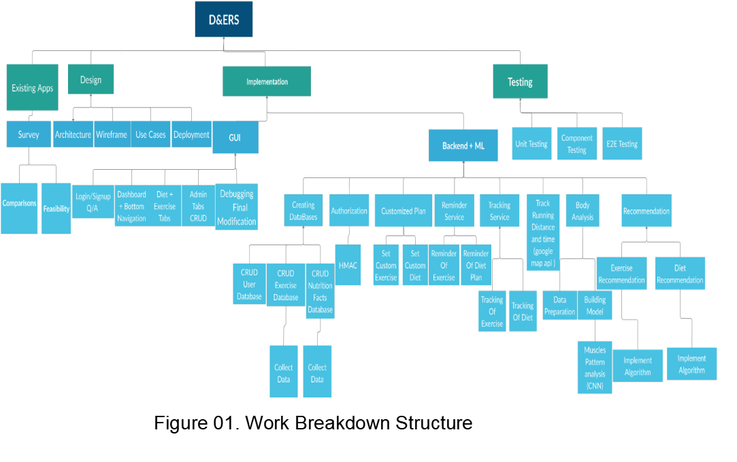

Project Gantt Chart

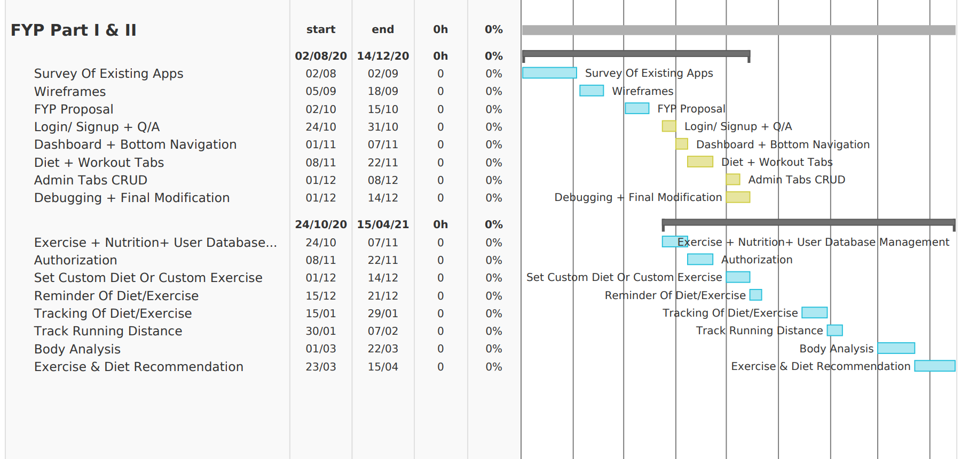

ER Diagram

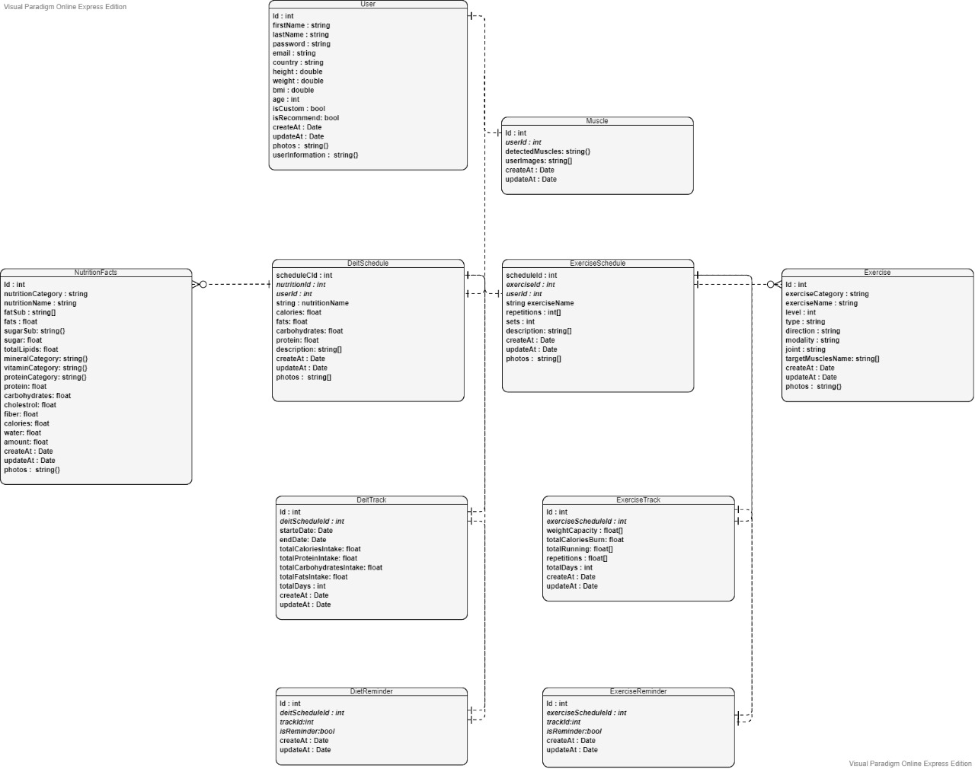

Setup Instructions:

Pre-requisite include mongodb and node js installed.

1. Download the project file.
2. Extract it.
3. Open command prompt and go to the folder ‘DAERS-Project-main’.
4. Now run command ‘cd user’.
5. Run ‘npm install’ and then ‘npm start’.
6. Open a new command prompt in ‘DAERS-Project-main’ and run ‘cd exercise’.
7. Run ‘npm install’ and then ‘npm start’.
8. Open a new command prompt in ‘DAERS-Project-main’ and run ‘cd exerciseschedule’.
9. Run ‘npm install’ and then ‘npm start’.
10. Open a new command prompt in ‘DAERS-Project-main’ and run ‘cd nutritionfacts’.
11. Run ‘npm install’ and then ‘npm start’.
12. Open a new command prompt in ‘DAERS-Project-main’ and run ‘cd nutritionschedule’.
13. Run ‘npm install’ and then ‘npm start’.
14. Open a new command prompt in ‘DAERS-Project-main’ and run ‘cd client’.
15. Run ‘npm install’ and then ‘npm run dev’.