1. Uml diagram for airline reservation system

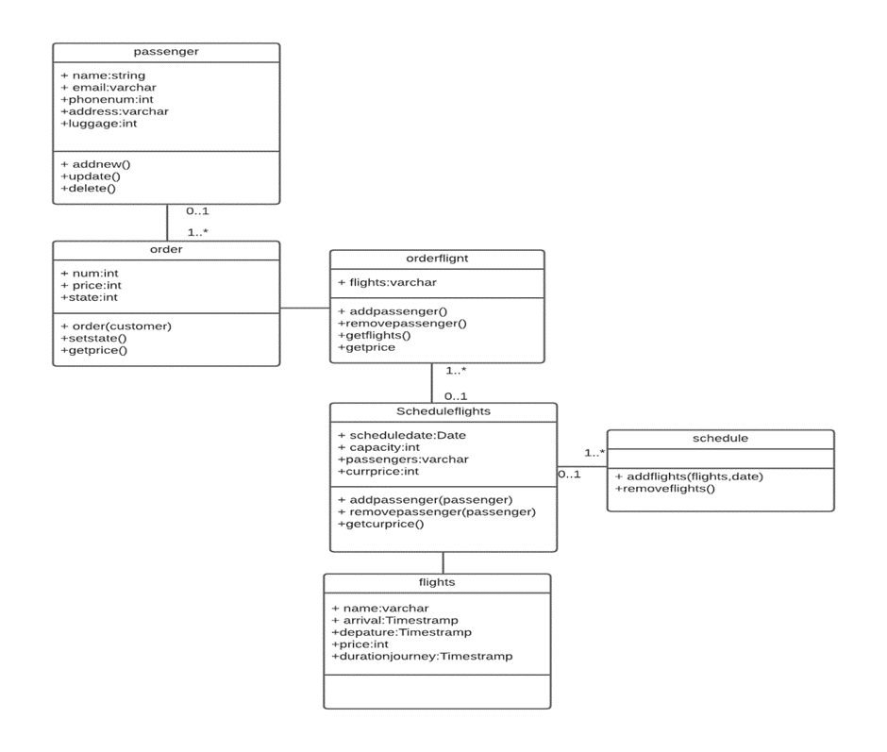

1. Uml activity diagram for student registration in university

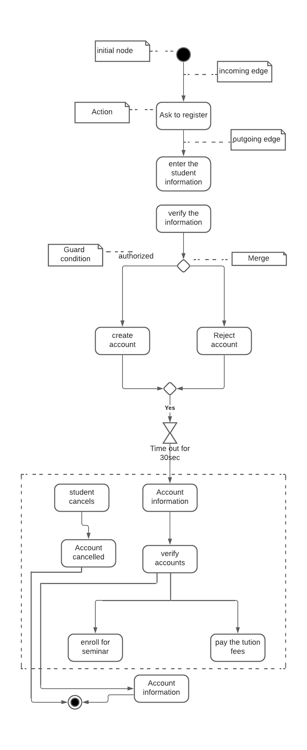

1. Uml class diagram for university and departments

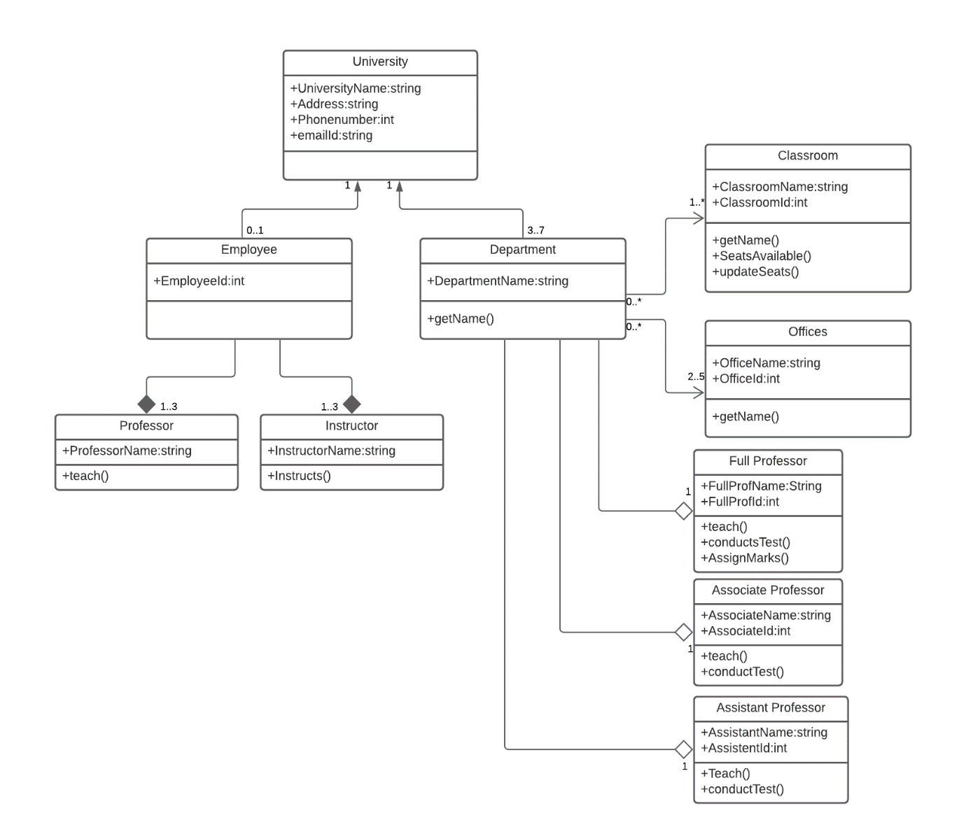

1. Uml sequence diagram

