EPIC

Our project will be an android app that is launched by pressing the app icon on the home screen. This app will allow the user to input text using the on-screen keyboard and convert audio to text through the implementation of text to speech. It will have the following modules:.........

UI Design

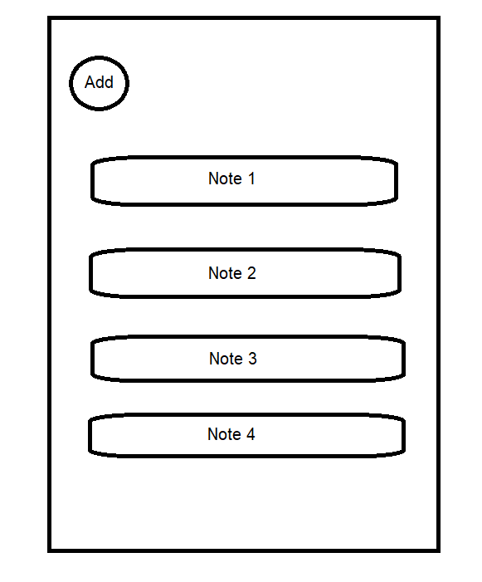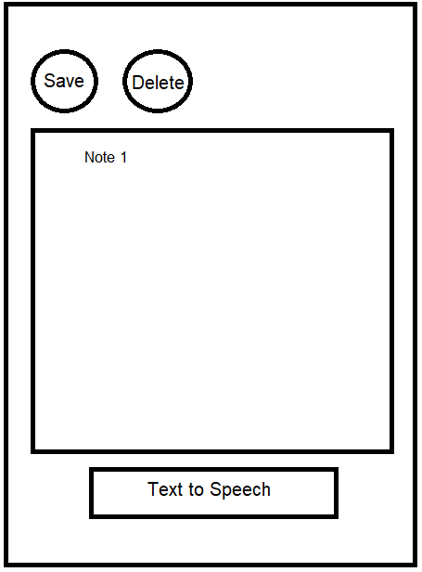

Functional Requirements

* New
* Open
* Save
* Delete
* Exit
* TTS

Non-Functional

* Ability to access notes quickly
* Security so only you can access notes
* Database will have a large capacity
* Seamless transition between notes
* Ability to create/delete/save notes quickly and easily

Error-handling, help, comments, code guidelines, and architectural guidelines

Code Guidelines:

* CamelCase
* Comments for every method
* Use classes and inheritance
* Try and catch for error handling