Software Requirements Specification for PhotoBomber

Version XX.XX

PhotoBomber Studios, LLC

Spring 2013

Table of Contents

Revision History
Name | Date | Reason for Changes | Version
Julian Nguyen | 4/3/2013 | Defining an valid Album name. | 2.001
Alejandro Sosa | 4/04/13 | Added screenshots/UML, fixed typos | 2.002

Introduction

>Purpose
This Software Requirements Document (referred to as SRS) defines the scope of the various phases of the CS 441 Software Project for Spring 2013. (Hereafter referred to as PhotoBomber)

>Document Conventions
<write something about how to read this document.>

>Intended Audience and Reading Suggestions
The SRS is to be used by Testers, Programmers and Analysts. Only Analysts will modify the document. The SRS is organized to give an overview of PhotoBomber, followed by specifics and then covers other related requirements. It is recommended that all readers read the entire document. Testers and Programmers should pay special attention to the System Features section. Testers will use the Functional Requirements section as a starting point for their test cases.

>Project Scope

PhotoBomber is a simple photo manager.

The project will be divided into three "sprints."

PhotoBomber will be a simple photo album. The project will be divided into three phases. For the first phase, PhotoBomber will allow users to create an album, name it and “fill” it. In addition, users can view reports. During the second and third phase, PhotoBomber will be enriched with added functionalities to create a more robust photo album software application.

>References
The document, Project.pdf, defines the overall goals of the Software project and can be found at http://cc.csusm.edu.

>>Overall Description

>Product Perspective
PhotoBomber is a new, self-contained product that is not part of any larger system.

>Product Features
PhotoBomber is a stand alone Image and Album manager.
The product feature are listed in detail in Section 3.

>User Classes and Characteristics
PhotoBomber is for and will be used by the End-user.

>Operating Environment
PhotoBomber is designed to run on Windows Vista, Windows 7 and Windows 8 operating systems.
An order for PhotoBomber to run, the operating system must have .NET Framework 4.0 or greater.

>Design and Implementation Constraints
PhotoBomber will be delivered to the End-user as a stand alone executable.
The executable is written in C# using Microsoft Visual Studio 2010, Microsoft Visual Studio 2012 and Microsoft Expression Blend.

>User Documentation
The current Team Analysts will compose and deliver a End-user manual detailing the uses of PhotoBomber. The End-user manual will be easy to understand and complete with screen shots of PhotoBomber.

>Assumptions and Dependencies
Hardware assumptions and dependencies
- The End-user's computer must have enough secondary storage to store all the Images the End-user hopes to manage using PhotoBomber.
- The End-User's computer must have at least 512 MB of RAM.
- PhotoBomber will only be expected to handle 500,000 Images total
- PhotoBomber will only be expected to handle 1000 Albums total.
Software assumptions and dependencies
- The End-user operating Environment must have the .NET framework 4.0 or greater installed to use PhotoBomber.

>3>System Features

Library → Album → Image!

Library Manipulation
The User can manipulate the Library in the following ways:
- The User can view the Library.
  - The Library can be viewed as an array/grid.
    - The array/grid is made of Albums in the Library.
    - Each element in the array/grid will display the Album cover and the Album name.

Album Manipulation
The User can manipulate an Album in the following ways:
- The User can add an Album to the Library.
    - A new Album can be added to the Library.
      - On creation of a new Album, the User must supply the valid name for the new Album.
      - On creation of a new Album, the Album will have a default Album cover.
- The User can remove an Album from the Library.
    - An Album can removed from the Library.
- The User can rename an Album in the Library.
    - An Album can be renamed.
      - The new Album name must be a valid Album name.
- The User can associated an Image to an Album.
    - An Image can be associated to an Album.
      - When a Image is associated to an Album, the Image will be given a Image default name.
    - An Image that are/is associated to Album can be disassociated from the same Album.
    - An Image can be associated to one or more Albums.
    - An Image will not be associated to an Album more than one time.
- The User can view an Album.
    - An Album can be viewed as an array/grid of the Images associated to an Album.
      - The array/grid is made of thumbnails of the Images associated to an Album.
    - The User can view a Slide Show of the Images associated to an Album.
- The User can pick an Album cover for an Album.
    - Any Image associated to an Album can be the Album's cover.
    - If the image that is the Album cover is disassociated from the Album, then Album will be given the default Album cover.
- The User can select Images associated to an Album and sent it another existing Album.
    - The set of selected of Images cannot be the empty set.
    - The set of selected of can only content Images associated to source Album.

Image Manipulation
The User can manipulate a Image in the following way:
- The User can rename an Image.
    - An Image can be renamed to any valid Image name.
      - If the Image is associated to more than one Album, then the change in the Image name is localized to an Album and independent of any other Album.
- The User can view an Image.
    - An Image can be viewed.
- The User can annotate an Image.
    - A comment can be added to an Image.
      - If the Image is associated to any other Album, then adding a comment is localized to Album and independent of any other Album.
    - An Image with an existing comment can be modified.
      - If the Image is associated to any other Album, then modifying an existing comment is localized to Album and independent of any other Album.

Valid characters for PhotoBomber
- For a character to be valid, it must be from one of the following Unicode categories:
  - Li
  - Lu
  - Lt
  - Lo
  - Lm
  - Nd
  - Pc

Default Album Cover
The default Album cover is defined in the User Interfaces section.

PhotoBomber Naming Requirements

Default Image Naming
- The Photo default name is constructed in the following this format: “<Album Name> Image <Number>”
  - Such that <Album Name> is the name of the Album that the Photo is associated to.
  - Such that <Number> is lowest positive integer that is not taken by another Photo with a Photo default name.
  - The default Image name given must be a valid Image name.

Image Naming
- For an Image name to be valid it must have all of the following attributes:
  - An Image name can only contain valid characters.
  - An Image name must not have leading or trailing whitespace characters.
  - An Image name must be at least 1 character and not exceed 32 characters
  - If Image X is associated to Album Y, then there must not be another Image associated to Album Y with the same name as Image X.

Album Naming
- For an Album name to be valid it must have all of the following attributes:
  - An Album name can only contain valid characters.
  - An Album name must not have leading or trailing whitespace characters.
    - The leading or trailing whitespace characters are to be trimmed for the Album name.
    - The leading or trailing whitespace characters are not counted to towards the length of the Album name.
  - An Album name must be at 1 character and not exceed 32 characters.
  - If Album X is in the Library, then there must not be another Album in the Library with the same name as Album X.

>>System Design

Overall System Design
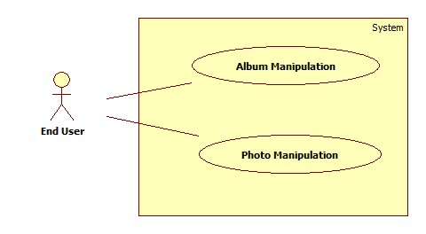

Album Manipulate Design
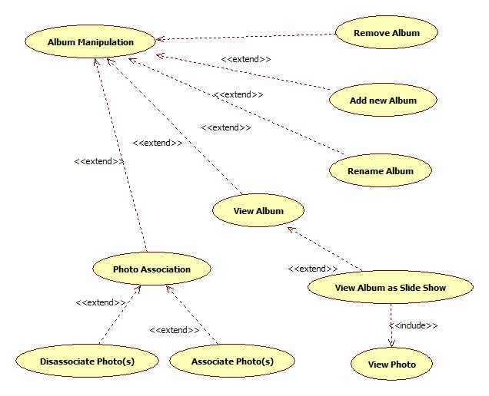

Image Manipulate Design
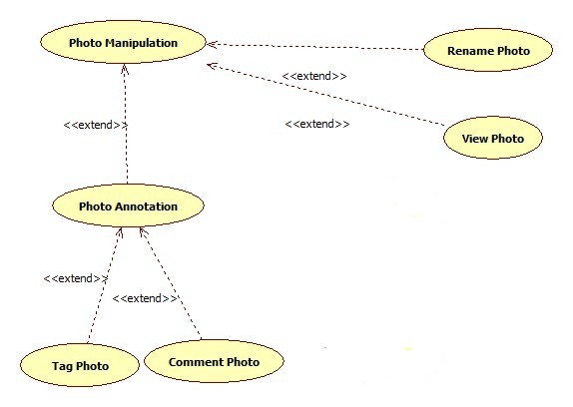

External Interface Requirements

User Interfaces
Library View.
Album View.
Image View
Slide Show View.
About View.

Library View
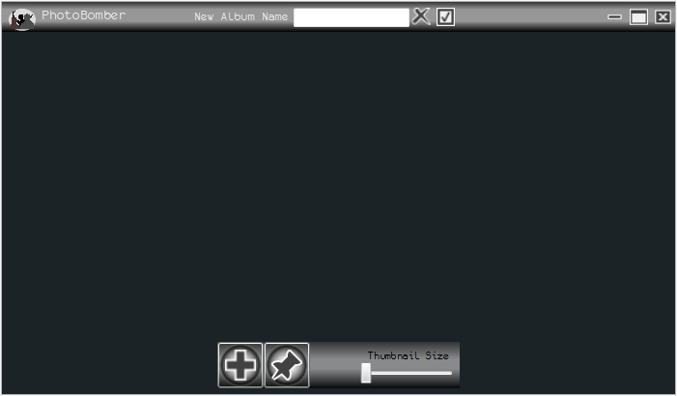
Thumbnail Slider
Add Button
Dock
Maximize
Minimize
About Button
Exit
Create Album Dialog
Clipboard
Program Name
Library View

Library View
- Library View has the following qualities:
  - The Library View is in a window.
- The Album View has the following elements.
  - The Library View has a title bar.
The title bar has the following elements listed from left to right:
    - There is a button sporting the PhotoBomber logo.
    - There is a label with the 'PhotoBomber'.
    - If the button with plus symbol on the dock activated, then
      - There is label with the words 'New Album Name'
      - There is a textfield.
      - There is a button with an 'X' symbol.
      - There is a button with of a checked box.
    - There is the Windows minimize button.
    - There is the Windows maximize button.
    - There is the Windows close button.
  - The Album View has a dock.
The dock has the following elements listed from left to right:
    - There is a Button with a plus symbol.
    - There is a Button with a canted U-turn symbol.
    - There is a Button with a push pin symbol.
    - There is a slider with a label above it with the words 'Thumbnails Size'

Album View
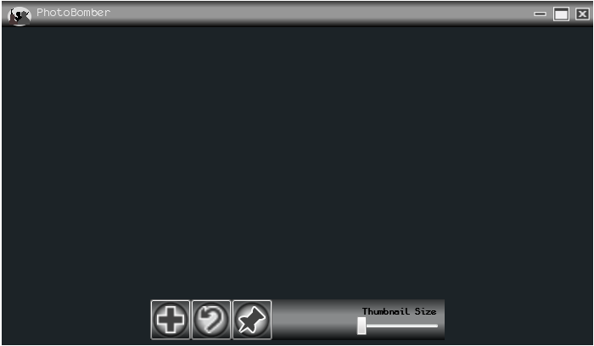
Thumbnail Slider
Add Button
Dock
Maximize
Minimize
About Button
Exit
To Library Button
Clipboard
Program Name
Album View

Album View
- Album View has the following qualities:
  - The Album View is in a window.
- The Album View has the following elements.
  - The Album View has a title bar.
The title bar has the following elements listed from left to right:
    - There is a button sporting the PhotoBomber logo.
    - There is a label with the 'PhotoBomber'.
    - There is the Windows minimize button.
    - There is the Windows maximize button.
    - There is the Windows close button.
  - The Album View has a dock.
The dock has the following elements listed from left to right:
    - There is a Button with a plus symbol.
    - There is a Button with a canted U-turn symbol.
    - There is a Button with a push pin symbol.
    - There is a slider with a label above it with the words 'Thumbnails Size'

Image View
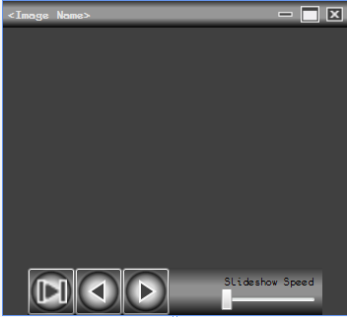
Name of the Image
View Image Window
Maximize
Minimize
Exit
Speed Control
Slideshow Button
Dock
Previous Button
Next Button
Image View
- Image View has the following qualities:
  - The Image View is in a window.
- The Image View has the elements.
  - The Image View has a title bar.
The title bar has the following elements listed from left to right:
    - There is a label with the name of the Image.
    - There is the Windows minimize button.
    - There is the Windows maximize button.
    - There is the Windows close button.
  - The Image View has a dock.
The dock has the following elements listed from left to right:
    - There is a Slideshow Button with a Play/Pause symbol.
    - There is a Previous Button with a triangle symbol.
    - There is a Next Button with a triangle symbol.
    - There is a slider with a label above it with the words 'Slideshow Speed'

Slide Show View

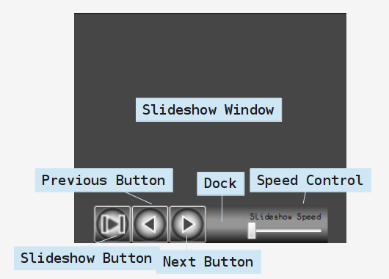
Slide Show View
- Slide Show View has the following qualities:
  - The Slide Show View is full screen.
- The Slide Show View has the elements.
  - The Slide Show View has a dock.
The dock has the following elements listed from left to right:
    - There is a Slideshow Button with a Play/Pause symbol.
    - There is a Previous Button with a triangle symbol.
    - There is a Next Button with a triangle symbol.
    - There is a slider with a label above it with the words 'Slideshow Speed'

About View

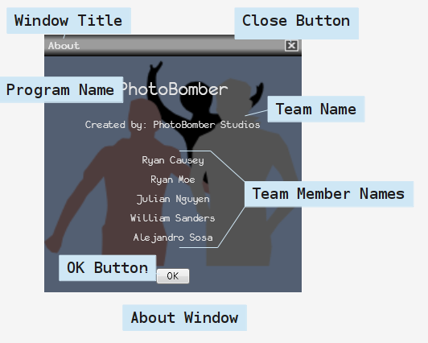
About View
- About View has the following qualities:
  - The Slide Show view is a window.
- The About View has the elements.
  - The About View has a title bar
The title bar has the elements listed from left to right:
    - There is a label with the words 'About'
    - There is a button with the symbol of a 'X' in a box.
  - There is a label of the the application name 'PhotoBomber'.
  - There is a label of the the application name 'PhotoBomber Studios, LLC'.
  - There is a label with the words 'Ryan Causey'.
  - There is a label with the words 'Ryan Moe' .
  - There is a label with the words 'Julian Nguyen '.
  - There is a label with the words 'William Sanders' .
  - There is a label with the words 'Alejandro Sosa'.
  - There is a Button label 'OK'.

Default Album Cover
<Define the default Album Cover here.>

Hardware Interfaces
For the End-user to interact with PhotoBomber, the End-user must have a:
Keyboard.
Mouse
Display (x server like thing)

Software Interfaces
The PhotoBomber must work as described on the following Operating Systems
- Windows Vista
- Windows 7

Programmer Requirements
- The PhotoBomber will not interface with any other software components. No data will be shared with any other software.

PhotoBomber Database
There is a database for PhotoBomber. The database is where the user data will be stored.
The PhotoBomber database is defined to have the following qualities:
- The PhotoBomber database is long-term persistent storage for the User data.
- The PhotoBomber database will reflect changes to the User data.
    - All changes in PhotoBomber Library will be reflected in PhotoBomber database.
    - All changes in the User's Albums will be reflected in PhotoBomber database.
    - All changes to a User's Image will reflected in PhotoBomber database
- The PhotoBomber database is made of components.
    - There is a directory containing all the Images in PhotoBomber.
      - This directory will not contain duplicates of any Images.
    - There is a directory containing thumbnail of all the Images in PhotoBomber.
      - This directory will not contain duplicates of any thumbnails.
    - There is an XML file cataloging all the Images in PhotoBomber.
    - There is an XML file cataloging all the Albums in PhotoBomber.
- If PhotoBomber database has a missing thumbnail, then PhotoBomber will regenerate the thumbnail for that Image if the Image is not missing.
- If one or more of PhotoBomber database XML files is missing or corrupted, then PhotoBomber will rebuild the PhotoBomber database.
    - If PhotoBomber database contains User Images.
      - All the User's Images will be consolidate into one new Album. This new Album is called “Backup Recover Album”
- The PhotoBomber database will be saved in the User's local appdata.

Performance Requirements
There are performance requirements.

Safety Requirements
There are no safety requirements.

Security Requirements
There are no security requirements.

Software Quality Attributes
There are no quality attributes requirements.

Other Requirements
- Data will be stored in a file using an XML schema to be designed initially by the Programmers.
- Programmers will extreme program.
  - Programmers will work as a team and strive to cooperate.
  - Programmers will take turns at the keyboard.
- Channels of Communication
  - Programmers may not talk to Testers except to hand off code for testing.
  - All communication between Programmers and Testers will be via the bug database or through the Analyst(s).

Approval
Before beginning work on PhotoBomber, all parties must sign off on the SRS

Phase 1
ROLE | NAME | SIGATURE | DATE
Programmer
Programmer
Software Analyst
Software Analyst
Tester
Tester

Phase 2
ROLE | NAME | SIGATURE | DATE
Programmer
Programmer
Software Analyst
Software Analyst
Tester
Tester

Phase 3
ROLE | NAME | SIGATURE | DATE
Programmer
Programmer
Software Analyst
Software Analyst
Tester
Tester

Appendix A: Glossary
- Two Images are said to be equal if and only if the two Image have an equal hash sum.
- A Library is a User defined collection of Album.
- An Album is a User defined collection of Images.
- PhotoBomber: The program to be completed by PhotoBomber Studios, LLC. <change this.>

Appendix B: Use Case Documentation

Use Case List
Use Case Number | Use Case Name | Primary Actor
AM00 | Add an Album to the Library. | End-User
AM01 | Remove an Album from the Library. | End-User
AM02 | Rename an Album | End-User
AM03 | Associated an Image to an Album | End-User
AM04 | Disassociated an Image to an Album. | End-User
AM05 | View an Album. | End-User
AM06 | Pick an Album cover for an Album | End-User
AM07 | Send Image From one Album to another Album. | End-User

Appendix C: Issues List
- Bug ID 20: There is no way to currently remove a photograph from PhotoBomber. This should be addressed second cycle.
- Bug ID 22: The SRS wire-frame does not have proper punctuation for add new album dialogue as stated by this bug. Will address in second cycle as currently, PhotoBomber conforms to the current version of the SRS.
- Bug ID 26: The functionality of using the keyboard to navigate around PhotoBomber needs to be documented in the SRS for next cycle as it is currently enabled. It also should be enabled consistently throughout PhotoBomber.
- Bug ID 29: The SRS needs to add an error flow for this bug into the relevant use case for next cycle.
- Bug ID 30: The application does not currently function correctly on Windows XP. This needs to be addressed next cycle.
- Bug ID 34: There is no error flow related to this error in the SRS so the next cycle SRS should document this case and then the programmers implement the required fix.
- Bug ID 35: PhotoBomber cannot handle its XML and photo folders being moved or deleted. There is not an error flow for this and should possibly be documented in the next cycle SRS. This definitely needs to be fixed second cycle.
- Bug ID 36: Either define a assumption in the SRS that the application will be run on the local hard drive and give installation instructions to install the application on the local hard dive in the readme or add this functionality to the SRS requirements and implement it next cycle.
- Bug ID 37: Need to document these additional ways to exit PhotoBomber as the programmers do not have control over these exit functionalities as far as we know right now. Document these in second cycle SRS.
- Inconsistency with the SRS requirements section name and GUI wire-frame names(E.G. SRS requirement heading Album View corresponds to FrontPage in the GUI wire-frame) needs to be addressed and fixed next cycle.
- Delete album functionality also needs to be implemented next cycle.
- A functionality to make sure duplicate photo files are not imported into PhotoBomber folder needs to be implemented next cycle.
- Ryan Causey is the best analyst??

