Reproducible Research: Peer Assessment 1

## Loading and preprocessing the data

* load needed packages
* load the data file

library(dplyr)

## Warning: package 'dplyr' was built under R version 3.2.3

##   
## Attaching package: 'dplyr'

## Следующие объекты скрыты от 'package:stats':  
##   
## filter, lag

## Следующие объекты скрыты от 'package:base':  
##   
## intersect, setdiff, setequal, union

library(ggplot2)

## Warning: package 'ggplot2' was built under R version 3.2.3

rs = read.csv("activity.csv")

## What is mean total number of steps taken per day?

* group the dataset by date
* summarise the grouped data by sum of steps
* create a histogram
* calculate the mean and the median of the total number of steps taken per day.

rs.q.1 = rs %>%   
 group_by(date) %>% #group the data  
 summarize(sum=sum(steps)) %>% #summarize it  
 .[["sum"]] #get the sum column  
  
#create a histogram  
hist(rs.q.1, xlab="Number of steps, per day",col=1:5,main="Total number of steps per day")

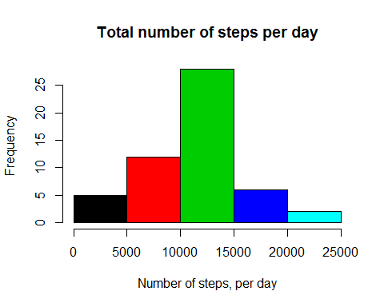

#calculate and print the mean and the median  
mean.steps = mean(rs.q.1,na.rm=T)  
median.steps = median(rs.q.1,na.rm=T)  
print(mean.steps)

## [1] 10766.19

print(median.steps)

## [1] 10765

## What is the average daily activity pattern?

* group the data by an interval
* summarise the grouped data by the mean of steps
* Make a time series plot (i.e. type = “l”) of the 5-minute interval (x-axis) and the average number of steps taken, averaged across all days (y-axis).

rs.q.2 = rs %>%   
 group_by(interval) %>% #group the data  
 summarize(mean.steps=mean(steps,na.rm=T)) #summarize it  
  
#create the time-series plot  
plot(rs.q.2$interval,rs.q.2$mean.steps, type="l",xlab="Interval", ylab="Average number of steps", main="Average number of steps averaged over all days")

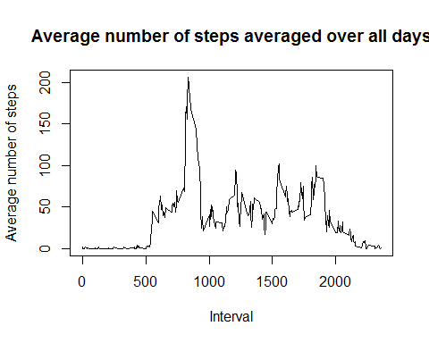

#search for the interval containing the maximum number of steps  
max.steps.interval = rs.q.2[which.max(rs.q.2$mean.steps),]  
print(max.steps.interval)

## Source: local data frame [1 x 2]  
##   
## interval mean.steps  
## (int) (dbl)  
## 1 835 206.1698

## Imputing missing values

* Calculate the total number of missing values in the dataset
* Impute the missing values using the daily mean
* Make a histogram of the total number of steps taken each day
* Calculate and report the mean and median total number of steps taken per day and compare it with the same values, calculated using the original dataset

#calculate the total number of missing values  
na.quantity = sum(!complete.cases(rs))  
print(na.quantity)

## [1] 2304

#copy the original dataset to the new one  
rs.q.3 = rbind(data.frame(),rs)  
  
#impute missing values using daily means  
for(row in 1:nrow(rs)) {  
 if(is.na(rs[row,"steps"])) {  
 c.date = rs[row,"date"]  
 rs.q.3[row,"steps"] = mean(rs["date"==c.date,"steps"],na.rm=T)  
 }  
}  
  
rs.q.3 = rs.q.3 %>%  
 group_by(date) %>% #group by date  
 summarize(sum=sum(steps)) %>% #summarise it  
 .[["sum"]] #get the sum column  
  
#create a histogram  
hist(rs.q.3, xlab="Number of steps, per day",col=1:5,main="Total number of steps per day")



#calculate the mean and the median of the imputed dataset  
mean.steps.imputed = mean(rs.q.3,na.rm=T)  
median.steps.imputed = median(rs.q.3,na.rm=T)  
  
answers = c(mean.steps,mean.steps.imputed,median.steps,median.steps.imputed)  
names(answers) = c("mean of the original","mean of the imputed","median of the original","median of the imputed")  
print(answers)

## mean of the original mean of the imputed median of the original   
## 10766.19 10766.19 10765.00   
## median of the imputed   
## 10765.00

## Are there differences in activity patterns between weekdays and weekends?

* Create a new factor variable in the dataset with two levels – “weekday” and “weekend” indicating whether a given date is a weekday or weekend day.
* Make a panel plot containing a time series plot of the 5-minute interval (x-axis) and the average number of steps taken, averaged across all weekday days or weekend days (y-axis)

#use the function for separating weekdays from weekands  
weekends.or.weekdays = function(x){  
 w = as.POSIXlt(as.Date(x, "%Y-%m-%d"))$wday  
 if (w == 0 | w == 6) {  
 "weekend"  
 } else "weekday"  
}  
#create the new factor variable "day"  
rs$day = vapply(rs$date,weekends.or.weekdays,character(1))  
rs$day = as.factor(rs$day)  
  
rs.q.4 = rs %>%  
 group_by(interval,day) %>% #group by an interval and a day  
 summarize(mean.steps=mean(steps,na.rm=T)) #summarize it, using mean function  
  
#create a plot  
p = qplot(interval, mean.steps, data=rs, geom=c("line"), xlab="Interval",ylab="Number of steps",facets=.~day)  
print(p)

