Software Engineering for Electrical Engineers · Module C: Software Architectures

Mini Energy Gateway
Lab Exercise – Task 1 (Requirements) and Task 2 (Architecture)
Item | Details
Author | Chuhan Zheng
Matriculation number | 03822471
Team | Software Project
Repository | https://gitlab.lrz.de/00000000014C491E/mini-energy-gateway
Date | 3 November 2026

1 Introduction

1.1 Scenario
A solar inverter provides its measurements over Modbus TCP. The Mini Energy Gateway is a software component that reads these measurements cyclically and makes them available to IT systems in two ways: on request via a REST API (pull) and continuously via MQTT (push). This document defines the requirements for the gateway (Task 1) and describes and justifies its architecture (Task 2). The implementation of Tasks 3–5 follows this design.

1.2 Scope
In scope:
- Reading the DC voltage (register 0x0010) and the AC power (register 0x0020) of one inverter via Modbus TCP.
- Providing the latest readings via GET /api/measurements (FastAPI).
- Publishing the readings as JSON to the topic solar/inverter01/readings every 5 s (paho-mqtt, Mosquitto broker).
Out of scope: writing setpoints to the inverter, long-term storage of measurement history, a graphical user interface, and support for several inverters (the design, however, allows these extensions).

1.3 Assumptions
- Each measurement is stored as a 32-bit IEEE 754 float in two consecutive holding registers (big-endian word order), as in the smart-meter example of Module C. If the simulator uses a different encoding (e.g. 16-bit integer with scale factor), only the Register Map has to be changed.
- Register addresses are zero-based protocol addresses: 0x0010 = address 16, shown as 40017 in tools that use 1-based Modbus numbering (e.g. ModRSsim2).
- Modbus unit ID 1; technology stack Python 3.11, pymodbus, FastAPI, paho-mqtt and Mosquitto; ModRSsim2 or diagslave as inverter simulator.

2 Requirements
Requirements are written as testable “shall” statements. Priorities follow the MoSCoW scheme: Must = needed for the lab exercise, Should = important for a robust gateway, Could = useful extension.

2.1 Functional Requirements
ID | Requirement | Priority
FR-01 | The gateway shall act as a Modbus TCP client and connect to the inverter; IP address, port and unit ID shall be configurable. | Must
FR-02 | The gateway shall read the DC voltage from holding register 0x0010. | Must
FR-03 | The gateway shall read the AC power from holding register 0x0020. | Must
FR-04 | The gateway shall convert raw register values into engineering units (V, W) using a configurable register map (address, register count, data type, scale factor, unit). | Must
FR-05 | The gateway shall poll the inverter cyclically; the polling interval shall be configurable with a default of 5 s. | Must
FR-06 | The gateway shall attach a UTC timestamp (ISO 8601) and a device identifier to every set of readings. | Must
FR-07 | The gateway shall keep the most recent valid set of readings available in memory. | Must
FR-08 | The gateway shall provide the latest readings as JSON via HTTP GET /api/measurements. | Must
FR-09 | If no reading has been acquired yet, GET /api/measurements shall respond with HTTP 503 and an error message instead of returning invented values. | Should
FR-10 | The gateway shall publish the latest readings as a JSON payload to the MQTT topic solar/inverter01/readings every 5 s. | Must
FR-11 | The REST response and the MQTT payload shall use the same JSON schema (Section 2.2). | Should
FR-12 | The gateway shall automatically re-establish lost connections to the inverter and to the MQTT broker. | Must
FR-13 | Each reading shall contain a status field (ok, stale, error); data shall be marked stale if the last successful read is older than three polling intervals. | Should
FR-14 | The gateway shall announce its online/offline state on solar/inverter01/status using a retained MQTT last-will message. | Could
FR-15 | The REST API shall provide a machine-readable OpenAPI description (Swagger UI at /docs). | Could

2.2 Data Interface (JSON Payload)
The same payload is returned by the REST API and published via MQTT:
{
"device_id": "inverter01",
"timestamp": "2026-11-03T10:15:00Z",
"dc_voltage_v": 612.4,
"ac_power_w": 4870.0,
"status": "ok"
}
Field | Type | Description
device_id | string | Identifier of the inverter (from configuration).
timestamp | string | Time of the Modbus read, ISO 8601, UTC.
dc_voltage_v | number | DC voltage in volts (register 0x0010).
ac_power_w | number | AC power in watts (register 0x0020).
status | string | ok = current data, stale = last successful read too old, error = read failed.

2.3 Non-Functional Requirements
ID | Category | Requirement | Verification
NFR-01 | Performance | GET /api/measurements shall respond within 100 ms (95th percentile), since it is served from memory and never waits for a Modbus request. | Load test with 10 parallel clients
NFR-02 | Timing | MQTT messages shall be published at intervals of 5 s ± 0.5 s (soft real-time: a late message degrades monitoring but causes no safety issue). | Log receive times with mosquitto_sub for 30 min
NFR-03 | Data freshness | Under normal operation, delivered values shall be no older than one polling interval plus 1 s. | Compare payload timestamp with receive time
NFR-04 | Reliability | A failure of one interface (inverter, broker or HTTP client) shall neither stop the other interfaces nor terminate the process. | Fault injection: stop simulator / broker
NFR-05 | Recoverability | When the inverter or broker becomes reachable again, the gateway shall resume normal operation within 10 s without manual intervention. | Fault injection test
NFR-06 | Availability | The gateway shall run for at least 24 h without restart and without growing memory consumption. | Soak test with memory monitoring
NFR-07 | Maintainability | Modbus-specific code shall be confined to the HAL; adding a register or replacing the field protocol shall not require changes to the REST or MQTT components. | Code review, dependency check
NFR-08 | Configurability | All deployment parameters (Modbus host, port, unit ID, register map, polling interval, broker address, topic, HTTP port) shall be configurable without code changes. | Run with modified configuration
NFR-09 | Portability | The gateway shall run on Python 3.11 on Windows and Linux, including edge hardware such as a Raspberry Pi or a Docker container. | Test on two platforms
NFR-10 | Resource usage | The gateway shall use less than 100 MB RAM and less than 10 % CPU on a Raspberry Pi 4 at a 5 s polling interval. | Measure with top / Task Manager
NFR-11 | Security | The gateway shall access the inverter read-only (read function codes only); the MQTT connection shall support username/password authentication and TLS. | Code review, broker configuration test
NFR-12 | Observability | Connection state changes and errors shall be logged with timestamp and severity level. | Inspect log during fault injection
NFR-13 | Testability | The Modbus Reader shall be replaceable by a mock or simulator so that REST and MQTT can be tested without hardware; the decoding logic shall be covered by unit tests. | Automated tests (pytest)
NFR-14 | Interoperability | Only open standards shall be used at the interfaces: Modbus TCP, HTTP/JSON, MQTT 3.1.1/5.0 and ISO 8601 timestamps. | Interface review

3 Architecture

3.1 Component Diagram
Figure 1 shows the components of the gateway, their assignment to the layers and the interfaces to the external systems. The editable source is docs/architecture.drawio (draw.io).
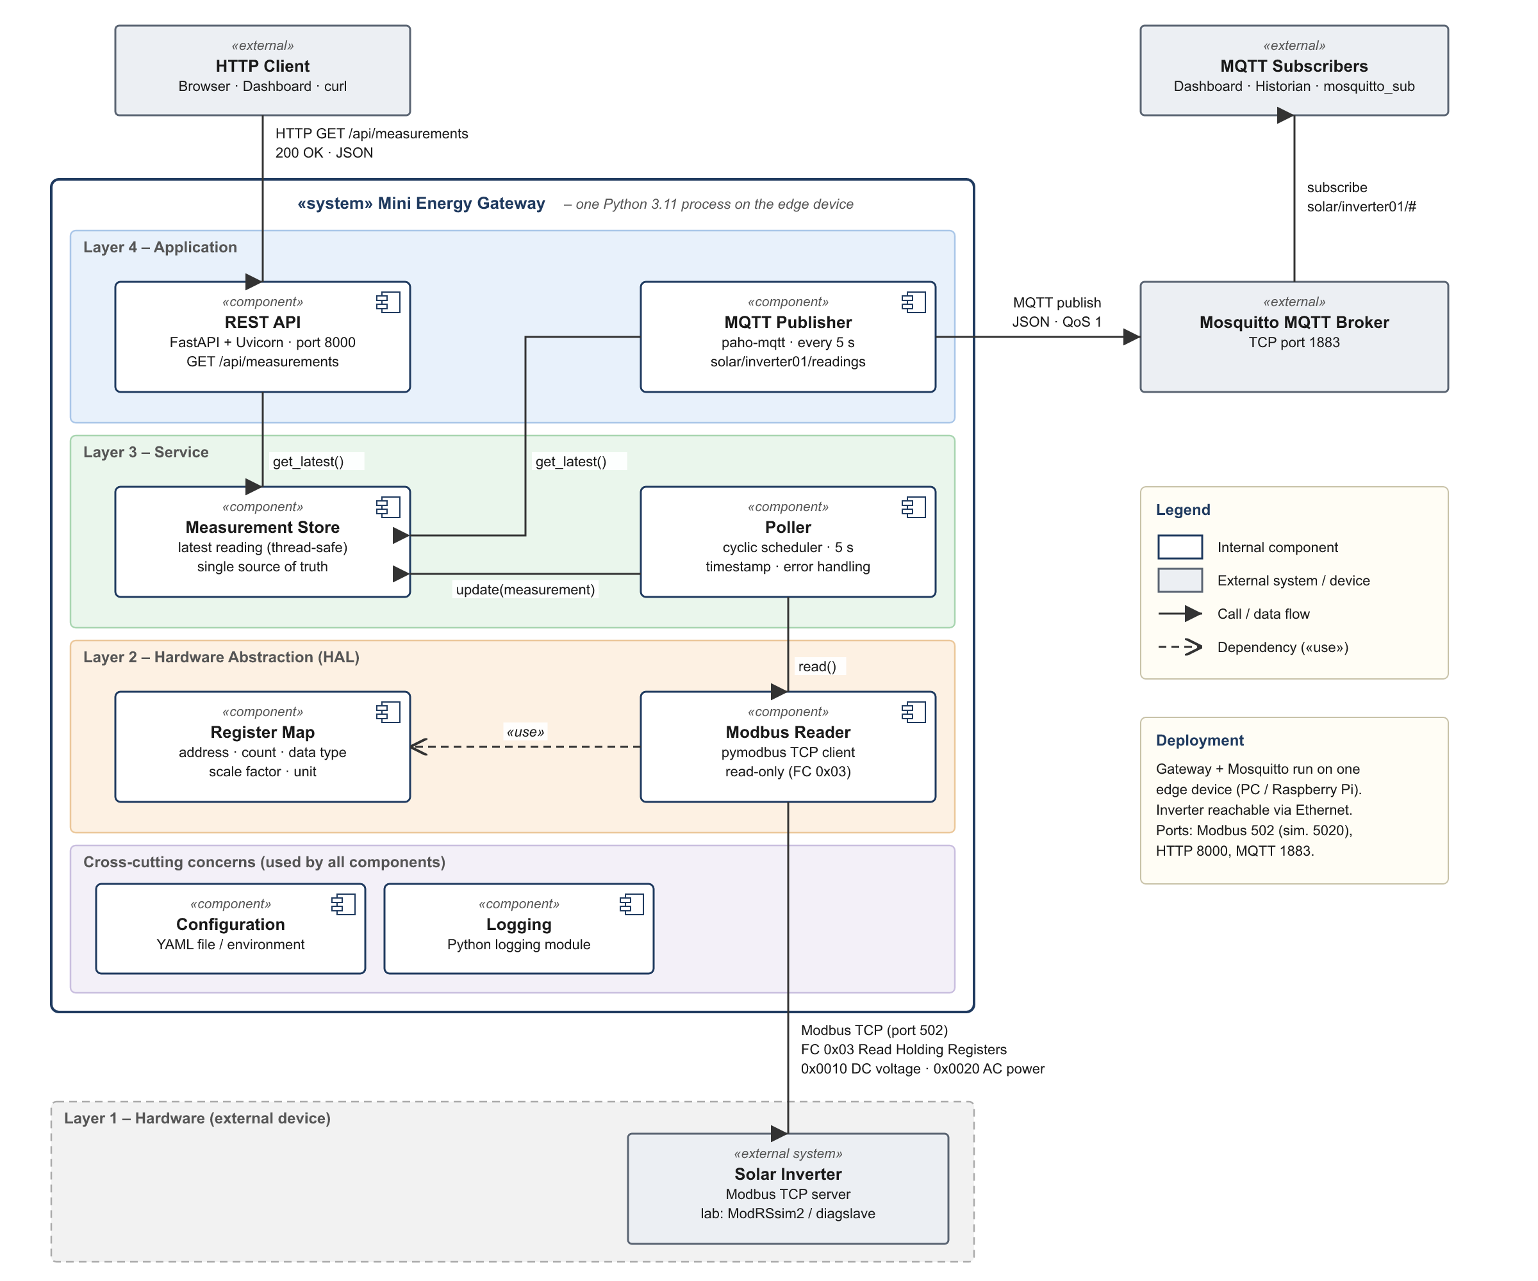
Figure 1 – Component diagram of the Mini Energy Gateway (layered architecture)

3.2 Components
Component | Layer | Responsibility | Technology / Lab task
REST API | Application | Handles GET /api/measurements: reads the latest reading from the Measurement Store and returns it as JSON, or HTTP 503 if none exists. | FastAPI, Uvicorn  Task 4
MQTT Publisher | Application | Every 5 s serialises the latest reading to JSON and publishes it to solar/inverter01/readings (QoS 1); manages the broker connection and the last-will message. | paho-mqtt  Task 5
Measurement Store | Service | Thread-safe in-memory holder of the latest reading; single source of truth for both outputs. | Python class with lock
Poller | Service | Triggers a read every polling interval, adds timestamp and status, updates the store, handles errors and reconnects. | Background thread
Modbus Reader | HAL | Encapsulates all Modbus details: connection, Read Holding Registers (FC 0x03) and decoding of register words. Offers a protocol-independent read() interface. | pymodbus  Task 3
Register Map | HAL | Declarative description of each measurement: address, register count, data type, scale factor, unit. | YAML / Python dict
Configuration | Cross-cutting | Loads all deployment parameters from a file or environment variables. | YAML, env variables
Logging | Cross-cutting | Uniform logging of state changes and errors for all components. | Python logging

3.3 External Interfaces
Interface | Protocol | Role of gateway | Details
IF-1 Inverter | Modbus TCP, port 502 (simulator e.g. 5020) | Client (master) | FC 0x03 Read Holding Registers; 0x0010 DC voltage, 0x0020 AC power; 2 registers each (float32).
IF-2 REST | HTTP/1.1, port 8000 | Server | GET /api/measurements → 200 + JSON, or 503 if no data is available.
IF-3 MQTT | MQTT 3.1.1 over TCP, port 1883 | Publisher (client of the broker) | Topic solar/inverter01/readings, QoS 1, every 5 s; status topic with last will.

3.4 Runtime Behaviour
- At start-up the gateway loads the configuration, connects to the MQTT broker and starts the Poller, the publish timer and the HTTP server.
- Every 5 s the Poller calls ModbusReader.read(). The reader sends Read Holding Registers requests for 0x0010 and 0x0020 and decodes the responses using the Register Map.
- The Poller adds timestamp and status and writes the new measurement to the Measurement Store.
- Every 5 s the MQTT Publisher takes the latest measurement from the store and publishes it; the broker forwards it to all subscribers.
- Independently, an HTTP client calls GET /api/measurements; the REST API answers from the store without contacting the inverter.
- If the inverter does not respond, the Poller logs the error and reconnects, the status changes to stale, and REST and MQTT keep working.

4 Choice of Architecture Model

4.1 Candidate Models from Module C
The following table assesses the architectural styles, system types and patterns presented in Module C for this exercise:
Model (Module C) | Fit for this exercise | Role in the design
Layered architecture | High – the gateway translates between a hardware protocol (bottom) and IT protocols (top), which matches the 4-layer embedded model. | Primary structural style
Modular / component-based | High – each component has one responsibility and communicates only via declared interfaces. | Structuring principle inside the layers
Publish/subscribe | High – required by Task 5; the broker decouples the gateway from all consumers. | Communication pattern for MQTT (push)
Client-server | High – required by Task 4; clients request data on demand. | Communication pattern for REST (pull)
Monolith (system type) | High – small scope, one edge device, one team. | Deployment model
Pipes & filters | Partial – read → decode → timestamp → publish is a linear chain, but there is no reconfigurable processing pipeline. | Not used as main style
State machine | Partial – suitable for the connection state (connected / disconnected / reconnecting). | Possible detail inside the Poller
Microservices | Low – distribution overhead without benefit for one device. | Rejected (Section 4.3)
MVC / MVP / MVVM | Not applicable – the gateway has no user interface. | Not used
Kruchten 4+1 views | Description model, not a style. | Used to document the architecture (Section 4.5)

4.2 Why a Layered Architecture
The chosen solution is a layered architecture with modular components, combined with publish/subscribe (MQTT) and client-server (REST) as communication patterns. The reasons are:
- The structure follows the problem. A gateway translates between the field level and the IT level. The four layers of the embedded reference model from Module C map directly onto it: the inverter is the hardware, the Modbus Reader is the hardware abstraction layer, polling and caching are reusable services, and REST and MQTT are the application-level interfaces.
- Replaceable hardware access (NFR-07). All Modbus details are hidden behind the read() interface of the HAL. Another inverter model, a different register layout, Modbus RTU or OPC UA only requires a new HAL implementation or a new Register Map, while the upper layers remain unchanged – the “swap the HAL to target different hardware” advantage of layering.
- Decoupled outputs (NFR-01, NFR-04). REST and MQTT depend only on the Measurement Store, not on each other and not on Modbus. A slow or failing inverter therefore cannot block HTTP requests, and the inverter is read exactly once per cycle regardless of how many clients request data. This matters because field devices often accept only a few concurrent Modbus connections.
- Low coupling and high cohesion (NFR-07, NFR-13). Every component has a single responsibility and communicates only through declared interfaces. Each layer can be tested in isolation – the REST API with a mocked store, the HAL against the Modbus simulator.
- Fits the required communication patterns. Publish/subscribe and client-server both live in the application layer, so the two interfaces required by the exercise are added on top of the data acquisition without affecting it. New consumers such as a historian or an alarm service can subscribe to the MQTT topic without any change to the gateway.

4.3 Why a Monolith and not Microservices
The gateway is deployed as one process on the edge device. As discussed in Module C, a monolith is often the right choice for embedded and edge systems: deployment is simple, components communicate through in-memory function calls without network overhead, and debugging is easier. Microservices would provide independent deployment and horizontal scaling, but these benefits are irrelevant for a single inverter on a single device, while their costs – network latency between services, distributed failure modes and the need for orchestration – would be significant. Because the internal structure is modular, the monolith can still be split later, for example by moving the MQTT Publisher into a separate service when data from many inverters has to be aggregated.

4.4 Trade-offs and Limitations
- Indirection: data passes through several layers; for two measurements every 5 s the overhead is negligible.
- Single point of failure: if the process crashes, both interfaces are unavailable. Mitigation: automatic restart by systemd or a Docker restart policy (NFR-05).
- No history: the Measurement Store keeps only the latest value. Long-term storage is out of scope and can be added as an MQTT subscriber writing to a time-series database such as InfluxDB.
- Polling: Modbus offers no push mechanism, so the polling interval is a trade-off between data freshness and load on the inverter.

4.5 Description with the Kruchten 4+1 View Model
View | Mini Energy Gateway
Logical view | Classes ModbusReader, RegisterMap, Measurement, MeasurementStore, Poller, RestApi, MqttPublisher (see Figure 1).
Process view | Three concurrent activities in one process: the Poller thread (5 s cycle), the MQTT publish timer with the paho-mqtt network thread, and the Uvicorn event loop for HTTP. The Measurement Store is protected by a lock. All tasks are soft real-time.
Development view | One Git repository on gitlab.lrz.de with the packages gateway/hal, gateway/services, gateway/api, gateway/mqtt and the folders config/, simulator/, tests/, docs/.
Physical view | Inverter (or PC running ModRSsim2/diagslave) – Ethernet – edge device (PC or Raspberry Pi) running the gateway and Mosquitto – clients in the same network.
Scenarios (+1) | S1: a dashboard calls GET /api/measurements and receives the current values within 100 ms.  S2: a subscriber receives a new message on solar/inverter01/readings every 5 s.  S3: the inverter goes offline → the status becomes stale and the error is logged; operation resumes automatically within 10 s after the inverter is back.

5 Summary
The Mini Energy Gateway reads two measurements from a solar inverter via Modbus TCP and provides them via REST and MQTT. A layered, modular architecture isolates the hardware protocol in the HAL, decouples the two output interfaces through a shared Measurement Store, and keeps every component independently testable and replaceable. Publish/subscribe and client-server are used as communication patterns in the application layer, and the system is deployed as a single process (monolith), which is the simplest suitable choice for an edge device. Tasks 3–5 implement the Modbus Reader, the REST API and the MQTT Publisher of this design.

