PROJECT REPORT
Federated Multi-Agent Reinforcement Learning
for Privacy-Preserving Distributed
Wireless Resource Management
B.Tech Project Report
Prepared from the supplied project presentation and results archive
submitted in partial fulfilment of the requirements for
MACHINE LEARNING 25SC2107E
In
A.Y.: 2026-27
by
K. Harshit Roll no: 2520040035
N. Karthik Ram Prasad Roll NO: 2520040046
M. Tirumala Teja Roll No:2520049126
Under the Esteemed guidance of
Dr. Vinnakota Venu Balaji
Assistant Professor,
Department of ECE



Abstract
Wireless devices compete for limited radio resources, and poor allocation can reduce throughput, increase latency, create channel contention, and produce unfair service. This project studies a Python-based simulation of privacy-conscious wireless resource management using Deep Q-Network (DQN) reinforcement learning, multi-agent learning, federated averaging, and a differentially private federated variant. Four approaches are compared: Centralized DQN, Independent Multi-Agent Reinforcement Learning (MARL), Federated MARL using FedAvg, and Differentially Private Federated MARL (DP-FedMARL).
The supplied results archive describes a dataset of 15,760 wireless telemetry observations and a simulated scenario with five agents competing for three orthogonal channel options. The reported evaluation focuses on wireless and system-level measures including throughput, latency, Jain's fairness index, collision rate, resource utilization, training time, inference latency, and model-update communication overhead. The supplied comparison CSV reports the highest mean throughput for Independent MARL (5,850.26 kbps), while Federated MARL reports 4,812.40 kbps and DP-FedMARL reports 4,912.90 kbps. The highest reported Jain's fairness index is 0.3735 for Independent MARL; collision rates remain high across all approaches.
The results should be interpreted as simulation outputs, not live hardware measurements. The archive also includes a separate supervised-learning comparison containing regression and classification scores. Those scores are not treated as the main wireless-resource-management outcomes because they relate to separate prediction tasks. Differential privacy is described as an intended mechanism, but a formal privacy guarantee should not be claimed without validating the accountant, sampling assumptions, and implementation details.
Keywords: Wireless resource management, DQN, multi-agent reinforcement learning, federated learning, FedAvg, differential privacy, throughput, latency, fairness.

Table of Contents
Abstract ii
1. Introduction 1
1.1 Background and Motivation 1
1.2 Problem Statement 1
1.3 Objectives 1
1.4 Organization of the Report 2
2. System Model 2
2.1 Network Scenario 2
2.2 Dataset and Wireless Channel Abstraction 2
3. Problem Formulation 3
3.1 Markov Decision Process 3
3.2 State Space 3
3.3 Action Space 3
3.4 Reward Design 3
4. Proposed Methodology 4
4.1 Centralized DQN and Independent MARL 4
4.2 Federated MARL and DP-FedMARL 4
4.3 Training and Evaluation Procedure 5
5. Simulation Environment and Implementation 5
5.1 Software Stack 5
5.2 Simulation Parameters 6
5.3 Baselines and Data Preparation 6
6. Results and Discussion 7
6.1 Training Behaviour 7
6.2 Comparative Wireless Performance 7
6.3 Discussion, Privacy and Limitations 8
7. Conclusion and Future Work 9
8. References 10
Note: Page numbers are indicative navigation based on the report structure; update the table of contents in Word after editing or pagination changes.

1. Introduction

1.1 Background and Motivation
Wireless communication systems support mobile applications, connected devices, and data-intensive services. Radio spectrum and channel capacity are limited, so devices must share communication resources. When many devices choose the same channel, contention and interference can increase, lowering the useful data rate and raising delay. Resource management therefore needs to balance data delivery, latency, fairness, and efficient spectrum use.
Reinforcement learning provides a way to learn decisions from feedback. In a Deep Q-Network (DQN), a neural network estimates the expected long-term value of candidate actions. In a multi-agent setting, multiple agents make decisions in the same environment. Federated learning can combine model updates from local agents without requiring the central coordinator to collect all raw local training records. Differential privacy may add a formal privacy layer, but only when its mechanism and accounting assumptions are valid.

1.2 Problem Statement
The problem studied is how to allocate wireless channels among multiple competing agents while improving network performance and reducing the need to centralize local telemetry. Four approaches are compared under a common simulation: centralized joint-action DQN, independent DQN agents, federated MARL using FedAvg, and a privacy-enhanced federated variant.

1.3 Objectives
- Build a Python-based simulation for wireless resource allocation.
- Represent wireless conditions as states and channel selections as actions.
- Compare centralized, independent, federated, and DP-federated learning approaches.
- Evaluate wireless-oriented outcomes such as throughput, latency, collisions, fairness, and resource utilization.
- Measure model-update communication overhead and examine privacy-performance trade-offs where supported by the implementation.

1.4 Organization of the Report
Section 2 describes the dataset and system model. Section 3 formulates the decision problem. Section 4 explains the four learning approaches. Section 5 records the simulation setup and data preparation. Section 6 discusses the supplied results and figures. Section 7 concludes and outlines future work, followed by references.

2. System Model

2.1 Network Scenario
The results archive describes five user-equipment agents (N = 5) competing for three orthogonal channel options (K = 3), with a stated base bandwidth of 5 MHz per channel. Each agent observes a local feature vector and chooses one discrete channel index. Because there are more agents than channels, multiple agents may choose the same channel, making collision and contention outcomes important.
This is a simulation abstraction. It should not be interpreted as five ordinary phones independently controlling the channel of one standard Wi-Fi router. Real deployment would require suitable infrastructure and control over channel/resource allocation.

2.2 Dataset and Feature Preparation
The archive identifies Zenodo Record 21625252 as the source and reports 15,760 empirical observations with eight columns. Timestamp and User_ID are described as metadata excluded from the learning state. The remaining feature categories are application type, signal strength, latency, required bandwidth, allocated bandwidth, and resource allocation.
Field | Meaning / role
Timestamp | Record-time metadata; reported as excluded from the learning state.
User_ID | Subscriber/device identifier; reported as excluded from the learning state.
Application_Type | Categorical traffic profile; values reported as 0–9.
Signal_Strength | Received signal power in dBm.
Latency | Observed transmission delay in milliseconds; negative anomalies were clipped.
Required_Bandwidth | Application's requested data rate in kbps.
Allocated_Bandwidth | Bandwidth assigned to the user in kbps.
Resource_Allocation | Reported radio-resource utilization percentage.

The supplied report states that 139 negative latency anomalies were clipped to at least 0.1 ms, and that no missing values were present. It describes a fixed-seed split of 70% training (11,032 records), 15% validation (2,364), and 15% testing (2,364). A StandardScaler was reportedly fitted on the training set only. These details should be verified against the preprocessing script before final academic submission.
Throughput, goodput, BER, PER, spectral efficiency and similar evaluation measures should not be assumed to be original CSV columns. The project report describes many of them as derived or simulated metrics.

3. Problem Formulation

3.1 Markov Decision Process
The reinforcement-learning problem can be described using a Markov Decision Process (MDP): state, action, transition, reward, and discount factor. At each decision step, an agent observes its state, selects a channel, receives feedback from the simulated environment, and updates its policy to improve expected cumulative reward.
The archive reports a discount factor γ = 0.95, an episode length of 15 time steps, and 100 training episodes per paradigm. These values are configuration details, not guarantees that the policies have converged optimally.

3.2 State Space
For each decentralized agent, the reported state dimension is seven: five scaled RF-related features, one normalized application profile, and one normalized previous action. The centralized model concatenates the states of all five agents into a 35-dimensional vector (5 × 7). The precise mapping of the five RF features should be confirmed against the source code.

3.3 Action Space
Each decentralized agent has three discrete actions, indexed 0, 1, and 2, representing the three channel choices. The centralized model considers joint actions for all five agents. The reported joint action count is 3⁵ = 243 possible combinations.

3.4 Reward Design
The reward is the feedback used by the DQN to evaluate a resource-allocation action. A useful wireless reward may combine throughput or satisfied demand with penalties for latency, collisions, and unfairness. The exact mathematical reward must match the implemented reward function. Because the supplied results archive does not provide a complete source-level reward equation in the summary, this report does not invent coefficients or claim a specific formula.
The reported average cumulative rewards are negative for all four methods. Their interpretation depends on the reward definition and scale; a less negative value is better only if the implemented reward is designed so that larger rewards are preferable.

4. Proposed Methodology

4.1 Centralized DQN
Centralized DQN uses one neural network that receives the concatenated state of all five agents and outputs values for 243 joint channel-allocation actions. The archive reports an architecture of Linear(35,128) → ReLU → Linear(128,128) → ReLU → Linear(128,243), with 52,467 parameters. This baseline has a global view but requires centralized access to the agents' state information.

4.2 Independent MARL
Independent MARL uses five separate DQN agents. Each agent has a seven-dimensional input, two 64-unit hidden layers with ReLU activations, and three outputs corresponding to channel choices. Agents learn from local observations and replay buffers without model aggregation. This reduces update sharing but also limits collaborative learning.

4.3 Federated MARL with FedAvg
Federated MARL trains local DQN agents and periodically sends model parameters or updates to an aggregation server. FedAvg combines compatible parameter tensors by coordinate-wise averaging and sends a global model back to participants. The reported setup uses 10 global rounds and 10 local episodes per round, giving 100 local training episodes in total.

4.4 DP-FedMARL
DP-FedMARL adds a privacy-oriented step to federated model aggregation. The supplied configuration lists an L2 clipping threshold C = 1.0 and Gaussian noise multiplier σ = 0.01. The presence of clipping and noise alone does not establish a formal differential-privacy guarantee: the accountant, effective noise scale, sampling assumptions, number of rounds, adjacency definition and implementation must all be validated.

4.5 Methodology Block Diagram
Dataset CSV → Preprocessing / train-validation-test split → Wireless simulation environment
↓
Five agents observe local state and select one of three channels
↓
Environment feedback: reward, contention and wireless metrics
↓
Local DQN training → model updates → FedAvg aggregation server
↓
Optional clipping + noise in the DP-FedMARL branch
↓
Global model redistributed to agents
↓
Compare all approaches using wireless metrics and overhead
Centralized DQN and independent MARL are comparison branches: the centralized baseline uses joint decisions, while independent MARL does not aggregate local model updates. All approaches feed into the common evaluation stage.

5. Simulation Environment and Implementation

5.1 Software Stack
The supplied presentation and result archive describe a Python-based simulation. The report names DQN neural networks and saved model checkpoints, and records experiment configuration in CSV files. The exact Python version, library versions and runtime environment should be stated from the project's environment file or console logs; they are not inferred here.

5.2 Simulation Parameters
Parameter | Reported setting
Wireless agents | 5
Orthogonal channels | 3
Bandwidth per channel | 5.0 MHz
Decentralized state/action | 7 state dimensions / 3 actions
Centralized state/action | 35 state dimensions / 243 joint actions
Episode length | 15 time steps
Training episodes | 100 per paradigm
Federated schedule | 10 global rounds × 10 local episodes
Optimizer | Adam, learning rate 0.001
Discount factor | 0.95
Batch size / replay buffer | 32 / 5,000 transitions
Exploration | ε from 1.0 to 0.05; decay 0.97
Target update rate | τ = 0.05
DP settings listed | Clipping C = 1.0; noise σ = 0.01
Evaluation | 30 test episodes, seed 999 (reported)

5.3 Baselines and Evaluation Metrics
The four learning approaches are compared on common simulated outcomes. Throughput measures a modelled data rate; latency measures simulated delay; Jain's fairness index measures distribution balance; collision rate measures channel contention under the project's definition; resource utilization measures the fraction of resources used. Training and inference times and model-update communication overhead are system-level measures.
The archive describes some physical-layer values, including QPSK BER, PER and PDR, as model-derived estimates rather than direct measurements. Ergodic capacity is based on the same Shannon-rate calculation as throughput in the supplied report, so it should not be presented as an independent validation metric. EVM is not evaluated because raw I/Q measurements are reported as unavailable.
The ZIP also includes a separate supervised-learning comparison (linear/ridge/lasso/elastic-net regression and logistic-regression, decision-tree, random-forest and XGBoost classifiers). Those are separate prediction experiments. Accuracy/F1 or R² values from that table must not be mixed with the four DQN wireless-resource-management approaches or presented as their performance.

6. Results and Discussion

6.1 Training Behaviour
The supplied figure set contains reward/convergence curves and a MARL convergence comparison. These visualizations provide evidence about the reported training trajectories, but a curve alone does not prove optimal convergence or generalization. The project archive describes independent MARL as reaching a reward plateau around −1.8, with ongoing fluctuation; FedAvg as smoother across rounds; and DP-FedMARL as tracking FedAvg closely under the listed noise setting.
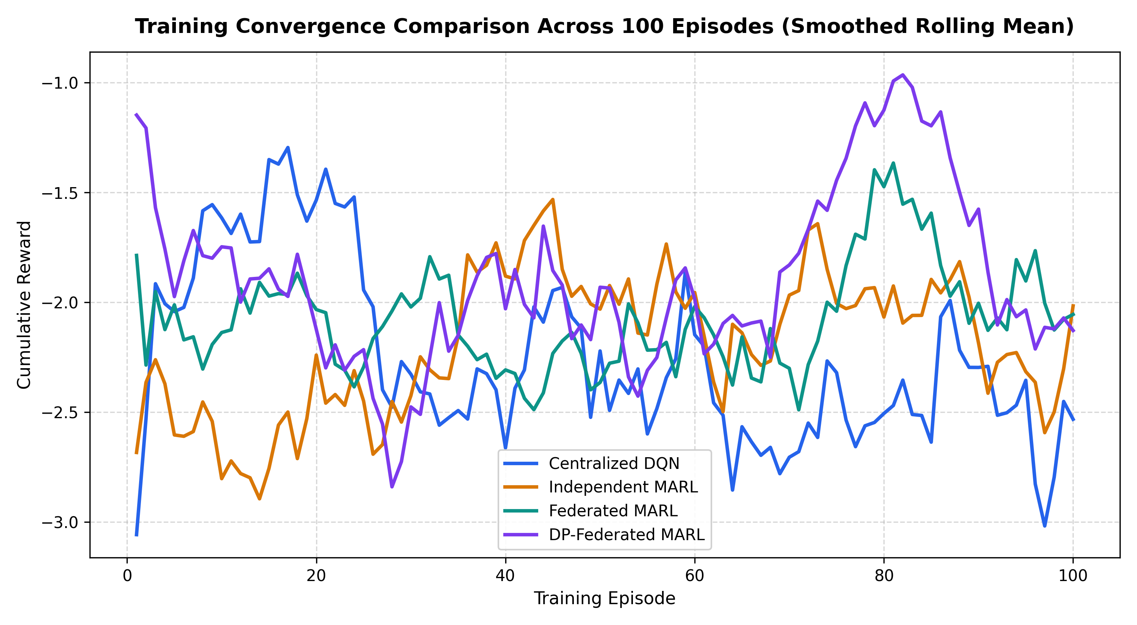
Figure 1. Reward convergence curves for the compared learning approaches.
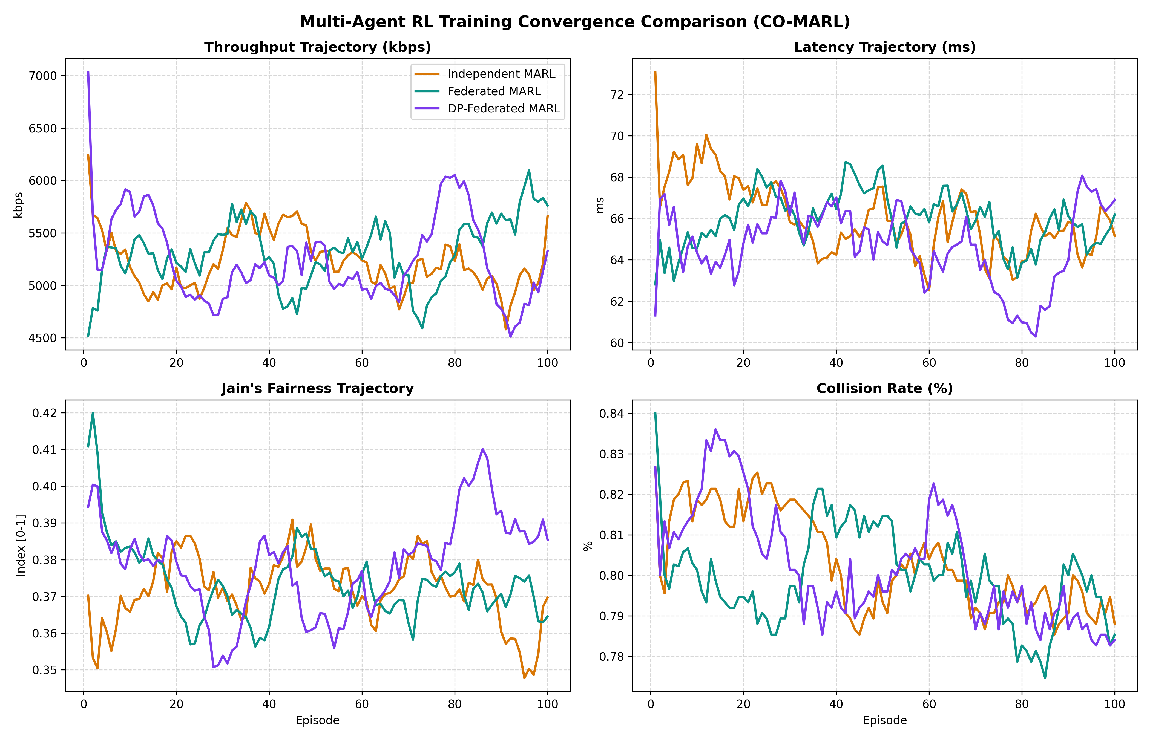
Figure 2. MARL convergence comparison from the supplied results archive.
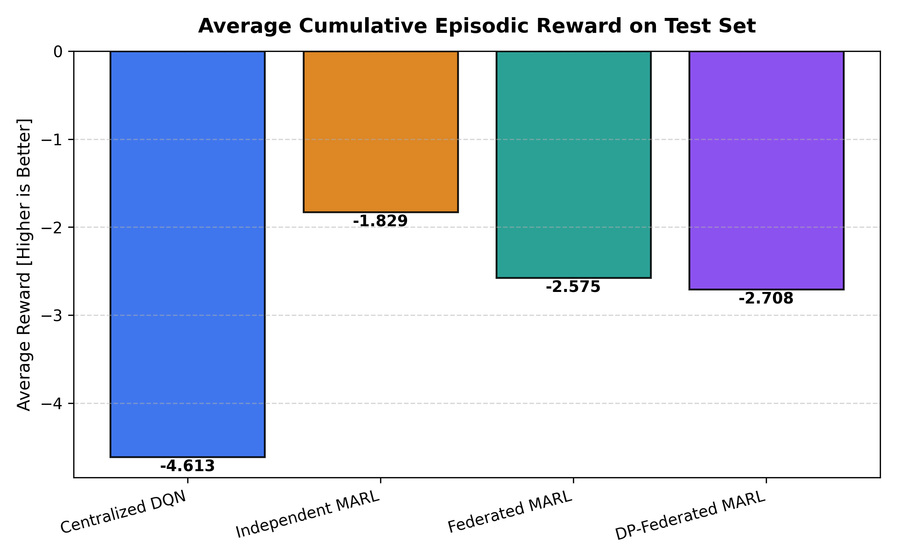
Figure 3. Average reward comparison across approaches.

6.2 Comparative Wireless Performance
The following table reproduces the supplied `final_model_comparison.csv`. These are reported simulation results from the provided archive; they have not been independently re-run from the source code.
Approach | Throughput (kbps) | Latency (ms) | Jain fairness | Collision rate | Utilization | Comm. overhead (KB)
Centralized DQN | 3,710.66 | 71.65 | 0.3656 | 98.58% | 51.96% | 0.00
Independent MARL | 5,850.26 | 64.74 | 0.3735 | 80.09% | 56.78% | 0.00
Federated MARL | 4,812.40 | 68.50 | 0.3715 | 81.82% | 53.83% | 1,901.17
DP-Federated MARL | 4,912.90 | 67.46 | 0.3630 | 81.87% | 55.61% | 1,901.17

Independent MARL has the highest reported throughput (5,850.26 kbps), lowest reported latency (64.74 ms), highest fairness index (0.3735), and highest resource utilization (56.78%) among the four approaches. Its collision rate is 80.09%, which is still high. FedAvg reports 4,812.40 kbps throughput and 1,901.17 KB communication overhead. DP-FedMARL reports 4,912.90 kbps throughput, 67.46 ms latency, and the same reported communication overhead. The centralized baseline has the highest collision rate (98.58%) and lowest throughput (3,710.66 kbps).
These findings show a trade-off rather than a universal winner. Independent learning leads on several reported network metrics, while federated methods offer collaborative model sharing without sending raw local telemetry according to the design description. The DP variant must be judged against a validated privacy guarantee, not merely the fact that noise was added.

6.3 Results Figures and Interpretation
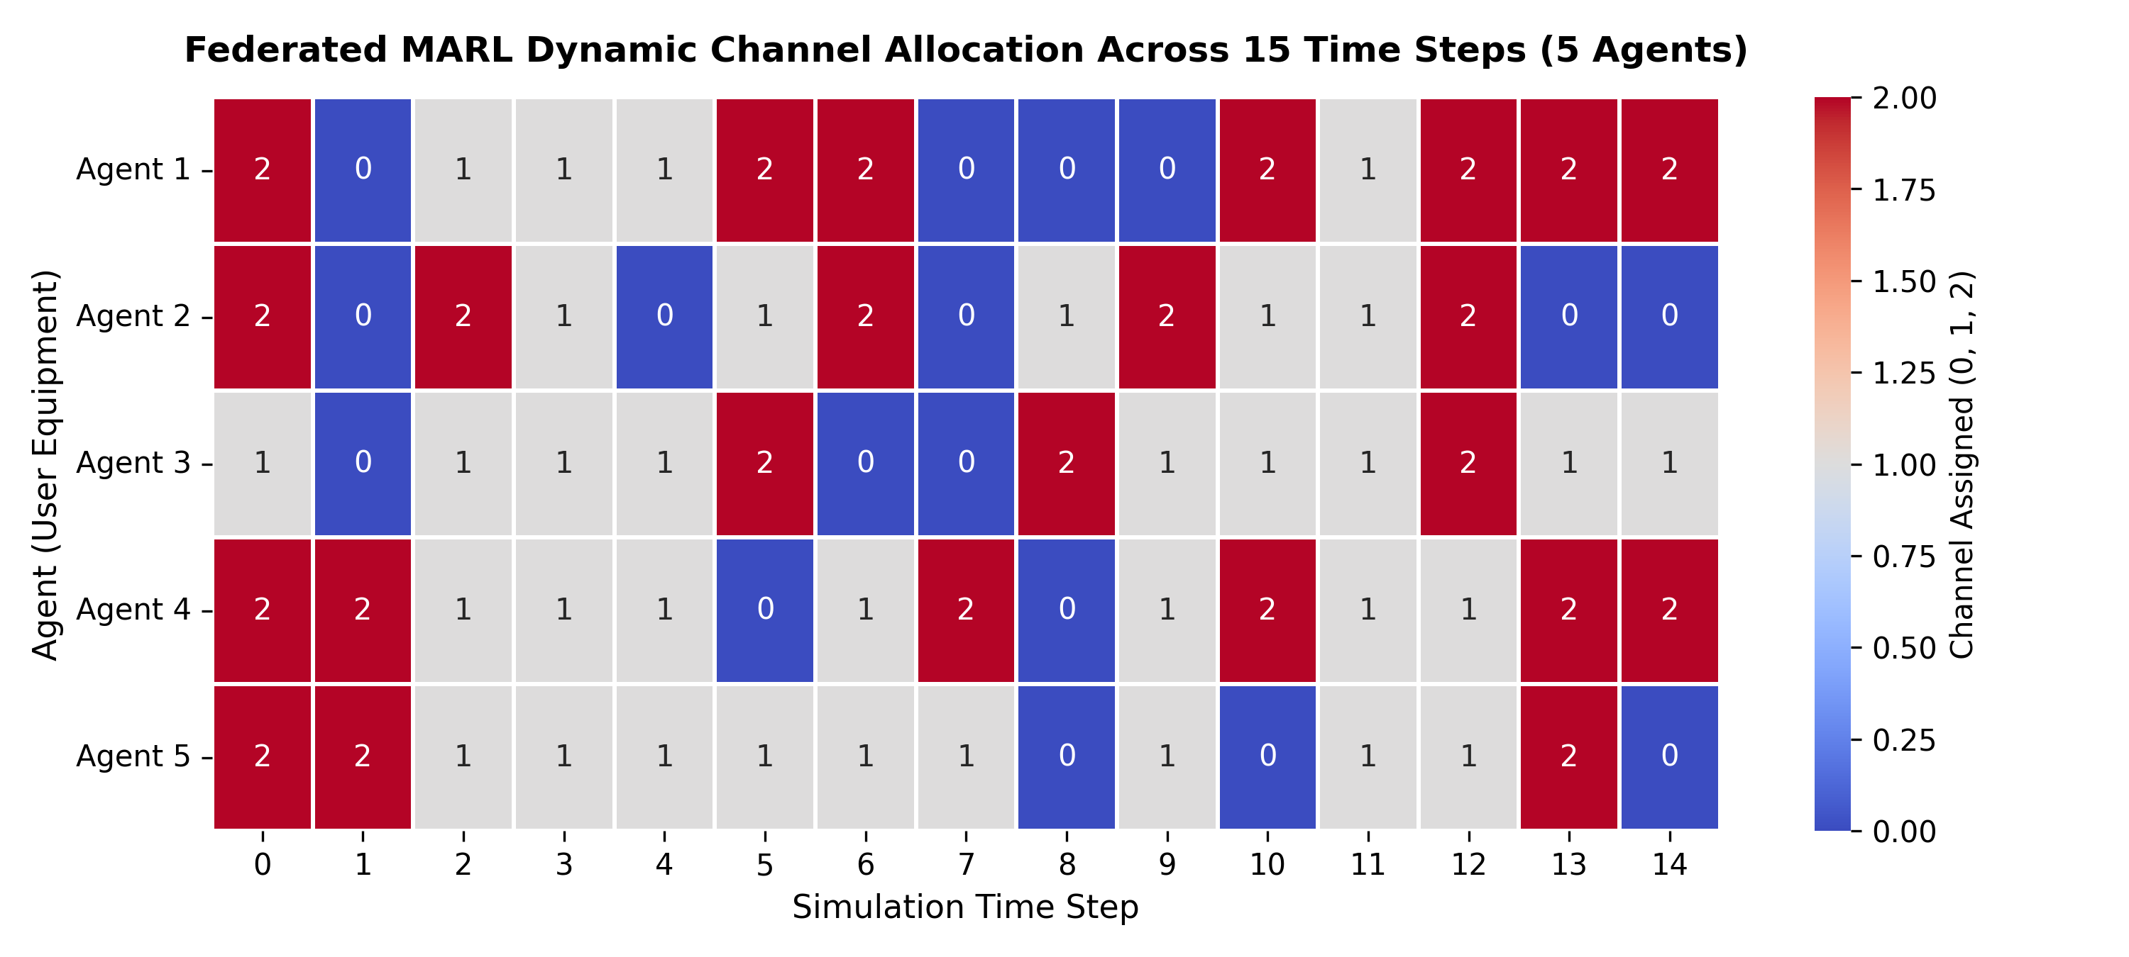
Figure 4. Channel allocation patterns. Use this figure to inspect whether agents distribute decisions across the available channels; interpretation depends on the plot's axis and allocation definition.
Interpretation: this is a simulation figure from the supplied archive, not a live wireless measurement.
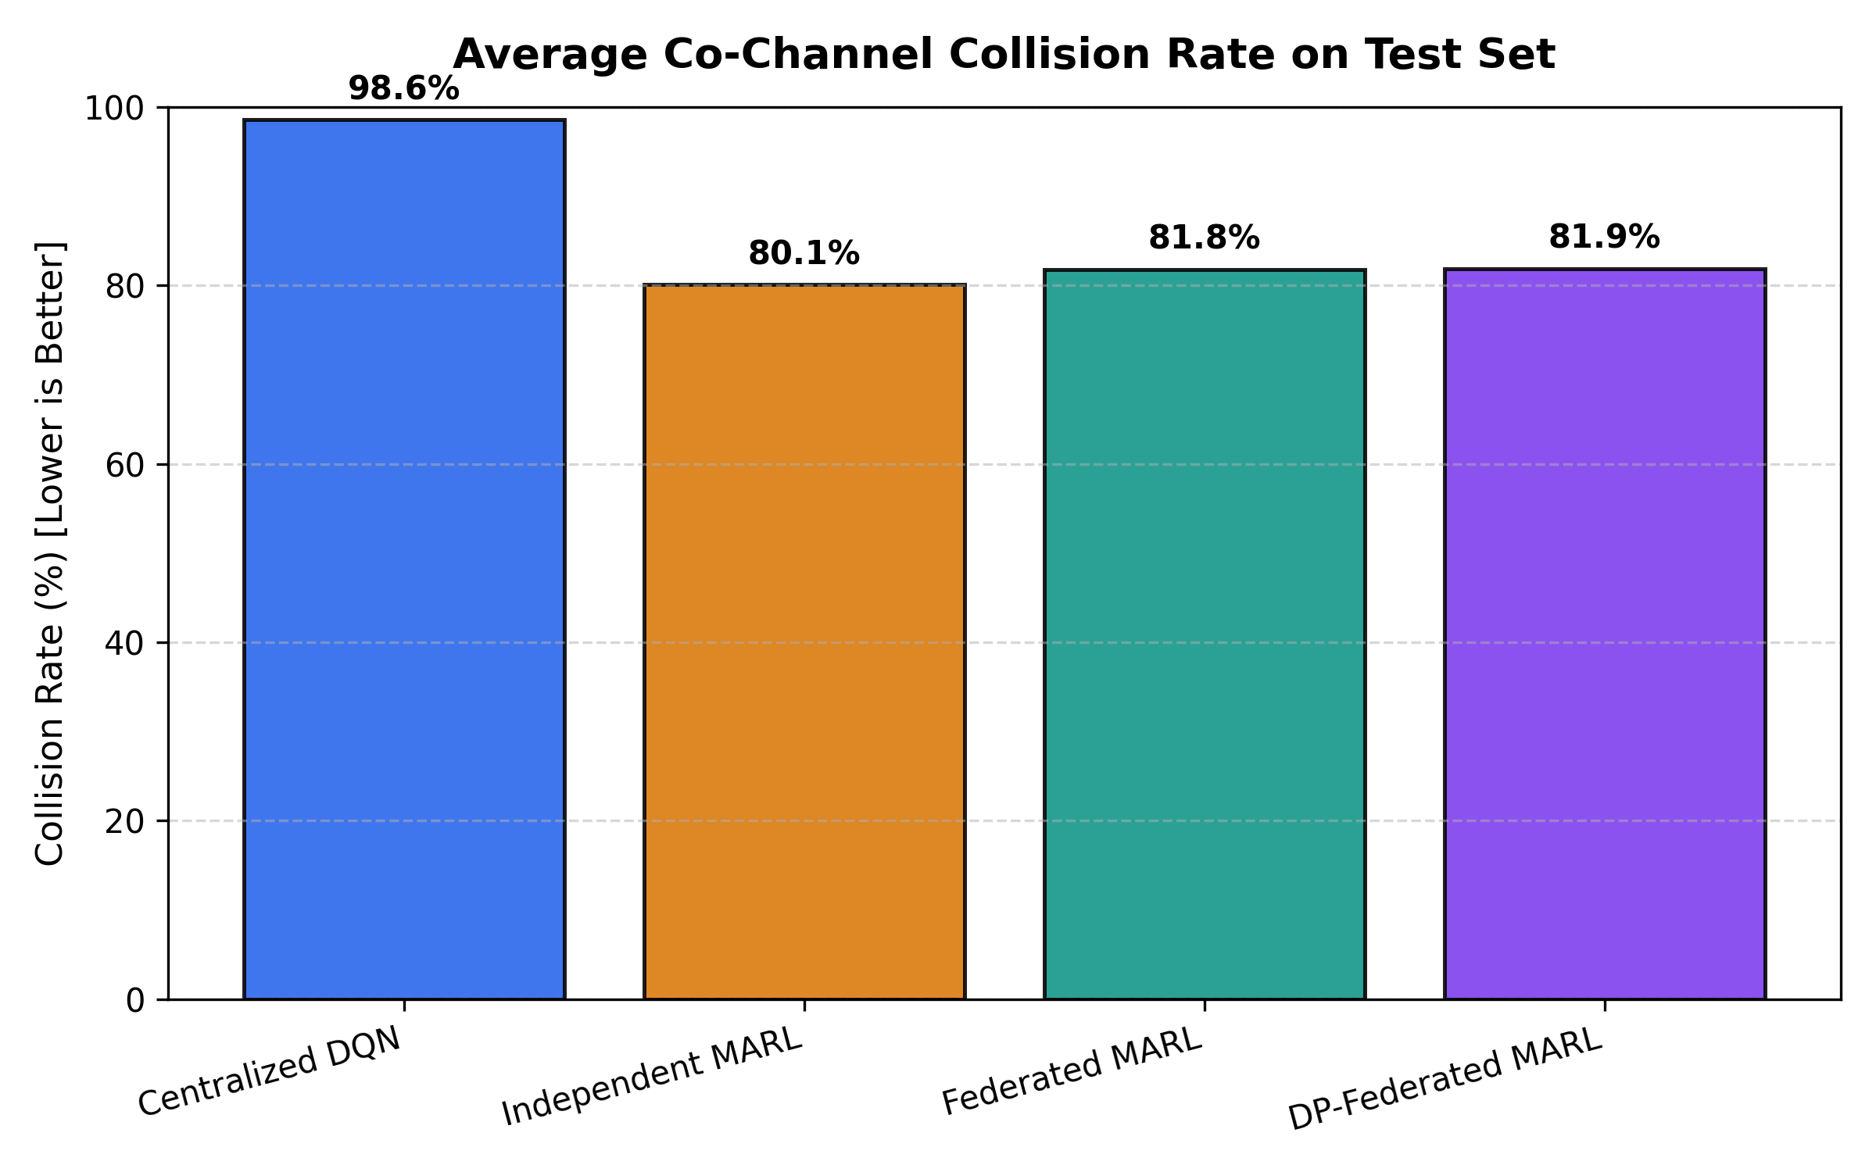
Figure 5. Collision-rate comparison. Lower collision rate is preferable under the simulation's collision definition.
Interpretation: this is a simulation figure from the supplied archive, not a live wireless measurement.
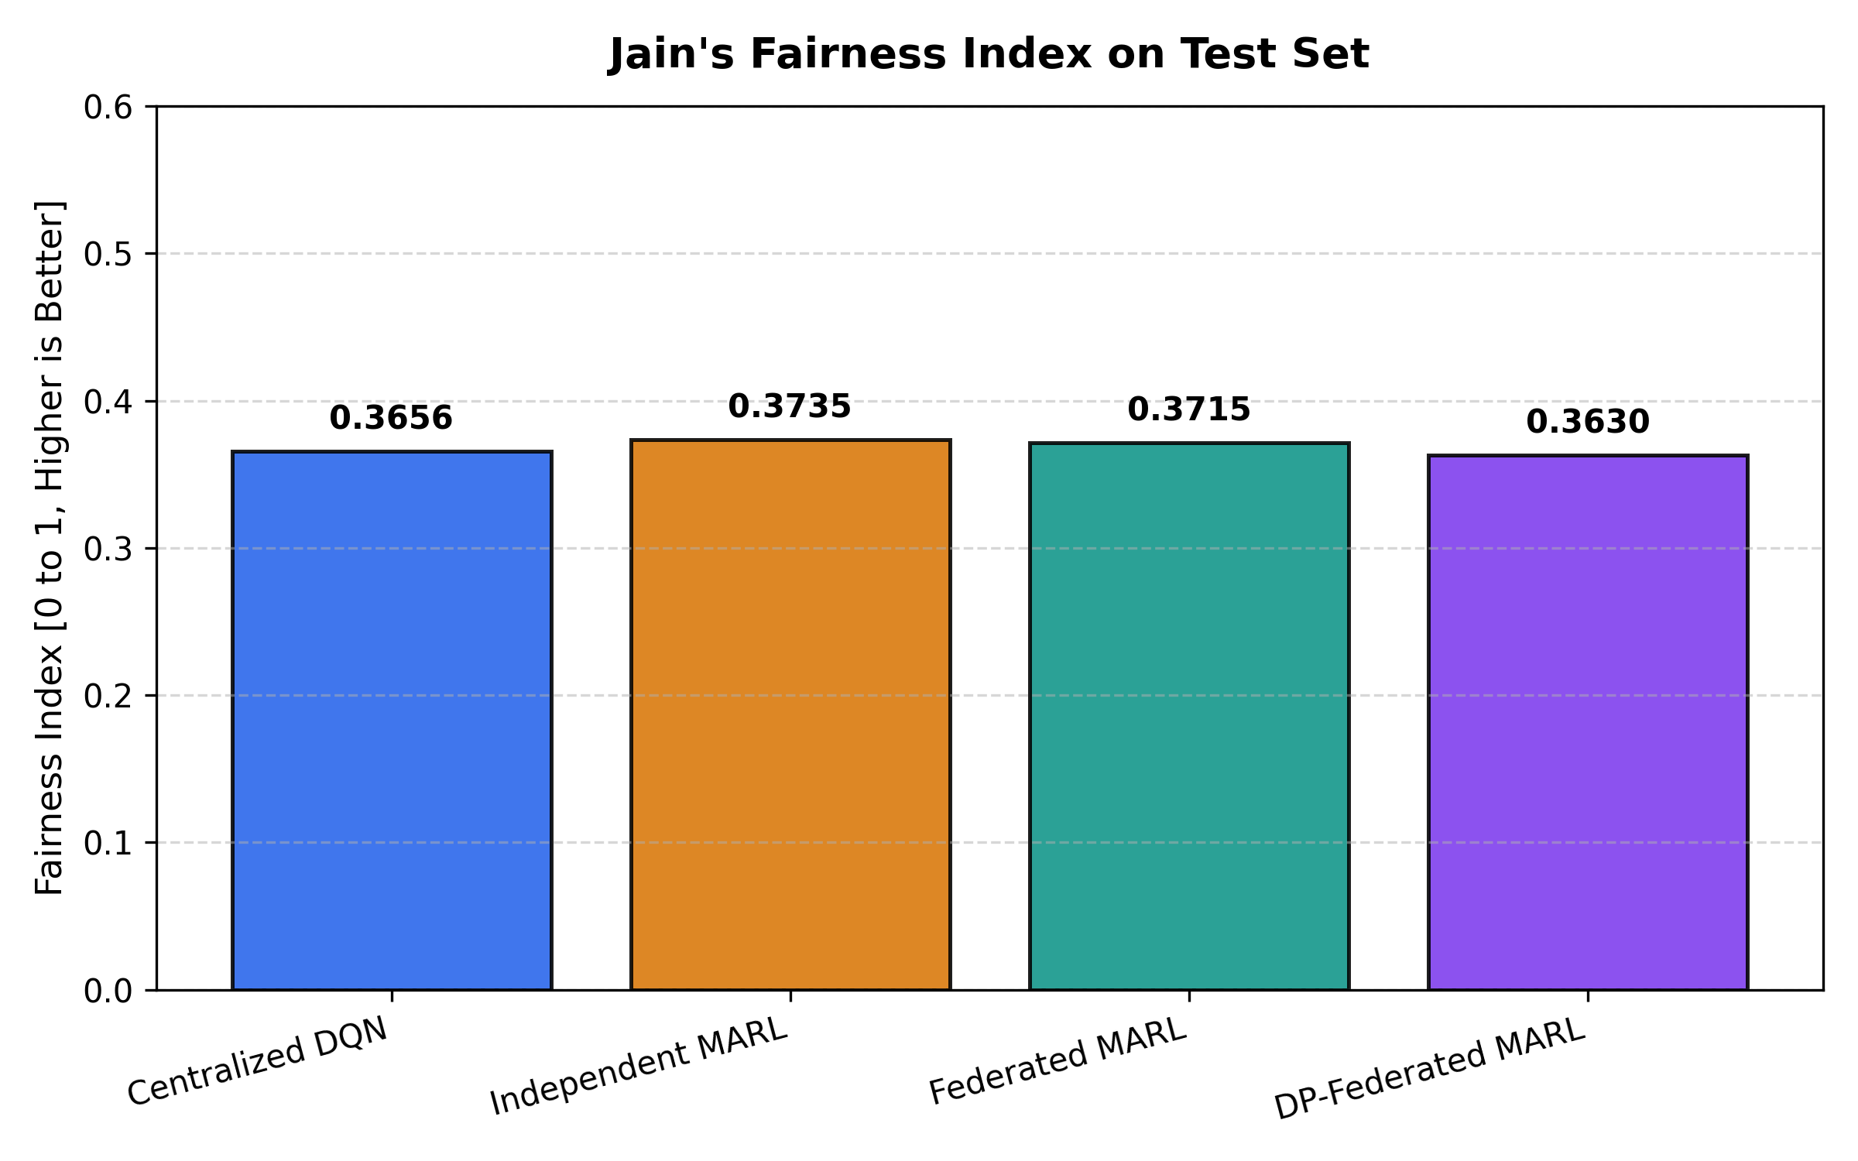
Figure 6. Jain's fairness comparison. Values closer to 1 indicate a more even allocation, although the reported values around 0.36–0.37 suggest fairness remains limited.
Interpretation: this is a simulation figure from the supplied archive, not a live wireless measurement.
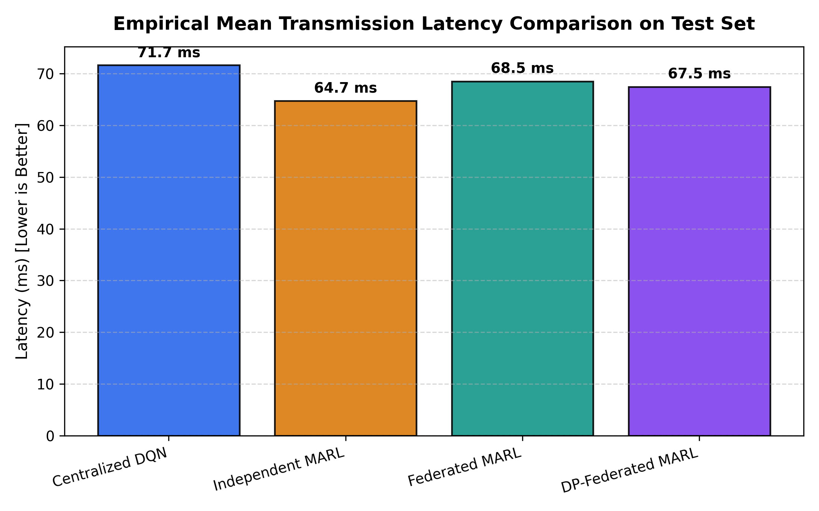
Figure 7. Latency comparison. Lower simulated latency is generally preferable for delay-sensitive services.
Interpretation: this is a simulation figure from the supplied archive, not a live wireless measurement.
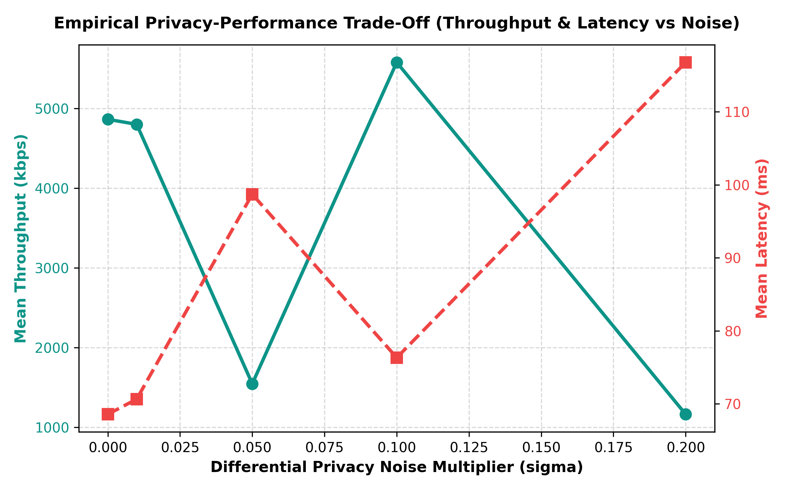
Figure 8. Privacy–performance trade-off. Read the plotted privacy parameter and metric axes carefully; a formal guarantee depends on correct privacy accounting.
Interpretation: this is a simulation figure from the supplied archive, not a live wireless measurement.
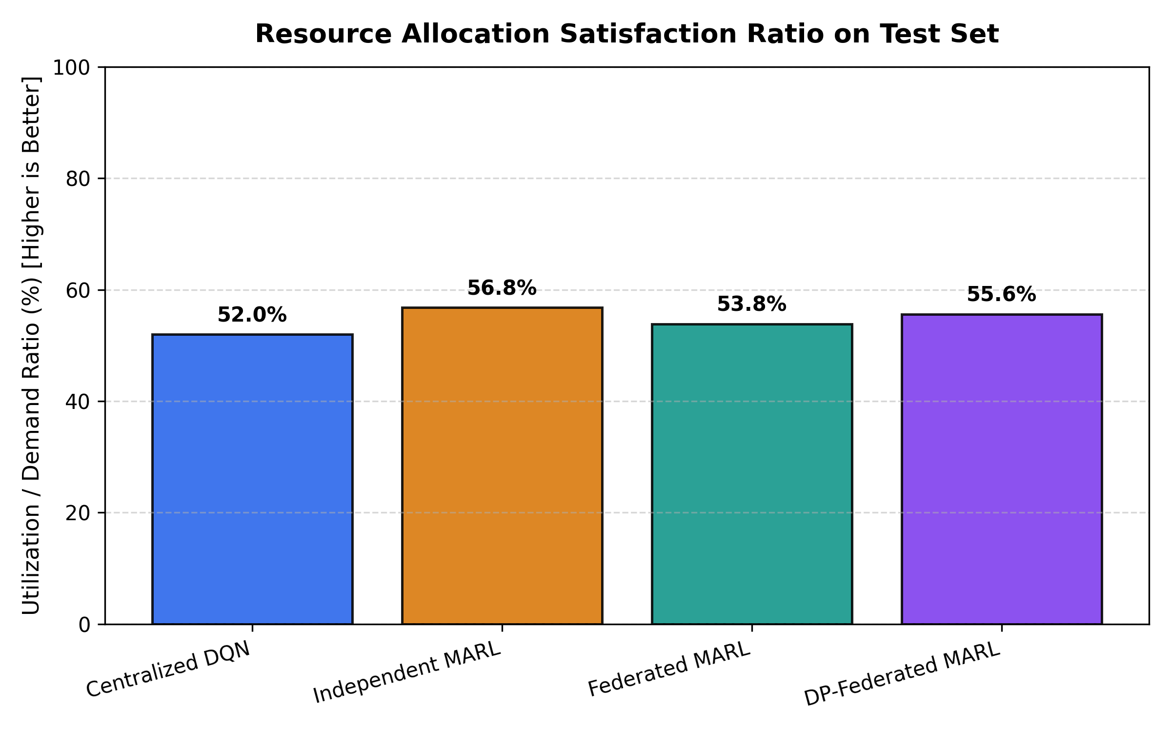
Figure 9. Resource-utilization comparison. Higher utilization is not automatically better if it comes with excessive collisions or poor delivery.
Interpretation: this is a simulation figure from the supplied archive, not a live wireless measurement.
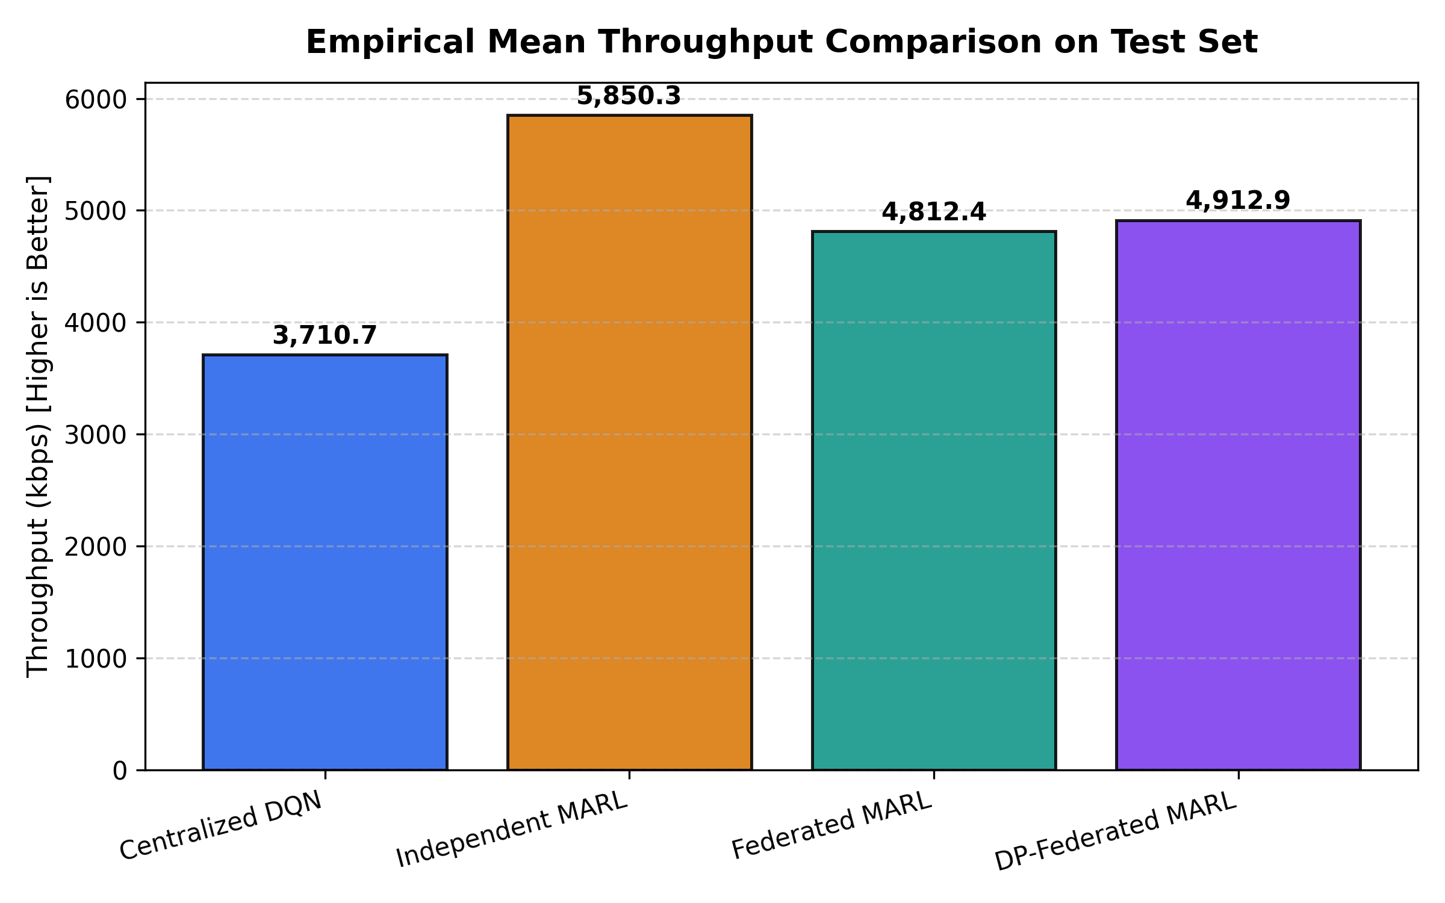
Figure 10. Throughput comparison. Independent MARL has the highest value in the supplied model-comparison table.
Interpretation: this is a simulation figure from the supplied archive, not a live wireless measurement.

6.4 Privacy, Overhead and Metric Cautions
The supplied final comparison records 1,901.17 KB of communication overhead for FedAvg and DP-FedMARL, versus 0 KB of model-update communication for the centralized and independent rows. These values should be read according to the archive's accounting conventions; a centralized system can still require data movement even if model-update overhead is recorded as zero. Raw-data privacy and communication overhead are separate concepts.
The supplied privacy-accounting table reports epsilon values of 2315.13 for σ = 0.01, 142.46 for σ = 0.05, 50.47 for σ = 0.1, and 20.18 for σ = 0.2 at δ = 10⁻⁵, alongside varying network outcomes. These epsilon values are very large and do not imply strong practical privacy. The table also lists an “effective sigma” different from the named multiplier; that relationship and the accountant assumptions need source-code verification before making a formal privacy claim.
Metric family | Interpretation and caution
Throughput / goodput | Throughput is a modelled rate; goodput should account for successful useful delivery and overhead consistently.
Spectral efficiency | Use bits/s/Hz and clearly specify whether the result is averaged per sample or calculated from mean SINR.
BER / PER / PDR | Label as measured or model-derived. Do not call theoretical QPSK BER a measured bit-error rate.
Ergodic capacity | If calculated with the same Shannon formula as throughput, it is not an independent result.
EVM | Not evaluated in this project archive because raw I/Q data are not reported.
Accuracy / Precision / F1 / R² | The ZIP contains a separate supervised-prediction table with these metrics. They are not the primary metrics for the DQN wireless resource-allocation comparison.

7. Conclusion and Future Work
This project studies privacy-conscious wireless resource management using a Python simulation with five agents and three channel options. Four approaches are compared: Centralized DQN, Independent MARL, Federated MARL with FedAvg, and DP-FedMARL. The supplied comparison table reports Independent MARL as the strongest approach on throughput, latency, fairness and resource utilization, while its collision rate remains high. Federated approaches exchange model updates and report approximately 1.9 MB of communication overhead under the archive's accounting.
The results indicate that decentralized learning can perform well in the specified simulation, while federated learning offers a way to synchronize models without centralizing raw local records. However, the privacy-enhanced approach requires careful accounting: the reported epsilon values are large, and a formal privacy claim should not be made until the implementation and accountant are audited. The simulation does not establish performance on a real router or wireless testbed.

7.1 Future Work
- Reduce collisions and improve packet delivery by redesigning the reward and resource-selection policy.
- Test a wider range of agent counts, channel counts, traffic loads and signal conditions.
- Audit the data split, state features, reward function and evaluation code for reproducibility.
- Validate differential-privacy clipping, noise scale, accountant and privacy assumptions.
- Report goodput and spectral efficiency using clearly documented per-step aggregation.
- Use a real wireless testbed for measured throughput, latency, BER/PER and EVM where suitable measurements are available.
- Report supervised prediction metrics only in a separate section if that task is part of the project objectives.

8. References
[1] V. Mnih et al., “Human-level control through deep reinforcement learning,” Nature, vol. 518, pp. 529–533, 2015.
[2] H. B. McMahan et al., “Communication-Efficient Learning of Deep Networks from Decentralized Data,” in Proceedings of AISTATS, 2017.
[3] C. Dwork and A. Roth, The Algorithmic Foundations of Differential Privacy. Foundations and Trends in Theoretical Computer Science, 2014.
[4] R. Jain, D.-M. Chiu, and W. Hawe, A Quantitative Measure of Fairness and Discrimination for Resource Allocation in Shared Computer Systems. DEC Research Report TR-301, 1984.
[5] Zenodo, Record 21625252, Open Wireless QoS / 5G-LTE telemetry benchmark, as identified in the supplied project results archive. Verify the exact dataset title, authors, version and DOI before final submission.
[6] Supplied project artifact: results/FINAL_RESULTS_REPORT.md and CSV/PNG files in results(1).zip, provided by the project author.
[7] Supplied project presentation: Federated_MARL_Wireless_Final_Presentation.pptx, provided by the project author.

Appendix A. Supplied Figures Included
- channel_allocation_patterns.png
- collision_rate_comparison.png
- jain_fairness_comparison.png
- latency_comparison.png
- marl_convergence_comparison.png
- privacy_performance_tradeoff.png
- resource_utilization_comparison.png
- reward_comparison.png
- reward_convergence_curves.png
- throughput_comparison.png

Appendix B. Submission Checks
- Confirm student names, registration numbers, guide name, department, institution and academic year on the cover page.
- Verify dataset source citation and DOI.
- Verify state feature mapping, reward equation and exact preprocessing code.
- Resolve discrepancies between model_comparison.csv and model_comparison_detailed.csv before final submission.
- Re-run evaluation and regenerate the final CSV/figures if any discrepancy is found.
- Verify privacy accounting before claiming formal differential privacy.
- Update the table of contents and page numbers in Microsoft Word after final formatting.

