https://en.wikipedia.org/wiki/Great_white_shark#In_North_America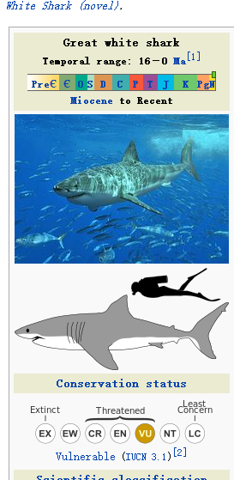
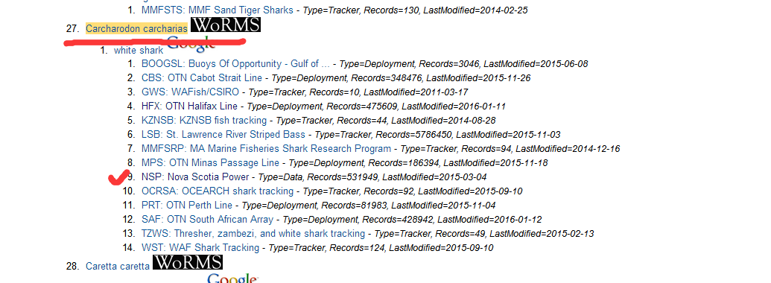

https://en.wikipedia.org/wiki/Atlantic_bluefin_tuna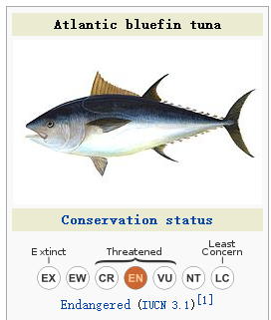
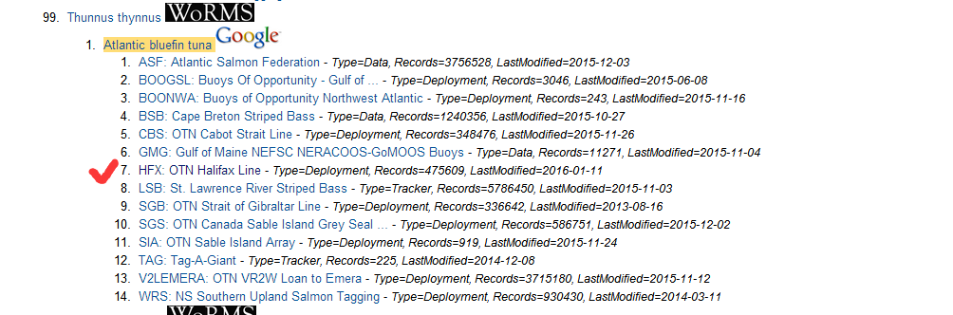

https://en.wikipedia.org/wiki/Atlantic_salmon