Intro. To Proj. Manag & Entr. CMPS307

L51
Group 4
SetScene
17/11/2025

1 | Bsmalla Mohamed | 202204404
2 | Atrab Ali | 202207802
3 | Non Allhidir | 202206484
4 | Ahya AlWattar | 202204901
5 | Aisha Adaaiki | 202206798
6 | Shahd Musa | 202106046

Table of Contents
P.E.R.T Analysis 3
S.W.O.T Analysis 6
Challenges 8
Business Model Canvas 13
Feasibility Study 14
Financial Study 20
Financial Opportunities MindMap 29
Market Feasibity MindMap 29
Customer Insights MindMap 30

- Program Evaluation and Review Technique
Why PERT (Program Evaluation and Review Technique) Instead of CPM (Critical Path Method)
PERT was chosen instead of the CPM mainly because the project on hand involves a high level of uncertainty and creativity. Our VR software startup is in the early innovation stage, where many activities, such as developing a prototype, conducting feasibility studies, and approaching customers, do not have clearly defined or predictable timelines. In such cases, PERT is more suitable since it allows us to estimate the time required for each task using three different scenarios: optimistic, most likely, and pessimistic. This makes it ideal for projects that are exploratory, research-driven, or dependent on experimentation.
In contrast, CPM is better suited for projects that are repetitive, well-structured, and have predictable workflows, such as construction or manufacturing, or even repetitive projects or process. CPM relies on fixed time estimates and focuses primarily on optimizing costs and resources. However, our project requires flexibility and a focus on managing time uncertainty rather than cost efficiency at this stage. PERT provides a probabilistic approach that helps us anticipate potential delays or variations in the timeline and adjust accordingly.
Therefore, PERT is more appropriate for our case because it allows us to plan and control the project effectively while accounting for unknowns in development, testing, and market validation. Its flexibility supports our iterative process of innovation and helps us make realistic estimates for each phase of the VR platform’s creation and launch.

The Table of Tasks and their related information:
ID | Task | Pred. | Opt. (O) | Most Lik. (M) | Pess. (P) | Expected time | Variance
A | Discuss the idea with another group to get feedback | - | 0.5 | 1 | 2 | 1.08 | 0.0625
B | Conduct detailed SWOT Analysis | - | 2 | 4 | 5 | 3.83 | 2.25
C | Identify Technical & Non-Technical Challenges | - | 1 | 2 | 3 | 2 | 0.11
D | Conduct Industry, Market and Financial Feasibility Studies | - | 2 | 3 | 6 | 3.33 | 0.44
E | Define the Minimum Viable Product (MVP) Scope | A, B, C, D | 3 | 4 | 7 | 4.33 | 0.44
F | Develop Prototype and Product Demo Video | E | 2 | 5 | 7 | 4.83 | 0.69
G | Develop Landing Page | F | 2 | 4 | 7 | 4.17 | 0.83
H | Approach Customers (Share Landing Page & Survey) | G | 4 | 6 | 8 | 6 | 0.44
I | Collect and Analyze Customer Insights | H | 1 | 2 | 4 | 2.17 | 0.25
J | Refine MVP and Business Model | I | 3 | 5 | 7 | 5 | 0.67
K | Prepare and Finalize the Presentation Materials | J | 1 | 2 | 3 | 2 | 0.11
L | Reach Investors and Partnerships | J | 3 | 5 | 9 | 5.33 | 1
M | Implement Marketing & Outreach Campaigns | G | 2 | 4 | 8 | 4.33 | 1

Note: The numbers provided above (optimistic, most likely, and pessimistic) are sourced from external sources, which can be found at the end of the document. Additionally, the values are in days.

The equation used to calculate the Expected Time is:
te=tp+4tm+to6
$$t_{e}=\frac{t_{p}+4t_{m}+t_{o}}{6}$$
The equation used to calculate the Variance is:
vt=σ2=(tp−t06)
$$v_{t}=σ^{2}=\left(\frac{t_{p}-t_{0}}{6}\right)$$
PERT Chart:
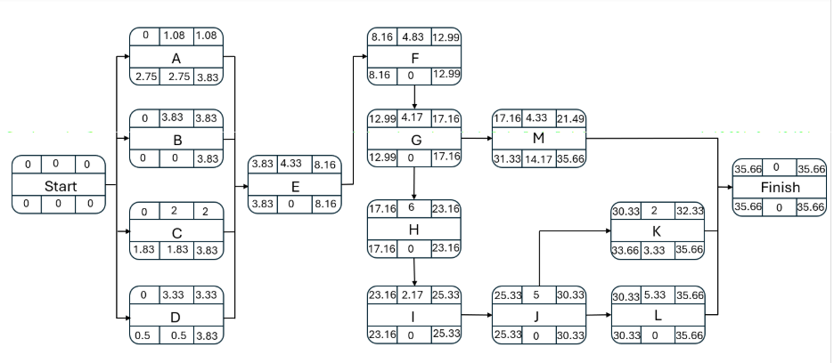
The critical path = B, E, F, G, H, I, J, L
Project mean (sum of duration of tasks on the critical path) =
3.83 + 4.33 + 4.83 + 4.17 + 6 + 2.17 + 5 + 5.33 = 35.66 days
Project variance (sum of variance of tasks on the critical path) =
2.25 + 0.44 + 0.69 + 0.83 + 0.44 + 0.25 + 0.67 + 1 = 6.57
Project standard deviation (square root of project variance) =
(6.57) ** 0.5 = 2.56
- S.W.O.T Analysis (Detailed)
- Strength:
- Unique idea: that mixes reading with VR effects.
Most VR projects focus on gaming, not reading. our idea stands out because it turns normal reading into an active, exciting and interactive adventure. This makes our business different and memorable, and gives us a strong position in a market with very few competitors.
- interactive and engaging for users.
People don’t just read, they see the world of the book, hear the sounds, and feel the atmosphere. This level of immersion makes users more interested and more emotionally connected to the story.
- Can be used for both education and entertainment.
Teachers can use it to help students understand. At the same time, casual readers and kids can use it for fun. This gives us more than one target market and more ways to make money.
- Can work with many types of stories or books.
(Versatility) our system can support novels, short stories, children’s books, fantasy worlds, horror scenes, or even educational chapters. This flexibility allows for endless content and expansion.

- Weaknesses:
- Expensive to make.
software development cost a lot of money. This makes starting and expanding the business difficult without funding.
- Not everyone uses VR technology.
Not a lot of people uses VR, as it is More popular among gamers not readers. even with gamers, it is still not very popular.
- Market is still small and new.
VR reading is not common yet, so people may need time to understand and trust this new idea. This means slower adoption at the beginning.

- Opportunities:
- VR is becoming popular around the world.
As more people buy VR headsets and use immersive experiences, the acceptance of VR storytelling will grow. The market is expanding, making it a good time to enter.
- Schools and universities might use it for educational purposes
Teachers want modern methods to help students understand books. our VR tool can make reading easier, especially for visual learners or students who struggle with imagination.
- Can work with authors and publishers to bring books to life.
Writers might want to turn their novels into VR experiences as a way to promote their books. Publishers may see VR as a new market to reach more readers.
- Qatar supports tech and innovation startups.
There are government programs, incubators, and competitions that support technology startups. This can help us get financial support, visibility, or mentorship.
- Can make Multilanguage's stories for a bigger audience.
we aren’t limited to one language. Creating VR stories in Arabic and English makes our product useful for locals, expats, tourists, and international users.

- Threats:
- Big companies might make something similar.
Large tech companies with more money could enter the same market and dominate. Their resources allow them to create similar experiences faster and cheaper. they also have a bigger audience and more people would engage in their idea instead.
- Some people still prefer normal books.
Traditional readers might not want to use technology to read. They may feel VR ruins the imagination part of reading.
- High prices might scare customers.
Because VR sessions can be expensive, people might not be willing to pay regularly, especially if the economy weakens.
- Need to get permission or pay for story rights.
To use famous novels, we must buy permissions or licenses, which can be expensive or impossible. This limits the type of content we can legally adapt and use for our base

3. Challenges (Technical and Non-Technical)
I. Technical Challenges
A. Product Development
- Inefficient or slow development cycles
- Incomplete or unreliable testing process
- Lack of proper documentation
- Integration issues between systems (APIs, SDKs, etc.)
- Compatibility issues across platforms/devices
- Poor architecture scalability (NFRs)
- Security vulnerabilities (data leaks, weak encryption, etc.)
- Incomplete cross-platform compatibility (OpenXR, SteamVR, etc.)

B. Infrastructure & Operations
- Server downtime or unreliable hosting
- Cost inefficiency in cloud infrastructure
- Poor backup and disaster recovery systems
- Scaling challenges under user growth
- Technical dependencies on third-party tools
- Memory and asset optimization for large scenes
C. Data Management
- Weak data analytics or insights pipeline
- Privacy compliance issues (GDPR, etc.)
- Poor database design or slow queries
- No clear data ownership policy
D. Hardware Limitations
- Inadequate computing power for AI/model training
- Limited GPU/TPU availability or cost constraints
- Insufficient testing hardware
- Hardware integration issues
- Hardware maintenance and upgrade challenges
E. Software Tools & Systems
1. Design & Creative Tools
- Tool compatibility across teams (Figma, Adobe, etc.)
- Licensing or subscription costs for design suites
- Version control for design assets
- Lack of integration between design and dev pipelines
- Performance issues with large design files
2. AI Systems & Data Tools
- Limited access to large datasets or high-quality training data
- Expensive or slow training due to hardware constraints
- Poor model reproducibility or version tracking
- Inadequate MLOps or deployment pipelines
- Ethical and bias-related concerns in models
- Difficulty integrating AI models into production systems
3. Software Development Tools
- Fragmented tech stack or tool overload
- Inefficient CI/CD pipelines
- Tool incompatibility across environments
- Lack of automation (testing, deployment, monitoring)
- Outdated IDEs or dependencies
- Vendor lock-in from proprietary tools
4. Payment Systems & Financial Tech
- Integration challenges with payment gateways (Stripe, PayPal, etc.)
- Transaction delays or failures
- Security vulnerabilities in payment processing
- Compliance issues (PCI DSS, local banking laws)
- Limited availability of regional payment options
- High transaction fees or currency conversion costs
- Fraud detection and refund handling inefficiencies

II. Team & Organizational Challenges
- Difficulty finding qualified talent (VR developers, 3D designers)
- Lack of cross-disciplinary collaboration (tech + design + storytelling)
- Undefined roles and responsibilities
- Lack of technical leadership or CTO-level guidance
- Weak company culture or low morale
- Co-founder conflicts or trust issues
- Burnout or overwork
- Lack of diversity or inclusivity

III. Financial Challenges
- Limited initial capital or runway
- Poor cash flow management
- Overestimation of early revenue
- Cost overruns in development or marketing
- Difficulty securing investors or funding rounds
- Inefficient pricing or monetization strategy
- Hidden operational costs (licenses, SaaS tools, etc.)
- Licensing costs for engines, assets, and motion libraries

IV. Marketing & Growth Challenges
- Ineffective marketing strategy
- Lack of brand awareness
- Poor user acquisition and retention
- High customer acquisition cost (CAC)
- Low lifetime value (LTV)
- Weak SEO, content, or social media presence
- Unclear or inconsistent brand identity
- Poor conversion funnel design
- Ignoring feedback loops and analytics
- Overdependence on paid ads

V. Legal & Compliance Challenges
- Unclear founder equity or shareholder agreements
- Missing company registration or incorporation issues
- Weak IP protection (trademarks, patents, copyright)
- Non-compliance with local or international laws
- Inadequate contracts with partners or clients
- Employment law violations (labor rights, benefits, etc.)
- Privacy and data protection non-compliance
- Licensing or regulatory approval delays

VI. Customer & Market Challenges

- Weak feedback collection process
- Poor customer support or response time
- Cultural or regional adaptation issues

VII. External & Environmental Challenges
- Economic downturn or inflation
- Political or regulatory instability
- Sudden shifts in technology trends
- Dependence on unstable suppliers or vendors
- Global events (pandemics, conflicts, etc.)

VIII. Partner & External Collaboration Challenges
- Misaligned expectations about deliverables or timelines (designers, writers)
- Intellectual property (IP) ownership disputes
- Data sharing or confidentiality issues (books, development process, releases)
- Slow partner responsiveness affecting workflow (writers, designers)
- Rising supplier costs or contract renegotiations (writers)
- Dependency on hardware vendors (Meta, HTC, Apple, etc.)
- Lack of reliable partnerships with content studios or 3D asset creators

- Business Model Canvas:
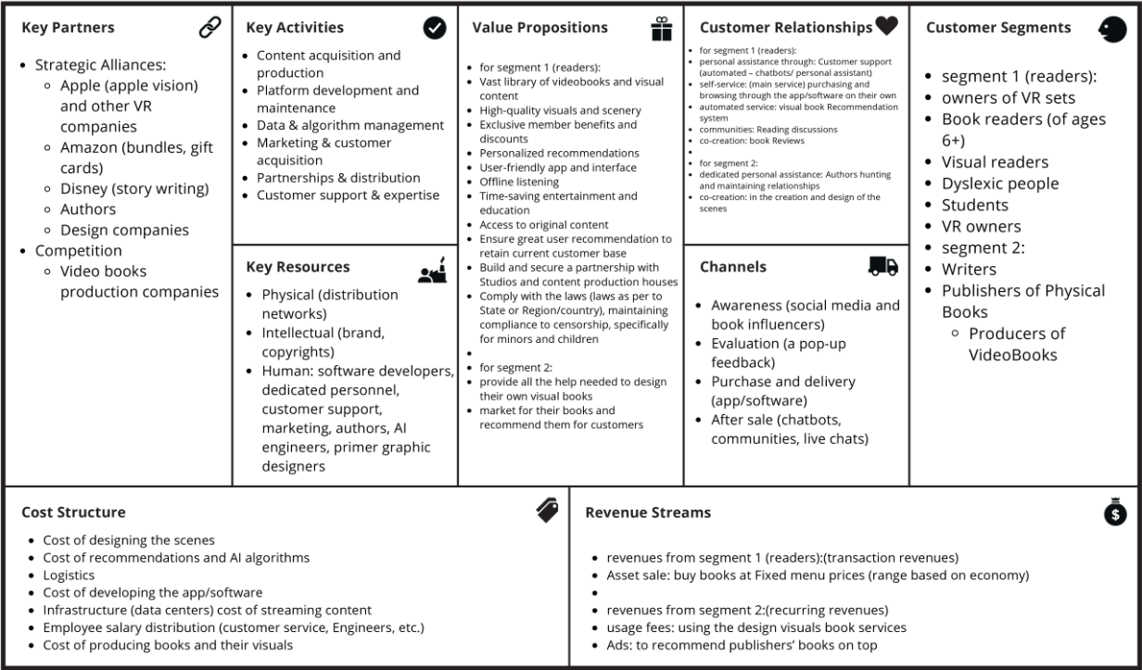

- Feasibility Study (Within Industry)

- Market Definition & Scope
- Target Segments :
Reader Target Segment
- Students (time-pressed, want faster and more immersive learning)
- Dyslexic readers / visual learners
- General readers seeking more engaging book experiences
- VR headset owners who need more content to justify their device purchases
Creator Target Segment
- Authors
- Publishers
- Video producers/visual artists
They get a new distribution channel, new audience access, and potential revenue. These creators also influence demand by bringing their existing readers.
- Product Scope:
SetScene offers:
- VR-based immersive videobooks
- AI recommendation algorithms
- Subscription or per-book access
- Author/publisher dashboard for content publishing
- Demand Analysis
- Evidence of Demand
primary research (Google Form + landing page engagement) helps confirm demand by:
- Identifying interest levels in:
- immersive videobooks
- AI recommendations
- VR-based learning
- Measuring willingness to pay
- Seeing which genres users prefer

- Market Size Estimate (Qatar & MENA)
references using:
- PSA demographic data (population, literacy, education levels)
- VR adoption stats
- E-learning market growth
- Key signals:
- Qatar has one of the highest literacy and mobile device penetration rates in the region.
- VR usage is rising, especially among youth & gamers.
- E-learning and audiobook markets are growing globally at 20%+ CAGR, indicating rising demand for new formats.
- Growth Trends
- VR becoming more affordable
- Education shifting toward multimedia learning
- Digital entertainment consumption rising
- Authors looking for alternative distribution channels
- Competitive Analysis
- Direct Competitors
- Audible (audiobooks)
- Storytell
- Other videobook-style apps
- Indirect Competitors
- Netflix / Disney+ (compete for attention)
- Kindle / eBooks
- YouTube summaries and lecture channels (substitute solutions)
- Gap Analysis
There is no VR-first videobook platform in Qatar or the MENA region.
This gives SetScene a first-mover advantage and makes the solution highly feasible.
- our Unique Differentiators
- VR immersion (unique experience)
- Two-sided platform (readers + creators)
- AI-driven recommendation engine
- Ability for authors to repurpose their books visually
4. Customer Insights:
- customer validation strategy:
Earlyvangelists include:
- dyslexic readers
- VR headset owners
- students
- authors struggling to reach readers
These groups actively look for solutions and are willing to pay early.
- Validation Methods:
- Landing Page MVP
- Wizard of Oz MVP
- Mock sales
- Innovation games
- Split testing
- Focus groups with VR and dyslexic users

5. Regulatory & Policy Feasibility (Qatar)
regulatory awareness:
- Copyright & Licensing
- Can be validated through MOCI, Qatar Chamber, and local publishing regulations.
- we must handle royalties for authors.
- Content Compliance
- Need to filter content for minors.
- Standard for book and media platforms.
- Ease of business
- Startup Qatar platform simplifies registration.
- Media/tech startups are encouraged under national digital transformation goals.
6. Financial Feasibility
Revenue Streams:
- Per-book sales
- Monthly subscriptions
- Premium memberships
- Creator revenue shares
- Ads for promoted videobooks
- AI-powered recommendation fees (B2B later)
Cost Structure
- App & VR platform development
- AI recommendation engine
- Cloud servers & video streaming
- Paying authors and creators
- Customer support
- Marketing expenses
Funding Opportunities in Qatar
- QDB Startup Funding (up to 500,000–18M QR)
- QSTP Incubation & R&D support
- Mada Innovation Program (assistive tech — supports dyslexic reading focus)
- Tamkeen Program
- MCIT Scale Now for scaling regionally
- Young Entrepreneurs Club and Qatar Chamber support
- Nama Center for socially impactful initiatives
7. Risk & Feasibility Check
Strengths
- First VR videobook platform in MENA
- Multiple revenue streams
- Strong societal impact (dyslexia, learning support)
- High-engagement immersive format
Weaknesses
- VR adoption is still growing
- High initial development cost
- Content creation requires authors + video production
Opportunities
- Rising VR usage
- Huge demand for educational innovation
- No regional competitors
- Government support for digital & creative industries
Threats
- Big global players (Audible, Disney) could enter later
- Cultural/regulatory constraints may limit certain content
8. Overall Feasibility Conclusion
Based on all evidence, SetScene is highly feasible, especially because:
- Market demand is growing (VR + e-learning + digital reading).
- The product solves real problems for multiple user groups.
- Competitive landscape has clear gaps our solution fills.
- Qatar’s ecosystem provides exceptional financial & regulatory support.
- our early validation strategy is strong and grounded in startup methodology.

- Financial Plan
This financial plan incorporates real-world signals from:
- User survey (50 respondents to “The Future of Reading: Exploring Visual & Immersive Books”)
- Landing page analytics (151 visitors, 34 waitlist sign-ups)
The projections cover 2025–2027 and assume a lean early-stage startup focused on testing product–market fit and growing an engaged base of paying users.

Key Insights from Data:
From the survey (50 responses):
Reading habits:
- 38% read at least weekly (Daily or A few times a week).
- 50% read occasionally, 14% read rarely or never.
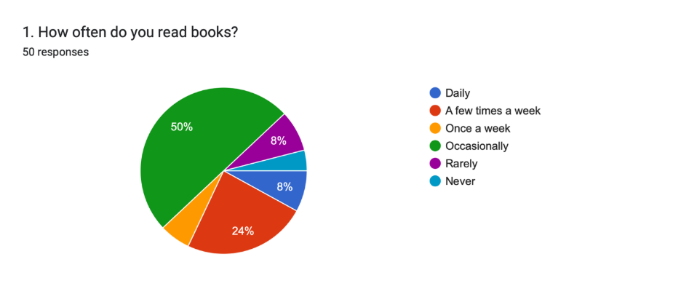

Interest in Set Scene concept:
- Interest question was on a 1–5 scale where 1 = extremely interested and 5 = not interested.
- 66% chose 1 (extremely interested) and another 16% chose 2 → 82% show high interest (4–5/5 after rescaling).
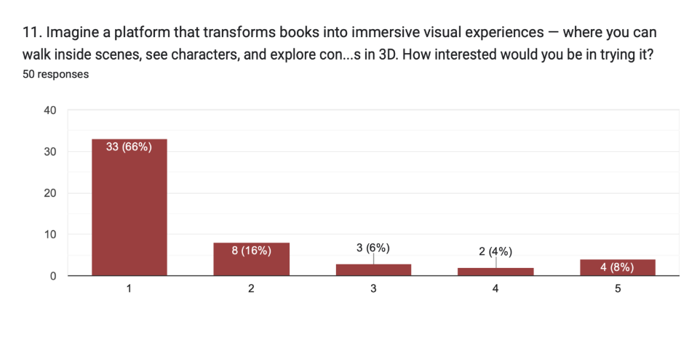
Willingness to pay:
- Yes, definitely: 5
- Maybe, depending on price: 38
- Not sure / No: 7
→ About 86% are open to paying if pricing is right.
→ If we treat “Maybe” as 50% likely, ~48% effective payers in this sample.
Preferred pricing model:
- Monthly subscription ($5–10/month): 22
- Pay-per-book: 15
- Free version with limited visuals (freemium): 13
→ Clear preference for subscription, but meaningful demand for pay-per-book and a free tier.
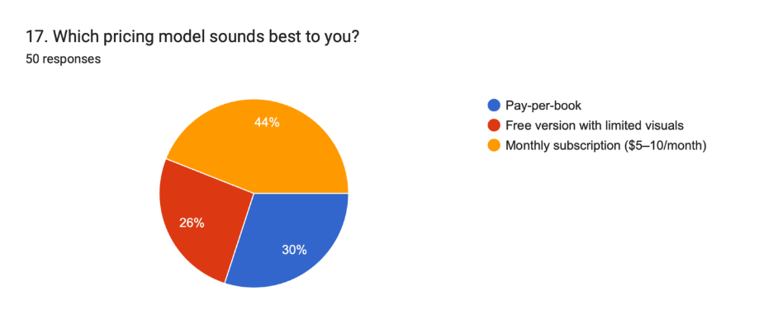
From the landing page:
- Visitors: 151
- Waitlist sign-ups: 34
- Waitlist conversion rate: 34 / 151 ≈ 22.5%
- Bounce rate: 74%
- Avg visit duration: ~44 seconds

Despite a high bounce rate (normal for early, unoptimized pages), the conversion from visitor → email waitlist is strong, suggesting that once people read the value proposition, many are interested enough to opt in.
Updated Assumptions :
Time Frame
- 2025–2027: Pre-launch → launch → early growth.
Pricing & Monetization
Based on the survey, users are comfortable with $5–10/month (≈ QAR 18–36) and still value a per-book option.
We adopt a hybrid model:
Core plan:
- Monthly subscription: QAR 25–30/month (access to a library of visual/immersive books and experiences).
Complementary model:
- Pay-per-book: QAR 25–30 per v-book for users who prefer ownership or occasional use.
- Freemium tier:
Limited visuals, teaser chapters, and occasional promotions to convert free users to paid.
For financial modelling, we simplify to:
- 2025: Effective price per “book-equivalent” ≈ QAR 30
- 2026: QAR 30
- 2027: QAR 35 (more premium content, better product, ability to charge slightly more)
User Acquisition & Conversion
Original assumption: 10% of website visitors convert to paying customers.
- Actual early data (landing page): 22.5% visitor → waitlist conversion.
- Survey: ~48% effective payers in a more engaged audience.
To stay conservative, we set:
Visitor → paying customer conversion:
- 2025: 15%
- 2026–2027: 17–18% as branding, UX, and targeting improve.

Average new paying customers per month (effective):
- 2025: ≈ 100 new paying users/month (as in original plan, but now grounded in data).
- 2026: ≈ 200–250/month.
- 2027: ≈ 350–400/month.
These monthly flows lead to the same order of magnitude as your original 1,000 / 3,000 / 6,000 active paying users, so we keep those targets but now they are justified by observed behavior.
Technical & Cost Assumptions:
These mostly stay as in your original plan:
Hosting (VRS, GPU, cloud):
- 2025: QAR 24,000
- 2026: QAR 30,000
- 2027: QAR 36,000
Cloud Storage & AI API:
- 2025: QAR 6,000
- 2026: QAR 8,000
- 2027: QAR 10,000
Platform Development & Maintenance:
- 2025: QAR 120,000 (initial build)
- 2026: QAR 40,000 (maintenance)
- 2027: QAR 60,000 (upgrades/new features)
Marketing:
- Keep a lean strategy: QAR 1,000/month (QAR 12,000/year) for 2025–2027 (organic social + content + communities). If funding permits, this can be scaled up.
Tax rate: 10% on positive profits (applied when relevant).
Development & Hosting Costs (unchanged structure)
Item | 2025 (QAR) | 2026 (QAR) | 2027 (QAR) | Notes
Platform Development | 120,000 | 40,000 | 60,000 | Initial build + maintenance
Hosting (VRS) | 24,000 | 30,000 | 36,000 | GPU servers / render hosting
Cloud Storage & API | 6,000 | 8,000 | 10,000 | Data, AI inference, storage
Total Dev & Hosting | 150,000 | 78,000 | 106,000
(As in your original plan, but now clearly justified as fixed/technical costs.)
Updated Revenue Model
We now reflect:
- Higher willingness to pay (subscription + per-book).
- Slightly higher effective price per book-equivalent, but still within the survey’s $5–10/month comfort zone.
Assumptions:
Blended effective price per book-equivalent:
- 2025: QAR 30
- 2026: QAR 30
- 2027: QAR 35
Active paying user base (per year):
- 2025: 1,000
- 2026: 3,000
- 2027: 6,000
Average book-equivalents per user / year (through subscription usage and/or pay-per-book):
- 2025: 3
- 2026: 4
- 2027: 5

Year | Estimated Paying Users | Avg “Book-Equivalents” per User | Effective Price (QAR) | Revenue (QAR)
2025 | 1,000 | 3 | 30 | 90,000
2026 | 3,000 | 4 | 30 | 360,000
2027 | 6,000 | 5 | 35 | 1,050,000
Note: These “book-equivalents” can be a mix of:
- Included books in a subscription,
- Add-on premium experiences, and
- Occasional one-off purchases.
Income Statement (2025–2027):
Item | 2025 (QAR) | 2026 (QAR) | 2027 (QAR) | Notes
Revenue | 90,000 | 360,000 | 1,050,000 | From updated Revenue Model
COGS (Hosting + Cloud/API) | 30,000 | 38,000 | 46,000 | As before (technical/usage costs)
Gross Profit | 60,000 | 322,000 | 1,004,000 | Revenue − COGS
Operating Expenses | 155,000 | 90,000 | 118,000 | Development + Maintenance + Marketing
Operating Income | −95,000 | 232,000 | 886,000 | Gross Profit − Operating Expenses
Taxes (10% on positive income) | — | 23,200 | 88,600 | No tax on 2025 loss
Net Income | −95,000 | 208,800 | 797,400 | After tax
Updated Break-even Analysis:
Fixed costs in Year 1 (approx):
- Development: QAR 120,000
- Marketing: QAR 12,000
- Hosting & Cloud: QAR 30,000
Total fixed costs ≈ QAR 162,000
Contribution margin per book-equivalent:
- Effective price: QAR 30
- Approx variable cost per book-equivalent (rendering, API, bandwidth): ~QAR 1
→ Contribution ≈ QAR 29/book-equivalent
Break-even units:
- Break-even v-books (or book-equivalents) = 162,000 ÷ 29 ≈ 5,600 units
With 1,000 users in 2025, each consuming ~3 book-equivalents (3,000 units/year), you’re likely to hit:
- Break-even around mid–2026, when cumulative units sold pass ~5,600–6,000.
This is a faster break-even than your earlier estimate (~23 months), thanks to the higher price point and strong willingness to pay.
Investor Funding & Use of Funds:
The structure of use-of-funds remains the same as your original plan (development, hosting, marketing, buffer), but now the underlying revenue and break-even logic is validated by real data.
- QAR 200,000–500,000 seed investment, allocated to:
- Product development & AI integration
- Year 1 hosting & API costs
- Lean marketing and partnerships
- Operational buffer & early hires
What changes is our story to investors:
“We validated the concept with 50 survey responses and 151 landing-page visitors.
82% of respondents are highly interested, 86% are open to paying, and 22.5% of landing-page visitors joined our waitlist. These signals justify a subscription-led hybrid pricing model and support our user and revenue projections for 2025–2027.”
Financial Risks & Mitigation (Now Data-Linked)
Risk: Overestimating conversion
- Mitigation: We used 15–18% conversion assumptions while early landing data shows 22.5% visitor-to-waitlist; this builds in cushion.
Risk: Pricing too high for students
- Mitigation: Keep a QAR 25/month student tier, a freemium tier, and occasional discounts.
Risk: Server/API cost spikes
- Mitigation: Optimize rendering, batch jobs, and possibly move to more efficient GPU setups once demand stabilizes.

- Market feasibility MindMap:
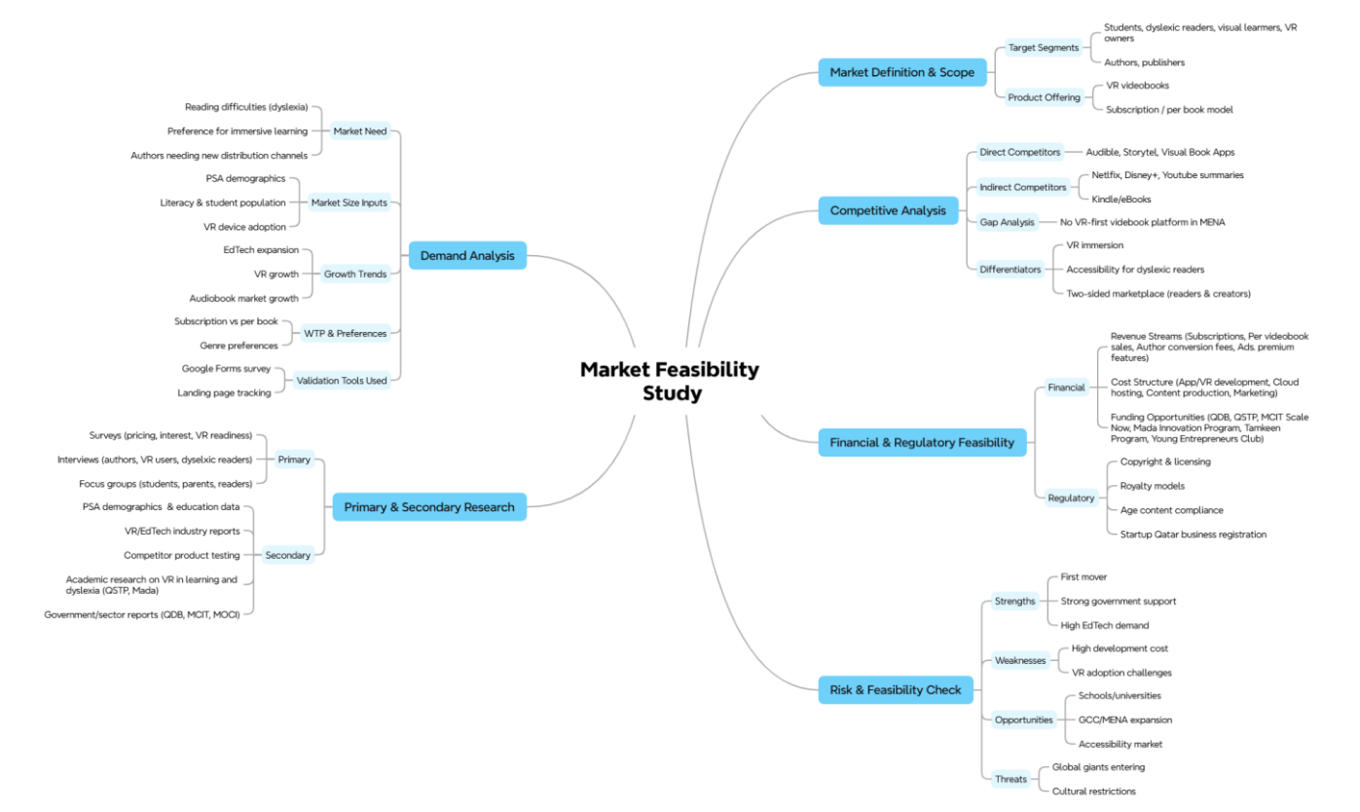
- Financial Opportunities MindMap:
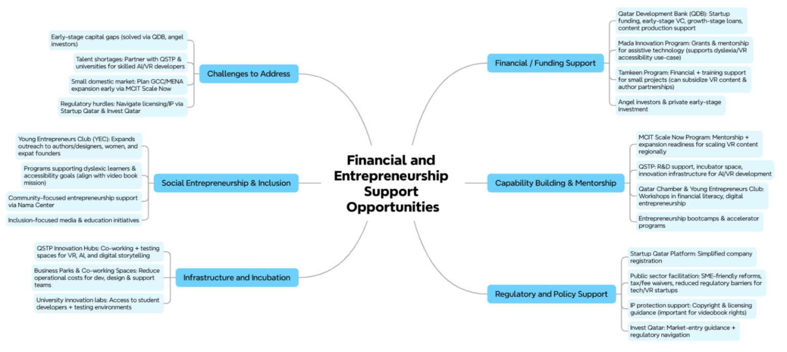

- Customer insights MindMap:
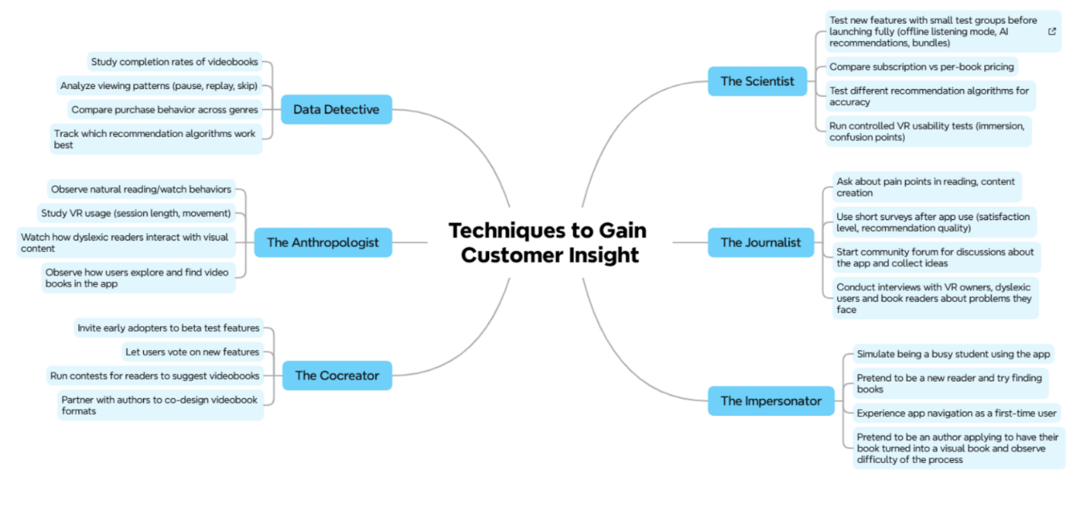
- Techniques to Test MVP:
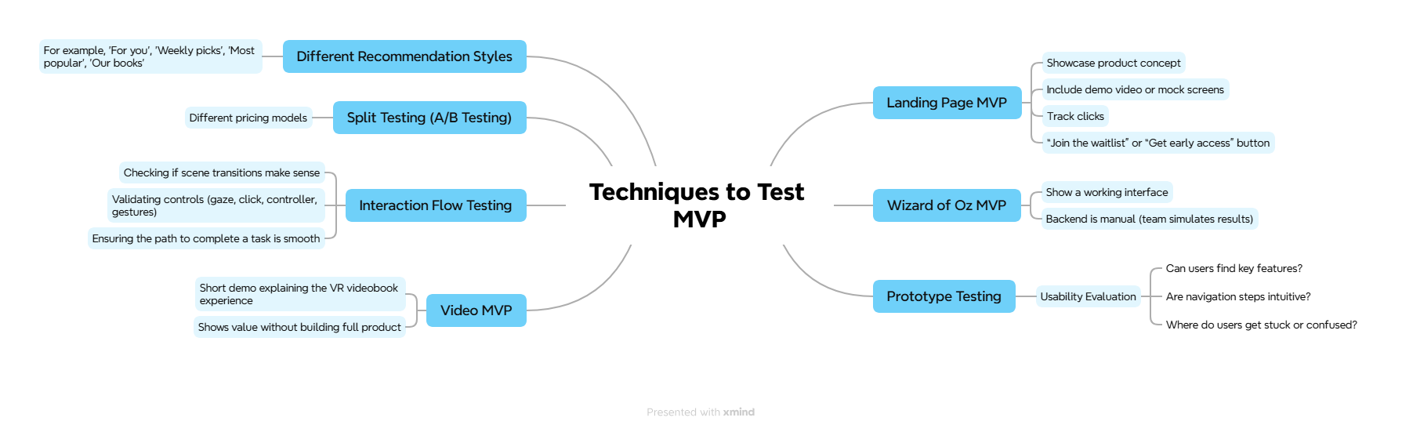

- Finding Your Earlyvangelists:
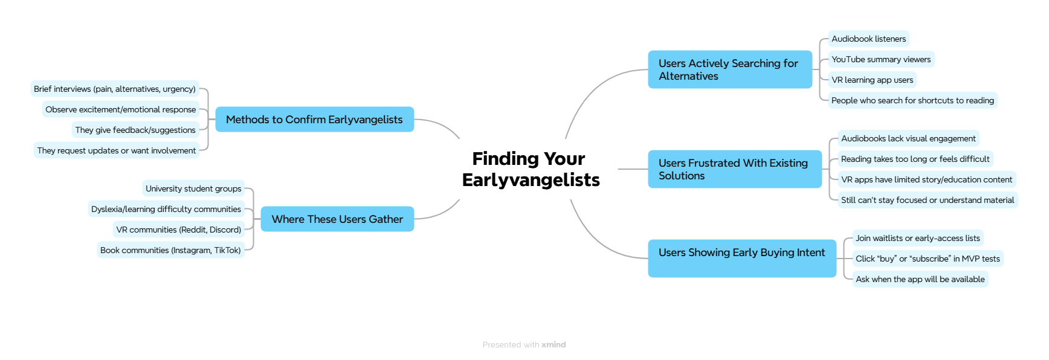

Refrences:
- GSER 2023 Showcases Top-Ranked Ecosystems, Key Trends, and $7.6 Trillion in Value Creation | Startup Genome. (2023). Startupgenome.com. https://startupgenome.com/library/gser-2023-showcases-top-ranked-ecosystems-key-trends-and-76-trillion-in-value-creation
- ‌Software Engineering Course (SWEBOK) | IEEE Computer Society. (n.d.). https://www.computer.org/education/bodies-of-knowledge/software-engineering
- YC Startup Library | Y Combinator. (2025). YC Startup Library. https://www.ycombinator.com/library/
- IDEO. (2015). Design Kit. Www.designkit.org. https://www.designkit.org/

