Important: Run the Flask server with an internet connection. If Flask is run without an internet connection, the Bootstrap stylesheet will not load correctly, and the website will display incorrectly.
Install packages:
pip install -r requirements.txt
Create tables the same as mine in MySQL only:
CREATE TABLE users (
id INT NOT NULL AUTO_INCREMENT,
email VARCHAR(255) NOT NULL UNIQUE,
password VARCHAR(255) NOT NULL,
PRIMARY KEY (id)
);
CREATE TABLE activities (
id INT AUTO_INCREMENT PRIMARY KEY,
activityType VARCHAR(255),
duration INT,
calories INT,
date DATE
);

Project README – Environment Variables & Security
This project uses a .env file to store sensitive configuration values. These include database credentials, Flask secret keys, and admin credentials.

Environment Variables (.env)
Create a .env file and write in the project root with the following content:
# MySQL Configuration
MYSQL_HOST=
MYSQL_USER=
MYSQL_PASSWORD=
MYSQL_DB=
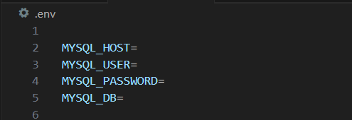

# Flask secret key
SECRET_KEY=
# Admin credentials
ADMIN_EMAIL=admin@gmail.com
ADMIN_PASSWORD_HASH=" "
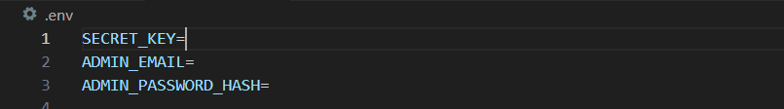
Replace the MYSQL_ values with your actual database host, username, password, and database name.
Why you must NOT upload the .env file
The .env file contains security-critical data, for example:
- SECRET_KEY – used by Flask for session management and CSRF protection.
- ADMIN_EMAIL and ADMIN_PASSWORD_HASH – allow login to the admin account.
- MySQL credentials – database host, username, password, and DB name.
If someone gains access to these values, they can:
- Generate valid session cookies
- Pretend to be any logged-in user
- Hijack sessions and modify session data
- Elevate permissions or access the admin account
- Bypass CSRF protection
- Access and modify the database

