Tech Stacks

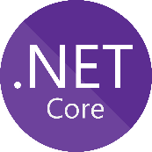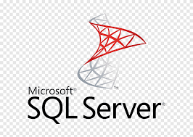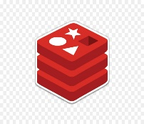

- Dapr

- Visual Studio 2019 last preview

- .Net Core 5

- Blazor

- Identityserver4

- Entity Framework Core

- SQL Server /MongoDB Todo

- Docker

- Kubernetes

- Redis (pub-sub & state store)

- Serilog

- Tye

- MediatR

- AutoMapper

- FluentValidation