# **Machine Learning Practical Backup**

**Name – Ritika Yadav**

**College Roll no.- 2019357**

**Examination Roll no. – 19066570049**

**Subject:-Machine Learning**

**Course - B.Sc. (Hons.) Computer Science**

**Semester:-Vl**

**Q1.Perform elementary mathematical operations in Python like addition, multiplication, division and exponentiation.**

**Program:**

x=int(input("Enter number 1: "))

y=int(input("Enter number 2: "))

print("Results after elementary maths operations:------")

print("Addition: ",x+y)

print("Subtraction: ",x-y)

if(y!=0):

print("Division: ",x/y)

else:

print("Division not possible!!")

print("Multiplication: ",x*y)

print("Exponent: ",x**y)

**Output:-**

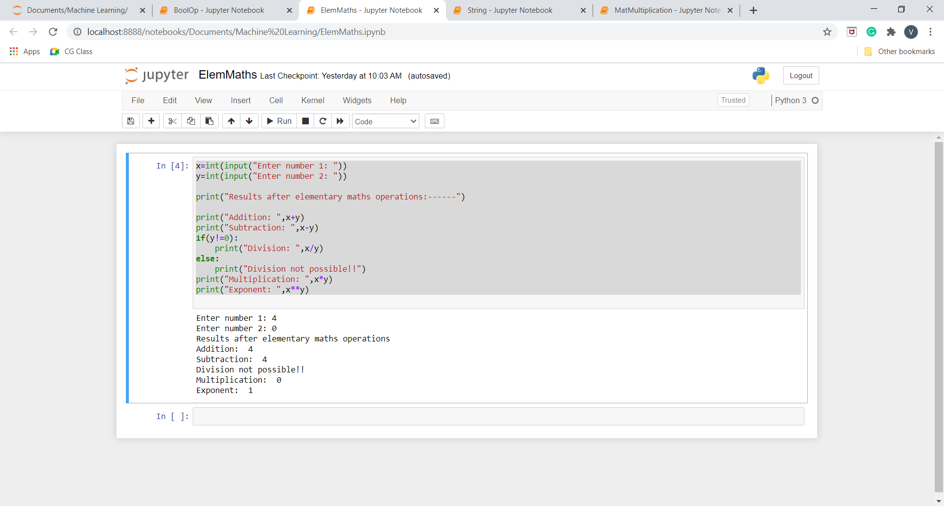

**Q2.Perform elementary logical operations in Python (like OR, AND, Checking for Equality, NOT, XOR).**

**Program:**

x=int(input("Enter number 1: "))

y=int(input("Enter number 2: "))

print("Results after boolean operations:------")

print("AND :",x and y)

print("OR :",x or y)

print("Checking Equality :",x==y)

print("NOT of number 1 :",not x)

print("NOT of number 2 :",not y)

print("XOR :",x^y)

**Output:**

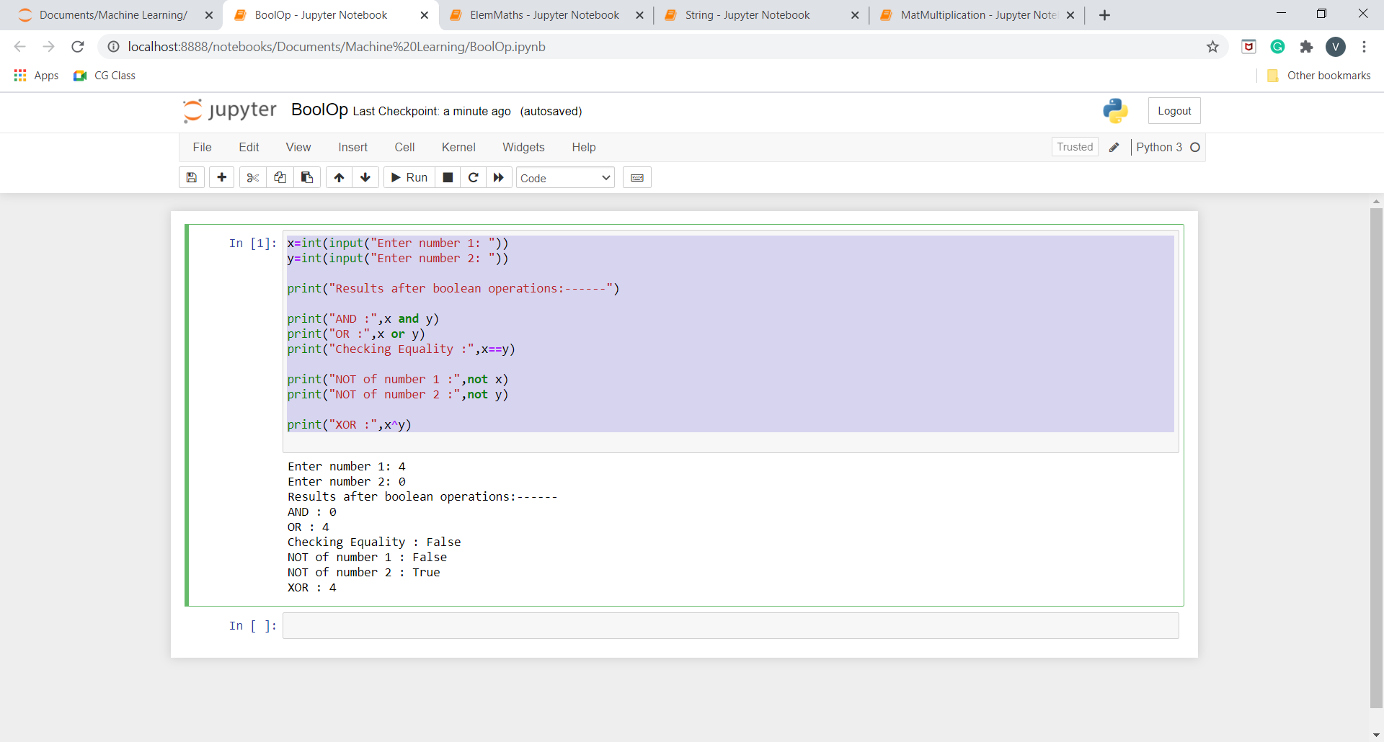

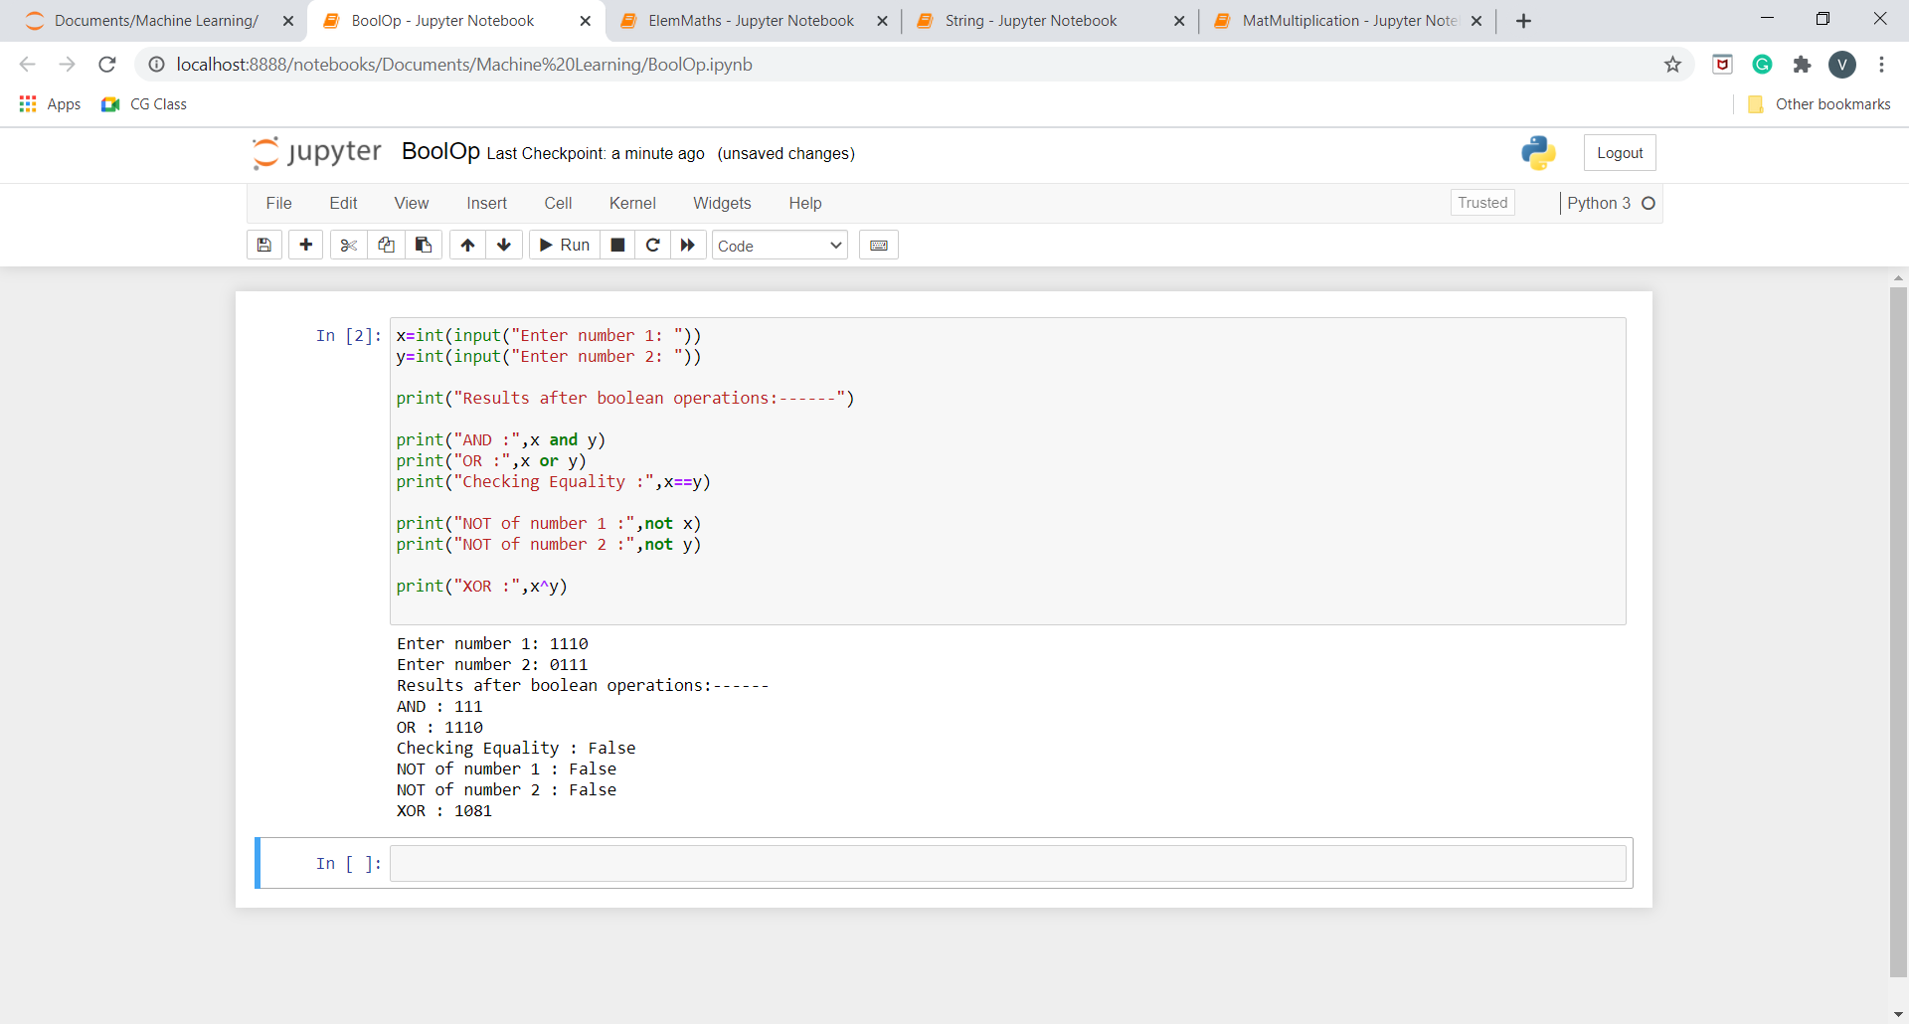

**Q3.Create, initialize and display simple variables and simple strings and use simple formatting for variable.**

**Program:**

x= 2/3

z=16

y= """ This is Machine Learning Program.

Hello World"""

print("String Formatting---------------------")

print(x)

print(y.split())

print(y.splitlines())

print(y.strip())

print(y.upper())

print(y.lower())

print(y.capitalize())

print(y.title())

print("_".join(y.split()))

print()

print("Number Formatting----------------------")

print(int(x))

print("%0.3f"%(x))

print(hex(z))

print(bin(z))

print(oct(z))

**Output:**

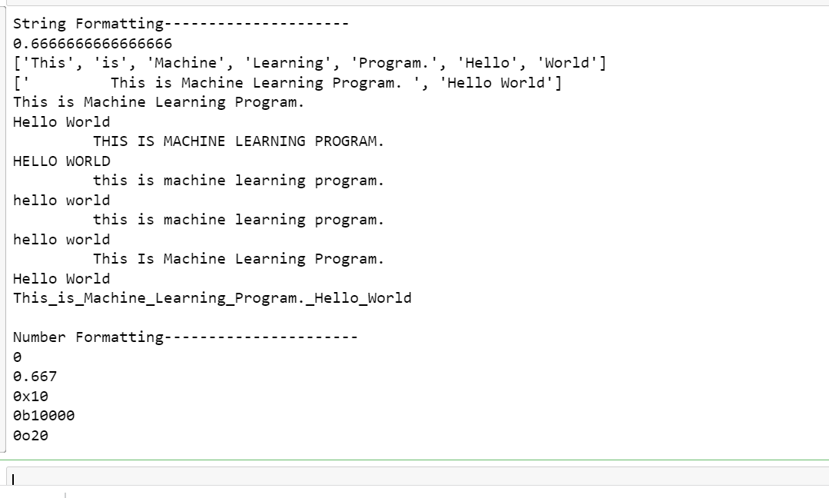

**Q4.Create/Define single dimension / multi-dimension arrays, and arrays with specific values like array of all ones, all zeros, array with random values within a range, or a diagonal matrix.**

**Program:**

import numpy as np

print('Single Dimensional Array :')

print('---------------------------------------------------------------------------')

print('With all zeroes')

print(np.zeros(5,int))

print()

print('With all ones')

print(np.ones(5,int))

print()

print('With all random integers')

print(np.random.randint(1,10,5))

print()

print('With values within a range')

print(np.arange(1,10))

print()

print('Multi Dimensional Array :')

print('---------------------------------------------------------------------------')

print('With all zeroes')

print(np.zeros((4,3),int))

print()

print('With all ones')

print(np.ones((4,3),int))

print()

print('With all random integers')

print(np.random.randint(1,10,(4,3)))

print()

print('With values within a range')

print(np.arange(1,10).reshape(3,3))

print()

print('With diagonal element')

print(np.eye(4,None,0,int))

print()

**Output:**

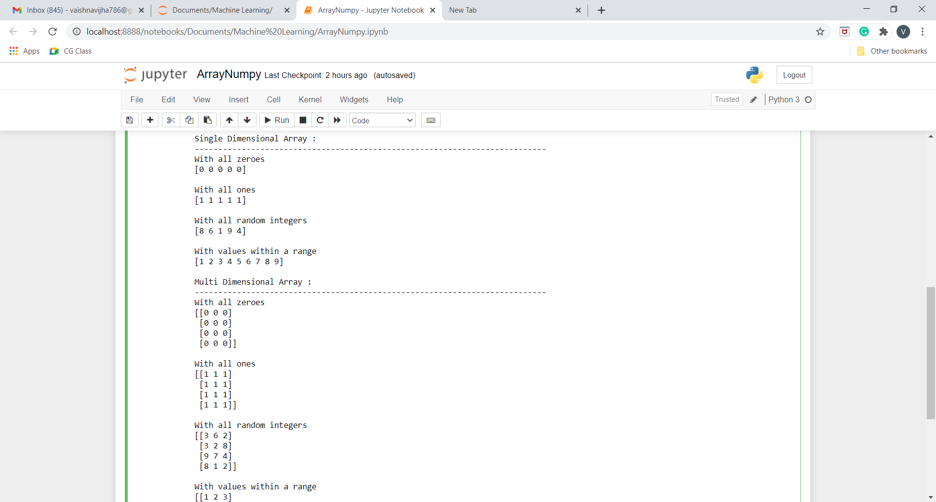

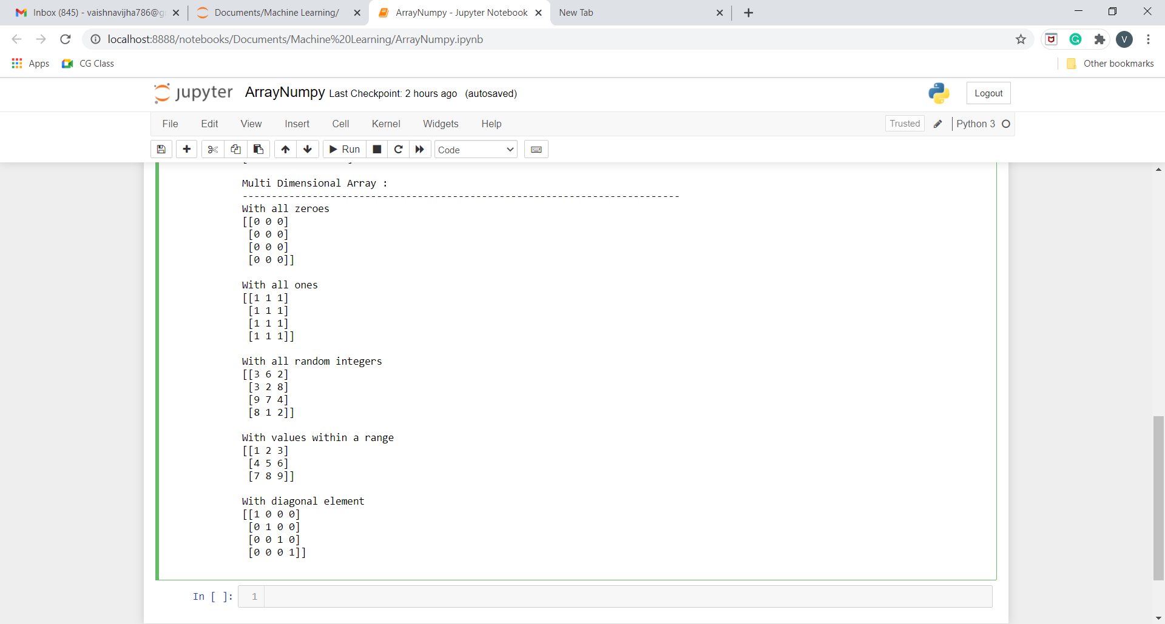

**Q5.Use command to compute the size of a matrix, size/length of a particular row/column, load data from a text file, store matrix data to a text file, finding out variables and their features in the current scope.**

**Program:**

import numpy as np

arr=np.random.randn(4,3)

print('Array:')

print('---------------------------------------------------------------------------')

print(arr)

print()

print('Size of Array:')

print('---------------------------------------------------------------------------')

print(arr.size)

print()

print('Size of particular row (row 2):')

print('---------------------------------------------------------------------------')

print(len(arr[:,2]))

print()

print('Size of particular column (column 2):')

print('---------------------------------------------------------------------------')

print(len(arr[2,:]))

print()

print('Taking input from file: ')

print('---------------------------------------------------------------------------')

with open('numpy2text.txt', 'r') as f:

l =np.loadtxt(f)

print(l)

print()

print('Saving Array to a file: ')

print('---------------------------------------------------------------------------')

with open('numpy2output.txt', 'wb') as f:

np.savetxt(f,arr)

**Output:**

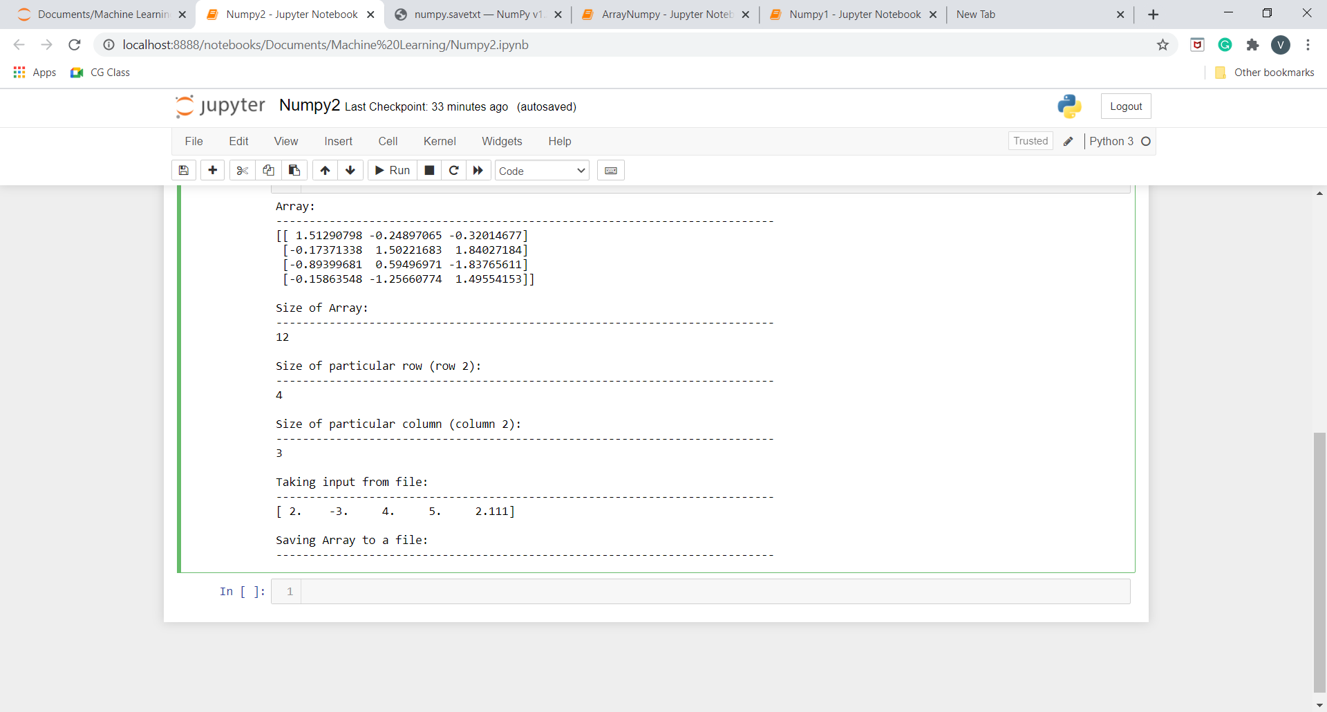

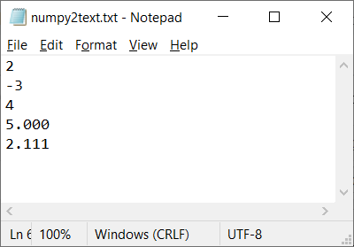

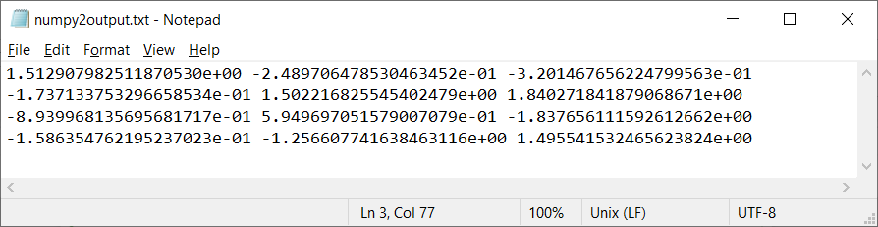

**Q6.Perform basic operations on matrices (like addition, subtraction, multiplication) and display specific rows or columns of the matrix.**

**Program:**

import numpy as np

mat1= np.random.randint(1,10,(3,3))

mat2= np.random.randint(1,10,(3,3))

print("Matrix 1:")

print(mat1)

print("Matrix 2:")

print(mat2)

print()

print('Addition of Two matrices')

print('---------------------------------------------------------------------------')

mat3=mat1+mat2

print(mat3)

print()

print('Subtraction of Two matrices')

print('---------------------------------------------------------------------------')

mat3=mat1+mat2

print(mat3)

print()

print('Multiplication of Two matrices')

print('---------------------------------------------------------------------------')

mat3=mat1*mat2

print(mat3)

print()

mat1= np.random.randint(1,10,(4,3))

mat2= np.random.randint(1,10,(3,2))

print("Matrix 1:")

print(mat1)

print("Matrix 2:")

print(mat2)

print()

print('Element-by-Element Multiplication of Two matrices')

print('---------------------------------------------------------------------------')

mat3=mat1.dot(mat2)

print(mat3)

print()

print('Displaying Specific Rows and column')

print('---------------------------------------------------------------------------')

print(mat3[1:,1:])

**Output:**

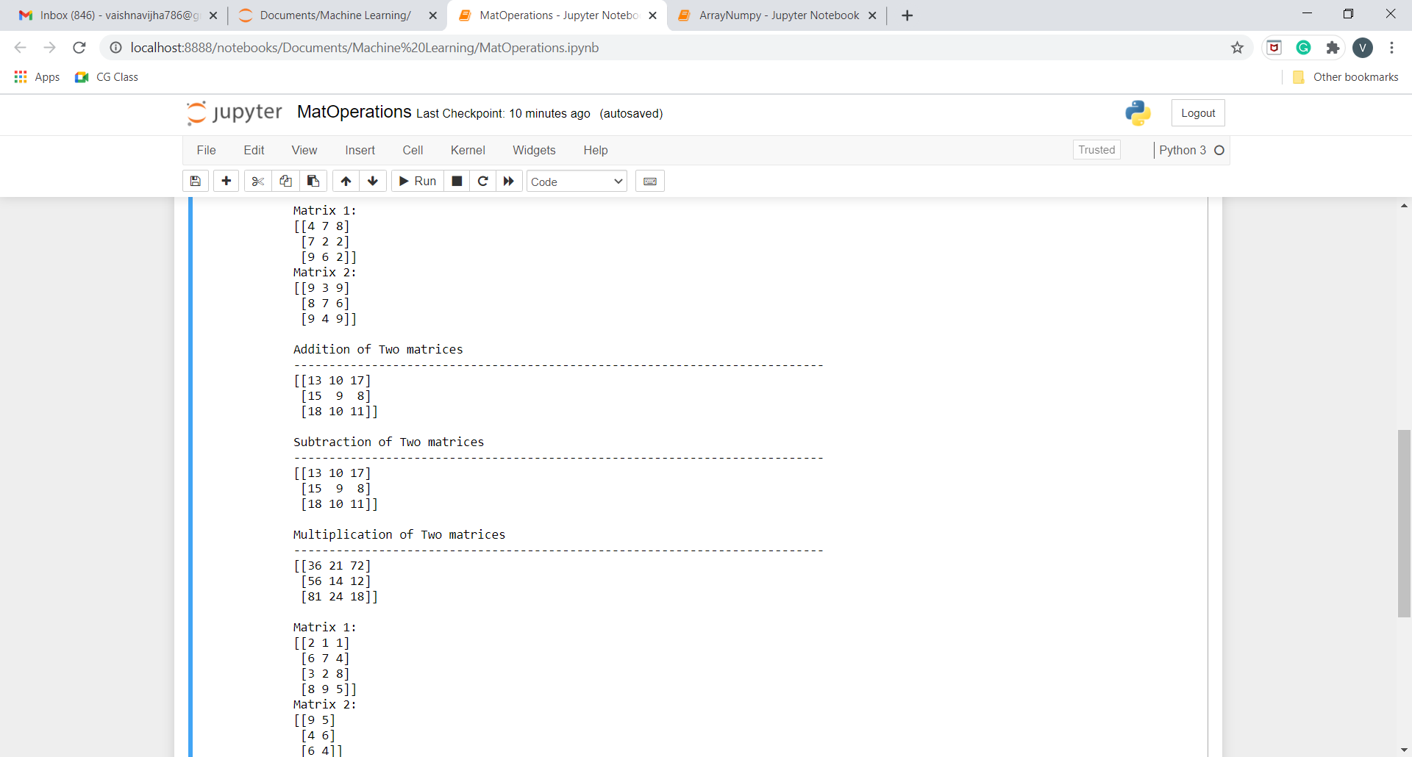

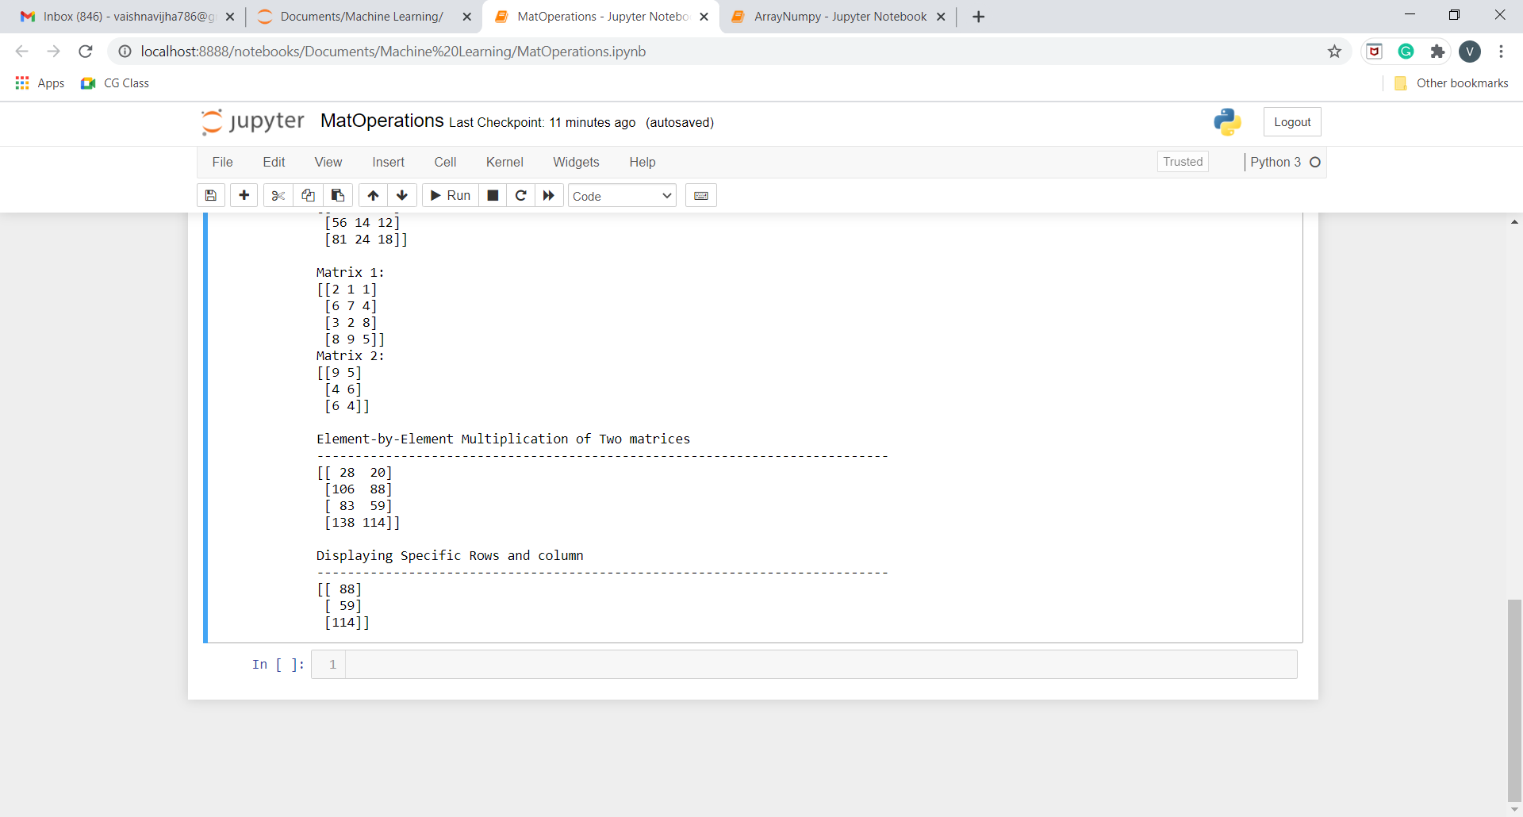

**Q7.Perform other matrix operations like converting matrix data to absolute values, taking the negative of matrix values, additing/removing rows/columns from a matrix, finding the maximum or minimum values in a matrix or in a row/column, and finding the sum of some/all elements in a matrix.**

**Program:**

import numpy as np

arr=np.random.randn(4,3)

print('Array:')

print('---------------------------------------------------------------------------')

print(arr)

print()

print('Absolute Value of the Array')

print('---------------------------------------------------------------------------')

print(np.absolute(arr))

print()

print('Negative Value of the Array')

print('---------------------------------------------------------------------------')

print(np.negative(arr))

print()

print('Array after deleting row 2')

print('---------------------------------------------------------------------------')

print(np.delete(arr,2,0))

print()

print('Array after deleting column 2')

print('---------------------------------------------------------------------------')

print(np.delete(arr,2,1))

print()

print('Maximum of Array')

print('---------------------------------------------------------------------------')

print(np.max(arr))

print()

print('Minimum of Array')

print('---------------------------------------------------------------------------')

print(np.min(arr))

print()

print('Sum of all elements of Array')

print('---------------------------------------------------------------------------')

print(np.sum(arr))

print()

print('Sum of all elements of Array row-wise')

print('---------------------------------------------------------------------------')

print(np.sum(arr,0))

print()

print('Sum of all elements of Array column-wise')

print('---------------------------------------------------------------------------')

print(np.sum(arr,1))  
  
**Output:**

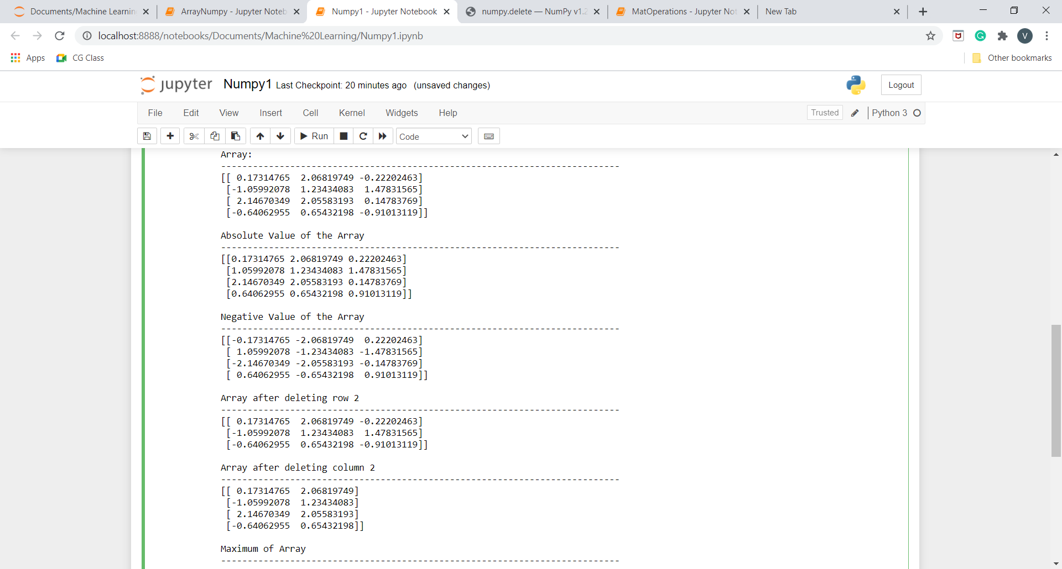

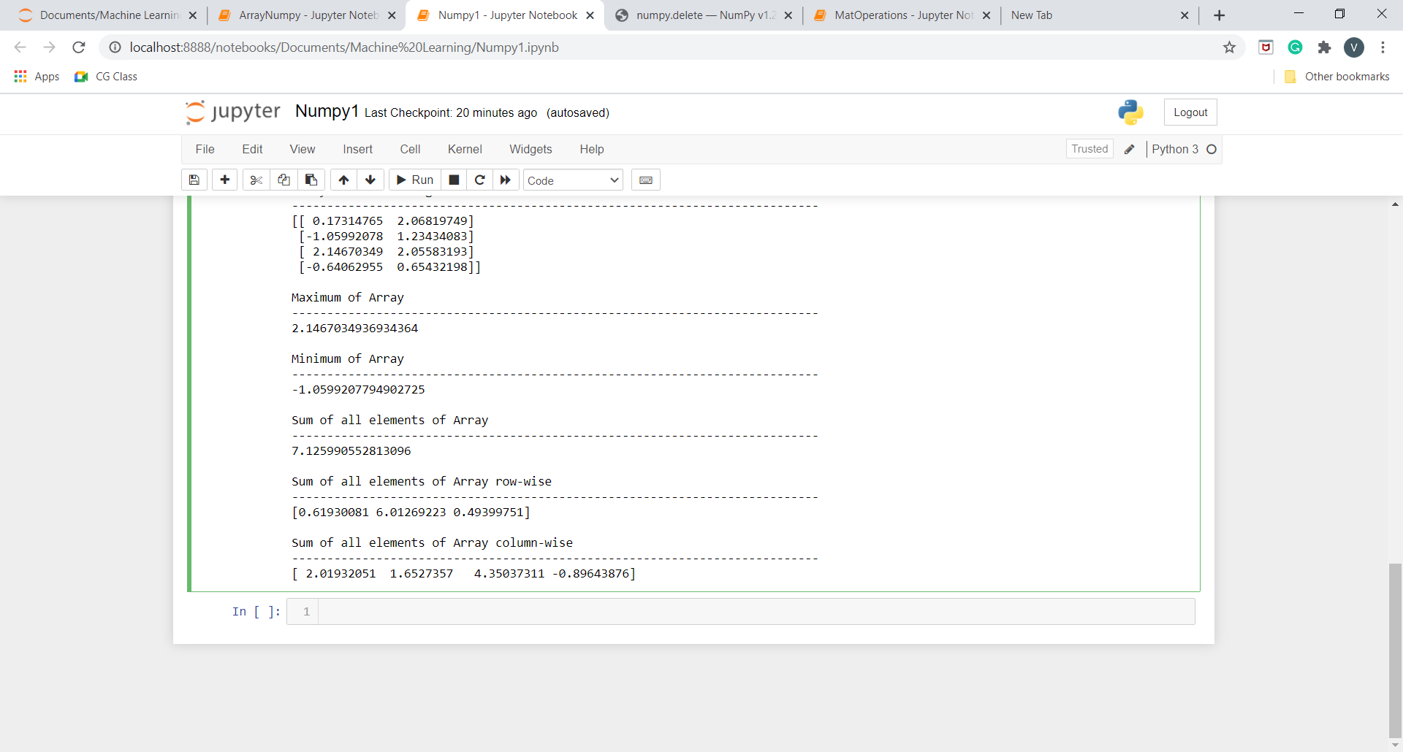

**Q8.Create various type of plots/charts like histograms, plot based on sine/cosine function based on data from a matrix. Further label different axes in a plot and data in a plot.**

**Program:**

#!/usr/bin/env python

# coding: utf-8

# In[2]:

import matplotlib.pyplot as plt

import numpy as np

# In[15]:

x=np.arange(40)

# In[16]:

x

# In[17]:

plt.plot(x)

plt.show()

# In[18]:

y=np.sin(x)

plt.plot(x)

plt.plot(y)

plt.show()

# In[19]:

y=np.cos(x)

plt.plot(x,color='green')

plt.plot(y)

plt.show()

# In[20]:

x=np.array([1,2,3,4,5])

y=x**2

plt.scatter(x,y,color="orange", label="squares of number", marker="o") #color, label, marker are optional arguments

plt.legend()

plt.xlabel("numbers")

plt.ylabel("squares")

plt.show()

# In[21]:

x=np.array([1,2,3,4,5])

plt.plot(x,x**2,label="squares of number", marker="o")

plt.plot(x,x**3,label="cubes of number", marker="o")

plt.legend()

plt.xlabel("numbers")

plt.title("Squares and Cubes")

plt.show()

# In[22]:

numbers=np.random.randint(0,10,5)

indices=np.arange(5)

indices=indices+2015

numbers2=np.random.randint(0,10,5)

indices2=np.arange(5)

indices2=indices2+2015

print(numbers)

print(numbers2)

# In[23]:

plt.bar(indices,numbers,0.25,color="red",label="rainfall")

plt.bar(indices2+0.25,numbers2,0.25,color="green",label="humidity")

plt.legend()

plt.show()

# In[4]:

labels=["english","hindi","maths","science","social science","computers"]

values=[90,80,40,73,78,43]

plt.pie(values,labels=labels,radius=1)

plt.show()

plt.pie(values,labels=labels,radius=1,explode=(0,0,1,0,0,0),shadow=True)

plt.show()

# In[24]:

u=5

sigma=2

vals=u+sigma*np.random.randn(1000)

print(vals.shape)

plt.hist(vals,50)

plt.show()

# In[26]:

plt.figure(figsize=(8,8))

plt.subplot(221)

plt.plot(x,x**2, label="2018")

plt.plot(x,x**3, label="2017")

plt.subplot(222)

plt.hist(vals,50)

plt.subplot(223)

plt.pie(values,labels=labels,radius=1)

plt.subplot(224)

plt.pie(values,labels=labels,radius=1,explode=(0,0,1,1,0,1),shadow=True)

plt.show()

# In[ ]:

**Output:**

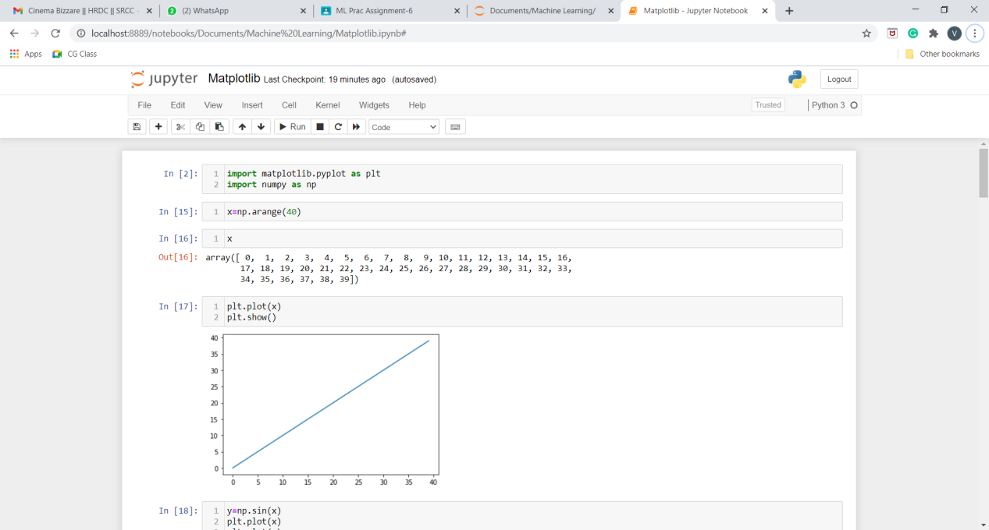

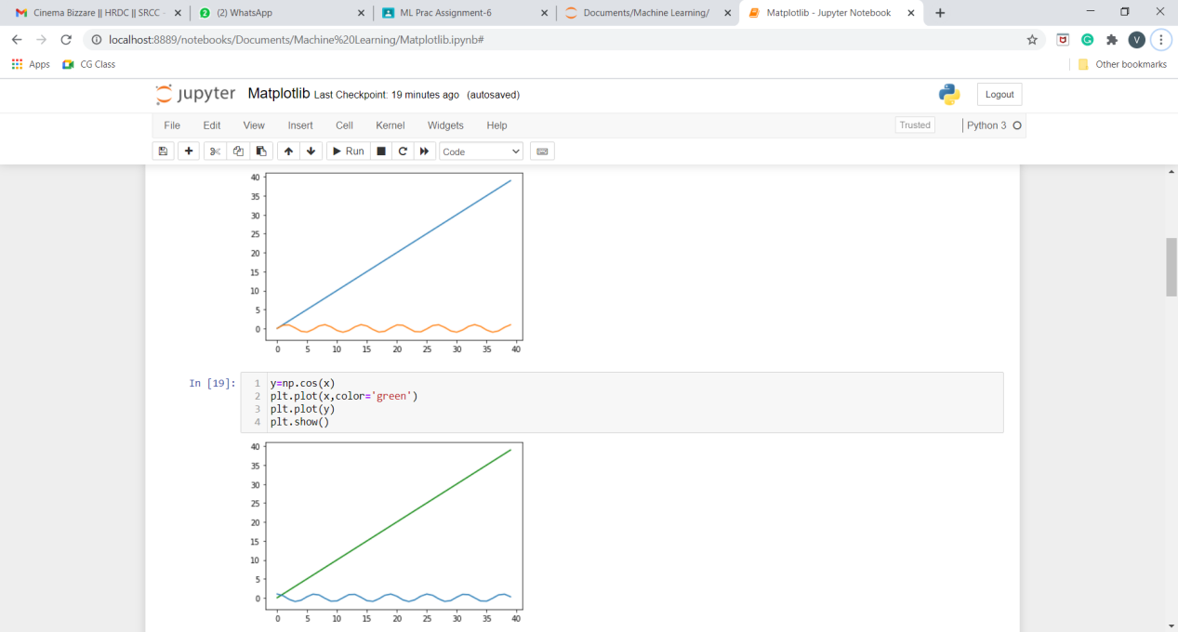

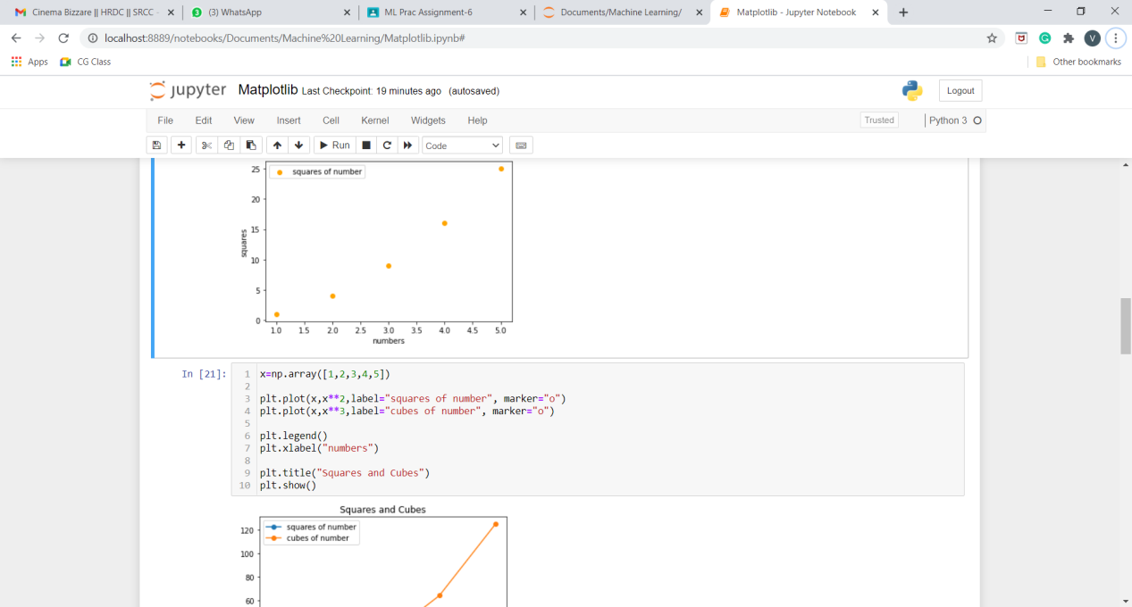

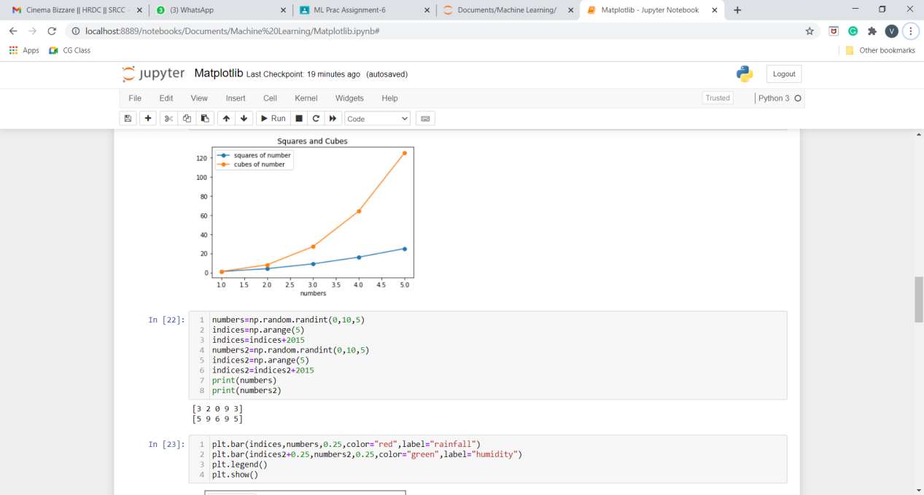

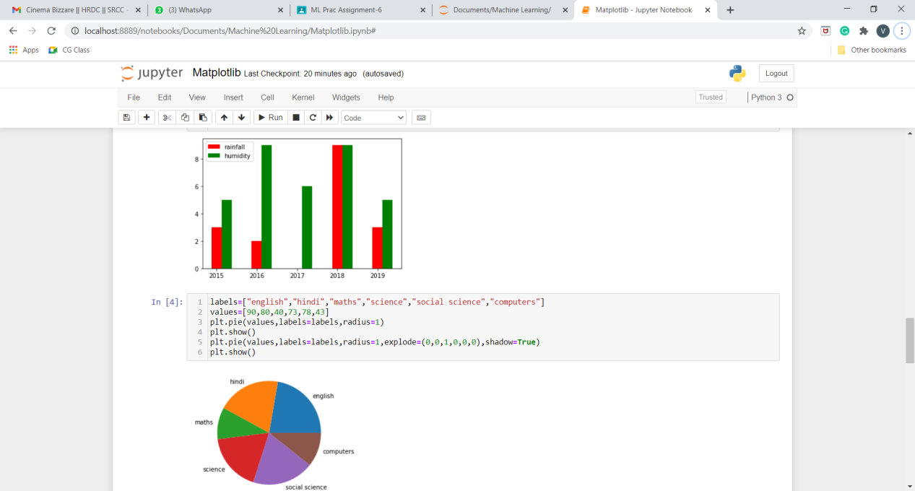

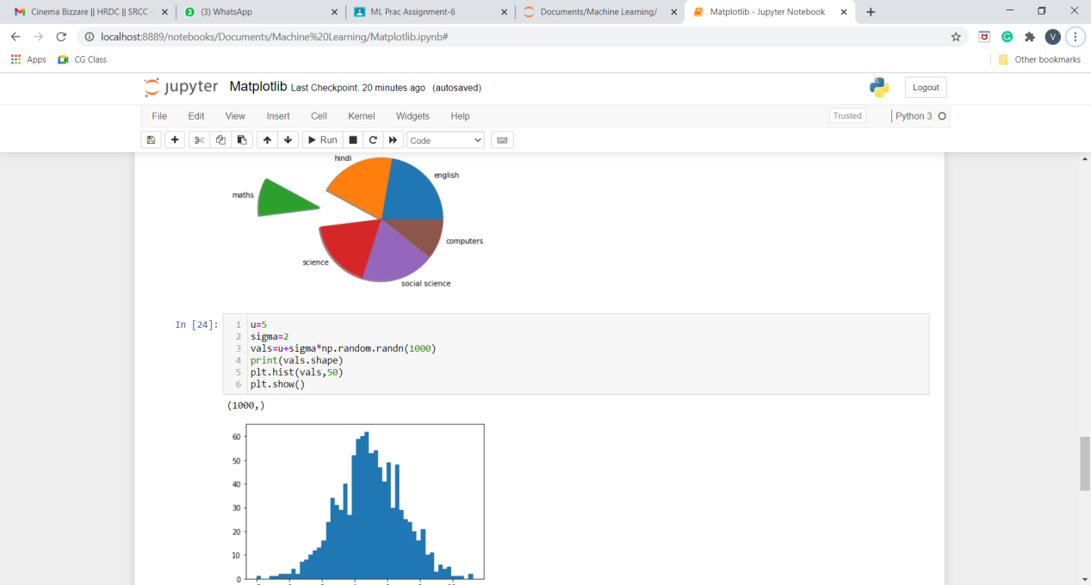

**Q9.Generate different subplots from a given plot and color**

**plot data.**

**Code:-**

#suplots

plt.figure(figsize=(8,8))

plt.subplot(221)

plt.plot(x,x**2, label="2018")

plt.plot(x,x**3, label="2017")

plt.subplot(222)

plt.hist(vals,50)

plt.subplot(223)

plt.pie(values,labels=labels,radius=1)

plt.subplot(224)

plt.pie(values,labels=labels,radius=1,explode=(0,0,1,1,0,1),shadow=True)

plt.show()

**Output:-**

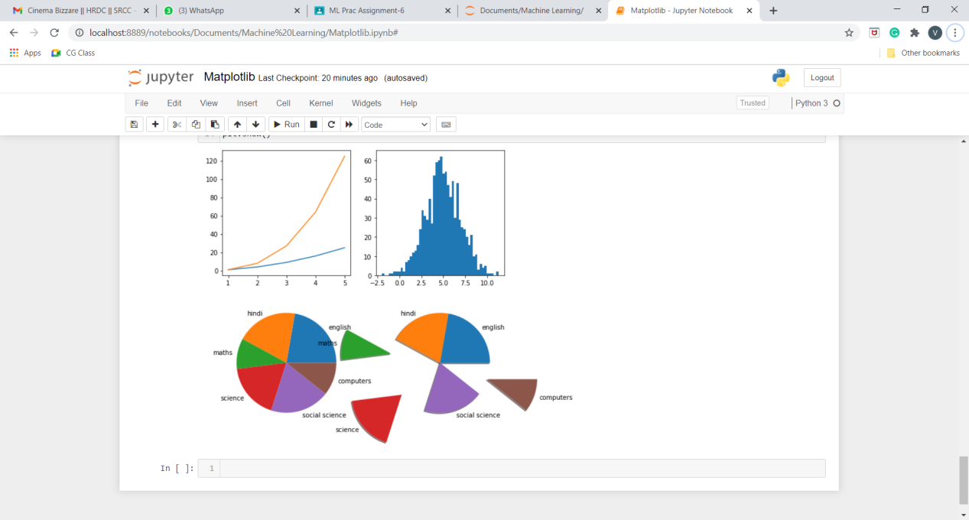

**Q10.Use conditional statements and different type of loops based on simple example/s. (Perform matrix multiplication using nested loops)**

**Program:**

A = [[1, 2, 3],

[4, 5, 6],

[7, 8, 9]]

B = [[10, 11, 12, 13],

[14, 15, 16, 17],

[18, 19, 20, 21]]

result = [[0, 0, 0, 0],

[0, 0, 0, 0],

[0, 0, 0, 0]]

for i in range(len(A)):

for j in range(len(B[0])):

for k in range(len(B)):

result[i][j] += A[i][k] * B[k][j]

for i in range(len(result)):

for j in range(len(result[0])):

print(result[i][j],end=" ")

print()

**Output:**

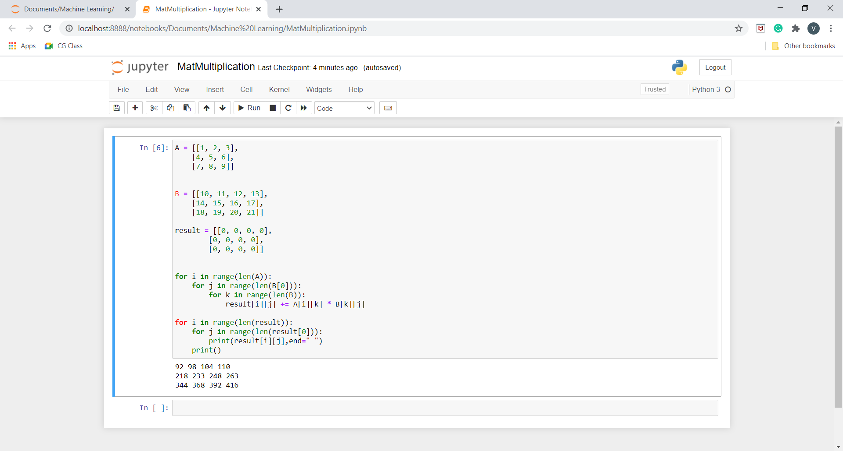

**Q11.Perform vectorized implementation of simple matrix operation like finding the transpose of a matrix, adding, subtracting or multiplying two matrices.**

**Program:**

1. **Plotting of Data:**

**Commands:**

>>> import matplotlib.pyplot as plt

>>> plt.plot([1,2,3],[4,5,6])

[<matplotlib.lines.Line2D object at 0x00000224330A0790>]

>>> plt.draw()

>>> plt.show()

**Output:**

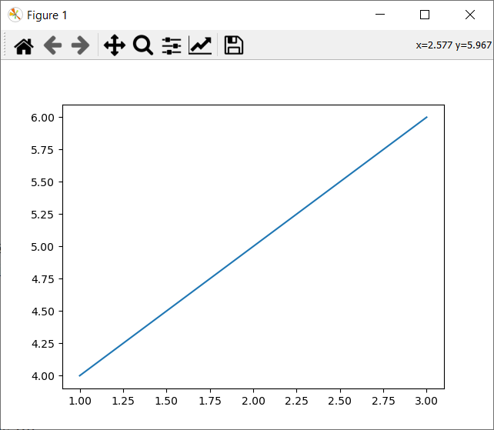

1. **Vectorization:**

**Commands:**

>>> import numpy as np

>>> #converting a tuple into a vector

>>> #using numpy methods to convert into a array

>>> #1-D array

>>> type((1,2,3,4,5))

<class 'tuple'>

>>> x=np.array((1,2,3,4,5))

>>> x

array([1, 2, 3, 4, 5])

>>> type(x)

<class 'numpy.ndarray'>

>>> #2-D array

>>> y=np.random.randn(3,4)

>>> y

array([[ 0.73970731, -0.11279598, 0.26243823, -0.77851299],

[-0.53945554, -0.95227891, -0.41367667, 0.08030448],

[-0.83408442, -0.99784631, -1.91956168, 1.04841069]])

>>> type(y)

<class 'numpy.ndarray'>

>>> #2-D array -->matrices

>>>

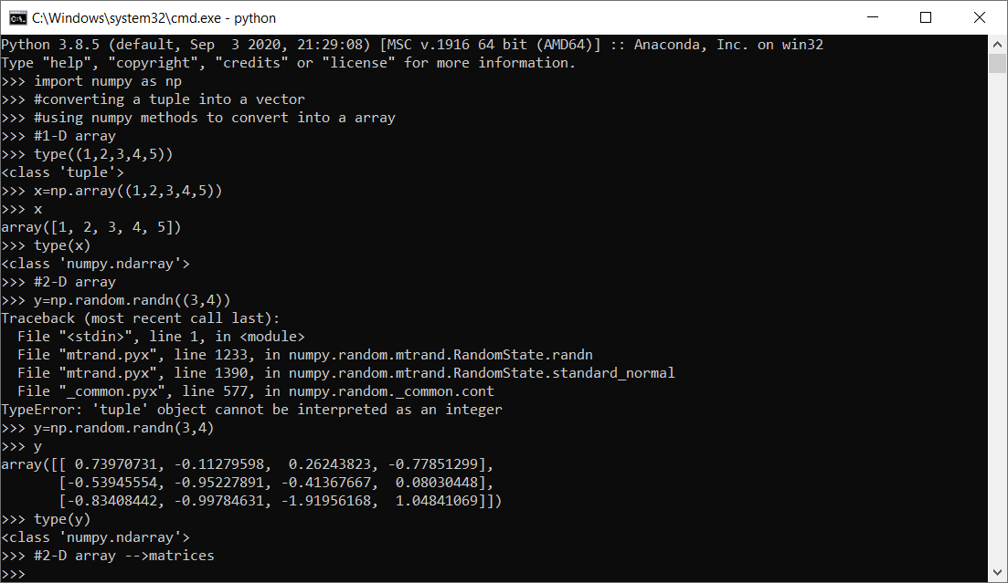

1. **Operations on Vectors:**

**Commands:**

>>> import numpy as np

>>> x=np.array([1,2,3])

>>> y=np.array([9,8,7])

>>> #addition

>>> x+y

array([10, 10, 10])

>>> #subtraction

>>> y-x

array([8, 6, 4])

>>> #product

>>> x*y

array([ 9, 16, 21])

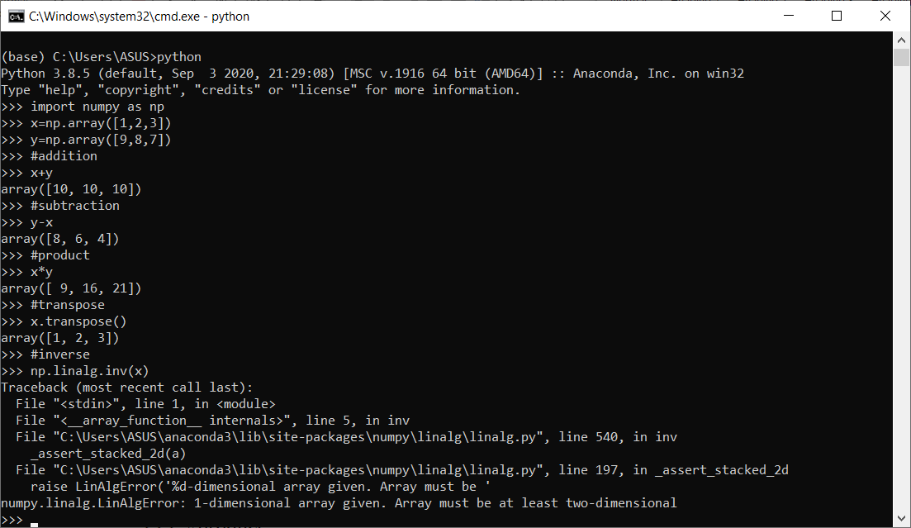

1. **Operations on matrices**

>>> mat1=np.random.randint(1,10,(3,3))

>>> mat2=np.random.randint(1,10,(3,3))

>>> mat1

array([[6, 3, 8],

[3, 4, 5],

[9, 3, 6]])

>>> mat2

array([[3, 7, 6],

[6, 8, 6],

[6, 7, 4]])

>>> #addition

>>> mat1+mat2

array([[ 9, 10, 14],

[ 9, 12, 11],

[15, 10, 10]])

>>> #subtration

>>> mat1-mat2

array([[ 3, -4, 2],

[-3, -4, -1],

[ 3, -4, 2]])

>>> #product

>>> mat1*mat2

array([[18, 21, 48],

[18, 32, 30],

[54, 21, 24]])

>>> #matrix multipliaction

>>> mat1.dot(mat2)

array([[ 84, 122, 86],

[ 63, 88, 62],

[ 81, 129, 96]])

>>> #transpose

>>> np.transpose(mat1)

array([[6, 3, 9],

[3, 4, 3],

[8, 5, 6]])

>>> np.transpose(mat2)

array([[3, 6, 6],

[7, 8, 7],

[6, 6, 4]])

>>> #inverse

>>> np.linalg.inv(mat1)

array([[-0.11111111, -0.07407407, 0.20987654],

[-0.33333333, 0.44444444, 0.07407407],

[ 0.33333333, -0.11111111, -0.18518519]])

>>> np.linalg.inv(mat2)

array([[-0.55555556, 0.77777778, -0.33333333],

[ 0.66666667, -1.33333333, 1. ],

[-0.33333333, 1.16666667, -1. ]])

>>>

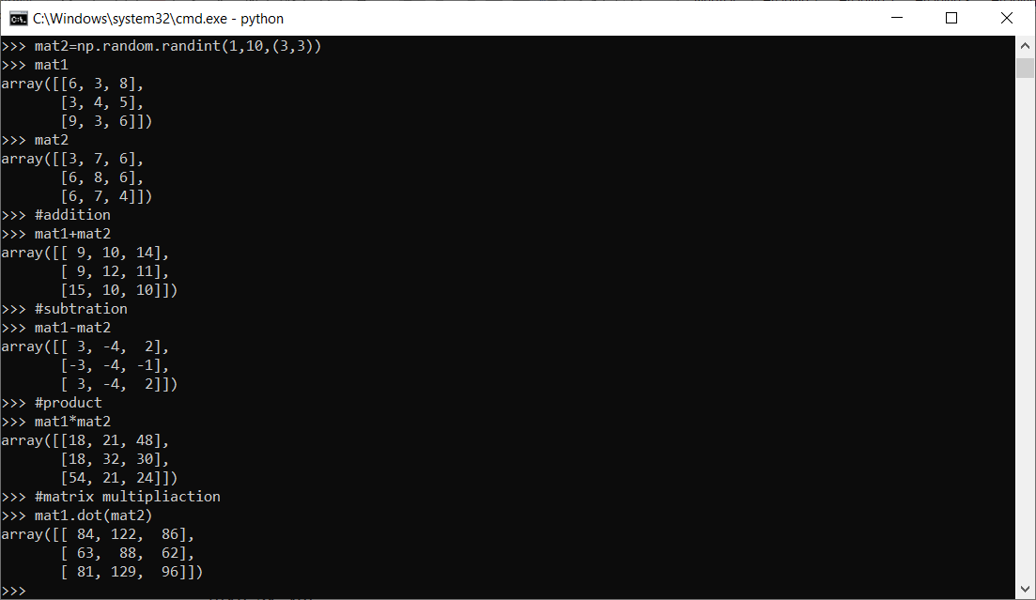

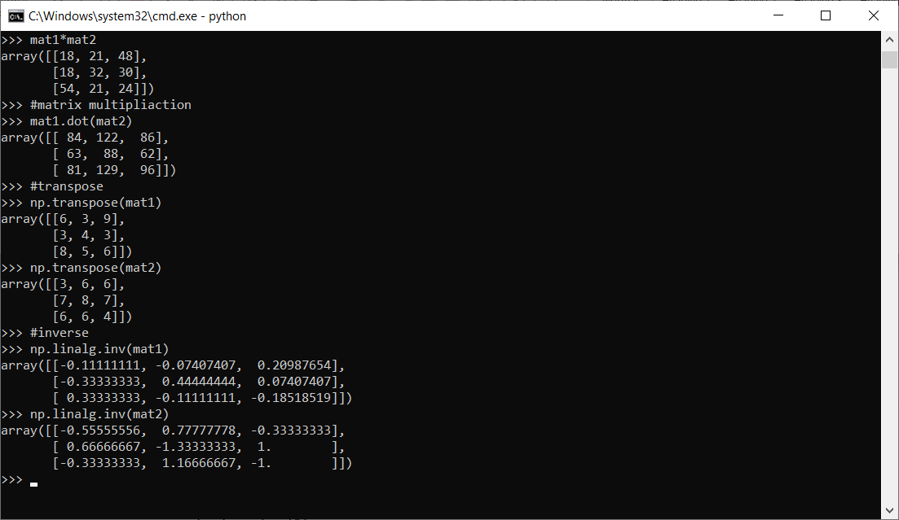

**Q12. Implement Simple Linear Regression using analytical method and depict model on scatter data plot.**

#a) Take x=[1,2,4], y=[2,3,6]

import numpy as np

import pandas as pd

import matplotlib.pyplot as plt

x=np.array([1,2,4])

y=np.array([2,3,6])

x_mean=np.mean(x)

print(x_mean)

y_mean=np.mean(y)

print(y_mean)

n=x.size

print(n)

ss_xy=np.sum(x*y) - n*x_mean*y_mean

print(ss_xy)

ss_xx=np.sum(x*x) - n*x_mean*x_mean

print(ss_xx)

b1=ss_xy/ss_xx

print(b1)

b0=y_mean-b1*x_mean

print(b0)

plt.scatter(x,y)

y_pred=b0+b1*x

print(y_pred)

plt.plot(x,y_pred,color='red')

plt.xlabel("x")

plt.ylabel("y")

plt.title("Linear Regression[x~y]")

plt.show()

#b) Regress Sales~Radio from Advertisingdata.csv

col_list = ["TV", "radio","newspaper","sales"]

data = pd.read_csv("Advertising.csv", usecols=col_list)

data["sales"]     #x-axis

data["radio"]     #y-axis

x_mean=np.mean(data["sales"])

print(x_mean)

y_mean=np.mean(data["radio"])

print(y_mean)

n=data["sales"].size

print(n)

ss_xy=np.sum(data["sales"]*data["radio"]) - n*x_mean*y_mean

print(ss_xy)

ss_xx=np.sum(data["sales"]*data["sales"]) - n*x_mean*x_mean

print(ss_xx)

b1=ss_xy/ss_xx

print(b1)

b0=y_mean-b1*x_mean

print(b0)

plt.scatter(data["sales"],data["radio"])

y_pred=b0+b1*data["sales"]

print(y_pred)

plt.plot(data["sales"],y_pred,color='red')

plt.xlabel("sales")

plt.ylabel("radio")

plt.title("Linear Regression[Sales~Radio]")

plt.show()

**Output:**

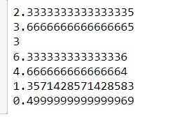

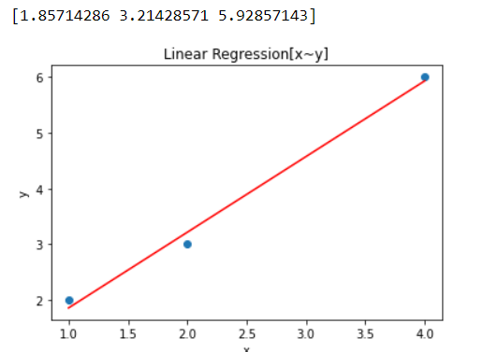

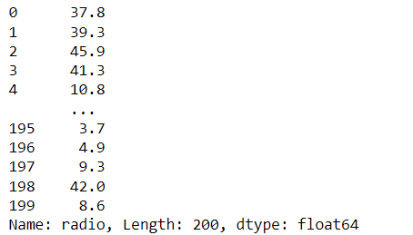

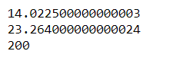

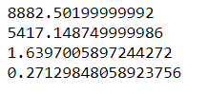

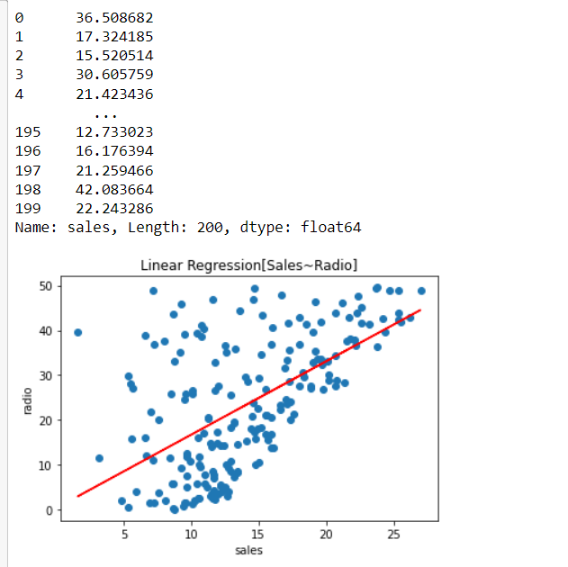

**Program( Linear Regression using scikitLearn) :-**

import pandas as pd

import numpy as np

import matplotlib.pyplot as plt

from sklearn.linear_model import LinearRegression

from sklearn.metrics import r2_score

import statsmodels.api as sm

data = pd.read_csv(r"Advertising.csv")

data

data.columns

plt.figure(figsize=(16, 8))

plt.scatter(

    data['TV'],

    data['sales']

)

plt.xlabel("TV ")

plt.ylabel("Sales ")

plt.show()

X = data['TV'].values.reshape(-1,1)

y = data['sales'].values.reshape(-1,1)

from sklearn.model_selection import train_test_split

X_train, X_test, y_train, y_test = train_test_split(X,y,test_size=0.3,random_state=0)

print(X_train.shape)

print(X_test.shape)

print(y_train.shape)

print(y_test.shape)

reg = LinearRegression()

reg.fit(X_train, y_train)

print(reg.coef_[0][0])

print(reg.intercept_[0])

print("The linear model is: Y = {:.5} + {:.5}X".format(reg.intercept_[0], reg.coef_[0][0]))

# In[24]:

predictions = reg.predict(X_test)

plt.figure(figsize=(16, 8))

plt.scatter(

    data['TV'],

    data['sales']

)

plt.plot(

    X_test,

    predictions,

    linewidth=2,

    color='red'

)

plt.xlabel("TV ")

plt.ylabel("Sales ")

plt.show()

X=X_train

y=y_train

X2 = sm.add_constant(X)

est = sm.OLS(y, X2)

est2 = est.fit()

print(est2.summary())

# In[14]:

print('Train Score :', reg.score(X_train,y_train))

print('Test Score:', reg.score(X_test,y_test))

# In[15]:

from sklearn import metrics

print('MSE :', metrics.mean_squared_error(y_test,predictions))

**Output:**

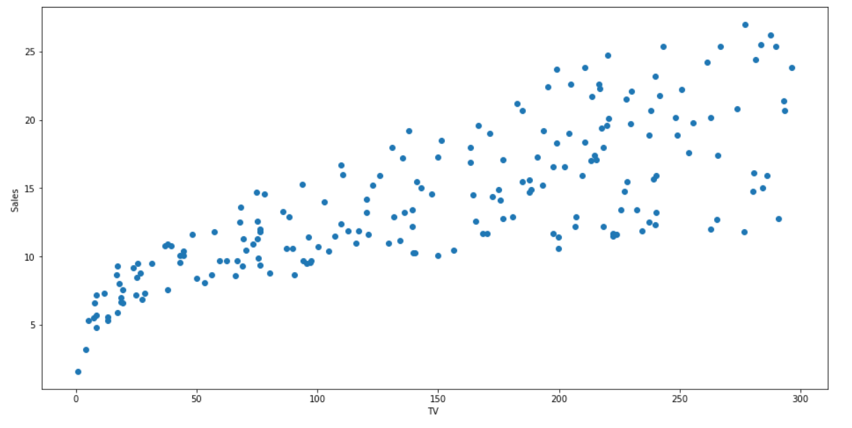

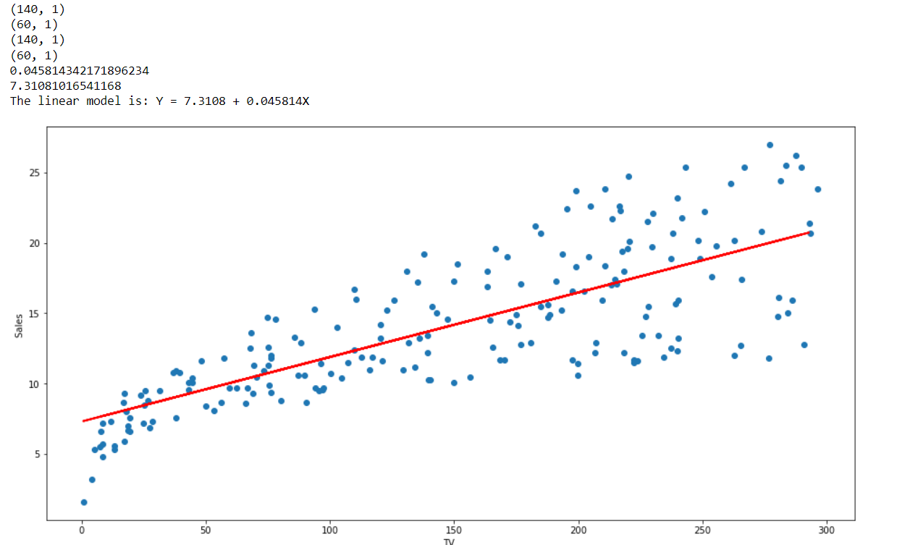

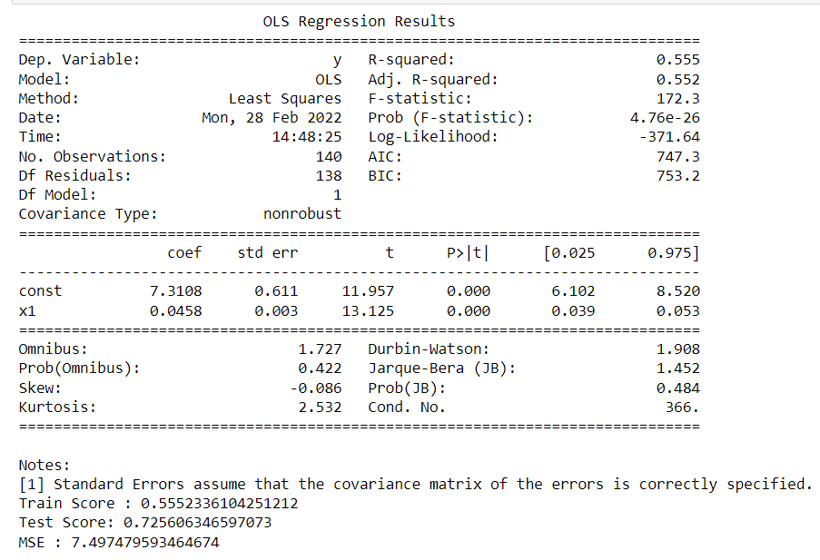

**Q13. Implement Multiple Linear Regression on Advertising.csv.**

**Hint : Use functions from sklearn.linear_model, statsmodels.api**

**Program:**

#!/usr/bin/env python

# coding: utf-8

# In[2]:

import pandas as pd

import numpy as np

import matplotlib.pyplot as plt

from sklearn.linear_model import LinearRegression

from sklearn.metrics import r2_score

import statsmodels.api as sm

# In[6]:

data = pd.read_csv(r"Advertising.csv")

# In[7]:

Xs = data.drop(['sales', 'Unnamed: 0'], axis=1)

y = data['sales'].values.reshape(-1,1)

reg = LinearRegression()

reg.fit(Xs, y)

print("The linear model is: Y = {:.5} + {:.5}*TV + {:.5}*radio + {:.5}*newspaper".format(reg.intercept_[0], reg.coef_[0][0], reg.coef_[0][1], reg.coef_[0][2]))

# In[8]:

X = np.column_stack((data['TV'], data['radio'], data['newspaper']))

y = data['sales']

X2 = sm.add_constant(X)

est = sm.OLS(y, X2)

est2 = est.fit()

print(est2.summary())

**Output:**

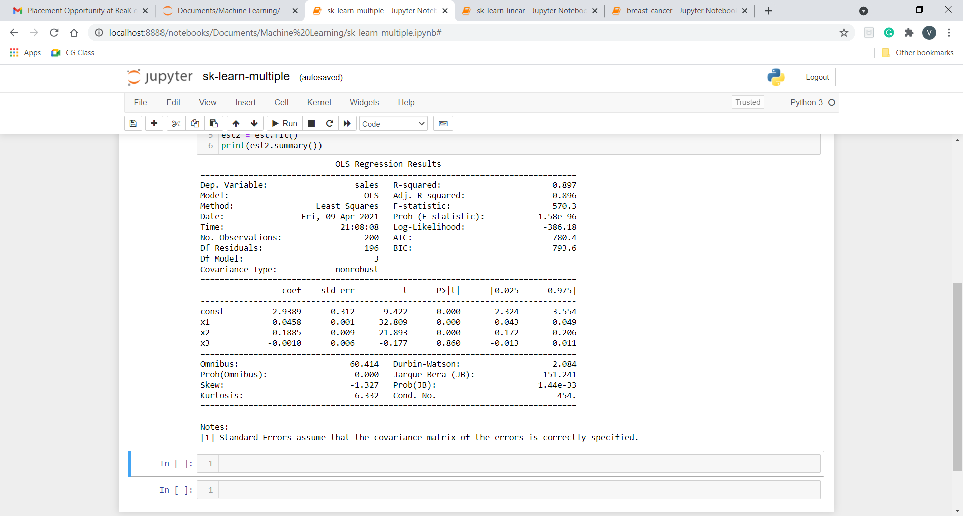

**Q14.Implement Logistic Regression on built in dataset breast_cancer from sklearn.datasets.**

**Program:**

import pandas as pd

from sklearn import metrics

import numpy as np

import matplotlib.pyplot as plt

import seaborn as sns

import math

from sklearn.model_selection import train_test_split

import array as arr

# implement a sigmoid function by hand

def sigmoid(x):

    a = []

    for item in x:

        a.append(1/(1+math.exp(-item)))

    return a

# evaluate the sigmoid at some x values

sigm = np.arange(-22, 22, 0.5)

# plot the sigmoid

plt.plot(sigm*0.2+4.57, np.array(sigmoid(sigm)), color = "red") # manually implemented sigmoid

plt.plot([0,10], [0.5, 0.5], linestyle = "dotted", color = "black")

plt.title("Sigmoid function")

plt.xlabel("x")

plt.ylabel("y")

plt.show()

col_names = ['pregnant', 'glucose', 'bp', 'skin', 'insulin', 'bmi', 'pedigree', 'age', 'outcome'] # load dataset

pima = pd.read_csv("diabetes.csv", header=None, names=col_names)

pima.head()

# split data into features/inputs and targets/outputs

feature_cols = ['pregnant', 'insulin', 'bmi',

                'age', 'glucose', 'bp', 'pedigree']

X = pima[feature_cols] # features

y = pima.outcome # target variable

# split data into training and validation datasets

X_train, X_test, y_train, y_test = train_test_split(X, y, test_size=0.25, random_state=0)

from sklearn.linear_model import LogisticRegression

# instantiate the model

model = LogisticRegression()

# fitting the model

model.fit(X_train, y_train)

coefficents = {"Features": ["Intercept"] + feature_cols,

              "Coefficients":np.concatenate((model.intercept_ ,model.coef_[0]))}

coefficents = pd.DataFrame(coefficents)

coefficents

y_pred = model.predict(X_test)

y_pred[0:5]

#out:

arr.array('i',[1, 0, 0, 1, 0])

# metrics

print("Accuracy for test set is {}.".format(round(metrics.accuracy_score(y_test, y_pred), 4)))

print("Precision for test set is {}.".format(round(metrics.precision_score(y_test, y_pred), 4)))

print("Recall for test set is {}.".format(round(metrics.recall_score(y_test, y_pred), 4)))

print(metrics.classification_report(y_test, y_pred))

#confusion matrix

conf_mat = metrics.confusion_matrix(y_test, y_pred)

# plotting the confusion matrix

plt.figure(figsize=(12,6))

plt.title("Confusion Matrix")

sns.heatmap(conf_mat, annot=True, fmt='d', cmap='Blues')

plt.ylabel("Actual Values")

plt.xlabel("Predicted Values")

plt.savefig('confusion_matrix.png')

# ROC curve

y_pred_proba = model.predict_proba(X_test)[::,1]

fpr, tpr, _ = metrics.roc_curve(y_test, y_pred_proba)

auc = metrics.roc_auc_score(y_test, y_pred_proba)

plt.plot(fpr, tpr, label="auc = " + str(round(auc,2)))

plt.legend(loc=4)

plt.show()

**Output:** -

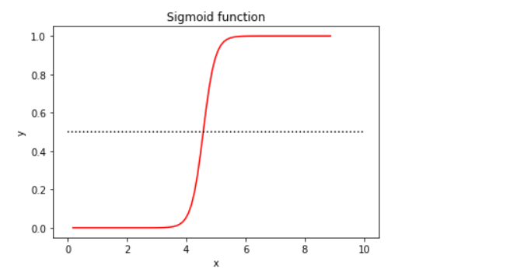

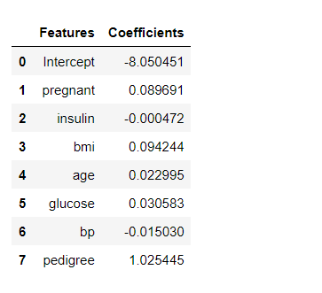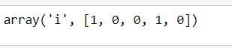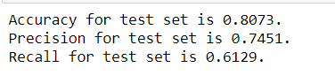

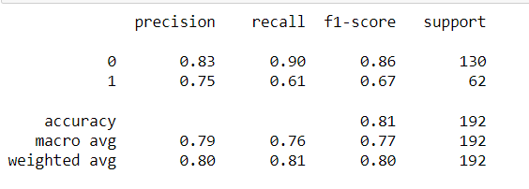

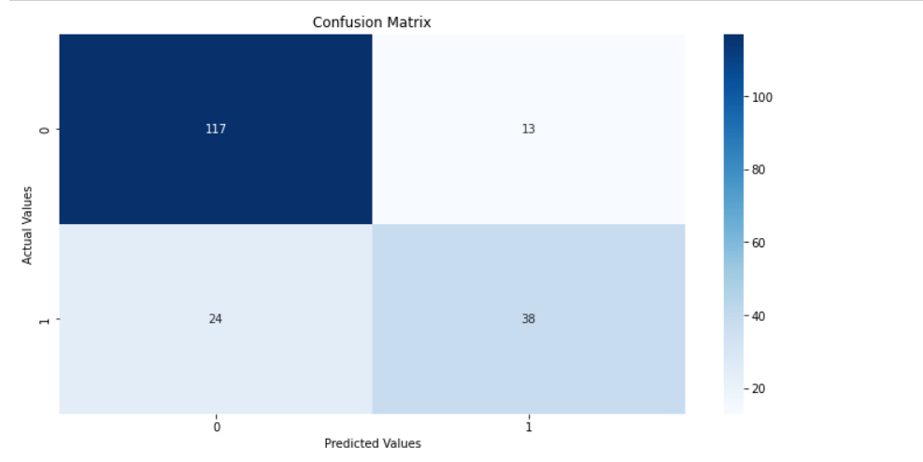

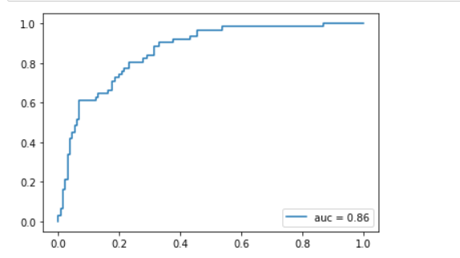

**Q15.Use some function for regularization of dataset based on problem 14.**

**Program:-**

import pandas as pd

from sklearn import metrics

import numpy as np

import matplotlib.pyplot as plt

import math

from sklearn.model_selection import train_test_split

import array as arr

from sklearn.linear_model import LinearRegression

from sklearn.metrics import mean_squared_error

from sklearn.linear_model import Ridge, Lasso

col_names = ['pregnant', 'glucose', 'bp', 'skin', 'insulin', 'bmi', 'pedigree', 'age', 'outcome'] # load dataset

pima = pd.read_csv("diabetes.csv", header=None, names=col_names)

pima.head()

target = ['outcome']

feature_cols = ['pregnant', 'insulin', 'bmi',

                'age', 'glucose', 'bp', 'pedigree']

X = pima[feature_cols] # features

y = pima.outcome # target variable

# split data into training and validation datasets

X_train, X_test, y_train, y_test = train_test_split(X, y, test_size=0.25, random_state=0)

print(X_train.shape)

print(X_test.shape)

print(y_train.shape)

print(y_test.shape)

linear_reg  = LinearRegression()

linear_reg.fit(X_train,y_train)

y_pred = linear_reg.predict(X_test)

mse_linear = mean_squared_error(y_pred,y_test)

print(mse_linear)

print(linear_reg.coef_)

#lasso regression

lambda_values = [0.000001,0.0001,0.001,0.005,0.01,0.2,0.3,0.4,0.5]

for i  in lambda_values:

    lasso_reg = Lasso(i)

    lasso_reg.fit(X_train,y_train)

    y_pred = lasso_reg.predict(X_test)

    mse_lasso =mean_squared_error(y_pred,y_test)

    print("lasso mse with lambda={} is {}".format(i,mse_lasso))

print(lasso_reg.coef_)

#ridge regression

lambda_values = [0.00001,0.01,0.05,0.1,0.5,1,1.5,3,5,6,7,8,9,10]

for i  in lambda_values:

    ridge_reg = Ridge(i)

    ridge_reg.fit(X_train,y_train)

    y_pred = lasso_reg.predict(X_test)

    mse_ridge =mean_squared_error(y_pred,y_test)

    print("lasso mse with lambda={} is {}".format(i,mse_ridge))

print(ridge_reg.coef_)

**Output:-**

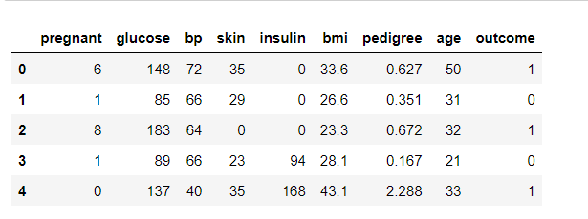

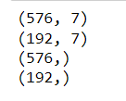





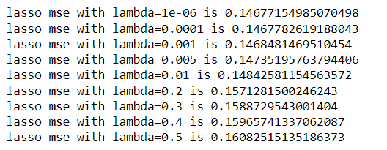

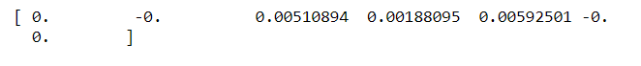

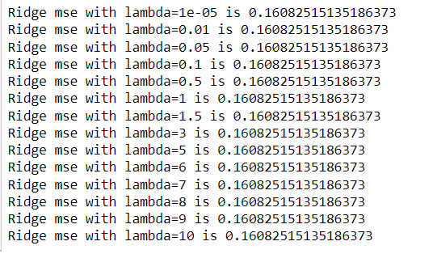



**Q16.Use some function for neural networks, like Stochastic Gradient Descent or backpropagation - algorithm to predict the value of a variable based on the dataset of problem 14.**

**Program:**

#!/usr/bin/env python

# coding: utf-8

# In[1]:

from numpy import*

import pandas as pd

from sklearn.datasets import load_breast_cancer

from sklearn.neural_network import MLPClassifier

from sklearn.model_selection import train_test_split

# In[2]:

df = load_breast_cancer()

# In[3]:

X_train, X_test, y_train, y_test = train_test_split(df.data,df.target,test_size=0.2,random_state=4)

y_test

# In[4]:

nn=MLPClassifier(activation='logistic',solver='sgd',hidden_layer_sizes=(10,15),random_state=1)

# In[5]:

nn.fit(X_train,y_train)

# In[6]:

pred=nn.predict(X_test)

pred

# In[7]:

from sklearn.metrics import accuracy_score

accuracy_score(y_test,pred)

# In[ ]:

**Output:**

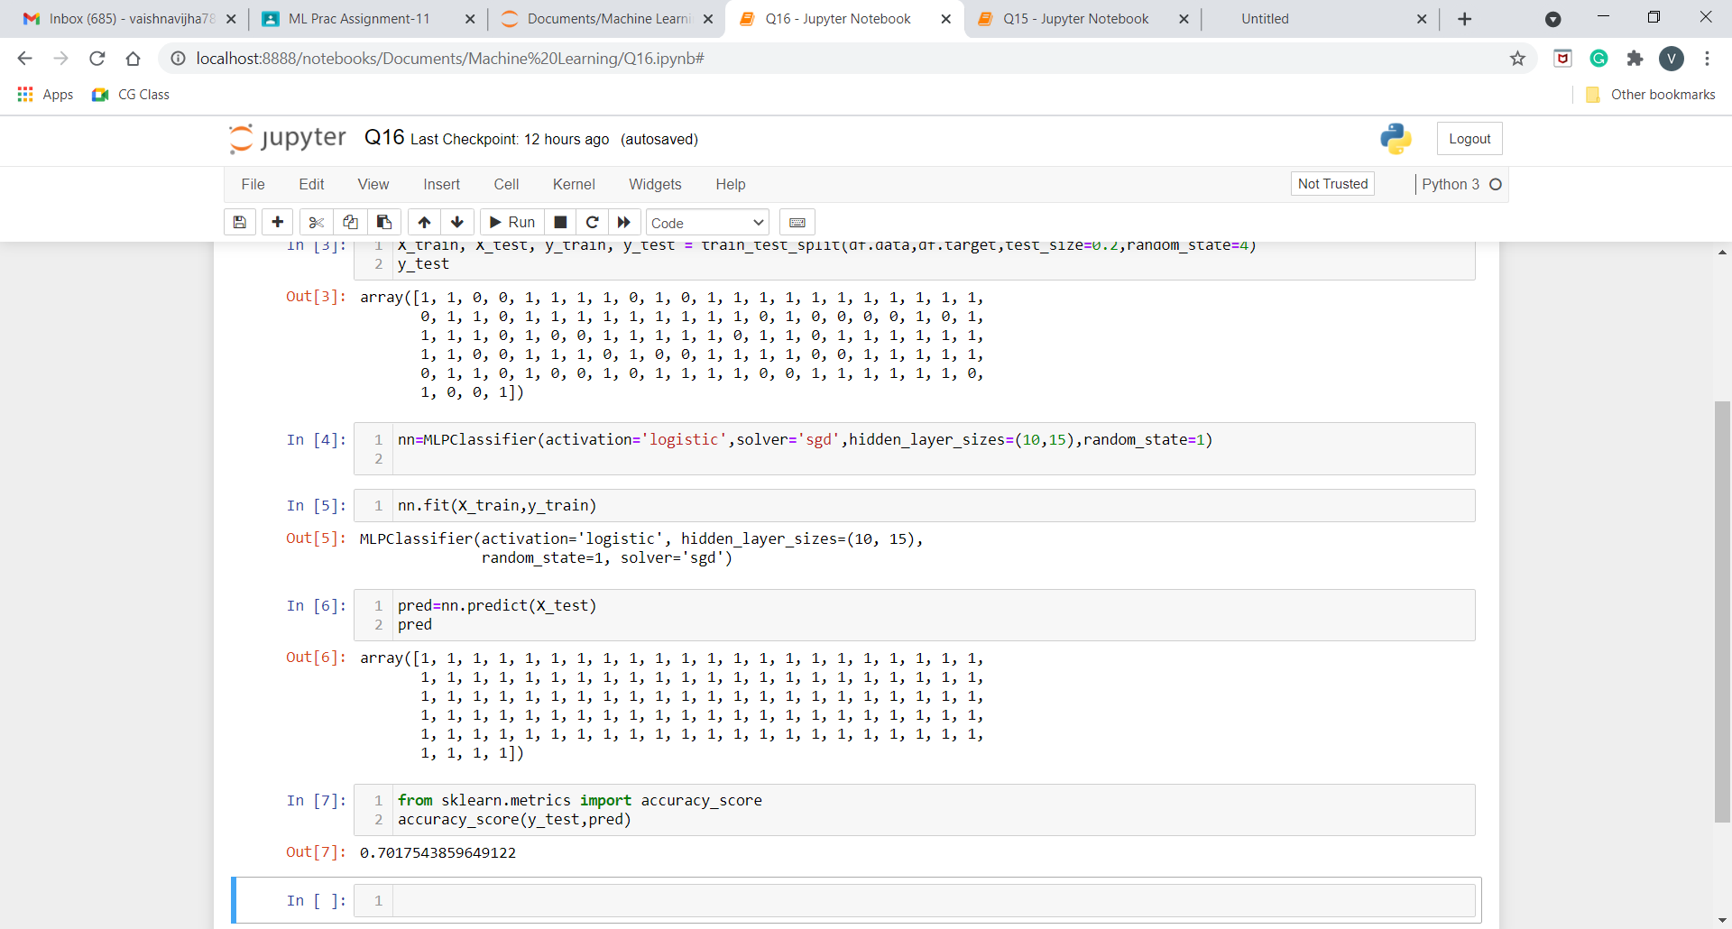

## **Extra Questions:-**

**Q17:Implementing Simple Linear Regression Using Least Square method.**

**Program:-**

# Making imports

import pandas as pd

import numpy as np

import matplotlib.pyplot as plt

plt.rcParams['figure.figsize'] = (12.0, 9.0)

# Preprocessing Input data

data = pd.read_csv('Advertising.csv')

X = data.iloc[:, 0]

Y = data.iloc[:, 1]

plt.scatter(X, Y)

plt.show()

# Building the model

X_mean = np.mean(X)

Y_mean = np.mean(Y)

num = 0

den = 0

for i in range(len(X)):

    num += (X[i] - X_mean)*(Y[i] - Y_mean)

    den += (X[i] - X_mean)**2

m = num / den

c = Y_mean - m*X_mean

print (m, c)

# Making predictions

Y_pred = m*X + c

plt.scatter(X, Y) # actual

# plt.scatter(X, Y_pred, color='red')

plt.plot([min(X), max(X)], [min(Y_pred), max(Y_pred)], color='red') # predicted

plt.show()

**Output:** -

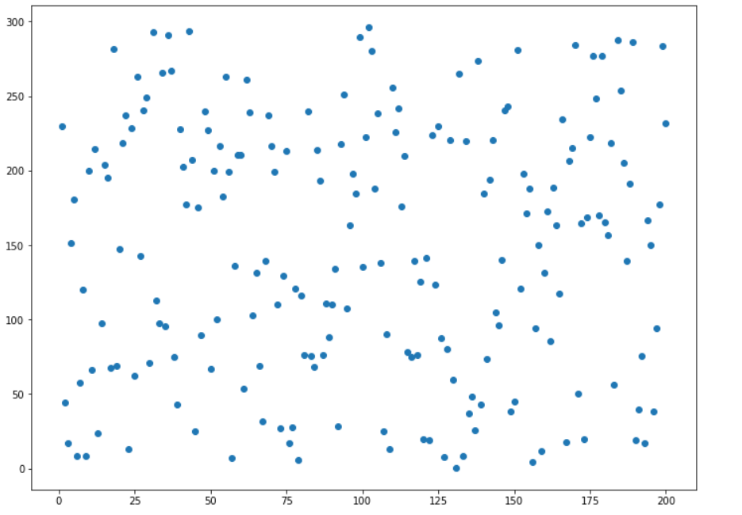



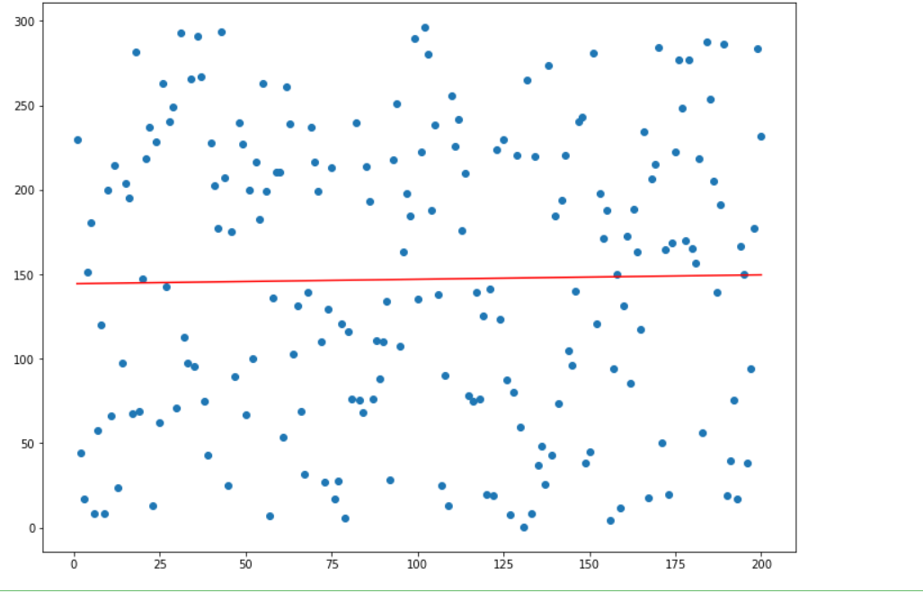

**Q18: Implementing Multiple Linear Regression using Normal Equation  Method.**

**Program:-**

# Multiple linear regression using Normal Method

import numpy as np

import pandas as pd

import matplotlib.pyplot as plt

col_list = ["TV", "radio","newspaper","sales"]

data = pd.read_csv("Advertising.csv", usecols=col_list)

data.head()

x1 = data["TV"]

x2 = data["radio"]

x3 = data["newspaper"]

y = data["sales"]

print(x1.shape)

print(x2.shape)

print(x3.shape)

#plot Tv vs Sale

plt.scatter(x1,y)

plt.xlabel("TV")

plt.ylabel("Sale")

#plot Radio vs Sale

plt.scatter(x2,y)

plt.xlabel("radio")

plt.ylabel("Sale")

#plot Radio vs Sale

plt.scatter(x3,y)

plt.xlabel("newspaper")

plt.ylabel("Sale")

x1 = np.array(x1)

x2 = np.array(x2)

x3 = np.array(x3)

y = np.array(y)

n = len(x1)

n

x_bias = np.ones((n,1))

x1_new = np.reshape(x1,(n,1))

x2_new = np.reshape(x2,(n,1))

x3_new = np.reshape(x3,(n,1))

x_new = np.append(x_bias,x1_new,axis=1)

x_new = np.append(x_new,x2_new,axis=1)

x_new = np.append(x_new,x3_new,axis=1)

X_new

x_new_transpose = np.transpose(x_new)

x_new_transpose_dot_x_new = x_new_transpose.dot(x_new)

temp_1 = np.linalg.inv(x_new_transpose_dot_x_new)

temp_2 = x_new_transpose.dot(y)

theta = temp_1.dot(temp_2)

theta

beta_0 = theta[0]

beta_1 = theta[1]

beta_2 = theta[2]

beta_3 = theta[3]

print(beta_0)

print(beta_1)

print(beta_2)

print(beta_3)

def predict_values(beta_0,beta_1,beta_2,beta_3,tv,radio,newspaper):

    predicted_value = beta_0 + tv*beta_1 + radio*beta_2 + newspaper* beta_3

    return predicted_value

tv = 10

radio = 20

newspaper = 30

print(predict_values(beta_0,beta_1,beta_2,beta_3,tv,radio,newspaper)

**Output:** -

