**Status Report**

**Online Homemade Food**

**and**

**Delivery Services**

By:

Nahla Elmehy

Huda Hadi

Annie Zeitounlian

Hala Dakhal

Table of Contents

1. Introduction.............................................................................................page 3
2. Architecture............................................................................................page 3
3. Data Aspect..................................................................................page 3
4. Function Aspect............................................................................page 4
5. Network Aspect............................................................................page 6
6. People Aspect...............................................................................page 7
7. Timing Aspect..............................................................................page 7
8. Motivation Aspect........................................................................page 9
9. Project Plan.............................................................................................page 9
10. New Updates 2/14/2018.......................................................................page 11

# Introduction

Our group members would like to develop a web application for an online homemade food with delivery services that will allow the users of the web application to browse through the provided information about all available foodstuffs/dishes by adding them to a shopping cart for purchases. The service will also provide the customer a quick delivery of the purchases to their home. Besides, the user will be able to view and browse the web application through any browser and some of the features will be provided for the version 0.1.

Team "Double-HAN" consists of the following members:

1. Nahla Elmehy
2. Huda Hadi
3. Annie Zeitounlian
4. Hala Dakhal

# Architecture

1. **Data Aspect:**

The application data will handle categories such as: User Information, Kitchen and dishes menus Information, Order Information, and Delivery information.

* User information: person id, name, password, address, phone number
* Kitchens Information: kitchen id, name, description
* Dishes information: dish id, name, description, kitchen id, size, price
* Order information: item id, and payment info's
* Delivery information: delivery address, valid locations

1. **Function Aspect:**

The user in the web application will be able to browse through all the available recipes and set the order quantity and add them to the cart. After the selections are made the user can proceed to checkout and enter the delivery address. The payment will be by credit. Also, before the payment happens the user will confirm the order if it is exactly what he/she wants or the user would like to edit the order by going back and update it.

Admin can look to the orders placed for the day, and update the information. Add new recipes, change daily menus, categories, and update the delivery time.

The web application features:

**Signup feature**

* User Name - Mandatory
* Address – Mandatory
* Second Address - Optional
* Phone Number - Mandatory
* Email Address - Optional
* Password - Mandatory
* Repeat Password - Mandatory

**Login/Logout**

* Allow the user to login to his/her account
* Allow the user to logout from his/her account

**Edit Profile**

* Change the user name
* Change the user password (logout and login back with the new password)
* Change the user address
* Change the user phone number

**Order Features**

* Allow the user to add a selection(s) to the cart
* View cart and Edit cart

**Delivery Features**

* The user selects the delivery address, date, and time
* Confirmation page for the user order/Edit page (remove or add to the cart)
* Payment will be online feature using credit cards

**Pick up Features**

* The user will have the option to choose between delivery or pickup for pick up all the user need to enter is the time to pick the food up the mini time will be 2 hours after the order time if the order is big more than 15 quantities the mini time to pick up is 6 hours after order time.

**Location Check**

* The user will enter the delivery address; the web app will check for the validation location that allowed to deliver to. If it is inside the area, will complete the order to payment process. If not cancel the order with a message indicate invalidation the address.

**Internationalization**

The web app will be bilingual website for both English and French languages.

**Admin Panel**

* Order Cancellation
* Update delivery time
* Add new recipes to the store
* Remove recipes from the store
* Recipes editing
* Price editing

1. **Network Aspect:**

The application client will be browser such as: Google Chrome, Firefox, and Safari. The data will be stored in MySQl. Using .jsp files for view and dao and servlet and Tomcat server.

As show in the diagram below:

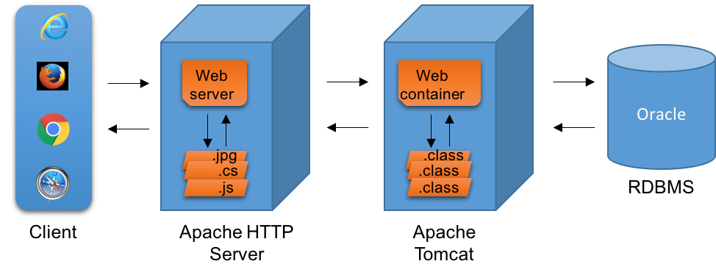

1. **People Aspect:**

The application will provide three interfaces:

* The administrator
* The customer
* The delivery services

1. **Timing Aspect:**

* After the user enter his basic information:
* Email address
* Password
* Address
* Phone number

The user will be able to sign up immediately and his/her account will be ready to use and browse through the website.

* Sending a confirmation email directly to confirm registration process.
* Once registration is complete, the user will be able to select any dish from the kitchen menus and add it to his cart.
* If the user already registered, he can login immediate to use and browse through the website.
* During checkout out process the user will be asked to enter the delivery time. The mini delivery time for regular order [between 1 to 15] quantities is 2 hours before delivery. if the order is big [more than 15] quantities the mini time for the order will be 6 hours before delivery.
* The project will be delivered in phases where each phase will build upon its previous phase by incorporating new features.

First Phase:

* Front end design and development using CSS style sheets for look and feel of the online store.
* Design the data in a relational database architecture.
* Back end logic design

Second Phase:

* Testing the first phase version of web application.
* Design and develop basic dynamic content of web pages.
* Development basic database architecture.
* Develop the connection between web page and database.

Third Phase:

* Testing the second phase version of web application.
* Implement and testing database architecture.
* Develop dynamic content of web pages.
* Improve system architecture as needs.

Forth Phase:

* Testing content of pages.
* Testing database architecture.
* Testing system architecture.

1. **Motivation Aspect:**

For the reason that the user is given her/his personal information we will use encryption for login credentials. Privacy concerns and information for the customers will be addressed and will not be shared with any third party without customer permission. A privacy policy will be displayed when the user sign up for the service. Besides, no span emails will be sent to the user (the user will have the option for signing up for online flyers or promotion, and the option of unsubscribing the emails).

3. Project Plan

We will be using a wide array of technologies like JSP, HTML, CSS, Server side, and Java Programming. To build our homemade food web application with delivery services. All the WebPages will be stored and tested on a local server running Tomcat Server, Version 9.0 and all the data needed as well as generated by the system will be stored in a MySQL.

|  |  |
| --- | --- |
| **Activity** | **Start and End Dates** |
| **Phase One, Phase Two** | Jan,29,2018 to Feb, 24,2018 |
| **Phase Two, Phase Three** | Feb,25, 2018 to March,10, 2018 |
| **Phase Three, Phase Four** | March, 11,2018 to March, 27, 2018 |

|  |  |  |  |  |
| --- | --- | --- | --- | --- |
| **DEVELOPMENT** | **ACTIVITY** | **TIME TABLE** | | |
|  |  | Month 1 | Month 2 | Month 3 |
| Annie Z, Hala Dakhal | Front-end | X | X |  |
| Nahla Elmehy, Huda Hadi | Back-end Architecture and database setup |  | X | X |
| Annie Zeitounlain, Hala Dakhal  Nahla Elmehy, Huda Hadi | Integrate front-end with backend | X | X | X |
| Annie Zeitounlain, Hala Dakhal  Nahla Elmehy, Huda Hadi | Testing | X | X | X |

4. New Updates 2/4/2018

* **Sign up** - Able to signup successfully to the web application. When user signup he/she will directly go to the store front.
* **Login** - Able to login successfully to the web application. When user login he/she will directly go to the store front.
* **Logout -** Able to logout successfully after logging in to the web application.
* **Browse Store** - This feature has been completed and is working perfectly. But of course some formatting changes are still required.
* **Internationalization** – This should allow the user to switch the language of the web application between English and French.
* We did our best trying to finish the transaction feature but unfortunately couldn’t not get it done by today .we promise next time will be done.
* **Edit Profile -** This feature is scheduled to be implement for version 0.2
* **Place Order -** This feature is scheduled to be implement for version 0.3
* **Payment -** This feature is scheduled to be implement for version 0.3
* **Admin Panel -** This feature is scheduled to be implement for version 1.0