Report for implementation changes Aug 3 2013:

List of changes:

1. Coordinates of the points get saved in a file

For an image for which we are detecting the outline and convex core, now “.txt” file gets created where we save the number and coordinates of all points. The files get saved in the “Experimental_Results” folder, just like the images they represent. Also, the files carry the exact same name as the images they represent, except they end on “.txt” instead of “.jpg”.

Demo:

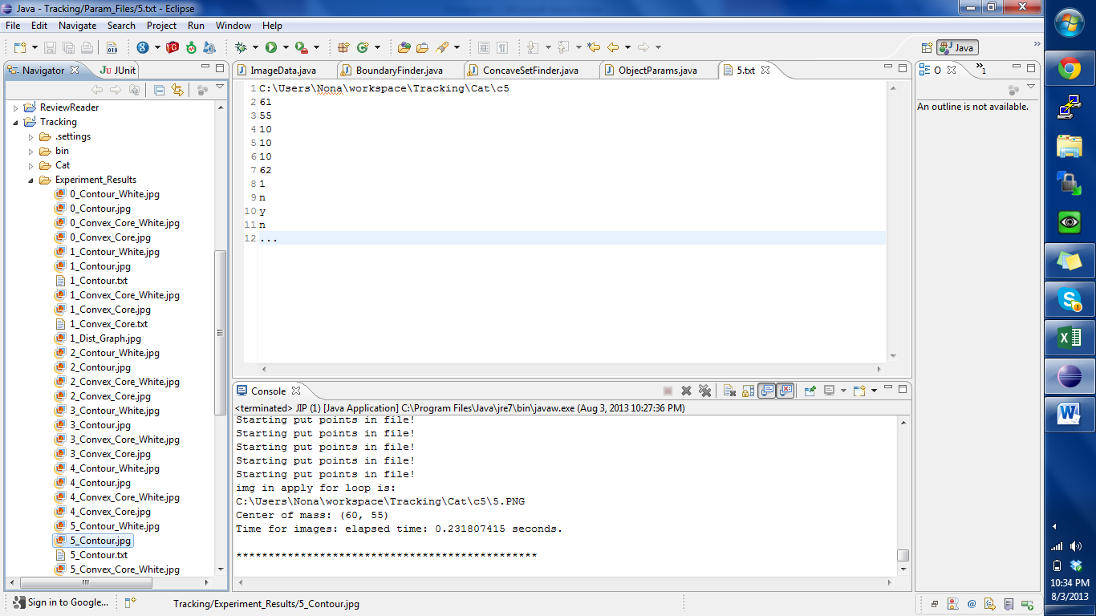

Folder containing jpg and txt files

1_Contour.txt contains the coordinates of the points displayed in 1_Contour.jpg and

1_Contour_Convex_Core_White.txt contains the coordinates of the points displayed in 1_Contour_Convex_Core.jpg and

1_Contour_Convex_Core_White.jpg

1. Added an option to display the number of each point on the image.

Since it is hard to determine which coordinates apply to which point, I added a feature to display the number of each point in the image. This requires adding a new option to each feature file:

Parameter file (located in folder Param_Files)

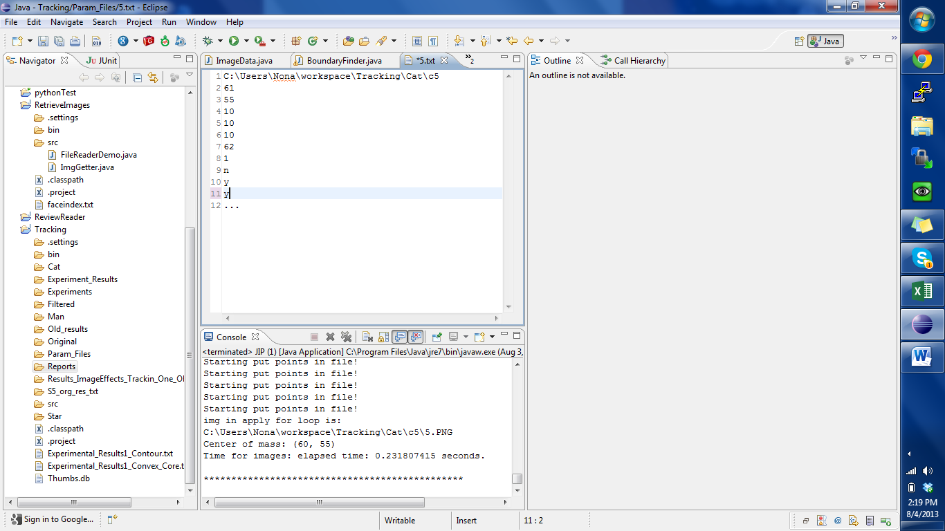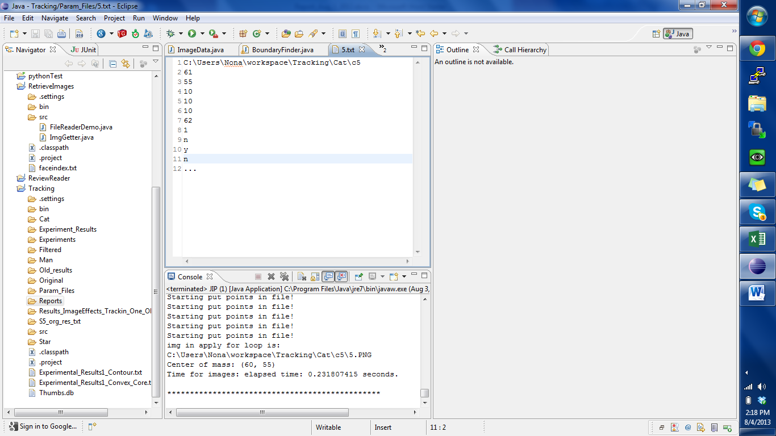

Parameters Present from before

New parameter (can take values “y” and “n”)

Two “.txt” files generated

Two “.txt” files generated

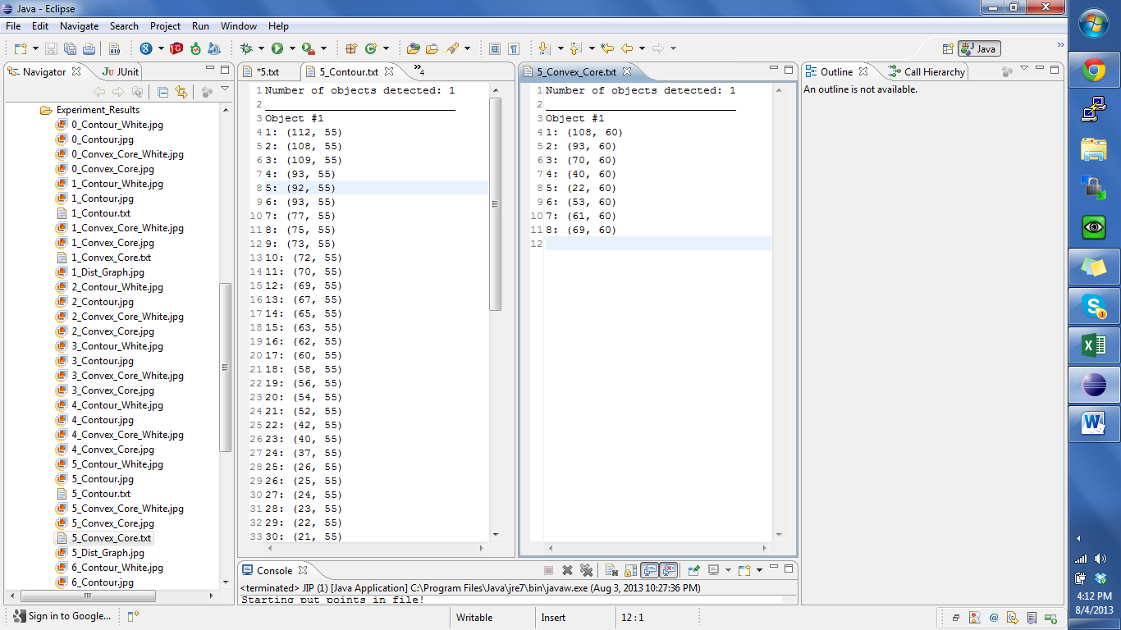



Image files generated.

Image files generated.

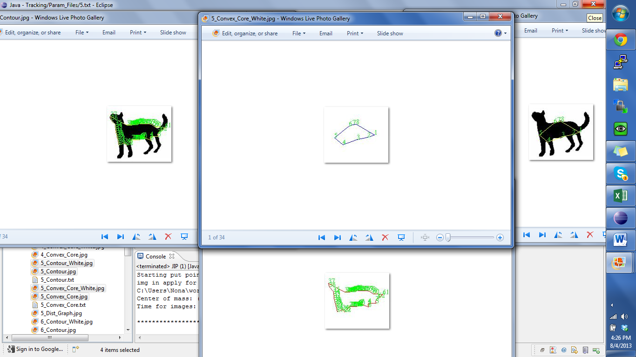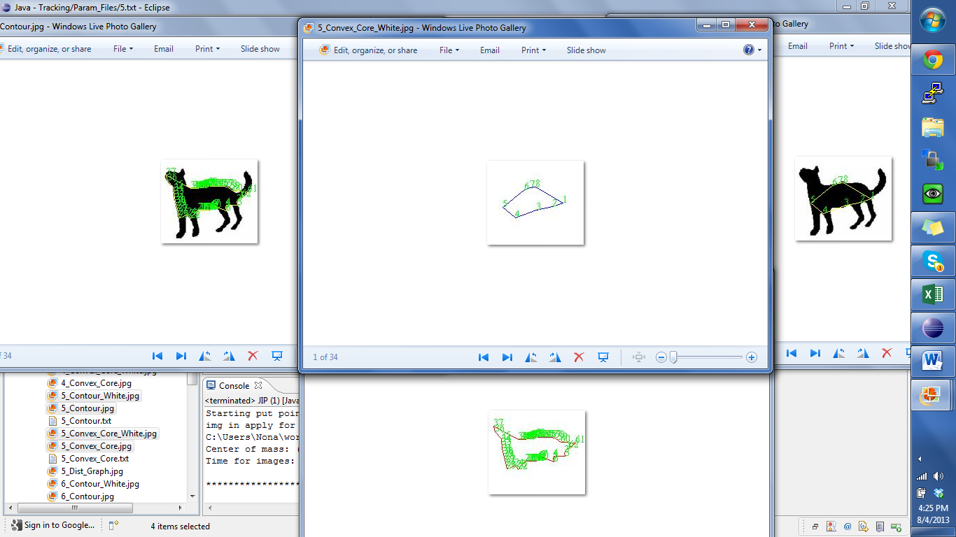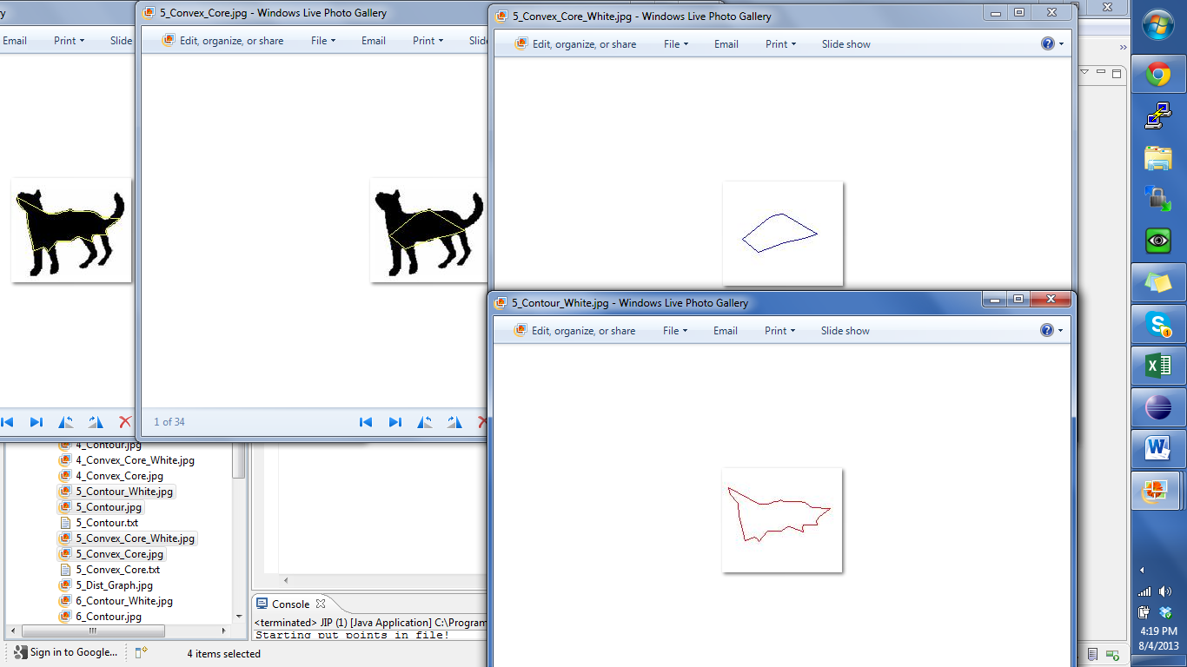



The number of each point (as it is numbered on the appropriate “txt” file.



