The Four MBTI Dimensions: Definitions & Criteria by信安2303梁好

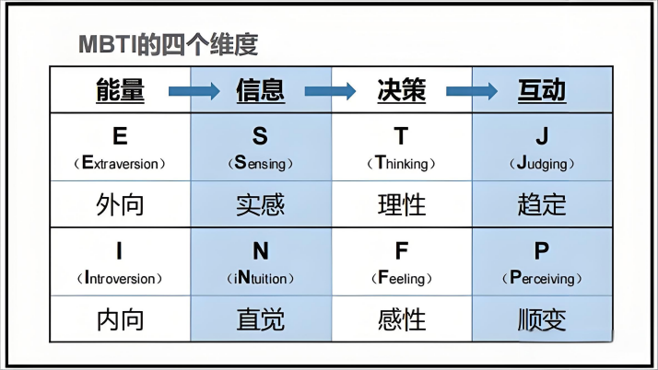
The Myers-Briggs Type Indicator is a popular personality assessment tool that classifies people into 16 personality types based on four dimensions: Extroversion/Introversion, Sensing/Intuition, Thinking/Feeling, and Judging/Perceiving.The following is a detailed introduction to each dimension.

1. Extroversion (E) vs Introversion (I)
Extroversion: Focus on external engagement. Extroverts gain energy from social interaction, active participation, and verbal expression.
Introversion: Focus on internal reflection. Introverts recharge through solitude, deep thinking, and quiet environments.
Assessment Criteria:
Extroverts are those who feel energized when interacting with the outside world and enjoy getting energy from interacting with people, while introverts are those who feel energized when thinking about ideas and concepts from their inner world and enjoy getting energy from focusing on their inner world.

2. Sensing (S) vs Intuition (N)
Sensing: Sensors prioritize facts, details, and practical experience.
Intuition: Intuitive type focus on possibilities, theories, and underlying meanings.
Assessment Criteria:
In learning or work, those who are good at dealing with specific tasks and emphasize practical operations and experience are sensing type. People who are interested in exploring new fields, have a strong imagination, and are good at seeing the big picture are intuitive type.

3. Thinking (T) vs Feeling (F)
Thinking: Decision-making based on logic and objectivity. Thinkers prioritize fairness, consistency, and cause-effect analysis.
Feeling: Decision-making based on empathy and harmony. The feeling type prioritize relationships, values, and social impact.
Assessment Criteria:
When solving problems, those who focus on facts, principles, and logical reasoning are thinking type. People who pay attention to the feelings of others, emphasize harmony, and seek solutions that consider human relationships are feeling type.

4. Judging (J) vs Perceiving (P)
Judging: Preference for structure and decisiveness. judgmental type thrive on planning, deadlines, and organization.
Perceiving: Preference for flexibility and spontaneity. Perceived type adapt to changes, keep options open, and enjoy improvisation.
Assessment Criteria:
Those who like to plan their days in detail, follow schedules, and have a strong sense of order are judgmental type. People who are more casual and are willing to explore new things without strict plans are perceived type .

