Joy Maduna
Penetration Testing Report Documentation
Milestone 1 to 4

Milestone 1 – Initial Access
The purpose of Milestone 1 was to investigate the website and obtain the three patient PDF reports. I started with basic reconnaissance and then moved towards the patient login page.
2.1 Website Reconnaissance
I first checked the website's robots.txt file to see whether it contained useful directory information.
Command used:
curl https://medirozahospital.com/robots.txt
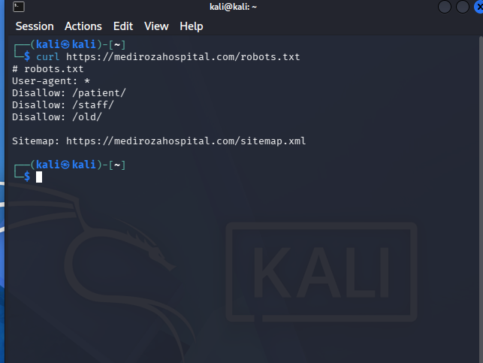
The output showed the following directories:
- Patient, Staff and old
The patient directory was relevant because it indicated that there was a patient-related part of the website that could be investigated.
2.2 Patient Login Page
I opened the patient directory in the browser and located the login page.
Login page: https://medirozahospital.com/patient/login.php
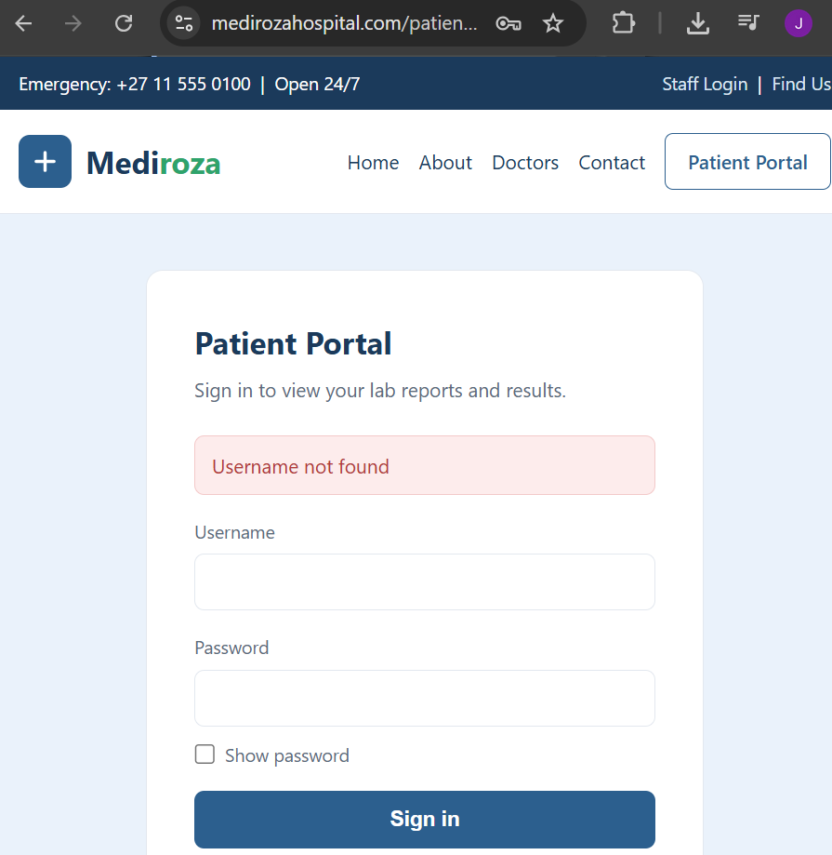 The page provided a username and password form. I used the test information supplied in the practical to examine how the application responded to different login attempts.
2.3 Authentication Response Testing
I tested two usernames using the same password so that I could compare the responses returned by the application.
Test | Username | Password | Response
1 | Joy | 1234 | Username Not Found
2 | admin | Password123 | Incorrect Password

The responses were different from when I typed a random name and password, than when I used “admin” as my username. When I entered a random username, it prompted “username not found” whilst when I used admin, it prompted “wrong password”.
2.4 Input Validation / SQL Injection Test
I then tested the username field using the SQL injection input specified in the practical instructions. The purpose was to see whether the application was safely handling the value entered by the user.
Test input: admin' and password123
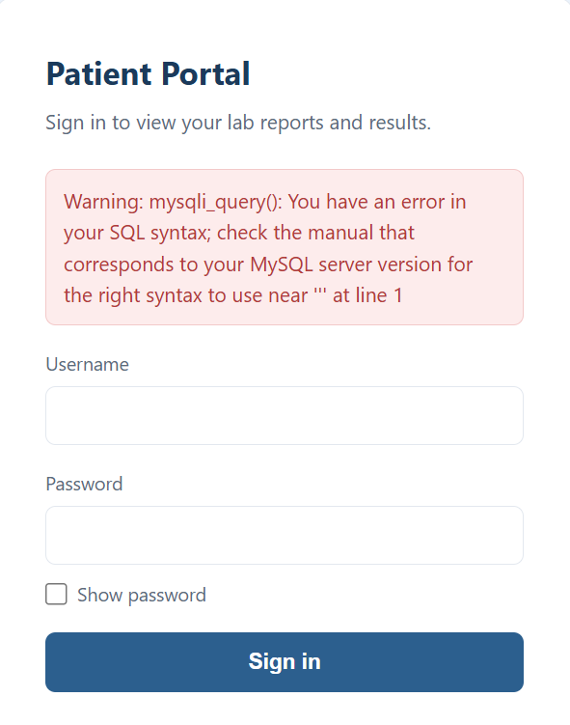
The application returned: Warning: mysqli_query(): You have an error in your SQL syntax; check the manual that corresponds to your MySQL server version for the right syntax to use near ''' at line 1 This indicated that login the input wasn’t sanitized before being placed in a database query.

2.5 Authentication Bypass
After identifying the SQL injection weakness, I tested the authentication bypass
Input used: admin’ – and password123
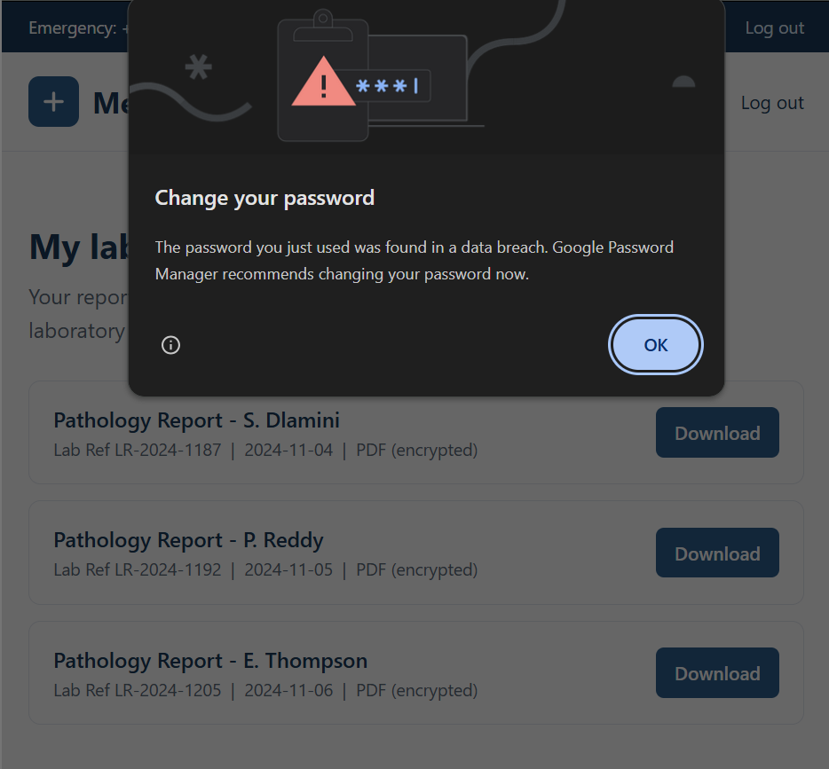
The result was successful. The patient portal became accessible and the three report files could be retrieved, but a warning showed on screen about a data breach.
2.6 Retrieval of Patient Reports
After accessing the portal, I identified and downloaded the three report files.
File | Downloaded? | Notes
patient_report_1.pdf | yes | It was a locked pdf that required hashing using hash calculator
patient_report_2.pdf | yes | It was a locked pdf that required hashing using hash calculator
patient_report_3.pdf | yes | It was a locked pdf that required hashing using hash calculator

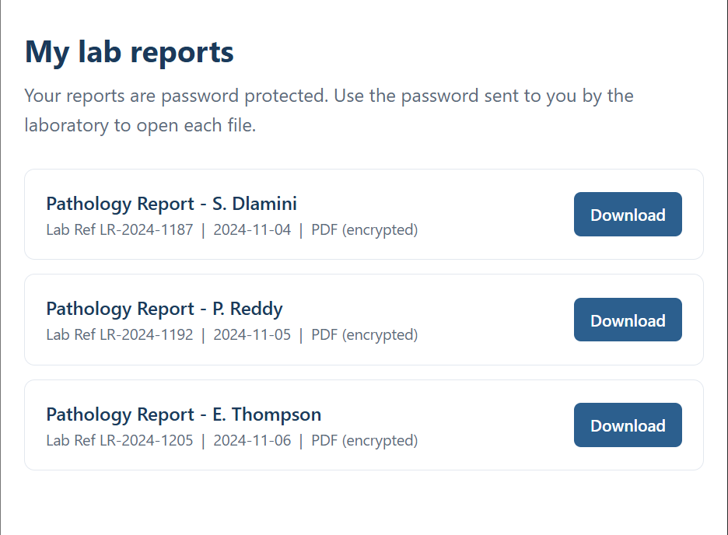
This completed Milestone 1 because the required three patient PDF lab reports had been retrieved.
3. Milestone 2 – Data Extraction
The purpose of Milestone 2 was to investigate the protection on the three PDF files and recover the passwords using the resources provided for the practical.

3.1 Checking the PDF Protection
I checked the three downloaded PDF files and confirmed that they were password protected.
File | Password Protected? | Next Action
patient_report_1.pdf | yes | Hash extraction
patient_report_2.pdf | yes | Hash extraction
patient_report_3.pdf | yes | Hash extraction

3.2 Hash Extraction
I used the Networkwalks hash calculator provided in the practical instructions and processed each PDF separately. The hashes were then used as the input for the password-cracking stage.
Hash calculator: https://networkwalks.com/hash-calculator/
PDF | Hash
patient_report_1.pdf | $pdf$2*3*128*4294967292*1*32*3361663365326235643333353531613238303137316238333238373763353339*32*ef16c52ab8efce2c18c79e9d28895b5928bf4e5e4e758a4164004e56fffa0108*32*c431fab9cc5ef7b59c244b61b745f71ac5ba427b1b9102da468e77127f1e69d6
patient_report_2.pdf | $pdf$2*3*128*4294967292*1*32*3166346338373236356437626464363834663737303265633666363264616463*32*39f4e6b0aedf12344c340ffb39f8905528bf4e5e4e758a4164004e56fffa0108*32*408b37bcf12da873d7f2840f3c1b917a023961ded4c8164d38e46e9655e66775
patient_report_3.pdf | $pdf$2*3*128*4294967292*1*32*3261393066326130336634386337323631306164373264323130316137616538*32*5090fa0a5dba99cb97c9d140cd23119428bf4e5e4e758a4164004e56fffa0108*32*58e03d692cf37b50b0b5eaa189fcbd372260a949c8992ad7b44fd13e2b40c1f8

Password 1: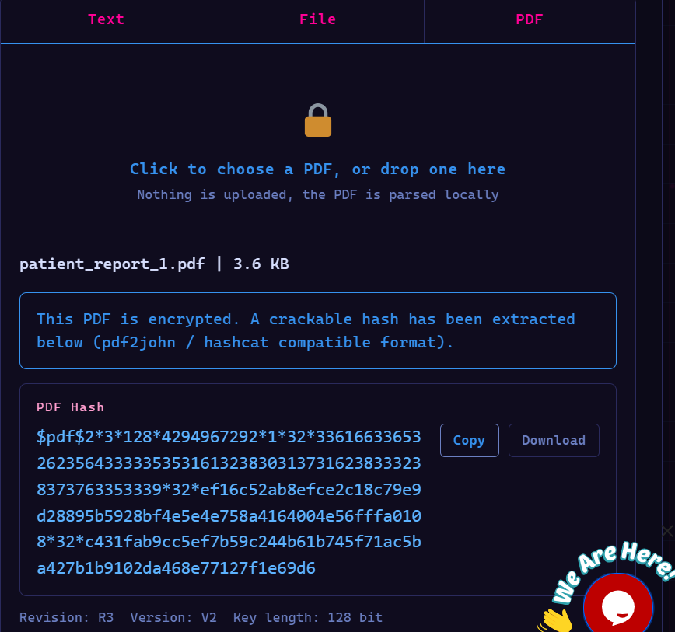
Password 2:
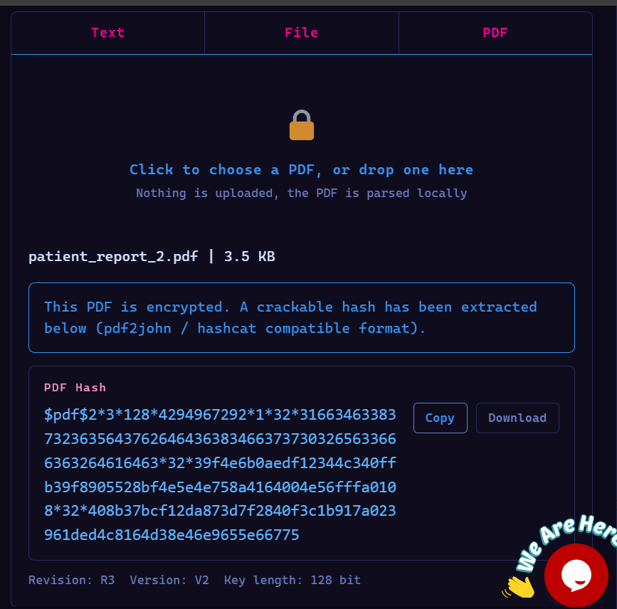

Password 3:
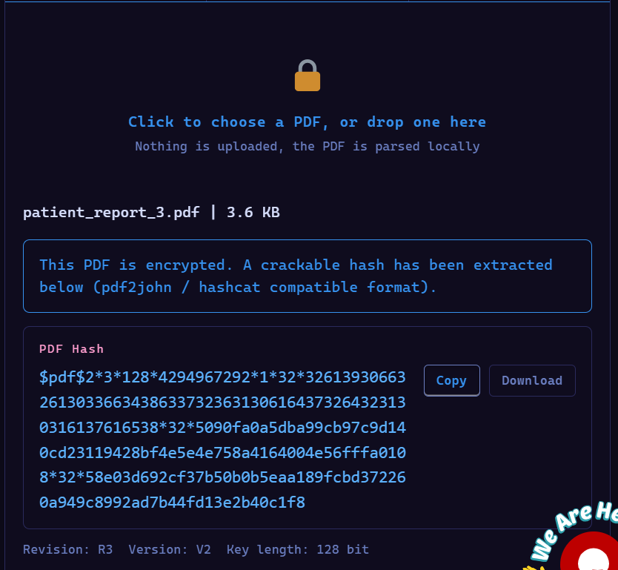
3.3 Password Recovery – Reports 1 and 2
I used the password cracker and the built-in wordlist supplied by the lab. The purpose was to determine whether the passwords could be recovered from the available wordlist.
File | Wordlist | Result | Recovered Password
patient_report_1.pdf | Built-in list | [SUCCESS/FAILURE] | [YOUR RESULT]
patient_report_2.pdf | Built-in list | [SUCCESS/FAILURE] | [YOUR RESULT]

Password 1 Cracked:
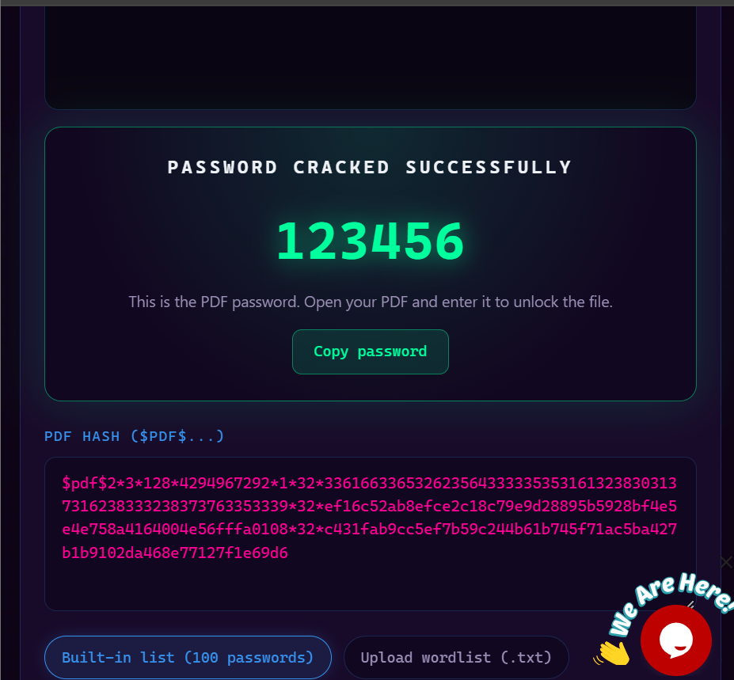
Password 2 cracked:
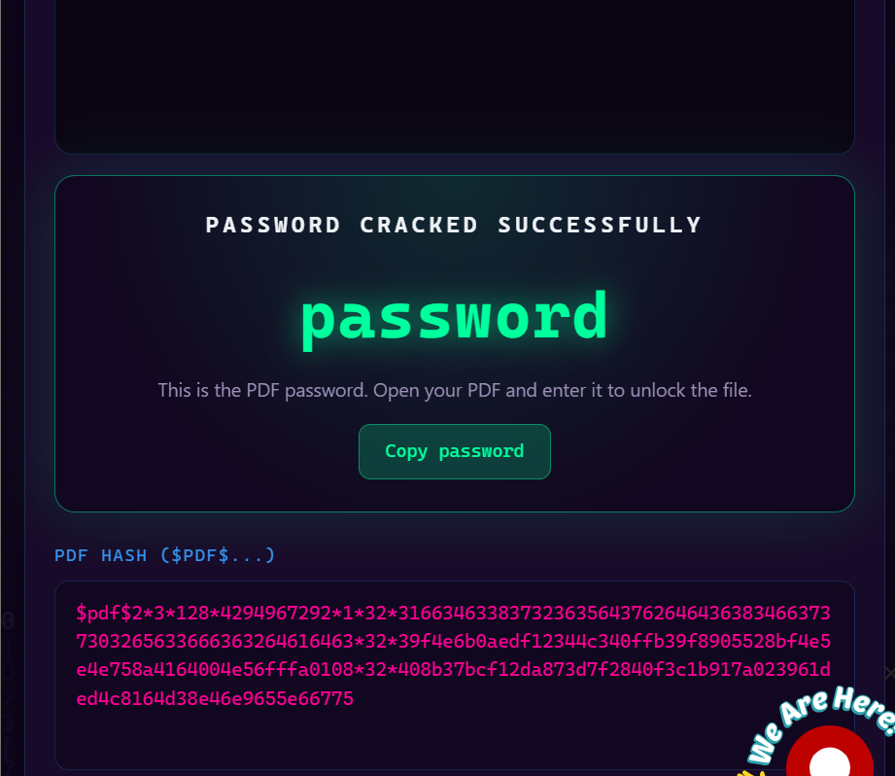
Password Recovery – Report 3
I first tested report 3 using the built-in wordlist. This attempt failed
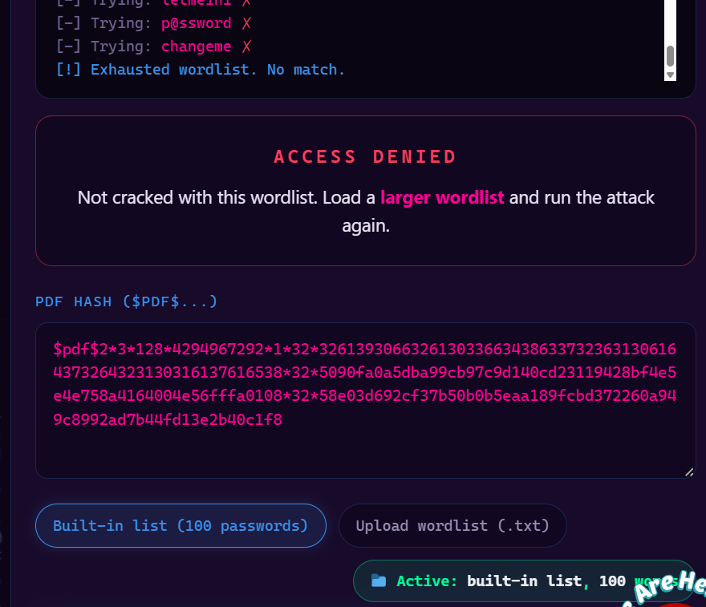
Because the first attempt failed I then used pdfcrack on kali linux
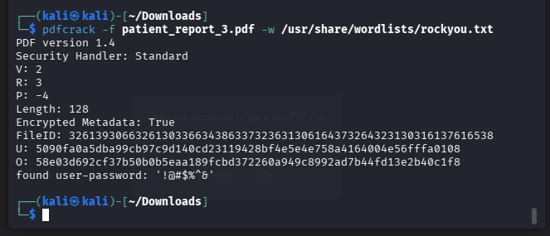
The final password recovered for report 3 was: !@#$%^&
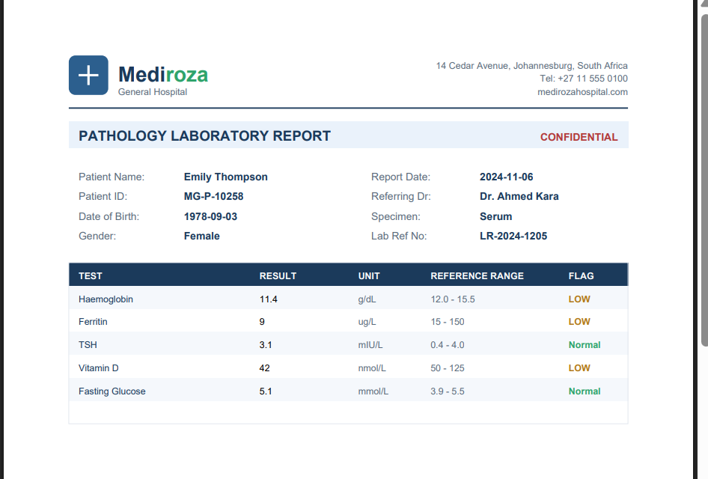
3.5 Decrypting Report 3
After recovering the password for report 3, I created an unlocked copy so that its metadata could be examined in the next milestone.
Command used:
qpdf --password='!@#$%^&' --decrypt patient_report_3.pdf report3_open.pdf
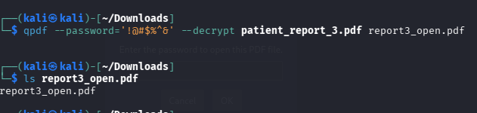
The unlocked file created was: report3_open.pdf
4. Milestone 3 – Attack / Cracking and Information Discovery
The objective of Milestone 3 was to follow information discovered during the earlier stages and find the staff salary and shareholder information requested in the practical.
4.1 PDF Metadata Investigation
I examined the unlocked report 3 PDF using ExifTool. This was done because metadata can contain information about the file's author, software, comments, or other properties that are not necessarily visible in the normal PDF content.
Command used:
exiftool report3_open.pdf
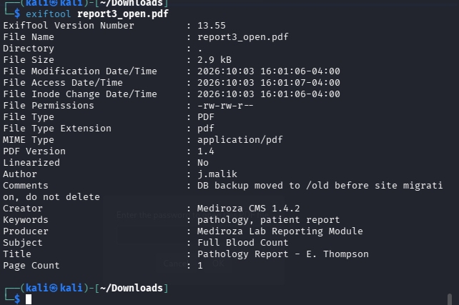
Important metadata I found:
Metadata Field | Value | Why It Was Relevant
Author | j.malik | To confirm
Comments | DB backup moved to /old before site migration, do not delete | In order not to delete mistakenly

4.2 Following the Clue
The metadata contained a clue relating to the old directory on the website. This was interesting because /old/ had already appeared during the initial reconnaissance stage.
My investigation therefore followed this sequence:
robots.txt → /old/ → unlocked PDF metadata → /old/ → database backup
This showed how information found at different stages of the practical could be connected to continue the investigation.
4.3 Investigating the Old Directory
I opened the authorised /old/ directory and checked the files that were exposed through directory listing.
URL: https://medirozahospital.com/old/
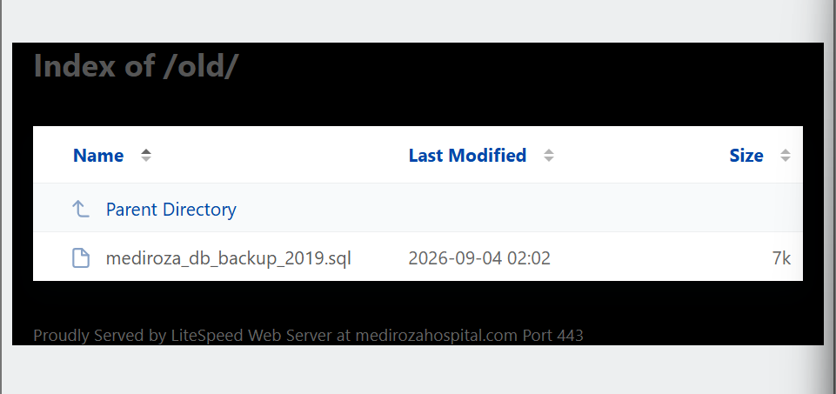
The database backup identified was: mediroza_db_backup_2019.sql

I downloaded the backup for analysis on kali linux
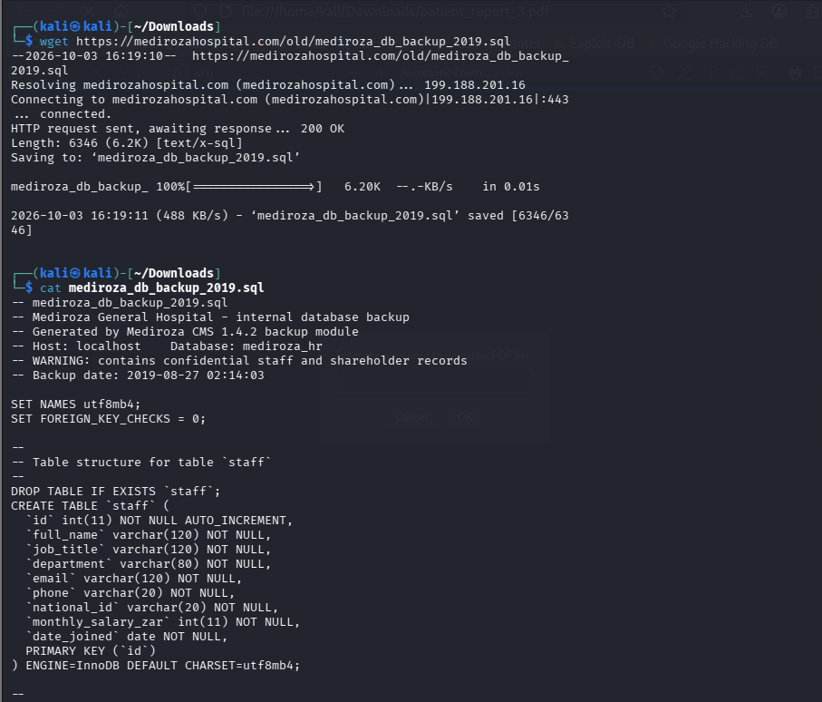
4.4 Examination of the SQL Backup
I opened the SQL backup as a text file and searched for the staff and shareholder records. I focused on the INSERT statements because these contain the data that would be inserted into the database tables.
Staff records were identified using the staff table, while shareholder records were identified using the shareholders table.
4.5 Staff Information
The following image contains the staff information I extracted from the database backup, The monthly salary is in the staff table, different for each staff member.
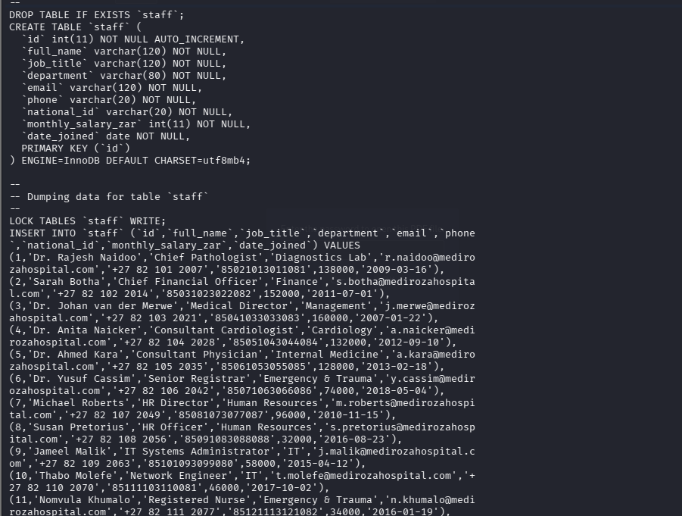
4.6 Shareholder Information
The following table contains the shareholder information I extracted from the database backup.
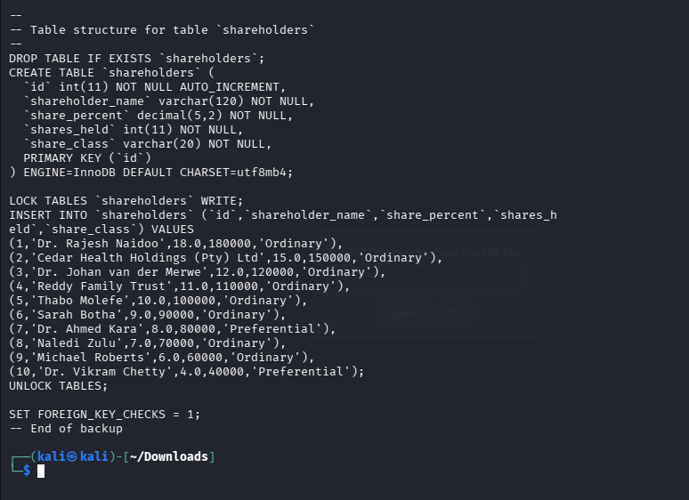
4.7 Linking the Evidence
I compared the information found in the PDF metadata with the records in the database backup. The purpose was to check whether the clues from the earlier stages could be connected to information in the recovered database.
The main connection I found was: [EXPLAIN YOUR ACTUAL CONNECTION HERE].
This was useful because it showed that the investigation was not based on one isolated weakness. Information discovered at one stage helped direct the next stage.

5. Milestone 4 – Penetration Testing Report
Mediroza General Hospital — Target: https://medirozahospital.com
Prepared by: Joy Maduna | Supervisor: Dr J. Iyanda | Botho University, Faculty of Engineering and Technology
5.1 Findings Summary
No. | Finding | Location | Risk
1 | Username enumeration | patient/login.php | Medium
2 | SQL injection / authentication bypass | patient/login.php | Critical
3 | Patient PDF access after login bypass | Patient reports | High
4 | Weak PDF passwords | patient_report_*.pdf | High
5 | Sensitive metadata in patient PDF | patient_report_3.pdf | Medium
6 | Exposed backup directory / directory listing | /old/ | Critical
7 | Sensitive staff and shareholder information in database backup | /old/mediroza_db_backup_2019.sql | Critical

Finding 1 — Username Enumeration
The login page returned different messages depending on whether the username existed. This could allow someone testing the login page to determine valid usernames.
Observed result: Submitting the username "bob" with any password returned "Username not found". Submitting "admin" with any password returned "Incorrect password" instead. The differing responses confirmed that "admin" is a valid, existing account without needing the correct password.
Evidence: insert your own screenshot of the two login attempts and their responses (captured in-browser).
Recommendation: Return the same general error message for incorrect usernames and incorrect passwords so account existence cannot be inferred from the response.
Finding 2 — SQL Injection / Authentication Bypass
The login input accepted SQL-related characters in a way that affected the database query. An authorised test was then used to demonstrate that the authentication process could be bypassed.
Observed result: Entering a single quote (admin') in the username field produced a MySQL syntax error (mysqli_query() warning), confirming the field was not sanitised and was vulnerable to SQL injection. Submitting the payload admin' -- as the username, with any password, successfully bypassed authentication and logged into the patient portal.
Evidence: insert your own screenshots of the SQL error message and the successful bypass login.
Recommendation: Use parameterised queries or prepared statements and never place raw user input directly into SQL queries.
Finding 3 — Patient PDF Access After Login Bypass
After the authentication weakness was successfully demonstrated, the patient portal and its report files became accessible in the lab.
Files obtained: patient_report_1.pdf, patient_report_2.pdf, patient_report_3.pdf
Evidence: insert your own screenshot of the portal page listing the three reports.
Recommendation: Store sensitive reports outside the public web root or protect them using proper access controls and authorisation checks, rather than relying on the login page alone.
Finding 4 — Weak PDF Passwords
The password testing stage showed that the PDF passwords could be recovered using the supplied wordlists.
Results: patient_report_1.pdf → 123456; patient_report_2.pdf → password (both cracked against the built-in common-password list). patient_report_3.pdf exhausted the built-in list with no match. Working locally on Kali Linux, the hash was extracted with pdf2john and tested with John the Ripper, which did not load the hash correctly; pdfcrack was then used directly against the PDF with the rockyou.txt wordlist and successfully recovered the password !@#$%^&.
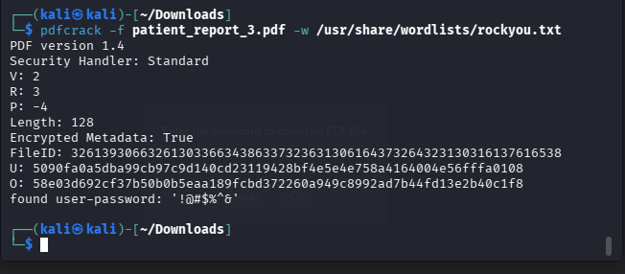
Figure 1: pdfcrack recovering the password for patient_report_3.pdf using rockyou.txt on Kali Linux.
Recommendation: Use strong, unique passwords for sensitive files and, where possible, stronger access-control mechanisms rather than relying only on password protection that common wordlists can defeat.
Finding 5 — Sensitive Metadata in Patient PDF
The unlocked report contained metadata that provided additional information useful for continuing the investigation.
Important metadata: After decrypting patient_report_3.pdf with qpdf using the recovered password, exiftool revealed Author: j.malik and Comments: "DB backup moved to /old before site migration, do not delete" — a direct pointer to a forgotten backup location on the server.
Figure 2: exiftool output on the decrypted report3_open.pdf, showing the Author and Comments fields.
Recommendation: Remove unnecessary metadata from sensitive documents before they are distributed, e.g. using exiftool -all= filename.pdf.
Finding 6 — Exposed Backup Directory / Directory Listing
The /old/ directory referenced in robots.txt and in the PDF metadata was accessible, and its contents could be listed, exposing a database backup file.
File found: mediroza_db_backup_2019.sql, downloaded directly via wget from https://medirozahospital.com/old/mediroza_db_backup_2019.sql
Figure 3: successful download of mediroza_db_backup_2019.sql from the exposed /old/ directory, with the start of its contents.
Recommendation: Disable directory listing on all web directories and ensure old backups are never stored inside publicly accessible web folders.
Finding 7 — Sensitive Staff and Shareholder Information in Database Backup
The recovered SQL backup contained staff and shareholder information in readable database records.
Sensitive information extracted: The backup's staff table included full name, job title, department, email, phone number, national ID, monthly salary, and date joined for hospital employees; a shareholders table listed shareholder names, share percentages, and share class. Cross-referencing the Author field from the PDF metadata (j.malik) against the staff table identified Jameel Malik as the IT Systems Administrator — the person who moved the backup and left the note inside the file, completing the attack chain.
Evidence: insert your ChatGPT-formatted staff and shareholder tables here.
Recommendation: Store database backups securely outside the public web root and protect them with appropriate access controls and secure storage practices.
5.2 Overall Risk Summary
The practical demonstrated that several weaknesses could be connected together. The initial web application weakness (SQL injection) allowed access to the patient reports; the weak protection on those reports allowed further investigation; and information discovered in the unlocked PDF's metadata led to an exposed backup directory. That backup then contained sensitive staff and shareholder information.
The main lesson from the practical was that individual weaknesses can become more serious when combined. A login weakness alone may appear to be one problem, but when it leads to confidential files, and those files contain information pointing to another exposed resource, the overall impact becomes much larger than any single finding on its own.
5.3 Recommendations
- Use consistent authentication error messages so that valid usernames are not revealed.
- Use parameterised SQL queries or prepared statements to prevent SQL injection.
- Apply proper authorisation checks to sensitive patient documents.
- Store confidential documents outside the public web root where appropriate.
- Use strong and unique passwords for protected files.
- Remove unnecessary metadata from sensitive documents.
- Disable directory listing on web directories.
- Do not store database backups in publicly accessible web folders.
- Restrict access to database backups and other internal files.
- Regularly check old directories and backup locations for accidentally exposed information.

6. Conclusion
This practical allowed me to work through a penetration testing scenario from initial reconnaissance to the discovery of sensitive information. I started by examining the web application and its exposed directories, investigated the login mechanism, and retrieved the three PDF reports. I then examined the PDF protection and recovered the passwords, switching from the course-supplied wordlist and tools to a local Kali Linux setup (pdf2john, John the Ripper, hashcat, and finally pdfcrack) when earlier attempts did not succeed, until the password for report 3 was recovered.
The next stage involved examining the unlocked PDF's metadata and following the information discovered there to an exposed backup directory. The database backup was then examined to identify the staff salary and shareholder information required for the milestone, and the chain was closed by matching the PDF's author metadata to a named staff record.
Overall, the practical helped me understand how different vulnerabilities can be connected during a penetration test, and how troubleshooting a tool failure (e.g. a hash not loading, or a VM running out of memory) is itself part of the practical skill being tested. It also showed the importance of documenting evidence at each stage instead of only recording the final result.
7. Limitations of the Practical
- The testing was limited to the authorised educational environment supplied for the exercise.
- The results depend on the configuration and files provided in the lab.
- The exercise did not represent a full real-world security assessment of a hospital.
- Only the tools and wordlists provided or specified by the practical were used, supplemented locally by standard, freely available Kali Linux tools (pdfcrack, rockyou.txt) when initial attempts did not succeed.
- The findings should therefore be understood in the context of the lab environment.
8. Sources Used for the Practical
- Networkwalks. Mediroza General Hospital – Pentest Project Solution. Batch B082, Week 4. Educational practical material supplied for the exercise.
- Networkwalks Hash Calculator. https://networkwalks.com/hash-calculator/ [Accessed during the practical]
- Networkwalks Password Cracker. https://networkwalks.com/password-cracker/ [Accessed during the practical]
- Kali Linux built-in tools: pdf2john, John the Ripper, hashcat, pdfcrack, qpdf, exiftool.
Appendix A — Evidence Checklist
Evidence | Captured? | File Name / Location
robots.txt output | Pending | Add from your browser/terminal work
Patient login page | Pending | Add from your browser work
Authentication response test | Pending | Add from your browser work
SQL injection response | Pending | Add from your browser work
Authentication bypass result | Pending | Add from your browser work
Three retrieved PDFs | Pending | patient_report_1/2/3.pdf
PDF hashes | Yes | report3_hash.txt (pdf2john, Kali)
Password cracking results | Yes | Figure 1 — pdfcrack result for report 3
Report 3 failed attempt | Yes | Built-in wordlist exhausted before pdfcrack succeeded
Report 3 successful attempt | Yes | Figure 1 — pdfcrack, password !@#$%^&
Decrypted report | Yes | report3_open.pdf (qpdf)
ExifTool output | Yes | Figure 2 — exiftool on report3_open.pdf
/old/ directory listing | Pending | Add your browser screenshot of https://medirozahospital.com/old/
SQL backup | Yes | Figure 3 — mediroza_db_backup_2019.sql download
Staff records | Pending | Add ChatGPT-formatted staff table screenshot
Shareholder records | Pending | Add ChatGPT-formatted shareholder table screenshot

