Software Requirements Analysis

for

Document Printing Request Form

05/08/2026

Submitted by

Sorrawit Thanakhwang 6531503080

Table of Contents
Table of Contents ii
Revision History iii
Document Approval iii
- Introduction 1
  - Business Background 1
  - Business Objective 1
  - Business Scope 1
  - Business Workflow 2
  - Definitions, Acronyms and Abbreviations 3
- Overall Description 4
  - Product Perspective 4
  - User Classes and Characteristics 4
- Software Requirement 5
  - Business Requirements 5
  - Overall Product Function 5
  - Functional Requirements 6
  - Software Quality Attributes (Nonfunctional Requirements) 11
- External Interface Requirements 12
  - User Interfaces 13
Appendix A: Data Dictionary 19

Revision History

No. | Name | Date | Description | Version
1 | Sorrawit Thanakhwang | 17/07/2026 | Initial Document (template + Business Background/Objective/Scope) | 0.1
2 | Sorrawit Thanakhwang | 22/07/2026 | Added Business Workflow, User Classes, Functional/Non-functional Requirements, Data Dictionary | 0.2
3 | Sorrawit Thanakhwang | 29/07/2026 | Major rework based on confirmed stakeholder requirements: ODPRS is now a standalone, semi-online system — Requesters no longer attach files; physical original documents must be hand-delivered to the Officer.  Added Admin role and Officer account management. Redefined business rules (no minimum copies; two independent lead-time rules).  Introduced Request Reference Number (assigned at submission) as distinct from RUN NUMBER (assigned only after physical verification), plus new “Ready for Pickup” status. | 0.3
4 | Sorrawit Thanakhwang | 01/08/2026 | Major rework based on a follow-up round of stakeholder requirements: restructured the print request form (multi-select finishing/binding, Color Mode + Print Side split, Document Type + Paper Source responsibility rule, optional per-copy “Copy Label” running number).  Formalized the resource-usage analytics Dashboard as a real functional requirement (FR-16).  Replaced physical-ID-based Receiver verification at Counter Handover with recording the Receiver's name, position, and work phone number (accountability record, not identity check). Removed the Folding option. | 0.4

Document Approval

The following Software Requirements Specification has been accepted and approved by the following:

Name | Role | Signature | Date
 | Advisor
 | Reviewer
 | Reviewer

Introduction

Business Background

To improve convenience and operational efficiency, the university plans to introduce an Online Document Printing Request System (ODPRS) as a standalone web application, independent of existing university systems aside from authentication. Currently, the process relies solely on physical forms, which can lead to processing delays and tracking difficulties. ODPRS digitizes the request, validation, tracking, and handoff-verification steps. Because the documents being printed are frequently official/internal university documents, the physical source material itself must never be uploaded, stored, or transmitted electronically. ODPRS is therefore a semi-online system: the request (what to print, specifications, and desired date) is submitted online, but the Requester must still hand-carry the physical original documents to the Officer in person before printing can begin.

Business Objective

To introduce a secure, standalone, web-based platform that lets Requesters submit print requests online while keeping physical original documents entirely outside the system, and lets Officers review request history, monitor live status, and see an overall picture of all requests — including how much paper/print resource is being consumed — at any time. Three design principles guide every requirement in this document: (1) Semi-Online, Physical Original Required — ODPRS never accepts a file attachment or scanned copy of the document to be printed; the Requester must physically bring the original document to the counter before the Officer can act on the request. (2) Lean & Realistic UX — the system must be usable with the equipment already at the counter, with no new hardware purchases required. (3) Full Visibility & Auditability — Officers must be able to check the live status of every request, see overdue items, retrieve a permanent audit record, and see resource-usage trends by agency and time period to support planning.

Business Scope
- Software Product
“Online Document Printing Request System”
- Capabilities & System Boundaries
In-Scope:
- Standalone web portal for submitting print specifications online (paper size, color mode, single/double-sided printing, finishing options, binding options, item list, original page count, number of copies, document type, and a proposed completion date) — no file or document attachment of any kind.
- Login restricted to university email accounts, authenticated via the university's SSO; role (Requester/Officer) is assigned inside ODPRS itself, managed by an Admin.
- Automated, real-time enforcement of business rules before a request can be submitted (minimum lead time for the proposed completion date).
- System-calculated deadline (based on business hours) by which the Requester must physically deliver the original documents to the Officer.
- Automatic determination and clear display of who must supply the physical printing paper (the Requester or the Registrar Division) based on Document Type, along with the exact number of paper sheets required.
- An optional, Requester-configured per-copy running number (“Copy Label”) printed on each physical copy, independent of the system's own tracking numbers.
Out-of-Scope:
- Any file/document upload or attachment (explicitly disallowed for confidentiality reasons) — the physical original must always be hand-delivered.
- Physical campus delivery (collection remains in-person at the counter).
- Direct printing hardware integration (Officers manually send files/print jobs using existing office equipment).
System-generated, printable Request Form (PDF) that the Requester brings to the counter together with the physical original documents.
Officer dashboard for reviewing requests awaiting physical document drop-off (including an overdue view), comparing the physical originals against the submitted specification, approving/rejecting, and marking jobs ready for pickup.
RUN NUMBER assignment and 6-digit Claim Code generation, issued only after the Officer physically receives and verifies the original documents.
Verification module at the counter (Officer inputs the Claim Code and records the Receiver's name, position, and work phone number via the existing desktop PC).
Officer-facing resource-usage analytics Dashboard, breaking down print/paper volume by year, month, agency category, and agency unit.
Automated email notifications to the Requester for every status change.
Permanent audit/history log binding Requester, Officer, Receiver, and timestamp to every completed RUN NUMBER, searchable by Officers.
Online payment gateways (expenses billed directly to internal university department accounting).
Barcode scanner / signature tablet hardware (verification is done via Claim Code entry plus recording the Receiver's name, position, and work phone number on the existing PC).
A Receiver-facing login/portal — the Receiver never logs into ODPRS.
Automatic cancellation/expiry of requests whose physical-document deadline has passed — these remain open and must be handled manually by an Officer.

Business Workflow

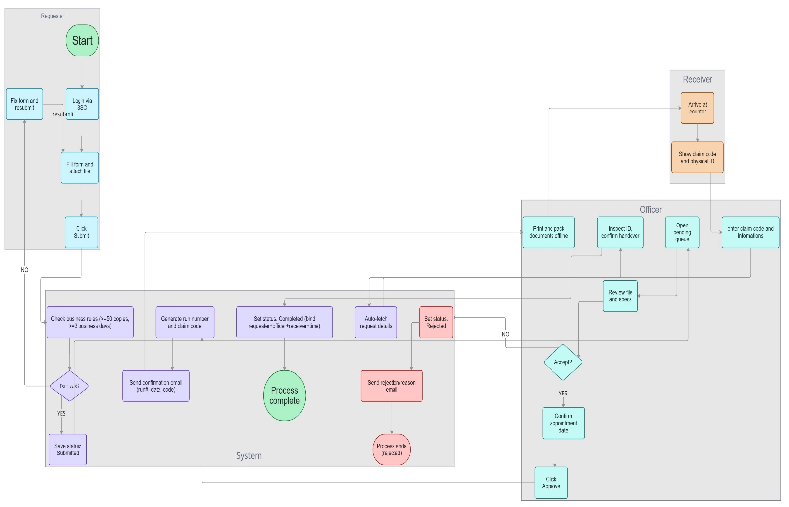
[Note: the workflow diagram above predates the v0.4 requirements update — it no longer shows the removed physical-ID check at handover (now name/position/work phone) and does not depict the paper-responsibility step. Needs to be redrawn.]

Definitions, Acronyms and Abbreviations

This section defines the terms, roles, and abbreviations used throughout this SRS to properly interpret the requirements of the Online Document Printing Request System (ODPRS).

Term | Description
Requester | A university faculty or staff member (or another non-student university role) who logs into ODPRS using a university email account to submit a print request and track its status. Students are explicitly excluded from the Requester role. The Requester never attaches or uploads the document to be printed.
Officer | Registrar Division staff who log into ODPRS to review requests awaiting physical document drop-off, approve or reject them after comparing the physical originals to the submitted specification, print/pack documents, mark jobs ready for pickup, and record the Receiver's information at the counter before handover.
Receiver | The individual who physically arrives at the Registrar Division counter to collect the printed documents. The Receiver does not log into the system; they present a Claim Code and provide their name, position, and work phone number to the Officer for the handover record — an accountability record, not an identity check. The Receiver may be the Requester or a third party designated by them (e.g. a TA).
Admin | A role within ODPRS responsible for managing which university email accounts have the Officer role. Not a per-request actor; operates outside the request workflow.
Stakeholder | Any person who has an interest in ODPRS but does not directly develop it — e.g., the Registrar Division head who approves this SRS, or university IT who maintains SSO integration.
Registrar Division | The university department that owns the document printing service and operates ODPRS.
Print Request | A single submission made by a Requester containing print specifications (paper size, color mode, print side, finishing options, binding options, item list, original pages, number of copies, Document Type) and a proposed completion date — with no attached file.
Document Type | A single classification, chosen once per request (Exam or General Document), that determines paper-supply responsibility (see Paper Source). A request cannot mix both types — a Requester needing to print both must submit two separate requests.
Paper Source | Determines who supplies the physical paper for a print job. For a General Document, the Requester must always supply the paper themselves — office paper stock may not be used, and no choice is offered on the form. For an Exam, the Requester chooses between the Registrar Division's own paper stock or bringing their own.
Request Reference Number | The identifier the system assigns immediately upon successful submission, before any physical document has been received. Printed on the Request Form and used by the Officer to look up the request when the Requester arrives.
Request Form | The system-generated, printable (PDF) document containing all submitted request data, which the Requester prints and brings to the counter together with the physical original documents.
ODPRS | Online Document Printing Request System — the software product described in this SRS.
MFU | Mae Fah Luang University.
SRS | Software Requirements Specification.
SSO | Single Sign-On — the university authentication mechanism used for login.
BR | Business Requirement.
FR | Functional Requirement.
NFR | Non-Functional Requirement.
DB | Database.
PK / FK | Primary Key / Foreign Key, used in the Data Dictionary (Appendix A).
RUN NUMBER | The unique, sequential tracking number the system assigns only after the Officer has physically received the original documents and clicked Approve and Receive Master. Used for printing/labeling and long-term tracking.
Claim Code | A random 6-digit code generated together with the RUN NUMBER at Approve and Receive Master. Presented at the counter so the Officer can look up the matching request and confirm handover. The Officer records the Receiver's name, position, and work phone number alongside it — an accountability record, not an identity check; no physical ID is inspected.
Copy Label | An optional, per-copy running number (e.g. M-10 through M-100) that the Requester may request to be printed in the top-right corner of each physical copy's first page, purely for the Requester's own tracking. Configured as a prefix plus a starting number; the ending number is derived from Number_of_Copies and previewed before submission. Entirely independent of, and not to be confused with, the Request Reference Number or RUN NUMBER.
Total Pages to Print | A derived value (Original_Pages × Number_of_Copies), not a stored field — the total logical content pages a print job represents. Distinct from Total Sheets to Print, which counts physical paper.
Total Sheets to Print | A derived value, not a stored field, representing the actual physical paper sheets a print job requires — the number relevant to whoever must supply the paper. Computed as ⌈Original_Pages ÷ 2⌉ × Number_of_Copies when Print_Side is Double-sided, or Original_Pages × Number_of_Copies when Print_Side is Single-sided.
Original Document Drop-off Deadline | The date/time, calculated from the submission timestamp and business hours (09:00–15:00), by which the Requester must hand-deliver the physical original documents to the Officer.
Business Day | Monday through Friday. Saturday and Sunday are excluded from every day-count in this document because they are government non-working days. Thai public holidays that fall on a weekday are a known, untracked gap.
Business Hours | 09:00–15:00 on business days, used both for computing the drop-off deadline and for counter operations such as handover.
Overdue | A request still in status Awaiting Original Document whose drop-off deadline has passed. Not auto-cancelled; the Officer dashboard must surface it so staff can follow up.
Business Rules | The conditions enforced automatically before a request can be submitted: the proposed completion date must be at least 3 business days after the submission date, and must itself be a business day. There is no minimum or maximum on the number of copies.
Lean & Realistic UX | The design principle that all Officer-facing workflows (queue review, approval, counter verification) must run on the desktop computer already at the counter, with no new hardware purchase.
Semi-Online | The design principle that ODPRS digitizes the request/validation/tracking/handoff-verification steps, but never accepts a digital copy of the document to be printed — the physical original is always hand-delivered.

Overall Description

Product Perspective

ODPRS is a standalone web-based system, independent of other university systems, apart from two integration points: the university's SSO for authentication, and the university email system for automated notifications. ODPRS deliberately never stores, transmits, or displays a digital copy of the document to be printed — no file upload capability exists anywhere in the system. All source-document handling remains physical, verified in person by the Officer. The system also does not integrate with printing hardware or require any new peripheral devices — all Officer-side actions are performed through a standard web browser on the desktop computer already available at the counter.

Requester - submit print requests online (specs only, no attachment) and track request status.

Officer - review requests, physically compare hand-delivered originals to submitted specs, approve/reject, assign RUN NUMBERs, mark jobs ready for pickup, and record Receiver information at the counter.

Receiver - collect completed print jobs at the counter by presenting the Claim Code and providing name, position, and work phone number.

Admin - manage which university email accounts are granted the Officer role within ODPRS.

User Classes and Characteristics

User Class | Description
Requester | University members who need documents printed. Logs in with a university email account. Uses the system infrequently, submits print specifications and a proposed date, and tracks status online. Never uploads a file.
Officer | Registrar Division staff responsible for reviewing requests, physically comparing hand-delivered originals to submitted specs, approving/rejecting, assigning RUN NUMBERs, marking jobs ready for pickup, recording Receiver information at the counter, and reviewing resource-usage trends on the Dashboard. Uses the system daily.
Receiver | The individual who arrives at the counter to collect the printed documents. May be the Requester or a designated third party. Does not log in — only presents a Claim Code and provides name/position/work phone to the Officer.
Admin | Manages which university email accounts are granted the Officer role within ODPRS. Uses the system rarely (only when Officer staffing changes).

Software Requirement

Business Requirements

BR #. | Description
BR-01 | Digitize the request, validation, tracking, and handoff-verification steps of the existing paper-based process, while requiring the physical original document to always be hand-delivered — never uploaded — to protect confidential/official documents.
BR-02 | Automatically enforce a minimum 3-business-day lead time between submission and the proposed completion date, and require that date itself to be a business day (not a Saturday/Sunday); the number of copies is unlimited (no minimum, no maximum).
BR-03 | Automatically calculate and communicate a deadline, based on business hours, by which the Requester must physically deliver the original documents to the Officer.
BR-04 | Provide real-time, self-service status tracking for Requesters, reducing phone/in-person inquiries to the Registrar Division.
BR-05 | Provide an auditable digital record of the full request lifecycle (submission → physical verification → approval/rejection → printing → handoff), binding Requester, Officer, Receiver, and timestamp.
BR-06 | Enable physical document handoff to be logged with a Claim Code plus the Receiver's name, position, and work phone number — an accountability record, not an identity-verification step — using only equipment already available at the counter.
BR-07 | Restrict system access to university email accounts (address must end in @mfu.ac.th) authenticated via the university SSO, with Officer and Admin roles explicitly assigned inside ODPRS rather than inferred from SSO alone.
BR-08 | Give Officers visibility into requests whose physical-document deadline has passed, without automatically cancelling them.
BR-09 | Automatically determine, based on Document Type (Exam vs. General Document), who is responsible for supplying the physical printing paper, and clearly communicate the exact number of paper sheets required to whichever party is responsible.
BR-10 | Give Officers a resource-usage analytics view of print volume (requests, copies, pages, and paper sheets) broken down by year, month, agency category, and agency unit, to support institutional planning and budgeting.

Overall Product Function

FR #. | Function name | User class | Dependency
FR-01 | Login via university SSO | Requester, Officer | None
FR-02 | Manage Officer accounts | Admin | FR-01
FR-03 | Fill and submit print request form (no attachment) | Requester | FR-01
FR-04 | Real-time validation of proposed completion date (≥ 3 business days) | System | FR-03
FR-05 | Assign Request Reference Number and drop-off deadline | System | FR-04
FR-06 | Generate printable Request Form (PDF) | System | FR-05
FR-07 | Send automated status-update email | System | FR-05
FR-08 | View Awaiting Original queue, incl. Overdue filter | Officer | FR-01
FR-09 | Compare physical original documents against submitted specification | Officer | FR-08
FR-10 | Approve and Receive Master (generate RUN NUMBER + Claim Code, confirm date) | Officer, System | FR-09
FR-11 | Reject request with reason | Officer | FR-09
FR-12 | Mark request Ready for Pickup | Officer | FR-10
FR-13 | Track request status | Requester | FR-05
FR-14 | Verify Claim Code and Receiver info; confirm handover | Officer, System | FR-12
FR-15 | View audit/history log of past requests | Officer | FR-14
FR-16 | View resource-usage analytics Dashboard | Officer | FR-01
FR-17 | Compute Total Sheets to Print and paper-supply responsibility | System | FR-03
FR-18 | Configure optional per-copy running number (Copy Label) | Requester, System | FR-03

Functional Requirements

FR-01 | Login via university SSO
Description | The system shall authenticate users via the university's Single Sign-On (SSO), accepting only accounts whose email address ends in @mfu.ac.th (faculty/staff), and shall then determine the user's ODPRS role (Requester or Officer) from the internal role-assignment table maintained by Admin.
User Class (Actors) | Requester, Officer
Priority | High
Input | University SSO credentials
Output | Authenticated session and redirection to the appropriate landing page (request form for Requester, dashboard for Officer)
Workflow | - 1. User selects "Login"  2. User is redirected to university SSO  3. On success, the system creates a session  4. System looks up the email in the Officer account table: found → Officer dashboard; not found → Requester request form

FR-02 | Manage Officer accounts
Description | The system shall allow an Admin to grant or revoke the Officer role for a given university email address. Any authenticated university email not on this list defaults to the Requester role.
User Class (Actors) | Admin
Priority | High
Input | University email address, grant/revoke action
Output | Updated Officer account list
Workflow | - 1. Admin opens Officer account management  2. Admin adds or removes an email  3. System updates the role-assignment table used by FR-01

FR-03 | Fill and submit print request form
Description | The system shall allow a logged-in Requester to fill in print specifications — paper size, color mode (Black & White / Color), print side (Single-sided / Double-sided), finishing options (Corner Staple / Side Staple / Hole Punch — any combination), binding options (Glue Binding / Coil Binding / Cloth Tape Binding / Saddle-stitch Binding — any combination), item list, number of original pages, number of copies, Document Type (Exam or General Document — exactly one per request), and, only when Document Type is Exam, Paper Source (Office-provided or Requester-provided) — and propose a completion date. No file or document attachment is offered anywhere in the form.
User Class (Actors) | Requester
Priority | High
Input | Requester name, tel (personal or work number), agency, paper size, color mode, print side, finishing options, binding options, item list, original pages, number of copies, Document Type, Paper Source (Exam only), proposed completion date
Output | Draft request passed to FR-04 for validation
Workflow | - 1. Requester fills form fields, choosing Document Type first  2. If Document Type is Exam, Requester also chooses Paper Source; if General Document, system fixes Paper Source to Requester-provided  3. Requester proposes a completion date  4. Requester clicks Submit  5. Request is passed to real-time validation (FR-04)

FR-04 | Real-time validation of proposed completion date
Description | The system shall check, before allowing submission, that the proposed completion date (a) is at least 3 business days after the current date, and (b) itself falls on a business day. The Submit action is unavailable/blocked until both conditions are satisfied; there is no minimum or maximum on the number of copies. The form also displays the counter's Business Hours (09:00–15:00).
User Class (Actors) | System
Priority | High
Input | Proposed completion date, current date
Output | Valid → request proceeds to FR-05; Invalid → inline error ("too soon" or "falls on a weekend"), Requester adjusts the date
Workflow | - 1. System computes business days between today and the proposed date  2. If < 3, show inline error and keep Submit disabled  3. If the date falls on a Saturday/Sunday, show inline error and keep Submit disabled  4. If both checks pass, allow submission to proceed

FR-05 | Assign Request Reference Number and drop-off deadline
Description | Upon successful submission, the system shall assign a unique Request Reference Number and compute the original-document drop-off deadline from the submission timestamp and business hours (09:00–15:00): same business day by 15:00 if submitted within business hours on a business day, otherwise the next business day 09:00–15:00.
User Class (Actors) | System
Priority | High
Input | Validated request, submission timestamp
Output | Request Reference Number, drop-off deadline, status "Awaiting Original Document"
Workflow | - 1. System generates the Request Reference Number  2. System computes the drop-off deadline  3. Status is set and both are stored against the request  4. Request Form generation is triggered (FR-06)

FR-06 | Generate printable Request Form (PDF)
Description | The system shall generate a printable document (PDF) containing all submitted request data, the Request Reference Number, the computed Total Pages to Print and Total Sheets to Print, the paper-supply responsibility notice, and the Copy Label range (when configured), for the Requester to print and bring to the counter with the physical original documents.
User Class (Actors) | System
Priority | High
Input | Submitted request data, Request Reference Number
Output | Downloadable Request Form (PDF)
Workflow | - 1. Request Reference Number is assigned  2. Requester or Officer clicks Download PDF  3. System renders the Request Form page server-side and converts it to PDF on the fly  4. Browser downloads the file

FR-07 | Send automated status-update email
Description | The system shall send an email to the Requester whenever the request status changes (Awaiting Original Document, Rejected, Printing In Progress, Ready for Pickup, Completed), including relevant details. All notifications are sent to the Requester only, regardless of who the eventual Receiver is.
User Class (Actors) | System
Priority | High
Input | Status change event
Output | Email delivered to the Requester's university email address
Workflow | - 1. Status changes  2. System composes email from the corresponding template  3. Email is sent to the Requester

FR-08 | View Awaiting Original queue, incl. Overdue filter
Description | The system shall display all requests in status "Awaiting Original Document" in a queue/dashboard, and shall let the Officer filter/distinguish those whose drop-off deadline has already passed (Overdue) without changing their status or auto-cancelling them.
User Class (Actors) | Officer
Priority | High
Input | Officer login session
Output | List of pending requests with key details, with an Overdue indicator/filter
Workflow | - 1. Officer logs in  2. Officer opens the Awaiting Original queue  3. System lists all requests in that status, computing Overdue = current time > drop-off deadline

FR-09 | Compare physical original documents against submitted specification
Description | The system shall display the full submitted specification (item list, original page count, copies, options) for a selected request so the Officer can compare it against the physical original documents the Requester hand-delivers.
User Class (Actors) | Officer
Priority | High
Input | Selected Request Reference Number
Output | Full request specification displayed for on-screen comparison
Workflow | - 1. Officer selects a request from the queue  2. System displays the submitted specification  3. Officer visually compares it against the physical originals in hand

FR-10 | Approve and Receive Master
Description | The system shall let the Officer approve a request once the physical originals match the submitted specification, generating a RUN NUMBER and a random 6-digit Claim Code, and confirming or adjusting the completion date proposed by the Requester.
User Class (Actors) | Officer, System
Priority | High
Input | Approval decision, confirmed/adjusted completion date
Output | RUN NUMBER, Claim Code, confirmed completion date, status "Printing In Progress"
Workflow | - 1. Officer clicks Approve and Receive Master  2. Officer confirms or adjusts the completion date  3. System generates RUN NUMBER and Claim Code  4. Status set to Printing In Progress; confirmation email triggered (FR-07)

FR-11 | Reject request with reason
Description | The system shall let the Officer reject a request — typically because the physical originals do not match the submitted specification — and record a reason, which is communicated to the Requester.
User Class (Actors) | Officer
Priority | High
Input | Rejection reason
Output | Status "Rejected", rejection email sent (FR-07)
Workflow | - 1. Officer selects Reject  2. Officer enters reason  3. System sets status Rejected and triggers rejection email  4. Process ends

FR-12 | Mark request Ready for Pickup
Description | The system shall let the Officer mark a request as Ready for Pickup once the documents have been physically printed, packed, and labeled with the RUN NUMBER, triggering an email to the Requester. Because this action cannot be undone from the UI, clicking Mark Ready for Pickup shall first open a confirmation dialog summarizing the job before the status change is applied.
User Class (Actors) | Officer
Priority | High
Input | Officer confirmation that printing is complete
Output | Status "Ready for Pickup"
Workflow | - 1. Officer finishes printing/packing offline  2. Officer clicks Mark Ready for Pickup  3. System shows a confirmation dialog with the job's key details  4. Officer confirms (or cancels, taking no action)  5. On confirm, system sets status and triggers the ready-for-pickup email (FR-07)

FR-13 | Track request status
Description | The system shall allow the Requester to check the current status of their request(s) at any time, and to re-download the Request Form.
User Class (Actors) | Requester
Priority | Medium
Input | Requester login session
Output | Status view with relevant dates/codes
Workflow | - 1. Requester logs in  2. Requester opens "My Requests"  3. System displays status per Request Reference Number / RUN NUMBER

FR-14 | Verify Claim Code and Receiver information; confirm handover
Description | The system shall let the Officer enter the Claim Code at the counter (using the existing desktop PC, no barcode scanner) to pull up the matching request, then record the Receiver's name, position (job title), and work phone number, and confirm the handover. This is an accountability record of who collected the documents, not an identity-verification step; no physical ID is inspected.
User Class (Actors) | Officer, System
Priority | High
Input | Claim Code, Receiver name, Receiver position, Receiver work phone, Officer confirmation
Output | Status "Completed", audit record created
Workflow | - 1. Receiver shows the Claim Code  2. Officer types the Claim Code into the system; matching request is displayed  3. Officer enters the Receiver's name, position, and work phone number  4. Officer clicks Confirm Handover  5. System sets status Completed and binds Requester+Officer+Receiver+timestamp to the RUN NUMBER
FR-15 | View audit/history log of past requests
Description | The system shall let the Officer search and view the full history of past requests (completed, rejected, or otherwise), including who submitted, approved, and received each one and when.
User Class (Actors) | Officer
Priority | Medium
Input | Search filters (date range, RUN NUMBER, Requester, status)
Output | List/detail view of historical requests with full audit trail
Workflow | - 1. Officer opens History / Audit Log  2. Officer applies filters  3. System returns matching historical records
FR-16 | View resource-usage analytics Dashboard
Description | The system shall provide Officers with a dashboard summarizing print-resource usage — total requests, total copies, total pages, and total paper sheets consumed — filterable by year and month, and broken down both by agency category and by agency unit.
User Class (Actors) | Officer
Priority | Medium
Input | Officer login session, selected year/month filter
Output | KPI tiles and charts summarizing usage; breakdowns by agency category and agency unit
Workflow | - 1. Officer opens Dashboard  2. Officer selects a year and, optionally, a month  3. System aggregates requests in that period and renders KPIs and per-agency breakdowns
FR-17 | Compute Total Sheets to Print and paper-supply responsibility
Description | The system shall compute Total Sheets to Print for a request from Original_Pages, Number_of_Copies, and Print_Side, and shall clearly display, based on Document_Type and Paper_Source, whether the Requester or the Registrar Division is responsible for supplying that many sheets of paper. This must appear on the New Print Request page, the Request Form (PDF), and the Officer's Request Detail view.
User Class (Actors) | System
Priority | High
Input | Original_Pages, Number_of_Copies, Print_Side, Document_Type, Paper_Source
Output | Total Sheets to Print value; a paper-responsibility notice (e.g. "Requester must bring 120 sheets")
Workflow | - 1. Requester fills in original pages, copies, print side, and Document Type (and Paper Source if Exam)  2. System recalculates Total Sheets to Print live as these fields change  3. System displays the responsibility notice inline, and includes both figures on the Request Form and Officer views
FR-18 | Configure optional per-copy running number (Copy Label)
Description | The system shall let the Requester optionally request a per-copy running number to be printed on each physical copy, by supplying a prefix and a starting number; the system derives the ending number from Number_of_Copies and shows a preview before submission. If not enabled, no Copy Label is generated.
User Class (Actors) | Requester, System
Priority | Low
Input | Copy Label enabled (yes/no), prefix (optional text), starting number
Output | Computed ending number and full range preview, stored against the request, printed on the Request Form
Workflow | - 1. Requester toggles "Add a running number to each copy"  2. Requester enters a prefix and a starting number  3. System computes and displays the ending number/range live  4. Requester confirms and submits

Software Quality Attributes (Nonfunctional Requirements)

NFR #. | Name | Description | Acceptance Criteria
NFR-01 | Security | All access requires university SSO authentication restricted to university email accounts; the system never accepts, stores, or transmits a digital copy of the document to be printed; Claim Codes and request data must not be guessable/exposed in URLs. | Query the database/logs to verify no source-document file exists anywhere in the system, no plaintext sensitive data is exposed, and Claim Codes use sufficiently random generation.
NFR-02 | Usability (Lean & Realistic UX) | All Officer-facing workflows (queue review, approve/reject, ready-for-pickup, counter verification) must be operable from a standard desktop browser with keyboard and mouse only — no barcode scanner or signature tablet required. | A new Officer can complete counter verification within 2 minutes using only the existing desktop PC, with no additional hardware.
NFR-03 | Auditability | Every status transition must be logged with actor, timestamp, and relevant data (reference number, RUN NUMBER, Claim Code, reason if rejected). | Every completed request has a traceable log binding Requester, Officer, Receiver, and timestamp, retrievable via the History / Audit Log (FR-15).
NFR-04 | Availability | The system shall be available during university operating hours with minimal downtime. | Uptime ≥ 99% during business hours, measured monthly.
NFR-05 | Performance | Form submission, business-rule validation, and status queries shall respond within an acceptable time for counter/staff use. | 95% of requests return within 3 seconds under normal load.
NFR-06 | Compatibility | The system shall run on standard desktop/laptop browsers used by the university (no mobile-only or hardware-dependent features required for core Officer flows). | Verified functional on the two most common browsers used by Registrar Division staff.

External Interface Requirements
The sections that follow present low-fidelity wireframes of ODPRS's core screens, produced in Figma using Mae Fah Luang University's Registrar Division system (REG.MFU) as the visual reference. The site map below shows how these screens relate to one another; each screen is detailed further in Section 4.1 User Interfaces.
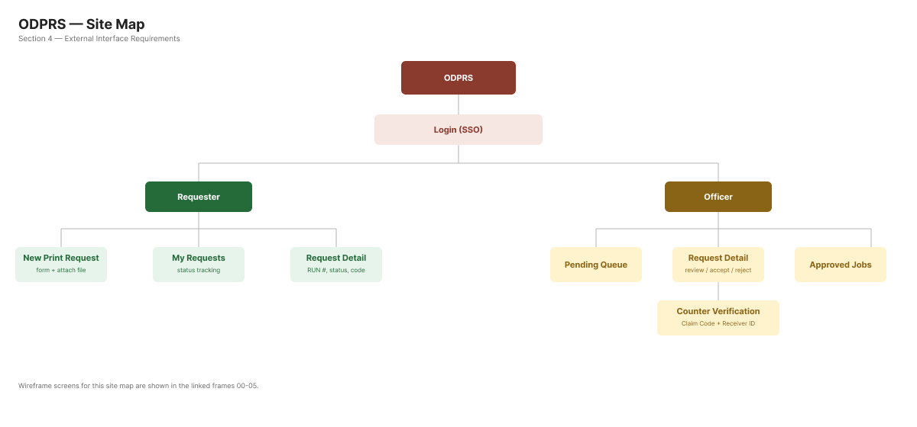
Figure 4-1 : ODPRS Site Map

4.1 User Interfaces

Login / Landing Page
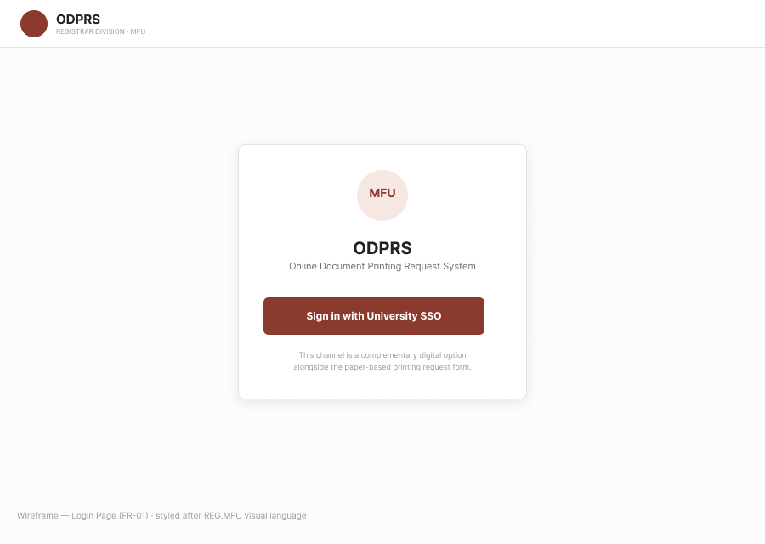
Figure 4-2 : Login / Landing Page wireframe
Purpose | Single entry point for every user — a branded page offering "Log in with Google," with no manual role selection (role is always resolved server-side per FR-01).
Prerequisite | None — this is the only page reachable while unauthenticated.
Use case procedure | 1. User opens the site  2. User clicks Log in with Google  3. User authenticates via university SSO  4. System resolves the account's role and redirects: Requester → New Print Request, Officer/Admin → Dashboard
Acceptance Criteria | An account whose email domain isn't allowed sees a clear inline error explaining the required domain; an already-authenticated user visiting this page is redirected immediately rather than shown the login form again.
Related Function Requirement | FR-01

New Print Request Page
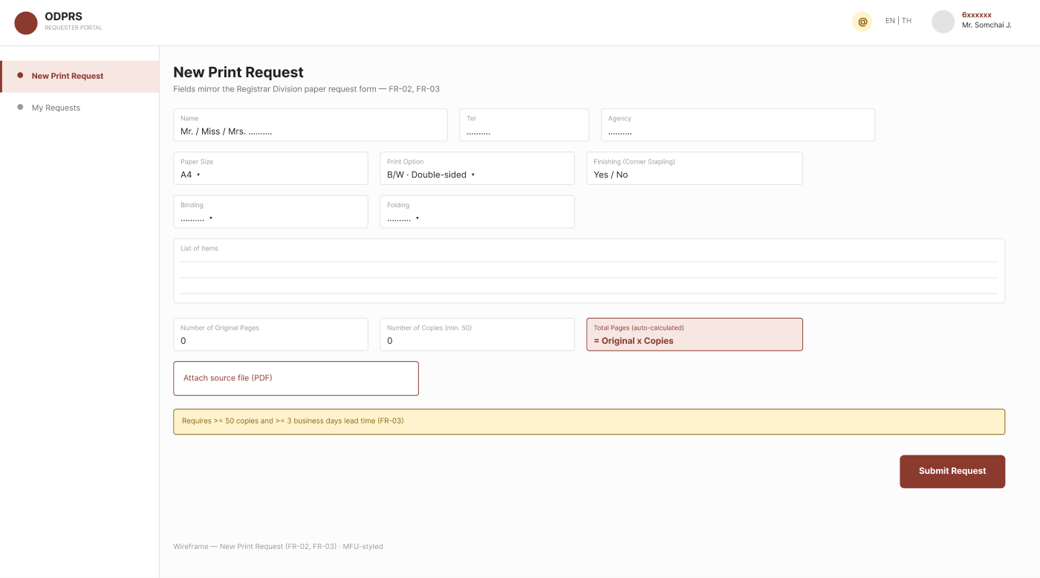
Figure 4-3 : New Print Request Page wireframe
[Note: wireframe above predates the v0.4 form redesign — Color Mode/Print Side split, multi-select finishing/binding, Document Type + Paper Source, Total Sheets to Print preview, and Copy Label are not yet shown. Needs to be redesigned.]
Purpose | Allow the Requester to submit print specifications and a proposed completion date, replacing the paper "Document Printing Request Form." No attachment field exists on this page.
Prerequisite | Requester has logged in via university SSO.
Use case procedure | 1. Requester fills in paper size, color mode, print side, finishing options, binding options, item list, original pages, and number of copies  2. Requester selects Document Type (Exam or General Document) and, only if Exam, Paper Source  3. Requester optionally enables a Copy Label (prefix + starting number)  4. Requester proposes a completion date  5. Requester clicks Submit
Acceptance Criteria | Submit is disabled until the proposed completion date is ≥3 business days from today and falls on a business day; finishing and binding options may each be multi-selected in any combination; the form shows a live-computed Total Sheets to Print and states which party must supply that paper; for a General Document, Paper Source is fixed to Requester-provided; if a Copy Label is enabled, the form previews the full label range before Submit is allowed; no file upload control is present anywhere on the page.
Related Function Requirement | FR-03, FR-04, FR-17, FR-18

My Requests / Status Tracking Page
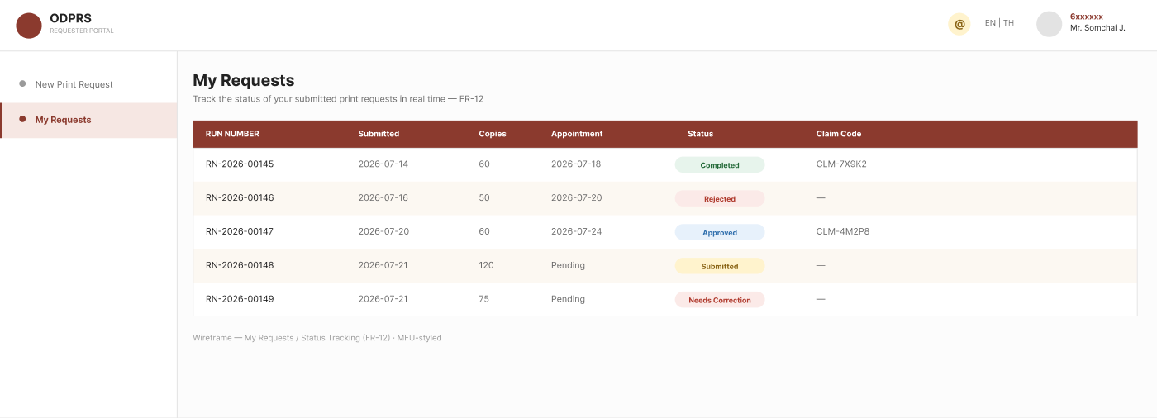
Figure 4-4 : My Requests / Status Tracking Page wireframe
Purpose | Let the Requester view the real-time status of all their submitted requests and re-download the Request Form.
Prerequisite | Requester has at least one submitted request.
Use case procedure | 1. Requester opens "My Requests"  2. System lists requests with reference number/RUN NUMBER and status
Acceptance Criteria | Status shown must be one of: Awaiting Original Document, Rejected, Printing In Progress, Ready for Pickup, Completed; the drop-off deadline is shown while status is Awaiting Original Document.
Related Function Requirement | FR-13

Officer Awaiting Original Queue
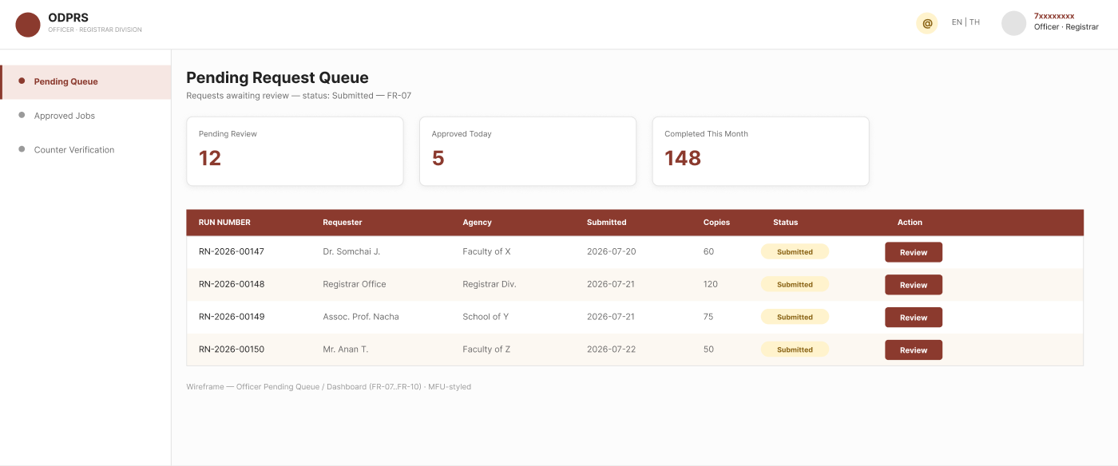
Figure 4-5 : Officer Awaiting Original Queue wireframe
[Note: this wireframe predates the v0.4 update; it no longer represents the separate resource-usage Dashboard, which is now documented as its own page below.]
Purpose | Let the Officer see incoming requests awaiting physical document drop-off, compare hand-delivered originals to the submitted specification, and approve or reject.
Prerequisite | Officer has logged in via SSO.
Use case procedure | 1. Officer opens the queue  2. Officer filters/notices Overdue requests if needed  3. Requester arrives with the Request Form and physical originals  4. Officer selects the matching request  5. Officer compares originals to the on-screen specification  6. Officer clicks Approve and Receive Master or Reject
Acceptance Criteria | Rejecting a request requires a reason; approving requires confirming/adjusting a completion date; requests past their drop-off deadline are visually distinguished as Overdue but remain actionable, never auto-cancelled.
Related Function Requirement | FR-08, FR-09, FR-10, FR-11

Officer Dashboard (Resource-Usage Analytics)
No wireframe has been designed yet for this new page; requirements only (see FR-16).
Purpose | Let Officers see print-resource usage (requests, copies, pages, and paper sheets) broken down by year, month, agency category, and agency unit — so the Registrar Division can answer "which agency/agency type used how much, when" for planning and budgeting.
Prerequisite | Officer has logged in via SSO.
Use case procedure | 1. Officer opens Dashboard  2. Officer selects a year and, optionally, a month  3. Officer views KPI tiles and breakdown charts by agency category and agency unit
Acceptance Criteria | Figures update when the year/month filter changes; breakdowns are available at both the agency-category and agency-unit level; the paper-sheet KPI reflects the Total Sheets to Print calculation, distinct from the existing total-pages KPI.
Related Function Requirement | FR-16

Printing Jobs / Ready for Pickup Page
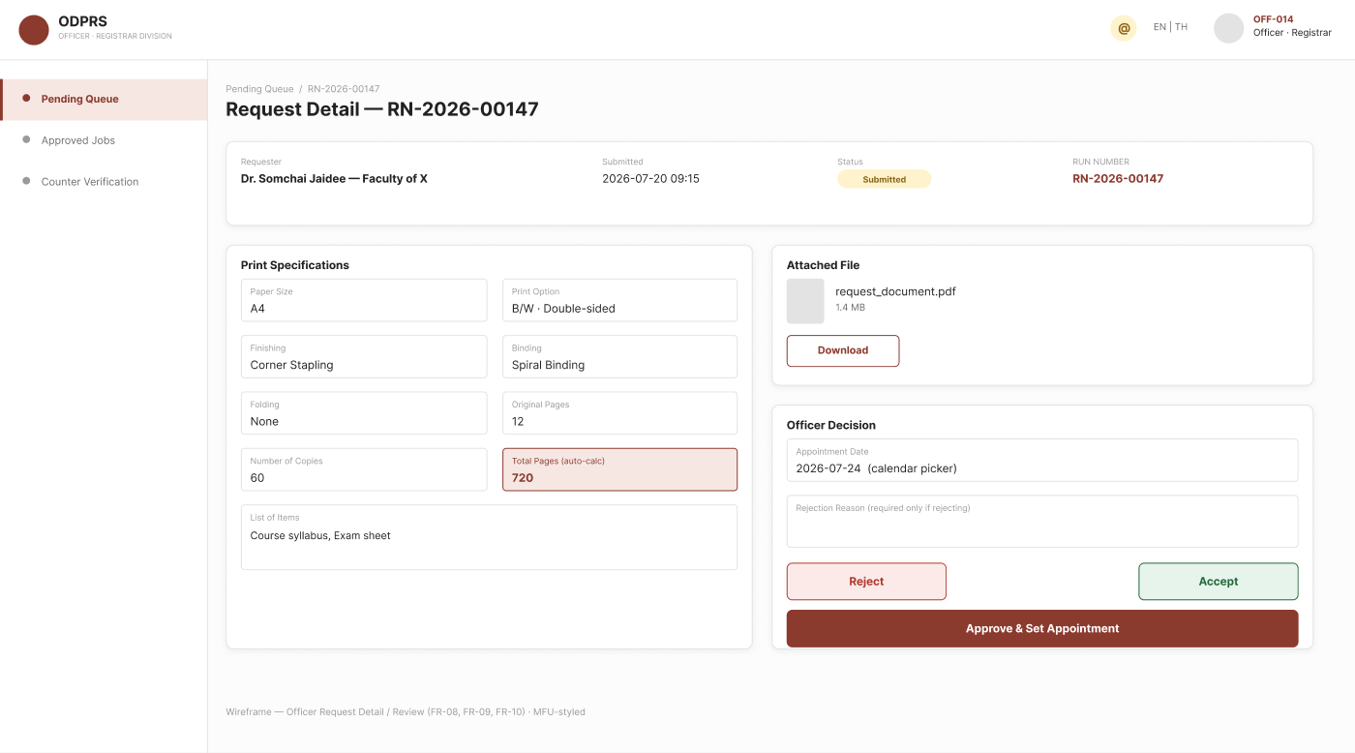
Figure 4-6 : Printing Jobs / Ready for Pickup Page wireframe
[Note: wireframe predates the v0.4 update — does not yet show the Total Sheets to Print column.]
Purpose | Let the Officer mark a request as Ready for Pickup once printing/packing is physically complete. The job list shows each job's Total Pages to Print and Total Sheets to Print at a glance.
Prerequisite | Request status is "Printing In Progress".
Use case procedure | 1. Officer finishes printing and packing offline  2. Officer opens the request (from the job list row, or via Mark Ready for Pickup directly)  3. Officer clicks Mark Ready for Pickup  4. Officer confirms in the dialog shown
Acceptance Criteria | The job list displays Total Pages to Print and Total Sheets to Print for every row; clicking a row opens that request's full detail; Mark Ready for Pickup requires an explicit confirm step; confirming immediately sends the ready-for-pickup email and updates the status visible on My Requests.
Related Function Requirement | FR-12, FR-17

Counter Handover Page
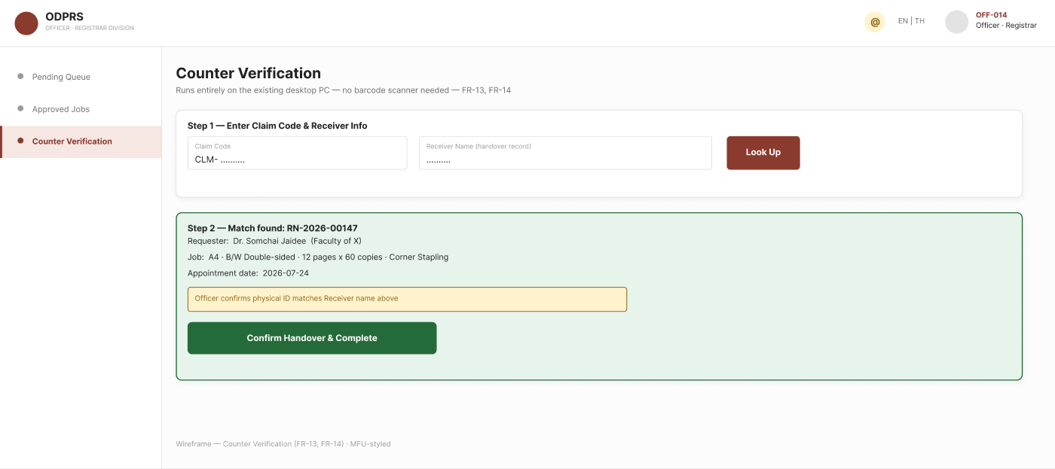
Figure 4-7 : Counter Handover Page wireframe
[Note: wireframe predates the v0.4 update — it still shows a physical-ID inspection step, which has been replaced with recording the Receiver's name, position, and work phone number. Needs to be redesigned.]
Purpose | Let the Officer look up a request by Claim Code and record the Receiver's name, position, and work phone number using only the existing desktop PC, then confirm handover.
Prerequisite | Request status is "Ready for Pickup".
Use case procedure | 1. Receiver shows the Claim Code  2. Officer enters the Claim Code  3. System displays the matching request  4. Officer records the Receiver's name, position, and work phone number, and clicks Confirm Handover
Acceptance Criteria | An incorrect/unknown Claim Code must show a clear error and must not display another Requester's data; a confirmed handover immediately sets status to Completed; no physical ID inspection is required — name, position, and work phone are recorded purely as an accountability record.
Related Function Requirement | FR-14

Admin — Officer Account Management Page
No wireframe has been designed yet for this new page; requirements only (see FR-02).
Purpose | Let an Admin grant or revoke the Officer role for university email accounts.
Prerequisite | Admin has logged in via SSO with Admin privileges.
Use case procedure | 1. Admin opens Officer account management  2. Admin adds or removes a university email from the Officer list
Acceptance Criteria | An email removed from the Officer list immediately loses Officer-dashboard access on next login/session check; any university email not on the list defaults to Requester. Both adding and revoking require an explicit confirmation step before taking effect.
Related Function Requirement | FR-01, FR-02

Appendix A: Data Dictionary

The table below documents the attributes of the PRINT_REQUEST entity referenced throughout the Functional Requirements (Section 3.3) and Business Workflow (Section 1.4) of ODPRS.

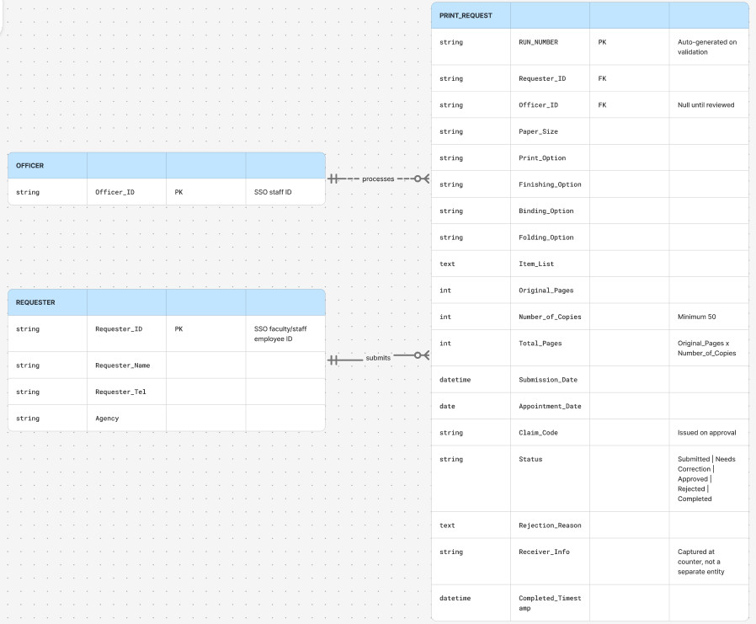
Figure A-1 : ODPRS Entity-Relationship Diagram (PRINT_REQUEST, REQUESTER, OFFICER)

Table: PRINT_REQUEST
Attribute | Description | Data type | Key | Example
Request_Reference_No | Identifier assigned immediately at submission, before any physical document is received; printed on the Request Form. Format REQ-YYYY-NNNNNN, 6-digit sequence resets yearly | String | PK | REQ-2026-000001
RUN_NUMBER | Sequential tracking number assigned only after Approve and Receive Master. Format RN-YYYY-NNNNNN, resets yearly (independent counter from Request_Reference_No) | String |  | RN-2026-000001
Requester_Email | University email used for SSO login; unique identifier of the Requester | String | FK | somchai.j@mfu.ac.th
Requester_Name | Full name of the Requester | String |  | Dr. Somchai Jaidee
Requester_Tel | Contact phone number — may be the Requester's personal mobile number or a workplace/office number | String |  | 0891234567 or 053-916-000
Agency | Requester's department/agency | String |  | School of X
Paper_Size | Requested paper size | String |  | A4
Color_Mode | Print color mode | Enum |  | Black & White
Print_Side | Whether each physical sheet is printed on one side or both — drives the Total Sheets to Print calculation | Enum |  | Double-sided
Finishing_Option | Finishing option(s) applied; any combination may be selected. Values: Corner Staple, Side Staple, Hole Punch | String (multi-select) |  | Corner Staple, Hole Punch
Binding_Option | Binding option(s) applied; any combination may be selected. Values: Glue Binding, Coil Binding, Cloth Tape Binding, Saddle-stitch Binding | String (multi-select) |  | Coil Binding
Document_Type | Classification chosen once per request; determines Paper_Source. A request may not mix Exam and General Document items | Enum |  | Exam
Paper_Source | Who supplies the physical paper. Always Requester-provided when Document_Type is General Document (no choice offered); Requester chooses when Document_Type is Exam | Enum |  | Office-provided
Item_List | List of document items requested for printing | Text |  | Course syllabus, Exam sheet
Original_Pages | Requester-declared page count of the original document; verified physically by the Officer at drop-off | Integer |  | 12
Number_of_Copies | Number of copies requested (no minimum or maximum) | Integer |  | 20
Copy_Label_Enabled | Whether the Requester requested a per-copy running number printed on each physical copy | Boolean |  | true
Copy_Label_Prefix | Prefix text for the per-copy running number (optional even when enabled) | String |  | M-
Copy_Label_Start_Number | Starting number for the per-copy running number; ending number is derived as Start + Number_of_Copies − 1 | Integer |  | 10
Submission_Date | Date/time the request was submitted | DateTime |  | 2026-07-20 09:15
Original_Doc_Deadline | Deadline (date + time) for the Requester to hand-deliver the physical original documents, computed from Submission_Date and business hours | DateTime |  | 2026-07-20 15:00
Original_Doc_Received_Timestamp | Actual date/time the Officer physically received and verified the original documents | DateTime |  | 2026-07-21 10:05
Appointment_Date_Proposed | Completion/pickup date proposed by the Requester at submission | Date |  | 2026-07-24
Appointment_Date_Confirmed | Final completion date confirmed/adjusted by the Officer at Approve and Receive Master | Date |  | 2026-07-25
Request_Form_File | Reserved for a persisted Request Form file path/URL; not currently populated — the PDF is generated on demand from live data instead | File/URL |  | (unused)
Claim_Code | Random 6-digit code issued at Approve and Receive Master, used for counter verification | String |  | 481920
Status | Current lifecycle state of the request | Enum |  | Awaiting Original Document / Rejected / Printing In Progress / Ready for Pickup / Completed
Officer_ID | Officer who processed the request | String | FK | OFF-014
Rejection_Reason | Reason provided if the request is rejected | Text |  | Original page count does not match submitted spec
Receiver_Name | Name of the person collecting the documents, entered by the Officer at Counter Handover | String |  | Provided at counter
Receiver_Position | Job title/position of the person collecting the documents, entered by the Officer at Counter Handover | String |  | Department Secretary
Receiver_Work_Phone | Work phone number of the person collecting the documents, entered by the Officer at Counter Handover | String |  | 053-916-000
Completed_Timestamp | Timestamp when handover was confirmed | DateTime |  | 2026-07-24 14:02

Officer Account (Role Assignment)
Attribute | Description | Data type | Key | Example
Officer_Email | University email granted the Officer role | String | PK | jane.d@mfu.ac.th
Assigned_By | Admin who granted the role | String | FK | admin01
Assigned_Date | Date the role was granted | Date |  | 2026-07-22

