Software Requirements Analysis

for

Document Printing Request Form

17/7/2026

Submitted by

Sorrawit Thanakhwang 6531503080

Table of Contents
Table of Contents ii
Revision History iii
Document Approval iii
- Introduction 1
  - Business Background 1
  - Business Objective 1
  - Business Scope 1
  - Business Workflow 2
  - Definitions, Acronyms and Abbreviations 3
- Overall Description 4
  - Product Perspective 4
  - User Classes and Characteristics 4
- Software Requirement 5
  - Business Requirements 5
  - Overall Product Function 5
  - Functional Requirements 6
  - Software Quality Attributes (Nonfunctional Requirements) 11
- External Interface Requirements 12
  - User Interfaces 13
Appendix A: Data Dictionary 19

Revision History

No. | Name | Date | Description | Version
1 | Ms. Sorrawit Thanakhwang | 17/7/2026 | Initial Document | 0.1
2 | Ms. Sorrawit Thanakhwang | 22/07/2026 | Added Business Workflow, User Classes, Functional/Non-functional Requirements, Data Dictionary | 0.2
3 | Ms. Sorrawit Thanakhwang | 01/08/2026 | Major rework based on a follow-up round of stakeholder requirements gathering restructured the print request form (finishing and binding are now independent multi-select choices; print settings split into Color Mode and Print Side to support paper-sheet calculation; added Document Type with a resulting Paper Source responsibility rule; added an optional per-copy running number "Copy Label"). Formalized the previously undocumented resource-usage analytics Dashboard as a real functional requirement (FR-16). Replaced physical-ID-based Receiver verification at Counter Handover with recording the Receiver's name, position, and work phone number — an accountability record, not an identity check. Removed the Folding option (no longer offered). | 0.3

Document Approval

The following Software Requirements Specification has been accepted and approved by the following:

Name | Role | Signature | Date
Mr. DDDD | Test
Ms. EEEE | Test
Ms. FFFF | Test

Introduction

Business Background

To improve convenience and operational efficiency, the university plans to introduce an Online Document Printing Request System alongside its current printing service. Currently, the process relies solely on physical forms, which can lead to processing delays and tracking difficulties. Adding this digital channel will allow users to submit requests, attach files, and track status online for a faster and more flexible service.

Business Objective

To introduce a secure, web-enabled platform as a complementary digital channel alongside the university's traditional paper-based printing process. Rather than an immediate replacement, the system aims to facilitate a gradual transition toward campus digitization—offering a more convenient online option for users, reducing operational processing times, providing real-time request tracking, and establishing an auditable mechanism for physical document handoff.

Business Scope
- Software Product
“Online Document Printing Request System”
- Capabilities & System Boundaries
In-Scope:
- Web portal for submitting print specifications and attaching source files (e.g. PDF, DOCX).
- Automated enforcement of business logic (minimum copies, lead time validation, total page auto-calculation).
- Officer dashboard for managing requests, assigning RUN NUMBER, setting appointments, and downloading files.
- Claim Code generation (digit code) upon job completion.
- Verification module at the counter (Officer inputs Claim Code and Receiver ID via PC).
- Automated email notifications for job status updates and handoff confirmation.
Out-of-Scope:
- Physical campus delivery (collection remains in-person at the counter).
- Direct printing hardware integration (officers manually send downloaded files to hardware).
- Online payment gateways (expenses billed directly to internal university department accounting).

Business Workflow

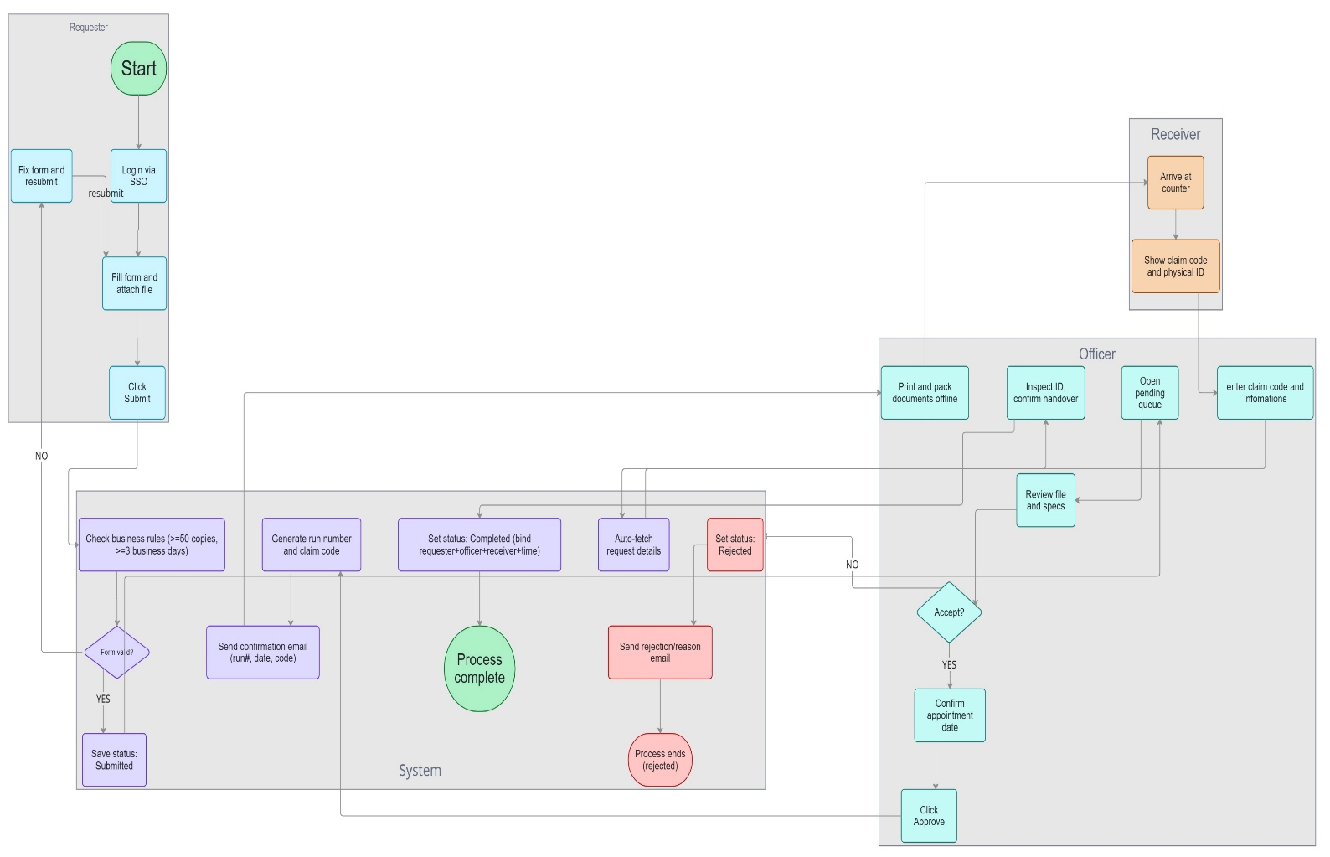

Definitions, Acronyms and Abbreviations

This section defines the terms, roles, and abbreviations used throughout this SRS to properly interpret the requirements of the Online Document Printing Request System (ODPRS).

Term | Description
Requester | A university faculty or staff member, or an external agency contact, who logs into ODPRS to submit a document printing request, attach a source file, and track its status. Access is limited to these roles: students do not submit requests through ODPRS, consistent with the original paper-based process.
Officer | Registrar Division staff who log into ODPRS to review pending requests, approve or reject them, set appointment dates, and verify the Claim Code and physical ID at the counter before handover.
Receiver | The individual who physically arrives at the Registrar Division counter to collect the printed documents. The Receiver does not log into the system; they present a Claim Code and a physical ID to the Officer. May be the same person as the Requester or a third party designated by them.
Stakeholder | Any person who has an interest in ODPRS but does not directly develop it, e.g., the Registrar Division head who approves this SRS.
Registrar Division | The university department that owns the document printing service and operates ODPRS as a complementary channel to its existing paper-based process.
Print Request | A single submission made by a Requester containing print specifications (paper size, print/finishing/binding/folding options, item list, original pages, number of copies) and an attached source file.
RUN NUMBER | The unique, sequential tracking number that the system automatically assigns to a request once it passes business rule validation, digitizing the field Registrar Division staff currently write by hand on the paper form.
Claim Code | A system-generated code issued to the Requester once a request is approved/completed, presented together with a physical ID at the counter so the Officer can verify identity and confirm handover without a barcode scanner.
Business Rules | The minimum-order conditions enforced automatically before a request is accepted: at least 50 copies per request, and at least 3 business days between submission and the requested completion date.
Lean & Realistic UX | The design principle that all Officer-facing workflows must run on the desktop computer already at the counter, with no new hardware purchase (e.g., no barcode scanner, no signature tablet).
Complementary Channel | The design principle that ODPRS supplements, rather than replaces, the existing paper-based printing request process, enabling a gradual digital transition.
ODPRS | Online Document Printing Request System, the software product described in this SRS.
MFU | Mae Fah Luang University.
SRS | Software Requirements Specification.
SSO | Single Sign-On, the university authentication mechanism used for Requester and Officer login.
BR | Business Requirement.
FR | Functional Requirement.
NFR | Non-Functional Requirement.
DB | Database.
PK / FK | Primary Key / Foreign Key, used in the Data Dictionary (Appendix A).

Overall Description

Product Perspective

ODPRS is a standalone, web-based system that acts as a complementary digital front-end to the Registrar Division's existing paper-based document printing service. It does not replace the physical printing/handoff process but digitizes the request, validation, approval, and status-tracking steps that currently rely on manual forms. The system integrates with the university's SSO for authentication and the university email system for automated notifications. It does not integrate with printing hardware or require any new peripheral devices - all Officer-side actions are performed through a standard web browser on the desktop computer already available at the counter. This software product has three types of actors who can work with the system:

Requester - submit print requests, attach source files, and track request status online.

Officer - review, approve or reject requests, set appointment dates, and verify the Claim Code and physical ID at the counter.

Receiver - collect completed print jobs at the counter by presenting the Claim Code and a physical ID.

User Classes and Characteristics

User Class | Description
Requester | University faculty and staff, or external agencies, who need documents printed. Access is limited to these roles: students do not submit requests through ODPRS. Uses the system infrequently (per request), submits print specifications, and tracks status online. Low-to-medium technical expertise assumed.
Officer | Registrar Division staff responsible for reviewing requests, assigning RUN NUMBERs, approving/rejecting jobs, setting appointment dates, printing/packing documents, and verifying receivers at the counter. Uses the system daily; primary power user.
Receiver | The individual who arrives at the counter to collect the printed documents. May be the Requester or a designated third party. Does not log in to the system directly - only presents a Claim Code and physical ID to the Officer.

Software Requirement

Business Requirements

BR #. | Description
BR-01 | Digitize the existing paper-based Document Printing Request Form into an online submission channel, without removing the paper-based option.
BR-02 | Automatically enforce business rules (minimum 50 copies per request, minimum 3 business days lead time) to reduce manual validation errors.
BR-03 | Provide real-time, self-service status tracking for Requesters, reducing phone and in-person inquiries to the Registrar Division.
BR-04 | Provide an auditable digital record of the request lifecycle (submission, approval or rejection, handoff), replacing manual signatures with a bound Requester, Officer, Receiver, and timestamp record.
BR-05 | Enable secure physical document handoff verification (Claim Code plus physical ID) using only equipment already available at the counter.
BR-06 | Reduce the Officer's manual re-entry effort by auto-fetching approved request details for printing and packing.

Overall Product Function

FR #. | Function name | User class | Dependency
FR-01 | Login via SSO | Requester, Officer | None
FR-02 | Fill and submit print request form (with file attachment) | Requester | FR-01
FR-03 | Automated business rule validation (min. copies, lead time) | System | FR-02
FR-04 | Fix and resubmit an invalid request | Requester | FR-03
FR-05 | Generate RUN NUMBER and Claim Code | System | FR-03
FR-06 | Send automated status-update email | System | FR-05
FR-07 | View pending request queue | Officer | FR-01
FR-08 | Review request file and specifications | Officer | FR-07
FR-09 | Approve request and set appointment date | Officer | FR-08
FR-10 | Reject request with reason | Officer | FR-08
FR-11 | Auto-fetch approved request details for printing | System | FR-09
FR-12 | Track request status | Requester | FR-05
FR-13 | Verify Claim Code and physical ID at counter | Officer | FR-09
FR-14 | Confirm handover and complete request (bind timestamp) | Officer, System | FR-13

Functional Requirements

FR-01 | Login via SSO
Description | The system shall authenticate Requesters and Officers via the university's Single Sign-On (SSO) before granting access to the portal or dashboard.
User Class (Actors) | Requester, Officer
Priority | High
Input | University SSO credentials
Output | Authenticated session and redirection to the appropriate landing page (request form for Requester, dashboard for Officer)
Workflow | - User selects "Login"  - User is redirected to university SSO  - On success, the system creates a session and role is checked  - Requester goes to the request form; Officer goes to the dashboard

FR-02 | Fill and submit print request form
Description | The system shall allow a logged-in Requester to fill in print specifications (paper size, print option, finishing/binding/folding, item list, number of original pages, number of copies), attach the source file, and submit the request.
User Class (Actors) | Requester
Priority | High
Input | Requester name, tel, agency, paper size, print options, finishing options, item list, original pages, number of copies, attached file
Output | Submitted request record with status "Pending Validation"
Workflow | - Requester fills form fields  - Requester attaches source file  - Requester clicks Submit  - Request is passed to business rule validation (FR-03)

FR-03 | Automated business rule validation
Description | The system shall automatically validate that the number of copies is at least 50 and that the submission date is at least 3 business days before the requested completion date, and auto-calculate total pages (original pages times copies).
User Class (Actors) | System
Priority | High
Input | Submitted request data
Output | Valid leads to status "Submitted"; Invalid leads to status "Needs Correction" with reason
Workflow | - System checks that copies is at least 50  - System checks that lead time is at least 3 business days  - If both pass, save status Submitted and continue to FR-05  - If either fails, return to Requester with reason (FR-04)

FR-04 | Fix and resubmit an invalid request
Description | The system shall allow a Requester to see why a submission was invalid and edit/resubmit without re-entering all data from scratch.
User Class (Actors) | Requester
Priority | Medium
Input | Corrected form fields
Output | Resubmitted request re-entering FR-03 validation
Workflow | - Requester views the validation error  - Requester edits the relevant field(s)  - Requester resubmits  - Request re-enters business rule validation

FR-05 | Generate RUN NUMBER and Claim Code
Description | Upon successful validation, the system shall generate a unique sequential RUN NUMBER for internal tracking and a Claim Code to be used later for document collection.
User Class (Actors) | System
Priority | High
Input | Validated request
Output | RUN NUMBER, Claim Code, status "Submitted"
Workflow | - System generates the RUN NUMBER  - System generates the Claim Code  - Both are stored against the request  - Confirmation email is triggered (FR-06)

FR-06 | Send automated status-update email
Description | The system shall send an email to the Requester whenever the request status changes (Submitted, Rejected, Completed), including relevant details (RUN NUMBER, date, Claim Code, or rejection reason).
User Class (Actors) | System
Priority | High
Input | Status change event
Output | Email delivered to Requester
Workflow | - Status changes  - System composes the email from a template  - Email is sent to the Requester's registered address

FR-07 | View pending request queue
Description | The system shall display all submitted requests awaiting Officer review in a queue/dashboard.
User Class (Actors) | Officer
Priority | High
Input | Officer login session
Output | List of pending requests with key details (RUN NUMBER, Requester, submission date, copies)
Workflow | - Officer logs in  - Officer opens the pending queue  - System lists all "Submitted" requests

FR-08 | Review request file and specifications
Description | The system shall let the Officer open a request to view/download the attached file and all submitted print specifications.
User Class (Actors) | Officer
Priority | High
Input | Selected RUN NUMBER
Output | Full request details and downloadable file
Workflow | - Officer selects a request from the queue  - System displays specifications and provides a file download link

FR-09 | Approve request and set appointment date
Description | The system shall let the Officer approve a reviewed request and set an appointment date/time for document collection.
User Class (Actors) | Officer
Priority | High
Input | Approval decision, appointment date
Output | Status "Approved", appointment date stored, request details auto-fetched (FR-11)
Workflow | - Officer clicks Accept  - Officer confirms the appointment date  - Officer clicks Approve  - System auto-fetches request details for printing

FR-10 | Reject request with reason
Description | The system shall let the Officer reject a request and record a reason, which is communicated to the Requester.
User Class (Actors) | Officer
Priority | High
Input | Rejection reason
Output | Status "Rejected", rejection email sent (FR-06)
Workflow | - Officer selects Reject  - Officer enters the reason  - System sets status "Rejected" and triggers the rejection email  - Process ends

FR-11 | Auto-fetch approved request details for printing
Description | The system shall present the Officer with all approved request details needed to manually print and pack the documents offline.
User Class (Actors) | System, Officer
Priority | Medium
Input | Approved request
Output | Consolidated print job details view/printout for the Officer
Workflow | - Request is Approved  - System compiles the specifications  - Officer views/downloads the details and proceeds to print offline

FR-12 | Track request status
Description | The system shall allow the Requester to check the current status of their request(s) at any time.
User Class (Actors) | Requester
Priority | Medium
Input | Requester login session
Output | Status view (Submitted / Needs Correction / Approved / Rejected / Completed) with relevant dates/codes
Workflow | - Requester logs in  - Requester opens "My Requests"  - System displays status per RUN NUMBER

FR-13 | Verify Claim Code and physical ID at counter
Description | The system shall let the Officer enter the Claim Code and Receiver information at the counter using the existing desktop PC (no barcode scanner) to pull up the matching request for verification against a physical ID.
User Class (Actors) | Officer
Priority | High
Input | Claim Code, Receiver information
Output | Matching request displayed for ID inspection
Workflow | - Receiver shows the Claim Code and physical ID  - Officer types the Claim Code and Receiver info into the system  - System retrieves and displays the matching request  - Officer visually inspects the physical ID against the displayed Receiver info

FR-14 | Confirm handover and complete request
Description | The system shall let the Officer confirm the handover once the ID check passes, binding Requester, Officer, Receiver, and timestamp into the completed record.
User Class (Actors) | Officer, System
Priority | High
Input | Officer confirmation
Output | Status "Completed", audit record created
Workflow | - Officer confirms the handover  - System sets status "Completed"  - System binds Requester, Officer, Receiver, and timestamp as an auditable record  - Process complete

Software Quality Attributes (Nonfunctional Requirements)

NFR #. | Name | Description | Acceptance Criteria
NFR-01 | Security | All access requires university SSO authentication; Claim Codes and request data must not be guessable or exposed in URLs. | Query the database/logs to verify no plaintext sensitive data is exposed; Claim Codes use sufficiently random generation.
NFR-02 | Usability (Lean and Realistic UX) | All Officer-facing workflows (queue review, approve/reject, counter verification) must be operable from a standard desktop browser with keyboard and mouse only, with no barcode scanner or signature tablet required. | A new Officer can complete counter verification within 2 minutes using only the existing desktop PC, with no additional hardware.
NFR-03 | Auditability | Every status transition must be logged with actor, timestamp, and relevant data (RUN NUMBER, Claim Code, reason if rejected). | Every completed request has a traceable log binding Requester, Officer, Receiver, and timestamp.
NFR-04 | Availability | The system shall be available during university operating hours with minimal downtime. | Uptime of at least 99% during business hours, measured monthly.
NFR-05 | Performance | Form submission and status queries shall respond within an acceptable time for counter/staff use. | 95% of requests return within 3 seconds under normal load.
NFR-06 | Compatibility | The system shall run on standard desktop/laptop browsers used by the university (no mobile-only or hardware-dependent features required for core Officer flows). | Verified functional on the two most common browsers used by Registrar Division staff.

External Interface Requirements
The sections that follow present low-fidelity wireframes of ODPRS's core screens, produced in Figma using Mae Fah Luang University's Registrar Division system (REG.MFU) as the visual reference. The site map below shows how these screens relate to one another; each screen is detailed further in Section 4.1 User Interfaces.
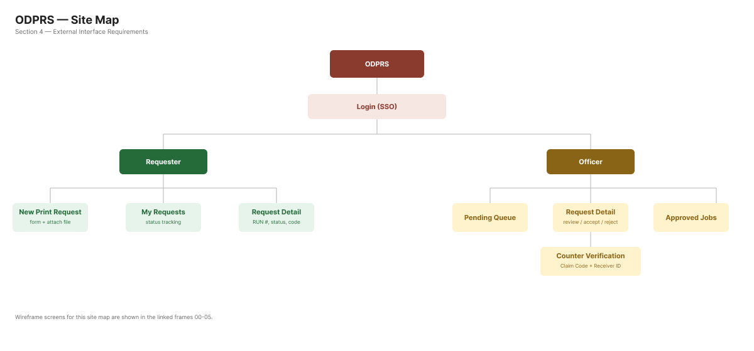
Figure 4-1 : ODPRS Site Map

4.1 User Interfaces

Login Page (SSO)
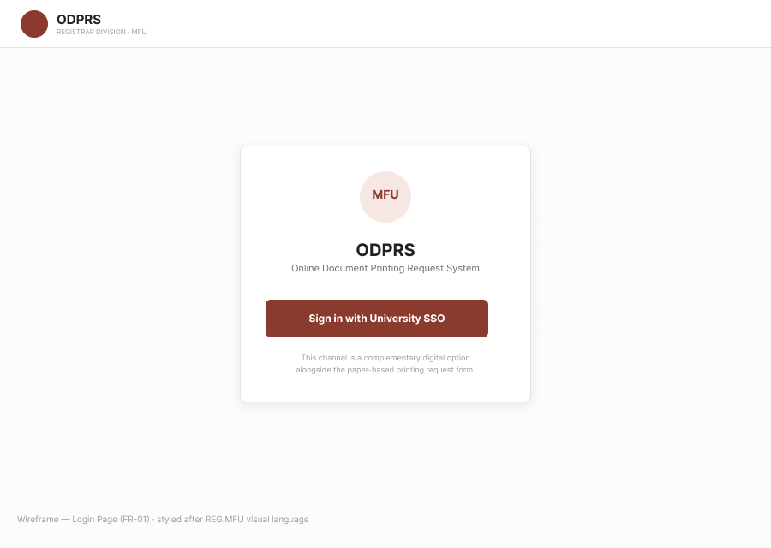
Figure 4-2 : Login Page (SSO) wireframe
Purpose | Authenticate Requesters and Officers via the university's Single Sign-On (SSO) before granting access to the portal or dashboard.
Prerequisite | User has a valid university SSO account (Requester or Officer role).
Use case procedure | 1. User selects "Sign in with University SSO" 2. User is redirected to the university SSO provider 3. On success, the system creates a session and checks the user's role 4. Requester is redirected to the New Print Request form; Officer is redirected to the Pending Queue dashboard
Acceptance Criteria | Users without a valid SSO session cannot reach any Requester or Officer page; failed authentication returns the user to the login page with an error message.
Related Function Requirement | FR-01

New Print Request Page
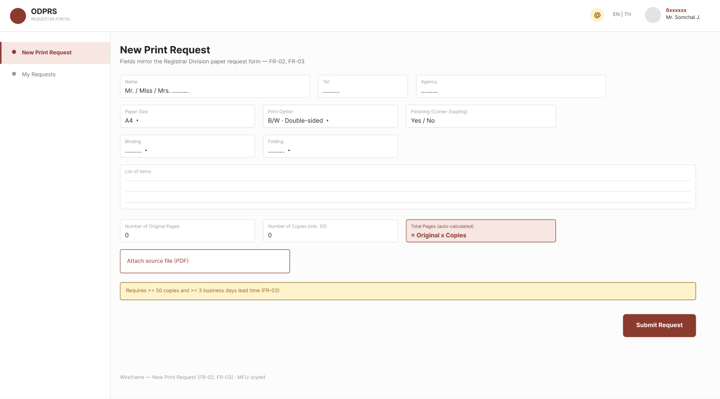
Figure 4-3 : New Print Request Page wireframe
Purpose | Allow the Requester to submit print specifications and attach the source file, replacing the paper "Document Printing Request Form."
Prerequisite | Requester has logged in via SSO.
Use case procedure | 1. Requester fills in paper size, print option, finishing/binding/folding, item list, original pages, and number of copies 2. Requester attaches the source file 3. Requester clicks Submit
Acceptance Criteria | Form cannot be submitted with copies < 50 or lead time < 3 business days; an inline validation message is shown; total pages are auto-calculated from original pages x copies.
Related Function Requirement | FR-02, FR-03

My Requests / Status Tracking Page
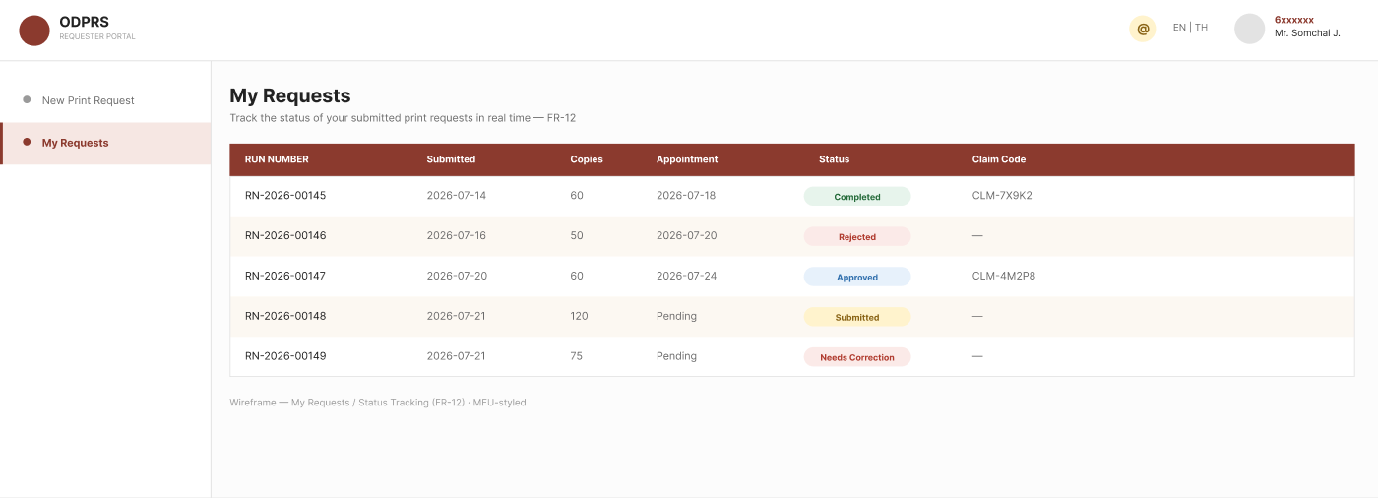
Figure 4-4 : My Requests / Status Tracking Page wireframe
Purpose | Let the Requester view the real-time status of all their submitted requests.
Prerequisite | Requester has at least one submitted request.
Use case procedure | 1. Requester opens "My Requests" 2. System lists requests with RUN NUMBER and status
Acceptance Criteria | Status shown must be one of: Submitted, Needs Correction, Approved, Rejected, Completed, and must reflect the latest system state.
Related Function Requirement | FR-12

Officer Pending Queue / Dashboard
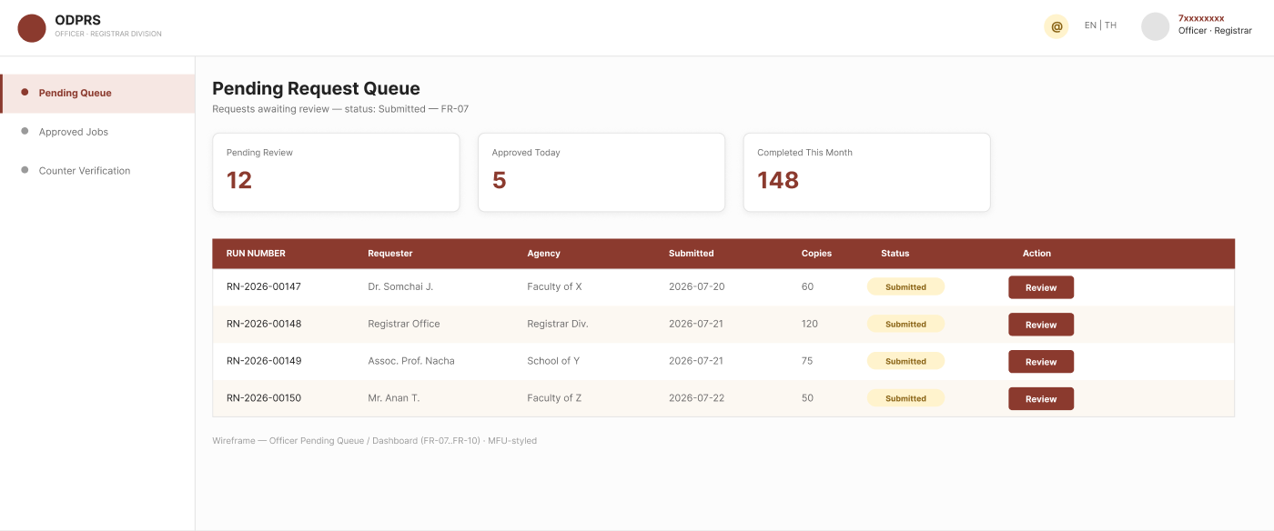
Figure 4-5 : Officer Pending Queue / Dashboard wireframe
Purpose | Let the Officer view, review, and act on incoming requests.
Prerequisite | Officer has logged in via SSO.
Use case procedure | 1. Officer opens the pending queue 2. Officer selects a request 3. Officer reviews the file/specs 4. Officer clicks Accept or Reject
Acceptance Criteria | Rejecting a request requires a reason; accepting a request requires setting an appointment date before it can be approved.
Related Function Requirement | FR-07, FR-08, FR-09, FR-10

Officer Request Detail (Review)
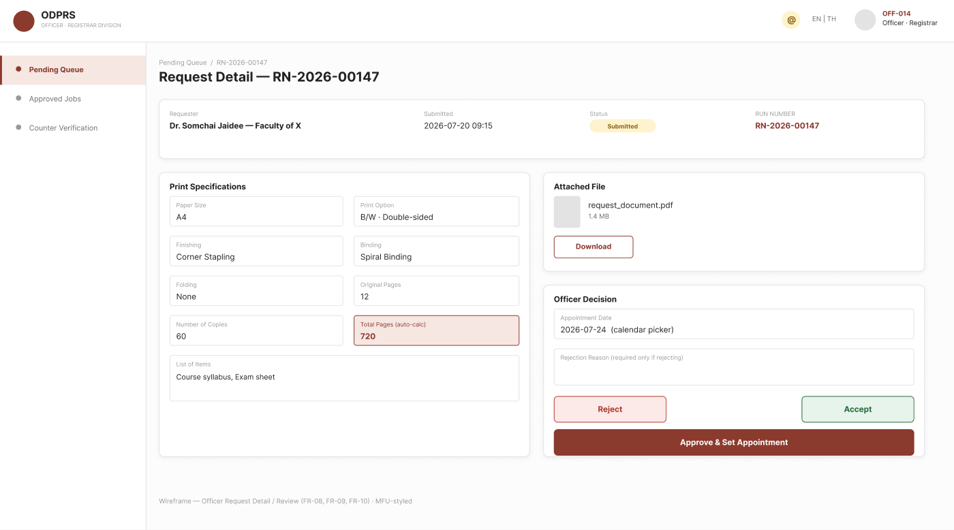
Figure 4-6 : Officer Request Detail (Review) wireframe
Purpose | Let the Officer review a request's file and specifications in full, then Approve/Reject it and set an appointment date.
Prerequisite | Officer has opened a request from the Pending Queue.
Use case procedure | 1. Officer reviews the requester info, print specifications, and attached file 2. Officer clicks Accept, sets an appointment date, and clicks Approve and Set Appointment - or clicks Reject and enters a reason
Acceptance Criteria | Approve and Set Appointment is disabled until an appointment date is set; Reject requires a non-empty reason before it can be submitted.
Related Function Requirement | FR-08, FR-09, FR-10

Counter Verification Page
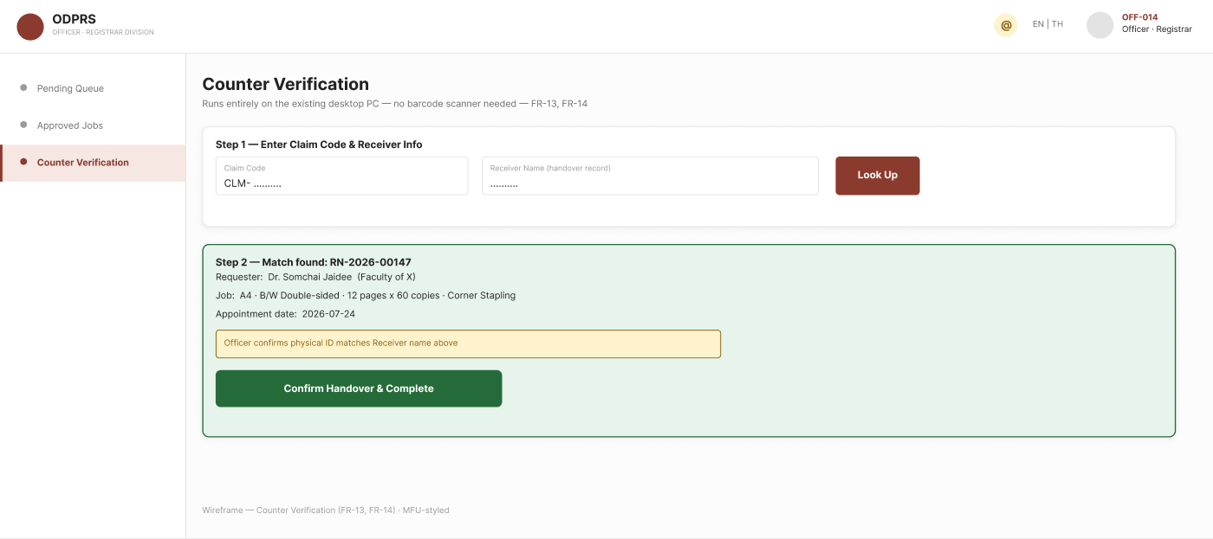
Figure 4-7 : Counter Verification Page wireframe
Purpose | Let the Officer verify a Receiver's Claim Code and physical ID using only the existing desktop PC, and confirm handover.
Prerequisite | Request status is Approved and the appointment date has arrived.
Use case procedure | 1. Receiver shows Claim Code and physical ID 2. Officer enters Claim Code and Receiver info 3. System displays the matching request 4. Officer visually confirms the ID match and clicks Confirm Handover
Acceptance Criteria | An incorrect/unknown Claim Code must show a clear error and must not display another Requester's data; a confirmed handover immediately sets status to Completed.
Related Function Requirement | FR-13, FR-14

Appendix A: Data Dictionary

The table below documents the attributes of the PRINT_REQUEST entity referenced throughout the Functional Requirements (Section 3.3) and Business Workflow (Section 1.4) of ODPRS.

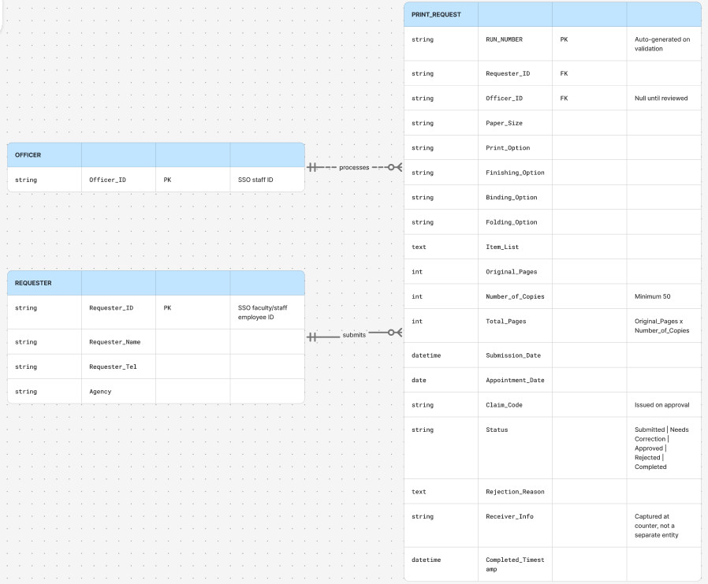
Figure A-1 : ODPRS Entity-Relationship Diagram (PRINT_REQUEST, REQUESTER, OFFICER)

Table: PRINT_REQUEST
Attribute | Description | Data type | Key | Example
RUN_NUMBER | Unique sequential tracking number assigned on successful validation | String | PK | RN-2026-00147
Requester_ID | Reference to the Requester (from SSO account; faculty/staff employee ID) | String | FK | RQ-xxx / 700000001
Requester_Name | Full name of the Requester | String |  | Dr. Somchai Jaidee
Requester_Tel | Contact phone number | String |  | 08X-XXX-XXXX
Agency | Requester's department/agency | String |  | School of X
Paper_Size | Requested paper size | String |  | A4
Print_Option | Print configuration (color/duplex etc.) | String |  | Black and White, Double-sided
Finishing_Option | Corner stapling, etc. | String |  | Corner Stapling
Binding_Option | Binding method | String |  | Spiral Binding
Folding_Option | Folding requirement | String |  | None
Item_List | List of document items requested | Text |  | Course syllabus, Exam sheet
Original_Pages | Number of pages in the original document | Integer |  | 12
Number_of_Copies | Number of copies requested (>= 50) | Integer |  | 60
Total_Pages | Auto-calculated (Original_Pages x Number_of_Copies) | Integer |  | 720
Submission_Date | Date/time the request was submitted | DateTime |  | 2026-07-20 09:15
Appointment_Date | Date set by Officer for document collection | Date |  | 2026-07-24
Claim_Code | Code given to Requester for verification at collection | String |  | CLM-7X9K2
Status | Current lifecycle state of the request | Enum |  | Submitted / Needs Correction / Approved / Rejected / Completed
Officer_ID | Officer who processed the request | String | FK | OFF-xxx / 1000000001
Rejection_Reason | Reason provided if request is rejected | Text |  | Missing original file
Receiver_Info | Name/ID info of the person collecting documents | String |  | Provided at counter
Completed_Timestamp | Timestamp when handover was confirmed | DateTime |  | 2026-07-24 14:02

