Monte Carlo Health Attuned Multiple Metrics Evaluation Rubric - preliminary tests

Nonie

09/03/2020

## Introduction

### Overview

There exist many tools to evaluate clusters resulting from patient subtyping studies, however the question is never asked whether the data being clustered actually contains clusters. This is an important question as many commenly used clustering methods such as k-means will find clusters independent of any cluster structure existing. A method proposed in Pattern Recognition (1) uses a hypothesis test to test for cluster structure by using a monte carlo simulation creating a null reference distribution, based on multiple generated data sets which are known to have no underlying cluster structure with the parameters of the original data set. It compares cluster statistic Q (any appropriate cluster statistic) from the original data set to the results of the Q statistic from the monte carlo generated null distribution, and if it is above (or below) a pre determined cut off it is determined to have a clustered structure. This method could also be used to determine number of clusters.

### Previous Research

As mentioned above this method is a development of a method outlined in the book Pattern Recognition. It has been used in practice in the method M3C (2)

#### Pattern Recognition

The method outlined in Pattern Recognition is based on the principle of hypothesis testing, in that you can test if data set has cluster structure through testing the following null and alternate hypothesis

**H1** The data set does have a cluster structure

**H0** The data set has no cluster structure

To perform this has to be compared to a range of data sets which we know has no cluster structure to either reject or accept the null hypothesis. Monte Carlo simulations which generates randomly dispersed data, known as ‘reference data sets’. These are used to generate the null distribution used to compare the original data to based on cluster statistic .

The steps involved in the process outlined in Pattern Recognition are below and in figure 1.

1. Generate n number of reference data sets based on parameters of orignal data set
2. Apply a clustering method to and
3. Find the cluster statistic for and to return and the set of statistics
4. Compare cluster statistc to set , if it above (or below depending on the nature of ) cut off the null hypothesis is rejected. If it is the reverse the null hypothesis is accepted.

It also outlines ways to carry out different parts of the method as follows:

1. **Generation of data with random distribution**. It states for ratio data that what is being tested is whether the points in have a random position in hypercube which has dimensions where the bounds of those dimensions are the minimum nad maximum value of each varible in .

To get the random data, points should be generated from a uniform distribution in hypercube .

1. **Cluster Statistic Q**. For non-hierachical concrete (not fuzzy) clustering problems it suggests the huberts gamma statistic.

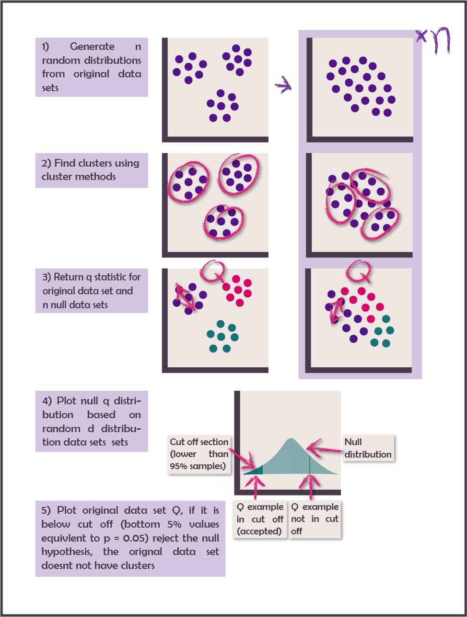

Figure 1: Method outlined in Pattern Recognition for Monte Carlo Method of Cluster Recognition

#### Monte Carlo Concensus Clustering (M3C)

**Aim** M3C uses the monte carlo method outlined above to identify cluster number and detect clusters in genome data when using consensus clustering. Consensus clustering is a clustering method which is based on stability. It clusters bootstrapped samples of the original data, records the frequency of when each point occurs in the same cluster as each other point and then uses the resulting matrix as a basis of a dissimilarity matrix for clustering. Senbabaofglu (3) found that this method finds clusters in null data sets. They use Proportion of ambiguos pairs (PAC) statistic compared to a null distribution to identify the best value of K. However the PAC statistic favours higher values of K, so M3C aims to eliminate that bias by turning the comparison to a null distribution into a formal hypothesis test.

**Method**

1. **Reference Data Set Genertation**. M3C use PCA to extract the eigen vectors of which are then multiplied by a randomly generated dataset from a gaussian distribution
2. **Cluster Statistic** . M3C use PAC statistic
3. **Calculating P value**. M3C uses the following equation to calculate the p value within the bounds of the Monte carlo experiment, where is the number of PAC scores in the reference population less than or equal to the PAC score of and is the total number of simulations. 1 is added to the numerator and demonitator so as not to get a p value of 0.
4. **Calculating P Values Beyond the Monte Carlo Experiment**. M3C fits a beta distribution to estimate the p value beyond the ranges of the monte carlo experiment (which has finate number of simulations). This is chosen over a normal distribution because especialy when K = 2, the PAC distribution has a non-normal skew and kurtosis.
5. **Cluster Methods**. M3C uses consencus clustering.

**Tests and Results**

1. MC3 compared monte carlo p values with reletive cluster stability index and the real PAC statistic in two different tests
   * Negative Control (no clusters) simulated data -> was not significant
   * Positive Control (4 clusters) simulated data -> Significant, all methods found 4 clusters
2. The method was then run on 7 previously clustered datasets to compare results with the method they used to identify K
   * They found 2 data sets that did not have cluster structure in the data
3. Running on simulated data with controlled seperation between the data sets
   * M3C using RCSI was found to be the most accurate method
   * M3C performs equally well compared to others with clusters of low seperation

**Limitations**

1. M3C does not provide a statistical test for identifying cluster number only comparison to null distribution
2. M3C only looks at consencus clustering and stability

This method seperates itself from M3C by looking at cluster structure rather than stability and being targetted for use on EHR rather than genomics data.

### Aims

This is a preliminary investigation to determine the best way to cary out the method. These include:

* Best method for generating a null distribution
* Best statistic for Q

They have been evaluated by their ability to identify the true number of clusters from generated data sets with a known number of clusters with a varied amount of seperation between clusters and noise variable

## Method

### Null Distribution

Three methods were chosen to create null distributions from the original data

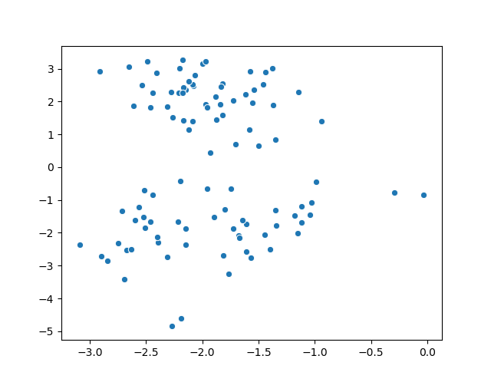

Figure 2: Original data (k = 2, 2 dimentions)

1. **Random Shuffle of the Data** takes all the original data points and shuffles the order in the variables to remove correlation between the variables

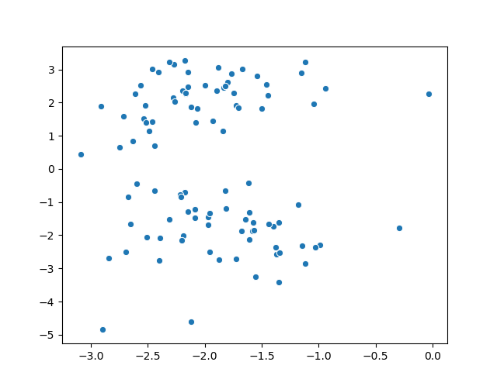

Figure 3: Results from random shuffle of data

1. **Max Min Uniform Distribution** is generated from a uniform distribution between the minumum and maximum values of the variable

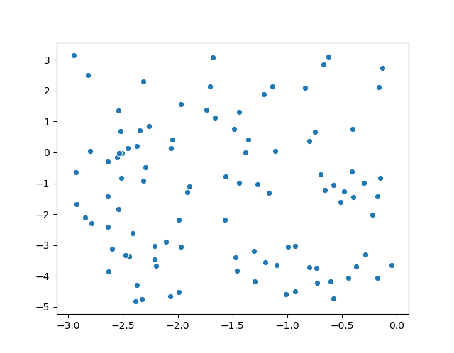

Figure 4: Results from Min max method applied to data

1. **PCA Distribution** takes the eigan vectures of the data set are gained through PCA, these are then used to transform a random data set generated from a single gaussian distribution. The resulting data set is one with only one cluster yet maintains the relationships between the variables

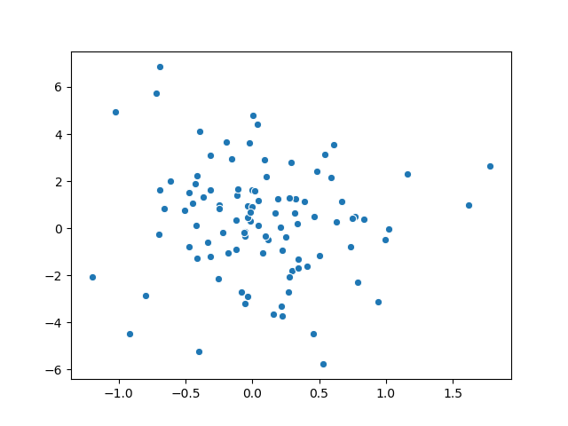

Figure 5: Results from PCA method applied to data

To create a null distribution, 500 test data sets were generated

### Cluster Seperation Metrics

Three Seperation metrics are used:

1. **Huberts Gamma Statistic** is a measure of how much the high distances between variables correlates with cluster membership. It uses 2 matrices the distance matrix which was the basis of clustering (D) and a matrix recording cluster membership where the value at point (i,j) is 1 if they are from different clusters and 0 if they are from the same. The statistic is shown in the equation below, where M is the number of pairs, N is the number of observations amd D and C are the matrices mentioned above.
2. **Normalised Gamma Statistic** is the normalised version of the statistic above. The normalised statistic is shown below where is the mean and is the variance
3. **Total Within Cluster Sum of Squares** (TSS) is the sum of the distances from each point to its assigned cluster center, the smaller the distance the better.

### Cluster Methodology

We apply k-means to each data set using a k++ initialisation with 50 resamples which then returns the optimum result

### Test Data Generation

The data was generated using SciKit learn Make Classifications function from the datasets module. 4 parameters of the data are altered we used a full factorial experimental design:

1. Number of clusters - 2,4,5
2. Number of features - 10,20
3. % Noise features - 0% 10% 50%
4. Seperation (measured in size of hypercube between clusters) - 0.5,1,3

This resulted in 54 distinct data sets.

### Overall Experiment Structure

1. 54 Datasets were created
2. For each data set 500 null distributions were made with each null distribution method (total 1500 null distributions)
3. K-means was run on the original data set and 1500 null datasets and the three cluster seperation metrics were returned, for k = 2-6
4. The mean and standard deviation is returned for each null distribution method, for each seperation metric and for each cluster number
5. The seperation metric score and p value for the original data set is returned for each null distribution method, for each seperation metric and for each cluster number

### Experiment Outcomes

Each distribution method and Cluster metric will be evaluated by the accuracy of identifying the correct cluster number

# Results

Figure 6 shows the senstivity for each metric, null distribution method pairing. Here it shows that with a sensitivity of 1 that TSS both with min max method and the random shuffle method performed the best and the huberts gamma statistic min max performed the worst with a sensitivity of 0. However using sensitivity is disingenious as if the method thought there were clusters at every k tried (so the returning values were either true positives or false positives) it would return a sensitivity of 1. To combat this we looked at when each method metric pair found only the correct cluster number and not identifying any other cluster number.

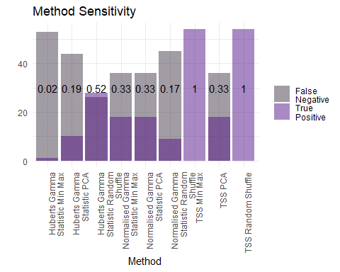

Figure 6: Sensitivity of each method metric pairing

Figure 7 shows how many times each method distribution pairing identified the correct cluster number and did not identify any other cluster number as significant, broken down by seperation and ratio of noise varabibles (max 6). As the ratio of noise variables increasesand the seperation value decreases (top right of each figure) the clustering problem gets harder.

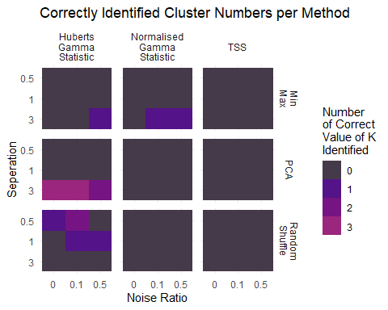

Figure 7: Number of times where only the correct K was found to be significant, for each metric, method, seperation, and noise ratio

Figure 7 shows huberts gamma statistic performs better than the other 2 metrics and shows a split between random shuffle being better at identifying the harder cluster problems with smaller seperation, and PCA better at solving the easier ones. This could be because if there a large seperation in the data already there will also be in the null distribution as it only uses the values that exist.

Figure 8 shows the total number of times each method, metric pairing identified a cluster (whether it was the true number or not). For each method metric pair for each seperation and noise values there are 30 tests (with only 6 correct in each). Here we can see that the reason for the sensitivity score from TSS and min max, and TSS and random shuffle are due to those methods identifying clusters in all or nearly all of cases.

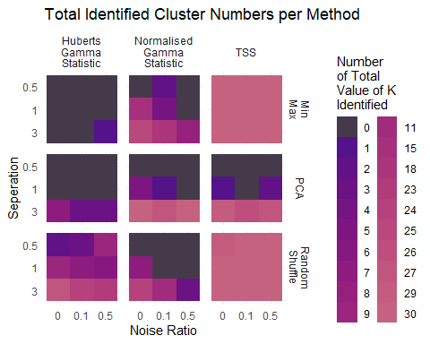

Figure 8: Total number of times any value of K was found to be significant , for each metric, method, seperation, and noise ratio

In the M3C paper they picked the cluster number with the lowest pvalue and the cluster identified, these results are shown in figure 9

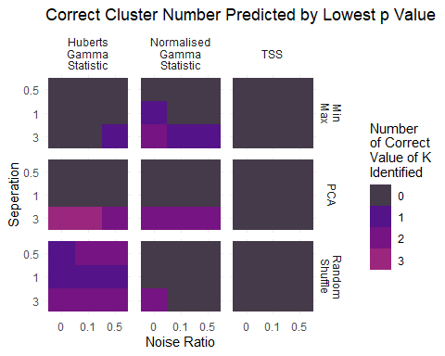

Figure 9: Number of times where the correct K was found to be significant and the lowest p value, for each metric, method, seperation, and noise ratio

PCA and Huberts statistic performs the best but only with high seperation, overall random order performs the best.

One potential reason for the methods not finding hte correct cluster number is that k-means did a terrible job of identifying the clusters, so we compared the mean matching score between the k means cluster labels and the original cluster. This is shown in figure 10. It appears from this plot that k-means is partly responsible for not being able to identify the correct cluster number

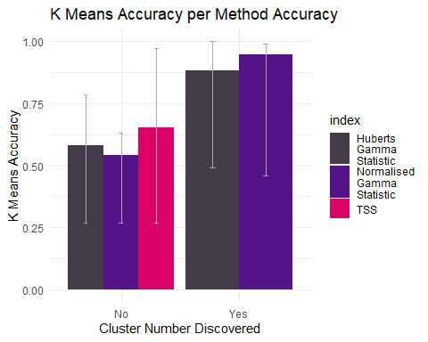

Figure 10: Mean accuracy of k-means for when the correct method was identified, split by monte carlo method, range bars showing inter quartile range

# Key findings

Overall Huberts gamma statistic in conjuction with random shuffle performed the best. TSS performed badly as did min max. However the results were overwhelmingly poor but this is partially due to inaccuracy of K-Means.

# Going Forward

1. Use PCA before K-means with greater number of random starts to improve performance
2. Return metrics on the distributions namely kertosis
3. Test against negetive control

# References

1. Theodoridis S. Pattern recognition. Pattern recognition. 2003;

2. John CR, Watson D, Russ D, Goldmann K, Ehrenstein M, Pitzalis C, et al. M3C: Monte carlo reference-based consensus clustering. Scientific reports. 2020;10(1):1–14.

3. ??enbabaoğlu Y, Michailidis G, Li JZ. Critical limitations of consensus clustering in class discovery. Scientific reports. 2014;4(1):1–13.