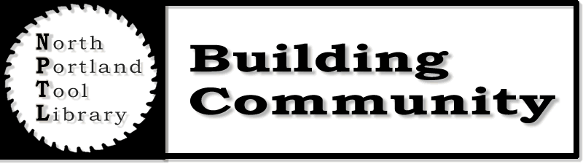
Borrowing Rules
1. Only residents of North Portland neighborhoods over the age of 18 are eligible to borrow tools from the North Portland Tool Library (NPTL).

2. Borrowers must register with NPTL prior to borrowing tools. Registration includes the completion of an application form and verification of the borrower's identity and North Portland residency. Verification is accomplished by presenting a valid photo ID and a utility bill, both displaying North Portland address. Additionally, the borrower must sign a form of WAIVER AND INDEMNIFICATION to be provided by the Library.

3. NPTL staff is available to assist in explaining operation of tools, and will make available upon request materials such as manuals. However, by taking possession of any item, the borrower is certifying that he or she is capable of using that item in a safe and proper manner.

4. Only the borrower is authorized to use NPTL tools. The borrower shall not permit the use of items checked out to them by any other person unless by the express permission of the NPTL.

5. The borrower agrees that the North Portland Tool Library is not responsible for any manufacturing defects in quality of workmanship or materials inherent in any borrowed tools. 6. The Borrower agrees that if any borrowed tool becomes unsafe or in a state of disrepair, they will immediately discontinue use of the tool and notify NPTL of the issue on return, if not earlier.

7. All tools borrowed are to be returned to the library no later than one week from checkout date within the first hour of business. Tools may only be returned during NPTL open hours. Late fines will be levied for each item kept past the loan period.

8. One renewal is possible if arranged ahead of time with NPTL staff. This requires coming into the Tool Library before 10am on Saturday morning and speaking with the Tool Coordinator. Phone calling is only effective if you are able to get through and personally speak to the coordinator. “Day-of” renewals may be possible, however, borrowers must be prepared to return all items by 10am on the original date. The library reserves the right to refuse or limit renewals, and will do so based on demand.

9. All items are first come, first serve.

10. Items are to be returned in the same condition as they were issued, barring normal wear and tear. All items must be returned clean. The borrower agrees to pay for the loss of or damage to any item and further agrees to accept NPTL staff’s assessment of condition of items and to further agree to NTPL staff’s assessment of fair restitution for damage, dirtiness, delinquency and/or loss of items in part or in total. This restitution amount could equal replacement cost of the item plus handling and processing fees.

11. When tools are not returned by the designated due date, the NPTL will issue an overdue notice. If the tools are not returned after the notice has been sent, appropriate steps will be taken to retrieve them, including the use of a collection agency and/or legal action. NPTL may replace severely delinquent tools, holding borrower responsible for full replacement cost plus applicable handling fees. Fines must be paid in full before borrowing additional items.

12. NPTL retains the right to refuse the loan of any item to any person for any reason whatsoever.

Updated 7/15

