Content
1 EHC_CR: External Hardware Controller Configuration Register 2
1.1 Table of Hardware Source Ids 3
1.2 Table of ADC Channels 3
2 Controller Assignment 4
3 EHC_SR: External Hardware Controller Status Register 4

Controller Types
An external hardware controller can either be a 3-wire type or a 2-wire type.
3-wire type is typically a passive potentiometer, and potentiometric readout is used. The wiper contract is read out unloaded, the top end contact is connected to the supply via a pullup.
2-wire types can be passive adjustable resistors (rheostats), passive mechanical/optical/analog switches (to Ground) or active control voltage sources. Control voltages are read out unloaded whereas rehostats and switches use a pullup to the supply to generate input voltage.
Controller final ouput values can be either continuous, spanning a whole range inside a 0%...100% interval, or they can be bi-stable, allowing only two output values 0% and 100%. Continuous controllers generate values either by using potentiometric ratio readout (potentiometer), by measuring the resistance (rheostat/switch) or by using the ADC input value directly (control voltage). Bi-stable controllers use that output value also but apply thresholds with hystersis for determining the final ouput value.
Controller final output values can be inverted.

Auto-ranging
Auto-ranging can be enabled for any type of controller. When enabled, current minimum and maximim values are used to normalize the output to 0%...100% even then the physical input only covers a small- to medium-sized span of values. Further, actual min/max limits are backed off a little bit for normalization to ensure 0% and 100% always can be reached even then the controller raw input value is noisy and/or doesn’t always reach the same end-stop values.

Auto-Hold
Auto-hold is a mechanism to „freeze“ the current output of a continuous controller until a large enough change has been detected again, in 5 steps from 0(off) to 4(extreme). This is useful to de-noise and stabilize controllers that a sharing a macro control on which they operate with other controllers (internal and external). By this, the normal noise from a controller does not overwrite the macro control ouput and therefore a value selected by, for example, a ribbon control remains valid and only gets overridden by the external controller when that controller detected enough movement.

EHC_CR: External Hardware Controller Configuration Register
EHC_CR is accessed by sending a ESPI message „BB_MSG_TYPE_SETTING“ (==0x0700) with message ID „SETTING_ID_EHC_CONFIG“ (==36) from the BBB to the LPC. The data word (uint16_t) contains the configuration bit field.

HWSID[3:0] : The Hardware Source ID (0..15) to be used for message transmission to Audio Engine and Playground. See table „Hardware Source IDs“. HWSID can be updated at any time and does not trigger a full hardware init of the controller.

SIL : Silent Mode. When set, the Hardware Source ID is not transmitted to Audio Engine. This might be useful to implement triggered control flow actions („next preset“, etc) assigned to controllers. SIL can be updated at any time and does not trigger a full hardware init of the controller.

CTRLID[2:0] : The Controller ID (0…7) for which the configuration will be applied. This is also the ID of main ADC channel involved. See table „ADC channel IDs“.

POT : Indicates attached hardware is treated as a 3-wire standard Potentiometer. Selecting POT makes the controller automatically use the adjacent ADC channel on the same TRS jack with pullup to apply the control voltage (and measure the voltage, for the potentiometric ration calculation). Changing POT will cause a full hardware init of the controller, also resetting auto-ranging.

PUP : Pullup is applied to the input line. Should be set for reading out passive 2-wire elements like rheostats and switches, whereas 3-wire pots and 2-wire control voltage input shall be read unloaded. Changing PUP will cause a full hardware init of the controller, also resetting auto-ranging.

INV : Invert final output value. Since the ouput is a 0%..100% range, this simply means the transmitted output value is 100 – controller raw output value. Useful for switches and the occasional pot/rheo which has reverse action (some damper pedals show this behavior). INV can be updated at any time and does not trigger a full hardware init of the controller.

ARAE : Auto-ranging enable. When set, a continuous controller remains silent until the input values have reached enough span for stable output, and then the output is normalized to the full 0%...100% range. A bi-stable controller uses a best guess threshold derived from the direct input value until auto-ranging has finished. When this bit is cleared and then overwritten with a 1, the auto-ranging limits are reset to initiate a new auto-ranging period. When the bit was set and then is overwritten with a 0, the limits are changed on the fly. ARAE can be updated at any time and does not trigger a full hardware init of the controller.
Range Limits in Manual Ranging Mode, Continuous output :
3-wire Potentiometer | 5…95% of full potentiometric range
2-wire Rheostat | 0…100% Ref. 0Ohms...10kOhms
control voltage | 0…100% Ref. 0V…5V

CONT : Output values are continuous (not bi-stable). A bi-stable controller uses the same output as a continuous controller and applies threshold with hysteresis on it to determine the transmitted output value. CONT can be updated at any time and does not trigger a full hardware init of the controller.

AHS[2:0] : Auto-hold strength (0..4) to freeze and de-noise ouput values (used for Continuous Mode only).
- 0 : transmits values as is
- 1..4 : applies increasing levels of auto-holding
The higher the strength the more change of input values (incl. noise) is required to make the controller output eventually follow the input signal. AHS can be updated at any time and does not trigger a full hardware init of the controller.

Table of Hardware Source Ids
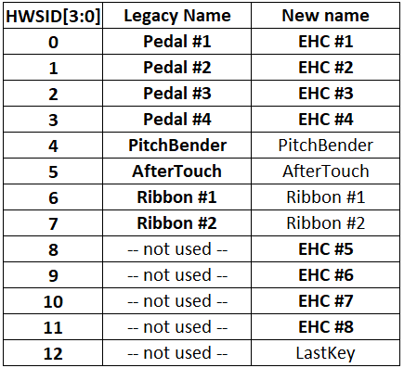

Table of ADC Channels
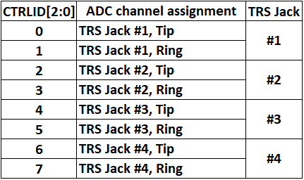

Controller Assignment
There are a total of 8 controllers available. When only 2-wire types of controllers are used, all 8 controllers can be assigned and used, simulataneously:
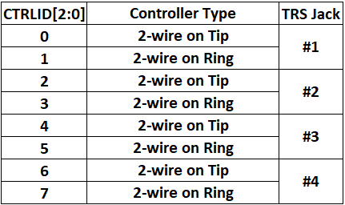
Whenever a 2-wire controller is assigned, any previously assigned 3-wire controller that used the associated ADC channel as the secondary ADC (for top contact) is deleted and that secondary ADC input is set to high-impedance state.
Controllers that are 3-wire potentiometers can be assigned to either an even Controller ID (indicating wiper contact is on tip) or an odd Controller ID (wiper on ring). For a given TRS jack, only one Potentiometer can be assigned at a time, hence only 4 controllers are available when all are 3-wire pots:
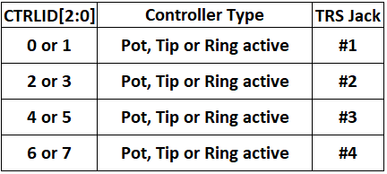
Again, whenever a 3-wire potentiometer is assigned, any controllers present on the adjacent channel of the same TRS are deleted.

EHC_SR: External Hardware Controller Status Register

