Content
1 Simple Extension of the current User Interface 2

Simple Extension of the current User Interface
The absolute simplest way to implement some of the new features would be to just extend the list of available types for the pedals, with no major UI and internal functionality change.
Currently we have, in the web-UI:
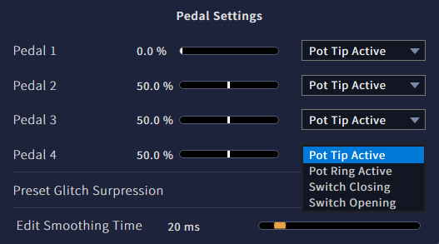
This list could be extended to the known pedal types by manufacturer and model where the required setup is exactly known, as well as generic types for pots (3-wire continuous controllers), rheostats (2-wire continuous controllers), switches (2-wire bi-stable controllers) and control voltage inputs.
The list of known pedals would contain:
“Boss FV500L” (3-wire continuous, tip active, with “min”)
“Fractal EV-2” (3-wire continuous, tip active)
“Millenium Lead Foot LFX-1” (3-wire continuous, tip active)
“Moog EP-3 (standard)” (3-wire continuous, tip active, with “range”)
“Roland DP-10 (continuous)” (3-wire continuous, tip active)
“Roland EV-5” (3-wire continuous, tip active, with “min”)
“Doepfer FP5” (3-wire continuous, ring active)
“Moog EP-3 (other)” (3-wire continuous, ring active, with “range”)
“Yamaha FC7” (3-wire continuous, ring active)
“Yamaha FC3A” (3-wire continuous, ring active, reverse action)
“Korg DS-1H” (2-wire continuous, on tip, reverse action)
“Roland DP-10 (switch)” (2-wire bi-stable, on tip)

Some pedals occur twice in the list as they have a selector switch that changes mode of operation or connector wiring.
Some have “min” or “range” adjusts which, for best operation, should be set to “0” (full counter-clockwise) in case of a “min” adjust”, and to “max” (full clock-wise) in case of “range”. This should be explicitely stated in the manual, online-help and the info screen on the hardware-UI.
The “reverse action” models (all of which are spring-loaded damper pedals) need inversion of the output, at least when compatibility to the NLL “quasi-standard” Roland DP-10 in continuous mode is aimed for, which outputs 0% in the unengaged (up) position.
The list of known pedals could be updated with firmware updates when the setup specifics (if any) for more commercially available pedals are known.
The other entries would contain:
“Pot, tip active” (3-wire continuous, tip active)
“Pot, ring active” (3-wire continuous, ring active)
“Pot, tip active, reversed” (3-wire continuous, tip active, reverse action)
“Pot, ring active, reversed” (3-wire continuous, ring active, reverse action)
“Rheostat” (2-wire continuous, on tip)
“Rheostat, reversed” (2-wire continuous, on tip, reverse action)
“Switch, closing” (2-wire bi-stable, on tip)
“Switch, opening” (2-wire bi-stable, on tip, inverted)
“Control Voltage, full range” (2-wire continuous, on tip, fixed range)
“Control Voltage, auto-ranging” (2-wire continuous, on tip, fixed range)
“--- off ---” (disabled controller)

The generic continuous types would use a default auto-hold strength whereas the explicit types would use the auto-hold strength that was found to be appropriate with regard to output stability.
Nonetheless, the software should temporarily increase the auto-hold strength when it is known a pedal is currently shared with something else (internal or pedal) to operate on a macro-control.
All contiuous types would use auto-hold set to “best-guess” values obtain from testing of the avaible specimem (typically, one unit). For example, the Moop EP-3 was found to require a much stronger setting than the Roland EV-5.
All types would use auto-ranging except for “Control Voltage, full range”. As noted in the API document, auto-ranging information is saved and restored across a power-up, power-down cycle. This means that auto-ranging can only ever be reset by unplugging and replugging the pedal or selecting another type that is largely different in setup – with that many entries in the list this is too obscure even for an experienced user.
Probably it would be wise to implement a “controller reset” function in the UIs. For the hardware-UI this could be as simple as pressing ENTER or the Encoder Button, whereas for the Web-UI an explicit “reset” function looks more promising. For consistency and obviousness a dedicate (soft-)button for both UIs seems to be the best choice.

Advantages of this solution:
- quick and easy to implement
- little change in usability for existing C15 users, and easy to understand by new users
Disadvantages:
- limited to only four controllers, one per TRS, with fixed HWSID assignments.
- limited to the given list of preset types which should not be too large. The more cases we want to take care of (especially the generic types) the longer a simple 1-dimensional list will get, making the selection procces sort of unwieldy. The list would have 23 entries already.
- 2-wire controllers on TRS ring contacts cannot be used.
- fixed association of controller hardware to output type, eg a pot cannot be used as a bi-stable output.
- fixed setting of auto-hold strength. Special circumstances (aging, strong vibration on stage etc) cannot be explicitly taken care of, unless the list is expanded.

