Content
1 Low-Level ADC read-out 2
2 Plug-In dead time 2
3 Controller Reset 2
4 High-Level read-out and „HWSource“ value generation 2
4.1 Intermediate value (IM) calculation 2
4.2 Autoranging to scaled output (SO) 2
4.3 Auto-Hold 3
4.3.1 Auto-Hold Strength Levels 4
4.4 Bi-stable controllers (working as switches) 4
5 Final output inversion 5

Low-Level ADC read-out
M0 core of the MCU reads the ADC channels 10 times per 12.5mS time-slice of the M4 processing, an 8kHz effective sample rate.
It keeps the read-out in a ring buffer 16 values deep and also keeps track of the sum of all sample values in the ring buffer. The sum, after division by the buffer size, is the average of all sample values in the buffer. This floating average helps to de-noise the input data. Since the averaging buffer is longer that the time-slice, even a single sample transient still does not get lost, only averaged.
M4 core main process reads out values every 12.5ms (800Hz)

Plug-In dead time
When a cable is plugged into a TRS jack, a timeout of 1.5 seconds is used to delay start of processing. The dead time starts the moment the detector contact reads „open“ and is reset whenever it reads „closed“, which also resets the whole controller. Controllers which read from unplugged ADC channels are ignored.

Controller Reset
A controller is reset either by a plug-in event or by the playground sending a „pedal type“ message different than the one the controller is currently initialized with (this avoids controller reset after preset changes which re-transmits the pedal type settings).

High-Level read-out and „HWSource“ value generation
The high-level code can choose to read out either the momentary raw ADC value or the pre-averaged data. Currently, only for the ribbons the momentary data is used.
ADC channel(s) used for continuous controllers, pedals in this case, can additionally be lowpass-filtered with a simple 2nd order IIR (which is not overly effective and is deemed to go away, therefore).

Intermediate value (IM) calculation
A contiuous controller is either a 3-wire pot or a 2-wire adjustable resistor and thus reads from two or one ADC channel(s). 3-wire pots have the top contact pulled up with 10k, the wiper contact is read unloaded. Variable resistors read out from the wiper which is pulled up with 10k.
For potentiometers, the intermediate output (IM) is calculated by a ratio
IM = ratio = V(wiper) / V(top),
whereas for adjustable resistors a value proportional to the measured resistance is used
IM = Rx/Rsense = V(wiper)/[Vmax-V(wiper)].

Autoranging to scaled output (SO)
Autoranging keeps track of the absolute max and min IM values. When a IM value is above/below current max/min, the absolute max/min is updated with a sligthly filtered version of the IM data (sliding average of 8 points).
From the absolue max/min values a narrower set of thresholds is calcluated for the actual scaling process, stripping away 4% of the min and 5% of the max. This establishes electrical deadranges at the start and end of electrical pedal travel. By this, even when the pedal doesn’t reach the true min or max positions again, the output will always read saturated 0% and 100% at/near the ends of the physical ranges.
SO = 100% * (IM - min) / (max - min)
Autoranging waits until IM data has produced large enough distance between the (narrowed) min and max values, for stable low-noise and high resolution readout. For pots, a threshold of 5% of total potentiometric range is used, whereas for variable resistors the ratio of max to min resistance must be greater than 1.17. These values have been obtained by experimentation to make all avalable pedaws work in 3-wire and 2-wire modes, even with any additionally „min“ or „range“ adjustments on the pedal hardware set to arbitrary position (note „range“ of a Moog-style pedal at „zero“ of course cannot work by design as there is no output).

Auto-Hold
Auto-Hold is a mechanism needed when a pedal is shared with a ribbon (or another pedal) in a macro control. The MC output value shall not be changed all the time by a sligthly noisy pedal read-out as this would overwrite any setting dialed in by using a ribbon or another pedal. Then again, slow drifts eventually must update the pedal output which means auto-hold moves the values in quantized steps to avoid updating constantly. However, when a step is finally initiated an update is unavoidable. For continuity, a ramp is used to move the output value to the next step which means we occasionally have periods of fast pedal updates but overall the ouput is frozen most of the time.
When a pedal is the only source for a macro control, auto-hold is not strictly required. Still some level of de-noising seems appropriate, if only to reduce traffic on SPI and USB.
Auto-Hold is implemented as follows:
The ADC values of the wiper contact are kept in a ringbuffer 64 values deep (800ms). The difference of current min and max values in this buffer is used for a first detection if the current controller is stable, has settled to a noise window within that 800ms. This detection works on the raw ADC input values:
settled = (max – min) < some_threshold, within a 64 samples buffer
(actually, the threshold does in current ADC input level as well, it turned out the used ADC increases random noise somewhat proportional to absolute level).
This threshold is the ADC Settling Threshold, required to be hit to inititate auto-hold.
There is a second, higher threshold, the ADC Unsettling Threshold which is used to determine if auto-hold mode is to be aborted. So there is some hysteresis, once the wiper has settled it take a little bit more movement to unlock it again. The unsettling threshold is usable in the 1x to 3x range of the settling threshold.
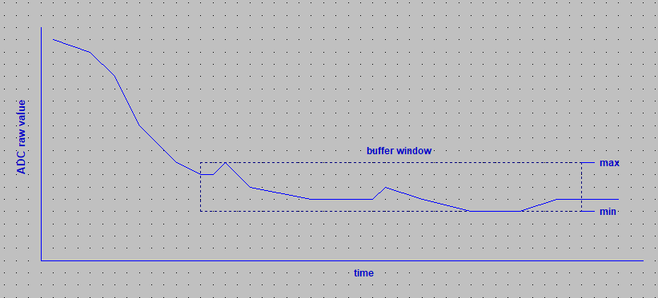

When auto-hold is initiated, the current output of the autoranger, the Scaled Output, is frozen. In practice, for a better fit, the average of the last 8 values is used. A ramp is used to move the ouput continuously from the current value to the frozen value (ramp time is that of the Normal Ramp, see below).
This averaging of 8 current values is also used for the current position to check if it has drifted away too much from the frozen value, a threshold for the maximum allowed relative drift:
drifted = abs[avg(current) – frozen] > some_threshold
Drift Thresholds are usable in are range of 0.1% to several % and define the achievable granularity in auto-hold mode.
When a drift is detected, a new frozen value is determined and a ramp is initiated to slowly move the current value to the frozen one, this is the Drift Ramp. Usable values are from 125ms to 500ms.
When another drift incident is detected before the current ramp has finished, the drift ramp speed is doubled.
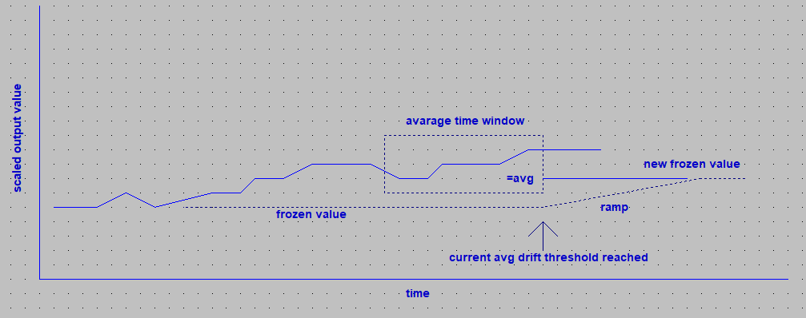
When auto-hold is forced out of settled (and drift-tracking) state, another ramp is applied to adjust the output value to remove the sort of DC-offset from the output value, this is the Normal Ramp which is shorter than the Drift Ramp, typically ~100ms.
Finally, whenever a shock change (> 10%...20% change of raw scaled value) is detected in the input, any current ramping is stopped, and an extra short ramp (3 samples, 38ms) is started, which also starts at the average value of current and requested output. By this, half of the total shock change is already done by the first ramping step.

Auto-Hold Strength Levels
Currently, auto-hold is implemented in four different strengths which can be selected.
In the „weak“ position it only removes random noise and allows settings to 0.1% granularity, and has a long and narrow window until settling is reached.
Depending on the auto-ranging span and pedal construction used, this setting is already too sensitive to really hold the value, rather random updates are seen, with smooth transistions.
In the „extreme“ position the granularity has increased to 1.5% and ADC settling windows are several times larger, as are shock change and other threshold and times and noise suppression is maximized, at the cost of reduced ability to dial in microscopic changes slowly (whereas micrsocopic changes are possible as long ADC settling has not been detected.

Bi-stable controllers (working as switches)
Switches are basically treated the same as continuous controllers, 2-wire „rheostat“ variety, with the following differences:
- While auto-ranging is not completed, a „best guess“ output value is determined by looking directly at the resistance. A value corresponding to 5kOhms is used a the threshold which should make any typical pedal work with a correct first guess for output state (unless there is a „min“ setting used on that pedal that is higher than 5k which is considered „low“ after autoranging, not „high“).
- Auto-Hold is neither needed nor performed, as is any averaging and ramping. The two-state (0%, 100%) output follows the input with zero delay (when thesholds are triggered).
- The output value is obtained by comparing the output of the autoranger to some threshold and with some hysteresis. Two thresholds are used, one at 33% (low to high) and one at 67% (high to low) of scaled output value range, both with 10% trigger hysteresis. The idea behind this that when a continuous pedal is used as a switch the reaction speed is improved. Because we are working on the resistance, the ouput is inverted before transmission (low resistance == switch closed == 100%)

Final output inversion
For any controller, the final output can be selected to be transmitted either „as is“ or inverted (100% - output). This is useful mainly for switches (inversion means switch active position is „open“) but there are some damper pedals that read 100% in the unengaged position, rather than the standard 0%.

