Content
1 Types of External Controllers 2
1.1 Potentiometer, 3-wire 2
1.2 Rheostat, 2-wire 2
1.3 Switch, 2-wire 2
1.4 External Control Voltage, 2-wire (CV) 3
2 C15 input circuit 3

Types of External Controllers
External Controllers to be connected to the C15’s TRS inputs comprise of:
- 3-wire Potentiometer : Pot
- 2-wire Rheostat : Rheostat
- 2-wire Switch (momentary/latching and normally open/closed) : Switch
- 2-wire Control Voltage (0…5V) : CV

Potentiometer, 3-wire
TRS connection variants:
- „Tip-Active“ (tip is wiper, ring is top) – „Roland“ standard
- „Ring-Active“ (ring is wiper, tip is top) – „Yamaha“ standard

Readout principle:
A voltage is applied to the top end of the pot and voltage is measured at the unloaded wiper. The readout is the quotient V(wiper)/V(top). V(top) should be large enough (significant fraction of the ADC range) for high resolution and might be applied resisitive.

Common types:
- Simple „Constant Resistance“ Pot: Yamaha FC7 (50k), FC3A(10k), Roland DP-10(10k), Doepfer FP-5(10k), Fractal EV-2(100k), Millenium LFX-1(20k). Input resistance is constant.
- Pot with additional „offset“ adjust pot in the GND leg: Roland EV-5(10k + 50k), Boss FV500L(10k+50k). The input resistance valies with „offset“ setting.
- Pot cascaded to another „range adjust pot: Moog EP-3(100k -> 100k). The input resistance varies with main setting.
None of the models checked had significant break-out resistor present on the wiper.
The range of input resistance ranges from 10k to 100k → 5k to 200k Pots shall be usable. 5k is a worst case for resultion as input voltage will be only Vcc/3 with a 10k Pullup.
A three-wire Pot obviously occupies one C15 TRS receptacle completely.

Rheostat, 2-wire
Readout principle:
A voltage is applied to the wiper via a known 10k pullup resistor to 5V and measured at the wiper. The readout is effectively a resistance measurement: Rx/10k = V(wiper)/[5V-V(wiper)].
Common types: Korg DS-1H (25k) … actually a 50k pot using only half the travel.
Rheostats up to 100k shall be usable with no drawbacks in resolution.
A Rheostat only occupies one ADC channel, either tip or ring of the TRS used.

Switch, 2-wire
Switches are assumed to have less than 100R short resistance and more than 500k open resistance, which relays and electronic analog switches should fulfil.
Readout principle:
Similar to Rheostats: 10k Pullup applied to contact and measuring the voltage, readout value determined by hystersis (10/90 Schmitt-trigger).
A Switch only occupies one ADC channel, either tip or ring of the TRS used.

External Control Voltage, 2-wire (CV)
It is assumed that a CV has low termination impedance below 3k at any output voltage (so that a 10k pot connected to a voltage is considered valid), typically ~100Ohms. Output voltage is measured directly, unloaded.
A CV only occupies one ADC channel, either tip or ring of the TRS used.

C15 input circuit
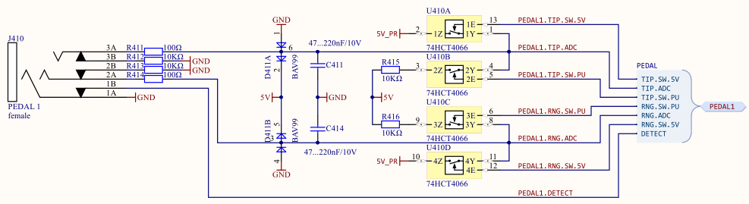
C15 can read out the unloaded voltage or apply 5V either „directly“ (via 74HCT4066 pass gate and 100R in series) or via a pullup (via 74HCT4066 pass gate and 100R+10k in series). The 4066’s can’t sustain short circuit current (with only 100R in series) of 50mA, they will saturate at about 20mA. Sustained short is not a recommended operation condition, therefore direct connection to 5V will be avoided (and is not needed).
In the unconnected state there are 10k pulldowns on tip and ring.
ADC input:
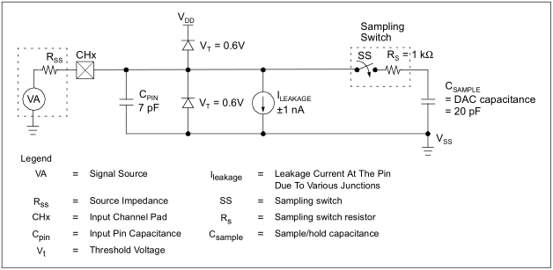
Input is capacitive with some leakage current that will pull an open input somewhere in the supply range, highly dependant on temperature etc → unstable.

Detection Strategies

Pots
Standard and Offset Type Pots can be detected, using 10 pullups on both wiper and top lines :
- When detect bit is set (cable plugged),
- And when both lines are within a reasonable resistive range (100R … 200k for the assumed wiper, and 2k …200k for the assumed top, can also be used for an estimate what is wiper and what is top lines),
- And when both lines always change simultaneously,
- And when the slope of the (V(wiper)/V(top))/V(wiper) point field is always positive and within some bounds (if negative and/or out of bounds, wiper and top are swapped).
Both lines pulled up with 10k will assure short settling times so there should be not too much dynamic error even when the pot is moved rather fast. Smoothing should be applied, though.

Completely Unplugged
Pedal detect switch is closed and can be sensed (will return 0). Both Tip and Ring are alternated (every 12.5ms) between open state and 10k pullup.
If the open state reads a stable zero and the pullup state reads a stable Vcc/2 and the Detect bit is zero, steady state is reached.

