Content
1 Simple Extension of the current User Interface 2
2 Full Extension of the current User Interface 4
2.1 “Hardware Amount” Panel 4
2.2 External Controller Setup Panel 4

! Please read the document “ExternalHardwareControllers_API” first, notably for definitions of terms like HWSID etc. !

Simple Extension of the current User Interface
The absolute simplest way to implement some of the new features would be to just extend the list of available types for the pedals, with no major UI and internal functionality change.
Currently we have, in the web-UI:
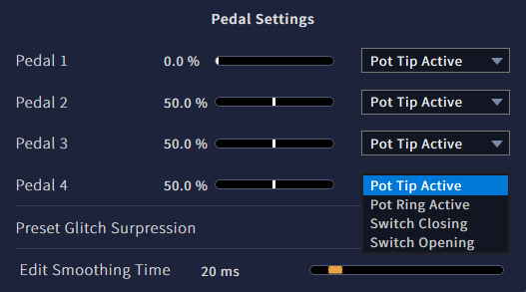
The entries are sorted by the hardware source ID, traditionally “Pedal 1” to “Pedal 4” which also is the number of the TRS jack,
Each entry has a controller type, selected from a drop-down list.
This list could be extended to the known pedal types by manufacturer and model where the required setup is exactly known, as well as generic types for pots (3-wire continuous controllers), rheostats (2-wire continuous controllers), switches (2-wire bi-stable controllers) and control voltage inputs.
The list of known pedals would contain:
“Boss FV500L” (3-wire continuous, tip active, with “min”)
“Fractal EV-2” (3-wire continuous, tip active)
“Millenium Lead Foot LFX-1” (3-wire continuous, tip active)
“Moog EP-3 (standard)” (3-wire continuous, tip active, with “range”)
“Roland DP-10 (continuous)” (3-wire continuous, tip active)
“Roland EV-5” (3-wire continuous, tip active, with “min”)
“Doepfer FP5” (3-wire continuous, ring active)
“Moog EP-3 (other)” (3-wire continuous, ring active, with “range”)
“Yamaha FC7” (3-wire continuous, ring active)
“Yamaha FC3A” (3-wire continuous, ring active, reverse action)
“Korg DS-1H” (2-wire continuous, on tip, reverse action)
“Roland DP-10 (switch)” (2-wire bi-stable, on tip)

Some pedals occur twice in the list as they have a selector switch that changes mode of operation or connector wiring.
Some have “min” or “range” adjusts which, for best operation, should be set to “0” (full counter-clockwise) in case of a “min” adjust”, and to “max” (full clock-wise) in case of “range”. This should be explicitely stated in the manual, online-help and the info screen on the hardware-UI.
The “reverse action” models (all of which are spring-loaded damper pedals) need inversion of the output, at least when compatibility to the NLL “quasi-standard” Roland DP-10 in continuous mode is aimed for, which outputs 0% in the unengaged (up) position.
The list of known pedals could be updated with firmware updates when the setup specifics (if any) for more commercially available pedals are known.
The other entries would contain:
“Pot, tip active” (3-wire continuous, tip active)
“Pot, ring active” (3-wire continuous, ring active)
“Pot, tip active, reversed” (3-wire continuous, tip active, reverse action)
“Pot, ring active, reversed” (3-wire continuous, ring active, reverse action)
“Rheostat” (2-wire continuous, on tip)
“Rheostat, reversed” (2-wire continuous, on tip, reverse action)
“Switch, closing” (2-wire bi-stable, on tip)
“Switch, opening” (2-wire bi-stable, on tip, inverted)
“Control Voltage, full range” (2-wire continuous, on tip, fixed range)
“Control Voltage, auto-ranging” (2-wire continuous, on tip, fixed range)
“--- off ---” (disabled controller)

The generic continuous types would use a default auto-hold strength whereas the explicit types would use the auto-hold strength that was found to be appropriate with regard to output stability.
Nonetheless, the software should temporarily increase the auto-hold strength when it is known a pedal is currently shared with something else (internal or pedal) to operate on a macro-control.
All contiuous types would use auto-hold set to “best-guess” values obtain from testing of the avaible specimem (typically, one unit). For example, the Moop EP-3 was found to require a much stronger setting than the Roland EV-5.
All types would use auto-ranging except for “Control Voltage, full range”. As noted in the API document, auto-ranging information is saved and restored across a power-up, power-down cycle. This means that auto-ranging can only ever be reset by unplugging and replugging the pedal or selecting another type that is largely different in setup, preferably the “off” preset – with that many entries in the list this is too obscure even for an experienced user.
Probably it would be wise to implement a “controller reset” function in the UIs. For the hardware-UI this could be as simple as pressing ENTER or the Encoder Button, whereas for the Web-UI an explicit “reset” function looks more promising. For consistency and obviousness a dedicate (soft-)button for both UIs seems to be the best choice.

Advantages of this solution:
- quick and easy to implement
- little change in usability for existing C15 users, and easy to understand by new users
Disadvantages:
- limited to only four controllers, one per TRS, with fixed HWSID assignments
- limited to the given list of preset types which should not be too large. The more cases we want to take care of (especially the generic types) the longer a simple 1-dimensional list will get, making the selection procces sort of unwieldy. The list would have 23 entries already
- 2-wire controllers on TRS ring contacts cannot be used
- fixed association of controller hardware to output type, eg a pot cannot be used with a bi-stable output
- fixed setting of auto-hold strength. Special circumstances (aging, strong vibration on stage etc) cannot be explicitly taken care of, unless the list is expanded

Full Extension of the current User Interface

“Hardware Amount” Panel
The number of external controller that are accessible would increase from 4 to 8.
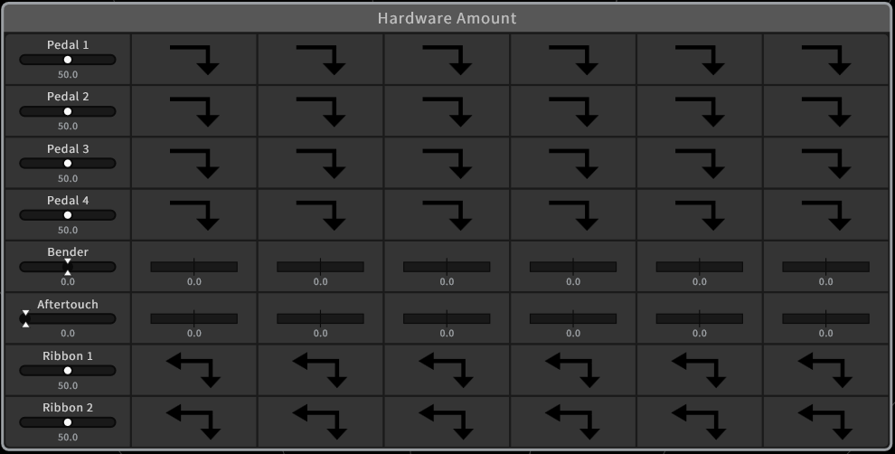
The “Hardware Amount” Panel in the UI would add another 4 External Controllers (Ext.Ctrl) after the first 4 entries. The string “Pedal” would be renamed to “Ext.Ctrl.” because a floor pedal is only one of several possible physical embodiments of an external controller. This renaming would apply to everywhere in the C15 UIs and docs.
In this panel and the associated code, the first column is the textual representation of the HWSID assigned to a controller (internal or external). Note that there is a mapping involved as the new HWSIDs for external controller 4..8 have been appended to the existing ones rather then inserting them after the first four.

External Controller Setup Panel
The expanded capabilities will require new sub-panels in the Setup-->Device-Settings Panel.
The would be an overview panel as before but with a different organization:
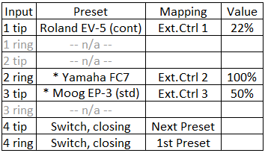
This actually reflects the way the external hardware controllers are organized internally.
The items are sorted by Input (which TRS jack and which contact of it), not by resulting HWSID, rather the HWSID has an extra column and is basically arbitrary. Again, Presets are used to basically describe a controller but the presets can be overwitten/edited.
The mapping of a controller can be set to a HWSID or, alternatively, to a “trigger event” (new feature to be discussed), then the controller is silent and will not output any “hardware amount” data, rather events can be assigned for control flow, like “next preset” etc.
The “Preset” and the “Mapping entries can be selected and changed, opening a drop-down menu for each. For Presets, see first chapter, with the signficant difference that now generic presets don't contain info whether they are for tip or for ring contact and that the specific presets are dynamically narrowed down to the types that apply for current input, that is, are a subset either from tip or ring contact groups.
For Mapping there would be the following list:
Type Hardware Amount: “Ext.Ctrl. 1” through “Ext.Ctrl. 8”, “Pitch Bender”, “Aftertouch”, “Ribbon 1” and “Ribbon 2”.
Type Event Triggers: “Next Preset”, “Previous Preset”, “First Preset”, “Last Preset”, “Next Bank”, “Previous Bank”, “First Bank”, “Last Bank”.

The selected Preset also can be viewed/edited to cater for specific needs, opening a per-preset view. Depending on the Mapping to “Amount” or to “Event” different views are required:
Hardware-Amount view:
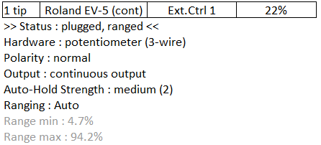
The needed raw data for this can be fetched from the LPC in a polling fashion (“Get EHC Data” command).
The top line is static and just a copy from the overview. Below that there are several editable items on the setup details, with the first line being status information, notably whether a controller is plugged in and ranging is finished (in case of auto-ranging).
Hardware : can be “potentiometer (3-wire)”, “switch/adjustable resistor (2-wire)”, or “control voltage (2-wire)”. Rheostat would be a shorted synomym for adjustable resistor but may not be commonly known.
Polarity : either “normal” or “inverted”. The final output value is inverted via output:=100%-output.
Output : either “contiuous” or “bi-stable”. A bi-stable output will only output 100% or 0%, a continuous output any value from 0% to 100%
Auto-Hold Strength (greyed out and unaccesible in bi-stable mode, displaying “---”) : “off”, “weak”, “medium”, “strong”, “extreme”.
Ranging : “auto”, “fixed”, “user”. Auto will activate auto-ranging, fixed will uses fixed ranges (hardcoded meaningful preset values) and user will allow the user to change the range ends used for scaling the output.
Range min, Range max (greyed out and unaccesible when not in “user”, but with actual values displayed – which will change during operation whern in “auto”, that is, these are dynamic values) : range ends currently in use. When switching to “user”, the current values are latched and can be edited. The units are %, the meaning differs with controller hardware type. Eg, for control voltages, it represents a factor of 0.0...1.0 referenced to 5 Volts of input range. For Rheostats, values above 100% are possible and correct, since 100% are equivalent to 10kOhms and resistances up to 130kOhms (1300%) can be measured.

