Content
1 Summary of controller types 2
1.1 Type I, 3-wire pot with no offset 2
1.2 Type Ia, 3-wire pot with no offset, with wiper resistance 2
1.3 Type II, 3-wire Pot with offset adjust 2
1.4 Type IIa, 3-wire Pot with offset adjust, with wiper resistance 3
1.5 Type III, 3-wire 100k Pot with 100k range adjust, various range factors 3
1.6 Type IV, 2-wire Rheostat 3
1.7 Type V, Switch 3
1.8 Type VI, Control Voltage 4
2 Read-out 4
2.1 Potentiometers 4
2.2 Rheostats 4
2.3 Switches 4
3 Error and Malfunction handling 5
4 C15 input circuit 5
5 Detection Strategies 6
5.1 3-wire Pots 6
5.1.1 Type I, 3-wire pot with no offset, various pot resistances: 6
5.1.2 Type Ia, 3-wire pot with no offset, various pot resistances, with 1k wiper resistor: 7
5.1.3 Type II, 3-wire 10k pot with 50k offset adjust 7
5.1.4 Type IIa, 3-wire 10k pot with 50k offset adjust and 1k wiper resistor 8
5.1.5 Type III, 3-wire 100k pot with 100k range adjust, various range factors 9
5.2 Completely Unplugged 10

C15 input circuit
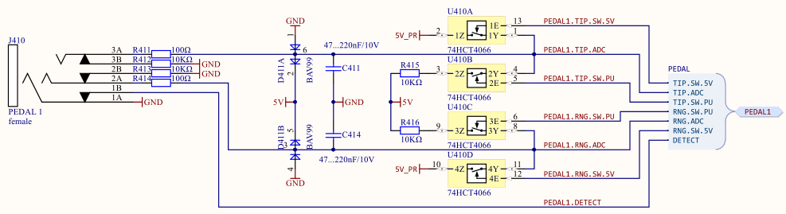
C15 can read out the unloaded voltage or apply 5V either „directly“ (via 74HCT4066 pass gate and 100R in series) or via a pullup (via 74HCT4066 pass gate and 100R+10k in series). The 4066’s can’t sustain a short circuit current (with only 100R in series) of 50mA, they will saturate at about 20mA. Sustained short is not a recommended operation condition, therefore direct connection to 5V will be avoided (and probably is not needed anyway).
On each line, after the 100R series resistors, there a filter caps whoose actual value can be anything between 47nF and 220nF.
In the unconnected state there are 10k pulldowns on tip and ring.
ADC converter chip input:
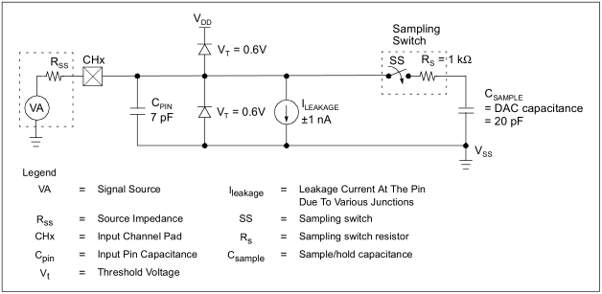
Input is capacitive with some leakage current that will pull an open input somewhere in the supply range, highly dependant on temperature etc → unstable.

Summary of Controller types
Basically we have :
- continuous 3-wire potentiometers and 2-wire rheostats
- two-state switches
- continuous control voltage

Type I, 3-wire Pot with no offset
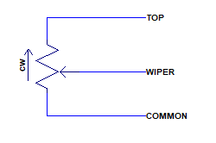
- Roland DP-10 damper pedal (in „continuous“ mode), 10k
- Doepfer FP5 expression pedal, 10k
- Yamaha FC3A damper pedal, 20k, has reverse action
- Millenium Lead Foot LFX-1 expression pedal, 20k
- Yamaha FC7 expression pedal, 50k
- Fractal EV-2 expression pedal, 100k
Resistance values range from 10k to 100k, therefore any value in the range from 5k to 200k shall give usable results, both for read-out and auto-detect.
Worst-case output impedance, assuming the „top“ line is feed with low impedance, is 1/4th of the total pot value.

Type Ia, 3-wire pot with no offset, with wiper resistance
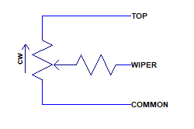
Similar to Type I, but with an additional series resistor on the wiper, for protection. None of the currently investigated pedals have this resistor but others may have it, and our in-house 10k test jig also uses this resistor. Typical value would be 1k and any wiper series resistance up to 1k shall not cause severe problems for read-out and auto-detect.

Type II, 3-wire Pot with offset adjust
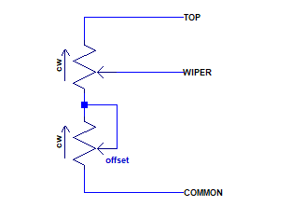
- Roland EV-5 expression pedal, 10k pot with 50k offset
- Boss FV500L expression pedal, 10k pot with 50k offset
Input impedance is not constant, it depends on the offset trim setting.
While only pedals with 10k main pot and 50k offset trim values have been encountered, pedals with a total input impedance between 5k and 200k shall be usable, with the offset trim no larger than 7 times the main pot value.
Worst-case output impedance depends on the offset setting and could be as high as 90% of the main pot’s value.

Type IIa, 3-wire Pot with offset adjust, with wiper resistance
Similar to Type II but with an additional series resistor on the wiper, for protection. None of the currently investigated pedals have this resistor but others may have it. Typical value would be 1k.

Type III, 3-wire 100k Pot with 100k range adjust, various range factors
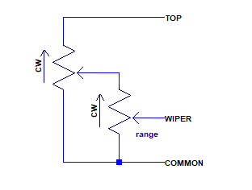
- Moog EP-3 expression pedal (100k into 100k)
This controller is not constant input impedance vs wiper setting whereas range trim does not affect imput impedance. Also, by the loading of the main wiper with range pot, the characteristic is not exatly linear, more like slightly exponential. Finally, with the range trimmer set to zero there is always zero output. This pedal is really somewhat exotic.
Worst-case output impedance is when main pot is centered and range trim is the point where lower leg value equals total upper leg value, with equal pots this would be when x=(1-x)+x/4, →x=0.57, giving almost 30% of the pot value.

Type IV, 2-wire Rheostat
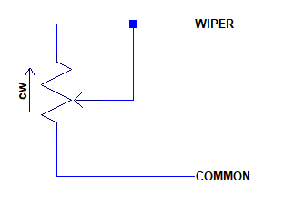
- Korg DS-1H damper pedal (0…25k), reverse action
Resistance values at max position from 2k to 200k shall cause no problem for readout and auto-detect.

Type V, Switch
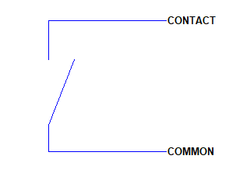
Mechanical switches or relays are easy, closed impedance can be safely assumed to be well below 10Ohms and open impedance is well above many Megohms.
Electrical switches less so. Depending on the type the „On“-resistance could be as high 100Ohms, there might be a small pedestal voltage (when bipolar switching transistors are used), and open resistance could be as low as a few hundred kOhms, limited by leakage currents (which will grossly increase at high temperatures). The only electronic switch in our arsenal, the Boss FS-6, showed near perfect on and off resistance, though.
Switch action types can be :
- Latching
- Momentary, normally open
- Momentary, normally closed
Switch bouncing should be handled in some way, even when this compromises response time. The filter capacitor in the input circuit only helps for short bounces to „open“ in closed state, not vice versa.

Type VI, Control Voltage
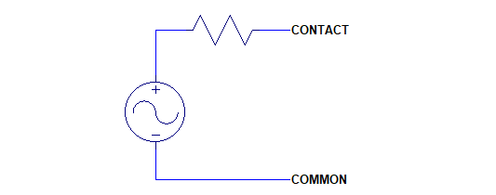
It is assumed that a CV has low termination impedance below 3k at any output voltage (so that a 10k pot connected to a voltage is considered valid), typically ~100Ohms.
Input range obviously is 0V to 5V and should not be exceeded too much, to avoid stress on the 100R safety resistors and clamping diodes in the input circuit.
Ideally the contact is used unloaded for read-out.

Basic Read-out

Potentiometers
A voltage is applied to the top end of the pot and voltage is measured at the unloaded wiper. The readout is the quotient V(wiper)/V(top). V(top) should be large enough (significant fraction of the ADC range) for high resolution and might be applied resisitive. Unless very low total resistance pots are used (2k and lower), applying the top voltage via 10k seems totally acceptable, in terms of resolution.

Rheostats
A voltage is applied to the wiper via a known 10k pullup resistor to 5V and measured at the wiper. The readout is effectively a resistance measurement: Rx/10k = V(wiper)/[5V-V(wiper)]. Because of various error term in this, an interpolating lookup table could be used.

Switches
Similar to Rheostats, a 10k Pullup is applied to contact and voltage is measured. Readout value then is determined by threshold hystersis (10/90 Schmitt-trigger) which will allow a bit of hardware debouncing.

Control Voltages
Control Voltages most likely are to be read out directly from the unloaded input line.

Error and Malfunction handling
For the pots and rheostats, short intermittent wiper lift-offs and crackling should not cause severe malfunction. For pots this is easily handled by the input filter capacitor keeping the read-out voltage constant when the input line goes open briefly.
Rheostats, like switches work on a pullup, therefore, wiper lift-off and switch bounce is harder to eliminate.
For switches, a debouncing scheme which needs at least N same states could be implemented at the cost of response time.
Rheostats may be assumed as controllers whose value only can change at a maximum speed, also some response delay could be tolerable. This might allow to catch and discard short glitches of one or two samples when the value return close to what was read before the glitch.

Auto-Ranging
For Pots and Rheostats, automatic range detection should be feasible. Some reasonable mimimum variation in the read-out must be present for this, obviously.
Because of mechanical tolerances of pots at the actual end-of-travel positions etc, the full detected range should not be used, rather something like a 5% to 95% sub-range. This would guarantee that the 0% and 100% end points of final read-out can almost always be reached. Too large electrical dead zones, on the other hand, will reduce the angular resolation which is often already compromised by mechanical dead zones at the end stops.
A new auto-ranging cycle should be started after a „plug-in“ event and additionally, upon software request.
Switches most likely can use fixed thresholds, no auto-ranging required.
Auto-ranging of Control Voltages doesn’t seem make too much sense in most cases. It could be done, though. Range and offset adjust might be feasible on the high-level software side.

Auto-Detection

Control Voltages
Auto-detect is not easy to implement. If one could rely on a medium low and, more importantly, pretty constant output impedance could be detected by a voltage difference proportional to voltage difference to the internal 5V, with and without the 10k pullup applied, assumed that the rate of change of the read-out is zero or very low.
An additional clue is that the sensed voltage settles rather quickly (compared to an open input) to whatever value when the pullup is released, and if that value is different from zero chances are high it is a CV.
Finally, when no other auto-detection succeeds, then the assumption that it is a CV might be OK and good enough.

3-wire Pots
For fast and reliable detection and to be compatible to the other detection strategies for 2-wire pots and switches, both input lines should be connected to the 10k pullups. This assures the inputs are never floating or high impedance (like 100k of the Fractal pedal, in reversed state) and thus the RC time constant of the input filter is sufficiently fast with 10k*220nF=2.2ms worst case. With settling assumed to be finished at 5*RC=11ms, and our sampling interval of 12.5ms, settling can be guaranteed to happen within two sample periods and channels will be well synchronized.
The following plots will show the voltages (normalized to 1V) at the top (blue) and wiper (red) lines vs. pot rotation, as well as the ratio of wiper to top vs. wiper voltage (red), and the same with top and wiper reversed, top/wiper vs top, (red). The ratio plot is more useful for detection as we don’t know the rotation at all.
If not stated otherwise, a 100R wiper series resistor is assumed.

Type I, 3-wire pot with no offset, various pot resistances:
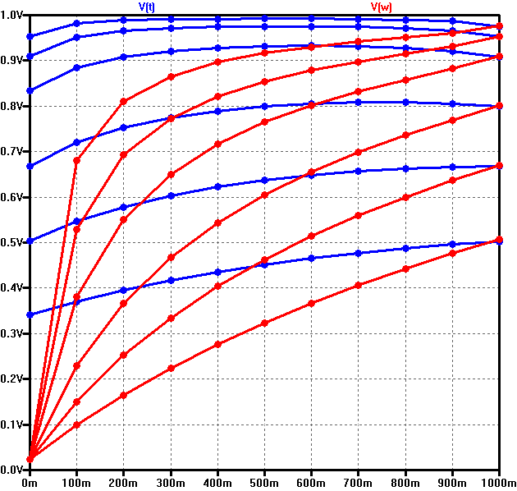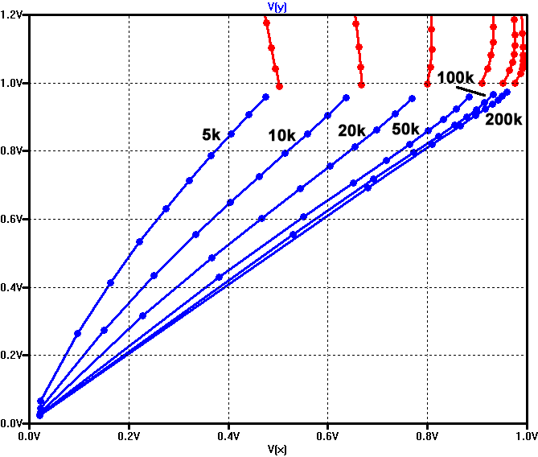
In the voltage plot (5k, 10k , 20k, 50k, 100k, 200k, bottom to top) we can see the wiper voltage is monotonically rising from zero to max, though not linear. The top voltage is not constant as well, at least when the full range of rotation is used.
In the ratio plot, with wiper and top lines correctly assumed, the ratios are always < 1.0. When swapped, the ratios are always >= 1.0.

Type Ia, 3-wire pot with no offset, various pot resistances, with 1k wiper resistor:
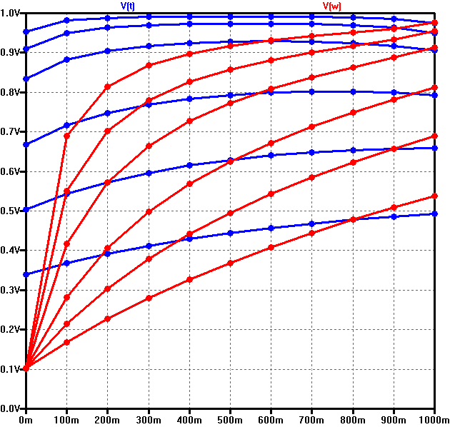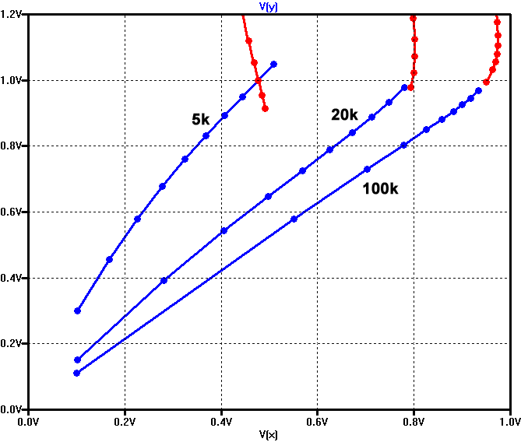
While the voltage plot is similar (again 5k, 10k , 20k, 50k, 100k, 200k, bottom to top), the ratio plot shows an overlap for low pot values. The 5k lines overlap in a region of about 0.9 to 1.1. Hence, within that region the ratio is no valid indicator for wiper and top pin assignment.

Type II, 3-wire 10k pot with 50k offset adjust
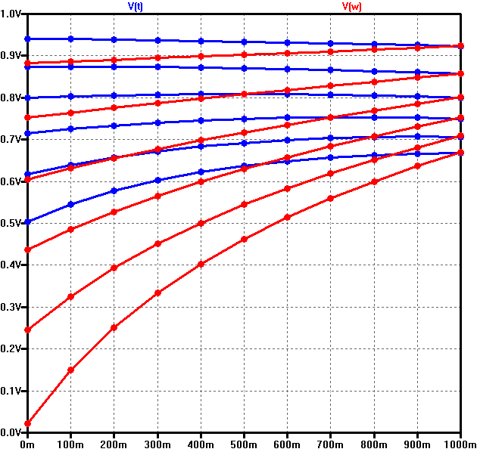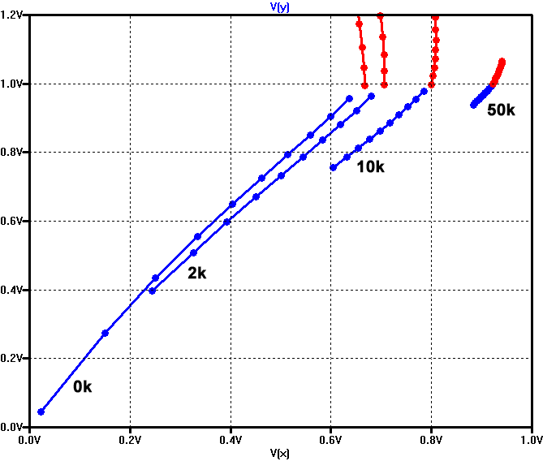
Voltage plot shown for 0k, 2k, 5k, 10k, 20k, 50k offsets. Again, top voltages is not constant over full rotation range but the range is very small, notably at 10k offset.
The ratio plot shows another issue with higher offset, the range gets small and very close to 1.0 in absolute value.

Type IIa, 3-wire 10k pot with 50k offset adjust and 1k wiper resistor
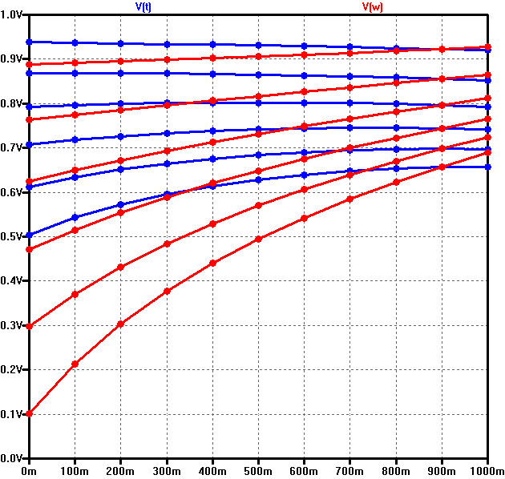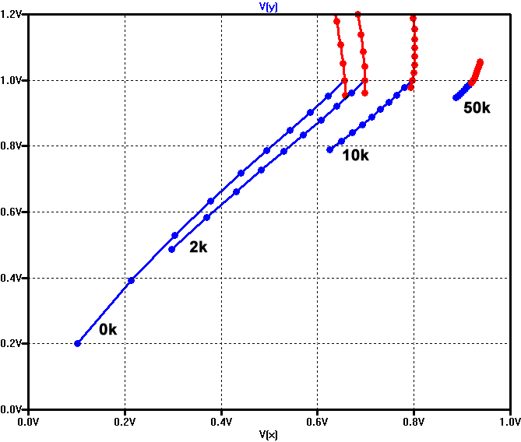
Here we can see the difficulties of high offset and wiper resistor combined. There is little change in top voltage for higher offsets, and in the ratio plot we have overlap in the 0.95 to 1.0 region, plus the total range for high offsets also is right in that region, making detection via ratio value practically impossible for offsets higher than 20k or so.

Type III, 3-wire 100k pot with 100k range adjust, various range factors
The voltage plots have been seperated not to clutter up one single plot pane.
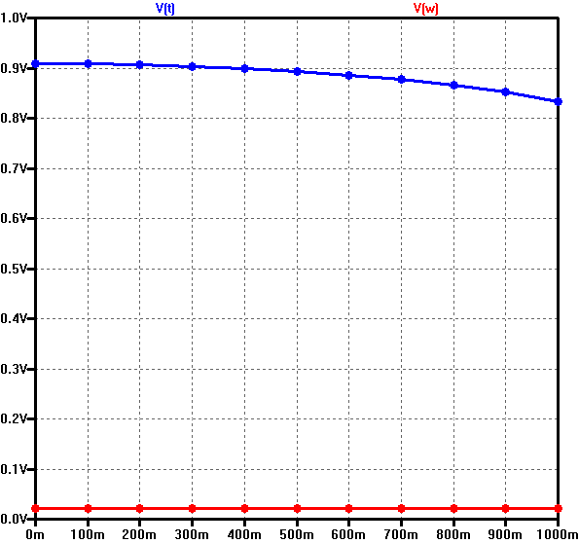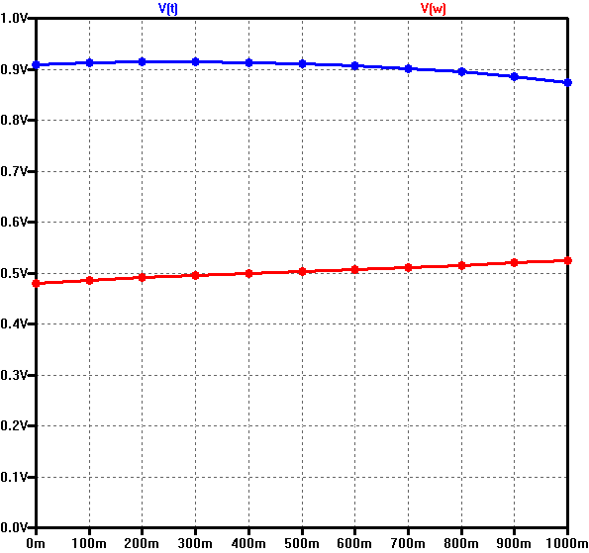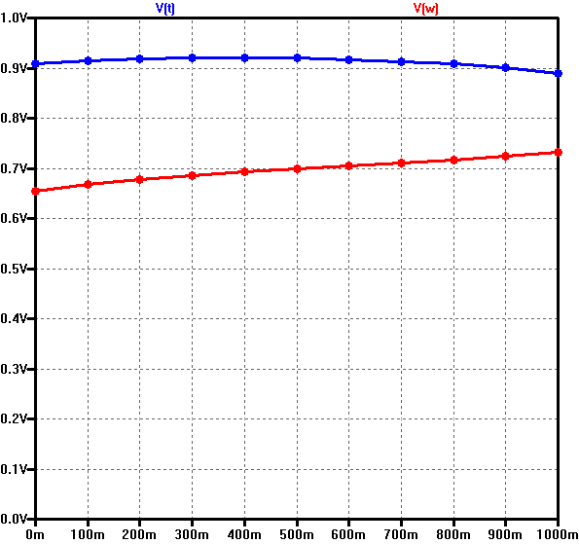
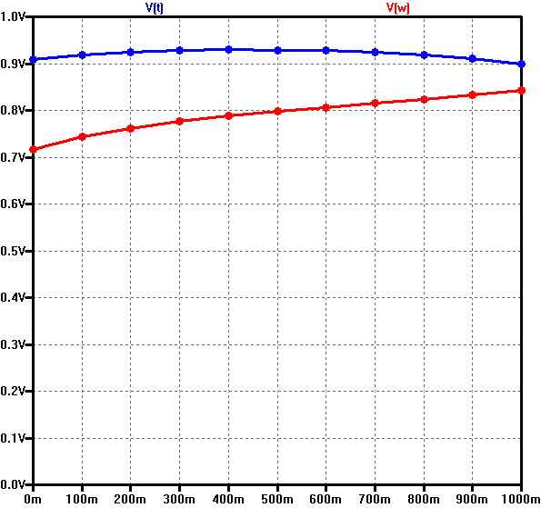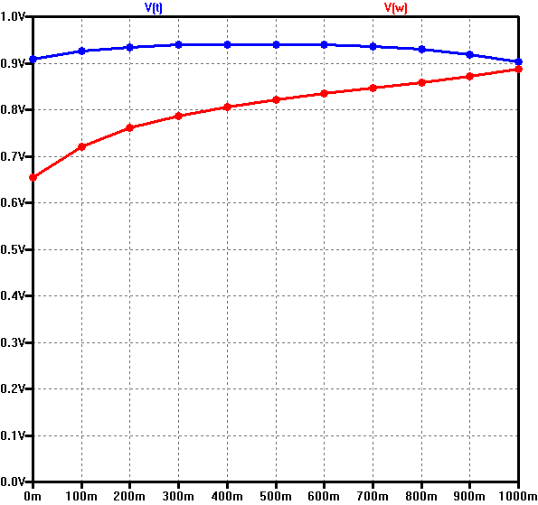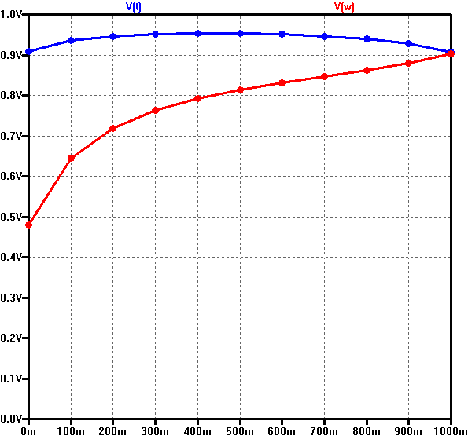
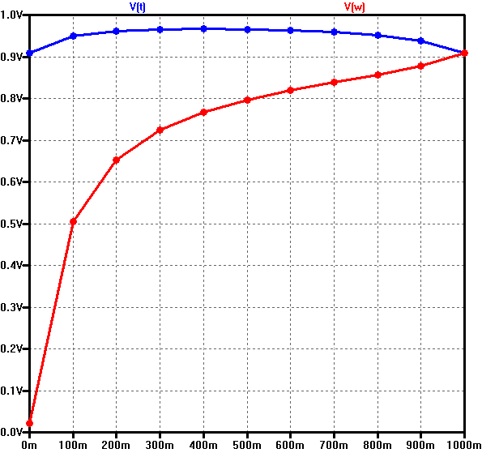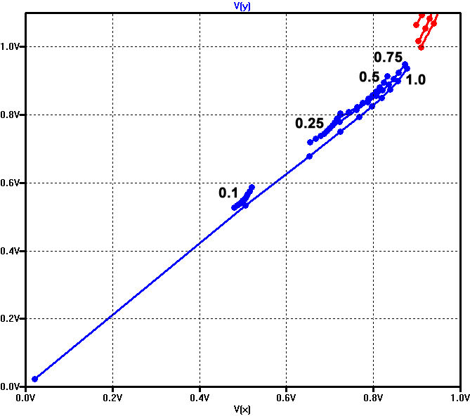
Range factors, left to right, top to bottom : 0.0, 0.1, 0.25, 0.5, 0.75, 0.9, 1.0
Bottom right the ration plots.
Because of the special circuit of the ranged pedal, at range „0“ there is no output on the wiper line (which actually is the output of the range pot). Also the top line shows little change for low and medium range factors making detection harder. The ratio plot shows small ranges for low factors but for anything above 0.25 detection seems possible.

Standard and Offset Type Pots can be detected, using 10 pullups on both wiper and top lines :
- When detect bit is set (cable plugged),
- And when both lines are within a reasonable resistive range (100R … 200k for the assumed wiper, and 2k …200k for the assumed top, can also be used for an estimate what is wiper and what is top lines),
- And when both lines always change simultaneously,
- And when the slope of the (V(wiper)/V(top))/V(wiper) point field is always positive and within some bounds (if negative and/or out of bounds, wiper and top are swapped).
Both lines pulled up with 10k will assure short settling times so there should be not too much dynamic error even when the pot is moved rather fast. Smoothing should be applied, though.

Completely Unplugged
Pedal detect switch is closed and can be sensed (will return 0). Both Tip and Ring are alternated (every 12.5ms) between open state and 10k pullup.
If the open state reads a stable zero and the pullup state reads a stable Vcc/2 and the Detect bit is zero, steady state is reached.

„Plug-In“ Event
In the first moment, the plug tip will touch then lift off the sleeve contact. From here, it goes either out again or it enters deeper and from there on the sleeve contact should always read „open“.
Next, the tip first touches then lifts the ring contact, breaking the lower leg of the 10k:10k divider. This will create fast „shock-changes“ of the read-out (arbitrary value) pulling away from the pretty exact/repeatable and stable „quiescent“ value. Again, either the tip retracts (step change back to „quiescent“) or continues to enter forward.
Eventually, the tip first touches then lifts the tip contact, with the same things happening again. And likewise, either the tip retracts (step change back to „quiescent“) or continues to be fully engaged.
From that moment, values will settle and stable basic read-out is possible.

