1. Lock & Exit:
a. "Never lock Trader Workstation": ensures continuous operations
b. "Auto Log Off Time": set to log off after the market close (after 4:00 pm EST)
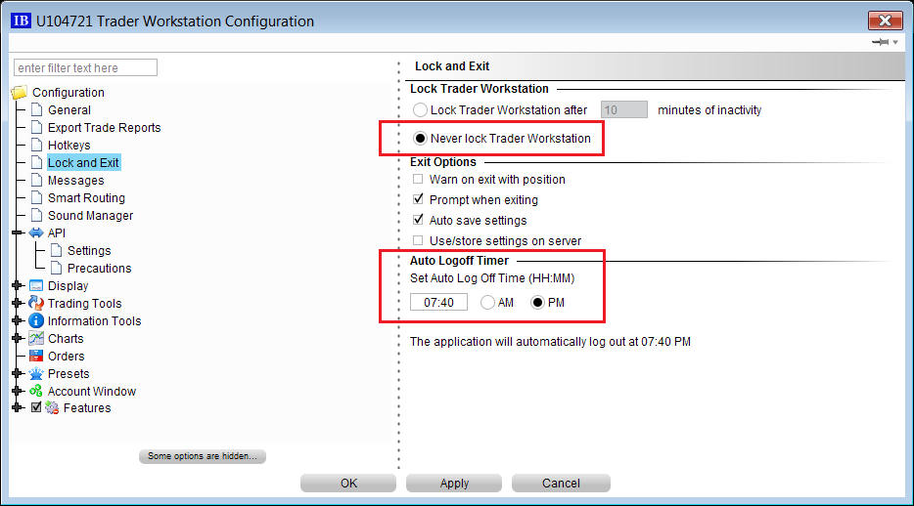
2. API settings:
a. "Enable ActiveX and Socket Clients": enables JBookTrader connection to TWS
b. "Download open orders on connection: enables JBookTrader to manage open orders after the loss of connectivity
c. "Socket port": must be the same as the socket port set in JBookTrader preferences
d. "Create API message log file": this is a TWS API log file useful for debugging purposes
e. "Trusted IP address": enables JBookTrader to connect to TWS, bypassing the confirmation
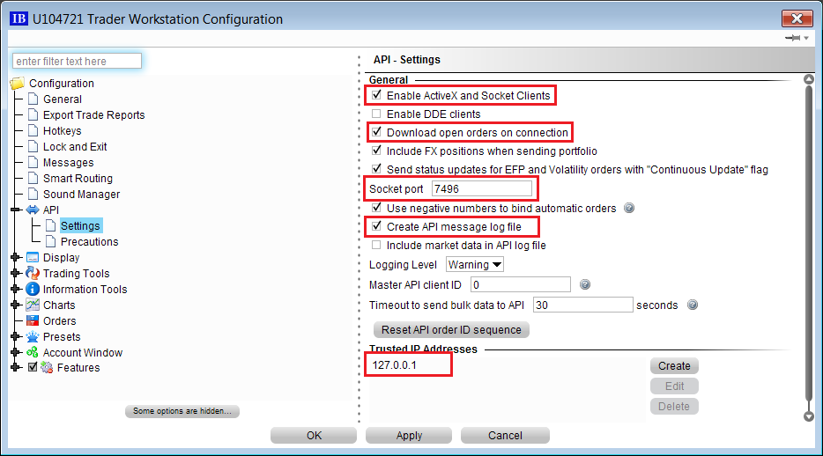
3. API precautions
a. "Bypass Order Precautions for API Orders": enables JBookTrader to place orders bypassing the confirmations
b. "Bypass negative yields to worst confirmation for API orders ": enables JBookTrader to place orders bypassing the confirmations
c. "Suppress market cap check for API orders": enables JBookTrader to place orders bypassing the confirmations
