CIS 377
Final project
N Medhora

410819
nmedhora@yahoo.com

TheProject.java 3
ClassBrowserTest.java 10
ClassLoaderTest.java 16
myPBEEncryptor.java 19
myPBEDecryptor.java 22
TestPrint.java 25
Running the project 28

TheProject.java
//import statements

import java.lang.*;
import java.lang.reflect.*;
import java.awt.*;
import java.awt.event.*;

import java.awt.Graphics2D;
import java.awt.image.BufferedImage;

import javax.swing.*;
import javax.swing.event.*;
import javax.swing.filechooser.*;
import javax.swing.JTree;
import javax.swing.tree.*;
import javax.swing.JList;

import java.io.*;
import java.io.File;
import java.io.FilenameFilter;
import java.util.*;
import java.util.Properties;

import java.awt.print.*;

public class theProject extends JFrame {

// io - file related stuff
private JFileChooser files; // File dialog
private String filename; //
private JLabel statusInfo;

// fields
private static final int WIDTH = 700;
private static final int HEIGHT = 700;

// force objects
private ClassLoaderFrame theLoader;
private ClassBrowserTestFrame theBrowser;
private myPBEEncryptor theEncryptor;
private myPBEDecryptor theDecryptor;
private TestPrint tp;

// fileds in the object for the UI controls
private static final JTextField tf_input = new JTextField();;//1
private JPanel pa_thePanel;

public theProject() {
addWindowListener(new WindowAdapter() {
public void windowClosing(WindowEvent e) {
System.exit(0);
}
});
this.setSize(WIDTH, HEIGHT);
this.setFocusableWindowState(true);

this.initUI();
}

// methods
/**********PRIVATE METHODS ****************/
/* Initialize UI controls */
private void initUI() {

Container cp ;//= this.getContentPane();
this.setDefaultCloseOperation(JFrame.EXIT_ON_CLOSE);
this.setTitle("Bawa's ClassProfiler");
this.setSize(WIDTH, HEIGHT);
this.setResizable(true);
cp = this.getContentPane();
cp.setLayout(new BorderLayout());

// Setup Menus
// Create toolbar
JMenuBar menuBar = new JMenuBar();
setJMenuBar (menuBar);

// Create a menu labeled File, accelerator F
JMenu file = new JMenu ("File");
file.setMnemonic (KeyEvent.VK_F);
JMenuItem item;

// Create a menu item Open, accelerator O
// Have it call via the doOpenCommand()
file.add (item = new JMenuItem ("Open"));
item.setMnemonic (KeyEvent.VK_O);
item.addActionListener (new ActionListener() {

public void actionPerformed (ActionEvent e) {
doOpenCommand ();
}
});

// Create a menu item Load, accelerator L
// Have it call ClassLoaderTest via the doLoadCommand()
file.add (item = new JMenuItem ("Load"));
item.setMnemonic (KeyEvent.VK_L);
item.addActionListener (new ActionListener() {

public void actionPerformed (ActionEvent e) {
doLoadCommand ();
}
});
// Create a menu item Encrypt, accelerator E
// Have it call DesEncrypter's encrypt(InputStream in, OutputStream out)
file.add (item = new JMenuItem ("Encrypt"));
item.setMnemonic (KeyEvent.VK_E);
item.addActionListener (new ActionListener() {

public void actionPerformed (ActionEvent e) {
doEncryptCommand ();
}
});
// Create a menu item Decrypt, accelerator D
// Have it call DesEncrypter's dncrypt(InputStream in, OutputStream out)
file.add (item = new JMenuItem ("Decrypt"));
item.setMnemonic (KeyEvent.VK_D);
item.addActionListener (new ActionListener() {

public void actionPerformed (ActionEvent e) {
doDecryptCommand ();
}
});

// Create a menu item Print, accelerator P
// Have it call doPrintCommand
file.add (item = new JMenuItem ("Print"));
item.setMnemonic (KeyEvent.VK_P);
item.addActionListener(new myPrinterCommand());

// Create a menu item Exit, accelerator x
// Have it call doCloseCommand when selected
file.add (item = new JMenuItem ("Exit"));
item.setMnemonic (KeyEvent.VK_X);
item.addActionListener (new ActionListener() {

public void actionPerformed (ActionEvent e) {
doExitCommand (0);
}
});

// Add file menu to menu bar
menuBar.add (file);

// Create a menu labelled Inspect, accelerator I
JMenu inspect = new JMenu("Inspect");
inspect.setMnemonic (KeyEvent.VK_I);

// Create a menu item Reflect, accelerator R
// Have it call doReflectionCommand when selected
inspect.add (item = new JMenuItem ("Reflect"));
item.setMnemonic (KeyEvent.VK_R);
item.addActionListener (new ActionListener() {

public void actionPerformed (ActionEvent e) {
doReflectionCommand ();
}
});

// Create a menu item Visualize, accelerator V
// Have it call doVisualizeCommand when selected
inspect.add (item = new JMenuItem ("Visualize"));
item.setMnemonic (KeyEvent.VK_V);
item.addActionListener (new ActionListener() {

public void actionPerformed (ActionEvent e) {
doVisualizeCommand ();
}
});

// Add inspect menu to menu bar
menuBar.add (inspect);

// Create a menu labeled Help, accelerator H
JMenu help = new JMenu ("Help");
help.setMnemonic (KeyEvent.VK_H);

// Create a menu item About, accelerator A
// Have it call doAboutCommand when selected
help.add (item = new JMenuItem ("About"));
item.setMnemonic (KeyEvent.VK_A);
item.addActionListener (new ActionListener() {
public void actionPerformed (ActionEvent e) {
doAboutCommand();
}
});

// Add help menu to menu bar
menuBar.add (help);

this.theBrowser = new ClassBrowserTestFrame();
theBrowser.setVisible(false);

// user customizable settings //
/// instantiate the panels individually first//

tf_input.setText("Type the class name to browse, ex.java.awt.Button");
tf_input.addActionListener(new ActionListener() {
public void actionPerformed(ActionEvent event) {
// add the class whose name is in the text field
try {
String text = tf_input.getText();
theBrowser.setVisible(true);
theBrowser.addClass(Class.forName(text));
// clear text field to indicate success
tf_input.setText("");
}
catch (ClassNotFoundException e) {
Toolkit.getDefaultToolkit().beep(); // make some noise
}
}
});

cp.add(tf_input, BorderLayout.NORTH);
cp.add(this.theBrowser, BorderLayout.CENTER);
cp.setSize(this.getToolkit().getScreenSize()); //(700, 700);

this.pack();
this.setVisible(true);
}

public void doOpenCommand () {
tp = new TestPrint();
tp.show();
}

public void doAboutCommand() {
String aboutTheProject = "\tBaWa's Class Profiler\n\n\n ";
aboutTheProject = aboutTheProject.concat( "FILE\n\n Open --- Open a java file \n\n Load --- Load a class file (with 'main method') \n\n" +
" Encrypt --- Encrypt any file ('key' is Optional) \n\n" +
" Decrypt --- Decrypt any file ('key' is Optional) \n\n" +
" Print --- Print Class Structure information contents \n\n" +
" INSPECT\n\n Reflect --- Run class from tree (MUST have 'main') \n\n" +
" Visualize ---- See the class diagram (coming soon)\n\n" +
"\u00a9 Navroz Medhora\nGolden Gate University\nAugust 2002" );
JTextArea aboutTextArea = new JTextArea();
aboutTextArea.setEditable(false);
aboutTextArea.setSize(500, 500);
aboutTextArea.setText(aboutTheProject);
aboutTextArea.setVisible(true);

JPanel aboutPanel = new JPanel();
aboutPanel.setBorder(BorderFactory.createCompoundBorder(
BorderFactory.createTitledBorder("BaWa's Class Profiler"),
BorderFactory.createEmptyBorder(0, 5, 5, 5)
));
aboutPanel.add(aboutTextArea);

JFrame aboutFrame = new JFrame();
aboutFrame.setSize(600,600);
aboutFrame.setVisible(true);
aboutFrame.setResizable(false);
aboutFrame.getContentPane().add(aboutPanel);

aboutFrame.setSize(600,600);
aboutFrame.setVisible(true);
aboutFrame.setResizable(false);
}

public void doLoadCommand() {
this.theLoader = new ClassLoaderFrame();
theLoader.setVisible(true);
}

public void doEncryptCommand() {
theEncryptor = new myPBEEncryptor ();

}

public void doDecryptCommand() {
theDecryptor = new myPBEDecryptor ();
}

public void doPrintCommand() {
// pc = new PrintCommand();

}

public void doExitCommand (int status) {
System.exit (status);
}

public void doReflectionCommand() {
try {
// the user selected a different node--update description
TreePath path = theBrowser.getTree().getSelectionPath();
if (path == null) { return ;}
DefaultMutableTreeNode selectedNode
= (DefaultMutableTreeNode)path.getLastPathComponent();
Class c = (Class)selectedNode.getUserObject();
String[] args = new String[] {};

Method m = c.getMethod("main", new Class[] { args.getClass() });
m.invoke(null, new Object[] { args });
}
catch (NoSuchMethodException nsme) {
JOptionPane.showMessageDialog(this, "WRONG", "No main method", JOptionPane.ERROR_MESSAGE);
}
catch (IllegalAccessException iae) {
JOptionPane.showMessageDialog( this, "ACCESS ERROR", "ILLEGAL", JOptionPane.ERROR_MESSAGE);
}
catch (InvocationTargetException e ) {
JOptionPane.showMessageDialog( this, "TARGET ERROR", "CANNOT BE INVOKED", JOptionPane.ERROR_MESSAGE);};
}

public void doVisualizeCommand() {

}

public static void main(String args[]) throws Exception {
theProject tPt = new theProject();
tPt.initUI();
}

// Print a file into the text area.
class myPrinterCommand implements ActionListener {
Properties p = new Properties();

public void actionPerformed (ActionEvent e) {
PrintJob pjob = Toolkit.getDefaultToolkit().getPrintJob(theProject.this, "Cool Stuff", p);
if (pjob != null) {
Graphics pg = pjob.getGraphics();
if (pg != null) {
String s = theBrowser.textArea.getText();
printLongString (pjob, pg, s);
pg.dispose();
}
pjob.end();
}
}
}

// Print string to graphics via printjob
// Does not deal with word wrap or tabs
void printLongString (PrintJob pjob, Graphics pg, String s) {
int pageNum = 1;
int linesForThisPage = 0;
int linesForThisJob = 0;
// Note: String is immutable so won't change while printing.
if (!(pg instanceof PrintGraphics)) {
throw new IllegalArgumentException ("Graphics context not PrintGraphics");
}
StringReader sr = new StringReader (s);
LineNumberReader lnr = new LineNumberReader (sr);
String nextLine;
int pageHeight = pjob.getPageDimension().height;
Font helv = new Font("Helvetica", Font.PLAIN, 12);
//have to set the font to get any output
pg.setFont (helv);
FontMetrics fm = pg.getFontMetrics(helv);
int fontHeight = fm.getHeight();
int fontDescent = fm.getDescent();
int curHeight = 0;
try {
do {
nextLine = lnr.readLine();
if (nextLine != null) {
if ((curHeight + fontHeight) > pageHeight) {
// New Page
System.out.println ("" + linesForThisPage + " lines printed for page " + pageNum);
pageNum++;
linesForThisPage = 0;
pg.dispose();
pg = pjob.getGraphics();
if (pg != null) {
pg.setFont (helv);
}
curHeight = 0;
}
curHeight += fontHeight;
if (pg != null) {
pg.drawString (nextLine, 0, curHeight - fontDescent);
linesForThisPage++;
linesForThisJob++;
} else {
System.out.println ("pg null");
}
}
} while (nextLine != null);
} catch (EOFException eof) {
// Fine, ignore
} catch (Throwable t) { // Anything else
t.printStackTrace();
}
System.out.println ("" + linesForThisPage + " lines printed for page " + pageNum);
System.out.println ("pages printed: " + pageNum);
System.out.println ("total lines printed: " + linesForThisJob);
}

} // ends theProject

ClassBrowserTest.java
/**
* ClassBrowserTest
* @author NMedhora
*/

import java.awt.*;
import java.awt.event.*;
import java.lang.reflect.*;
import java.util.*;
import javax.swing.*;
import javax.swing.event.*;
import javax.swing.tree.*;

public class ClassBrowserTest {
public static void main(String[] args) {

JInternalFrame frame = new ClassBrowserTestFrame();
frame.show();
}
}

class ClassBrowserTestFrame extends JInternalFrame
implements ActionListener, TreeSelectionListener {
private DefaultMutableTreeNode root;
private DefaultTreeModel model;
private JTree tree;
public JTextArea textArea;

JScrollPane treePane;
JScrollPane areaPane;

public ClassBrowserTestFrame() {
setTitle("ClassBrowserTest");
setSize(300, 200);
setVisible(true);
setResizable(true);

// the root of the class tree is Object
root = new DefaultMutableTreeNode(java.lang.Object.class);
model = new DefaultTreeModel(root);
tree = new JTree(model);

// add this class to populate the tree with some data
addClass(java.lang.Object.class);//getClass()

// set up selection mode
tree.addTreeSelectionListener(this);
int mode = TreeSelectionModel.SINGLE_TREE_SELECTION;
tree.getSelectionModel().setSelectionMode(mode);

// this text area holds the class description
textArea = new JTextArea();
textArea.setEditable( false );

// add tree and text area to the content pane
JPanel panel = new JPanel();
panel.setLayout(new GridLayout(1, 2));

treePane = new JScrollPane(tree);
areaPane = new JScrollPane(textArea);

panel.add(treePane);
panel.add(areaPane);

Container contentPane = getContentPane();
contentPane.add(panel, "Center");
}

public void actionPerformed(ActionEvent event) {
}

public void valueChanged(TreeSelectionEvent event) {
// the user selected a different node--update description
TreePath path = tree.getSelectionPath();
if (path == null) { return ;}
DefaultMutableTreeNode selectedNode
= (DefaultMutableTreeNode)path.getLastPathComponent();
Class c = (Class)selectedNode.getUserObject();

String ctorDescription = getConstructorDescription(c);
String innerClassDescription = getInnerClassDescription(c);
String interfaceDescription = getInterfaceDescription(c);
String fieldDescription = getFieldDescription(c);
String methodDescription = getMethodDescription(c);

textArea.setText( "\t\t============================\n" +
"\t\tCLASS ==> " + c.getName() + "\n" +
"\t\t============================\n"
);

textArea.append(ctorDescription);
textArea.append(interfaceDescription);
textArea.append(fieldDescription);
textArea.append(methodDescription);
textArea.append(innerClassDescription);
}

public DefaultMutableTreeNode findUserObject(Object obj) {
// find the node containing a user object
Enumeration e = root.breadthFirstEnumeration();
while (e.hasMoreElements()) {
DefaultMutableTreeNode node = (DefaultMutableTreeNode)e.nextElement();
if (node.getUserObject().equals(obj)) {
return node;
}
}
return null;
}

public DefaultMutableTreeNode addClass(Class c) {
// add a new class to the tree

// skip non-class types
if (c.isInterface() || c.isPrimitive()) {
return null;
}

// if the class is already in the tree, return its node
DefaultMutableTreeNode node = findUserObject(c);
if (node != null) {
return node;
}

// class isn't present--first add class parent recursively
Constructor[] cn = c.getDeclaredConstructors();
Class s = c.getSuperclass();
Class e[] = c.getInterfaces();
Class n[] = c.getClasses();

DefaultMutableTreeNode parent;
if (s == null) {
parent = root;
}
else {
parent = addClass(s);
}

parent = addClass(s);

// add the class as a child to the parent
DefaultMutableTreeNode newNode = new DefaultMutableTreeNode(c);
model.insertNodeInto(newNode, parent, parent.getChildCount());

// make node visible
TreePath path = new TreePath(model.getPathToRoot(newNode));
tree.makeVisible(path);

return newNode;
}

/*
* Each class has an array of constructors
* Each constructor has one return type - void and is public
* Each ctor can have an array of parameters
*/

public static String getConstructorDescription(Class c) {
// use reflection to identify the ctors
String r = "CONSTRUCTORS\n============\n";
Constructor[] cn = c.getDeclaredConstructors();
for(int i = 0; i < cn.length; i++) {
Constructor ctor = cn[i];
Class paramCt[] = ctor.getParameterTypes();
r += "public void " + ctor.getName() + " " ;

if (paramCt.length == 0) { r += "( ) \n";}
else {
r += "( ";

for (int j = 0; j < paramCt.length; j++) {
r += paramCt[j] + " ";
}
r+= " )\n";
}
}
r += "\n";
return r;
}

/*
* Each class may have an array of Interfaces
* Get the full class path for same
*/

public static String getInterfaceDescription(Class c) {
// use reflection to identify interfaces implemented by the class c
String r = "INTERFACES IMPLEMENTED\n======================\n";
Class[] interfaces = c.getInterfaces();
if (interfaces.length == 0) {
r += "NONE\n";
}
else {
for(int i = 0; i < interfaces.length; i++) {
Class ie = interfaces[i];
r += ie.getName() + "\n";
}
}
r += "\n";
return r;
}

/*
* Each class has an array of class fields
* Fields may be
*/

public static String getFieldDescription (Class c) {

// use reflection to find types and names of fields
String r = "CLASS FIELDS\n============\n";
Field[] fields = c.getDeclaredFields();
if (fields.length == 0) {
r += "NONE\n";
}
else {
for (int i = 0; i < fields.length; i++) {
Field f = fields[i];

if ((f.getModifiers() & Modifier.STATIC) != 0) {
r += "static ";
}

if ((f.getModifiers() & Modifier.PUBLIC) != 0) {
r += "public ";
} else if ((f.getModifiers() & Modifier.PRIVATE) != 0) {
r += "private ";
}
else {
r += "protected ";
}

r += f.getType().getName() + " " + f.getName() + "\n";//+ f.get(c)
}

}
r += "\n";
return r;
}

public static String getMethodDescription (Class c) {
// use reflection to determine the method signatures
String r = "METHODS\n=======\n";
Method [] methods = c.getDeclaredMethods();
if (methods.length == 0) {
r += "NONE\n";
}
else {

for (int i = 0; i < methods.length; i++) {
Method m = methods[i];
Class[] mParam = m.getParameterTypes();
Class[] mExec = m.getExceptionTypes();
if ((m.getModifiers() & Modifier.STATIC) != 0) {
r += "static ";
}
if ((m.getModifiers() & Modifier.PUBLIC) != 0) {
r += "public ";
} else if ((m.getModifiers() & Modifier.PRIVATE) != 0) {
r += "private ";
}
else {
r += "protected ";
}
r += m.getReturnType().getName().toString() + " " +
// m.getParameterTypes().toString() + " " +
m.getName().toString() ;
if (mParam.length == 0) {
r += " ( ) ";
}
else {
r += " ( ";
for (int j = 0; j < mParam.length; j++) {
r += mParam[j] + " ";
}
r += " ) ";
}

if (mExec.length == 0 ) {
r += "\n";
}
else {

r += " throws Exception ";
for (int j = 0; j < mExec.length; j++) {
r += " " + mExec[j] + " ";
}
r += "\n";
}
}
}

r += "\n";
return r;
}

public static String getInnerClassDescription(Class c) {
// use Reflection to locate inner classes
String r = "Inner Classes\n=============\n";
Class [] n = c.getDeclaredClasses();
if (n.length == 0) {
r += "NONE\n";
}
else {
for (int i = 0; i < n.length; i++) {
Class nn = n[i];
r += nn.getName() + "\n";
}
}
r += "\n";
return r;
}

public JTree getTree () {
return this.tree;
}
} // ends ClassBrowserTest

ClassLoaderTest.java

/**
* ClassLoaderTest
* @author NMedhora
*/

import java.util.*;
import java.io.*;
import java.lang.reflect.*;
import java.awt.*;
import java.awt.event.*;
import javax.swing.*;

public class ClassLoaderTest {

public static void main(String[] args) {
Frame f = new ClassLoaderFrame();
f.show();
}
}

class ClassLoaderFrame extends JFrame {
public ClassLoaderFrame() {
setTitle("ClassLoaderTest");
setSize(300, 200);
addWindowListener(new WindowAdapter() {

public void windowClosing(WindowEvent e) {
dispose();
}
});
getContentPane().setLayout(new GridBagLayout());
GridBagConstraints gbc = new GridBagConstraints();
gbc.weightx = 0;
gbc.weighty = 100;
gbc.fill = GridBagConstraints.NONE;
gbc.anchor = GridBagConstraints.EAST;
add(new JLabel("Class"), gbc, 0, 0, 1, 1);
add(new JLabel("Key"), gbc, 0, 1, 1, 1);
gbc.weightx = 100;
gbc.fill = GridBagConstraints.HORIZONTAL;
gbc.anchor = GridBagConstraints.WEST;
add(nameField, gbc, 1, 0, 1, 1);
add(keyField, gbc, 1, 1, 1, 1);
gbc.fill = GridBagConstraints.NONE;
gbc.anchor = GridBagConstraints.CENTER;
JButton loadButton = new JButton("Load");
add(loadButton, gbc, 0, 2, 2, 1);
loadButton.addActionListener(
new ActionListener()
{ public void actionPerformed(ActionEvent event)
{ runClass(nameField.getText(), keyField.getText());
}
});
}

public void add(Component c, GridBagConstraints gbc,
int x, int y, int w, int h)
{ gbc.gridx = x;
gbc.gridy = y;
gbc.gridwidth = w;
gbc.gridheight = h;
getContentPane().add(c, gbc);
}

public void runClass(String name, String key)
{ try
{ ClassLoader loader
= new CryptoClassLoader(Integer.parseInt(key));
Class c = loader.loadClass(name);
String[] args = new String[] {};

Method m = c.getMethod("main", new Class[] { args.getClass() });
m.invoke(null, new Object[] { args });
}
catch (Throwable e)
{ JOptionPane.showMessageDialog(this, e);
}
}

private JTextField keyField = new JTextField("3", 4);
private JTextField nameField = new JTextField(30);
}

class CryptoClassLoader extends ClassLoader
{ public CryptoClassLoader(int k)
{ key = k;
}

protected synchronized Class loadClass(String name, boolean resolve)
throws ClassNotFoundException { // check if class already loaded
Class cl = (Class)classes.get(name);

if (cl == null) // new class
{ try
{ // check if system class
return findSystemClass(name);
}
catch (ClassNotFoundException e) {}
catch (NoClassDefFoundError e) {}

// load class bytes--details depend on class loader

byte[] classBytes = loadClassBytes(name);
if (classBytes == null)
throw new ClassNotFoundException(name);

cl = defineClass(name, classBytes,
0, classBytes.length);
if (cl == null)
throw new ClassNotFoundException(name);

classes.put(name, cl); // remember class
}

if (resolve) resolveClass(cl);

return cl;
}

private byte[] loadClassBytes(String name)
{ String cname = name.replace('.', '/') + ".caesar";
FileInputStream in = null;
try
{ in = new FileInputStream(cname);
ByteArrayOutputStream buffer
= new ByteArrayOutputStream();
int ch;
while ((ch = in.read()) != -1)
{ byte b = (byte)(ch - key);
buffer.write(b);
}
in.close();
return buffer.toByteArray();
}
catch (IOException e)
{ if (in != null)
{ try { in.close(); } catch (IOException e2) { }
}
return null;
}
}

private Map classes = new HashMap();
private int key;
} // ends ClassLoaderTest

myPBEEncryptor.java

import java.io.*;
import java.awt.*;
import java.awt.event.*;
import java.security.*;
import javax.crypto.*;
import javax.crypto.spec.*;

public class myPBEEncryptor extends Frame {
private int WIDTH = 400;
private int HEIGHT = 300;
private int BUFFER_SIZE = 8;
private TextField inputTF;

public static void main(String[] args) {
new myPBEEncryptor();
}

public myPBEEncryptor() {
super("Bawa' PBEFileEncryptApp");
setup();
pack();
setSize(WIDTH,HEIGHT);
addWindowListener(new WindowHandler());
setVisible(true);
}

void setup() {
// Create panel for password input
Panel inputPanel = new Panel();

inputPanel.setLayout(new GridLayout(8,3));
Label encryptLabel_1 = new Label("ENCRYPTION....");
encryptLabel_1.setFont(new Font("Monospaced",Font.BOLD,18));
Label encryptLabel_2 = new Label("1 Enter pass phrase (Optional)");
Label encryptLabel_3 = new Label("2 Press \"Encrypt\" OR File >> Encrypt");
Label encryptLabel_4 = new Label("3 Select File to Encrypt");
Label encryptLabel_5 = new Label("4 Choose File to Save Encrypted Output");
Label thePhrase = new Label(" Enter pass phrase:");
inputTF = new TextField(70);
inputTF.setFont(new Font("Monospaced",Font.PLAIN,14));
inputTF.setEchoChar('*');
Button encrypt = new Button("Encrypt");
encrypt.addActionListener(new ActionListener () {
public void actionPerformed (ActionEvent e) {
encryptFile();
}
});
inputPanel.add(encryptLabel_1);
inputPanel.add(encryptLabel_2);
inputPanel.add(encryptLabel_3);
inputPanel.add(encryptLabel_4);
inputPanel.add(encryptLabel_5);
inputPanel.add(thePhrase);
inputPanel.add(inputTF);
inputPanel.add(encrypt);
add("North",inputPanel);

// Setup menu bar
MenuBar menuBar = new MenuBar();
Menu fileMenu = new Menu("File");
MenuItem fileEncrypt = new MenuItem("Encrypt");

MenuItem fileExit = new MenuItem("Exit");
fileMenu.add(fileEncrypt);

fileMenu.add(fileExit);
fileEncrypt.addActionListener(new MenuItemHandler());
fileExit.addActionListener(new MenuItemHandler());
menuBar.add(fileMenu);
setMenuBar(menuBar);
}

Cipher createCipher(int mode) throws Exception {
// Get the pass phrase out of the text field
char[] charArray = inputTF.getText().toCharArray();
// Create a PBEKeySpec from the pass phrase
PBEKeySpec keySpec = new PBEKeySpec(charArray);
// Create a SecretKeyFactory
SecretKeyFactory keyFactory =
SecretKeyFactory.getInstance("PBEWithMD5AndDES");
// Generate a secret key using the keyspec
SecretKey key = keyFactory.generateSecret(keySpec);
// Create the salt using the MD5 digest of the pass phrase
MessageDigest md = MessageDigest.getInstance("MD5");
md.update(inputTF.getText().getBytes());
byte[] digest = md.digest();
byte[] salt = new byte[8];
for(int i=0;i<8;++i) salt[i] = digest[i];
// Create a PBEParameterSpec using the salt
PBEParameterSpec paramSpec = new PBEParameterSpec(salt,20);
// Create an instance of the cipher
Cipher cipher = Cipher.getInstance("PBEWithMD5AndDES");
// Initialize it for encryption/decryption with the key and salt
cipher.init(mode,key,paramSpec);
return cipher;
}
void encryptFile() {
try {
// Create and initialize a cipher
Cipher cipher = createCipher(Cipher.ENCRYPT_MODE);
// Select input file
String inPathString =
getPath("Select file to encrypt",FileDialog.LOAD);
if(inPathString == null) return;
// Select output file
String outPathString =
getPath("Save encrypted file as",FileDialog.SAVE);
if(outPathString == null) return;
// Open files and encrypt/decrypt
applyCipher(inPathString,outPathString,cipher,"Encrypting ...");
}catch(Exception ex) {
ex.printStackTrace();
}
}

void applyCipher(String inFile,String outFile,Cipher cipher,
String message) throws Exception {
// Open input file using a CiperInputStream
CipherInputStream in = new CipherInputStream(
new BufferedInputStream(new FileInputStream(inFile)),cipher);
// Open output file
BufferedOutputStream out = new BufferedOutputStream(
new FileOutputStream(outFile));
// Notify user that encryption/decryption is in progress
WaitDialog dialog = new WaitDialog(message);
dialog.pack();
dialog.setBounds(100,100,150,100);
dialog.show();
// Encrypt/decrypt file
byte[] buffer = new byte[BUFFER_SIZE];
int numRead = 0;
do {
numRead = in.read(buffer);
if(numRead > 0) out.write(buffer,0,numRead);
} while(numRead == 8);
in.close();
out.close();
// Remove dialog box after a second
Thread.sleep(1000);
dialog.hide();
dialog.dispose();
}

String getPath(String title,int mode) {
FileDialog fd = new FileDialog(this,title,mode);
fd.show();
// If file a file has not been selected then return null
String inDirectoryString = fd.getDirectory();
String inFileString = fd.getFile();
if(inDirectoryString == null || inFileString == null)
return null;
return inDirectoryString + inFileString;
}
class MenuItemHandler implements ActionListener {
public void actionPerformed(ActionEvent e) {
String s = e.getActionCommand();
if(s.equals("Encrypt")) encryptFile();
else{
setVisible(false);
dispose();
}
}
}
class WindowHandler extends WindowAdapter {
public void windowClosing(WindowEvent e) {
setVisible(false);
dispose();
}
}
class WaitDialog extends Dialog {
public WaitDialog(String s) {
super(myPBEEncryptor.this,"Please wait");
setLayout(new BorderLayout());
add("Center",new Label(s,Label.CENTER));
}
}
} // ends myPBEEncryptor

myPBEDecryptor.java

import java.io.*;
import java.awt.*;
import java.awt.event.*;
import java.security.*;
import javax.crypto.*;
import javax.crypto.spec.*;

public class myPBEDecryptor extends Frame {
private int WIDTH = 400;
private int HEIGHT = 300;
private int BUFFER_SIZE = 8;
private TextField inputTF;

public static void main(String[] args) {
new myPBEDecryptor();
}

public myPBEDecryptor() {
super("Bawa's File Decryptor");
setup();
pack();
setSize(WIDTH,HEIGHT);
addWindowListener(new WindowHandler());
setVisible(true);
}

void setup() {
// Create panel for password input
Panel inputPanel = new Panel();
inputPanel.setLayout(new GridLayout(8,3));
Label decryptLabel_1 = new Label("DECRYPTION....");
decryptLabel_1.setFont(new Font("Monospaced",Font.BOLD,18));
Label decryptLabel_2 = new Label("1 Enter pass phrase (Optional)");
Label decryptLabel_3 = new Label("2 Press \"Decrypt\" OR File >> Decrypt");
Label decryptLabel_4 = new Label("3 Select File to Decrypt");
Label decryptLabel_5 = new Label("4 Choose File to Save Decrypted Output");
Label thePhrase = new Label(" Enter pass phrase:");
inputTF = new TextField(70);
inputTF.setFont(new Font("Monospaced",Font.PLAIN,14));
inputTF.setEchoChar('*');
Button decrypt = new Button("Decrypt");
decrypt.addActionListener(new ActionListener () {
public void actionPerformed(ActionEvent e) {
decryptFile();
}
});

inputPanel.add(decryptLabel_1);
inputPanel.add(decryptLabel_2);
inputPanel.add(decryptLabel_3);
inputPanel.add(decryptLabel_4);
inputPanel.add(decryptLabel_5);
inputPanel.add(thePhrase);
inputPanel.add(inputTF);
inputPanel.add(decrypt);

add("North",inputPanel);
// Setup menu bar
MenuBar menuBar = new MenuBar();
Menu fileMenu = new Menu("File");
MenuItem fileDecrypt = new MenuItem("Decrypt");
MenuItem fileExit = new MenuItem("Exit");
fileMenu.add(fileDecrypt);

fileMenu.add(fileExit);
fileDecrypt.addActionListener(new MenuItemHandler());
fileExit.addActionListener(new MenuItemHandler());
menuBar.add(fileMenu);
setMenuBar(menuBar);
}

Cipher createCipher(int mode) throws Exception {
// Get the pass phrase out of the text field
char[] charArray = inputTF.getText().toCharArray();
// Create a PBEKeySpec from the pass phrase
PBEKeySpec keySpec = new PBEKeySpec(charArray);
// Create a SecretKeyFactory
SecretKeyFactory keyFactory =
SecretKeyFactory.getInstance("PBEWithMD5AndDES");
// Generate a secret key using the keyspec
SecretKey key = keyFactory.generateSecret(keySpec);
// Create the salt using the MD5 digest of the pass phrase
MessageDigest md = MessageDigest.getInstance("MD5");
md.update(inputTF.getText().getBytes());
byte[] digest = md.digest();
byte[] salt = new byte[8];
for(int i=0;i<8;++i) salt[i] = digest[i];
// Create a PBEParameterSpec using the salt
PBEParameterSpec paramSpec = new PBEParameterSpec(salt,20);
// Create an instance of the cipher
Cipher cipher = Cipher.getInstance("PBEWithMD5AndDES");
// Initialize it for encryption/decryption with the key and salt
cipher.init(mode,key,paramSpec);
return cipher;
}

void decryptFile() {
try {
// Create and initialize a cipher
Cipher cipher = createCipher(Cipher.DECRYPT_MODE);
// Select input file
String inPathString =
getPath("Select file to decrypt",FileDialog.LOAD);
if(inPathString == null) return;
// Select output file
String outPathString =
getPath("Save decrypted file as",FileDialog.SAVE);
if(outPathString == null) return;
// Open files and encrypt/decrypt
applyCipher(inPathString,outPathString,cipher,"Decrypting ...");
}catch(Exception ex) {
ex.printStackTrace();
}
}

void applyCipher(String inFile,String outFile,Cipher cipher,
String message) throws Exception {
// Open input file using a CiperInputStream
CipherInputStream in = new CipherInputStream(
new BufferedInputStream(new FileInputStream(inFile)),cipher);
// Open output file
BufferedOutputStream out = new BufferedOutputStream(
new FileOutputStream(outFile));
// Notify user that encryption/decryption is in progress
WaitDialog dialog = new WaitDialog(message);
dialog.pack();
dialog.setBounds(100,100,150,100);
dialog.show();
// Encrypt/decrypt file
byte[] buffer = new byte[BUFFER_SIZE];
int numRead = 0;
do {
numRead = in.read(buffer);
if(numRead > 0) out.write(buffer,0,numRead);
} while(numRead == 8);
in.close();
out.close();
// Remove dialog box after a second
Thread.sleep(1000);
dialog.hide();
dialog.dispose();
}

String getPath(String title,int mode) {
FileDialog fd = new FileDialog(this,title,mode);
fd.show();
// If file a file has not been selected then return null
String inDirectoryString = fd.getDirectory();
String inFileString = fd.getFile();
if(inDirectoryString == null || inFileString == null)
return null;
return inDirectoryString + inFileString;
}
class MenuItemHandler implements ActionListener {
public void actionPerformed(ActionEvent e) {
String s = e.getActionCommand();
if(s.equals("Decrypt")) decryptFile();
else{
setVisible(false);
dispose();
}
}
}
class WindowHandler extends WindowAdapter {
public void windowClosing(WindowEvent e) {
setVisible(false);
dispose();
}
}
class WaitDialog extends Dialog {
public WaitDialog(String s) {
super(myPBEDecryptor.this,"Please wait");
setLayout(new BorderLayout());
add("Center",new Label(s,Label.CENTER));
}
}
}// ends myPBEDecryptor

TestPrint.java
import java.awt.*;
import java.awt.event.*;
import java.io.*;
import java.util.Properties;

public class TestPrint extends Frame {
TextArea textArea;
Label statusInfo;
Button loadButton, printButton, closeButton;
Properties p = new Properties();

public TestPrint() {
super ("File Opener");
add (statusInfo = new Label(), "North");
Panel p = new Panel ();
p.add (loadButton = new Button ("Open"));
loadButton.addActionListener( new LoadFileCommand() );
p.add (printButton = new Button ("Print"));
printButton.addActionListener( new PrintCommand() );
p.add (closeButton = new Button ("Close"));
closeButton.addActionListener( new CloseCommand() );
add (p, "South");
add (textArea = new TextArea (10, 40), "Center");
pack();
}

public static void main (String args[]) {
TestPrint f = new TestPrint();
f.show();
}

// Bail Out
class CloseCommand implements ActionListener {
public void actionPerformed (ActionEvent e) {
dispose();
}
}

// Load a file into the text area.
class LoadFileCommand implements ActionListener {
public void actionPerformed (ActionEvent e) {
int state;
String msg;
FileDialog file = new FileDialog (TestPrint.this, "Load // Open File", FileDialog.LOAD);
file.setFile ("*.java"); // Set initial filename filter
file.show(); // Blocks
String curFile;
if ((curFile = file.getFile()) != null) {
String filename = file.getDirectory() + curFile;
char[] data;
setCursor (Cursor.getPredefinedCursor(Cursor.WAIT_CURSOR));
File f = new File (filename);
try {
FileReader fin = new FileReader (f);
int filesize = (int)f.length();
data = new char[filesize];
fin.read (data, 0, filesize);
} catch (FileNotFoundException exc) {
String errorString = "File Not Found: " + filename;
data = errorString.toCharArray ();
} catch (IOException exc) {
String errorString = "IOException: " + filename;
data = errorString.toCharArray ();
}
statusInfo.setText ("Load / Open: " + filename);
textArea.setText (new String (data));
setCursor (Cursor.getPredefinedCursor(Cursor.DEFAULT_CURSOR));
}
}
}

// Print a file into the text area.
class PrintCommand implements ActionListener {
public void actionPerformed (ActionEvent e) {
PrintJob pjob = getToolkit().getPrintJob(TestPrint.this, "Cool Stuff", p);
if (pjob != null) {
Graphics pg = pjob.getGraphics();
if (pg != null) {
String s = textArea.getText();
printLongString (pjob, pg, s);
pg.dispose();
}
pjob.end();
}
}
}

// Print string to graphics via printjob
// Does not deal with word wrap or tabs
void printLongString (PrintJob pjob, Graphics pg, String s) {
int pageNum = 1;
int linesForThisPage = 0;
int linesForThisJob = 0;
// Note: String is immutable so won't change while printing.
if (!(pg instanceof PrintGraphics)) {
throw new IllegalArgumentException ("Graphics context not PrintGraphics");
}
StringReader sr = new StringReader (s);
LineNumberReader lnr = new LineNumberReader (sr);
String nextLine;
int pageHeight = pjob.getPageDimension().height;
Font helv = new Font("Helvetica", Font.PLAIN, 12);
//have to set the font to get any output
pg.setFont (helv);
FontMetrics fm = pg.getFontMetrics(helv);
int fontHeight = fm.getHeight();
int fontDescent = fm.getDescent();
int curHeight = 0;
try {
do {
nextLine = lnr.readLine();
if (nextLine != null) {
if ((curHeight + fontHeight) > pageHeight) {
// New Page
System.out.println ("" + linesForThisPage + " lines printed for page " + pageNum);
pageNum++;
linesForThisPage = 0;
pg.dispose();
pg = pjob.getGraphics();
if (pg != null) {
pg.setFont (helv);
}
curHeight = 0;
}
curHeight += fontHeight;
if (pg != null) {
pg.drawString (nextLine, 0, curHeight - fontDescent);
linesForThisPage++;
linesForThisJob++;
} else {
System.out.println ("pg null");
}
}
} while (nextLine != null);
} catch (EOFException eof) {
// Fine, ignore
} catch (Throwable t) { // Anything else
t.printStackTrace();
}
System.out.println ("" + linesForThisPage + " lines printed for page " + pageNum);
System.out.println ("pages printed: " + pageNum);
System.out.println ("total lines printed: " + linesForThisJob);
}
} // ends TestPrint

Running the project
First compile all the java files: theProject.java, ClassLoaderTest.java, TestPrint.java, ClassBrowserTest.java, myPBEEncryptor.java and myPBEDecryptor.java.

Then invoke java interpreter on theProject: java theProject
OUTPUT
{NOTE -- a bug --- the project on starting does not expand to preferred size it is important for you to hit the maximise button.}

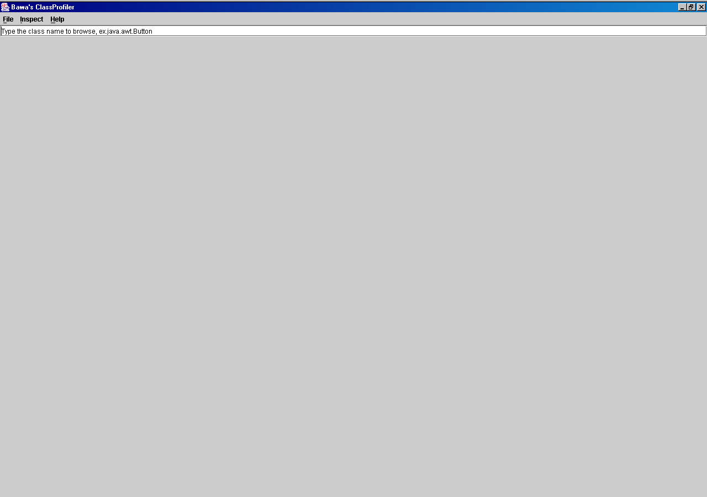

The opening screen. The user is presented with a host of menu options:
FILE
- Open – Alt O (keyboard shortcut) --- opens a java file which can be read…. One can also print this file out
- Load – Alt L --- opens a Class through a customized class loader
- Encrypt --- Alt E – Encrypt any file
- Decrypt --- Alt D – Decrypt any file
- Print Alt P --- Print the contents of the “Class Information”
INSPECT
- Reflect Alt R --- Invoke a class which exists on the tree pane (left side, using mouse click, or keyboard)
- Visualize Alt V – View info of the class in a class diagram – not yet implemented

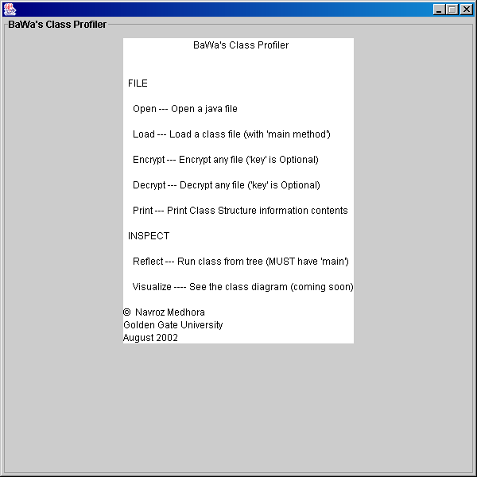
Pressing Help --- About

Output on entering java.awt.Button in the textfield

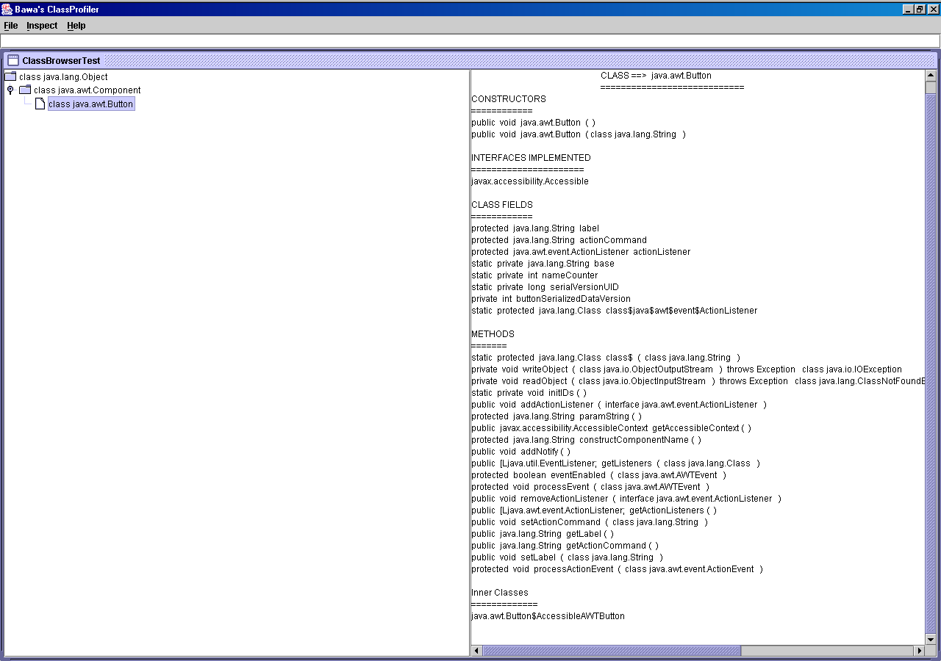

The information provided include: The class name (including path); all the constructors and their parameters; all interfaces implented; all class fields; all methods (including return type, modifiers , parameters and exceptions); and all InnerClasses
Class Information for BuildTree

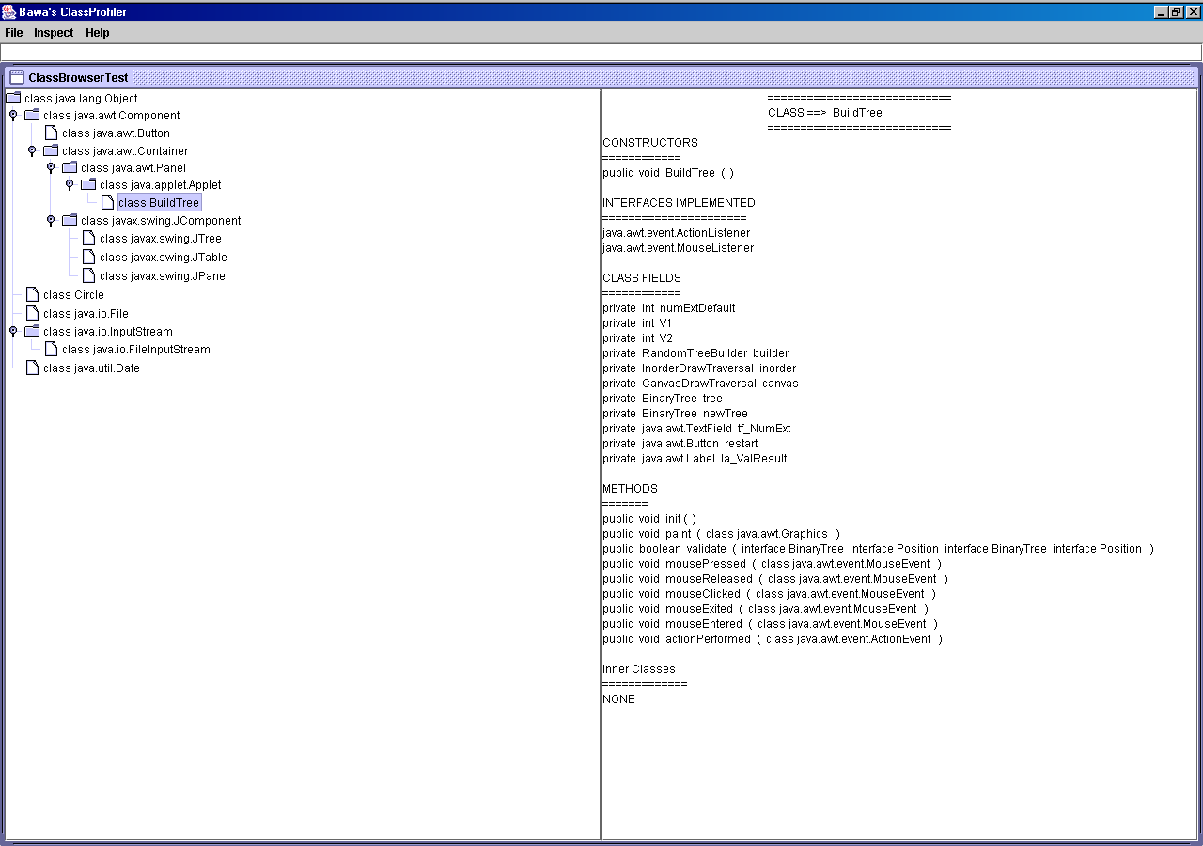

Navigating to “CircleTest” on the tree; then hitting Inspect – Reflect

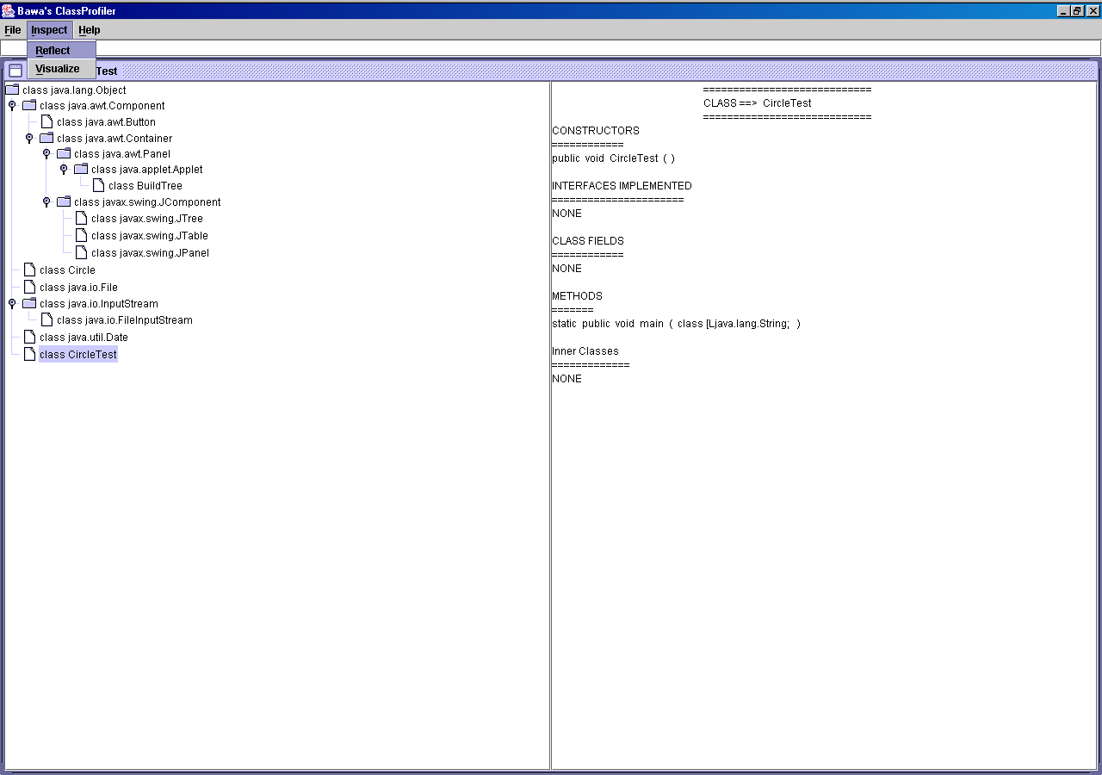
See output on next page

Output on hitting Reflect after navigating to CircleTest

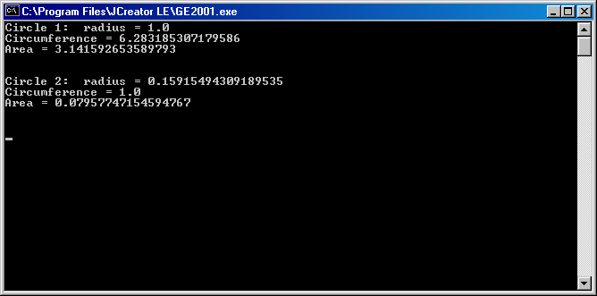

Hitting File – Open (this will now give us option to open & print any file)

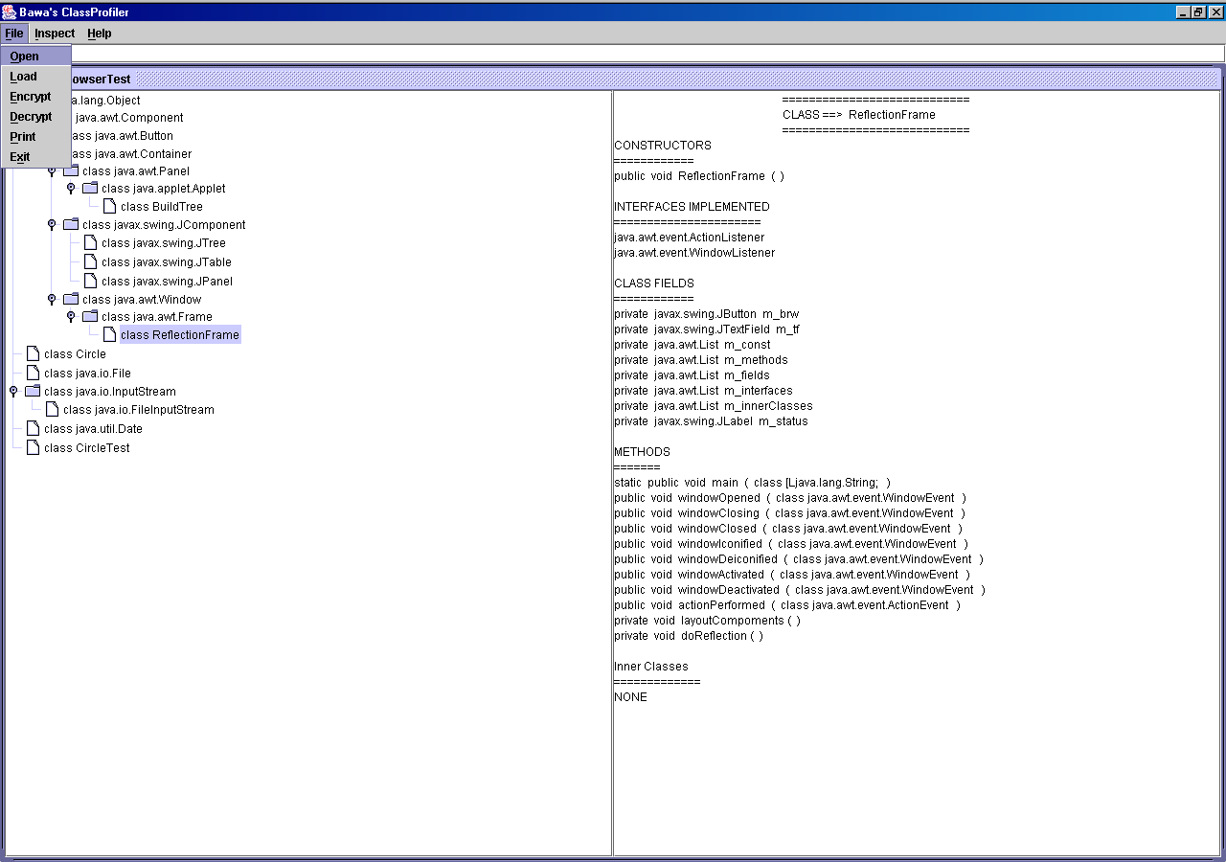

Initial Output on hitting File – Open Navigating to a file to open (Only *.java files are displayed)

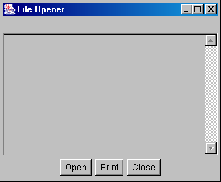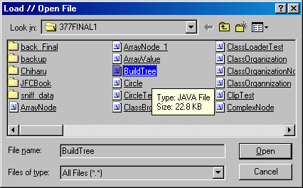

The output upon selecting BuildTree.java

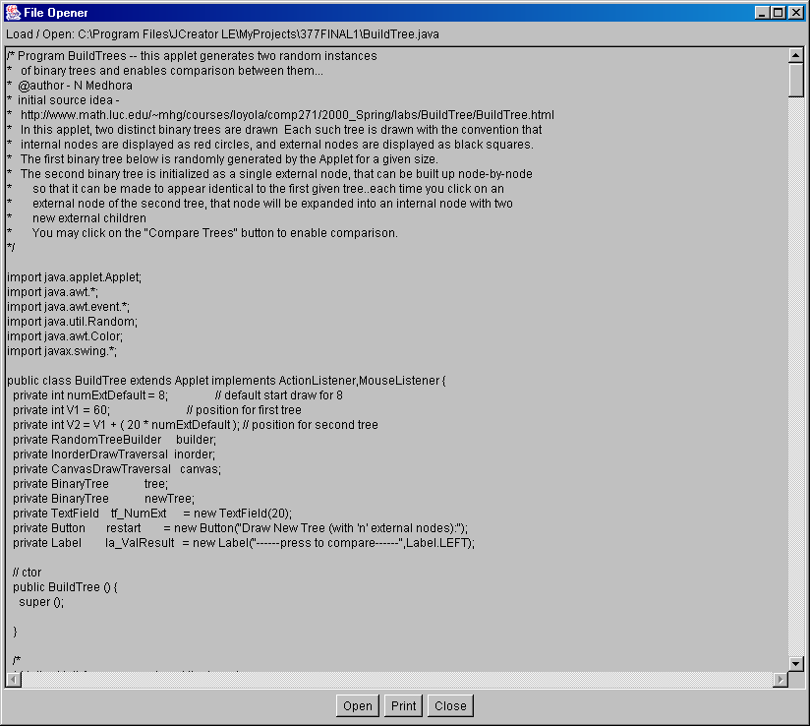
The contents of the readable .java file BuildTree are displayed --- the user can open other java files – Presently there is also a Print facility implemented; however this is not so for editing and saving .

{PS – I do not have a printer at home and so I cannot provide output for that here}

Hitting File – Load : enables us to Load any class file --- we enter the full path name.

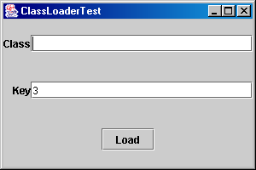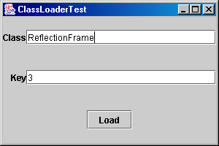

The output from the ClassLoader causes a new instance of ReflectionFrame (another class – code not provided)
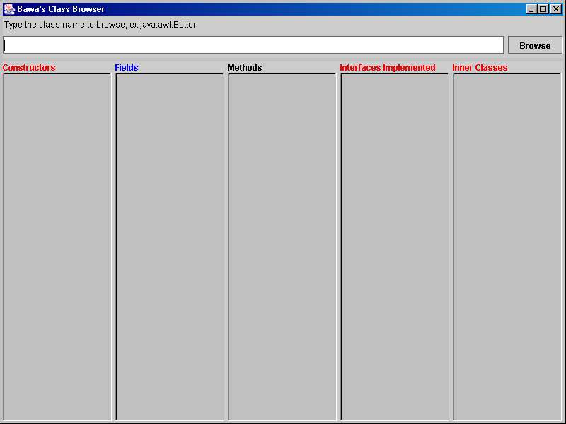

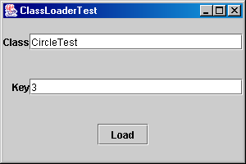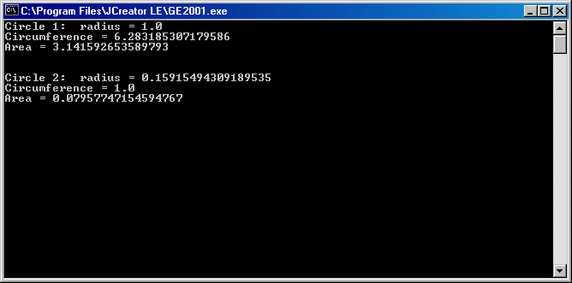

The custom class loader – loads and runs CircleTest
Compare with page 32 (Inspect – Reflect)
Encryption
Httting File – Encrypt; we first enter the pass phrase – here I entered ‘nonny’
The File menu in the Encryptor has two menu options (Encrypt and Exit )

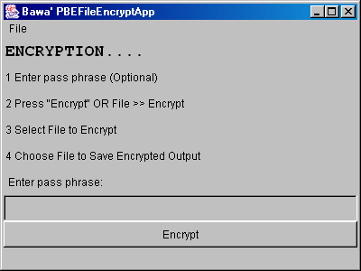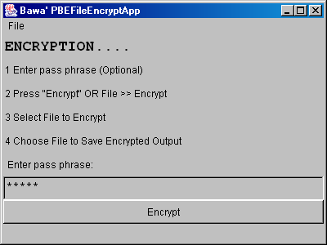

After htiing “Encrypt” button – or File >> Encrypt we are initially asked to select a file for encryption
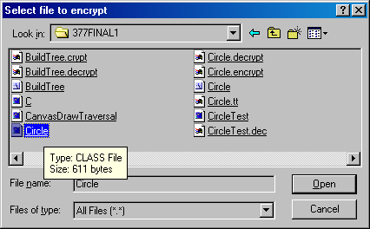
Navigating to file “Circle.class” for Encryption

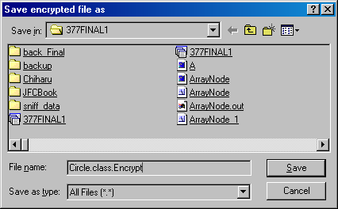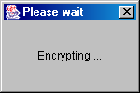

Choosing target file “Circle.class.Encrypt” to save the encrypted version The output while encrypting
of the original file “Circle.class”
Now a new Encrypted file has been created
Decryption
A similar process for Decrypting files…. We now try to decrypt the file we encryted in the previous page… we use the same pass phrase “nonny”….. If we use any othe pass phrase then the output of the decryption will appear encrypted

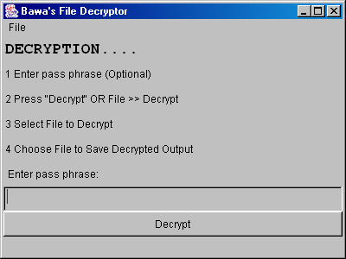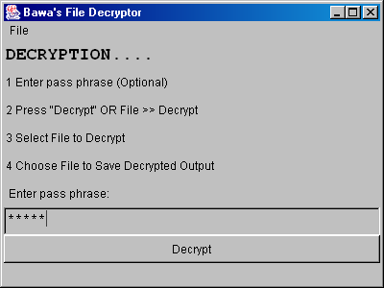

After hitting “Decrypt” button – or File >> Decrypt we are initially asked to select a file to decrypt

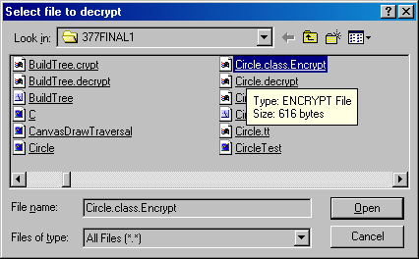
Navigating to file “Circle.class.Encrypt” for Decryption

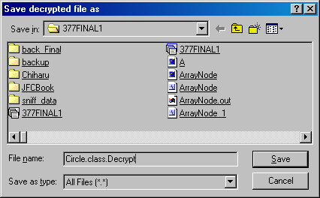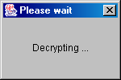
Choosing target file “Circle.class.Decrypt” to save the decrypted version The output while decrypting
of the originally encrypted file “Circle.class.Encrypt”
Now the encrypted file “Circle.class.Encrypt” has been decrypted
Encryption // Decryption Demo on file CircleTest.java ---- this is being done because .class files cannot be read by humans
Using Pass phrase “manhattan”
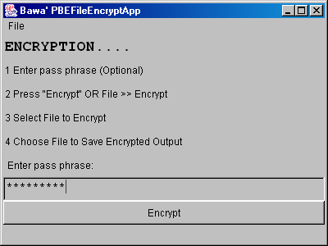 Entering pass phrase “manhattan”

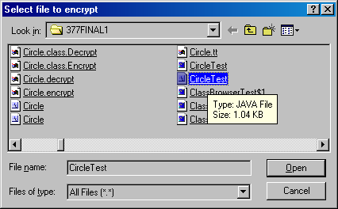 Choosing “CircleTest.java” for encryption

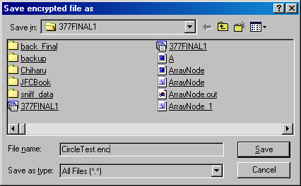 Selected target encrypted file as “CircleTest.enc”

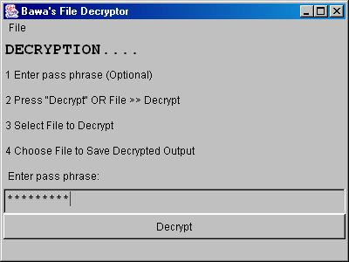 Entering pass phrase “manhattan”

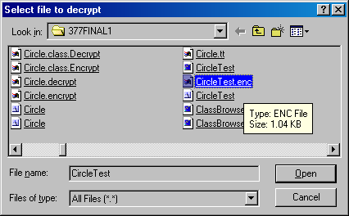 Selecting “CircleTest.enc” for decryption

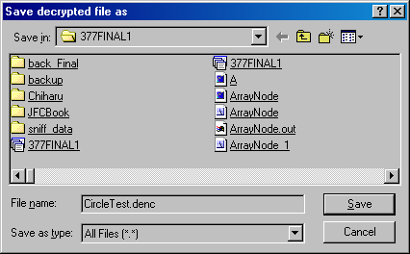 Selecting target decrypted file as “CircleTest.denc”

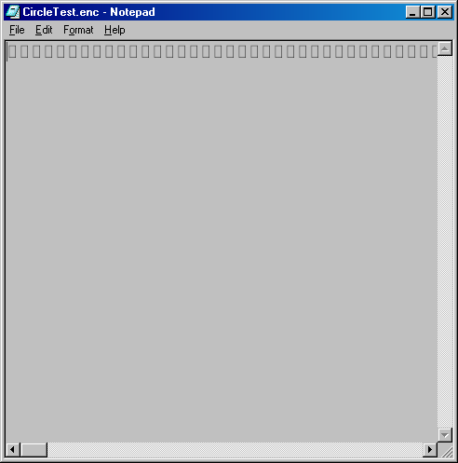
Opening “CircleTest.enc” and “CircleTest.denc” with Notepad

Since CircleTest.enc is an encrypted file it cannot be read by Notepad

“CircleTest.denc” is the decrypted version of “CircleTest.enc” --- in both the encryption and decryption process the SAME PASS PHRASE was used, and so is readable when opened from Notepad

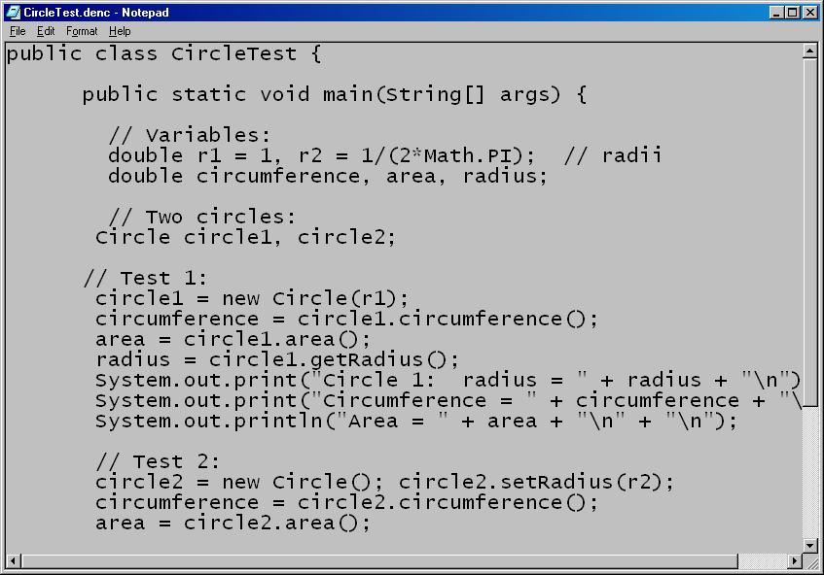
Note if we had decrypted CircleTest.enc with another pass phrase it will not be readable:
Attempting decryption without any pass phrase and then opeing output in Notepad

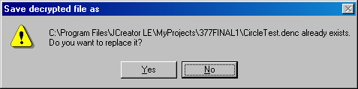
Since file CircleTest.denc already exists we are overwriting it

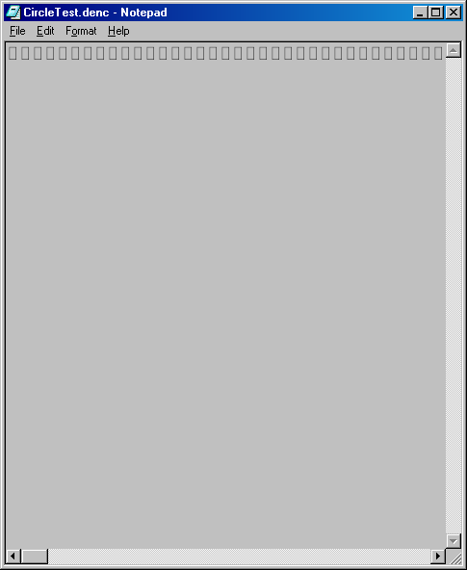
Since the pass phrase was not the same we cannot get viewable output in Notepad
Exercising File – Print to get the contents of the Class Information

